Exercise 1 Look and write

|  |  |  |  |
| --- | --- | --- | --- |
| Nam | noodles | Nick | nuts |

|  |  |  |  |
| --- | --- | --- | --- |
|  |  |  |  |
| *…………………….* | *…………………….* | *…………………….* | *…………………….* |

Exercise 2 Look and read. Put a tick or cross in the box.

|  |  |  |
| --- | --- | --- |
|  |  |  |
| 1. She is Lucy. | 1. I like chips. | 1. Look at the lemons |
|  |  |  |
| 1. I like nuts. | 1. He is Ben. | 1. He is Dan. |
|  |  |  |
| 1. Look at the lake. | 1. There are pots. | 1. I like nuts. |

Exercise 3 Look and circle the correct words

|  |  |  |
| --- | --- | --- |
| Hình ảnh có liên quan |  |  |
| a) He’s having **noodles /nuts**. | b) She’s having **nuts/ apples** | c) He’s having**fish /chips** |
| Kết quả hình ảnh cho eating a cake clipart | Kết quả hình ảnh cho eat apple clipart |  |
| d) He’s having a **cake /nuts** | e) She’s having an **lemon /apple** | f) She’s having **chips/fish** |

Exercise 5 Find the mistakes and correct them

|  |  |  |
| --- | --- | --- |
| Hình ảnh có liên quan |  | Hình ảnh có liên quan |
| 1. She’s having noodles | 1. She’s having chips. | 1. He’s having rice. |
| He’s having noodles | *………………………………….* |  |
| Kết quả hình ảnh cho eat a pizza clipart | Kết quả hình ảnh cho eating a cake clipart |  |
| d) She’s having a pizza. | e) He’s having noodles. | f) He’s having fish. |
| *………………………………….* | *………………………………….* | *………………………………….* |

Exercise 5 Look and write : like or don’t like

|  |  |  |  |  |  |
| --- | --- | --- | --- | --- | --- |
| Kết quả hình ảnh cho happy clipart | Hình ảnh có liên quan | a) I **like** milk. |  | Kết quả hình ảnh cho juice clipart | d)I *……………….* juice. |
|  | Kết quả hình ảnh cho NOODLES clipart | b)I *………………….* noodles | Kết quả hình ảnh cho happy clipart |  | e) I *……………….* chips. |
| Kết quả hình ảnh cho happy clipart | Hình ảnh có liên quan | c) I *………………….* cake. |  | Hình ảnh có liên quan | f)I *…………….* apples*.* |
| Kết quả hình ảnh cho happy clipart | Hình ảnh có liên quan | g) I *………………….* fish. |  | Hình ảnh có liên quan | h) I *……………….*lemons |

Exercise 6 Put the words in the correct order

a) I – chips – like

*………………………………………………….*

b) is – Lucy – having – noodles

*………………………………………………….*

c) He – having – is – nuts

*………………………………………………….*

d) noodles – Dan – likes

*………………………………………………….*

e) lemons – She – likes

*………………………………………………….*

f) chips – Ben – having – is

*………………………………………………….*

g) She – apples – likes

*………………………………………………….*

Exercise 7 Look and complete the sentences

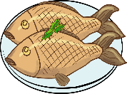 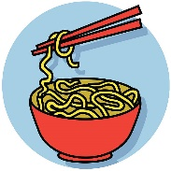 a) Nam’s having noodles. He isn’t having fish 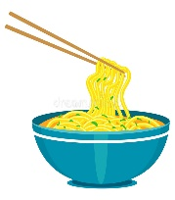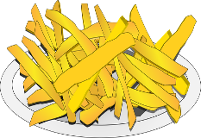b) *…………………………………………………….*

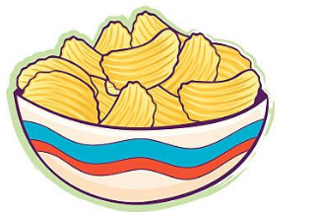 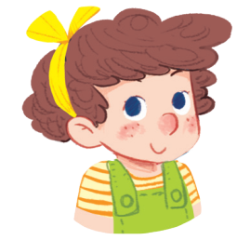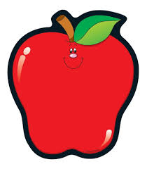 c) *…………………………………………………….* 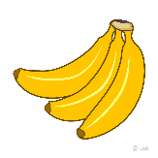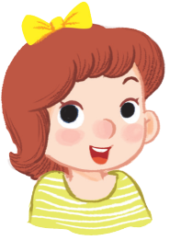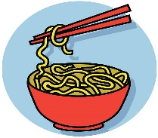d) *…………………………………………………….*

Exercise 8 Read and write

|  |  |  |
| --- | --- | --- |
| He | She | They |

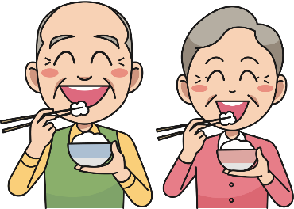 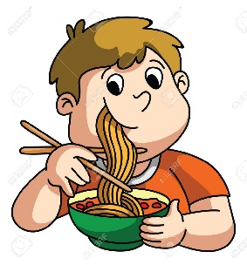

a) *………………*are having rice. b) *………………*is having chips.

 

c) *………………*is having chicken. d) *………………*is having chips.

Exercise 9 Circle the beginning sound

|  |  |  |  |
| --- | --- | --- | --- |
| Káº¿t quáº£ hÃ¬nh áº£nh cho ball clipart | Kết quả hình ảnh cho NOODLES clipart | Kết quả hình ảnh cho monkey clipart |  |
| a c | a b c | k l m | e f g |
|  | Kết quả hình ảnh cho hat clipart |  | Káº¿t quáº£ hÃ¬nh áº£nh cho goat  clipart |
| l m n | f h g | j k l | e f g |

Exercise 10 Write the beginning letter for each picture :

|  |  |  |  |
| --- | --- | --- | --- |
| Káº¿t quáº£ hÃ¬nh áº£nh cho apple cartoon | **A** |  |  |
|  |  |  |  |
| Kết quả hình ảnh cho monkey clipart |  | Kết quả hình ảnh cho NOODLES clipart |  |
|  |  | Káº¿t quáº£ hÃ¬nh áº£nh cho ball clipart |  |