Exercise 1 Look and write:

|  |  |  |  |
| --- | --- | --- | --- |
| lake | lemons | leaf | Lucy |





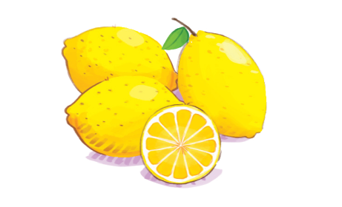

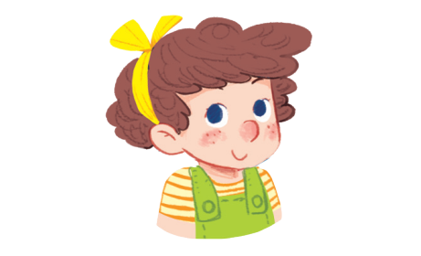

Exercise 2 Look and circle the correct words









leaf / lake

leaf /lake

apples/ lemons

Lucy /Ann

Exercise 3 Look and match

|  |  |  |
| --- | --- | --- |
| a) Look at Lucy. |  |  |
| b) Look at the lemons. |  |  |
| c) Look at the leaf. |  |  |
| d) Look at the lake. |  |  |

Exercise 4 Put the words in the correct order

|  |  |  |  |
| --- | --- | --- | --- |
|  | a) lemons – at – Look - the  *…………………………………..* |  | b) at – Look – the - lake  *……………………………………..* |
| Hình ảnh có liên quan | c) at – Look – the – sun  *……………………………………* |  | d) at – Look - Lucy  *……………………………………..* |
|  | e) Look – the – leaf – at  *……………………………………* |  | f) Look – Mary - at  *……………………………………..* |
|  | g) the – truck – at – Look  *……………………………………* |  | h) the – bus – at – Look  *……………………………………..* |

Exercise 5 Look and tick (✓) or cross (🗶)

|  |  |  |
| --- | --- | --- |
|  |  |  |
| 1. I like apples. | 1. Look at the lake. | 1. Look at the sun. |
|  | Kết quả hình ảnh cho run  clipart |  |
| d. She is Mary. | e. He is running. | f. Look at the bus. |

Exercise 6 Look and choose the correct words

|  |  |  |  |
| --- | --- | --- | --- |
| a) Look at the **leaf/lake**. |  | c) I like **apples / lemons.** | Kết quả hình ảnh cho apples clipart |
| b) **He / She** is running. |  | d) Look at the **eggs/ lemons.** |  |
| e) Look at the **star / sun.** | Hình ảnh có liên quan | f) There **is / are** a mouse. | Kết quả hình ảnh cho mouse  clipart |
| g) There **are / is** boxes. |  | h) She is **Hoa / Lucy.** |  |

Exercise 7 Read and complete the sentences.

|  |  |  |  |
| --- | --- | --- | --- |
| a) Look at the *…………………* |  | b) I like*………………………* |  |
| c) He is*…………………………..* |  | d) *…………*at the lake . |  |
| e)*…………………..*is Lucy. |  | f) Look at the *……………….* | Hình ảnh có liên quan |

Exercise 8 Circle the beginning sound

|  |  |  |  |
| --- | --- | --- | --- |
| Káº¿t quáº£ hÃ¬nh áº£nh cho ball clipart | Káº¿t quáº£ hÃ¬nh áº£nh cho apple cartoon | Kết quả hình ảnh cho monkey clipart |  |
| a c | a b c | k l m | e f g |
|  | HÃ¬nh áº£nh cÃ³ liÃªn quan |  | Káº¿t quáº£ hÃ¬nh áº£nh cho goat  clipart |
| c d e | e f g | j k l | e f g |

Exercise 9 Write the beginning letter for each picture :

1. 

A

2. 

3. 



4.

5. 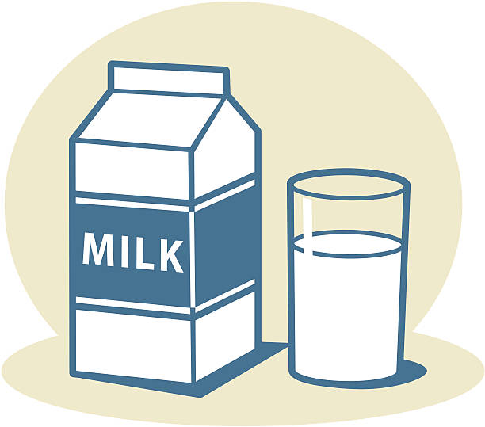



6.