Exercise 1 Look and write:

|  |  |  |  |
| --- | --- | --- | --- |
| sun | truck | running | bus |



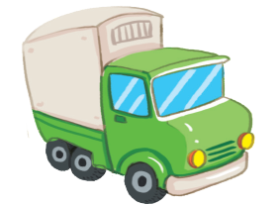

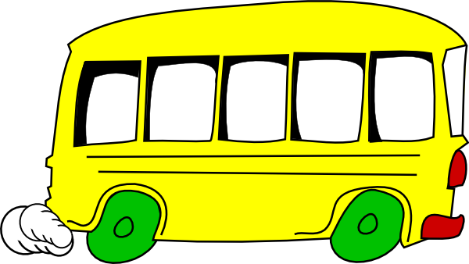

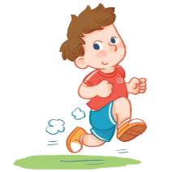

Exercise 2 Look and circle the correct words

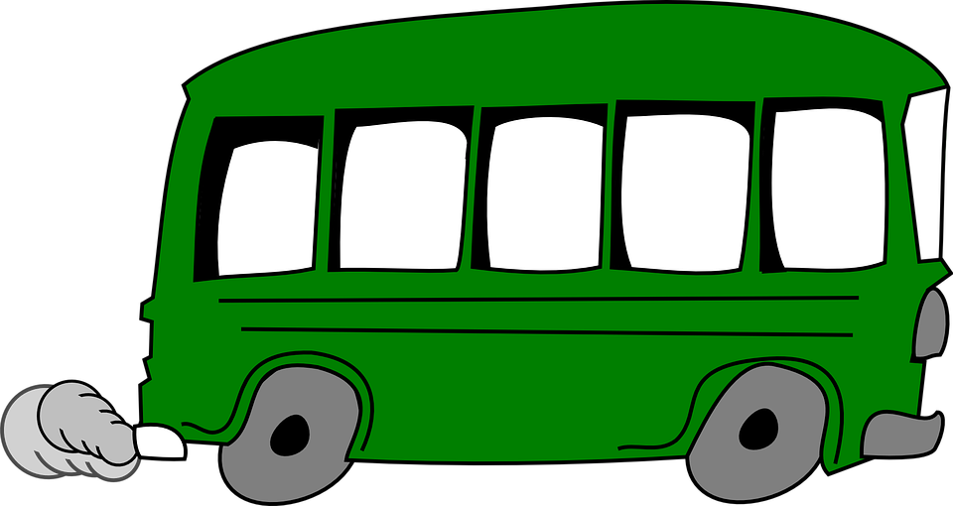





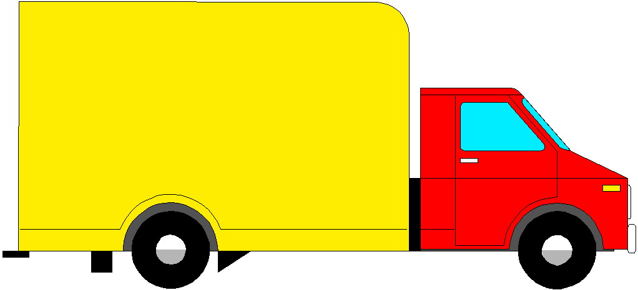

sun / star

plane / truck

bus / ball

jumping / running

Exercise 3 Look and match

|  |  |  |
| --- | --- | --- |
| a) Look at the sun. |  | Kết quả hình ảnh cho bus clipart |
| b) Look at the bus. |  | Hình ảnh có liên quan |
| c) Look at the truck. |  |  |
| d) He is running. |  |  |

Exercise 4 Put the words in the correct order

|  |  |  |  |
| --- | --- | --- | --- |
| Kết quả hình ảnh cho bus clipart | a) It – bus – is - a  *…………………………………..* |  | b) truck – is – a – It  *………………………………..* |
| Hình ảnh có liên quan | c) at – Look – the – sun  *……………………………………* |  | d) running – He – is  *………………………………..* |
| Hình ảnh có liên quan | e) Look – the – umbrella – at  *……………………………………* |  | f) He – jumping – is  *……………………………………* |

Exercise 5 Look and write the missing letters

|  |  |  |  |  |
| --- | --- | --- | --- | --- |
| Kết quả hình ảnh cho bus clipart |  |  |  | Hình ảnh có liên quan |

|  |  |  |  |  |  |  |  |  |  |  |  |
| --- | --- | --- | --- | --- | --- | --- | --- | --- | --- | --- | --- |
| b |  | s |  | t | r |  | k |  | s |  | n |

|  |  |  |  |  |
| --- | --- | --- | --- | --- |
| Kết quả hình ảnh cho duck clipart |  |  |  | Kết quả hình ảnh cho under clipart |

|  |  |  |  |  |  |  |  |  |  |  |  |  |  |
| --- | --- | --- | --- | --- | --- | --- | --- | --- | --- | --- | --- | --- | --- |
| d |  | c | k |  | c |  | p |  |  | n | d | e | r |

Exercise 6 Read and complete the sentences.

|  |  |  |  |
| --- | --- | --- | --- |
| Kết quả hình ảnh cho bus clipart | a) Look at the *…………………* |  | b) Look at the *……………* |

|  |  |  |  |
| --- | --- | --- | --- |
| Hình ảnh có liên quan | c) Look at the *…………………* |  | d) He is *……………….* |

|  |  |  |  |
| --- | --- | --- | --- |
| Hình ảnh có liên quan | e) Look at the *…………………* |  | f )Look at the *……………….* |

|  |  |  |  |
| --- | --- | --- | --- |
| Kết quả hình ảnh cho duck clipart | g) There is a *…………………* | Kết quả hình ảnh cho under clipart | h)A dog is *……….*the table. |

Exercise 7 Complete the lyrics

It’s a sunny day.

It’s a *…………………………..*

It’s a *…………………………..*. It’s a sunny today.

The boy is running.

The boy is*………………………….*

The boy is*………………………….*

The boy is running in the *………………………….*

Exercise 8 Sort out the words into the correct category

Short Vowel

/e/ /i/ /a/ /u/

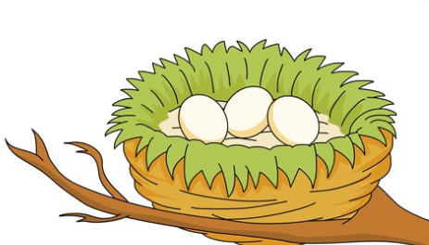 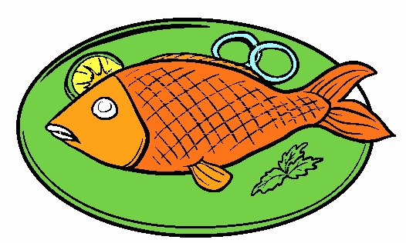  

|  |
| --- |
| s**u**n - **e**ggs – **a**pple – ch**i**ps - d**u**ck b**e**d – T**i**m – f**i**sh  b**u**s- h**e**n - B**e**n – m**i**lk – h**a**t – **A**nn – **b**ag – r**u**n -**u**nder |

|  |  |  |  |
| --- | --- | --- | --- |
| /e/ | /i/ | /a/ | /u/ |
| *……………………………*  *……………………………*  *……………………………*  *……………………………* | *……………………………*  *……………………………*  *……………………………*  *……………………………* | *……………………………*  *……………………………*  *……………………………*  *……………………………* | *…………………………*  *…………………………*  *…………………………*  *…………………………* |

Exercise 9 Circle the short vowels and write the word.

a e i u a e i o u a e i o u

 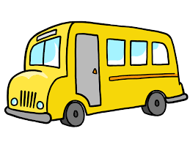 

_ _ _

_ _ _

box

a e i o u a e i o u a e i o u

  

   

  

  