Exercise 1 Look and write:

|  |  |  |  |
| --- | --- | --- | --- |
| monkey | mother | mouse | Mary |



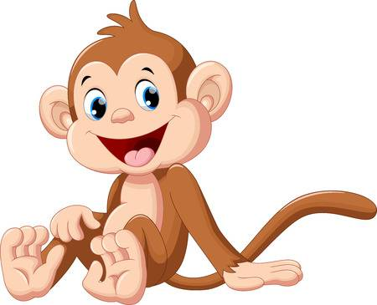

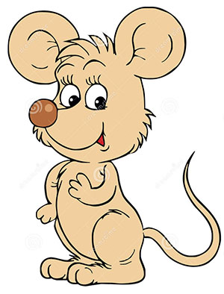



Exercise 2 Look and circle the correct words









mouse / hen

goat / monkey

Mother / Father

Ann / Mary

Exercise 3 Look and match

|  |  |  |
| --- | --- | --- |
| a) She is my mother. |  | Kết quả hình ảnh cho monkey clipart |
| b) There is a monkey. |  |  |
| c) She is Mary. |  | Hình ảnh có liên quan |
| d) There is a little mouse. |  |  |

Exercise 4 Put the words in the correct order



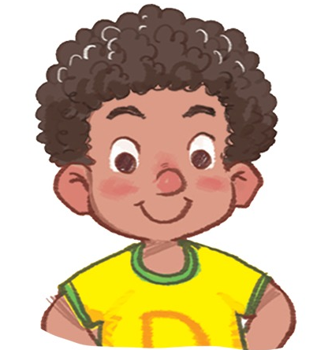

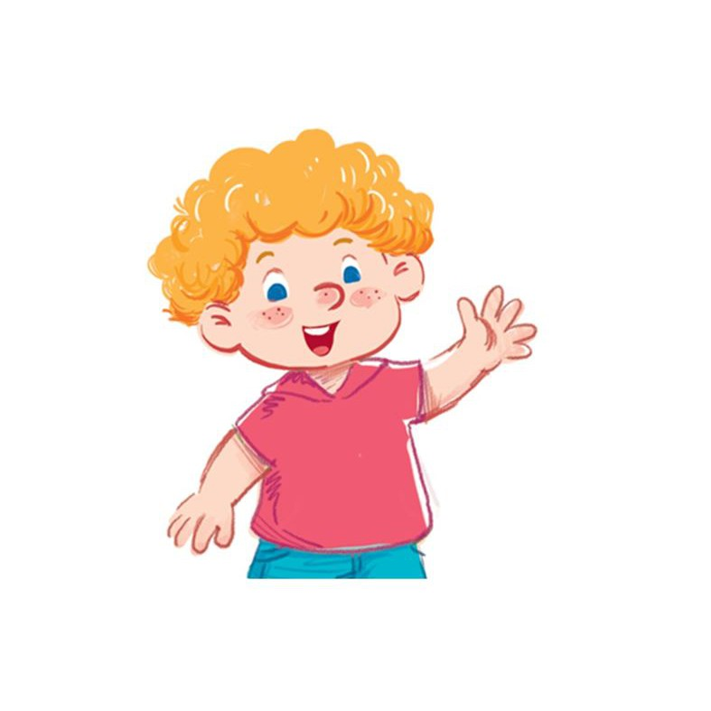

a) is – He – Bill b) She – Ann – is c) He – Dan - is

He is Bill.  *………………………………… …………………………………*







d) is – Mary – She e) Ben – He - is f) She – Hoa - is

*…………………………….. ………………………………… ………………………………*

Exercise 6 Look and tick (✓) or cross (🗶)

|  |  |  |
| --- | --- | --- |
|  |  | Kết quả hình ảnh cho monkey clipart |
| 1. There is a cat. | 1. There is a dog. | 1. There is a hen. |
| Káº¿t quáº£ hÃ¬nh áº£nh cho goat clipart | Kết quả hình ảnh cho hen clipart | Kết quả hình ảnh cho mouse  clipart |
| 1. There is a pig. | 1. There is a monkey. | 1. There is a mouse. |

Exercise 7 Look and circle the correct words

|  |  |  |
| --- | --- | --- |
|  | a) *……………..*name is Mary. | a) His b) Her |
| Kết quả hình ảnh cho monkey clipart | b) It is a *……………………….* | a) monkey b) mouse |
|  | c) She is a *…………………….* | a) boy b) girl |
|  | d) *………………………...*is Ba. | a) He b) She |
|  | e) It *………………….*my hand. | a) are b) is |
|  | f) There*……………….…*boxes. | a) are b) is |

Exercise 8 Find the mistakes and correct them

|  |  |  |  |
| --- | --- | --- | --- |
|  | a) She is Anna .  She is Mary. | Kết quả hình ảnh cho monkey clipart | b) It’s a mouse.  *…………………………………….* |
|  | c) He is Ben.  *…………………………………….* |  | d) There is a box.  *…………………………………….* |
| Hình ảnh có liên quan | e) There are boxes.  *…………………………………….* | Káº¿t quáº£ hÃ¬nh áº£nh cho touch your head clipart | f) Touch your hand .  *…………………………………….* |
|  | g) There is a goat.  *…………………………………….* |  | h) They are hens.  *…………………………………….* |

Exercise 9 Circle the letter that makes each picture name’s beginning sound.

|  |  |  |  |  |
| --- | --- | --- | --- | --- |
| Kết quả hình ảnh cho monkey clipart |  |  |  | Káº¿t quáº£ hÃ¬nh áº£nh cho goat  clipart |

|  |  |  |  |  |  |  |  |  |  |  |  |
| --- | --- | --- | --- | --- | --- | --- | --- | --- | --- | --- | --- |
|  | h | a |  | m | l | h |  | c | g | d |  |

|  |  |  |  |  |
| --- | --- | --- | --- | --- |
|  |  |  |  | Káº¿t quáº£ hÃ¬nh áº£nh cho cat clipart |

|  |  |  |  |  |  |  |  |  |  |  |  |
| --- | --- | --- | --- | --- | --- | --- | --- | --- | --- | --- | --- |
| d | e | f |  | d | c | a |  | a | b | c |  |

Exercise 10 Look and answer

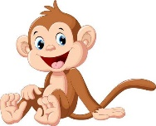 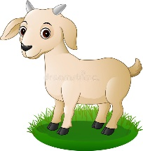 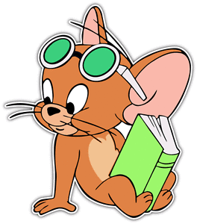

a) What is this ? b) What is this ? c) What is this ?

It’s a monkey.  *…………………………….. ……………………………..*

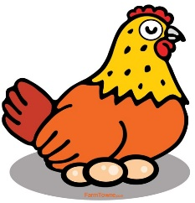 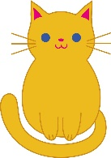 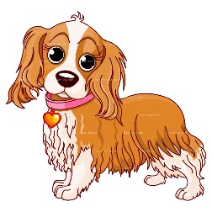

d) What is this ? e) What is this ? f) What is this ?

*…………………………….. …………………………….. …………………………….*