Exercise 1 Look and write:

|  |  |  |  |
| --- | --- | --- | --- |
| boxes | mops | bottles | pots |

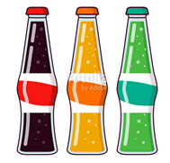

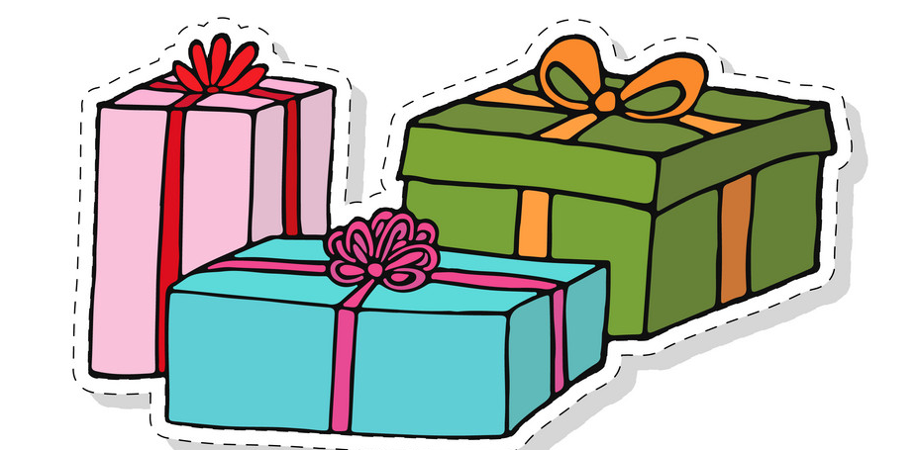

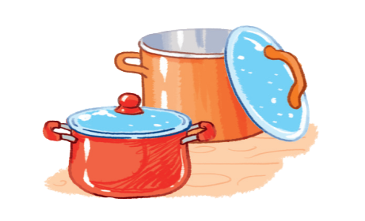

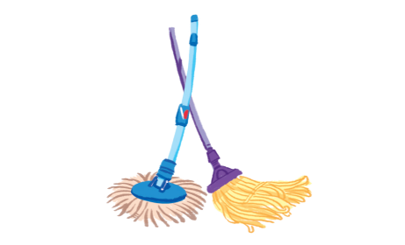

Exercise 2 Look and write the missing letters









|  |  |  |  |  |  |  |  |  |  |  |  |  |  |  |  |  |  |  |  |  |  |  |
| --- | --- | --- | --- | --- | --- | --- | --- | --- | --- | --- | --- | --- | --- | --- | --- | --- | --- | --- | --- | --- | --- | --- |
| b |  | x | e | s |  | m |  | p | s |  | b |  | t | t | l | e | s |  | p |  | t | s |

Exercise 3 Look and match

|  |  |  |
| --- | --- | --- |
| a) There are mops. |  | HÃ¬nh áº£nh cÃ³ liÃªn quan |
| b) There are bottles. |  |  |
| c) There are boxes. |  |  |
| d) There are pots. |  |  |

Exercise 4 Look and write :

|  |  |
| --- | --- |
| There is | There are |

|  |  |  |  |
| --- | --- | --- | --- |
|  | a) *………………….* a mop. | HÃ¬nh áº£nh cÃ³ liÃªn quan | b) *………………….*mops. |
|  | c) *………………….*boxes. | HÃ¬nh áº£nh cÃ³ liÃªn quan | d) *………………….*a box. |
| Káº¿t quáº£ hÃ¬nh áº£nh cho bottle  cliparts | e) *………………….* a bottle. |  | f) *………………….*bottles. |
|  | g) *………………….*pots. |  | h) *………………….* a pot. |
| HÃ¬nh áº£nh cÃ³ liÃªn quan | i) *………………….* a ball. | Káº¿t quáº£ hÃ¬nh áº£nh cho two balls cliparts | j)*………………….*balls. |
| Káº¿t quáº£ hÃ¬nh áº£nh cho hens  cliparts | k) *………………….*hens. | Káº¿t quáº£ hÃ¬nh áº£nh cho hen  cliparts | l) *………………….* a hen. |
| Káº¿t quáº£ hÃ¬nh áº£nh cho book  cliparts | m)*………………….*a book. | HÃ¬nh áº£nh cÃ³ liÃªn quan | n)*………………….*books. |

Exercise 5 Look and tick (✓) or cross (🗶)

|  |  |  |
| --- | --- | --- |
|  | Kết quả hình ảnh cho banana clipart | Hình ảnh có liên quan |
| a) There is a box. | b) There is an apple. | c) There are boxes. |
| Hình ảnh có liên quan | Hình ảnh có liên quan |  |
| d) There are apples. | e) There is a bottle. | f) There is a mop. |
| Hình ảnh có liên quan |  | Hình ảnh có liên quan |
| g) There are hats. | h) There are pots. | i) There is a goat. |

Exercise 6 Put the words in the correct order

|  |  |
| --- | --- |
|  | a) are – There – pots  *………………………………………………..* |
| Hình ảnh có liên quan | b) There – bottles – are  *………………………………………………..* |
|  | c) boxes – are – There  *………………………………………………..* |
|  | d) are – mops – There  *………………………………………………..* |

Exercise 7 Look at the piture and write with There is or There are

|  |  |  |
| --- | --- | --- |
|  | Hình ảnh có liên quan |  |
| a) There are boxes. | b)*……………………………………* | c)*……………………………………* |
|  |  |  |
| d)*……………………………………* | e) *……………………………………* | f)*……………………………………* |

Exercise 8 Make questions for the underlined parts

a) There is **a cat** in the garden.

*How many cats are there in the garden ?*

b) There are two bottles on the desk.

*……………………………………………………………………………………*

c) There is an apple in the box.

*……………………………………………………………………………………*

d) There are three mops in the shop.

*……………………………………………………………………………………*

e) There are four books on the desk.

*……………………………………………………………………………………*

f) There is a ball in the box.

*……………………………………………………………………………………*

Exercise 9 Write the correct vowel to complete each word

|  |  |  |  |
| --- | --- | --- | --- |
| a | e | i | o |

|  |  |  |
| --- | --- | --- |
| Hình ảnh có liên quan |  | Káº¿t quáº£ hÃ¬nh áº£nh cho hat cartoon |

|  |  |  |  |  |  |  |
| --- | --- | --- | --- | --- | --- | --- |
| c |  | t |  | h |  | t |

|  |  |  |
| --- | --- | --- |
| Hình ảnh có liên quan |  |  |

|  |  |  |  |  |  |  |  |
| --- | --- | --- | --- | --- | --- | --- | --- |
| d |  | g |  | f |  | s | h |

|  |  |  |
| --- | --- | --- |
| Kết quả hình ảnh cho henclipart |  |  |

|  |  |  |  |  |  |  |  |
| --- | --- | --- | --- | --- | --- | --- | --- |
| h |  | n |  | m |  | l | k |

Exercise 10 Find the mistakes and correct them.

|  |  |
| --- | --- |
|  | a) There is a box .  There are boxes. |
| Hình ảnh có liên quan | b) There is a goat.  *………………………………………………………..* |
|  | c) There are pots.  *………………………………………………………..* |
|  | d) There is a bottle.  *………………………………………………………..* |
| Káº¿t quáº£ hÃ¬nh áº£nh cho book  cliparts | e) There are books.  *………………………………………………………..* |

Exercise 11 Cross out that doesn’t rhyme

|  |  |  |  |  |
| --- | --- | --- | --- | --- |
|  | 1. hat | 1. bag | 1. cat |  |
|  | a) fish | b) hen | c) egg | d) Ben |
|  | 1. dog | 1. mop | 1. pot | 1. hen |
|  | a) fish | b) book | c) milk | d) chips |
|  | 1. hat | 1. bag | 1. cat | 1. six |
|  | 1. hop | 1. egg | 1. stop | 1. not |