Exercise 1 Look and circle the correct words

|  |  |  |  |
| --- | --- | --- | --- |
|  | Káº¿t quáº£ hÃ¬nh áº£nh cho goat  clipart | HÃ¬nh áº£nh cÃ³ liÃªn quan |  |
| 1. girl 2. goat 3. garden | 1. garden 2. girl 3. goat | 1. girl 2. garden 3. gate | 1. gate 2. garden 3. goat |

Exercise 2 Look and write the missing letters

 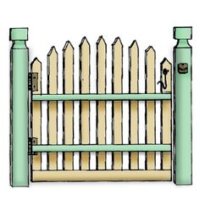 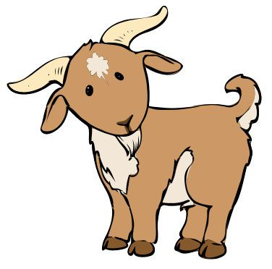 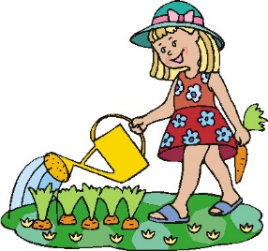

|  |  |  |  |  |  |  |  |  |  |  |  |  |  |  |  |  |  |  |  |  |
| --- | --- | --- | --- | --- | --- | --- | --- | --- | --- | --- | --- | --- | --- | --- | --- | --- | --- | --- | --- | --- |
|  | i | r | l |  |  | a |  | e |  |  |  | a | t |  |  |  | r | d | e | n |

Exercise 3 Connect the g’s. Color them red :

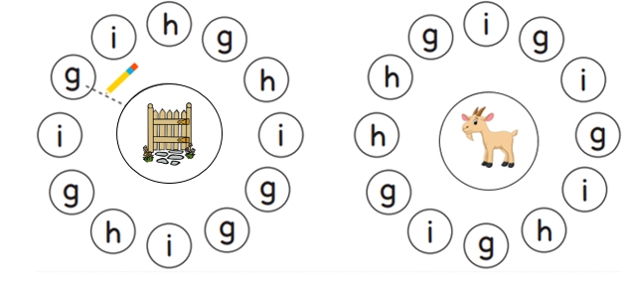

Exercise 4 Look and tick (✓) or cross (🗶)

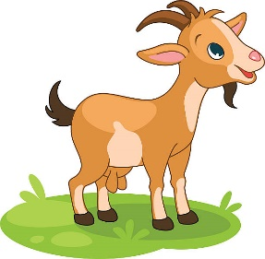  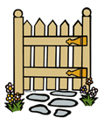

a) There is a hen. b) There is a garden. c) There is a goat.

 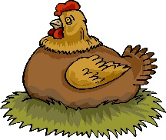 

d) There is a hat. e) There is a hen. f) There is a girl.

Exercise 5 Look and write

|  |  |  |  |
| --- | --- | --- | --- |
| goat | cat | girl | hen |

|  |  |  |
| --- | --- | --- |
| Káº¿t quáº£ hÃ¬nh áº£nh cho girl in the garden clipart |  | HÃ¬nh áº£nh cÃ³ liÃªn quan |

a) ) There is a ________ in the garden. b) There is a ________in the garden.

|  |  |  |
| --- | --- | --- |
| Káº¿t quáº£ hÃ¬nh áº£nh cho a hen in the garden clipart |  |  |

c) There is a ________ in the garden. d) There is a ________on the desk.

Exercise 6 Put the words in the correct order

|  |  |
| --- | --- |
|  | a) is – There – a – girl  *………………………………………………….* |
| HÃ¬nh áº£nh cÃ³ liÃªn quan | b) There – a – goat - is  *………………………………………………….* |
|  | c) is – There – a – gate  *………………………………………………….* |
| HÃ¬nh áº£nh cÃ³ liÃªn quan | d) a – garden – There - is  *………………………………………………….* |

Exercise 7 Circle the beginning sound for each picture .

|  |  |  |  |  |  |
| --- | --- | --- | --- | --- | --- |
|  | A |  | E |  | E |
|  | B |  | G |  | G |
|  | C |  | A |  | A |
|  | A |  | A |  | C |
|  | G |  | E |  | G |
|  | D |  | G |  | A |

Exercise 8 Look at picture and complete the sentence

|  |  |  |  |
| --- | --- | --- | --- |
| HÃ¬nh áº£nh cÃ³ liÃªn quan | a) I like *……………………….* | Káº¿t quáº£ hÃ¬nh áº£nh cho book clipart | b) It’s a *…………………………* |
|  | c) I have a *……………………..* |  | d) I have a *……………………..* |
| HÃ¬nh áº£nh cÃ³ liÃªn quan | e) This is my *………………….* | Káº¿t quáº£ hÃ¬nh áº£nh cho bag clipart | f) This is my *…………………..* |
| HÃ¬nh áº£nh cÃ³ liÃªn quan | i)There is a*………………………* |  | j) This is my *…………………..* |

Exercise 9 Look and complete the sentences.

a) Hi, I *……………..* Ben.

b) There *……………..* a hen in the garden.

c) There is *……………..* book in the bag.

d) It *……………..* a car.

d) This *……………..* my dog.

e) There is *……………..* hat on the desk.

f) I have *……………..* book.

g) What *……………..* this ? It’s a ball.

h) What do you like ? I *……………..* chips and fish.

i) They *……………..* eggs.