Exercise 1 Look and write:

|  |  |  |  |
| --- | --- | --- | --- |
| eggs | hens | Ben | umbrellas |

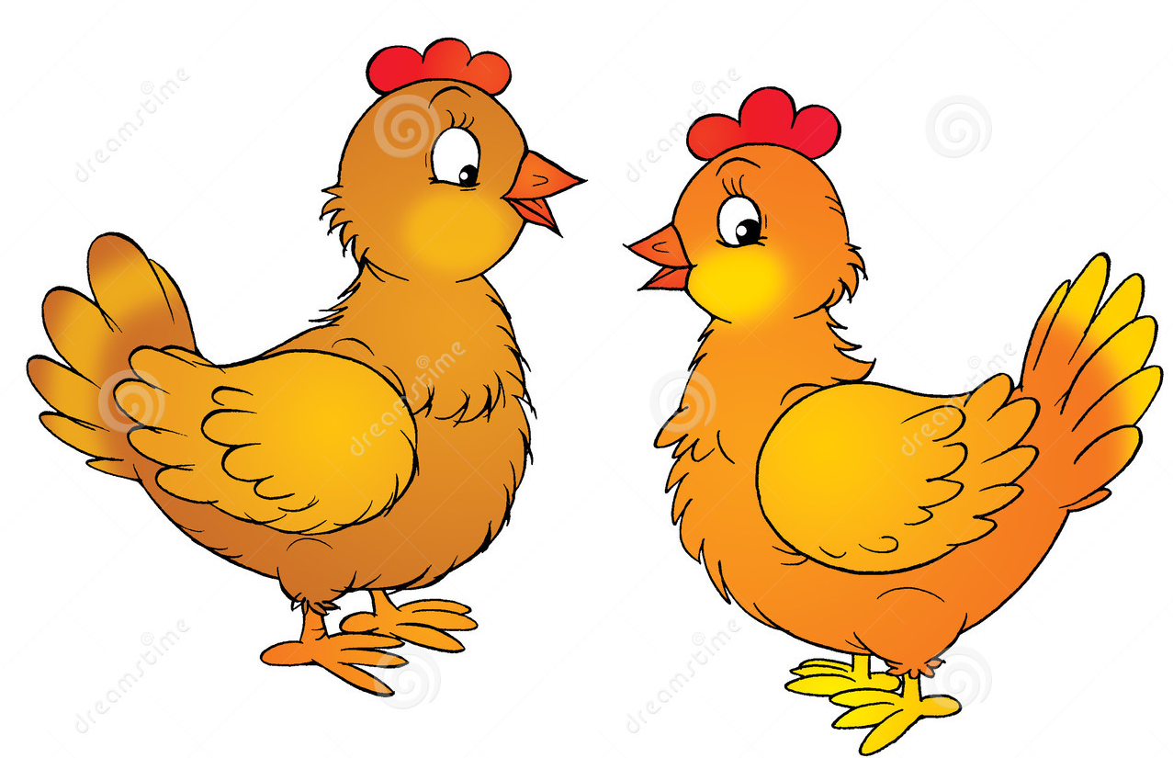

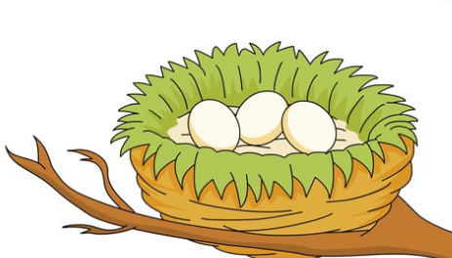





Exercise 2 Look and write the missing letters









_ _ _s

B _ n

e _ _ s

_ _ brella

Exercise 3 Look and match

|  |  |  |
| --- | --- | --- |
| a) Hi , I’m Ben. |  |  |
| b) They are eggs. |  |  |
| c) They are umbrellas. |  |  |
| d) They are hens. |  | Káº¿t quáº£ hÃ¬nh áº£nh cho two umbrellas clipart |

Exercise 4 Look and circle

|  |  |  |
| --- | --- | --- |
|  |  | Káº¿t quáº£ hÃ¬nh áº£nh cho Unit 5 At the fish and chip shop tim |
| a) eggs b) chips | a) bags b) umbrellas | a) Tim b) Dan |
|  |  |  |
| a) Bill b) Ben | a) dogs b) cats | a) cats b) hens |

Exercise 5 Put the words in the correct order

|  |  |  |
| --- | --- | --- |
|  | a) umbrellas – They – are | *………………………………………* |
|  | b) Hi – Ben – I’m | *………………………………………* |
|  | c) eggs – are - They | *………………………………………* |
|  | d) hens – They – are | *………………………………………* |

Exercise 6 Look and tick (✓) or cross (🗶)

  

a) Hi , I’m Tim . b) Hi , I’m Ben. c) They are cats.

  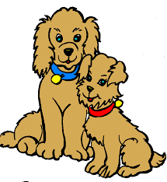

d) They are eggs. e) They are balls. f) They are dogs.

Exercise 7 Look and circle the best answer

|  |  |  |
| --- | --- | --- |
|  | 1) I like *…………………* | a) fish b) milk c) chips |
|  | 2) *…………………*are eggs. | a) This b) They c) It |
| Káº¿t quáº£ hÃ¬nh áº£nh cho mILK clipart | 3) I like *……………………..* | a) fish b) apples c) milk |
|  | 4) I have two *………………* | a) dogs b) hens c) cats |
|  | 5) They are *…………………* | a) hens b) bags c) umbrellas |

Exercise 8 Read and circle the correct answer

|  |  |
| --- | --- |
| Can you see my pet hen ?  My hen is little.  My hen is brown.  My hen can lay lots of eggs. | 1) I have a pet *…………………*  a) cat  b) dog  c) hen  2) My hen is *…………………*  a) little and yellow  b) little and brown  c) big and brown  3)My hen can *…………………*  a) lay lots of eggs.  b) hop  c) jump high |

Exercise 8 Sort out the words into the correct category

Short Vowel

/e/ /i/ /a/

  

|  |
| --- |
| **e**ggs – **a**pple – ch**i**ps - b**e**d – T**i**m – f**i**sh – h**e**n - B**e**n – m**i**lk – h**a**t – **A**nn - **b**ag |

|  |  |  |
| --- | --- | --- |
| /e/ | /i/ | /a/ |
| *……………………………*  *……………………………*  *……………………………*  *……………………………*  *……………………………* | *……………………………*  *……………………………*  *……………………………*  *……………………………*  *……………………………* | *……………………………*  *……………………………*  *……………………………*  *……………………………*  *……………………………* |