Exercise 1 Look and write:

|  |  |  |  |
| --- | --- | --- | --- |
| chips | Tim | milk | fish |

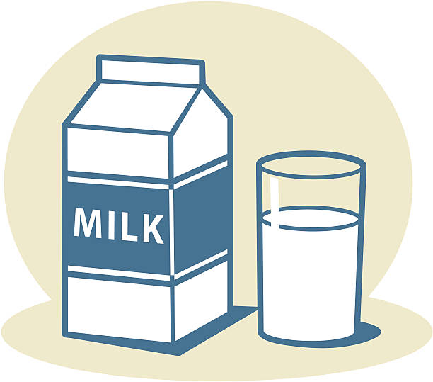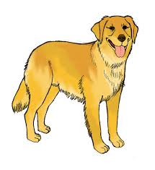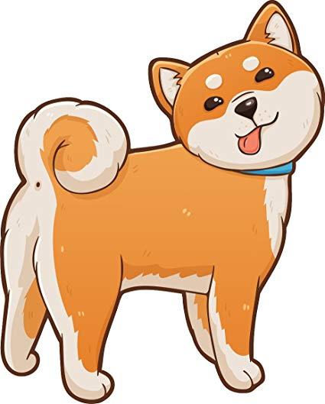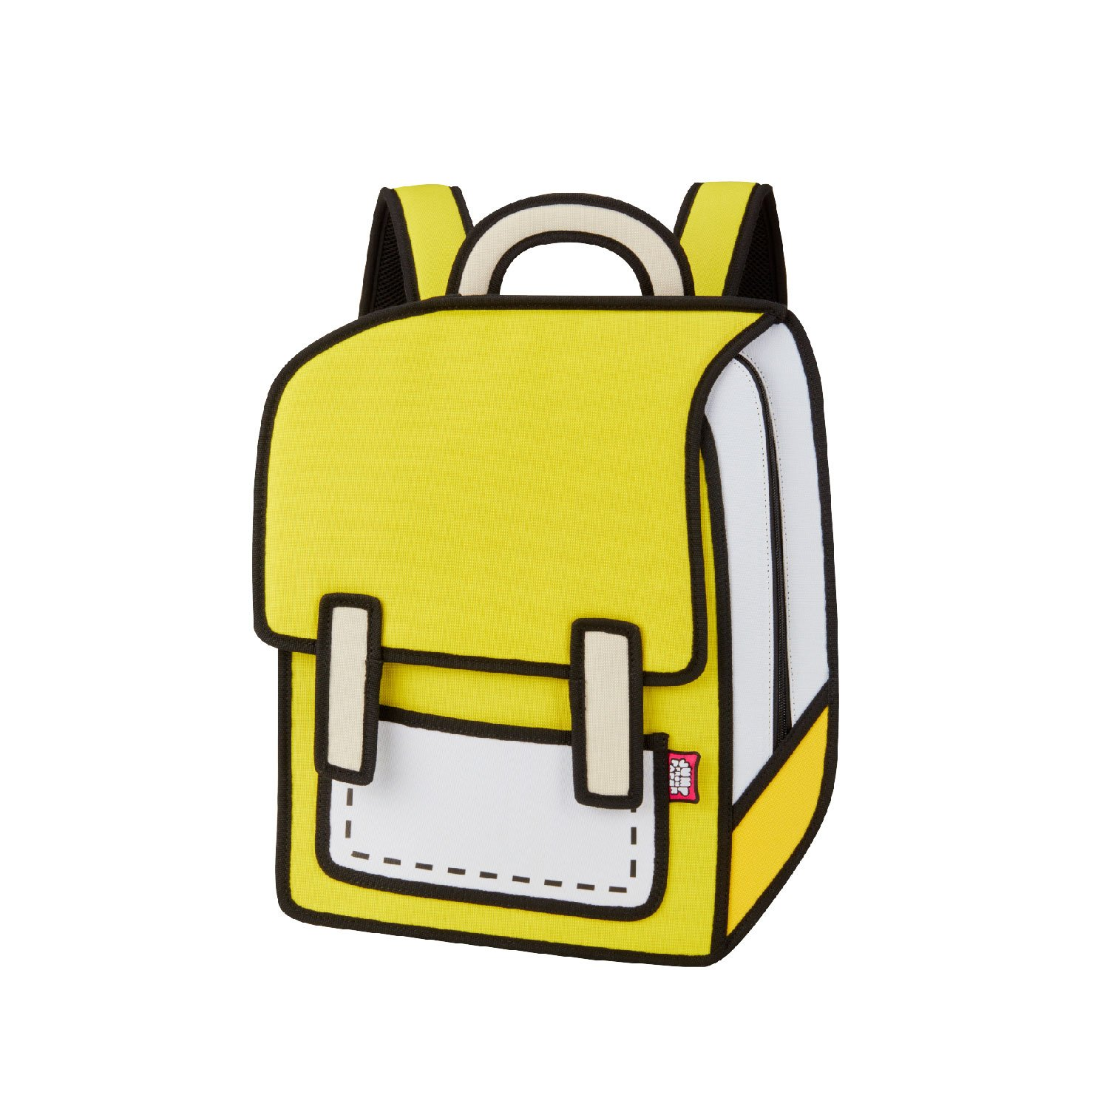

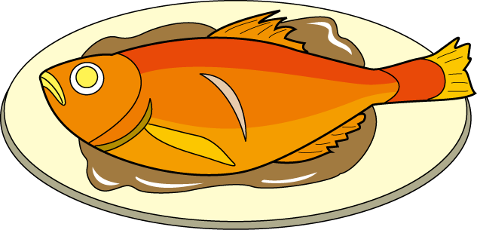

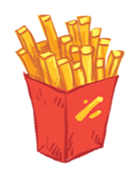

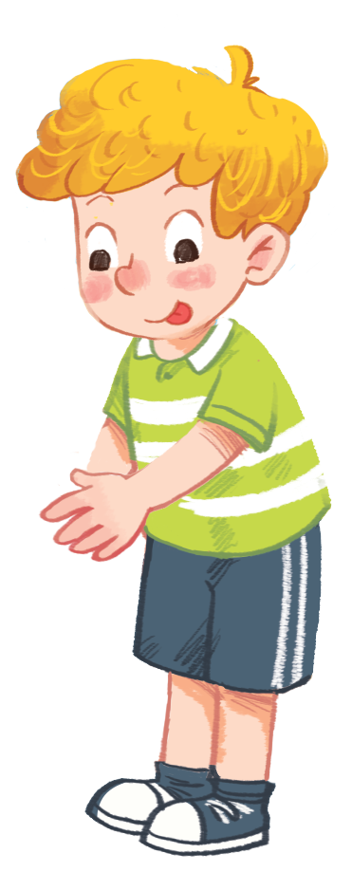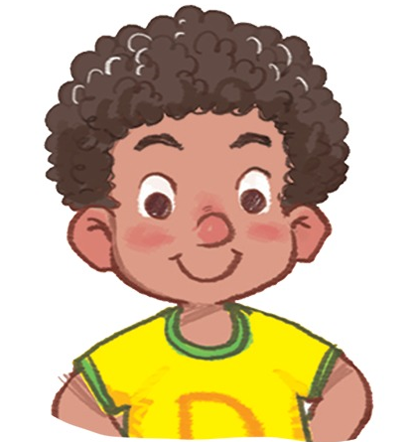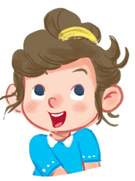

Exercise 2 Look and write the missing letters

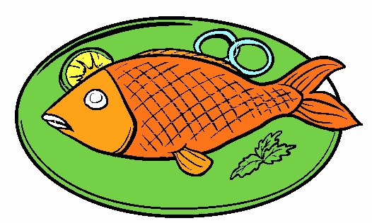





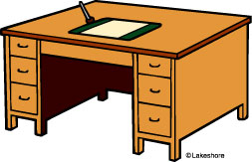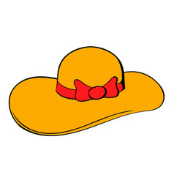

f _ _ _

T _ m

_ _ lk

ch _ _ s

Exercise 3 Look and match

|  |  |  |
| --- | --- | --- |
| a) Hi , I’m Tim. |  |  |
| b) I like milk. |  | Káº¿t quáº£ hÃ¬nh áº£nh cho Unit 5 At the fish and chip shop tim |
| c) I like chips. |  | HÃ¬nh áº£nh cÃ³ liÃªn quan |
| d) I like fish. |  | Káº¿t quáº£ hÃ¬nh áº£nh cho milk clipart |

Exercise 4 Look and circle

|  |  |  |
| --- | --- | --- |
|  | HÃ¬nh áº£nh cÃ³ liÃªn quan |  |
| a) cake b) fish | a) chips b) bread | a) Bill b) Dan |
| Káº¿t quáº£ hÃ¬nh áº£nh cho Unit 5 At the fish and chip shop tim | Káº¿t quáº£ hÃ¬nh áº£nh cho mILK clipart | Káº¿t quáº£ hÃ¬nh áº£nh cho apple cartoon |
| a) Tim b) Ann | a) cake b) milk | a) banana b) apple |

Exercise 5 Put the words in the correct order

|  |  |  |
| --- | --- | --- |
| Káº¿t quáº£ hÃ¬nh áº£nh cho mILK clipart | a) milk – I - like | *………………………………………* |
| Káº¿t quáº£ hÃ¬nh áº£nh cho Unit 5 At the fish and chip shop tim | b) Hi – Tim – I’m | *………………………………………* |
|  | c) I – fish - like | *………………………………………* |
| HÃ¬nh áº£nh cÃ³ liÃªn quan | d) chips – I - like | *………………………………………* |
| Káº¿t quáº£ hÃ¬nh áº£nh cho apples clipart | e) apples – I - like | *………………………………………* |

Exercise 6 Look and tick (✓) or cross (🗶)

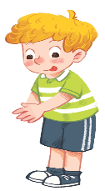  

a) Hi , I’m Tim . b) Hi , I’m Ann. c) I like milk.

 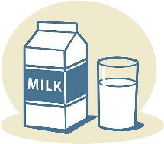 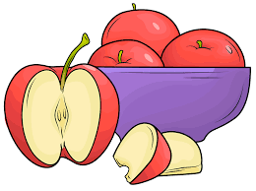

d) I like chips. e) I like fish . f) I like apples.

Exercise 7 Look and write

|  |  |
| --- | --- |
| like | don’t like |

|  |  |
| --- | --- |
| HÃ¬nh áº£nh cÃ³ liÃªn quan HÃ¬nh áº£nh cÃ³ liÃªn quan | Káº¿t quáº£ hÃ¬nh áº£nh cho mILK clipartKáº¿t quáº£ hÃ¬nh áº£nh cho apples clipart |
| I chips.  I fish. | I milk.  I apples. |
| Káº¿t quáº£ hÃ¬nh áº£nh cho chicken food clipart | Káº¿t quáº£ hÃ¬nh áº£nh cho cake clipart  Káº¿t quáº£ hÃ¬nh áº£nh cho mILK clipart |
| I fish.  I chicken. | I cake.  I milk. |

Exercise 8 Read and match.

|  |  |  |
| --- | --- | --- |
| Káº¿t quáº£ hÃ¬nh áº£nh cho apples clipart |  | Hi. I’m Bill. I like milk. |
| Káº¿t quáº£ hÃ¬nh áº£nh cho chicken food clipart |  | Hi. I’m Ba. I like apples. |
|  |  | Hi. I’m Ann. I like chips. |
| Káº¿t quáº£ hÃ¬nh áº£nh cho mILK clipart |  | Hi. I’m Dan . I like chicken. |
| HÃ¬nh áº£nh cÃ³ liÃªn quan |  | Hi. I’m Tim . I like fish. |

Exercise 9 Read and compelete the sentences.

a) It’s a *……………………….* b) It is *…………………….*door. 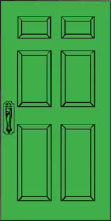

c) I like *……………………….* d) Hi , I *……………………*Tim. 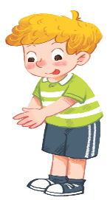

e) I don’t like *…………………*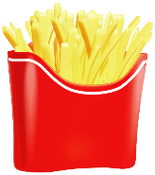f) I like *………………………...*