NAME OF SCHOOL:
…………………….Primary School
LESSON PLAN
UNIT 4: FREE TIME
Lesson 1: Part 4-5-6

Full name of Teacher: .............................................
Unit 4: FREE TIME
Lesson 1: Part 4-5-6
Duration (period): 35 minutes
I. OBJECTIVES:
1. Knowledge:
Students will:
+ Review some words related to the topic: Free time.
+ Learn and use new grammar: be good at, love +Ving.
+ Talk about what someone likes doing.
2. Competences:
- English competences: Students can talk about a topic: Free time.
- Common competences: Students can develop logical thinking and develop communication among friends.
3. Qualities:
- Students will be confident and active in communicating with friends and teachers.
I. EQUIPMENT AND MATERIALS:
- Basic things: Student’s book, flashcards, photos.
- Advanced things: PPT, laptop, TV.
III. LESSON PROCEDURE:
Activity 1: Warm-up
Activity 2: Presentation
Activity 3: Practice
Activity 4: Production
Activity 5: Wrap-up & Assessment
Activity 1: Warm-up (5 minutes)
A game “Lucky Wheel”
 | Teacher’s Activities | Students’ Activities
 | Aims: warm-up activity to greet the class, create an exciting environment and introduce the new lesson.
 | b, Procedure  1. Greet students.  2. The T divides the class into 4 groups called …….(the names of sports)  Ask the Ss to join the game to create an exciting environment.  2. Introduce the game:(Review vocabulary and structure).  - Show the game on the side, and tell the instructor how to play the game.  - Show the question of the game and ask Ss to say the correct answer. Will spin the lucky wheel and say the correct answer.  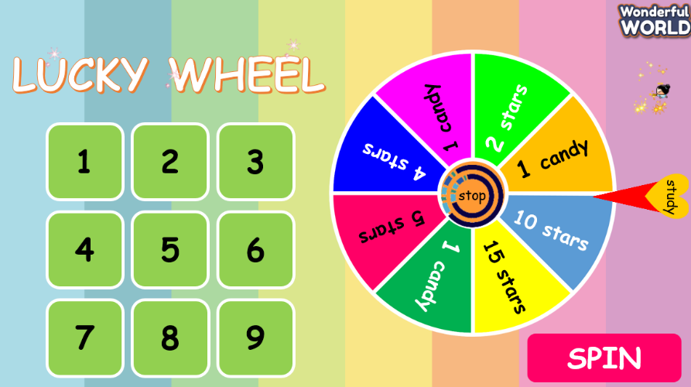 | - Greet Teacher.  - Listen to the rules of the game.  - Join an activity.
Activity 2: Presentation (13 minutes)
Teacher’s Activities |  | Students’ Activities
- a. Aims:
- - Learn and use new grammar:
S + like(s)/ love(s)/enjoy(s)+Ving, S + tobe + good at + Ving/ Noun, yes/no question.
- - Develop listening and speaking skills.
- Know how to use these structures in their life.
b, Procedure  - Introduction to grammar.  +Explain the structures and how to use them:  - Like/love/enjoy + Ving (give some example)  - I like playing football./ She/he likes playing football.  - I love playing outside./She/he loves playing outside.  - To be + good at + Ving (skillful and successful doing it)  Example: - She is good at playing guitar.  - He is good at singing.  - Tobe + S + good at +Ving? (Yes/No question).  - Yes, S + to be. / - No, S+to be + not.  - Ask Ss to answer the question: “What do you like doing?”  What is she good at?  - Then, T calls randomly Ss to say it.  - Check grammar and pronunciation for Ss.  2. A game: the little bee.  - Explain rules of this game:  - Show powerpoint to Ss to choose the correct flower for the little bee.  2. Task 4. Listen and read. Track 4.3  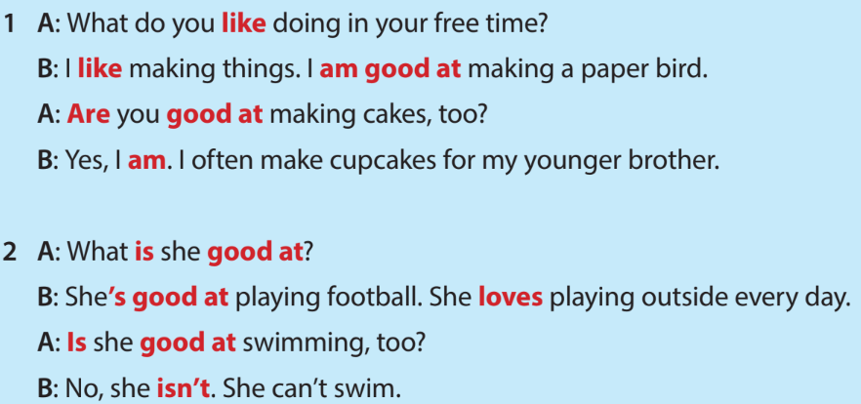  - Tell students to look at activity 4 on page 41 in their book.  - Ask Ss to read to oneself.  - Play the audio for the conversations.  - Instruct Ss to listen carefully and then repeat the conversations to enhance pronunciation.  - Draw attention to the phrase “be good at”.  - Call 2 pairs of students to stand up and read conversations 1 and 2 |  | - Look and listen to the Teacher.  - Give some examples of new grammar.  - Write new grammar in the notebook.  -  - Listen to the rules of the game.  - Join an activity.  - Look and follow the teacher.  - Listen and repeat conversations.  - Attention to the phrase (be good at).  - Read in front of the class.
Activity 3: Practice (4 minutes)
Teacher’s Activities |  | Students’ Activities
a. Aims: - Controlled practice:
+ Can use grammar proficiently.
+ Develop speaking and listening skills.
b, Procedure  Task 5: What are they good at? listen and tick (v) or cross (x).  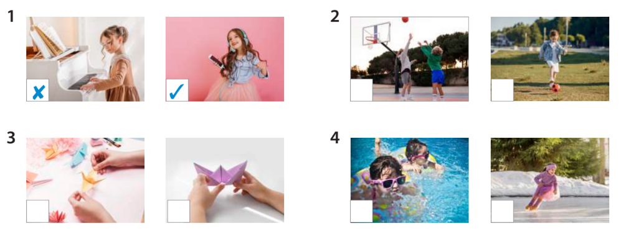  - Explain the title of the article in task 5, on page 41.  - Play the audio for the conversations.  - Instruct Ss to listen attentively to find out what each person is good at.  - Ask Ss to tick (✓) the skills the speaker is good at or cross (✘) if the skill the speaker isn’t good at.  - Ask Ss to work in pairs to discuss their answer with a partner.  - Invite some students to answer each sentence.  - Check answers as a class.  - Let’s practice speaking with the partner:  - Ask Ss to look at the picture task 5 again, then 1 student to ask and 1 student to answer.  - Invite volunteers to speak out in front of class. |  | - Look at the book in task 5, on page 41.  - Listen to the teacher’s instructions.  - Listen to the audio for the conversations.  - Tick (✓) or cross (✘) for task 5.  - Work in pairs to share answers.  - Raise Ss’ hands and read out the answer.  - Practice speaking with the partner.
Activity 4: Production (8 minutes)
Teacher’s Activities |  | Students’ Activities
- Aims:
- - Practice conversations in task 6.
- Apply the questions in task 6 to present to the class about your favourite activities in free time.
b. Procedure  Task 6: Let’s talk.  - Briefly explain the task.  - Display the example conversation on the slide.  - Ask Ss to read to practice pronunciation.  - Ask Ss to work in pairs. Assign roles: one student will be person A and the other will be person B.  - Ask Ss to take turns being person A and person B.  - Encourage them to use gestures and express themselves freely.  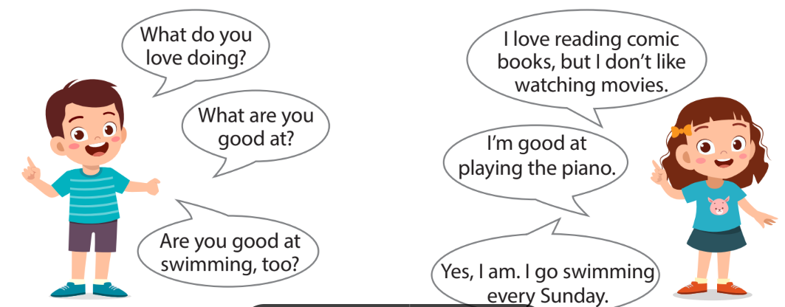  - Invite several pairs to perform their conversations in front of the class. |  | - Work in pairs and practice conversation in task 6.
Activity 5: Wrap up & Assessment (5 minutes)
Teacher’s Activities |  | Students’ Activities
a, Aims:
- - Check student's understanding of what they have learned.
- Rehearse what they have learned in the lesson.
- Ask Ss to work in pairs and match the questions with the answers.  - Check answers as a class.  - Ask Ss to read each correct word out loud.  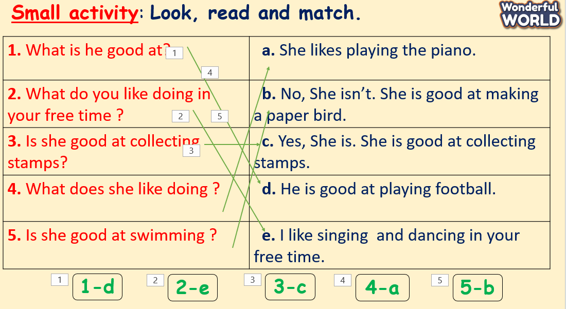  Wrap-up  * Remember  VOCABULARY  - Learn and use new grammar:  - be good at, love +Ving. |  | - Join an activity.  - Check with the teacher.  - Read the wrap-up.  - Stand up and say goodbye to the teacher.

