NAME OF SCHOOL…  ------------------------- | SOCIALIST REPUBLIC OF VIETNAM  INDEPENDENCE - FREEDOM - HAPPINESS  --------------o0o-------------
 | Place, Date…, month…. year…
LESSON PLAN
(Based on Official Letter No. 2345/BGDDT-GDTH dated June 07, 2021 of the MOET)

Full name of Teacher:
Unit 9: Places in town.
Lesson 2: Period 1-Task 1,2,3
Duration (period): 35 minutes
I. OBJECTIVES:
1. Knowledge:
Students will learn to use some new vocabulary: bus stop, post office, shopping centre, supermarket.
And use new grammar: Where to ask and answer about places in town.
2. Competences:
- English competences: Students will be able to introduce their town
- Common competences: Students will have the opportunity to develop creativeness in drawing and coloring the craft and show their confidence in asking and answering their town.
3. Qualities:
- Students develop love toward their town.
II. EQUIPMENT AND MATERIALS:
- For Teacher: PP, flashcards, handout, track 9.4, track 9.5
- For students: pens, A4 paper, crayons,
III. LESSON PROCEDURE:
Activity 1: Warm up (5 minutes)
Aims: Review the knowledge of the previous lesson by playing a game or warm up n activity
Play a song to start the lesson
Teacher’s Activities | Students’ Activities
-Option 1: Use the flashcards to revise the words  from Lesson 1. Give volunteers a word to mime or draw on the board for classmates to guess. Repeat until all students have mimed or drawn a  word (repeat words if necessary).  -Option 2: Listen to the song.  https://www.youtube.com/watch?v=krPMYK2aY3o  and T asks sts about the places in the song. Give stars for the correct answer and give them some suggestions.  Especially, elicit the new words in the presentation part.  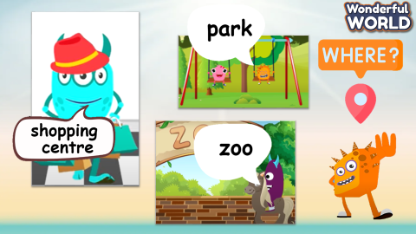 | Watch the video.  Answer the questions.
Activity 2: Presentation (8 minutes)
a. Aim: Present new vocabulary: bus stop, post office, shopping centre,
supermarket.
Teacher’s Activities | Students’ Activities
- Introduce the new words with the flashcards.  Vocabulary: bus stop, post office, shopping centre,  supermarket  -Using skills: Vary the volume (e.g. whisper, shout), speed, and intonation used to read words, and encourage students to copy. Younger learners will particularly enjoy using a silly voice or saying the words ‘like a robot’ or ‘like a monster’.  Listen and point. Repeat.  -Tell students to look at the vocabulary box on page 32. Ask if they know any of the words and what they are. Play the recording for students to listen and point to the correct pictures.  • Play the recording again, pausing after each word for students to say it. Ask volunteers to say the words in random order for their classmates to point to the correct pictures. Ask them which of the words they can match to the photo on page 32 (all of them)  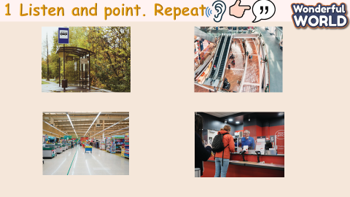 | - Follow the teacher.  - Read the words.  - Look, listen and point.
Activity 3: Practice (10 minutes)
a. Aim: Controlled-practice: to listen comprehension and read and write following a model sentence.
Teacher’s Activities | Students’ Activities
2. Listen, read. Write  -Tell students that they are going to listen to a dialogue about the places in the town and where the children go…  • Play the recording. Tell students to follow the text with their fingers. Play the recording again. Pause after each sentence and ask students to repeat.  -Ask some volunteers to act it out in front of the whole class.  -Ask students to look back at the picture and dialogue in order to complete the sentences.  • Check the answers with the whole class.  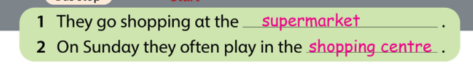  3. Look and say  Game: Who wants to be a millionaire.  T gives the Sts these questions to answer and practice to be a millionaire in the game.  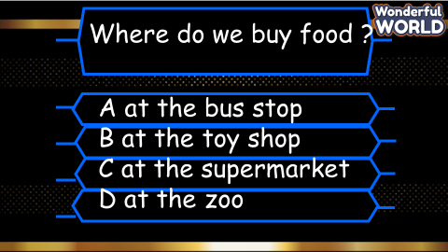  • Suggested answer:  1At the supermarket.  2. At the shopping centre  3. At the bus stop  4. At the post office  5. It’s in front of the toy shop  6. It’s next to the fountain  7. It’s behind the toy shop  8. It’s opposite the library | - Look and answer.  - Listen.  - Read.  - Look and read.  - Play the game by answering the questions.
Activity 4: Production (9 minutes)
a. Aims: Apply the learned knowledge to make their own conversation (attached with illustrated craft)
Teacher’s Activities | Students’ Activities
Draw: “My town”  T tells Sts to take out the paper and draw their town and write the places of the town.  The sts will ask and answer each other.  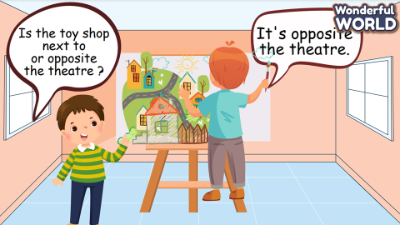 | - Draw.  - Write.  - Ask and answer.
Activity 5: Assessment and Wrap Up(3 minutes)
a. Aims: Consolidate the content of the lesson
Teacher’s Activities | Students’ Activities
b. Procedure  Let Ss do the assessment: Match  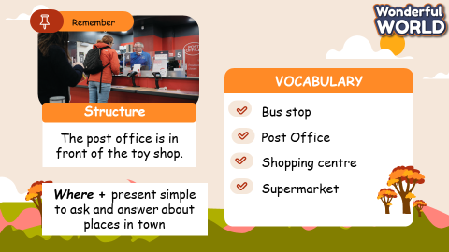 | Do the assessment.  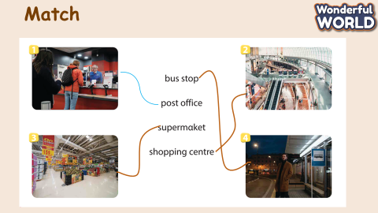

SCHOOL  MANAGER | HEAD OF  DEPARTMENT | FULL NAME OF  TEACHER

