GIÁO ÁN HỘI GIẢNG LỚP 4E
Năm học 2024-2025
GV :Dương Thị Yên
UNIT 4: FOOD AND DRINK
LESSON 2: TASK 1,2,3
I. OBJECTIVES:
1. Knowledge:
Students will learn words and phrases related to the topic Food and Drink: a cookie, a cupcake, pizza, a piece of pizza.
2. Competences:
- English competences: Students will be able to talk about food and drink.
- Common competences: Students will have the opportunity to develop logical thinking and develop communication among friends.
3. Qualities:
- Students develop a love for different leisure activities.
II. EQUIPMENT AND MATERIALS:
- For Teacher: PPT, flashcards, handout, track 4.4, track 4.5
- For students: textbook
III. LESSON PROCEDURE:

Activity 1: Warm up (5 minutes)
Teacher’s Activities | Students’ Activities
Warm up: Play a small game “Puzzle game”  The teacher asks SS to identify different colours and choose a colour to guess the image behind the puzzles.  T calls Ss to answer and check their answers.  T asks Ss to repeat the names of objects in the image.  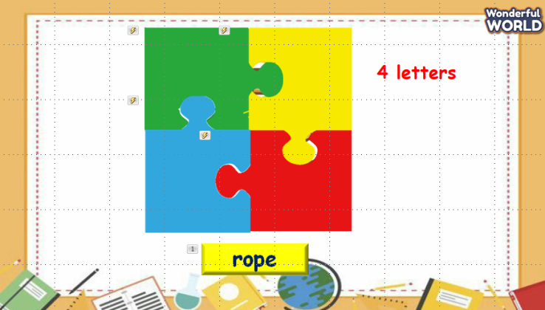  Lead in:  - T introduces that they will learn about “Food and drink” which uses the words in warm up today. | - Listen and answer the questions.  - Listen to T.
Activity 2: Presentation (8 minutes)
Teacher’s Activities | Students’ Activities
- Use flashcards to introduce the vocabulary of the lesson.  - Say the words for students to listen to and repeat in the chorus.  - Say a word for students to repeat then point.  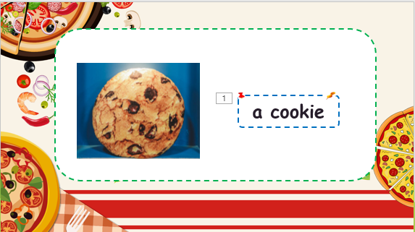 | - Repeat after the teacher.
Activity 3: Practice (10 minutes)
Teacher’s Activities | Students’ Activities
Task 1: Listen and point. Repeat. (Track 4.4)  - Play track 5.4 for the students to listen to, point to, and repeat the words in chorus and groups.  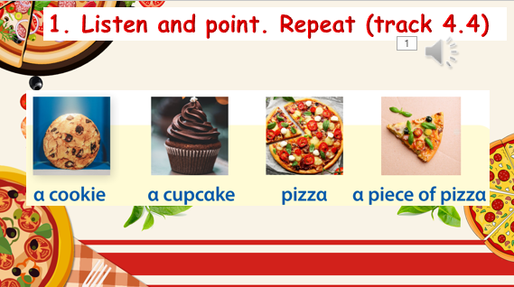  Task 2: Listen and read. Tick. Track 4.5.  - Ask SS to look at the picture and answer some questions about it.  - Call Ss to answer the questions.  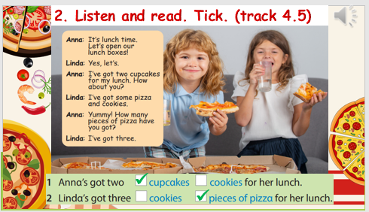  - Ask SS to identify the names of characters in the dialogue.  - Play track 4.5 and let SS listen to the dialogue, then repeat each sentence.  - Ask SS to read again, then write the correct answers.  Task 3: Let’s talk.  • Tell students to look at the pictures and the sample  sentence. Read out loud the sentence and ask students to  repeat it.  • Ask students to look at the prompt pictures and look back  at activity 1 when doing the task.  • Explain to students that they are interviewing their friends  about what their friends want for their lunch. Allow them  enough time to practice saying sentences individually and  then in pairs. Go round the class helping students where  necessary. | - Listen and answer.  - Read and answer.  - Listen and repeat.  - Read and write answers.  - Role play.  - Write the sentences and say.  - Listen to T.  - Work in pairs and present in front of the class.
Activity 4: Production (9 minutes)
Teacher’s Activities | Students’ Activities
Game: The little bee.  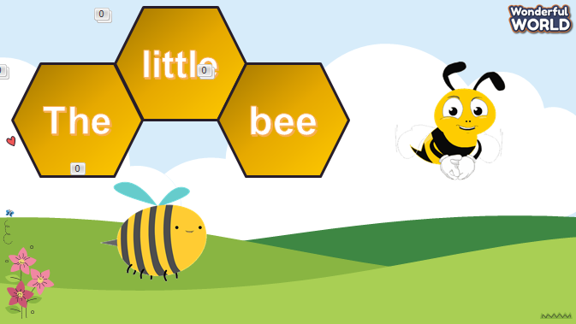  - Let Ss look at the picture. Then choose the best answer. | - Listen to the rule carefully.  - Join the game.  -Look and read.  -Read  -Identify and read.  - Check with friends and then with the teacher and the whole class.
Activity 5: Assessment (3 minutes)
Teacher’s Activities | Students’ Activities
-Ask sts to do the assessment.  - Check with the class.  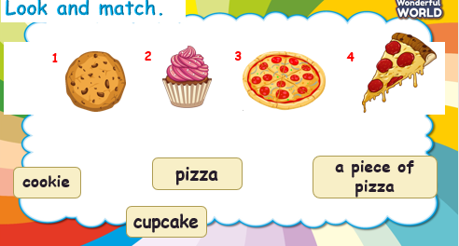 | -Do the assessment.  - Check with the teacher.

