Giáo án hội giảng chào mừng Ngày nhà giáo Việt Nam 20/11
Năm học 2023-2024
GV: Nguyễn Thị Soa – Tổ môn chuyên

Date of teaching: Monday, October 30th, 2023
Unit 4.FOOD AND DRINKS
Lesson 1 (4,5,6) Period 33 (class 4I)
I. OBJECTIVES:
1. Knowledge:
Students learn the quantifiers some, a
2. Competences:
- English competences: Students will be able to ask and answer about whether someone would like a certain food and express the quantity of fruits using “some”, “a”
- Common competences: Students will have the opportunity to develop the communicative by role play activities.
3. Qualities:
- Students will be friendly and confident in communicating with friends.
II. EQUIPMENT AND MATERIALS:
- Basic things: Student’s book, flashcards, crayons, paper, glue
- Advanced things: PPT, projector/interactive whiteboard/laptop/TV.
III. LESSON PROCEDURE:
Activity 1: Warm-up (5 minutes)
Aims: To make Ss get ready for the topic Food and drink
Teacher’s activities | Student’s activities
- Greet students  Game: Spelling bee game  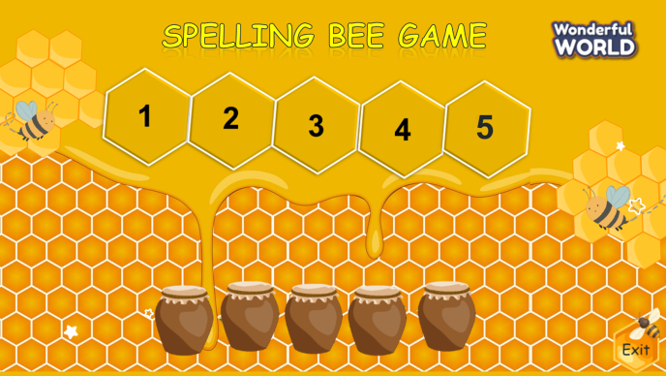  (There are 4 questions. Students have to spell a word of food. Students choose the jar to get the stars with each correct answer.)  - Divide the class into 4 groups  - Set the game rules  - Play as a model.  - Have students play in turns.  - Award the best groups  Lead-in: Use the pictures of the game to lead in the new lesson. | - Greet teacher  - Sit in 4 groups  - Listen to the game rules  - Look  - Join the game  - Listen
Activity 2: Presentation (8 minutes)
Aims: Present new structure: Would you like….? Yes, please/ No, thanks using
vocab of task 1
Teacher’s activities | Student’s activities
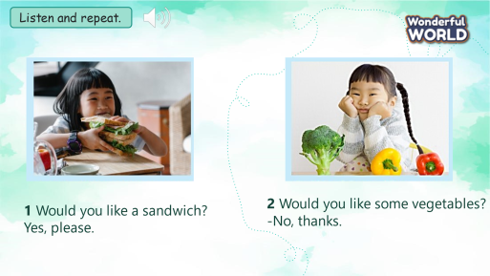  Task 4: Listen and repeat. (Track 4.3)  - Ask students to point and say the name of the food in each picture.  - Use the picture to teach the quantifiers: some, a  - Play the track 4.3.  - Play the track 4.3 again, ask students to listen and repeat in chorus, groups.  - Structure checking:  + Show the question:  - Ask Ss If you want it what do they say?  - Show the answer to make sure Ss understand meaning.  - Show the question:  - If they don’t want they should say: No, thanks.  -Call some pair practice ask and answer. | - Point and say: sandwich, vegetable  - Learn the grammar  - Listen  - Listen and repeat  Answer T’s question:  Ask and answer question:
Activity 3: Practice (12 minutes)
Aims: Controlled- practice to Free practice: to discuss and practice the model structures
Teacher’s activities | Student’s activities
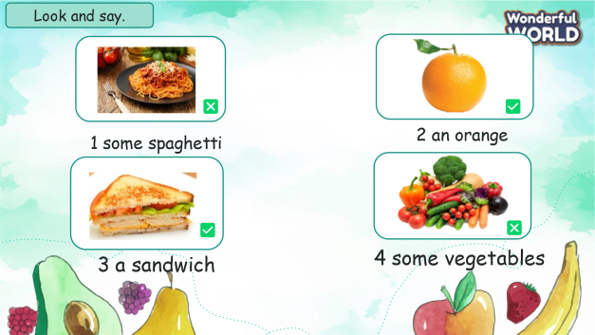  Task 5: Circle and say.  - Show the pictures in task 5  - Ask students to look at the picture and pay attention in the symbol or  - Use 2 balls and ask Ss they are going to pass the ball one by one around the class when they hear the music.  - When the music stop, Who has the ball will stand up to ask and aswer the sentences.  - Play music again then do with another pictures. | - Look at the picture  - Identify is No, thanks. Is Yes, please.  - Play game.
Activity 4: Production (7 minutes)
Aims: Apply structures to real world, promoting Sts’ activities
Teacher’s activities | Student’s activities
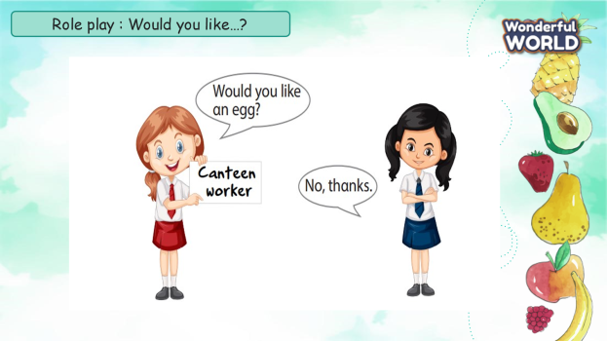  Task 6: Role play  - Ask Ss work in pairs.  - Ask them draw a picture of food. Then ask Their friend if he/she would like to eat this food or not.  - T goes around the class to support Student.  - Call some pairs practice ask and answer .  - Give feedback then give Ss stars. | - Pair work  - Draw a food.  - Ask and answer about  whether someone would like a certain food  -
Activity 5: Assessment and wrap-up(3 minutes)
Aims: Consolidate the content of the lesson
Teacher’s activities | Student’s activities
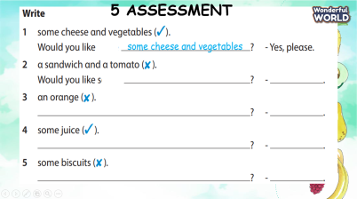  - Ask students to do the assessment.  - Check in pair then whole class.  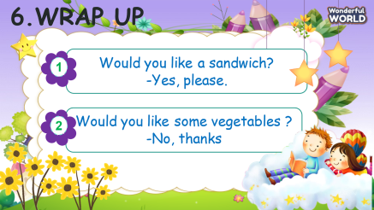  - Say goodbye | - Do the assessment.  - Check with friends and then with the teacher and the whole class.  - Say goodbye.

