GIÁO ÁN HỘI GIẢNG
Năm học 2023-2024
Họ và tên giáo viên: Nguyễn Thị Thùy Dung
Lớp dạy : 3D
UNIT 3: ANIMALS
Lesson 3: Part 1-3 ( P46)
I. OBJECTIVES:
1. Knowledge:
Students will learn about sea animals: sea, turtle, shark, whale in both singular and plural form.
2. Competences:
- English competences: Students will be able to introduce the sea animals properly using These are…They are…
- Common competences: Students will develop their problem-solving skill through making sea animal fact file.
3. Qualities:
- Students will be benevolent with sea animals.
II. EQUIPMENT AND MATERIALS:
- For Teacher: PP, TV, flashcards, track 3.9, track 3.10, handout
- For students: A0 paper, pen, crayons
III. LESSON PROCEDURE:
Activity 1: Warm up (5 minutes)
Teacher’s Activities | Students’ Activities
Baby Shark songs  - Introduce the song by using picture if the sea  - Ask sts some questions about what they know about animals living in the sea  - Lead-in Shark, but it’s a baby shark. Today you’re visiting a friendly shark family. You’ll be shark friends if you can say shark language. What do sharks say? (doo dooo dooo dooo)  - Mime some shark actions  - Have sts guess number members of shark family  - Have sts do some animal actions like: baby shark, mommy shark, daddy shark, grandma shark, grandpa shark, doo doo doo doo  - Listen and copy the actions  - Sing and dance | - Listen to teacher  - Look and guess  - Do actions  - Sing and dance
Activity 2: Presentation (8 minutes)
Teacher’s Activities | Students’ Activities
Task 1: Look and point. Repeat  -Set context: Summer is coming. Where do you want to go on summer holiday? (Let sts say the places). Today, I’ll introduce you a new friend. He’s not from Vietnam. Guess where he’s from? (let sts guess the country). Show the picture of Janet holding Australian flags. Introduce Janet to class. Australia is a country of beauty. Every summer. Janet’s family goes on holiday. Guess where they go (let sts give their guess)  - Show the picture of the sea  - Have sts listen and repeat  - Lead sts going on the marine ship and explore sea animals  - Show: shark, whale, octopus and turtle in turn  - Ask sts to listen and repeat  Checking: Fast Ears, speed mouth Game  - Context: Janet’s family got lost to the Mermaids’ world in the deep sea. - Help them come back by solving Mermaid’s trick.  -Teacher prepares 10 colourful mermaids. Each mermaids contains sounds or words of 5 vocabulary  How do sharks say? Doo doo doo doo  How do whales say? (whale sound)  How do turtles say? …. (turtle sound)  How does the sea say? ……… (sea sound)  - Ask 5 sts holding flashcards: sea, shark, whale, octopus, turtle in the corners of the room  - Arrange sts to stand in four groups. - Name each group after sea, shark, whale,, octopus, sea, turtle  - Ask sts choose a Mermaid  - As soon as they hear the sound or see the word. The group with that name do action. Others point to and say aloud the word.  - The fastest group gets the point  - Give points for the fastest correct answer  Optional: Teacher can let sts play themselves. Have sts make the sound or do action, others point to the correct picture and say the word. Then change the role, teacher asks a player from each team to face back the board. Teacher shows the words, sts do action or make sound. The players look, listen and say. The first correct answer gets the point. | -Listen to teacher  - Answer the questions  - Look at the picture  - Listen and repeat  - Join the trip  - Listen and repeat  - Listen to teacher  - Hold flashcards  - Form groups  - Choose a mermaid  - Listen to the sound/ Look at the words  - Do action  - Point and say
Activity 3: Practice (14 minutes)
Teacher’s Activities | Students’ Activities
Task 2: Listen and tick  - Context: Janet visit Aunt Lena at home near the sea. Aunt Lena shows Janet some photos. What are the photos about? Listen to their conversation and check what the photos are about.  - Introduce listening task  - Ask sts to listen and tick  - Check answer with friends  - Check with whole class  Play role:  - Show the two pictures in task 2  - Ask sts some questions:  What sea animals can you see?  How are they?  Do you like turtles? /sharks?  Do you like these photos?  - It’s time for you to show the pictures to Janet.  - Ask sts to listen and repeat  - Spend time for sts practising in pairs  - Perform their role in front of class  - Vote for the best performance  Task 3: Look and say  Listing Game  - Arrange sts to work in 2 groups  - Hand groups 4 pictures  Turtles, sharks, whales, and octopus  -Ask sts to list out the words used with 3 animals by using mind map  - Give time for groups to list  - Play listing Game.  - Teacher holds the picture and ask sts to say the sentence: These are turtles in the sea.  - Groups tic-tac-toe to take turn saying: They’re small. They’re cool.  - Continue until the end. The group made most correct answer wins the game | -Listen to teacher  - Answer the question  - Listen and tick  - Check with friends  - Check with teacher  - Look at the pictures  - Answer the questions  - Listen and repeat  - Practise in pairs  - Perform  - Vote for the best performance  - Form 2 groups  - Get pictures  - List words to describe animals  - Play game:  - Look at the picture  - Say the sentence  - Tic-tac—toe  - Make descriptive sentences by chance.
Activity 4: Production (9 minutes)
Teacher’s Activities | Students’ Activities
My favourite sea animal  -Guide sts to choose their favourite sea animals  - Draw their pictures  - Note their facts  - Ask sts to move around and talk with friends | - Choose a favourite animal  - Draw picture of it  - Note some facts  - Talk to friends
Activity 5: Assessment (3 minutes)
Teacher’s Activities | Students’ Activities
-Ask sts to do assessment  Unscramble the words  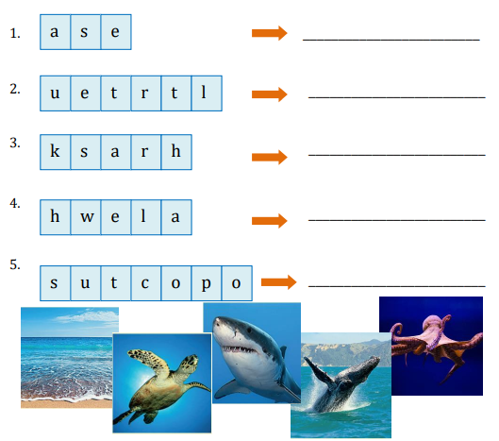  - Check with whole class  - Say goodbye | - Do assessment  - Check with teacher  Answer:  - sea  - turtle  - shark  - whale  - octopus  - Say goodbye
IV. ADJUSTMENTS (if necessary):
………………………………………………………………………………………….…..……………………………………………………………………………..............
Duyệt, ngày 8 tháng 11 năm 2024
BGH

Trần Thị Ngọc Hoa

