ĐĂNG KÝ GIẢNG DẠY TUẦN 17 ( Từ ngày 29/12-02/2/2025)
Thứ  Ngày | Buổi | Lớp | Tiết | Môn | Tên bài
Hai | Chiều | 5B | 4 | English | Unit 10: Our school trip- Lesson 2 (4,5,6)
Ba | Sáng | 5A | 1 | English | Unit 10: Our school trip- Lesson 2 (4,5,6)
Ba | Sáng | 5A | 2 | English | Unit 10: Our school trip- Lesson 3 (1,2,3)
Ba | Sáng | 5C | 3 | English | Unit 10: Our school trip- Lesson 2 (4,5,6)
Ba | Sáng | 5C | 4 | English | Unit 10: Our school trip- Lesson 3 (1,2,3)
Ba | Chiều | 5B | 1 | English | Unit 10: Our school trip- Lesson 3 (1,2,3)
Ba | Chiều | 5B | 2 | English | Unit 10: Our school trip- Lesson 3 (4,5,6)
Ba | Chiều | 5B | 4 | English | Review 2 (Activity 1- 2)
Tư | Sáng | 2C | 1 | English | Self check:  1. Listen and tick.  2. Listen and circle.  3. Write and say
Tư | Sáng | 2C | 2 | English | Self check  4. Read and tick.  5. Find the words.  6. Write the words
Tư | Sáng | 2B | 3 | English | Self check:  1. Listen and tick.  2. Listen and circle.  3. Write and say
Tư | Sáng | 2B | 4 | English | Self check  4. Read and tick.  5. Find the words.  6. Write the words
Tư | Chiều | 4A | 1 | English | Unit 10: Our summer holiday  Lesson 2 (4,5,6)
Tư | Chiều | 4A | 2 | English | Unit 10: Our summer holiday  Lesson 3 (1,2,3)
Tư | Chiều | 5C | 3 | English | Unit 10: Our school trip- Lesson 3 (4,5,6)
Tư | Chiều | 5A | 4 | English | Unit 10: Our school trip- Lesson 3 (4,5,6)
Năm | Sáng | 5B | 1 | English | NGHỈ TẾT DƯƠNG LỊCH
Năm | Sáng | 5B | 2 | English | NGHỈ TẾT DƯƠNG LỊCH
Năm | Sáng | 5A | 3 | English | NGHỈ TẾT DƯƠNG LỊCH
Năm | Sáng | 5A | 4 | English | NGHỈ TẾT DƯƠNG LỊCH
Sáu | Sáng | 4A | 1 | English | Unit 10: Our summer holiday  Lesson 3 (4,5,6)
Sáu | Sáng | 4A | 2 | English | Review 2 (Activity 1- 2)
Sáu | Sáng | 5C | 4 | English | Review 2 (Activity 1- 2)
Sáu | Chiều | 5A | 4 | English | Review 2 (Activity 1- 2)

Duyệt bài, Ngày 26 tháng 12 năm 2025
Phó hiệu trưởng

Nguyễn Thị Hằng

WEEK 17
Grade 2 : Lớp 2B, 2C: Sáng thứ tư, Ngày 31 tháng 12 năm 2025
LESSON PLAN
Self check – Period 2
I. OBJECTIVES |  |  | By the end of the lesson, pupils will be able to:
 |  |  | - recognise the sounds they have learnt;
 |  |  | - recognise the words they have learnt;
 |  |  | - listen for specific sounds and words.
II. INPUT |  |  | Language:
- Sounds: Q/q (/k/), x (/ks/), J/j (/dʒ/), V/v (/v/)
- Vocabulary: question, square, quiz, box, fox, ox, juice, jelly, jam, village, van, volleyball
Resources/Material:
- Student’s book, page 38
- Teacher’s guide, pp. 75 - 76
- hoclieu.vn
- Flashcards
- Computer, projector
III. PROCEDURE |  | Warm-up – Listen and tick – Listen and circle – Write and say – Wrap-up
Procedure | Teaching and learning activities |  |  | Classroom management
Warm-up | 5 minutes
 | Option 1  Using hoclieu.vn, play the video of the story in Lesson 1. Have pupils role play it. |  |  | Group work
 | Option 2  Show flashcards of the letters q, x, j and v. Have pupils say the letter names and the letter sounds. |  |  | Whole class  Group work
 | Option 3  Have pupils play Hot seat to revise the words they learnt in previous units. |  |  | Group work
1. Listen and tick. 8 minutes
Step 1: | Have pupils look at the pictures and say the words (say “Point and say.”). When pupils answer correctly, confirm by saying “jam/ jelly/ van/ volleyball/ square/ circle”. |  |  | Whole class  Individual work
Step 2: | Play the recording and ask pupils to listen and tick the correct box (say “Listen and tick”). Give further support to those pupils who find it difficult to do the task. Play the recording again, if necessary (say “Listen again.”). |  |  | Whole class  Individual work
Step 3: | Follow the same procedure with the pictures of questions 2 and 3. Go around and oﬀer help, if necessary. |  |  | Whole class  Individual work
Step 4: | Check the answers by asking “a or b?”. When pupils answer correctly, confirm by saying  “1a. jam”/“2b. volleyball”/“3a. square” and encourage them to repeat. |  |  | Whole class
Audio script: 1. jam 2. volleyball 3. square
Answers: 1. a 2. b 3. a
Extension: | Put the flashcards of Units 1-4 at different places in the class. Have pupils play in groups of four. Say one word, for example, van, the pupils will try to run to the flashcard “van” as fast as he/she could to slap on the word. |  |  | Group work
2. Listen and circle. 7 minutes
Step 1: | Have pupils look at the pairs of letters and say the letter sounds in pairs (say “Point and say.”). Invite some pupils to say the letters and the sounds in front of the class. |  |  | Whole class
Step 2: | Play the recording, ask pupils to listen and circle the letters of the sounds (say “Listen and circle.”). Allow pupils time to complete the activity. Play the recording again, if necessary (say “Listen again.”). |  |  | Individual work
Step 3: | Check the answer to Question 1 by asking “/k/ or/v/?” Invite some pupils to say the sounds they have heard. When pupils answer correctly, confirm by saying “/k/.” and encourage them to repeat. |  |  | Individual work
Step 4: | Repeat Step 3 for Questions 2, 3 and 4. |  |  | Individual work
 | Audio script: 1. q 2. j 3. x 4. v
Extension: | Divide pupils into groups. Have them listen to one sound, for example /v/, and in one minute, pupils try to find out the words contaning the sound /v/ such as van, village, ... The group with the most correct words wins.
3. Write and say. 10 minutes
Step 1: | Draw pupils’ attention to Picture 1, say “Look at Picture 1”. Have pupils point and say the words (say “Point and say.”). When pupils answer correctly, confirm by saying “fox/ question/ juice/ village”. |  |  | Whole class
Step 2: | Have pupils write the letters to complete the words (say “Look and write.”). Allow pupils time to complete the activity. Go around the class to oﬀer support. |  |  | Individual work
Step 3: | Get pupils to check their answers in pairs. Then ask some pairs to give their answers. Give comments and confirm the correct answers. |  |  | Pair work
Step 4: | Have pupils say the words (say “Now say.”) |  |  | Whole class
Extension: | Write incomplete words on the board and have some pupils to write letters to complete them.  E.g: _ an , _ am, _uice, _bo_ , … |  |  | Individual work
Wrap–up 5 minutes
 | Option 1  Have pupils play Kim’s game. Stick flashcards on the board. Have pupils look at the cards for 30 seconds. Then ask them to close their eyes. Have them open their eyes again and say what words have been missing. |  |  | Whole class
 | Option 2  Stick some picture cards on the board. Write the words on the board. Have pupils match. |  |  | Group work  Individual work
 | Option 3  Have pupils play Pass the ball game. Give flashcards for pupils to pass with the music, then when the music stops, those who get the flashcards will say the words. |  |  | Individual work
----------------------------------------------
Grade 2 : Lớp 2B, 2C: Sáng thứ tư, Ngày 31 tháng 12 năm 2025
LESSON PLAN
Self check – Period 3
I. OBJECTIVES |  | By the end of the lesson, pupils will be able to:
– recognize the target words and sentence structures;
– write the learnt words.
II. INPUT |  | Language:  - Vocabulary: question, square, quiz, box, fox, ox, juice, jelly, jam, village, van, volleyball
- Structures:
What’s he/she doing? and He’s/She’s _____ (verb + –ing). to ask and answer questions about what someone is doing.
Is there a/an _____? and Yes, there is./No, there isn’t. to ask and answer questions about whether or not something is present.
Pass me the _____, please. and Here you are. to make and respond to a request.
Can you draw a _____? and Yes, I can./ No, I can’t. to ask and answer questions about ability.
Resources/Material:
- Student’s book, page 39
- hoclieu.vn
- Teacher’s guide, pp. 76 - 77
- Flashcards
- Computer, projector
III. PROCEDURE |  | Warm-up – Read and tick – Find the words – Write the words – Wrap-up
Procedure | Teaching and learning activities |  | Classroom management
Warm-up | 5 minutes
 | Option 1  - Have pupils sing one or two songs from Units 5 - 8 to revise the words and structures they have learnt. If pupils do not remember the songs, play the recording for them to sing along. |  | Whole class
 | Option 2  Show pupils the lyrics of a chant or a song from Units 5 - 8 with some missing words, e.g.:  Is there a fox? Is there a __?  Yes, there is. Yes, there is.  There’s a __ in the box.  Is there an ox? Is there an ___?  No, there isn’t. No, there isn’t.  There isn’t an ___on the farm.  Then ask pupils to listen to the chant/song and fill in the blanks, then sing the complete chant/song aloud. |  | Whole class  Individual work
 | Option 3  Have pupils play the game Mystery bag to revise the sounds and words they learnt in previous units. |  | Group work
4. Read and tick. 8 minutes
Step 1: | Have pupils read and say the sentence structures in Question 1 Is there a box? Yes, there is. (say “Read and say.”) |  | Whole class
Step 2: | Have pupils look at the pictures underneath the sentence structure (saying “Look at the pictures in Question 1, please!") and say what they can see. When pupils answercorrectly, confirm by saying “box/ book”. |  | Whole class
Step 3: | Have pupils read the sentence structures and tick the correct box (say “Read and tick.”). Allow pupils time to complete the activity. Give further support to those pupils who find it difficult to do the task. |  | Individual work
Step 4: | Check answers by saying “a. or b.?” When pupils answer correctly, confirm by saying “a.” and encourage them to repeat the question and answer. |  | Whole class
Step 5: | Repeat Steps 1 to 4 for the sentence structures in Questions 2 and 3. |  | Whole class  Individual work
Extension: | Say aloud some sentences and have pupils slap the suitable pictures. |  | Group work
5. Find the words. 8 minutes
Step 1: | Draw pupils’ attention to the word search and the list of eight words. Have them point to and say each word (say “Point and say.”) |  | Whole class
Step 2: | Ask pupils to look at the word search, find and circle the words in it individually. Allow pupils time to complete the activity. |  | Individual work
Step 3: | Check answers by showing the word search grid on the board and inviting pupils to come to the front and circle the words. |  | Whole class
Extension: | Ask some advanced pupils to make sentences with these words.
Extension: | Have pupils rearrange the sentences to make meaningful sentence. E.g:  the sail / I / can see (I can see the sail.)  flying/ He’s/ a kite (He’s flying a kite.)
6. Write the words. 8 minutes
Step 1: | Have pupils look at and describe the picture using the words they have learnt. |  | Whole class
Step 2: | Write v _ _ _ _ _ _ on the board and encourage pupils to complete the word. When they answer correctly, confirm by saying “village” and encourage them to repeat. |  | Whole class
Step 3: | Repeat Step 2 for square (s _ _ _ _ _), box  (b _ _), juice (j _ _ _ _), jelly (j _ _ _ _) and volleyball (v _ _ _ _ _ _ _ _ _). |  | Whole class
Step 4: | Say “Write the words.” and allow pupils time to complete the activity. |  | Individual work
Step 5: | Check answers by inviting pupils to come to the front and complete the words village, square, box, juice, jelly and volleyball on the board. |  | Individual work
Extension: | Show the picture of some learnt words and ask pupils to write the words on their notebooks. Ask pupils to swap their answers with other classmates. Then check the answers as a class. |  | Whole class  Individual work
Wrap–up 5 minutes
 | Option 1: Have pupils play Pass the ball game. Give flashcards for pupils to pass with the music, then when the music stops, those who get the flashcards will say the words. |  | Whole class
 | Option 2: Show flashcards and have pupils say the words. Ask some pupils to make sentences with the words. |  | Individual work
 | Option 3: Write incomplete sentences on the board (with pictures). Invite some pupils to go to the board and write the letters to complete the sentences.  E.g. The picture of the jam and the text: Pass me the _____, please. |  | Individual work
--------------------------------------------------------------
Grade 4: Lớp 4A: Chiều thứ Tư, Ngày 31 tháng 12 năm 2025
ENGLISH
Unit 10: Our summer holidays
Lesson 2 (4, 5, 6)
A. OBJECTIVES:
By the end of the lesson, Ss will be able to:
1. Knowledge:
- use the phrases Bangkok, London, Sydney and Tokyo in relation to the topic “Our summer holidays”
- someone was in the past; listen to and demonstrate understanding of simple communicative contexts in relation to the topic “Our summer holidays”.
- Vocabulary: Review
- Skills: speaking, listening, reading and writing.
2. Competences:
- Critical Thinking: look, complete and read
- Co-operation: ready to help friends in pair work/ group work.
- Self-control and independent learning: perform listening tasks.
3. Attitude/ Qualities:
- Honesty: tell the truth about feelings and emotions.
- Diligence: complete learning tasks.
B. TEACHING AIDS:
- Teacher: Teacher’s guide Pages 145, 146; audio Tracks 103; website hoclieu.vn, posters, laptop, pictures, textbook, lesson plan, TV or projector.
- Students: Pupil’s book Page 71, notebooks, workbooks, school things.
C. PROCEDURES:
Teacher’s activities | Students’ activities
1.Warm- up: (5’)  Game: Who says fast?  *Aims: to create a friendly and active atmosphere in the class to beginning the lesson.  *Procedure:  - Hold a places card, then reveal it slowly.  - Ask Where was you last summer?  - Ask the Ss guess the answer as fast as possible.  - Then have Ss do the same with the rest.  - This can be played in groups to make it more interesting.  - Say “Open your book page 71” and look at “Unit 10, Lesson 2 (4,5,6)”.  2.Practice: (27’)  Activity 1. Listen and match:  *Aims: Ss will be able to listen to and understand four communicative contexts about where someone was in the past and match the correct pictures.  *Procedure:  - Elicit the action of the character in each picture.  + Who are they?  + Which places are they?  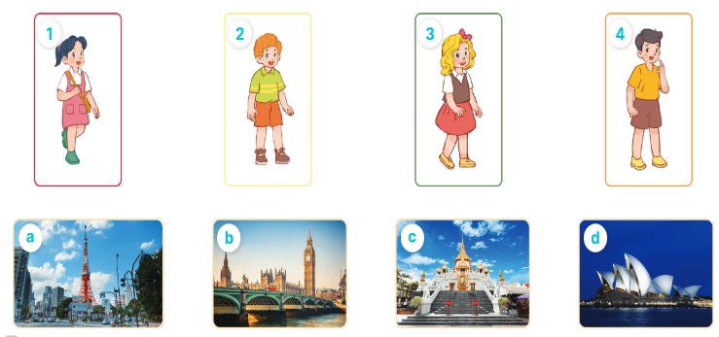  - T ask Ss to guess the answers.  + T writes Ss’guessing on the board.  - Listen to the tape:  + Play the recording  + Play the recording again and get Ss to swap books with their partners.  + Play the recording again to check answers together as a class.  + Write the answers on the board for Ss to correct their answers. Then checks Ss’ guessing.  - Play the recording, sentence by sentence, for the class to listen and repeat in chorus.  Key: 1. d 2. c 3. a 4. b  Activity 2. Look, complete and read  *Aims: Ss will be able to complete two gapped dialogues with the help of picture cues.  *Procedure:  - Get Ss to look at the pictures and identify the characters and the places in the pictures.  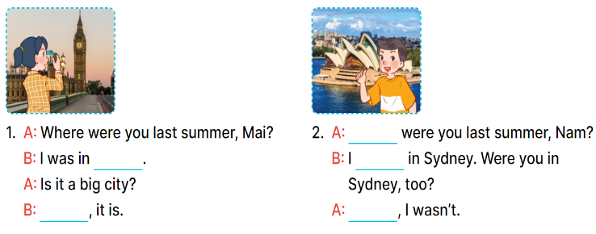  - Have Ss look at the first sentence and the pictures. Elicit and model with number 1: I was in London.  + Ask Ss read and complete the sentence.  -Have Ss work in pairs and complete the other gaps  - Ask a few Ss to stand up and read the sentences aloud.  -T gives feedbacks.  Key:  1. London, Yes 2. Where, was, No  Activity 3. Let’s play  *Aims: Ss will be able to review target words to make sentences about where someone was in the past by playing the game Making sentences.  *Procedure:  - Tell pupils that they are going to play the game Making sentences in groups of four or five.  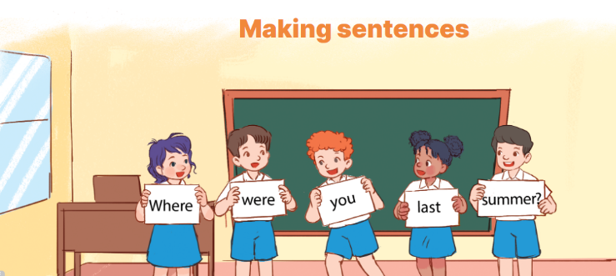  - Nominate one pupil in each group as a leader.  + The leader says a sentence and the other group members have to stand in a line, holding the word cards to make a sentence. Example: Where were you last summer?  - Have pupil work in groups to play the game.  - Invite two groups to the front of the class to play the game.  - Have the class give comments and announce the winner.  - The group that makes most correct sentences will win.  *Consolidation  *Aims: Ss will be able consolidate and wrap up the content of the lesson.  *Procedure:  - T asks ss to answer the following questions:  + What have you learnt from the lesson today?  +What are the core values of the lesson? (if the teacher can take from the lesson).  - T praises some Ss who are hardworking / active/ good…. as well as encourage others to try more.  3. Homework. (3’)  - Practice part 5 again.  - Prepare the new lesson: Unit 10, Lesson 3 (1,2,3). | - Ss listen  - Ss play game  -Ss play game  - Ss open their books  -Look at the pictures and say:  1. Mai 2. Bill 3. Mary 4. Nam  + Picture a. Tokyo Tower  + Picture b. Big Ben  + Picture c. Temple of the Golden Buddha  + Picture d. Opera House  -Ss guess the answers  - Ss listen to the tape and match  - Ss listen again, match and swap books with their partners.  -Ss listen again and check together  - Ss check their answers and guessing  -Ss listen and repeat.  -Ss look at the picture and say  -Ss look and answer  -Ss read and complete  -Ss work in pairs and do the task  -Ss read aloud  -Ss listen and pay attention  -Ss listen  - Ss listen  -Ss play the game  - Ss play the game  -Ss answer the questions  -Ss listen and clap their hands  -Ss listen and take note
D. ADJUSTMENTS (if necessary):
………………………………………………………………………………………….…..……………………………………………………………………………...
-------------------------------------------------------------
Grade 4: Lớp 4A: Chiều thứ Tư, Ngày 31 tháng 12 năm 2025
ENGLISH
Unit 10: Our summer holidays - Lesson 3 (1, 2, 3)
A. OBJECTIVES:
By the end of the lesson, Ss will be able to:
1. Knowledge:
- Correctly repeat the sounds of the letter ere in isolation, in the words were and where, and in the sentences Were you on the beach last summer? and Where were you last weekend? with correct pronunciation and intonation.
- Identify the target words were and where while listening.
- listen to and demonstrate understanding of simple communicative contexts in relation to the topic “Our summer holidays”
- Say the chant with the correct rhythm and pronunciation.
- Vocabulary: Review
- Skills: speaking, listening, reading and writing.
2. Competences:
- Co-operation: ready to help friends in pair work/ group work.
- Sociability: Talk to each other, say good words to others.
3. Attitude/ Qualities:
- Kindness: Help partners to complete learning tasks.
- Honesty: tell the truth about feelings and emotions
B. TEACHING AIDS:
- Teacher: Teacher’s guide Pages 147, 148; audio Tracks 104, 105, 106; website hoclieu.vn, posters, laptop, pictures, textbook, lesson plan, TV or projector.
- Students: Pupil’s book Page 72, notebooks, workbooks, school things.
C. PROCEDURES:
Teacher’s activities | Students’ activities
1.Warm- up: (5’)  Sing a song: If you’re happy and you know it  *Aims: to create a friendly and active atmosphere in the class to beginning the lesson.  *Procedure:  - Show the song in the screen  https://www.youtube.com/watch?v=zyMWcWqmhRc  - Have pupils to sing and dance together  - Say “Open your book page 72” and look at “Unit 10, Lesson 3 (1,2,3)”.  2. Presentation (9’)  Activity 1. Listen and repeat:  *Aims: Ss will be able to correctly repeat the sounds of the letter ere in isolation, in the words were and where, and in the sentences Were you on the beach last summer? and Where were you last weekend? with correct pronunciation and intonation.  *Procedure:  - T gives instruction to the letter ere, the words were and where, and in the sentences Were you on the beach last summer? and Where were you last weekend?  - Play the recording for the letter ere.  - Encourage Ss to point at the letter/ word/ sentence while listening.  - Play the recording again and encourage Ss to listen and repeat.  - Do this several times until Ss feel confident.  - T calls some Ss to practice.  - T gives feedbacks.  3.Practice: (19’)  Activity 2. Listen and circle.  *Aims: Ss will be able to identify the target words were and where while listening.  *Procedure:  - Explain that they have to listen to the recording and circle the correct options.  - Play the recording for pupils to listen.  - Play the recording again for them to listen and circle the correct options.  - Tell pupils to swap books with a partner, then check the answers together as a class. - Write the correct answers on the board.  - Play the recording again for pupils to double-check their answers.  - Invite one or two pupils to stand up, listen to and repeat the sentences.  Key: 1.b 2.c  Activity 3. Let’s chant  *Aims: Ss will be able to say the chant with the correct rhythm and pronunciation  *Procedure:  - Introduce the title and lyrics of the chant.  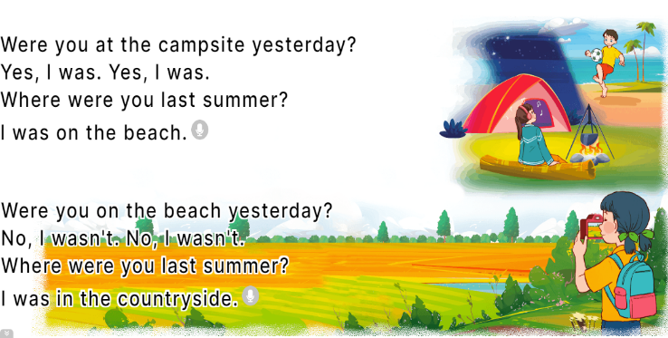  - Play the recording for Ss to listen to the whole chant.  + Have them repeat the title and lyrics line by line.  + Ask Ss to attend to the sounds of the letters ere and the words were and where.  - Play the recording all the way through for Ss to listen to pronunciation and melody.  - Play the recording line by line for Ss to listen and repeat  - Play the recording for Ss to chant and clap along.  - Ask Ss to practice chant and clap along in pairs or groups.  - Invite groups to the front of the classroom to perform the chant  -T gives feedback.  *Consolidation  *Aims: Ss will be able consolidate and wrap up the content of the lesson.  *Procedure:  - T asks ss to answer the following questions:  + What have you learnt from the lesson today?  +What are the core values of the lesson? (if the teacher can take from the lesson).  - T praises some Ss who are hardworking / active/ good…. as well as encourage others to try more.  4. Homework. (2’)  - Practice the chant more.  - Prepare the new lesson: Unit 10, Lesson 3 (4, 5, 6). | - Ss listen  -Ss sing and dance  - Ss open their books  - Ss recognize the differences about color of letter  - - Ss listen  - Ss listen and point  - Ss listen again and repeat  -Ss listen again and repeat  -Ss practice  -Ss listen  -Ss listen and pay attention  -Ss listen to the tape  - Ss listen to the tape and circle  - Ss listen again, circle and swap books with their partners.  - Ss write the correct answer  - Ss check their answers  -Ss listen and repeat.  - Ss look and listen.  -Ss listen to the chant  - Ss listen and repeat line by line without clap their hands  -Ss note the sounds, words  -Ss listen to melody of the chant  - Ss listen and chant line by line.  - Ss chant and clap along.  - Ss work in groups (two groups) to chant  -Ss perform in front of the class.  -Ss listen  -Ss answer the questions  -Ss listen and clap their hands  -Ss listen and take note
D. ADJUSTMENTS (if necessary):
………………………………………………………………………………………….…..……………………………………………………………………………...
--------------------------------------------------------------------------
Grade 4: Lớp 4A: Sáng thứ Sáu, Ngày 02 tháng 1 năm 2026
ENGLISH
Unit 10: Our summer holidays
Lesson 3 (4, 5, 6)
A. OBJECTIVES:
By the end of the lesson, Ss will be able to:
1. Knowledge:
- read and write about if someone was somewhere and where someone was in the past.
- make a mind map of where pupils were on holiday in the previous summer and present the results to the class at Project time.
- Vocabulary: Review
- Skills: speaking, listening, reading and writing.
2. Competences:
- Critical thinking: complete a task in reading a text.
- Co-operation: ready to help friends in pair work/ group work.
- Self-control and independent learning: perform listening tasks.
3. Attitude/ Qualities:
- Show pride in the travelling experience in their summer holidays.
B. TEACHING AIDS:
- Teacher: Teacher’s guide Pages 149, 150; website hoclieu.vn, posters, laptop, pictures, textbook, lesson plan, TV or projector.
- Students: Pupil’s book Page 73, notebooks, workbooks, school things.
C. PROCEDURES:
Teacher’s activities | Students’ activities
1.Warm- up: (5’)  Game: “Chant”  *Aims: to review the vocabulary and structure about greet and respond to greetings.  *Procedure:  - Ask Ss chant and do the actions in Unit 10, Lesson 3 page 66 in groups.  - Give point for the groups and encourage them.  - Say “Open your book page 73” and look at “Unit 10, Lesson 3 (4, 5, 6)”.  2.Practice: (8’)  Activity 1. Read and complete:  *Aims: Ss will be able to read two texts and complete the sentences about Mai’s and Tony’s summer holiday.  *Procedure:  - Elicit Sentence 1 about the location, Sentence 2 about the description of Ha Long Bay, Sentence 3 about the people in London, and Sentence 4 about Mai’s and Tony’s feelings of their summer holidays.  - Have pupils read the texts to find the information and complete four sentences.  - Have pupils work in pairs and do the task  - Get pupils to swap their answers with a partner.  - Check answers together as a class.  Key: 1. Ha Long Bay. 2. beautiful.  3. helpful 4. great.  3.Production: (19’)  Activity 2. Let’s write  *Aims: Ss will be able to read and complete a gapped paragraph about where someone was on holiday in the previous summer *Procedure:  - Check comprehension and elicit to Ss read the gapped text and fill in the gaps.  - Let Ss read the gapped text and fill in the gaps.  - Have Ss complete the first gap together as an example: I am Huong.  - Ask Ss to look at the gap and ask them what is missing. Then let them identify the the name. After that, let them write down the suitable word in the gap.  - Give Ss time to complete the text independently.  - In pairs or groups, ask Ss to swap their complete texts before checking as a class.  - Invite some Ss to come to the board and read the answer.  Key: Pupils’ answer  Example: I am Huong. Last summer, I was on holiday in London with my family. The city was busy. The food was good. The people were friendly. My holiday was great!  Activity 3. Project.  *Aims: Ss will be able to make a mind map of where pupils were on holiday in the previous summer, and use the notes to make a presentation to the class  *Procedure:  - Explain that they have to look at the notes in their mind maps and present the results to the class.  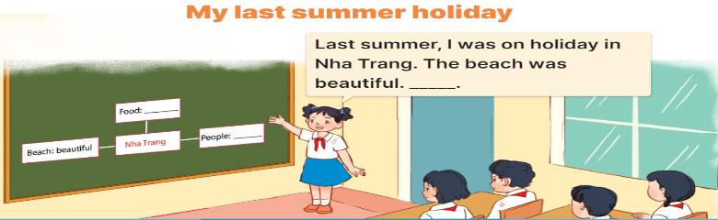  - Have pupils work in groups of five.  + Each pupil looks at the notes in his / her mind map and tells the group about where he / she was on holiday in the previous summer, and describe the place.  - Invite a few pupils to look at the notes in their mind maps and tell the class about them, ex: Last summer, I was on holiday in Nha Trang. The beach was beautiful ...  - Have the rest of the class give comments and praise pupils if they perform well.  *Consolidation  *Aims: Ss will be able consolidate and wrap up the content of the lesson.  *Procedure:  - T asks ss to answer the following questions:  + What have you learnt from the lesson today?  +What are the core values of the lesson? (if the teacher can take from the lesson).  - T praises some Ss who are hardworking / active/ good…. as well as encourage others to try more.  4. Homework. (3’)  - Prepare the new lesson: Review 2 (1, 2). | - Ss listen and chant  - Ss open their books  -Ss read  -Ss read the text and complete  -Ss work in pairs and complete  -Ss swap their answers  -Ss check their answer  -Ss pay attention and read  -Ss read the gapped text  -Ss complete the first gap  -Ss answer and write  - Ss complete the text independently.  -Ss swap the book and check together  -Ss read the answer  - Ss listen and answer  -Ss work in groups and tell about their holiday.  -Ss look at the notes in their mind maps and tall the class.  -Ss clap their hands or congratulation.  -Ss answer the questions  -Ss listen and clap their hands  -Ss listen and take note
D. ADJUSTMENTS (if necessary):
………………………………………………………………………………………….…..……………………………………………………………………………...
---------------------------------------------------
Grade 4: Lớp 4A: Sáng thứ Sáu, Ngày 02 tháng 1 năm 2026
ENGLISH
Review 2-Parts 1, 2
A. OBJECTIVES:
By the end of the lesson, Ss will be able to:
1. Knowledge:
- correctly use the following sentence patterns:
Where’s your school? – It’s in the …...
How many ….. are there at your school? – There is / are …………
What subjects do you have today? – I have ………..
When do you have……….. – I have it on ………..
What’s your favourite subject? – It’s ………
Why do you like ……….? – Because I want to be ………..
Is your sports day in ……….? – Yes, it is. / No, it isn't. It's in ……………
When's your sports day? – It's in ………..
Were you ……..last weekend? – Yes, I was. / No, I wasn't.
Where were you last summer? – I was in ………
- Vocabulary: Review
- Skills: speaking, listening, reading and writing.
2. Competences:
- Co-operation: ready to help friends in pair work/ group work.
- Self-control and independent learning: perform listening tasks.
3. Attitude/ Qualities:
- Kindness: Help partners to complete learning tasks.
- Diligence: complete learning tasks.
B. TEACHING AIDS:
- Teacher: Teacher’s guide Pages 151,152; Track 107, website hoclieu.vn, posters, laptop, pictures, textbook, lesson plan, TV or projector.
- Students: Pupil’s book Page 74, notebooks, workbooks, school things.
C. PROCEDURES:

Teacher’s activities | Students’ activities
1.Warm- up: (5’)  Game: Whispering  *Aims: to review the vocabulary and structure about greet and respond to greetings.  *Procedure:  - Divide class into 2 groups.  -Ask 5 Ss in each group stand in a straight line.  - T says a word or phrase to the first pupil in this line.  - Then, the first pupil whispers what she/ he hear to the second person in line; the second one whispers what he/ she hears to the third one and so on until the last pupil in group hears the word or phrase.  - The last pupil says the word or phrase out loud.  - The faster group has correct word or phrase is the winner.  - Say “Open your book page 74” and look at Review 2.  2.Practice: (27’)  Activity 1. Listen and tick:  *Aims: Ss will be able to listen to and understand five communicative contexts in which characters talk about familiar topics such as our school, our timetable, my favourite subjects, our sports day, our summer holidays and tick the correct pictures.  *Procedure:  - Elicit the words or phrases to describe the pictures in each option.  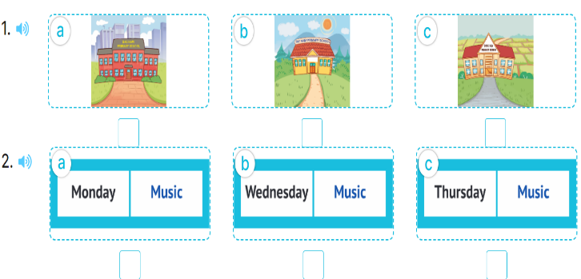  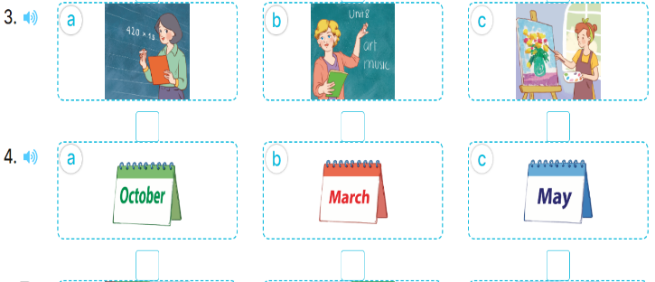  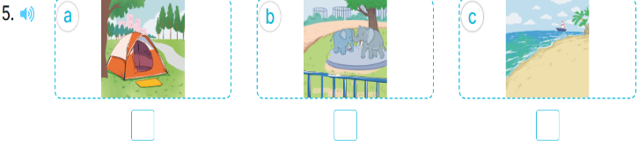  - T ask Ss to guess the answers.  + T writes Ss’guessing on the board.  - Listen to the tape:  + Play the recording  + Play the recording again and get Ss to swap books with their partners.  + Play the recording again to check answers together as a class.  + Write the answers on the board for Ss to correct their answers. Then checks Ss’ guessing.  - Play the recording, sentence by sentence, for the class to listen and repeat in chorus.  Key: 1. b 2. c 3. b 4. c 5. b  Activity 2. Ask and answer  *Aims: Ss will be able to ask and answer questions using picture cues or personal information.  *Procedure:  - Elicit the content and context of each picture.  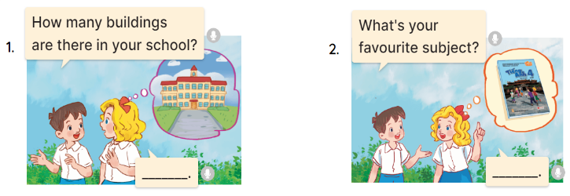  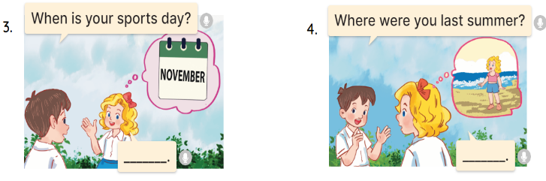  - Draw pupils’ attention to the first question and read it in chorus.  - Elicit the answer and give feedback.  - Have pupils to role-play the exchange.  - Give pupils role-play the four exchanges.  - Invite a few pairs of pupils to stand up and take it in turns to role-play the target exchanges.  * Game: Play game (ppt)  - Play the game “chain game”.  + Divide the class into a lot of groups. There are four or five pupils in each group.  + T says a sentence. Then, the first pupil repeats teacher’s sentence and adds to it. Next, the second pupil repeats what the first pupil has said and adds to it, ect.  - T gives feedback by a game  *Consolidation  *Aims: Ss will be able consolidate and wrap up the content of the lesson.  *Procedure:  - T asks ss to answer the following questions:  + What have you learnt from the lesson today?  +What are the core values of the lesson?  - T praises some Ss who are hardworking / active/ good…. as well as encourage others to try more.  3. Homework. (3’)  - Prepare the new lesson: review 2 (3,4,5) | - Ss listen  -Ss play game  - Ss open their books  -Look at the pictures and say:  + Picture 1a. a school in a city  + Picture 1b. a school in the mountains  + Picture 1c. a school in a village  + Picture 2a. a timetable having music on Monday  + Picture 2b. a timetable having music on Wednesday  + Picture 2c. a timetable having music on Thursday  + Picture 3a. a Math teacher  + Picture 3b. an English teacher  + Picture 3c. a painter  + Picture 4a. a calendar of October  + Picture 4b. a calendar of March  + Picture 4c. a calendar of May  + Picture 5a. a tent  + Picture 5b. a zoo  5c. a beach  -Ss guess the answers  - Ss listen to the tape and tick  - Ss listen again, tick and swap books with their partners.  - Ss check their answers and guessing  -Ss listen and repeat.  -Look at the pictures  -Ss pay attention and read  - Ss answer the question  - Ss ask and answer  - Ss ask and answer  -Ss role play  -Ss listen and play game  -Ss listen and answer  -Ss listen and clap their hands  -Ss listen and take note
D. ADJUSTMENTS (if necessary):
………………………………………………………………………………………….…..……………………………………………………………………………...
----------------------------------------------------
Grade 5: Lớp 5A: Sáng thứ Ba, Ngày 30 tháng 12 năm 2025
Lớp 5B: Chiều thứ Hai, Ngày 30 tháng 12 năm 2025
Lớp 5C: Sáng thứ Ba, Ngày 23 tháng 12 năm 2025
ENGLISH
Unit 10: Our school trip
Lesson 2 (4, 5, 6)
A. OBJECTIVES:
By the end of the lesson, Ss will be able to:
1. Knowledge:
- listen to and understand two communicative contexts in which characters ask and answer questions about what they did on their school trips and tick the correct pictures.
- complete two gapped exchanges with the help of picture cues.
- revise the target vocabulary items and structures through the game What did they do there?
- Vocabulary: Review
- Skills: speaking, listening, reading and writing.
2. Competences:
- Communication and collaboration: work in pairs and groups to complete the learning tasks.
- Self-control and independent learning: perform pronunciation and speaking tasks.
3. Attitude/ Qualities:
- Show their pride in famous places of Viet Nam.
- Show their love and interest in school trips.
B. TEACHING AIDS:
- Teacher: Teacher’s guide Pages 161, 162, 163; audio Tracks 102; website hoclieu.vn, posters, laptop, pictures, textbook, lesson plan, TV or projector.
- Students: Student’s book Page 71, notebooks, workbooks, school things.
C. PROCEDURES:
Teacher’s activities | Students’ activities
1.Warm- up and review: (5’)  Game: pass the bag  *Aims: to revise the learned words *Procedure:  - Put some flashcards about places and activities in a bag.  - Have ss sit in a circle.  - Ask ss to pass the bag around the circle while music plays.  - When the music stops, ask the pupil holding the bag to take out a flashcard in the bag and ask a question about the place and invite their friend to answer the question.  - Give stickers if they ask and answer the questions correctly.  - Say “Open your book page 71” and look at “Unit 10, Lesson 2(4,5,6)”.  2.Practice: (25’)  Activity 1. Listen and tick:  *Aims: Ss will be able to listen to and understand two communicative contexts in which characters ask and answer questions about what they did on their school trips and tick the correct pictures.  *Procedure:  - Draw ss’ attention to the pictures and identify the characters. 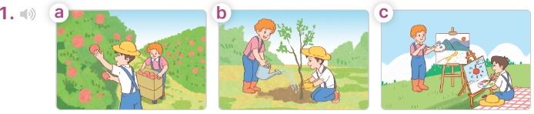  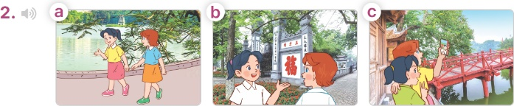  - T ask Ss to guess the answers.  + T writes Ss’guessing on the board.  - Listen to the tape:  + Play the recording  + Play the recording again for pupils to do the task.  + Play the recording a third time for pupils to check their answers.  - Get Ss to swap books with their partner, then check answers as a class.  + Write the answers on the board for Ss to correct their answers. Then checks Ss’ guessing.  - Have Ss to listen and repeat individually and in chorus  Key: 1. b 2. a  Activity 2. Read and complete  *Aims: Ss will be able to complete two gapped exchanges with the help of picture cues.  *Procedure:  - Have Ss look at the pictures and read the question and answer, and guess the missing word in the answer.  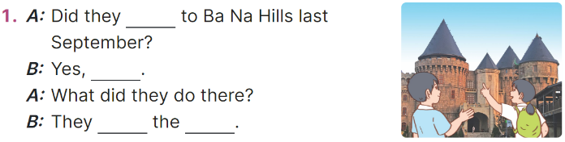  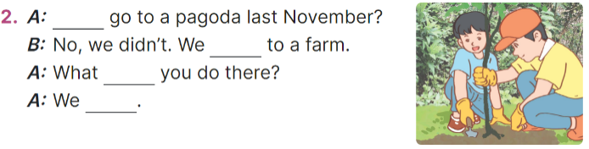  - T models: have Ss read the question and says what words are missing (go)  - Give Ss a time limit to read the gapped dialogues, look at the pictures and do the task independently.  - Get Ss to swap books with a partner and check their answers before checking as a class.  + Invite one student to write the answers on the board.  - Invite two pairs of Ss to act out the completed dialogues.  Key:  1. go; they did; visited; buildings  2. Did; went; did; planted trees  Activity 3. Let’s play  *Aims: Ss will be able to revise target vocabulary items and structures through the game What did they do there?  *Procedure:  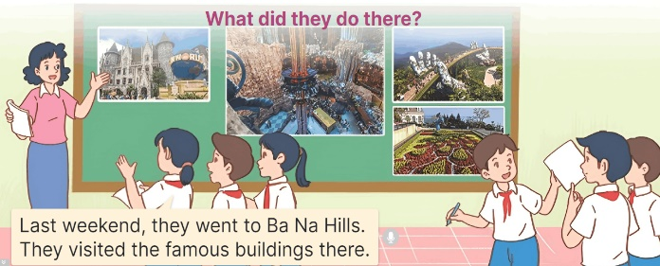  - Explain how the game is played.  - Hang four or six pictures on the board.  + Invite two groups of ss (three or four pupils each) to the front of the class.  + Give ss a time limit to look at the pictures, discuss and make notes of the place they went to and the activities they did.  - Let the group members take turns, pointing at the pictures and telling the class about the place they went to and the activities they did there.  - The group that presents more correct sentences in a short time will win the game.  3. Fun corner and wrap- up (5’)  Game: Throw the dice  - Prepare some pictures about famous places and number them from 1 to 6.  - Invite a volunteer to throw the dice and choose a picture to answer the teacher’s question about activities someone did on a school trip.  - Give stickers to ss if they have correct answers. | -Ss listen to the teacher  -Ss play the game  -Ss play the game  - Ss open their books  -Look at the pictures and say:  + Picture 1a: Bill and Minh picking apples on a farm  + Picture 1b: Bill and Minh planting trees on a farm  + Picture 1c: Bill and Minh painting pictures on a farm  + Picture 2a: Mai and Lucy walking around Hoan Kiem Lake  + Picture 2b: Mai and Lucy walking around Hoan Kiem Lake  + Picture 2c: Mai and Lucy walking around Hoan Kiem Lake  -Ss guess the answers  - Ss listen to the tape  - Ss listen again and do the task.  - Ss listen and check their answers  - Ss swap books with their partner, then check answers as a class and guessing  -Ss write the answer on the board  -Ss listen and repeat  -Ss look at the picture and say  -Ss follow the teacher  - Ss do the task independently.  - Ss swap books with a partner and check their answers.  - Ss write the answers on the board  - Pairs of Ss read the completed dialogues aloud  - Ss listen to the teacher’s explanation.  - Ss look at pictures, discuss and make notes  - The group members take turns, pointing at the pictures and telling the class  -Ss praise the winner  - Ss to the teacher  - Ss play the game  Ex:  1. Ba Na Hills 2. Suoi Tien Theme Park  3. Hoan Kiem lake 4. Thu Le Zoo  5. Opera House 6. Bai Dinh Pagoda
D. ADJUSTMENTS (if necessary):
………………………………………………………………………………………….…..……………………………………………………………………………...
----------------------------------------------------
Grade 5: Lớp 5A: Sáng thứ Ba, Ngày 30 tháng 12 năm 2025
Lớp 5B: Chiều thứ Ba, Ngày 30 tháng 12 năm 2025
Lớp 5C: Sáng thứ Ba, Ngày 30 tháng 12 năm 2025
ENGLISH Unit 10: Our school trip - Lesson 3 (1, 2, 3)
A. OBJECTIVES:
By the end of the lesson, Ss will be able to:
1. Knowledge:
- correctly repeat the second stress in the three syllable words No‘vember, De‘cember, andin the sentences We went to Sa Pa last No‘vember. and They visited Da Lat last De‘cember.
- identify the second stress in the three syllable words and check while listening.
- say the chant with the correct pronunciation, stress and rhythm.
- Vocabulary: Review
- Skills: speaking, listening, reading and writing.
2. Competences:
- Communication and collaboration: work in pairs and groups to complete the learning tasks.
- Self-control and independent learning: perform pronunciation and listening tasks.
3. Attitude/ Qualities:
- Show their pride in famous places of Viet Nam.
- Show their love and interest in school trips.
B. TEACHING AIDS:
- Teacher: Teacher’s guide Pages 164, 165, 166; audio Tracks 103, 104, 105; website hoclieu.vn, posters, laptop, pictures, textbook, lesson plan, TV or projector.
- Students: Students’ book Page 72, notebooks, workbooks, school things.
C. PROCEDURES:
Teacher’s activities | Students’ activities
1.Warm- up and review: (5’)  Chain game  *Aims: to revise the previous structures about activities someone did on a school trip.  *Procedure:  - Ask ss to stand up.  - Stick flashcards about places and the phrases about activities on the board  - Model the game. Have the first student ask a question and invite another one to answer that question. Have the student answering the question continue asking the question and so on.  - Have ss play the game until all ss can ask and answer the questions about activities someone did on a school trip.  - Say “Open your book page 72” and look at “Unit 10, Lesson 3 (1,2,3)”.  2. Presentation (9’)  Activity 1. Listen and repeat:  *Aims: Ss will be able to correctly repeat the second stress in the three syllable words No‘vember, De‘cember, and in the sentences We went to Sa Pa last No‘vember. and They visited Da Lat last De‘cember  *Procedure:  - Have Ss point at the words No‘vember, De‘cember with the stress on the second syllable, in isolation and in the sentences We went to Sa Pa last No‘vember. and They visited Da Lat last De‘cember  - Play the recording for Ss to listen and repeat in chorus and individually until they feel confident.  - Let Ss work in pairs or groups, saying the words and reading the sentences.  - T invites some Ss to practice.  3.Practice: (17’)  Activity 2. Circle, listen and check.  *Aims: Ss will be able to identify the second stress in the three syllable words and check while listening  *Procedure:  - Tell Ss circle the word having a different stress from each line. Then listen to the recording to check their answers.  - Set a time for Ss to do the task.  - Play the recording, once or twice, for Ss to listen and check their answers.  - Get Ss to swap books with a partner and check their answers before checking as a class.  - Play the recording again for Ss to double-check their answers.  - Invite a few Ss to read aloud all the words in the words.  Key: 1. Sep‘tember 2. ‘Saturday  3. ba‘nana  Activity 3. Let’s chant  *Aims: Ss will be able to say the chant with correct pronunciation, stress and rhythm.  *Procedure:  - Introduce the title and lyrics of the chant.  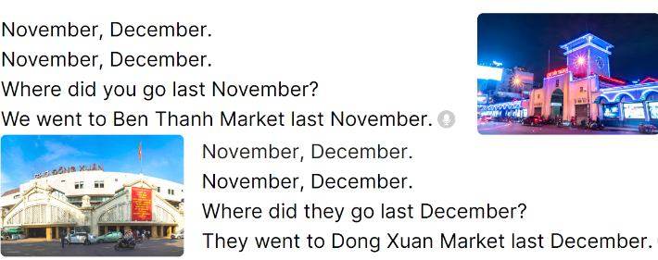  - Play the recording for Ss to listen to the whole chant.  + Have them repeat the title and lyrics line by line.  + Ask Ss to attend to three-syllable words with the stress on the second syllable in the chant, November and December.  - Play the recording all the way through for Ss to listen to pronunciation and melody.  - Play the recording line by line for Ss to listen and repeat  - Play the recording for Ss to chant and clap along.  - Ask Ss to practice chant and clap along in pairs or groups.  - Invite groups to the front of the classroom to perform the chant  3. Fun corner and wrap- up (4’)  Game: Whispering  - Divide the class into two groups.  - Have ss from each group stand in a line.  - The teacher whispers a sentence to the first ss in each row.  - Have the first ss whisper the sentence to the second ss.  - Have groups continue whispering the sentence until it reaches the last ss.  - The last student in the row has to say out the sentence.  - Give the first group to say the sentence correctly one point.  - The group that gets more points wins. Praise the winner. | - Ss follow the T’s instructions.  -Ss pay attention and play the game  Ex:  A: What did you do at Ba Na Hills?  B: I visited the old buildings. What did you do at Suoi Tien Theme park?  C: I played games. ...  D: ...  - Ss open their books  - - Ss point and pay attention  - Ss listen to the recording again and repeat.  -Ss work in pairs and practice  -Ss say the words and sentences  - Ss pay and listen to the teacher’s explanation.  - Ss do the task  - Ss listen to the recording to check their answers (individual)  - Ss swap books with a partner and check the answers  - Ss listen to the recording again and check their answers again.  - Ss stand up and read aloud the words.  - Ss look and listen.  - Ss listen to the chant  - Ss listen and repeat line by line  - Ss note the rhythm and pronunciation.  -Ss listen to melody of the chant  - Ss listen and chant line by line.  - Ss chant and clap along.  - Ss work in groups (two groups) to chant  -Ss perform in front of the class.  -Ss listen to the teacher  -Ss play the game  -Ss play the game  -Ss praise the winner
D. ADJUSTMENTS (if necessary):
………………………………………………………………………………………….…..……………………………………………………………………………...

-------------------------------------------------
Grade 5: Lớp 5A: Chiều thứ Tư, Ngày 31 tháng 12 năm 2025
Lớp 5B: Chiều thứ Ba, Ngày 30 tháng 12 năm 2025
Lớp 5C: Chiều thứ Tư, Ngày 31 tháng 12 năm 2025
ENGLISH
Unit 10: Our school trip
Lesson 3 (4, 5, 6)
A. OBJECTIVES:
By the end of the lesson, Ss will be able to:
1. Knowledge:
- read and show understanding of the text by completing the gapped sentences with correct options.
- use the suggested questions to write a gapped text about Mai’s last school trip.
- revise the target language they have learnt by making a mind map of their school trip and presenting it to the class.
- Vocabulary: Review
- Skills: speaking, listening, reading and writing.
2. Competences:
- Communication and collaboration: work in pairs and groups to complete the learning tasks.
- Self-control and independent learning: perform reading and writing tasks.
3. Attitude/ Qualities:
- Show their pride in famous places of Viet Nam.
- Show their love and interest in school trips.
B. TEACHING AIDS:
- Teacher: Teacher’s guide Pages 166, 167; website hoclieu.vn, posters, laptop, pictures, textbook, lesson plan, TV or projector.
- Students: Pupil’s book Page 73, notebooks, workbooks, school things.
C. PROCEDURES:
Teacher’s activities | Students’ activities
1.Warm- up and review: (5’)  Game: Guessing Places  *Aims: to revise the new words and structures from previous lessons.  *Procedure:  - Divide the class into two groups.  - Ask one student from each group to elicit a sentence about doing an activity and have another group guess the place.  - The group guessing more places wins the game.  - Say “Open your book page 73” and look at “Unit 10, Lesson 3 (4,5,6)”.  2.Practice: (8’)  Activity 1. Read and circle:  *Aims: Ss will be able to read and show understanding of the text by completing the gapped sentences with correct options.  *Procedure:  - Explain that Ss should read the text and choose the correct option to complete the gapped sentences.  - Model the first sentnce: have ss read the sentence and identify the gap and the options given and find the appropriate information from the text to select the correct option (c. Sunday) to complete the gap.  - Set a time limit for ss to do the rest of the task independently.  - Get ss to swap their books with a partner and check their answers before checking as a class.  - Have ss retell or write some sentences about the main ideas of the text  (Ex: They visited a farm near their school last Sunday. They planted trees with the farmers. They watched a film about the farm. They played some games and danced together.)  Key: 1. c, 2. a, 3. b, 4. c  3.Production: (18’)  Activity 2. Let’s write  *Aims: Ss will be able to use the suggested questions to write a gapped text about Mai’s last school trip.  *Procedure:  - Explain that they should answer the suggested questions and use the gapped sentences as a guide to write the text.  - Ask ss to answer the first question (Where did Mai’s class go on their last school trip?) and elicit the place they went for their school trip (ex: Ba Na Hills).  + Have ss write the first sentence of the text  - Give ss time to write the text independently.  - Get ss to swap their books with a partner and check their answers before checking as a class.  - Invite one or two ss to read their completed texts in front of the class.  Key: Pupil’s answer  On Mai’s last school trip, they went to Ba Na Hills. In the morning, they visited the old buildings. In the afternoon, they walked along the Golden Bridge and took photos of the flowers. In the evening, they listened to music and watched the dances. They had a lot of fun.  Activity 3. Project.  *Aims: Ss will be able to revise the target language they have learnt by making a mind map of their school trip and presenting it to the class  *Procedure:  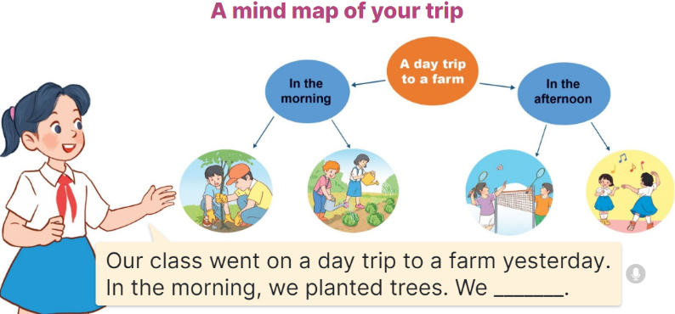  - Explain Ss have to make the mind  map of their school trip at home and present it to their groups.  - Have ss work in groups of five. Each student shows his / her mind map and tells  the group about it.  - Invite a few ss to show their mind maps and tell the class about them. Praise  good performances.  4. Fun corner and wrap- up (4’)  Game: Pass the ball  - T gives Ss a ball.  - T asks Ss to listen to music and transfer a ball around the class.  - When the music stops, Ss who keep a ball have to answer the question using: We went to………….. | - Ss listen  -Ss play game  Ex: A: I played games there. Which place is it?  B: Suoi Tien Theme Park  - Ss open their books  - ass listen to the teacher’s explanation.  - Ss read the text to find the appropriate information from the text to select the correct option to complete the gap.  - Ss do the task independently.  - Ss swap books and check the answers  - Ss retell some sentences about the main ideas of the text.  - Ss listen to the teacher’s explanation.  - Ss answer the first question and elicit the place they went for their school trip.  +Ss write the first sentence  - Ss write the text independently.  - Ss swap their books and check their answers  - Ss read their completed texts  - Ss listen to the teacher’s explanation.  - Ss work in groups and show and tell about his / her mind map of their school trip at home  - Ss show their mind maps and tell the class  Ex: Hi. Our class went on a day trip to a farm yesterday. In the morning, we planted trees. We watered the vegetables. In the afternoon, we played badminton and danced. We had a lot of fun.  -Ss listen to the teacher  -Ss play the game
D. ADJUSTMENTS (if necessary):
………………………………………………………………………………………….…..……………………………………………………………………………...
-----------------------------------------------
Grade 5: Lớp 5A: Chiều thứ Sáu, Ngày 02 tháng 01 năm 2026
Lớp 5B: Chiều thứ Ba , Ngày 30 tháng 12 năm 2025
Lớp 5C: Sáng thứ Sáu, Ngày 02 tháng 01 năm 2026
ENGLISH
Review 2 - Parts 1, 2
A. OBJECTIVES:
By the end of the lesson, Ss will be able to:
1. Knowledge:
- listen to and understand five communicative contexts in which characters talk about familiar topics such as our school, our favourite school activities, location of school things, where someone went, what someone did, and tick the correct pictures
- ask and answer questions using picture cues or personal information.
- Vocabulary: Review
- Skills: speaking, listening, reading and writing.
2. Competences:
- Communication and collaboration: work in pairs and teams to complete the learning tasks.
- Self-control and independent learning: perform reading and writing tasks.
3. Attitude/ Qualities:
- Study hard to review the vocabulary and sentence patterns they have learnt.
- Be honest in the learning tasks.
B. TEACHING AIDS:
- Teacher: Teacher’s guide Pages 171, 172, 173; Track 106; website hoclieu.vn, posters, laptop, pictures, textbook, lesson plan, TV or projector.
- Students: Pupil’s book Page 74, notebooks, workbooks, school things.
C. PROCEDURES:
Teacher’s activities | Students’ activities
1.Warm- up: (5’)  Game: Whispering  *Aims: to revise the sentence structures they have learnt.  *Procedure:  - Divide class into 2 groups.  - Ask 5 Ss in each group stand in a straight line.  - T says a word or phrase to the first student in this line.  - Then, the first student whispers what she/ he hear to the second person in line; the second one whispers what he/ she hears to the third one and so on until the last student in group hears the word or phrase.  - The last student says the word or phrase out loud.  - The faster group has correct word or phrase is the winner.  - Say “Open your book page 74” and look at Review 2.  2.Practice: (26’)  Activity 1. Listen and tick:  *Aims: Ss will be able to listen to and understand five communicative contexts in which characters talk about familiar topics such as our school, our favourite school activities, location of school things, where someone went, what someone did, and tick the correct pictures.  *Procedure:  - Draw Ss’ attention to the pictures and elicit the informations  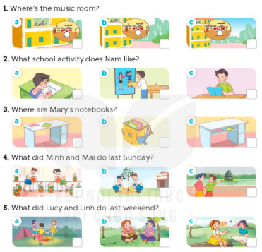  - Play the recording for Ss to do the task. (three times)  - Get Ss to swap books with a partner, then check answers as a class.  - Write the correct answers on the board.  - Play the recording for S to double-check their answers.  - Play the recording, have Ss listen and repeat in chorus.  Key: 1. a 2. a 3. c 4. b 5. a  Activity 2. Ask and answer:  *Aims: Ss will be able to ask and answer questions using picture cues personal information.  *Procedure:  - Draw ss’ attention to look at the picture, the questions and elicit the answer.  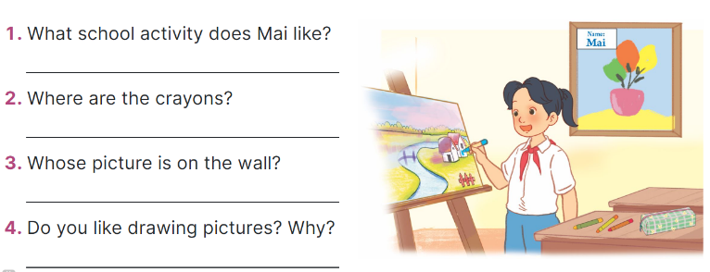  - Have Ss look at the picture to answer the question.  - Have Ss work in pairs to role-play the four exchanges.  - Invite pairs of Ss to stand up and take it in turns to role-play the target exchanges.  Suggested answers:  1. She likes drawing pictures.  2. They’re on the desk.  3. It’s Mai’s.  4. For example: Yes, I do. Because I think it’s interesting.  3. Fun corner and wrap- up (4’)  Game: “Pass the ball”  - Give two different colored balls to two pupils, a blue ball (ask the question) and a white ball (answer the question).  - Ask Ss to listen to music and pass the balls.  - Stop music suddenly. Have the student with a blue ball make a question. Have the student with a white ball answer the question.  - Repeat the game several times. | - Ss listen  -Ss play game  -Ss play game  -Ss praise the winner  - Ss open their books  - Ss listen and say  + Picture 1a: a music room on 1st floor  + Picture 1b: a music room on 2nd floor  + Picture 1c: a music room on 3rd floor  + Picture 2a: Nam doing maths  + Picture 2b: Nam doing crafts  + Picture 2c: Nam reading a book  + Picture 3a: two notebooks on a desk  + Picture 3b: two notebooks in a school bag  + Picture 3c: two notebooks in a desk  + Picture 4a: Minh and Mai watering the flowers  + Picture 4b: Minh and Mai planting trees  + Picture 4c: Minh and Mai walking around Hoan Kiem Lake  + Picture 5a: Lucy and her friends dancing  + Picture 5b: Lucy and Linh playing the guitar and singing  + Picture 5: Lucy and Linh listening to music  - Ss listen to the recording and do the task.  - Ss swap books with a partner, then check answers as a class.  - Ss listen to the recording to double-check their answers.  - Sls listen to the recording and repeat  -Look at the pictures and say  - Ss look at and answer.  - Ss work in pairs to role play  - Ss role play  -Ss listen to the teacher  -Ss play the game  Ex: A: Where did you go last Sunday?  B: I went to Ba Na Hills  -Ss continue playing the game.
D. ADJUSTMENTS (if necessary):
………………………………………………………………………………………….…..……………………………………………………………………………...

Duyệt bài, Ngày 26 tháng 12 năm 2025
Phó hiệu trưởng

Nguyễn Thị Hằng

