ĐĂNG KÝ GIẢNG DẠY TUẦN 11 ( Từ ngày 17-21/11/2025)
Thứ  Ngày | Buổi | Lớp | Tiết | Môn | Tên bài
Hai | Sáng | 5B | 1 | English | Unit 6: Our school rooms  Lesson 2 (4,5,6)
Hai | Sáng | 5B | 2 | English | Unit 6: Our school rooms  Lesson 3 (1,2,3)
Hai | Sáng | 5A | 3 | English | Unit 6: Our school rooms  Lesson 2 (4,5,6)
Ba | Sáng | 5A | 1 | English | Unit 6: Our school rooms  Lesson 3 (1,2,3)
Ba | Sáng | 5A | 2 | English | Unit 6: Our school rooms  Lesson 3 (4,5,6)
Ba | Sáng | 5C | 3 | English | Unit 6: Our school rooms  Lesson 2 (4,5,6)
Ba | Sáng | 5C | 4 | English | Unit 6: Our school rooms  Lesson 3 (1,2,3)
Ba | Chiều | 5B | 1 | English | Unit 6: Our school rooms  Lesson 3 (4,5,6)
Ba | Chiều | 5B | 2 | English | Unit 7: Our favourite school activities  Lesson 1 (1,2,3)
Tư | Sáng | 2C | 1 | English | Unit 6: On the farm - Lesson 1: 1,2
Tư | Sáng | 2C | 2 | English | Unit 6: On the farm - Lesson 2: 3,4,5
Tư | Sáng | 2B | 3 | English | Unit 6: On the farm - Lesson 1: 1,2
Tư | Sáng | 2B | 4 | English | Unit 6: On the farm - Lesson 2: 3,4,5
Tư | Chiều | 4A | 1 | English | Unit 6: Our school facilities  Lesson 2 (4,5,6)
Tư | Chiều | 4A | 2 | English | Unit 6: Our school facilities  Lesson 3 (1,2,3)
Tư | Chiều | 5C | 3 | English | Unit 6: Our school rooms  Lesson 3 (4,5,6)
Năm | Sáng | 5B | 1 | English | Meeting kỉ niệm và Hội diễn văn nghệ chào mừng 20/11 ( Theo kế hoạch hoạt động của Đội)
Năm | Sáng | 5B | 2 | English
Năm | Sáng | 5A | 3 | English
Năm | Sáng | 5A | 4 | English | Unit 7: Our favourite school activities  Lesson 1 (1,2,3)
Sáu | Sáng | 4A | 1 | English | Unit 6: Our school facilities  Lesson 3 (4,5,6)
Sáu | Sáng | 4A | 2 | English | Unit 7: Our timetables  Lesson 1 (1,2,3)
Sáu | Sáng | 5C | 4 | English | Unit 7: Our favourite school activities  Lesson 1 (1,2,3)

Duyệt bài, Ngày 14 tháng 11 năm 2025
Phó hiệu trưởng

Nguyễn Thị Hằng

WEEK 11
Grade 2 : Lớp 2B, 2C: Sáng thứ tư, Ngày 19 tháng 11 năm 2025
LESSON PLAN
Unit 6. On the farm Period 2
 | I. OBJECTIVES |  |  |  |  |  | By the end of the lesson, pupils will be able to:
- pronounce the sound of the letter X/x in isolation.
- say the words box, fox and ox.
 | II. INPUT |  |  |  |  |  | Language:
- Sound /x/
- Vocabulary: box, fox, ox
Resources/Material:
- Student’s book, page 26
- Teacher’s guide, pp. 50 - 52
- hoclieu.vn
- Flashcards for Unit 6
- Flashcards/pictures of farm animals
- Vocabularies for Fun Corner, e.g. box, fox, ox.
- Poster for Unit 6
- Computer, projector
III. PROCEDURE |  |  |  |  | Warm-up – Listen and repeat – Point and say – Fun corner  – Wrap-up
 |  | Procedure |  | Teaching and learning activities |  |  |  | Classroom management
 |  | Warm-up |  | 5 minutes
 |  |  |  | Option 1
 |  |  |  | - Ask pupils to sing the song in Unit 5, Lesson 3 and make the gesture (e.g. expressing what you are doing while singing). |  |  |  | Whole class
 |  |  |  | - Have some pupils demonstrate the song in front of the class, the rest of the class listen to them and clap hands.
 |  |  |  | Option 2
 |  |  |  | - Ask some pupils to talk about the present progressive actions in the classroom. |  |  |  | Whole class
 |  |  |  | - Get some pairs of pupils to practice asking  and answering about their friends’ miming actions, using What is he/she doing?  – He’s / She’s + V-ing. |  |  |  | Pair work
 |  |  |  | Option 3
 |  |  |  | - Show pupils some pictures/slides of farm animals (kitten, chicken, fox, ox, goat, cow, dog, cat, …). |  |  |  | Whole class
- Ask pupils some questions about the farm or the farm animals (in Vietnamese), e.g. Have you ever been to …? Have you ever seen …?
Do you like …? What animals can you see on the farm?
 |  | 1. Listen and repeat. 10 minutes
 |  | Step 1: |  | Have pupils look at the picture, saying Look at the picture, please! and describe the picture. Draw pupils’ attention to the letter X/x, the words next to the thing/animals and the colour  of the letter X/x. Check comprehension. |  |  |  | Whole class
 |  | Step 2: |  | Ask pupils to point to the letter X/x. Have them listen and repeat the sound of the letter X/x, saying Point to the letter X/x, listen and repeat,  please! more than once, if necessary. |  |  |  | Individual work
 |  | Step 3: |  | Tell pupils to point to the word box, saying Point to the word “box”. Ask them to listen and repeat the word, saying Listen and repeat, please! Then play the recording again, if necessary, for them to repeat individually and in chorus. Correct pronunciation, if necessary. If they repeat well,  praise them, saying Well done! |  |  |  | Whole class
 |  | Step 4: |  | Repeat the same procedure with the fox and the ox. Correct pronunciation, if necessary. |  |  |  | Whole class
 |  | Step 5: |  | Play the recording again and have them listen, point to the letter X/x and the words box, fox and ox and repeat until they feel confident. Give further support to those pupils who find it difficult to do the task, if necessary. |  |  |  | Whole class
 |  | Step 6: |  | Play the recording in full and encourage pupils to repeat the name and sound of the letter X/x,  box, fox and ox both individually and in chorus, saying Excellent! when they performed well. |  |  |  | Individual work
 |  | 2. Point and say. 7 minutes
 |  | Step 1: |  |  |  | Have pupils look at the picture again. Ask them to describe the picture. Draw their attention to the letter X/x, the thing/ animals, if necessary. |  | Whole class
 |  | Step 2: |  |  |  | Get them to point to the letter X/x and say it, saying Point to the letter X/x and say, please! |  | Whole class
 |  | Step 3: |  |  |  | Let them point to the box in the picture and say the word box as a model, saying Point to the box and say “box”, please! Remind them of the sound of the letter x in the word box. |  | Individual work
 |  | Step 4: |  |  |  | Follow the same procedure with the animals. Go around and correct pronunciation, if necessary. Give further support to those pupils who find it difficult to do the task. |  | Whole class
 |  | Step 5: |  |  |  | Have pupils work in pairs or in groups to look at the picture, point to the letter X/x, the thing/animals, say the sound of the letter and the words. Say Point to the picture and say, please! Go around and offer help or correct pronunciation, if necessary. |  | Group/ Pair work
 |  | Step 6: |  |  |  | Invite a few pupils to point to the picture and say the sound of the letter and the words in front of the class. If they performed well, praise them,  saying Good work! |  | Individual work
 |  | Fun corner: Whispers (race version) 8 minutes
 |  | Step 1: |  |  |  | Divide the class into two teams. Say You are going to play Whispers game. |  | Whole class
 |  | Step 2: |  |  |  | Tell each team to form a line. Pupils should be spaced far enough apart that they won't overhear the word when it isn't their turn. |  | Group work
 |  | Step 3: |  |  |  | Explain that when you whisper a word to the first pupil  in each line, he/she must in turn whisper it to the second pupil in the line. The second pupil then whispers it to the |  | Group work
 |  |  |  |  |  | third, and so on. When the word reaches the last pupil in the line, he/she should call it out. The fastest team to call out a correct word scores one point.
 |  |  | Step 4: |  |  | Play the game. Remember to nominate a pupil from each team before saying the word. |  | Group work
 |  |  | Step 5: |  |  | Count the points for each team and announce the winner.  The team with the most points wins. The winning team must then correctly pronounce all the three words. |  | Group work
 |  |  | Wrap-up: 5 minutes
 |  |  |  |  |  | Revise the main teaching point of the lesson: the sound of the letter x and the words box, fox, ox. |  | Whole class
 |  |  |  |  |  | Option 1
 |  |  |  |  |  | Using hoclieu.vn, have pupils look at the things in the picture and repeat the words after the recording. |  | Whole class
 |  |  |  |  |  | Option 2
 |  |  |  |  |  | Using Poster for Unit 6, ask pupils to point to the things in the picture and say the words. For better pupils, teacher may cover the words and ask them to point to the things and say the words aloud. |  | Individual work
 |  |  |  |  |  | Option 3
 |  |  |  |  |  | Using pictures and flashcards, get some pupils to match the words box, fox, ox and the pictures. Then ask the class to say the words aloud. |  | Individual work
----------------------------------------------
Grade 2 : Lớp 2B, 2C: Sáng thứ tư, Ngày 19 tháng 11 năm 2025
LESSON PLAN
Unit 6. On the farm Lesson 2 – Period 2
I. OBJECTIVES |  |  |  |  | By the end of the lesson, pupils will be able to:
 |  |  |  |  | - say the letter X/x, the words box, fox, ox and the phrases/sentences containing /x/ and box, fox, ox in a chant.
 |  |  |  |  | - listen and identify the words box, fox, ox.
 |  |  |  |  | - write the letter X/x and complete the words bo_, fo_, o_.
II. INPUT |  |  |  |  | Language:
- Sound /x/
- Vocabulary: box, fox, ox
- Phrases/sentences with the sound /x/ and the words box, fox, ox
Resources/Material:
- Student’s book, page 27
- hoclieu.vn
- Teacher’s guide, pp. 52- 54
- Workbook, pp. 19-20
- Flashcards to play games in Warm-uP Computer, projector
 |  | III. PROCEDURE |  |  |  | Warm-up – Listen and chant – Listen and tick – Look and write – Wrap - up
 | Procedure |  |  | Teaching and learning activities |  |  | Classroom management
 | Warm-up |  |  | 5 minutes
 |  |  |  | Option 1  Ask two or three pupils to look at the picture in Lesson 1 (Student’s book or hoclieu.vn) and say the sound of the letter X/x and the words box, fox and ox.  Option 2  Ask the class to play Whispers game again, using the words in Lesson 1, Unit 6 and those in the previous units, saying Now let us play Whispers game!  Option 3  Get pupils to play What’s Missing? Game, using the pictures and flashcards with the incompleted words bo _, fo_ and o _. Pupils should guess the missing letters and say the words correctly. |  |  | Whole class  Whole class  Whole class
 | 3. Listen and chant. 10 minutes
 | Step 1: |  |  | Have pupils look at the chant, saying Look at the chant, please! Draw pupils’ attention to the first verse and explain its meaning. Ask them to pay attention to the letter X/x and the words box,  fox, ox. Check comprehension. |  |  | Whole class
 | Step 2: |  |  | Play the recording of the first verse for pupils to listen and to get familiarized with the rhythm, saying Listen to the first verse, please! Then play the recording for them to listen and repeat until they feel confident, saying Listen again and repeat, please! |  |  | Whole class
 | Step 3: |  |  | Follow the same procedure with the second and third verse. Correct pronunciation, if necessary. |  |  | Whole class
 | Step 4: |  |  | Play the recording all the way through. Ask pupils to listen and repeat the chant individually and in chorus, saying Listen, chant and clap your hands, please! Go around and offer help, if necessary. |  |  | Whole class  Individual work
 | Step 5: |  |  | Select some pupils to the front of the class to chant and clap their hands. The rest of the class may sing the chant and clap their hands along. If they sing the chant well, praise them, saying  Great work! |  |  | Individual work  Whole class
 | Extension: |  |  | For better pupils, cover or omit some letters/ words in the chant and have them guess and say all the lines aloud. For example:  X, x, a box.  I can see a on the farm. X, x, a fox.  I can see a on the farm. X, x, an ox.  I can see an on the farm. |  |  | Individual work  Whole class
 | 4. Listen and circle. 7 minutes
 | Step 1: |  |  | Have pupils look at the pictures in Question 1 and say What can you see? Draw pupils’ attention to the letters a and b. Check comprehension. Invite some pupils to point to the pictures in Question 1 and say the words in front of the class. Say Point to the pictures and  say the words, please! E.g. 1a: a fox, 1b: an ox. |  |  | Whole class
 | Step 2: |  |  | Play the recording of the first sentence for pupils to listen, saying Now listen, please! Ask pupils what they have heard and circled, saying What did you hear? Did you hear “I can see a fox.” or “I can see an ox.”? Yes, it said “I can see an ox.”. You circle the letter b. If some pupils say “I can see a fox.”, let them listen to the recording again, |  |  | Individual work
 |  |  | saying Now listen again, please! Play the recording and ask What did you hear? Did you hear “I can see a fox.” or “I can see an ox.”? Yes, “I can see an ox.”. Circle the letter b. So b is the correct answer.
 | Step 3: |  | Follow the same procedure with the pictures in Question 2. Before playing the recording, say Are you ready? OK, now listen, please! Play the  recording (several times if needed) for pupils to listen and circle the correct option. |  |  |  | Individual work
 | Step 4: |  | Call a few pupils to the front of the class to point to the pictures and say what they have heard. If they said correct words, praise them, saying Well done! or Very good! |  |  |  | Individual work
 | Step 5: |  | Audio script: 1. I can see an ox.  2. I can see a fox.  Answers: 1. b 2. a |  |  |  | Whole class
 | 5. Look and write. 8 minutes
 | Step 1: |  | Have pupils look at the letter X (upper case) and  x (lower case). Remind them how to write it. |  |  |  | Whole class
 | Step 2: |  | Give pupils time to write the letter X/x independently, saying Now write the letter X/x with your pencil. You can demonstrate by air writing of the letter X/x or open hoclieu.vn’s guide for writing. Then let pupils write the letter. Give further support to those pupils who find it  difficult to do the task. |  |  |  | Individual work
 | Step 3: |  | Check the results of pupils’ writing and give feedback. Ask pupils to work in pairs, swap and check their answers. Give pupils time to work. Go around and offer help, if necessary. |  |  |  | Pair work
 | Step 4: |  | Then have pupils look at the three pictures in the activity. Ask some questions to help them identify the thing and animals in the pictures (e.g. What’s that? What can you see in the  pictures?). Use the first picture as an example, |  |  |  | Whole class
 |  |  | ask pupils to look at it, guess what letter is missing and complete the word.
 | Step 5: |  | Give pupils time to complete the words independently, saying Look at the pictures and complete the words, please! Go around and offer  help, if necessary. |  |  |  | Individual work
 | Step 6: |  | Ask some pupils to show what they have done. Praise them if they have done well, saying You’ve done a good job! |  |  |  | Whole class Individual work
 | Extension: |  | - For weaker pupils, have them do Activity 3, Unit 6 in their workbooks.  - For better pupils, have them do Activity 4, Unit 6 in their workbooks. |  |  |  | Whole class  Individual work
 | Wrap – up 5 minutes
 |  |  | Option 1  Have pupils listen to the recording, then say the chant again.  Option 2  Ask pupils to look at the pictures in 4. Listen and circle and say about them, e.g. box, fox, ox. Encourage better pupils to use learnt structures e.g. I can see an ox; I can see a fox,  Option 3  To reinforce the vocabulary, get pupils to do  Activity 1, Unit 6 in their workbooks. |  |  |  | Whole class  Whole class  Individual work
------------------------------------------------------
Grade 4: Lớp 4A: Chiều thứ Tư, Ngày 19 tháng 11 năm 2025
ENGLISH
Unit 6: Our school facilities - Lesson 2 (4, 5, 6)
A. OBJECTIVES:
By the end of the lesson, Ss will be able to:
1. Knowledge:
- Use How many …. are there at your school? – There is ……. / There are …..to ask and answer questions about the quantity of school facilities.
- Listen to and demonstrate understanding of simple communicative contexts in relation to the topic “Our school facilities”.
- Draw their school with some facilities and present it to the class.
- Vocabulary: Review
- Skills: speaking, listening, reading and writing.
2. Competences:
- Critical Thinking: self-introduce
- Co-operation: ready to help friends in pair work/ group work.
- Self-control and independent learning: perform listening tasks.
3. Attitude/ Qualities:
- Kindness: Help partners to complete learning tasks.
- Honesty: tell the truth about feelings and emotions.
- Show pride and responsibility in the facilities they have at their school.
B. TEACHING AIDS:
- Teacher: Teacher’s guide Pages 94,95; audio Tracks 62,63; website hoclieu.vn, posters, laptop, pictures, textbook, lesson plan, TV or projector.
- Students: Pupil’s book Page 47, notebooks, workbooks, school things.
C. PROCEDURES:
Teacher’s activities | Students’ activities
1.Warm- up: (5’)  Game: Slap the board  *Aims: to create a friendly and active atmosphere in the class to beginning the lesson.  *Procedure:  - Divide class into 2 groups  - How to play:  + Each group chooses five Ss to play.  + Class will read aloud.  + Look at the picture, listen and slap the picture you heard.  + Who faster will get 1 mark.  + Which group with higher mark is the winner.  - T gives feedback.  - Say “Open your book page 47” and look at “Unit 6, Lesson 2 (4,5,6)”.  2.Practice: (27’)  Activity 1. Listen and tick:  *Aims: Ss will be able to listen to and understand two communicative contexts in which characters ask and answer questions about the quantity of school facilities, and tick the correct pictures.  *Procedure:  - Elicit the word for the place in each picture  - Point at the pictures respectively to explain the context.  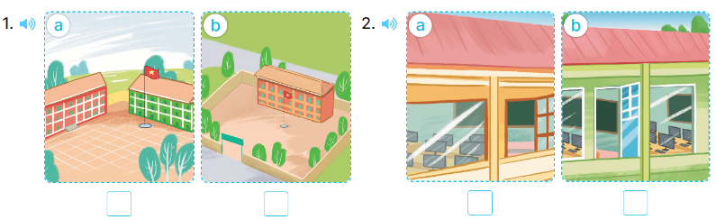  - T ask Ss to guess the answers.  + T writes Ss’guessing on the board.  - Listen to the tape:  + Play the recording  + Play the recording again and get Ss to swap books with their partners.  + Play the recording again to check answers together as a class.  + Write the answers on the board for Ss to correct their answers. Then checks Ss’ guessing.  - Play the recording, sentence by sentence, for the class to listen and repeat in chorus.  Key: 1. a 2. a  Activity 2. Look, compelete and read  *Aims: Ss will be able to complete target sentence patterns in two dialogues with the help of picture cues.  *Procedure:  - Get Ss to look at the pictures and identify about school location.  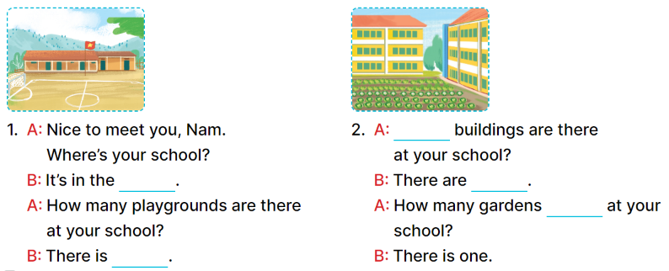  - Give pupils complete the gaps in Dialogue 1, then have them compare their answers in pairs.  - Ask some pairs to read aloud the dialogue.  - Repeat the same procedure with Dialogue 2.  - Invite one or two Ss to stand up and read the completed sentences.  Key:  - mountains, one  - How many, two, are there  Activity 3. Let’s sing  *Aims: Ss will be able to sing the song How many …? with the correct pronunciation, rhythm and melody.  *Procedure:  - Have pupils read the lyrics to familiarise themselves with the questions and answers  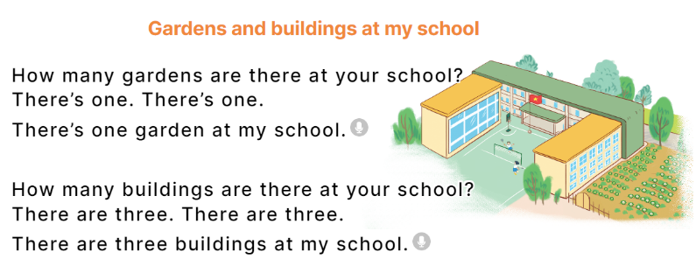  - Have pupils listen to the whole song, drawing their attention to the pronunciation, the rhythm and the melody of the song.  - Play the recording of the song once or twice for pupils to listen and repeat line by line and do related actions, ex: using fingers for numbers one and three.  - Ask the to sing the whole song while doing actions or clapping hands.  - Invite a few groups to the front of the class to sing the song. The class may sing along to reinforce the activity.  *Consolidation  *Aims: Ss will be able consolidate and wrap up the content of the lesson.  *Procedure:  - T asks ss to answer the following questions:  + What have you learnt from the lesson today?  +What are the core values of the lesson? (if the teacher can take from the lesson).  - T praises some Ss who are hardworking / active/ good…. as well as encourage others to try more.  3. Homework. (3’)  - Practice part 5 again.  - Prepare the new lesson: Unit 6, Lesson 3 (1,2,3). | - Ss read the words  - Ss play game  -Ss play game  - Ss open their books  -Look at the pictures and say:  + Picture 1a. a school with a red building and a green building  + Picture 1b. a school with three buildings  + Picture 2a. a school with a computer room  + Picture 2b. a school with two computer rooms  -Ss guess the answers  - Ss listen to the tape and tick  - Ss listen again, tick and swap books with their partners.  - Ss check their answers and guessing  -Ss listen and repeat.  -Ss look at the picture and say  -Ss look and answer  -Ss read aloud  -Ss work in pairs and complete  -Ss read aloud  - Ss listen  -Ss listen and pay attention  -Ss listen and repeat line by line  -Ss sing the whole song  -Ss sing in front of the class  -Ss answer the questions  -Ss listen and clap their hands  -Ss listen and take note
D. ADJUSTMENTS (if necessary):
………………………………………………………………………………………….…..……………………………………………………………………………...………………………………………….…..………………………………………
---------------------------------------------------------------------
Grade 4: Lớp 4A: Chiều thứ Tư, Ngày 19 tháng 11 năm 2025
ENGLISH
Unit 6: Our school facilities - Lesson 3 (1, 2, 3)
A. OBJECTIVES:
By the end of the lesson, Ss will be able to:
1. Knowledge:
- correctly pronounce the sounds of the letters s and es as final consonants in the words mountains and villages, and in the sentences My school is in the mountains. and There are three villages near my school.
-listen to and demonstrate understanding of simple communicative contexts in relation to the topic “Our school facilities”.
-read about school locations and describe the surrounding
- Vocabulary: Review
- Skills: speaking, listening, reading and writing.
2. Competences:
- Co-operation: ready to help friends in pair work/ group work.
- Sociability: Talk to each other, say good words to others.
3. Attitude/ Qualities:
- Kindness: Help partners to complete learning tasks.
- Honesty: tell the truth about feelings and emotions
B. TEACHING AIDS:
- Teacher: Teacher’s guide Pages 96,97; audio Tracks 64, 65, 66; website hoclieu.vn, posters, laptop, pictures, textbook, lesson plan, TV or projector.
- Students: Pupil’s book Page 48, notebooks, workbooks, school things.
C. PROCEDURES:
Teacher’s activities | Students’ activities
1.Warm- up: (5’)  Game: play the Zootopia Game ( ppt)  *Aims: to create a friendly and active atmosphere in the class to beginning the lesson.  *Procedure:  - Divide the class into 3 teams.  - Pupils from each team choose a letter, then answer the question  - Pupils answer correctly get some points corresponding to the number of dollars for the letter they choose.  They can choose deal to get more or less points  - Say “Open your book page 48” and look at “Unit 6, Lesson 3 (1,2,3)”.  2. Presentation(9’)  Activity 1. Listen and repeat:  *Aims: Ss will be able to correctly pronounce the sounds of the letters s and es in isolation, in the words mountains and villages, and in the sentences My school is in the mountains. and There are three villages near my school  *Procedure:  - T gives instruction to the letter s and es in isolation, in the words mountains and villages, and in the sentences My school is in the mountains. and There are three villages near my school  - Play the recording for the letter s, es  - Encourage Ss to point at the letter/ word/ sentence while listening.  - Play the recording again and encourage Ss to listen and repeat.  - Do this several times until Ss feel confident.  - T calls some Ss to practice.  - T gives feedbacks.  3.Practice: (19’)  Activity 2. Listen and circle.  *Aims: Ss will be able to identify the target words mountains and village while listening.  *Procedure:  - Elicit the sentences and the gap-fill options.  - T ask Ss to guess the answers.  + T writes Ss’guessing on the board.  - Listen to the tape:  + Play the recording  + Play the recording again and get Ss to swap books with their partners.  + Play the recording again to check answers together as a class.  + Write the answers on the board for Ss to correct their answers. Then checks Ss’ guessing.  - Play the recording, sentence by sentence, for the class to listen and repeat in chorus.  - Invite one or two Ss to stand up and read the completed sentences.  Key: 1.b 2.c  Activity 3. Let’s chant  *Aims: Ss will be able to say the chant with the correct rhythm and pronunciation.  *Procedure:  - Introduce the title and lyrics of the chant.  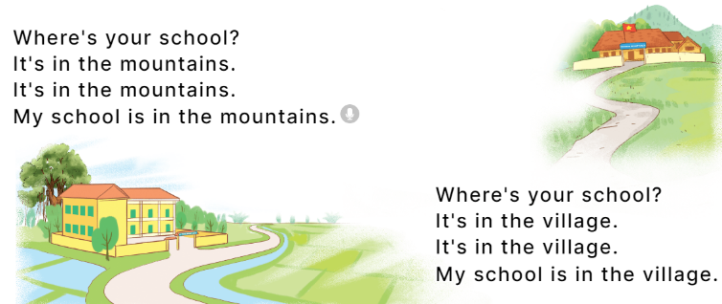  - Play the recording for Ss to listen to the whole chant.  + Have them repeat the title and lyrics line by line.  + Ask Ss to attend to the sounds of the letters s and es and the words mountains and villages.  - Play the recording all the way through for Ss to listen to pronunciation and melody.  - Play the recording line by line for Ss to listen and repeat  - Play the recording for Ss to chant and clap along.  - Ask Ss to practice chant and clap along in pairs or groups.  - Invite groups to the front of the classroom to perform the chant  -T gives feedback.  *Consolidation  *Aims: Ss will be able consolidate and wrap up the content of the lesson.  *Procedure:  - T asks ss to answer the following questions:  + What have you learnt from the lesson today?  +What are the core values of the lesson? (if the teacher can take from the lesson).  - T praises some Ss who are hardworking / active/ good…. as well as encourage others to try more.  4. Homework. (2’)  - Practice the chant more.  - Prepare a poster about their school in order to introduce their school to a new pupil.  - Prepare the new lesson: Unit 6, Lesson 3 (4,5,6). | - Ss listen  -Ss play game  -Ss play game  - Ss open their books  - Ss recognize the differences about color of letter  - - Ss listen  - Ss listen and point  - Ss listen again and repeat  -Ss listen again and repeat  -Ss practice  -Ss listen  -Ss listen and say:  + Number 1: Our school is near two ……  + Number 2: There are two ……. not far from my school.  -Ss guess the answers  - Ss listen to the tape and circle  - Ss listen again, circle and swap books with their partners.  - Ss check their answers and guessing  -Ss listen and repeat.  -Ss read the sentences  - Ss look and listen.  -Ss listen to the chant  - Ss listen and repeat line by line without clap their hands  -Ss note the sounds, words  -Ss listen to melody of the chant  - Ss listen and chant line by line.  - Ss chant and clap along.  - Ss work in groups (two groups) to chant  -Ss perform in front of the class.  -Ss listen  -Ss listen.  -Ss answer the questions  -Ss listen and clap their hands  -Ss listen and take note
D. ADJUSTMENTS (if necessary):
………………………………………………………………………………………….…..……………………………………………………………………………...
----------------------------------------------------
Grade 4: Lớp 4A: Sáng thứ Sáu, Ngày 21 tháng 11 năm 2025
ENGLISH
Unit 6: Our school facilities - Lesson 3 (4, 5, 6)
A. OBJECTIVES:
By the end of the lesson, Ss will be able to:
1. Knowledge:
- use the words city, mountains, town, village in relation to the topic "Our school facilities".
- use Where’s your school? – It’s in the …... to ask and answer questions about the location of a school;
- read and demonstrate understanding of simple communicative contexts in relation to the topic “Our school facilities”.
- write and draw about school locations and describe the surrounding.
- Vocabulary: Review
- Skills: speaking, listening, reading and writing.
2. Competences:
- Co-operation: ready to help friends in pair work/ group work.
- Self-control and independent learning: perform listening tasks.
3. Attitude/ Qualities:
- Show pride in where they’re from and great respect for other people’s locations by using appropriate gesture and intonation when asking and answering about school locations
B. TEACHING AIDS:
- Teacher: Teacher’s guide Pages 98, 99; website hoclieu.vn, posters, laptop, pictures, textbook, lesson plan, TV or projector.
- Students: Pupil’s book Page 49, notebooks, workbooks, school things.
C. PROCEDURES:
Teacher’s activities | Students’ activities
1.Warm- up: (5’)  Game: “Chant”  *Aims: to review the vocabulary and structure about greet and respond to greetings.  *Procedure:  - Ask Ss chant and do the actions in Unit 6, Lesson 3 page 48 in groups.  - Give point for the groups and encourage them.  - Say “Open your book page 49” and look at “Unit 6, Lesson 3 (4, 5, 6)”.  2.Practice: (8’)  Activity 1. Read and complete:  *Aims: Ss will be able to read a paragraph about a school and complete four gapped sentences about its location and facilities.  *Procedure:  - Elicit and introduce the context.  - Have Ss read aloud the words to fill in.  - Model the first blank with Ss to make sure that they know how to do the task.  - Give Ss enough time to complete the text.  - Check the answers as a class.  - Have Ss read the text aloud.  Key: 1. village 2. three  3. garden 4. big playground  3.Production: (19’)  Activity 2. Let’s write  *Aims: Ss will be able to read, understand and complete a gapped paragraph about their own school locations and facilities.  *Procedure:  - Explain to the class the goal of this activity.  - Have pupils to guess the missing information and complete the sentence with their own information.  - Give pupils time to write their answers.  - Get pupils to swap books and correct their answers in pairs.  - Invite a pupil to stand up and read his / her completed sentences.  Key: Pupils’ answer  Ex: My school is big. There are three buildings at my school. There is a big garden. My school has a playground. We can play football, badminton and volleyball there. I love my school!  Activity 3. Project.  *Aims: Ss will be able to draw pupils’ schools and its facilities and present their drawings to the class  *Procedure:  - Point at the sample drawing and explain that pupils are going to talk about the drawings of their schools including its location and some of its facilities.  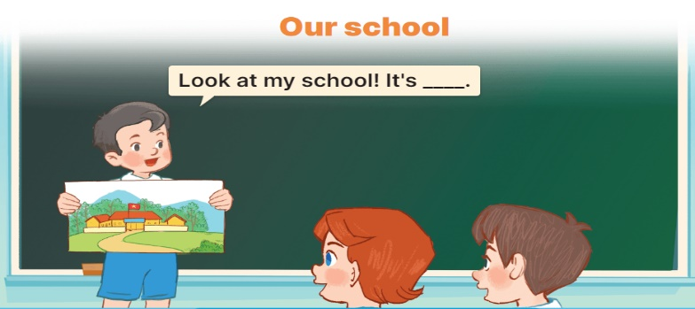  - Have pupils show their drawings that they have prepared for the project.  - Give pupils time to practise their presentations by themselves.  - Give pupils some time to use their drawings to practise presenting in groups.  - Select a few pupils to give their presentations in front of the class.  - Get other pupils to give comments, and give corrections and feedback as necessary.  *Consolidation  *Aims: Ss will be able consolidate and wrap up the content of the lesson.  *Procedure:  - T asks ss to answer the following questions:  + What have you learnt from the lesson today?  +What are the core values of the lesson? (if the teacher can take from the lesson).  - T praises some Ss who are hardworking / active/ good…. as well as encourage others to try more.  4. Homework. (3’)  - Prepare the new lesson: Unit 7, Lesson 1 (1, 2, 3). | - Ss listen and chant  - Ss open their books  - Ss listen and answer  -Ss read the words and fill  -Ss fill in the gap  -Ss complete the text  -Ss check their answer  -Ss read aloud  -Ss listen  -Ss guess the missing word  -Ss write the answers  -Ss swap books and check the answer  -SS read aloud  -Ss listen  -Ss show the picture  -Ss practice  -Ss work in groups and practice  -Ss present in front of the class  -Ss comments, and give corrections  -Ss answer the questions  -Ss listen and clap their hands  -Ss listen and take note
D. ADJUSTMENTS (if necessary):
………………………………………………………………………………………….…..……………………………………………………………………………...

---------------------------------------------------
Grade 4: Lớp 4A: Sáng thứ Sáu, Ngày 21 tháng 11 năm 2025
ENGLISH
Unit 7: Our timetables - Lesson 1 (1, 2, 3)
A. OBJECTIVES:
By the end of the lesson, Ss will be able to:
1. Knowledge:
- use the words English, maths, science, Vietnamese in relation to the topic “Our timetable”
- use What subjects do you have today? – I have ……. to ask and answer questions about school subjects
- Vocabulary: English, maths, science, Vietnamese, subject
- Skills: speaking and listening
2. Competences:
- Co-operation: ready to help friends in pair work/ group work.
- Sociability: Talk to each other, say good words to others.
3. Attitude/ Qualities:
- Show their responsibility to follow the timetable and prepare their subjects before school.
B. TEACHING AIDS:
- Teacher: Teacher’s guide Pages 100, 101, audio Tracks 67, 68, website hoclieu.vn, posters, laptop, pictures, textbook, lesson plan, TV or projector.
- Students: Pupil’s book Page 50, notebooks, workbooks, school things.
C. PROCEDURES:
Teacher’s activities | Students’ activities
1.Warm- up: (3’)  Sing: Baby shark  *Aims: to create a friendly and active atmosphere in the class to beginning the lesson.  *Procedure:  - Show the song on the screen.  https://www.youtube.com/watch?v=XqZsoesa55w  - Ask Ss to listen, sing and dance the song.  - Say “Open your book page 50” and look at “Unit 7, Lesson 1 (1,2,3)”.  2. Presentation (16’)  Activity 1. Vocabulary.  *Aims: Ss will be able to know the vocabulary in the new lesson.  *Procedure:  -T elicits the new words  + English : môn tiếng anh (realia)  + Vietnamese : môn tiếng việt (realia)  + Maths :môn toán (realia)  + Science : môn khoa học (realia)  + subject : môn học (translation)  - T models (3 times).  - T writes the words on the board.  - Checking: Rub out and remember  Activity 2. Look, listen and repeat:  *Aims: Ss will be able to understand and correctly repeat the sentences in two communicative contexts in which characters ask and answer questions about what subjects they have.  *Procedure:  - Have Ss look at Pictures a and b and identify names of the speakers in the pictures.  + Who is he / she?  + Where is he / she?  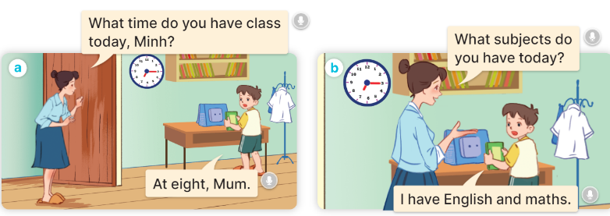  - Play the audio twice (sentence by sentence). Correct their pronunciation where necessary.  - Have Ss to practice the dialogue  - T invites a few pairs to the front of the class to practice.  - T checks pronunciation for ss.  Activity 3 2. Listen, point and say.  *Aims: Ss will be able to correctly say the words and use What subjects do you have today? – I have …….. to ask and answer questions about school subjects. *Procedure:  * Model sentences:  - T asks Ss look at picture b and helps Ss know the structure from the dialogue.  - T introduces new structure for Ss.  - T explains, models and gives meaning.  -Have Ss repeat the model sentences.  A: What subjects do you have today?  B: I have English.  3.Practice: (7’)  *Drill pictures  - Ask pupils to look at Pictures a, b, c and d and identify the names of the subjects.  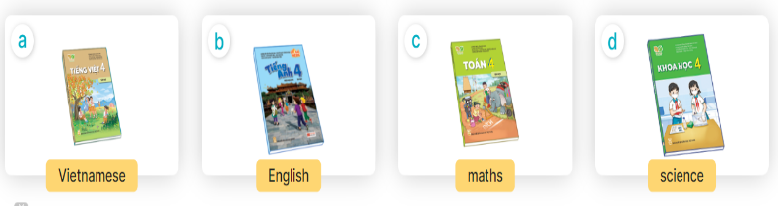  - Play the recording for pupils to listen to and repeat the words under the pictures in chorus and individually.  - Play the recording for pupils to listen to and repeat the sentences in both bubbles a few times.  - Let pupils practise asking and answering questions in pairs.  - Invite a few pairs to point at the pictures and ask and answer questions about what subject they have today.  4.Production: (7’)  Activity 4. Let’s talk.  *Aims: Ss will be able to enhance the correct use of What subjects do you have today? – I have …… to ask and answer questions about school subjects in a freer context.  *Procedure:  - Ask questions to help them identify the context  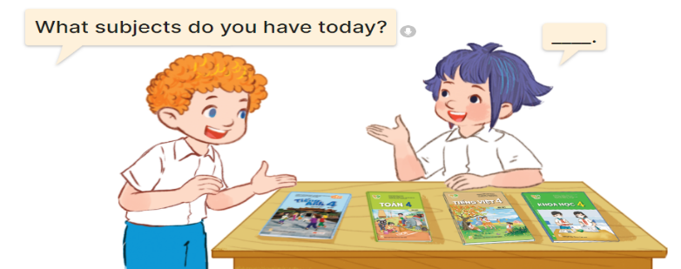  - Elicit the missing words in the speech bubble and write them on the board.  - Get pupils to say the completed sentences.  - Put pupils into pairs to practice the exchanges.  - Invite a few pairs to point at the pictures and ask and answer questions about school subjects.  *Consolidation  *Aims: Ss will be able consolidate and wrap up the content of the lesson.  *Procedure:  - T asks ss to answer the following questions:  + What have you learnt from the lesson today?  +What are the core values of the lesson? (if the teacher can take from the lesson).  - T review the vocabulary and model sentences.  - T praises some Ss who are hardworking / active/ good…. as well as encourage others to try more.  5. Homework. (2’)  - Learn the vocabulary and model sentences by heart  - Prepare the new lesson: Unit 7, Lesson 1 (4,5,6). | - Ss sing and dance the song  - Ss open their books  -Ss listen and answer  - - Ss listen and repeat  + Choral repetition (3 times).  + Individual repetition (3 ss)  - Ss take note  - Ss look, remember and write  -Look at the pictures and say  + In picture a:  Mum: What time do you have school today, Minh?  Minh: At eight, Mum.  + In picture b:  Mum: What subjects do you have today?  Minh: I have English and maths.  -Ss listen and repeat in chorus (twice)  -Ss work in pairs to practice  -Ss practice the dialogue  -Ss listen  -Ss look at the picture and answer.  -Ss listen  -Ss listen and repeat  -Ss repeat  - Ss look, listen and answer  + Picture a: A Vietnamese textbook  + Picture b: An English textbook  + Picture c: A maths textbook  + Picture d: A science textbook  -Ss listen and repeat  -Ss listen and repeat  -Ss practice  -Ss point, ask and answer.  -Ss look at the picture and answer  + a boy and a girl talking about school subjects with four textbooks (Vietnamese, English, maths, science) on a desk  -Ss listen and answer  -Ss say the completed sentences  -Ss work in pairs  -SS point, ask and answer.  -Ss answer the questions  - Ss listen  -Ss listen and clap their hands  -Ss listen and take note
D. ADJUSTMENTS (if necessary):
………………………………………………………………………………………….…..……………………………………………………………………………...
----------------------------------------------------
Grade 5: Lớp 5A: Sáng thứ Hai, Ngày 17 tháng 11 năm 2025
Lớp 5B: Sáng thứ Hai , Ngày 17 tháng 11 năm 2025
Lớp 5C: Sáng thứ Ba, Ngày 18 tháng 11 năm 2025
ENGLISH
Unit 6: Our school rooms - Lesson 2 (4, 5, 6)
A. OBJECTIVES:
By the end of the lesson, Ss will be able to:
1. Knowledge:
- listen to and understand two communicative contexts in which people ask for and give directions at school and tick the correct pictures
- complete two gapped exchanges with the help of picture cues
- revise the target vocabulary items and structures by playing Memory game.
- Vocabulary: Review
- Skills: speaking, listening, reading and writing.
2. Competences:
- Communication and collaboration: work in pairs and groups to complete the learning tasks.
3. Attitude/ Qualities:
- Show their pride in their school and raise awareness about the location of different rooms in their school.
B. TEACHING AIDS:
- Teacher: Teacher’s guide Pages 88, 89, 90; audio Tracks 62; website hoclieu.vn, posters, laptop, pictures, textbook, lesson plan, TV or projector.
- Students: Student’s book Page 47, notebooks, workbooks, school things.
C. PROCEDURES:
Teacher’s activities | Students’ activities
1.Warm- up and review: (5’)  Game: Bad luck Billy  *Aims: to revise the learned words *Procedure:  - Ask Ss to stand up and read the words on the screen.  - If the lightning struck while a student is reading, that student as to sit down.  - At the end of the game, the Ss still standing is the winner(s).  - Have Ss read all the words one more time.  - Say “Open your book page 47” and look at “Unit 6, Lesson 2 (4,5,6)”.  2.Practice: (25’)  Activity 1. Listen and tick:  *Aims: Ss will be able to listen to and understand two communicative contexts in which people ask for and give directions at school, and tick the correct pictures.  *Procedure:  - Draw Ss’ attention to the pictures of the three arrows showing the directions to the art room.  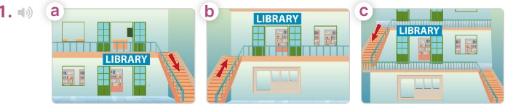  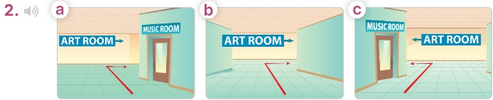  - T ask Ss to guess the answers.  + T writes Ss’guessing on the board.  - Listen to the tape:  + Play the recording  + Play the recording again for pupils to do the task.  + Play the recording a third time for pupils to check their answers.  - Get Ss to swap books with their partner, then check answers as a class.  + Write the answers on the board for Ss to correct their answers. Then checks Ss’ guessing.  - If time allows, play the recording, sentence by sentence, for Ss to listen and repeat individually and in chorus Key: 1. c 2. a  Activity 2. Read and complete  *Aims: Ss will be able to complete two gapped exchanges with the help of the picture cues  *Procedure:  - Have Ss look at the pictures and identify the directions to the rooms in the pictures.  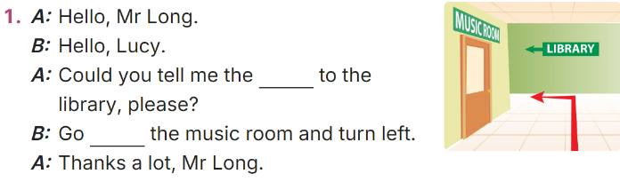  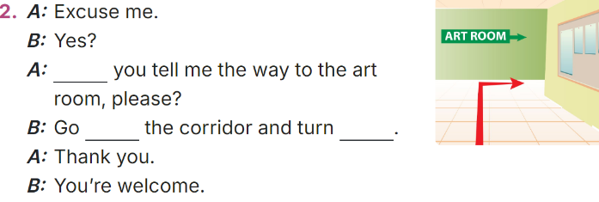  - Model sentences: have Ss read the question and ask what words are missing (way)  - Give Ss a time limit to read the gapped dialogues, look at the pictures and do the task independently.  - Get Ss to swap books with a partner and check their answers before checking as a class.  + Invite one student to write the answers on the board.  - Invite two pairs of Ss to act out the completed dialogues.  Key: 1. way, past  2 Could, along, right  Activity 3. Let’s play  *Aims: Ss will be able to revise the target vocabulary items and structures by playing Memory game.  *Procedure:  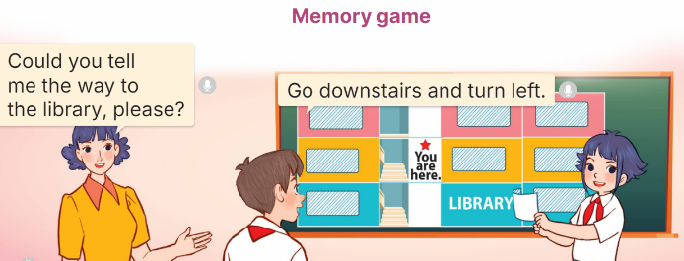  - Tell Ss that they are going to play Memory game using the language learnt in Lessons 1 and 2.  - Draw a map with school rooms on the board.  + Divide the class into two teams. Have Ss look at the school rooms on the map for 20 seconds, then cover the room names with paper / cards. (Ex: Could you tell me the way to the library, please?), then ask one student in a team to give you directions while the other pupil in the same team follows the directions and opens the right card to find the room.  + If he / she finds the right room by following the directions, the team gets one point.  + If he / she doesn't end up at the right room, he / she covers the room name up again and it becomes the other team’s turn.  - The team that has the most points at the end of the game wins.  3. Fun corner and wrap- up (5’)  Game: Guessing Game  * Review vocabulary  - Have Ss look at the pictures on the screen and say the appropriate phrases.  - Check the pronunciation when necessary.  * Review stress and syllable  - Show some words on the screen and ask pupils to decide whether they are two or three syllable words. Then sort out.  - Explain what the word stress and stress mark is, if necessary. | -Ss listen to the teacher  -Ss play the game  -Ss read the words  - Ss open their books  -Look at the pictures and say:  + Picture 1a: a library on the ground floor, an arrow showing the direction of going downstairs  + Picture 1b: a library on the first floor, an arrow showing the direction of going upstairs  + Picture 1c: a library on the first floor, an arrow showing the direction of going downstairs  + Picture 2a: an arrow showing the direction of going along the corridor, past the music room and turning right to reach the art room  + Picture 2b: an arrow showing the direction of going along the corridor and turning right to reach the art room  + Picture 2c: an arrow showing the direction of going along the corridor, past the music room and turning left to reach the art room  -Ss guess the answers  - Ss listen to the tape  - Ss listen again and do the task.  - Ss listen and check their answers  - Ss swap books with their partner, then check answers as a class and guessing  -Ss write the answer on the board  -Ss listen and repeat  -Ss look at the picture and say  -Ss follow the teacher  - Ss do the task independently.  - Ss swap books with a partner and check their answers.  - Ss write the answers on the board  - Pairs of Ss read the completed dialogues aloud  -Ss listen to the teacher  - Ss play the game.  - Ss praise the winner.  -Ss listen to the teacher  - Ss play the game.
D. ADJUSTMENTS (if necessary):
………………………………………………………………………………………….…..……………………………………………………………………………...
---------------------------------------------
Grade 5: Lớp 5A: Sáng thứ Ba, Ngày 18 tháng 11 năm 2025
Lớp 5B: Sáng thứ Hai, Ngày 17 tháng 11 năm 2025
Lớp 5C: Sáng thứ Ba, Ngày 18 tháng 11 năm 2025
ENGLISH
Unit 6: Our school rooms - Lesson 3 (1, 2, 3)
A. OBJECTIVES:
By the end of the lesson, Ss will be able to:
1. Knowledge:
- correctly stress the two-syllable words up’stairs and down’stairs in isolation and in the sentences He’s going up’stairs. and She’s running down’stairs.
- identify the word stress on some two-syllable words and circle the word with a different stress pattern from the other two words
- say the chant with the correct pronunciation, word stress and rhythm.
- Vocabulary: Review
- Skills: speaking, listening, reading and writing.
2. Competences:
- Communication and collaboration: work in pairs and groups to complete the learning tasks.
- Self-control and independent learning: perform pronunciation and listening tasks.
3. Attitude/ Qualities:
- Show their pride in their school and raise awareness about the location of different rooms in their school.
B. TEACHING AIDS:
- Teacher: Teacher’s guide Pages 97, 98, 99; audio Tracks 63, 63, 65; website hoclieu.vn, posters, laptop, pictures, textbook, lesson plan, TV or projector.
- Students: Students’ book Page 48, notebooks, workbooks, school things.
C. PROCEDURES:
Teacher’s activities | Students’ activities
1.Warm- up and review: (5’)  Chatting  *Aims: to create a friendly and active atmosphere in the class to beginning the lesson.  *Procedure:  - Teacher divides the class into 2 teams.  - Each team takes turns asking and answering about the room on the screen, using the structures learnt.  - Teacher checks the answer with the whole class.  - Pss choose a box and get the point(s).  - The team with more points is the winner.  - Say “Open your book page 48” and look at “Unit 6, Lesson 3 (1,2,3)”.  2. Presentation (9’)  Activity 1. Listen and repeat:  *Aims: Ss will be able to correctly stress the two-syllable words up'stairs and down'stairs in isolation and in the sentences He’s going up'stairs. and She’s running down'stairs.  *Procedure:  - Have Ss point at the words up'stairs and down'stairs with the stress on the second syllable, in isolation and in the sentences He’s going up'stairs. and She’s running down'stairs.  - Play the recording for Ss to listen and repeat in chorus and individually until they feel confident.  - Let Ss work in pairs or groups, saying the words and reading the sentences.  - T invites some Ss to practice.  3.Practice: (17’)  Activity 2. Circle, listen and check.  *Aims: Ss will be able to identify the word stress on some two-syllable words and circle the word with a different stress pattern from the other two words.  *Procedure:  - Tell Ss circle the word having a different stress from each line. Then listen to the recording to check their answers.  - Set a time for Ss to do the task.  - Play the recording, once or twice, for Ss to listen and check their answers.  - Get Ss to swap books with a partner and check their answers before checking as a class.  - Play the recording again for Ss to double-check their answers.  - Invite a few Ss to read aloud all the words in the words.  Key: 1. a 2. c 3. b  Activity 3. Let’s chant  *Aims: Ss will be able to say the chant with the correct pronunciation, word stress, and rhythm  *Procedure:  - Introduce the title and lyrics of the chant.  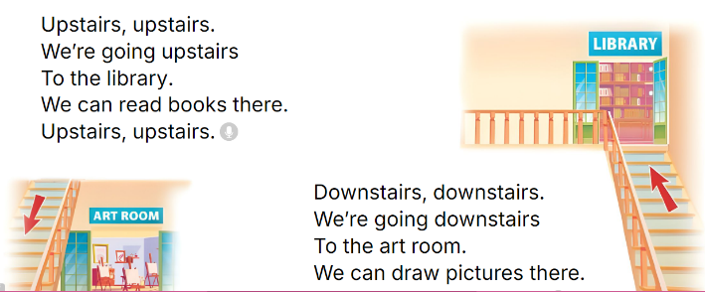  - Play the recording for Ss to listen to the whole chant.  + Have them repeat the title and lyrics line by line.  + Ask Ss to attend to two-syllable words with the stress on the second syllable in the chant, upstaisr and downstairs.  - Play the recording all the way through for Ss to listen to pronunciation and melody.  - Play the recording line by line for Ss to listen and repeat  - Play the recording for Ss to chant and clap along.  - Ask Ss to practice chant and clap along in pairs or groups.  - Invite groups to the front of the classroom to perform the chant  3. Fun corner and wrap- up (4’)  Review syllables and stress.  - T writes a word on the board then says. (two syllable words)  - Ss will clap their hands twice if the stress of that word is on the first syllable.  - Ss will clap their hands once if the stress of that word is on the second syllable.  - Invite a student to come to the front and draw the stress mark for that word.  - Word list: downstairs, second, active, happy, along, ahead, upstairs. | - Follow the T’s instructions.  -Ss play the game  - Ss open their books  - - Ss point and pay attention  - Ss listen to the recording again and repeat.  -Ss work in pairs and practice  -Ss say the words and sentences  - Ss pay and listen to the teacher’s explanation.  - Ss do the task  - Ss listen to the recording to check their answers (individual)  - Ss swap books with a partner and check the answers  - Ss listen to the recording again and check their answers again.  - Ss stand up and read aloud the words.  - Ss look and listen.  - Ss listen to the chant  - Ss listen and repeat line by line without clap their hands  - Ss note the rhythm and pronunciation.  -Ss listen to melody of the chant  - Ss listen and chant line by line.  - Ss chant and clap along.  - Ss work in groups (two groups) to chant  -Ss perform in front of the class.  -Ss listen  -Ss play the game  -Ss play the game
D. ADJUSTMENTS (if necessary):
………………………………………………………………………………………….…..……………………………………………………………………………...
-------------------------------------------------
Grade 5: Lớp 5A: Sáng thứ Ba, Ngày 20 tháng 11 năm 2025
Lớp 5B: Chiều thứ Ba, Ngày 18 tháng 11 năm 2025
Lớp 5C: Chiều thứ Tư, Ngày 19 tháng 11 năm 2025
ENGLISH
Unit 6: Our school rooms - Lesson 3 (4, 5, 6)
A. OBJECTIVES:
By the end of the lesson, Ss will be able to:
1. Knowledge:
- Read a text about rooms in a school and show understanding by deciding whether some statements are true or false;
- Read and complete the table about rooms in their school;
- Make a picture of a favourite school and present it to the class by using the target language.
- Vocabulary: Review
- Skills: speaking, listening, reading and writing.
2. Competences:
- Communication and collaboration: work in pairs and groups to complete the learning tasks.
- Self-control and independent learning: perform reading and writing tasks.
3. Attitude/ Qualities:
- Show their knowledge about their schools.
B. TEACHING AIDS:
- Teacher: Teacher’s guide Pages 99, 100; website hoclieu.vn, posters, laptop, pictures, textbook, lesson plan, TV or projector.
- Students: Pupil’s book Page 49, notebooks, workbooks, school things.
C. PROCEDURES:
Teacher’s activities | Students’ activities
1.Warm- up and review: (5’)  Game: Odd one out  *Aims: to revise the new words and structures from previous lessons.  *Procedure:  - Divide the class into two teams.  - Each team has a representative to play “Rock, paper, scissors” to play first.  - The winning team answers the question first. Ss get the points if their team answers the question.  - Say “Open your book page 49” and look at “Unit 6, Lesson 3 (4,5,6)”.  2.Practice: (8’)  Activity 1. Read and tick True or False:  *Aims: Ss will be able to read a text about rooms in a school and show understanding by deciding whether some statements are true or false.  *Procedure:  - Draw Ss’ attention to the text and read it together as a class.  - Draw ss’ attention to the four statements below the text and four boxes to tick True or False.  - Have ss pay attention to the sentences about the rooms in the school.  - Give Ss time to tick the correct boxes.  - Tell ss to swap books with a partner, then check answers together as a class.  - Ask Ss to read the text aloud in front of the class.  - Have Ss write sentences to compare the location of and direction to the rooms in the reading and the rooms in their school.  Ex: Our computer room is on the ground floor, but their computer room is on the second floor.  Key: 1. True 2. True 3. False 4. True  3.Production: (18’)  Activity 2. Let’s write  *Aims: Ss will be able to read and complete the table about rooms in their school.  *Procedure:  - Ask Ss to read the gapped letter and explain that they need to fill in the gaps with information about the boy in the pictures’ free-time activities.  - Have Ss complete the first, second and third gaps with names and an activity of their choice from the pictures.  - Give Ss time to complete the rest of the letter independently.  - Get Ss to swap their books with a partner and check each other’s spelling  before checking as a class.  Key: Pupil’s answer  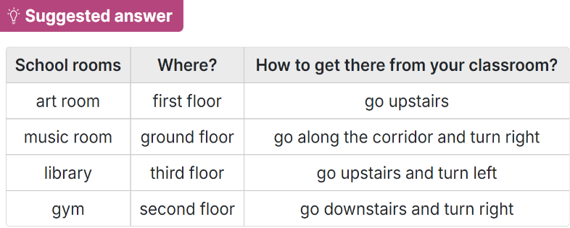  Activity 3. Project.  *Aims: Ss will be able to make a picture of a favourite school and present it to the class by using the target language.  *Procedure:  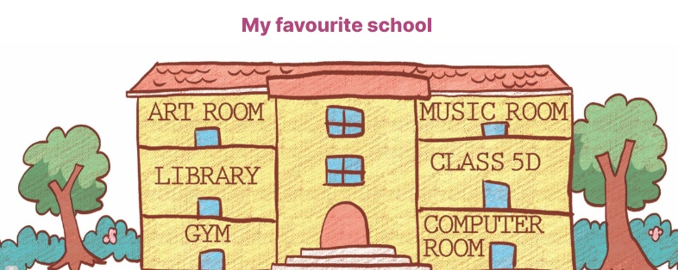  - Tell Ss about the goal of the activity.  - Have Ss work in groups. Each student shows a picture that he / she has drawn at home and tells the group about his / her favourite school,  - Invite a few ss show their work and talk about their favourite schools in front of the class, ex: This is my favourite school. It has many rooms in it.  -T gives feedback  4. Fun corner and wrap- up (4’)  * Presentation: Talk to your friend  - Ss show their pictures to their classmates, and present the school to the class at the Project time.  - Have Ss work in groups of four.  - Call some volunteers to perform in front of the class.  - Praise Ss if they perform well. | - Ss listen  -Ss play game  - Ss open their books  - Ss pay attention to the text and read  - Ss read the four statements and find the information  -Ss pay attention  -Ss do the task  - Ss swap books and check  - Ss read the text aloud in front of the class.  - Ss write the sentences  - Ss listen to the teacher  - Ss complete the first, second and third gaps with names and an activity  - Ss complete the rest of the letter independently.  - Ss swap their and check  - Ss listen to the teacher  - Ss work in groups of five.  - Ss show their work and talk  - Ss listen  -Ss listen to the teacher  -Ss play the game  -Ss congratulate the winner
D. ADJUSTMENTS (if necessary):
………………………………………………………………………………………….…..……………………………………………………………………………...
-----------------------------------------------
Grade 5: Lớp 5A: Sáng thứ Năm, Ngày 20 tháng 11 năm 2025
Lớp 5B: Chiều thứ Ba, Ngày 18 tháng 11 năm 2025
Lớp 5C: Sáng thứ Sáu, Ngày 21 tháng 11 năm 2025
ENGLISH
Unit 7: Our favourite school activities - Lesson 1 (1, 2, 3)
A. OBJECTIVES:
By the end of the lesson, Ss will be able to:
1. Knowledge:

- understand and correctly repeat the sentences in two communicative contexts focusing on asking and answering questions about someone’s favourite school activity.

- correctly say the phrases and use What school activity does he / she like? – He / She likes ____. to ask and answer questions about someone’s favourite school activity.

- use What school activity does he / she like? – He / She likes ______. in a freer context

- Vocabulary: do projects, read books, play games, solve maths problems, activity.

- Structures:
A: What school activity does he / she like?
B: He/ she likes reading books.
- Skills: speaking and listening
2. Competences:
- Communication and collaboration: work in pairs and groups to complete the learning tasks.
- Self-control and independent learning: perform speaking tasks.
3. Attitude/ Qualities:
- Show their pride in their school and show their interest in their favorite school activities.
B. TEACHING AIDS:
- Teacher: Teacher’s guide Pages 101, 102, 103, audio Tracks 66, 67; website hoclieu.vn, posters, laptop, pictures, textbook, lesson plan, TV or projector.
- Students: Students’ book Page 50, notebooks, workbooks, school things.
C. PROCEDURES:
Teacher’s activities | Students’ activities
1.Warm- up and review: (3’)  Game: Guessing game  *Aims: to revise the vocabulary about different activities.  *Procedure:  - T introduces and explains the game.  - How to play:  + T will show some pictures which is hidden about different activities.  + Ss look at the pictures in the screen.  + Ss tell what someone is doing.  - T models. (painting a mask)  - Ss play the game.  - T gives feedback.  - Say “Open your book page 50” and look at “Unit 7, Lesson 1 (1,2,3)”.  2. Presentation (15’)  Activity 1. Vocabulary.  *Aims: Ss will be able to know the vocabulary in the new lesson.  *Procedure:  -T elicits the new words  + do projects : làm các bài tập dự án  (explain)  + read books : đọc sách (picture)  + play games : chơi trò chơi (picture)  + solve maths problem : giải các bài toán  (explain)  + activity :hoạt động (translation)  - T models (3 times).  - T writes the words on the board.  - Checking: Matching  Activity 2. Look, listen and repeat:  *Aims: Ss will be able to understand and correctly repeat the sentences in two communicative contexts (pictures) on the phone, focusing on greetings, asking and answering questions about someone’s favourite school activitiy.  *Procedure:  - Have Ss look at Pictures a and b and identify the characters and what they can see in the pictures.  + Who is he/ she?  + Where is he/ she?  + What is he/ she doing?  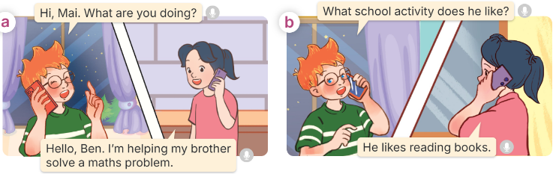  - Play the audio twice (sentence by sentence). Correct their pronunciation where necessary.  - Have Ss to practice the dialogue  - T invites a few pairs to the front of the class to practice.  - T checks pronunciation for ss.  Activity 3 Listen, point and say.  *Aims: Ss will be able to correctly say the phrases and use What school activity does he / she like? – He / She likes …. to ask and answer questions about someone’s favourite school activity.  *Procedure:  * Structures:  - T asks Ss look at picture b in activity 1 and helps Ss know the structure from the dialogue.  - T introduces new structures for Ss.  - T explains, models and gives meaning.  - Have Ss repeat the structures  A: What school activity does he / she like?  B: He/ she likes reading books.  3.Practice: (7’)  *Drill pictures  - Have Ss look at the pictures and identify the characters and their activities.   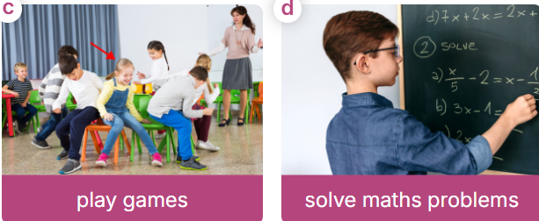  - Tell Ss that in the question, the verb like follows does, so is in the base form (like). But in the answer, like + s must be used after He or She, like + Verb with -ing  - Have Ss point at pictures, listen and run through all the pictures.  - Have Ss point at the bubbles, listen and run through model sentences.  - Have Ss to practise:  + T asks the first picture, Ss answer  + Ss asks the second picture, T answers  + Group A asks the third picture, group B  answers  + Group B asks the last picture, group A  - Ask Ss to work in pairs to practise asking and answering the What school activity does he / she like? – He / She likes ….  - T controls and corrects.  - Invite a few pairs to point at the pictures and say the questions and answers in front of the class.  4. Production: (6’)  Activity 4. Let’s talk.  *Aims: Ss will be able to enhance the correct use of What school activity does he/ she like? - He/ she likes……… to ask and answer questions about school activity in freer contexts.  *Procedure:  - Ask Ss to look at the pictures and elicit the context  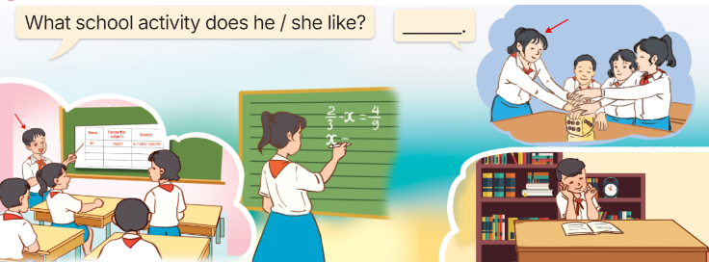  - Point at the ﬁrst building and elicit the question in the ﬁrst speech bubble What school activity does he/ she like? and the answer in the second speech He/ she likes…….. as an example.  - Give Ss time to work in pairs and take turns pointing at each picture to ask and answer using What school activity does he/ she like? - ………..  - Invite a few pairs to come to the front of the classroom and act out the exchanges.  5. Fun corner and wrap- up (4’)  Game: Pass the teddy bears  - Give two different colored teddy bears to two Ss, a black teddy bear (ask the question) and a white teddy bear (answer the question).  - Ask Ss to listen to music and pass the teddy bears.  - Stop music suddenly. Have the student with a black teddy bear make a question. Have the student with a white teddy bear answer the question.  - Repeat the game several times. | -Ss listen and pay attention  - Ss listen to the teacher  -Ss play the game  .  - Ss listen and open their books  -Ss listen and answer  - - Ss listen and repeat  + Choral repetition (3 times).  + Individual repetition (3 ss)  - Ss take note  - Ss look and match  -Look at the pictures and say.  + In picture a:  Ben: Hi, Mai. What are you doing?  Mai: Hello, Ben. I’m helping my brother solve a maths problem.  + In picture b:  Ben: What school activity does he like?  Mai: He likes reading books.  -Ss listen and repeat in chorus (twice)  -Ss work in pairs to practice  -Ss come to the front of the classroom to practice.  -Ss listen  - Ss look at the picture and answer.  -Ss listen  -Ss listen and repeat  -Ss repeat to the structures  - Ss look, listen and repeat  +Picture a: a boy doing a project  + Picture b: a girl - reading a book  + Picture c: a girl playing a game in class with her classmates  + Picture d: a boy - solving a maths problem at the board  -Ss listen to the teacher  -Ss point at pictures, listen and repeat  -Ss point at the bubbles, listen and repeat  -Ss practice in chorus  -Ss practice in chorus  -Ss work in pairs to practise asking and answering the question  - Pairs of Ss point at the pictures and say in front of the class  -Ss look at the picture and say  - Ss look at the first building and elicit the missing words in speech bubbles and say the completed sentences.  - Ss role-play to practise asking and answering questions  - Ss practise asking and answering questions in front of the class.  -Ss listen to the teacher  -Ss play the game  Ex:  A: What school activity does she like?  B: She likes doing projects.  -Ss read all the words again.
D. ADJUSTMENTS (if necessary):
………………………………………………………………………………………….…..……………………………………………………………………………...

Duyệt bài, Ngày 14 tháng 11 năm 2025
Phó hiệu trưởng

Nguyễn Thị Hằng

