ĐĂNG KÝ GIẢNG DẠY TUẦN 10 ( Từ ngày 10-14/11/2025)
Thứ  Ngày | Buổi | Lớp | Tiết | Môn | Tên bài
Ba | Sáng | 5A | 1 | English | Extension activities
Ba | Sáng | 5A | 2 | English | Unit 6: Our school rooms  Lesson 1 (1,2,3)
Ba | Sáng | 5C | 3 | English | Extension activities
Ba | Sáng | 5C | 4 | English | Unit 6: Our school rooms  Lesson 1 (1,2,3)
Ba | Chiều | 5B | 1 | English | Extension activities
Ba | Chiều | 5B | 2 | English | Unit 6: Our school rooms  Lesson 1 (1,2,3)
Tư | Sáng | 2C | 1 | English | Unit 5: In the classroom: Lesson 2: 3,4,5
Tư | Sáng | 2C | 2 | English | Unit 5: In the classroom: Lesson 3: 6,7,8
Tư | Sáng | 2B | 3 | English | Unit 5: In the classroom: Lesson 2: 3,4,5
Tư | Sáng | 2B | 4 | English | Unit 5: In the classroom: Lesson 3: 6,7,8
Tư | Chiều | 4A | 1 | English | Extension activities
Tư | Chiều | 4A | 2 | English | Unit 6: Our school facilities  Lesson 1 (1,2,3)
Tư | Chiều | 5C | 3 | English | Unit 6: Our school rooms  Lesson 1 (4,5,6)
Năm | Sáng | 5B | 1 | English | Unit 6: Our school rooms  Lesson 1 (4,5,6)
Năm | Sáng | 5B | 2 | English | Unit 6: Our school rooms  Lesson 2 (1,2,3)
Năm | Sáng | 5A | 3 | English | Unit 6: Our school rooms  Lesson 1 (4,5,6)
Năm | Sáng | 5A | 4 | English | Unit 6: Our school rooms  Lesson 2 (1,2,3)
Sáu | Sáng | 4A | 1 | English | Unit 6: Our school facilities  Lesson 1 (4,5,6)
Sáu | Sáng | 4A | 2 | English | Unit 6: Our school facilities  Lesson 2 (1,2,3)
Sáu | Sáng | 5C | 4 | English | Unit 6: Our school rooms  Lesson 2 (1,2,3)
Duyệt bài, Ngày 7 tháng 11 năm 2025
Phó hiệu trưởng

Nguyễn Thị Hằng
WEEK 10
Grade 2 : Lớp 2B, 2C: Sáng thứ tư, Ngày 12 tháng 11 năm 2025
LESSON PLAN
Unit 5. In the classroom
Lesson 2 – Period 2
I. OBJECTIVES | By the end of the lesson, pupils will be able to:
- say the letter Q/q, the words question, square, quiz, the phrases/sentences containing /k/ and square, question, quiz, the sentence structure He’s/She’s _____ (verb +
–ing). in a chant.
 | - listen and recognize the words square, quiz and the sentence structure He’s/She’s _____ (verb + –ing).
 | - write the letter Q/q and complete the words s_uare, _uiz, _uestion.
II. INPUT | Language:
- Sound /k/
- Vocabulary: question, square, quiz
- Phrases/sentences with the sound /k/, the words question, square, quiz, the sentence structure He’s/She’s _____ (verb + –ing).
Resources/Material:
- Student’s book, page 24
- hoclieu.vn
- Teacher’s guide, pp. 45-47
- Workbook, pp. 16-17
- Computer, projector
III. PROCEDURE | Warm-up – Listen and chant – Listen and tick – Look and write – Wrap-up

Procedure | Teaching and learning activities | Classroom management
Warm-up | 5 minutes
 | Option 1  - Ask pupils what letter and sound they learnt in Lesson 1 (Q/q, /k/).  - Show pictures of the words that pupils learnt in Lesson 1 (question, square, quiz) and encourage them to say the words in chorus. More advanced classes can add other words beginning with or containing the letter Q/q. | Whole class
 | Option 2  Ask the class to play Whispers again, using the words in Lesson 1, Unit 5 and those in the previous units, saying Now let us play Whispers! | Group work
 | Option 3  Get pupils to play Listen and clap. In groups, ask them to stand up and clap when they hear “k” sound. | Group work
3. Listen and chant. 10 minutes
Step 1: | Draw pupils’ attention to the picture and have them point to the square (say “Look at the picture. Point to the square.”). | Whole class
Step 2: | Say “He’s colouring a square.” and encourage pupils to repeat. | Whole class
Step 3: | Repeat Steps 1 and 2 for question and quiz. | Whole class
Step 4: | Play the recording of the chant to familiarize pupils with the words and rhythm (say “Listen.”). | Whole class
Step 5: | Have pupils point to each line of the chant (say e. g. “Point to line one.”). Play the recording of each line and encourage pupils to chant  (say “Listen and chant.”). | Individual work  Whole class
Step 6: | Play the recording in full and encourage pupils to chant (say “Listen and chant.”). Pupils can clap along or do other actions to help them keep the rhythm. | Whole class
Step 7: | Divide the class into three teams. The teams take it in turns to chant a line. The whole class can clap along or do other actions. | Group work
Extension: | For better pupils, cover or omit some letters/words in the chant and have them guess and say all the lines aloud.  For example:  Q, q, a square.  He’s colouring a _____. | Individual work
4. Listen and tick. 7 minutes
Step 1: | Have pupils point to the pictures and say the words (say “Point and say.”). When pupils answer correctly, confirm by saying “square/ circle/ question/ quiz”. | Whole class
Step 2: | Play the recording and allow pupils time to complete the activity (say “Listen and tick.”). | Individual work
Step 3: | Play the recording again, if necessary (say “Listen again.”) | Individual work
Step 4: | Check the answers by asking “a or b?” When pupils answer correctly, confirm by saying  “1a. He’s colouring a square.”/“2b. She’s doing a quiz.” and encourage them to repeat. | Whole class  Individual work
Audio script: 1. He’s colouring a square. 2. She’s doing a quiz.
Answers: 1. a 2. b
5. Look and write. 8 minutes
Step 1: | Write the letter Q (upper case) on the board and say “Q” (/kjuː/). | Whole class
Step 2: | Write the letter Q (upper case) on the board again, but this time more slowly. Invite a few pupils to come to the front of the class and write the letter Q (upper case) on the board. | Individual work
Step 3: | Repeat Steps 1 and 2 for q (lower case). | Whole class  Individual work
Step 4: | Draw pupils’ attention to the writing grids (say “Look and write.”). Allow pupils time to complete the activity. Go around the class to offer support and feedback. | Whole class
Step 5: | Draw pupils’ attention to the pictures and labels (say “Look and write.”). Allow pupils time to complete the activity. Go around the class to offer support and feedback. | Individual work
Extension: | - For weaker pupils, have them do Activity 3, Unit 5 in their workbooks.  - For better pupils, have them do Activity 4, Unit 5 in their workbooks. | Individual work
Wrap–up 5 minutes
 | Option 1  Have pupils listen to the recording, then say the chant again. | Whole class
 | Option 2  Ask pupils to look at the pictures in 4. Listen and circle and say about them, e.g. square, circle, ... Encourage better pupils to use learnt structures e.g. I can see the square.; That’s the circle.; ... | Whole class
 | Option 3  To reinforce the vocabulary, get pupils to do Activity 1, Unit 5 in their workbooks. | Individual work
----------------------------------------------
Grade 2 : Lớp 2B, 2C: Sáng thứ tư, Ngày 12 tháng 11 năm 2025
LESSON PLAN
Lesson 3 – Period 3
I. OBJECTIVES |  |  | By the end of the lesson, pupils will be able to:
- use the sentence structures What’s he/she doing? and He’s/She’s _____ (verb + –ing). to ask and answer questions about what someone is doing.
- sing a song with the structure What’s he/she doing? and He’s/She’s _____ (verb + –ing).”
II. INPUT |  |  | Language:
- What’s he/she doing? and He’s/She’s _____ (verb +
–ing).”
Resources/Material:
- Student’s book, page 25
- hoclieu.vn
- Teacher’s guide, pp. 47 - 49
- Workbook, page 18
- Computer, projector
III. PROCEDURE |  |  | Warm-up – Listen and repeat – Let’s talk – Let’s sing – Wrap-up
 | Procedure | Teaching and learning activities |  | Classroom management
 | Warm-up | 5 minutes
 |  | Option 1  - Have pupils listen to the recording, then sing the chant on Page 24.  - Select some better pupils to sing the chant in front of class. The class listens to them and claps hands along. |  | Whole class  Individual work
 |  | Option 2  - Invite one or two pupils to write the letter Q/q on the board.  - Get pupils to say words that contain the sound of the letter Q/q (from Lessons 1 & 2 and the learnt units). |  | Individual work
 |  | Option 3  - Draw or show pictures of a square, a quiz and a question mark. Say “He’s colouring a _____.” and encourage pupils to complete the sentence with “square”.  - Repeat for “She’s doing a quiz.” and  “He’s answering a question. |  | Individual work
 | 6. Listen and repeat. 5 minutes
 | Step 1: | Draw pupils’ attention to the picture (say “Look at the picture.”). Say “What’s she doing? She’s colouring a square.” |  | Whole class
 | Step 2: | Have pupils point to the sentences (say “Point to the sentences.”). |  | Individual work
 | Step 3: | Play the recording and encourage pupils to repeat (say “Listen and repeat.”). |  | Whole class
 | Step 4: | Have pupils repeat the sentences both individually and in chorus. Correct their pronunciation if necessary, and praise them when their pronunciation is good. |  | Whole class  Individual work
 | 7. Let’s talk. 10 minutes
 | Step 1: | Write What’s he doing? and What’s she doing? on the board. Underneath the questions, write He’s _____. and She’s _____. |  | Whole class
 | Step 2: | Have pupils look at Picture a (say “Look at Picture a.”). Say “What’s she doing?” and encourage them to answer using the full sentence structure. When they answer correctly, confirm by saying “She’s answering a question.” |  | Whole class
 | Step 3: | Repeat Step 2 for Pictures b and c. |  | Whole class
 | Step 4: | Have pupils work in pairs to look at each picture and practise asking and answering questions about what the people are doing.  Go around the class to offer support and feedback. |  | Pair work
 | Extension: | Invite some pupils to point to the pictures and act out the exchanges in front of the class. |  | Pair work
 | 8. Let’s sing. 10 minutes
 | Step 1: | Draw pupils’ attention to the picture (say “Look at the picture.”). Say “What’s he/ she doing?” and encourage pupils to answer using the full sentence structure. |  | Whole class
 | Step 2: | Play the recording of the song to familiarize pupils with the rhythm and melody (say “Listen.”). |  | Whole class
 | Step 3: | Read the song line by line and encourage pupils to repeat (say “Listen and repeat.”). Do this several times, with pupils repeating both individually and in chorus. Correct their pronunciation if necessary, and praise them when their pronunciation is good. |  | Whole class  Individual work
 | Step 4: | Say “Let’s sing!”. Play the recording line by line and encourage pupils to sing along. |  | Whole class
 | Step 5: | Have pupils work in groups to make up actions for the song. Invite a few groups to perform the song for the class. |  | Group work
 | Wrap–up 5 minutes
 |  | Revise the main teaching point of the lesson: the structures What’s he/she doing? and He’s/She’s _____ (verb + –ing). to ask and answer questions about what someone is doing. |  | Whole class
 |  | Option 1: Ask pupils to play Charade, using What’s he/she doing? and He’s/She’s _____ (verb + –ing). |  | Whole class
 |  | Option 2: Have pupils do Activity 6, Unit 5 in their workbooks. |  | Individual work
 |  | Option 3: Show pupils the lyrics of the song with some missing words, e.g.:  What’s he doing?  He’s doing a _____.  What’s he doing?  He’s clolouring a _____.  Then ask some advanced pupils to guess the missing words and sing the complete song aloud. |  | Individual work
---------------------------------------------------
Grade 4: Lớp 4A: Chiều thứ Tư, Ngày 12 tháng 11 năm 2025
ENGLISH
Extension activities
A. OBJECTIVES:
By the end of the lesson, Ss will be able to:
1. Knowledge:
- Kake part in fun activities to apply their language knowledge and competences.
- Vocabulary: Review
- Skills: speaking, writing and listening
2. Competences:
- Co-operation: ready to help friends in pair work/ group work.
- Sociability: Talk to each other, say good words to others.
3. Attitude/ Qualities:
- Kindness: Help partners to complete learning tasks.
- Honesty: tell the truth about feelings and emotions
B. TEACHING AIDS:
- Teacher: Teacher’s guide Pages 76, 77; website hoclieu.vn, posters, laptop, pictures, textbook, lesson plan, TV or projector.
- Students: Pupil’s book Page 42, 43, notebooks, workbooks, school things.
C. PROCEDURES:
Teacher’s activities | Students’ activities
1.Warm- up: (3’)  Sing: Head, shoulders, knees and toes  *Aims: to create a friendly and active atmosphere in the class to beginning the lesson.  *Procedure:  - Show the song on the screen.  https://www.youtube.com/watch?v=WX8HmogNyCY  - Ask Ss to listen, sing and dance the song.  - Say “Open your book page 42, 43” and look at “Extension activites”.  2. Practice (30’)  Activity 1. Look and write  *Aims: Ss will be able to identify five different countries in the pictures.  *Procedure:  - Have Ss look at the pictures and ask  + What do you see in the pictures?  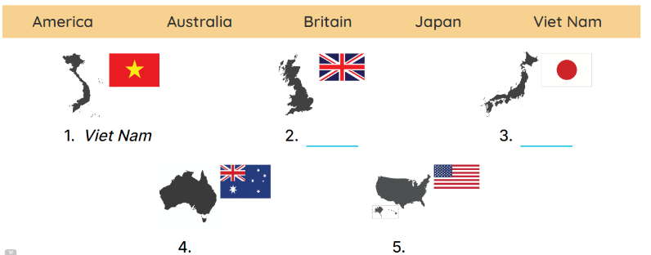  - Draw pupils’ attention to the pictures.  - Ask Where is Viet Nam? and encourage pupils to point to it. Write Viet Nam on the board.  - Point and ask about the other pictures: England, Japan, Australia and America.  - Have pupils complete the activity by writing the name next to each country.  - Check answers together as a class.  Key: 1. Viet Nam 2. England  3. Japan 4. Australia 5.America.  Activity 2. Look and write  *Aims: Ss will be able to identify the different times in different countries.  *Procedure:  - Have pupils look at the clocks. 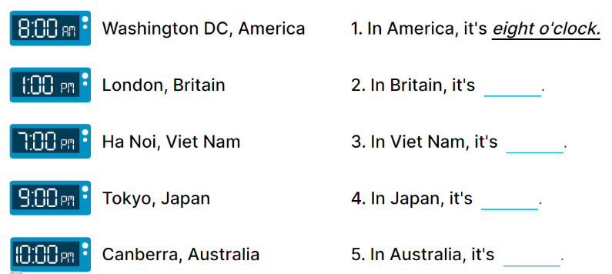  - Draw pupils’ attention to the different times in different countries.  - Write In America, it’s _____. on the board.  -Read the first part of the sentence aloud and encourage pupils to complete it. When pupils answer correctly, write the answer on the board: 8:00 AM.  - Have pupils work in pairs and complete the activity by completing the sentences.  - Check answers as a class.  Key: 1. 8:00 AM 2. 1:00 PM  3. 7:00 PM 4. 9:00 PM  5. 10:00 PM  Activity 3. Read the questions. Then tick the answers.  *Aims: Ss will be able to read the questions and tick the correct answers, then say what countries are near / far from Viet Nam.  *Procedure:  - Draw pupils’ attention to Question 1 and read it as a class.  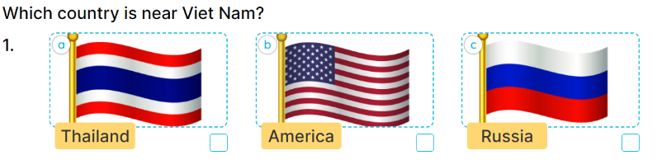        - Ask pupils to look at Answer A with three answer options a, b and c.  - Explain the new word Russia. Get them to look at the flags of Thailand, America and Russia, elicit the right answer and tick it (Picture a).  - Repeat the same procedure with Answer B and question 2.  - Get pupils to swap books with a partner, then check answers together as a class.  - Write the correct answers on the board for pupils to correct their answers.  - Have pupils say the answers by asking them Questions 1 and 2  Key: 1. A. It’s Thailand. B. It’s Malaysia  . 2. A. It’s Canada. B. It’s Australia.  *Consolidation  *Aims: Ss will be able consolidate and wrap up the content of the lesson.  *Procedure:  - T asks ss to answer the following questions:  + What have you learnt from the lesson today?  +What are the core values of the lesson? (if the teacher can take from the lesson).  - T praises some Ss who are hardworking / active/ good…. as well as encourage others to try more.  3. Homework. (2’)  - Prepare the new lesson: Unit 6, Lesson 1 (1,2,3). | - Ss listen  - Ss sing a song  -Ss open the book  -Ss look at the picture and answer  - - Ss note  -Ss answer  -SS point and answer  -Ss do the task  -Ss check their answer  -Ss look at the clocks  -Ss pay attention  -Ss listen and answer  -Ss answer  -Ss complete the sentences  -Ss check their answers  - Ss look, listen and answer  - Ss answer  -Ss listen and answer  -Ss do the task  -Ss swap books and check their answer.  -Ss write the correct answer on the board  - Ss ask and answer the questions  -Ss answer the questions  -Ss listen and clap their hands  -Ss listen and take note
D. ADJUSTMENTS (if necessary):
………………………………………………………………………………………….…..……………………………………………………………………………...
---------------------------------------------------------------------
Grade 4: Lớp 4A: Chiều thứ Tư, Ngày 12 tháng 11 năm 2025
ENGLISH
Unit 6: Our school facilities - Lesson 1 (1, 2, 3)
A. OBJECTIVES:
By the end of the lesson, Ss will be able to:
1. Knowledge:
- Use the words city, mountains, town, village in relation to the topic "Our school facilities".
- Use Where’s your school? – It’s in the …………. to ask and answer questions about the location of a school;
-Listen to and demonstrate understanding of simple communicative contexts in relation to the topic “Our school facilities”.
- Read and write about school locations
- Vocabulary: city, mountains, village, town
- Skills: speaking and listening
2. Competences:
- Co-operation: ready to help friends in pair work/ group work.
- Sociability: Talk to each other, say good words to others.
3. Attitude/ Qualities:
- Kindness: Help partners to complete learning tasks.
- Honesty: Show pride in where they’re from and great respect for other people’s locations by using appropriate gesture and intonation when asking and answering about school locations.
B. TEACHING AIDS:
- Teacher: Teacher’s guide Pages 78,79, audio Tracks 58, 59, website hoclieu.vn, posters, laptop, pictures, textbook, lesson plan, TV or projector.
- Students: Pupil’s book Page 44, notebooks, workbooks, school things.
C. PROCEDURES:
Teacher’s activities | Students’ activities
1.Warm- up: (3’)  Sing: Jigsaw puzzle  *Aims: to create a friendly and active atmosphere in the class to beginning the lesson.  *Procedure:  - Divide class into 4 groups: Tom, Jerry, Miu and Chit.  - Ask Ss look at the pieces of picture.    - Ask Ss go to the board and jigsaw puzzle into the correct picture.  -T checks who’s the winner?  - Say “Open your book page 44” and look at “Unit 6, Lesson 1 (1,2,3)”.  2. Presentation (16’)  Activity 1. Vocabulary.  *Aims: Ss will be able to know the vocabulary in the new lesson.  *Procedure:  -T elicits the new words  + city : thành phố (picture)  + mountain : vùng núi (picture)  + town :thị trấn (picture)  + village : ngôi làng (picture)  - T models (3 times).  - T writes the words on the board.  - Checking: Matching  Activity 2. Look, listen and repeat:  *Aims: Ss will be able to understand and correctly repeat the sentences in two communicative contexts focusing on asking and answering questions about the location of a school.  *Procedure:  - Have Ss look at Pictures a and b and guess the locations of the schools.  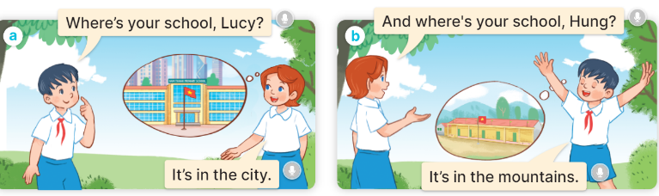  - Play the audio twice (sentence by sentence). Correct their pronunciation where necessary.  - Have Ss to practice the dialogue  - T invites a few pairs to the front of the class to practice.  - T checks pronunciation for ss.  Activity 3 Listen, point and say.  *Aims: Ss will be able to correctly say the words and use Where’s your school? – It’s in the ……….. to ask and answer questions about the location of a school.  *Procedure:  * Model sentences:  - T asks Ss look at picture a and helps Ss know the structure from the dialogue.  - T introduces new structure for Ss.  - T explains, models and gives meaning.  -Have Ss repeat the model sentences.  A: Where is your school?  B: It’s in the village.  3.Practice: (7’)  *Drill pictures  - Elicit and check comprehension the places of school  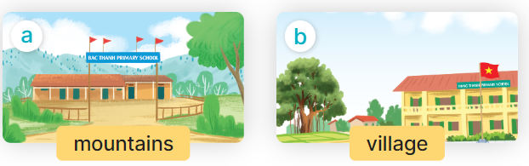  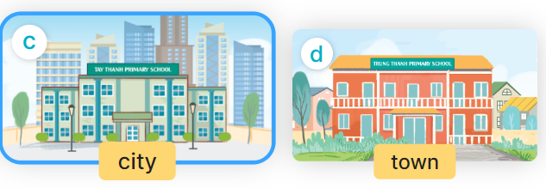  - Run through all the pictures.  - Run through model sentences.  +Run through the question sentences  +Run through the answer sentences  - Have Ss to practise:  + T asks, Ss answer picture a  + Ss ask, T answers picture b  + Group A ask, group B answer picture c  + Group B ask, group A answer picture d  - Ask Ss to work in pairs.  - T controls and corrects.  - Invite a few pairs to come to the front of the classroom and point at the pictures and say the questions and answers in front of the class.  - T gives feedbacks.  4.Production: (7’)  Activity 4. Let’s talk.  *Aims: Ss will be able to enhance the correct use of Where’s your school? – It’s in the ……. to ask and answer questions about the location of a school in a freer context  *Procedure:  - Have Ss look at the picture and elicit the question and the answer in context.  + What can you see in the picture?  + How many places are there?  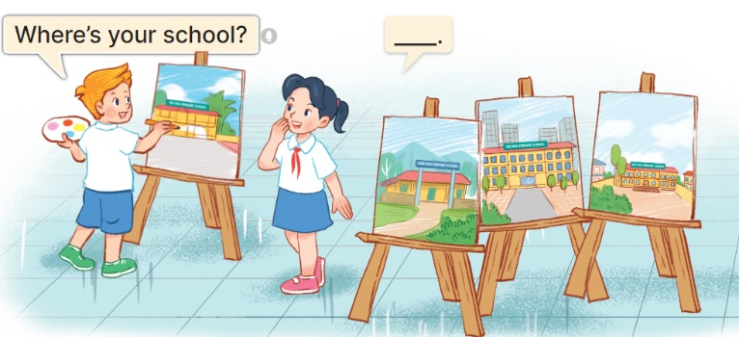  - Ask pupils to look at the second bubble and identify what the answer should be.  -Give an example answer It’s in the village. - Get pupils to repeat the question and the answer several times.  - Have pairs of pupils practise asking and answering questions about the locations of the schools in the paintings.  - Invite some pairs of Ss to the front of the class to perform their conversations.  *Consolidation  *Aims: Ss will be able consolidate and wrap up the content of the lesson.  *Procedure:  - T asks ss to answer the following questions:  + What have you learnt from the lesson today?  +What are the core values of the lesson? (if the teacher can take from the lesson).  - T review the vocabulary and model sentences.  - T praises some Ss who are hardworking / active/ good…. as well as encourage others to try more.  5. Homework. (2’)  - Learn the vocabulary and model sentences by heart  - Prepare the new lesson: Unit 6, Lesson 1 (4,5,6). | - Ss listen  -Ss look at the pieces of the picture  -Ss put into the correct picture  -Ss check  - Ss open their books  -Ss listen and answer  - - Ss listen and repeat  + Choral repetition (3 times).  + Individual repetition (3 ss)  - Ss take note  - Ss look, remember and match  Look at the pictures and say  + In picture a:  Hung: Where’s your school, Lucy?  Lucy: It’s in the city  + In picture b:  Lucy: And where’s your school, Hung?  Hung: It’s in the mountains  -Ss listen and repeat in chorus (twice)  -Ss work in pairs to practice  -Ss practice the dialogue  -Ss listen  -Ss look at the picture and answer.  -Ss listen  -Ss listen and repeat  -Ss repeat to the place  - Ss look, listen and answer  + Picture a. a school in the mountains  + Picture b. a school in the village  + Picture c. a school in the city  + Picture d. a school in the town  -Ss listen and repeat  -Ss practice in chorus  -Ss work in pairs to practice  -Ss point and say  -Ss listen.  -Ss look at the picture and answer  + I can see 4 places…  + There are 4 pictures  -Ss look and answer  -Ss pay attention and answer  -Ss repeat and answer  -Ss work in pairs to ask and answer  -Ss perform in front of the class.  -Ss answer the questions  - Ss listen  -Ss listen and clap their hands  -Ss listen and take note
D. ADJUSTMENTS (if necessary):
………………………………………………………………………………………….…..……………………………………………………………………………...
----------------------------------------------------
Grade 4: Lớp 4A: Sáng thứ Sáu, Ngày 14 tháng 11 năm 2025
ENGLISH
Unit 6: Our school facilities - Lesson 1 (4, 5, 6)
A. OBJECTIVES:
By the end of the lesson, Ss will be able to:
1. Knowledge:
- Use the words city, mountains, town, village in relation to the topic "Our school facilities";
- Use Where’s your school? – It’s in the ……. to ask and answer questions about the location of a school;
- Listen to and demonstrate understanding of simple communicative contexts in relation to the topic “Our school facilities”.
- Read and write about school locations
- Vocabulary: Review
- Skills: speaking, listening, reading and writing.
2. Competences:
- Critical Thinking: self-introduce
- Co-operation: ready to help friends in pair work/ group work.
- Self-control and independent learning: perform listening tasks.
3. Attitude/ Qualities:
- Kindness: Help partners to complete learning tasks.
- Honesty: tell the truth about feelings and emotions.
- Diligence: complete learning tasks.
B. TEACHING AIDS:
- Teacher: Teacher’s guide Pages 80,81,82; audio Tracks 60; website hoclieu.vn, posters, laptop, pictures, textbook, lesson plan, TV or projector.
- Students: Pupil’s book Page 45, notebooks, workbooks, school things.
C. PROCEDURES:
Teacher’s activities | Students’ activities
1.Warm- up: (5’)  Game: play the Doraemon Game ( ppt)  *Aims: to create a friendly and active atmosphere in the class to beginning the lesson.  *Procedure:  - Divide the class into 3 teams.  - Pupils from each team choose a letter, then answer the question  - Pupils answer correctly get some points corresponding to the number of pies.  - Say “Open your book page 45” and look at “Unit 6, Lesson 1 (4,5,6)”.  2.Practice: (27’)  Activity 1. Listen and number:  *Aims: Ss will be able to listen to and understand four communicative contexts in which pupils ask and answer questions about school locations and number the correct pictures.  *Procedure:  - Point at the pictures respectively to explain the context.  + How many pictures are there?  + What can you see in each picture?  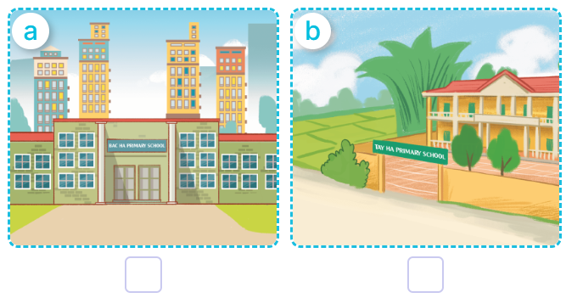  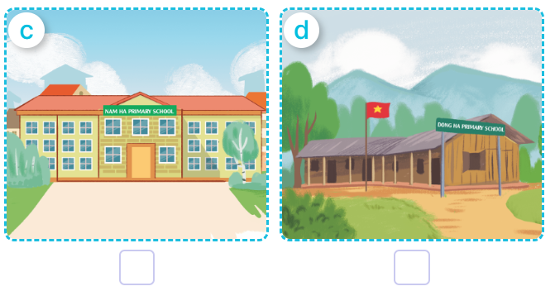  - T ask Ss to guess the answers.  + T writes Ss’guessing on the board.  - Listen to the tape:  + Play the recording  + Play the recording again and get Ss to swap books with their partners.  + Play the recording again to check answers together as a class.  + Write the answers on the board for Ss to correct their answers. Then checks Ss’ guessing.  - Play the recording, sentence by sentence, for the class to listen and repeat in chorus.  Key: 1. c 2. d 3.a 4.b  Activity 2. Look, complete and read  *Aims: Ss will be able to complete four target gapped exchanges with the help of picture cues  *Procedure:  - Ask pupils to look at the pictures and identify the school locations in the four pictures.  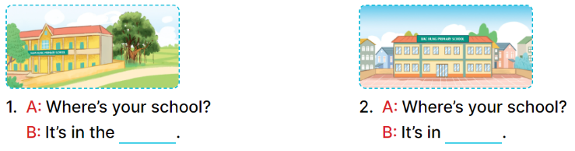  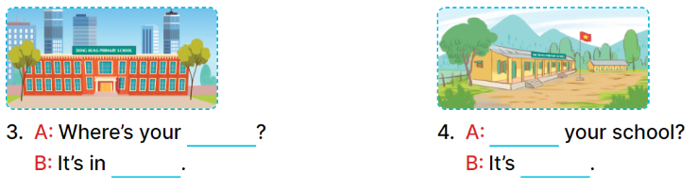  - Have Ss look at the four dialogue and the pictures. Elicit and model with picture 1  + Ask Ss to read the sentence 1 in chorus.  + Ask them what is missing in the question (village). Then have them complete the gap (Is It’s in the village).  -Have Ss work in pairs and complete the dialogue 2, 3, 4.  - Ask a few Ss to stand up and read the sentences aloud.  -T gives feedbacks.  Key:  1. village 2. the town  3. school, the city  4. Where’s, in the mountains  Activity 3. Let’s play  Matching pairs  *Aims: Ss will be able to review the words mountains, village, city and town by playing the game Matching pairs.  *Procedure:  -Tell pupils that they are going to find four pairs of pictures and words as quickly as possible.  - Stick the picture cards face down in the left column on the board. Stick the word cards face down in the right column on the board.  - Invite one pupil to play the game by selecting a picture card and a word card, turning them over.  + If two cards are a matching pair, ask the pupil to say the word aloud.  + The pupil can continue to take another turn.  + If the cards do not make a match, ask the pupil to turn them face down again, and invite another pupil to take the next turn.  - Let pupils play the game until all pairs have been matched.  - Play the game several times if there is enough time.  *Consolidation  *Aims: Ss will be able consolidate and wrap up the content of the lesson.  *Procedure:  - T asks ss to answer the following questions:  + What have you learnt from the lesson today?  +What are the core values of the lesson? (if the teacher can take from the lesson).  - T praises some Ss who are hardworking / active/ good…. as well as encourage others to try more.  3. Homework. (3’)  - Practice part 5 again.  - Prepare the new lesson: Unit 6, Lesson 2 (1,2,3). | - Ss read the words  - Ss play game  -Ss play game  - Ss open their books  -Look at the pictures and say:  + Picture a. a school in the city  + Picture b. a school in the village  + Picture c. a school in the town  + Picture d. a school in the mountains  -Ss guess the answers  - Ss listen to the tape and number  - Ss listen again, number and swap books with their partners.  - Ss check their answers and guessing  -Ss listen and repeat.  -Ss look at the picture and say  -Ss look and answer  -Ss read  -Ss say and complete  -Ss work in pairs and complete  -Ss read aloud  - Ss listen  -Ss listen  -Ss play the game  -Ss play the game  -Ss play the game  -Ss answer the questions  -Ss listen and clap their hands  -Ss listen and take note
D. ADJUSTMENTS (if necessary):
………………………………………………………………………………………….…..……………………………………………………………………………...
---------------------------------------------------
Grade 4: Lớp 4A: Sáng thứ Sáu, Ngày 14 tháng 11 năm 2025
ENGLISH
Unit 6: Our school facilities - Lesson 2 (1, 2, 3)
A. OBJECTIVES:
By the end of the lesson, Ss will be able to:
1. Knowledge:
- Use How many ….. are there at your school? – There is ….. / There are …… to ask and answer questions about the quantity of school facilities;
-Listen to and demonstrate understanding of simple communicative contexts in relation to the topic “Our school facilities”.
-Draw their school with some facilities and present it to the class.
- Vocabulary: building, garden.
- Skills: speaking and listening
2. Competences:
- Co-operation: ready to help friends in pair work/ group work.
- Sociability: Talk to each other, say good words to others.
3. Attitude/ Qualities:
- Kindness: Help partners to complete learning tasks.
- Honesty: tell the truth about feelings and emotions
B. TEACHING AIDS:
- Teacher: Teacher’s guide Pages 82, 83, 84; audio Tracks 61, 62, website hoclieu.vn, posters, laptop, pictures, textbook, lesson plan, TV or projector.
- Students: Pupil’s book Page 46, notebooks, workbooks, school things.
C. PROCEDURES:
Teacher’s activities | Students’ activities
1.Warm- up: (3’)  Game: Guessing and Choosing  *Aims: to create a friendly and active atmosphere in the class to beginning the lesson.  *Procedure:  - T shows 4 pictures of places and calls 4 Ss to come to the board and choose.  - T asks 4 Ss to come to the board and choose 1 picture of place and keep them in secret by covering them.  - The others will write their place in the board at their desks and keep their ideas in secret.  - The Ss on the board will 1 by 1 show their pictures they choose.  - When the teacher says the word of the pictures 1 by 1 shown on the board, who has the same places will raise their board or raise their hands.  - The Ss on the board will get the same points as the numbers of Ss raising their hands.  - Say “Open your book page 46” and look at “Unit 6, Lesson 2 (1,2,3)”.  2. Presentation (16’)  Activity 1. Vocabulary.  *Aims: Ss will be able to know the vocabulary in the new lesson.  *Procedure:  -T elicits the new words  + building : tòa nhà (picture)  + garden : khu vườn (picture)  - T models (3 times).  - T writes the words on the board.  - Checking: What and where  Activity 2. Look, listen and repeat:  *Aims: Ss will be able to understand and correctly repeat the sentences in two communicative contexts focusing on asking and answering questions about the quantity of school facilities.  *Procedure:  - Have Ss look at Pictures a and b and identify the characters in the pictures.  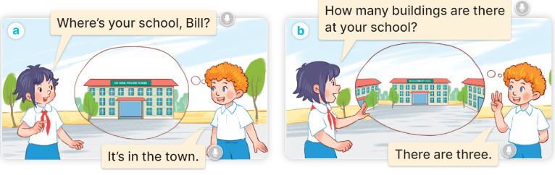  - Play the audio twice (sentence by sentence). Correct their pronunciation where necessary.  - Have Ss to practice the diaguage  - T invites a few pairs to the front of the class to practice.  - T checks pronunciation for ss.  Activity 3. Listen, point and say.  *Aims: Ss will be able to correctly say the phrases and use How many …… are there at your school? – There is …….. / There are …….. to ask and answer questions about the quantity of school facilities.  *Procedure:  * Model sentences:  - T asks Ss look at picture a and helps Ss know the structure from the dialogue.  - T introduces new structure for Ss.  - T explains, models and gives meaning.  - Have Ss repeat the model sentences.  A: How many buildings are there at your school?  B: – There is one. / There are two.  3.Practice: (7’)  *Drill pictures  - Have Ss look at the pictures and elicit the names of the places  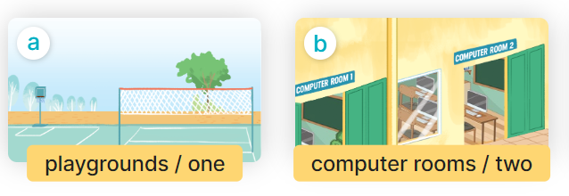  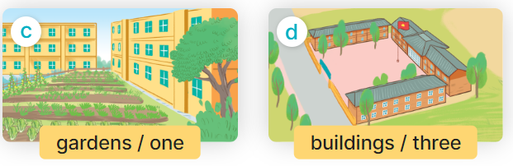  - Run through all the pictures.  - Run through model sentences.  - Have Ss to practise:  + T say – Ss respond (change role).  + Ss – Ss (change role).  - Ask Ss to work in pairs.  - T controls and corrects.  - Invite a few pairs to come to the front of the classroom, point at the pictures and say the questions and answers in front of the class.  - T gives feedbacks.  4.Production: (7’)  Activity 4. Let’s talk.  *Aims: Ss will be able to enhance the correct use of How many…… are there at your school? and There is …….. / There are ……… to ask and answer questions about the quantity of school facilities in a freer context.  *Procedure:  - Ask questions to help them identify the context.  + What can you see in the picture?  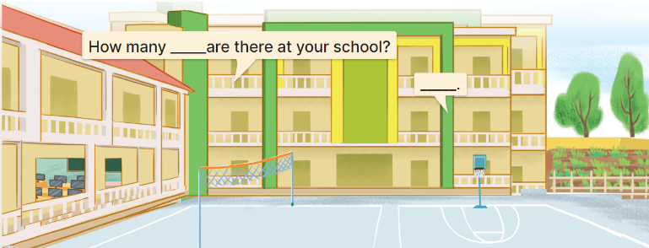  - Elicit the missing words in the speech bubbles and write them on the board. Get pupils to say the completed sentences.  - Have pairs of pupils practise asking and answering the questions about the quantity of school facilities in the picture.  - Invite some pairs to practise asking and answering questions about the quantity of school facilities in front of the class.  *Consolidation  *Aims: Ss will be able consolidate and wrap up the content of the lesson.  *Procedure:  - T asks ss to answer the following questions:  + What have you learnt from the lesson today?  - T review the vocabulary and model sentences.  - T praises some Ss who are hardworking / active/ good…. as well as encourage others to try more.  5. Homework. (2’)  - Learn the vocabulary and model sentences by heart  - Prepare the new lesson: Unit 6, Lesson 2 (4,5,6). | - Ss listen  - Ss play the game  -Ss play game  - Ss open their books  -Ss listen and answer  - - Ss listen and repeat  + Choral repetition (3 times).  + Individual repetition (3 ss)  - Ss take note  - Ss look, remember and slap  -Look at the pictures and get to know the characters in the pictures.  + In picture a:  Linh: Where’s your school, Bill?  Bill: It’s in the town.  – In picture b:  Linh: How many buildings are there at your school?  Bill: There are three.  -Ss listen and repeat in chorus (twice)  -Ss work in pairs to practice  -Ss practice the diaguage  -Ss listen  -Ss look at the picture and answer.  -Ss listen  -Ss listen and repeat  -Ss repeat to the hobbies  -Ss listen and answer  +Picture a: one playground  +Picture b: two computer rooms  +Picture c: one garden  +Picture d: three buildings  - Ss look, listen and repeat  - Ss practice in chorus  - Ss practice in chorus  -Ss work in pairs to practice  -Ss listen  -Ss go to the board and point and say  -Ss listen  -Ss look at the picture and answer  + a school with two buildings, a playground, a computer room and a garden  -Ss listen and answer  -Ss work in pairs and ask, answer  -Ss perform in font of the class.  -Ss answer the questions  - Ss listen  -Ss listen and clap their hands  -Ss listen and take note
D. ADJUSTMENTS (if necessary):
………………………………………………………………………………………….…..……………………………………………………………………………...
----------------------------------------------------
Grade 5: Lớp 5A: Sáng thứ Ba, Ngày 11 tháng 11 năm 2025
Lớp 5B: Chiều thứ Ba, Ngày 11 tháng 11 năm 2025
Lớp 5C: Sáng thứ Ba, Ngày 11 tháng 11 năm 2025
ENGLISH
Extension activities
A. OBJECTIVES:
By the end of the lesson, Ss will be able to:
1. Knowledge:
- read six descriptions of jobs and match them to the jobs and places of work.
- complete a table about jobs, workplaces and job activities.
- talk about future jobs and give reasons for wanting these jobs.
- Vocabulary: Review
- Skills: speaking, writing and listening
2. Competences:
- Co-operation: ready to help friends in pair work/ group work.
- Sociability: Talk to each other, say good words to others.
3. Attitude/ Qualities:
- Kindness: Help partners to complete learning tasks.
B. TEACHING AIDS:
- Teacher: Teacher’s guide Pages 93, 94; website hoclieu.vn, posters, laptop, pictures, textbook, lesson plan, TV or projector.
- Students: Student’s book Page 42, 43, notebooks, workbooks, school things.
C. PROCEDURES:
Teacher’s activities | Students’ activities
1.Warm- up: (3’)  Sing: Head, shoulders, knees and toes  *Aims: to create a friendly and active atmosphere in the class to beginning the lesson.  *Procedure:  - Show the song on the screen.  https://www.youtube.com/watch?v=WX8HmogNyCY  - Ask Ss to listen, sing and dance the song.  - Say “Open your book page 42, 43” and look at “Extension activites”.  2. Practice (28’)  Activity 1. Look and read. Choose and write the correct words on the lines  *Aims: Ss will be able to read six descriptions of jobs and match them to the jobs and places of work.  *Procedure:  - Have Ss look at the pictures and ask  + What do you see in the pictures?      - Draw pupils’ attention to the pictures.  - Have Ss work independently to read and choose the picture that matches each one.  - Get Ss swap the books and check  - Check answers together as a class.  Key: 1 - school 2 –doctor 3 – theatre  4 - reporter 5 – firefighter 6 - garden  Activity 2. Complete the table about jobs  *Aims: Ss will be able to complete a table about jobs, workplaces and job activities.  *Procedure:  - Tell Ss the goal of the activity.  - Have Ss point to each heading and give examples, ex: doctor, help people.  - Have Ss read and complete the reat of the table.  - Have ss check their answer in pairs, the check as a class.  Key:  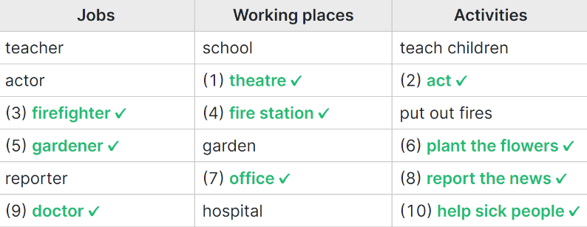  Activity 3. Work in groups. Talk about what you want to be in the future. Say why you like this job.  *Aims: Ss will be able to talk about future jobs and give reasons for wanting these jobs.  *Procedure:  - Tell Ss the goal of the activity  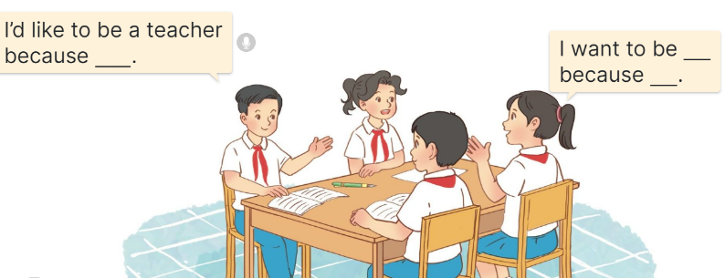  - Have Ss read the sentences in the speech bubbles aloud.  - Have ss name as many jobs as they can and write.  - Revise the questions and the answers  - Put ss work in groups and talk about the job in the future.  - Have a few groups repeat the conversations in front of the class.  Ex: I’d like to be a teacher because I want to teach children.  I’d like to be a biological professor because I like studying.  3. Fun corner and wrap- up (4’)  Game: “Kim’s game”  - Divide the class into two teams.  - Display many words and phrases on the board. Give sls two minutes to memorise these words and phrases.  - Turn the word cards face down on the board. In their teams, the ss try to write down many words as they can remember.  - Check the answers as the class.  - Count the points for each team and announce the winner. The team with the most points wins. | - Ss listen  - Ss sing a song  -Ss open the book  -Ss look at the picture and answer  - - Ss note  -Ss do the task  -Ss swap the books and check  -Ss check together  -Ss listen to the teacher  -Ss read and do the task  -Ss work in pair and check  -Ss pay attention  -Ss read aloud  -Ss work in groups and talk  -Ss repeat the conversations  - Ss listen to the teacher  -Ss play the game  Ex: sandwich, pink, pizza, Japanese, American, building, friendly, active, play the violin, go for a walk, water the flowers, firefighter, gardener.  -Ss praise the winner
D. ADJUSTMENTS (if necessary):
………………………………………………………………………………………….…..……………………………………………………………………………...
---------------------------------------------
Grade 5: Lớp 5A: Sáng thứ Ba, Ngày 11 tháng 11 năm 2025
Lớp 5B: Chiều thứ Ba, Ngày 11 tháng 11 năm 2025
Lớp 5C: Sáng thứ Ba, Ngày 11 tháng 11 năm 2025
ENGLISH
Unit 6: Our school rooms - Lesson 1 (1, 2, 3)
A. OBJECTIVES:
By the end of the lesson, Ss will be able to:
1. Knowledge:

- Understand and correctly repeat the sentences in two communicative contexts focusing on asking and answering questions about the location of rooms in a school

- Use Where’s the ___? – It’s on the ___. to ask and answer questions about the location of a room in a school

- Use Where’s the _____? – It’s on the _____. in a freer context.

- Vocabulary: first ﬂoor, ground ﬂoor, second ﬂoor, third ﬂoor.

- Structures:
A: Where’s the library?
B: It’s on the second floor.
- Skills: speaking and listening
2. Competences:
- Critical thinking and creativity: learn how to ask and answer questions about personal information correctly and fluently.
- Self-control and independent learning: perform speaking tasks.
3. Attitude/ Qualities:
- Show their love and interest in school.
B. TEACHING AIDS:
- Teacher: Teacher’s guide Pages 88, 89, 90, audio Tracks 56, 57, website hoclieu.vn, posters, laptop, pictures, textbook, lesson plan, TV or projector.
- Students: Students’ book Page 44, notebooks, workbooks, school things.
C. PROCEDURES:
Teacher’s activities | Students’ activities
1.Warm- up and review: (3’)  Game: Slap the board  *Aims: to revise the vocabulary about different rooms that pupils have learnt in English 4.  *Procedure:  - Prepare some flashcards about different jobs and stick on the board  (library, computer room, classroom, music room…)  - Divide class into 2 groups: Tom and Jerry.  - How to play:  + Each group chooses five Ss to play.  + Class will read aloud.  + Look at the picture, listen and slap the picture you heard.  + Who faster will get 1 mark.  + Which group with higher mark is the winner.  - Say “Open your book page 44” and look at “Unit 6, Lesson 1 (1,2,3)”.  2. Presentation (15’)  Activity 1. Vocabulary.  *Aims: Ss will be able to know the vocabulary in the new lesson.  *Procedure:  -T elicits the new words  + ground floor : tầng trệt (picture)  + first floor : tầng 1 (picture)  + second floor : tầng 2 (picture)  + third floor : tầng 3 (picture )  - T models (3 times).  - T writes the words on the board.  - Checking: Matching  Activity 2. Look, listen and repeat:  *Aims: Ss will be able to understand and correctly repeat the sentences in two communicative contexts focusing on asking and answering questions about the location of rooms in a school.  *Procedure:  - Have Ss look at Pictures a and b and identify the characters and say what they are talking  + Who is he/ she?  + Where is he/ she?  + What are they talking about?  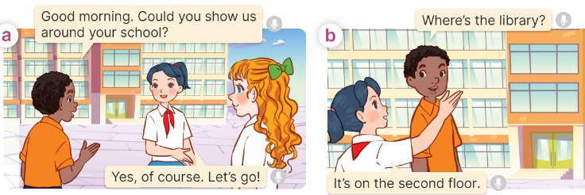  - Play the audio twice (sentence by sentence). Correct their pronunciation where necessary.  - Have Ss to practice the dialogue  - T invites a few pairs to the front of the class to practice.  - T checks pronunciation for ss.  Activity 3 Listen, point and say.  *Aims: Ss will be able to correctly say the phrases and use “Where’s the ____? – It’s on the ____. to ask and answer questions about the location of a room in a school.  *Procedure:  * Structures:  - T asks Ss look at picture b in activity 1 and helps Ss know the structure from the dialogue.  - T introduces new structures for Ss.  - T explains, models and gives meaning.  - Have Ss repeat the structures  A: Where’s the library?  B: It’s on the second floor.  3.Practice: (7’)  *Drill pictures  - Have Ss look at the pictures and say what they can see in the pictures.  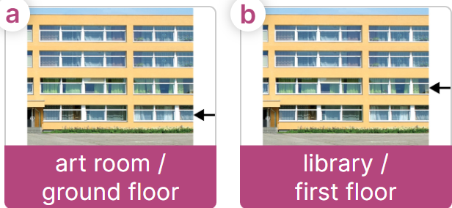  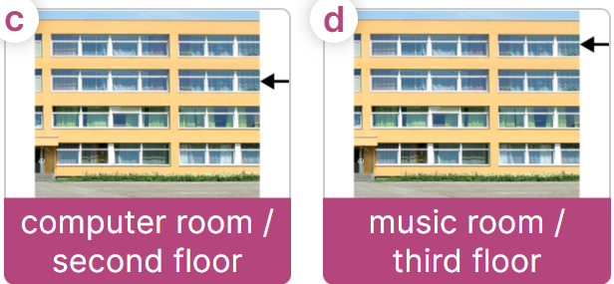  - Have Ss point at pictures, listen and run through all the pictures.  - Have Ss point at the bubbles, listen and run through model sentences.  - Have Ss to practise:  + T asks the first picture, Ss answer  + Ss asks the second picture, T answers  + Group A asks the third picture, group B  answers  + Group B asks the last picture, group A  - Ask Ss to work in pairs to practise asking and answering the Where’s the …….?  - It’s on the ……..  - T controls and corrects.  - Invite a few pairs to point at the pictures and say the questions and answers in front of the class.  4. Production: (6’)  Activity 4. Let’s talk.  *Aims: Ss will be able to use Where’s the ____? – It’s on the ____. in a free context  *Procedure:  - Ask Ss to look at the pictures and elicit the context  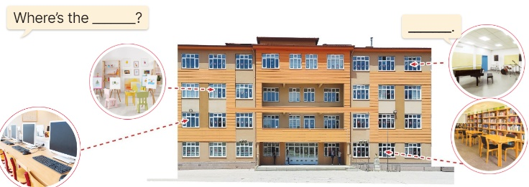  - Point at the ﬁrst building and elicit the question in the ﬁrst speech bubble Where’s the……? and the answer in the second speech bubble It’s ……. as an example.  - Give Ss time to work in pairs and take turns pointing at each picture to ask and answer using structures.  - Invite a few pairs to come to the front of the classroom and act out the exchanges.  5. Fun corner and wrap- up (4’)  Game: Spin the wheel  - Divide class into 2 teams: Boys and Girls  - Draw ss’ attention to the questions on the screen.  - In teams, they take turns spinning the wheel and answer the questions. Read the question aloud and answer it. If they have the correct ones, they get the points.  - The team with more points wins the game. | -Ss listen and pay attention  - Ss listen to the teacher  -Ss play the game  .  -Ss continute playing the game  - Ss listen and open their books  -Ss listen and answer  - - Ss listen and repeat  + Choral repetition (3 times).  + Individual repetition (3 ss)  - Ss take note  - Ss look and match  -Look at the pictures and say.  + In picture a:  Boy: Good morning. Could you show us around your school?  Mai: Yes, of course. Let’s go!  + In picture b:  Boy: Where’s the library?  Mai: It’s on the second floor.  -Ss listen and repeat in chorus (twice)  -Ss work in pairs to practice  -Ss come to the front of the classroom to practice.  -Ss listen  - Ss look at the picture and answer.  -Ss listen  -Ss listen and repeat  -Ss repeat to the structures  - Ss look, listen and repeat  +Picture a: an art room on the ground floor  + Picture b: a library on the first floor  + Picture c: a computer room on the second floor  + Picture d: a music room on the third floor  -Ss point at pictures, listen and repeat  -Ss point at the bubbles, listen and repeat  -Ss practice in chorus  -Ss practice in chorus  -Ss work in pairs to practise asking and answering the question  - Pairs of Ss point at the pictures and say in front of the class  -Ss look at the picture and say  + four rooms (computer room, art room, music room and library) located on different floors of a school building.  - Ss look at the first building and elicit the missing words in speech bubbles and say the completed sentences.  - Ss role-play to practise asking and answering questions  - Ss practise asking and answering questions in front of the class.  -Ss listen to the teacher  -Ss play the game  -Ss continute the game
D. ADJUSTMENTS (if necessary):
………………………………………………………………………………………….…..……………………………………………………………………………...
-------------------------------------------------
Grade 5: Lớp 5A: Sáng thứ Năm, Ngày 13 tháng 11 năm 2025
Lớp 5B: Sáng thứ Năm, Ngày 13 tháng 11 năm 2025
Lớp 5C: Chiều thứ Tư , Ngày 12 tháng 11 năm 2025
ENGLISH
Unit 6: Our school rooms - Lesson 1 (4, 5, 6)
A. OBJECTIVES:
By the end of the lesson, Ss will be able to:
1. Knowledge:
- Listen to and understand four communicative contexts in which the characters ask and answer questions about the location of a room in a school and tick or cross the correct pictures
- Complete four gapped exchanges with the help of picture cues
- Sing the song Where are the rooms in our school? with the correct pronunciation, rhythm and melody.
- Vocabulary: Review
- Skills: speaking, listening, reading and writing.
2. Competences:
- Communication and collaboration: work in pairs and groups to complete the learning tasks.
- Self-control and independent learning: perform listening and reading tasks.
3. Attitude/ Qualities:
- Knowing their way around the school and recognizing different spaces can help pupils feel more comfortable and secure in their learning environment.
B. TEACHING AIDS:
- Teacher: Teacher’s guide Pages 90, 91, 92; audio Tracks 58, 59; website hoclieu.vn, posters, laptop, pictures, textbook, lesson plan, TV or projector.
- Students: Student’s book Page 45, notebooks, workbooks, school things.
C. PROCEDURES:
Teacher’s activities | Students’ activities
1.Warm- up and review: (5’)  Game: Hot potato  *Aims: to create a friendly and active atmosphere in the class to beginning the lesson.  *Procedure:  - Ss pass the ball while the teacher plays the music. When the music stops, the pupil holding the ball says a word or sentence learnt in the lesson.  - Say “Open your book page 45” and look at “Unit 6, Lesson 1 (4,5,6)”.  2.Practice: (25’)  Activity 1. Listen and tick or cross:  *Aims: Ss will be able to listen to and understand four communicative contexts in which the characters ask and answer questions about the location of a room in a school and tick or cross the correct pictures.  *Procedure:  - Draw Ss’ attention to the pictures and ask questions  + How many pictures are there?  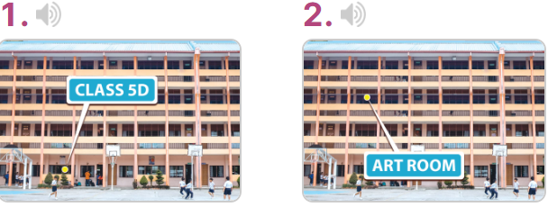  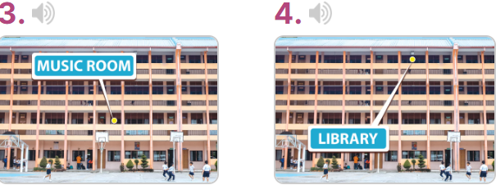  - T ask Ss to guess the answers.  + T writes Ss’guessing on the board.  - Listen to the tape:  + Play the recording  + Play the recording again for ss to do the task.  + Play the recording a third time for ss to check their answers.  - Get Ss to swap books with their partner, then check answers as a class.  + Write the answers on the board for Ss to correct their answers. Then checks Ss’ guessing.  - If time allows, play the recording, sentence by sentence, for Ss to listen and repeat individually and in chorus Key: 1. v 2. x 3. x 4. v  Activity 2. Read and complete  *Aims: Ss will be able to complete four gapped exchanges with the help of picture cues.  *Procedure:  - Have Ss read the sentences and elicit the answer to fill in the gap.  (ex: first).  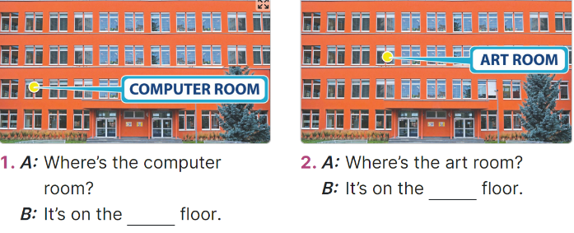  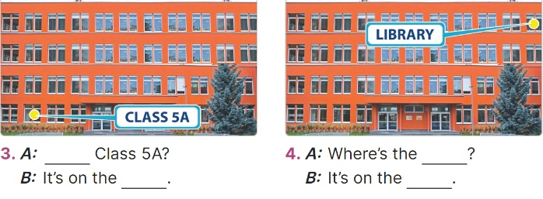  - Give Ss a time limit to read the gapped dialogues, look at the pictures and do the task independently.  - Get Ss to swap books with a partner and check their answers before checking as a class.  + Invite one student to write the answers on the board.  - Invite two pairs of Ss to act out the completed dialogues.  Key: 1. first  2. second  3. Where’s; ground floor  4. library; third floor  Activity 3. Let’s sing  *Aims: Ss will be able to sing the song Where are the rooms in our school? with the correct pronunciation, rhythm and melody.  *Procedure:  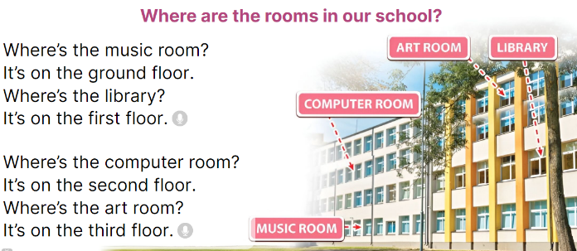  - Introduce the title and lyrics of the song: Where are the rooms in our school? song.  Play the recording for Ss to listen to the whole song.  + Have them repeat the title and lyrics line by line.  - Play the recording all the way through for Ss to listen to pronunciation and melody of the song.  - Play the recording line by line for Ss to listen, repeat  - Play the recording for Ss to sing and do actions.  - Ask Ss to practice singing and doing actions in pairs or groups.  - Invite groups to the front of the classroom to perform the song  -T gives feedback.  3. Fun corner and wrap- up (5’)  Game: Roll the dice  - Divide the class into groups of six. Have each student count the numbers from one to six.  - Ask a student from each group to roll the dice to choose a pupil asking the question.  - Have that student ask the question and invite another student of the group to answer  the question about future jobs.  - The student who gives the correct answers will continue rolling the dice. | -Ss listen to the teacher  -Ss play the game  - Ss open their books  -Look at the pictures and say:  + Picture 1: Class 5D on the ground floor  + Picture 2: Art room on the second floor  + Picture 3: Music room on the first floor  + Picture 4: Library on the third floor  -Ss guess the answers  - Ss listen to the tape  - Ss listen again and do the task.  - Ss listen and check their answers  - Ss swap books with their partner, then check answers as a class and guessing  -Ss listen and repeat  Ss look at the picture and read, fill the gap  - Ss do the task independently.  - Ss swap books with a partner and check their answers.  - Ss write the answers in the notebook  - Pairs of Ss read the completed dialogues aloud  -Ss look and listen to the teacher  -Ss listen to the song  - Ss listen and repeat line by line without the action.  -Ss listen to melody of the song  - Ss listen and sing line by line.  - Ss sing and do actions.  - Ss work in groups (two groups) to sing.  -Ss perform in front of the class.  -Ss listen  -Ss listen to the teacher  - Ss play the game.  Ex. A: Where is the library?  B: It’s on the ground floor.  - Ss continue playing the game.  - Ss praise the winner.
D. ADJUSTMENTS (if necessary):
………………………………………………………………………………………….…..……………………………………………………………………………....
-----------------------------------------------
Grade 5: Lớp 5A: Sáng thứ Năm, Ngày 13 tháng 11 năm 2025
Lớp 5B: Sáng thứ Năm, Ngày 13 tháng 11 năm 2025
Lớp 5C: Sáng thứ Sáu, Ngày 14 tháng 11 năm 2025
ENGLISH
Unit 6: Our school rooms - Lesson 2 (1, 2, 3)
A. OBJECTIVES: By the end of the lesson, Ss will be able to:
1. Knowledge:

- Understand and correctly repeat the sentences in two communicative contexts focusing on asking for and giving directions in a school.

- Use Could you tell me the way to the computer room, please? - ________. to ask for and give directions in a school;

- use Where’s ______? – It’s on the ______. and Could you show me the way to _____, please? – ____. in a freer context.

- Vocabulary: go along, go downstairs, go past, go upstairs.
- Structures:
A: Could you show me the way to the computer room, please?
B: Go upstairs. It’s on the first floor.
- Skills: speaking and listening
2. Competences:
- Critical thinking and creativity: learn how to ask and answer questions about personal information correctly and fluently.
- Self-control and independent learning: perform pronunciation and speaking tasks.
3. Attitude/ Qualities:
- Show their pride in their school and raise awareness about the location of different rooms in their school.
B. TEACHING AIDS:
- Teacher: Teacher’s guide Pages 92, 93, 94, audio Tracks 60, 61; website hoclieu.vn, posters, laptop, pictures, textbook, lesson plan, TV or projector.
- Students: Students’ book Page 46, notebooks, workbooks, school things.
C. PROCEDURES:
Teacher’s activities | Students’ activities
1.Warm- up and review: (3’)  Game: School tour  *Aims: to create a friendly and active atmosphere in the class to beginning the lesson.  *Procedure:  - Display the slide of 6 doors.  - Put Ss in 3 teams. Each team chooses a door and completes the questions and the answer by looking at the picture cues.  - Check Ss’ pronunciation and their answers. Give points as the stars appeared on the screen to the team having the correct answer.  - Continue playing until all six doors are opened.  - Say “Open your book page 46” and look at “Unit 6, Lesson 2 (1,2,3)”.  2. Presentation (15’)  Activity 1. Vocabulary.  *Aims: Ss will be able to know the vocabulary in the new lesson.  *Procedure:  -T elicits the new words  + go along: đi dọc theo (situation)  + go downstairs: đi lên lầu (picture)  + go upstair: đi xuống lầu (situation)  + go past: đi qua (picture)  - T models (3 times).  - T writes the words on the board.  - Checking: Rub out and remember  Activity 2. Look, listen and repeat:  *Aims: Ss will be able to understand and correctly repeat the sentences in two communicative contexts focusing on asking for and giving directions in a school  *Procedure:  - Have Ss look at Pictures a and b and identify the characters  + What can you see in the picture?  + What are they talking about?  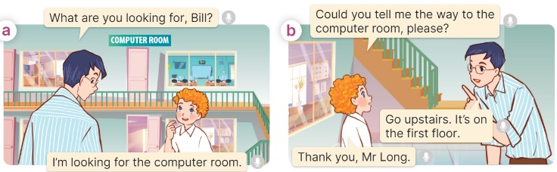  Play the audio twice (sentence by sentence). Correct their pronunciation where necessary.  - Have Ss to practice the dialogue  - T invites a few pairs to the front of the class to practice.  - T checks pronunciation for ss.  Activity 3 Listen, point and say.  *Aims: Ss will be able to correctly say the phrases and use Could you show me the way to the computer room, please? - ______. to ask for and give directions in a school.  *Procedure:  * Structures:  - T asks Ss look at picture b in activity 1 and helps Ss know the structure from the dialogue.  - T introduces new structures for Ss.  - T explains, models and gives meaning.  - Have Ss repeat the structures  A: Could you show me the way to the computer room, please?  B: Go upstairs. It’s on the first floor.  3.Practice: (7’)  *Drill pictures  - Have Ss look at the pictures and say what they can see in the pictures.  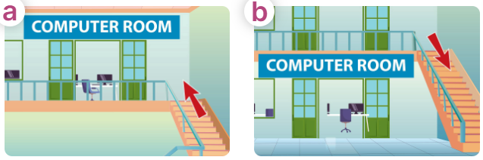  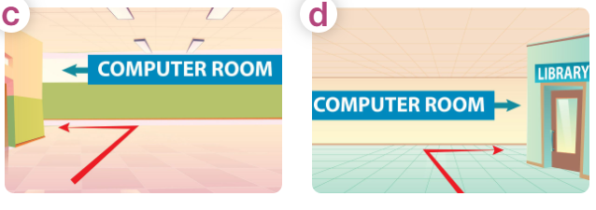  - Have Ss point at pictures, listen and run through all the pictures.  - Have Ss point at the bubbles, listen and run through model sentences.  - Have Ss to practise:  + T asks the first picture, Ss answer  + Ss asks the second picture, T answers  + Group A asks the third picture, group B  answers  + Group B asks the last picture, group A  - Ask Ss to work in pairs to practise asking and answering the question Could you show me the way to the computer room, please?  - Go upstairs. It’s on the first floor.  - T controls and corrects.  - Invite a few pairs to point at the pictures and say the questions and answers in front of the class.  4. Production: (6’)  Activity 4. Let’s talk.  *Aims: Ss will be able to use Could you show me the way to……., please? – ____.in a freer context.  *Procedure:  - Ask Ss to look at the pictures and point to the locations of each of the school rooms  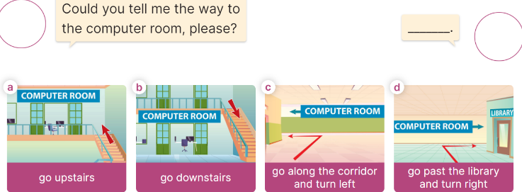  - Remind Ss that Could you show me the way to……., please? – ____. are used to ask and answer questions about the reasons why someone would like to be a certain job.  - Give Ss time to work in pairs and take turns pointing at each picture to ask and answer using Could you show me the way to……., please? – ____.  - Invite a few pairs to come to the front of the classroom and act out the exchanges.  5. Fun corner and wrap- up (4’)  Game: Pass the teddy bears  - Divide the class into 2 teams: boys and girls.  - Draw Ss’ attention to the questions on the screen.  - In teams, they take turns looking at the picture and answer the questions. Read the question aloud and answer it. If they have the correct ones, they will get the points.  - The team with more points wins the game. | -Ss listen and pay attention  -Ss play the game  - Ss listen and open their books  -Ss listen and answer  - - Ss listen and repeat  + Choral repetition (3 times).  + Individual repetition (3 ss)  - Ss take note  - Ss look, remember and write  -Look at the pictures and say.  + In picture a:  Mr Long: What are you looking for, Bill?  Bill: I’m looking for the computer room.  + In picture b:  Bill: Could you tell me the way to the computer room, please?  Mr. Long: Go upstairs. It’s on the first floor.  Bill: Thank you  -Ss listen and repeat in chorus (twice)  -Ss work in pairs to practice  -Ss come to the front of the classroom to practice.  -Ss listen  - Ss look at the picture and answer.  -Ss listen  -Ss listen and repeat  -Ss repeat to the structures  - Ss look, listen and repeat  +Picture a: a go upstairs  + Picture b: go downstairs  + Picture c: go along the corridor and turn left  + Picture d: go past the library and turn right  -Ss point at pictures, listen and repeat  -Ss point at the bubbles, listen and repeat  -Ss practice in chorus  -Ss practice in chorus  -Ss work in pairs to practise asking and answering the question  - Pairs of Ss point at the pictures and say in front of the class  -Ss look at the picture and say  - Ss listen to the teacher  - Ss role-play to practise asking and answering questions about address  - Ss practise asking and answering questions in front of the class.  -Ss listen to the teacher  -Ss play the game  Ex:  A: Could you tell me the way to the computer room, please?  B: Go upstairs and turn right.  -Ss play the game  -Ss congratulate the winner.
D. ADJUSTMENTS (if necessary):
……………………………………………………………………………………….…..……………………………………………………………………………...……
Duyệt bài, Ngày 07 tháng 11 năm 2025
Phó hiệu trưởng

Nguyễn Thị Hằng

