ĐĂNG KÝ GIẢNG DẠY TUẦN 9 ( Từ ngày 03-07/11/2025)
Thứ  Ngày | Buổi | Lớp | Tiết | Môn | Tên bài
Ba | Chiều | 5B | 1 | English | Unit 5: My future job- Lesson 3 (1,2,3)
Ba | Chiều | 5B | 2 | English | Unit 5: My future job- Lesson 3 (4,5,6)
Ba | Sáng | 5A | 1 | English | Unit 5: My future job- Lesson 3 (1,2,3)
Ba | Sáng | 5A | 2 | English | Unit 5: My future job- Lesson 3 (4,5,6)
Ba | Sáng | 5C | 3 | English | Unit 5: My future job- Lesson 3 (1,2,3)
Ba | Sáng | 5C | 4 | English | Unit 5: My future job- Lesson 3 (4,5,6)
Tư | Sáng | 2C | 1 | English | Self-check:  4. Read and tick.  5. Guess, read and circle. Then say.  6. Write the words
Tư | Sáng | 2C | 2 | English | Unit 5: In the classroom: Lesson 1: 1,2
Tư | Sáng | 2B | 3 | English | Self-check:  4. Read and tick.  5. Guess, read and circle. Then say.  6. Write the words
Tư | Sáng | 2B | 4 | English | Unit 5: In the classroom: Lesson 1: 1,2
Tư | Chiều | 4A | 1 | English | Unit 5: Things we can do  Lesson 3 (1,2,3)
Tư | Chiều | 4A | 2 | English | Unit 5: Things we can do  Lesson 3 (4,5,6)
Tư | Chiều | 5C | 3 | English | Review 1 (Activity 1-2)
Năm | Sáng | 5B | 1 | English | Review 1 (Activity 1-2)
Năm | Sáng | 5B | 2 | English | Review 1 (Activity 3 5)
Năm | Sáng | 5A | 3 | English | Review 1 (Activity 1-2)
Năm | Sáng | 5A | 4 | English | Review 1 (Activity 3 5)
Sáu | Sáng | 4A | 1 | English | Review 1 (Activity 1-2)
Sáu | Sáng | 4A | 2 | English | Review 1 (Activity 3 5)
Sáu | Sáng | 5C | 4 | English | Review 1 (Activity 3 5)
Duyệt bài, Ngày 31 tháng 10 năm 2025
Phó hiệu trưởng

Nguyễn Thị Hằng
WEEK 9
Grade 2 : Lớp 2B, 2C: Sáng thứ tư, Ngày 5 tháng 11 năm 2025
LESSON PLAN
Self check – Period 3
I. OBJECTIVES | By the end of the lesson, pupils will be able to:
– recognize the target words and sentence structures;
– write the learnt words.
II. INPUT | Language:  - Vocabulary: pasta, pizza, popcorn, kite, bike, kitten, sail, sea, sand, rainbow, road, river
- Structures:
The ____ is yummy. to express this feeling about a particular food.
- Is he/she _____ (verb + –ing)? and Yes, he/she is.
/ No, he/she isn’t. to ask and answer questions about actions in progress.
Let’s look at the _____! to suggest doing something.
What can you see? and I can see a _____. to describe features of a scene.
Resources/Material:
- Student’s book, page 22
- hoclieu.vn
- Teacher’s guide, pp. 41 - 42
- Flashcards
- Computer, projector
III. PROCEDURE | Warm-up – Read and tick – Guess, read and circle.  Then say – Write the words – Wrap-up

Procedure | Teaching and learning activities | Classroom management
Warm-up | 5 minutes
 | Option 1  - Have pupils sing one or two songs from Units 1 - 4 to revise the words and structures they have learnt. If pupils do not remember the songs, play the recording for them to sing along. | Whole class
 | Option 2  Show pupils the lyrics of a chant or a song from Units 1 - 4 with some missing words, e.g.:  What can you see?  I can see a ______.  A rainbow in the sky.  What ________?  I can see a river.  A ____ near the road.  Then ask pupils to listen to the chant/song and fill in the blanks, then sing the complete chant/song aloud. | Whole class  Individual work
 | Option 3  Have pupils play the game Missing flashcard to revise the sounds and words they learnt in previous units. | Group work
4. Read and tick. 8 minutes
Step 1: | Have pupils read and say the sentence structure in Question 1 Let’s look at the river! (say “Read and say.”) | Whole class
Step 2: | Have pupils look at the pictures underneath the sentence structure (saying “Look at the pictures in Question 1, please!") and say what they can see. When pupils answer  correctly, confirm by saying “sand/river”. | Whole class
Step 3: | Have pupils read the sentence again and tick the correct box (say “Read and tick.”) Allow pupils time to complete the activity. Give further support to those pupils who find it difficult to do the task. | Individual work
Step 4: | Check answers by saying “a. or b.?” When pupils answer correctly, confirm by saying “b. Let’s look at the river!” and encourage them to repeat. | Whole class
Step 5: | Repeat Steps 1 to 4 for the sentence structures in Question 2 Is she ﬂying a kite? and Question 3 I can see a road. | Whole class  Individual work
Extension: | Say aloud some sentences and have pupils slap the suitable pictures. | Group work
5. Guess, read and circle. Then say. 8 minutes
Step 1: | Draw pupils’ attention to Picture 1 and encourage them to guess what is in the picture (say “Look at Picture 1. Guess what it is.”) | Whole class
Step 2: | Have pupils read the two sentences underneath Picture 1 (say “Look at and read the sentences.”). | Whole class
Step 3: | Say “Circle the correct sentence.” and allow pupils time to complete the activity. | Individual work
Step 4: | Check answers by saying “a or b?” When pupils answer correctly, confirm by saying “a. The pasta is yummy.” and encourage them to repeat. | Whole class  Individual work
Step 5: | Repeat Steps 1 to 4 for Picture 2 and Picture 3. | Whole class
Extension: | Have pupils rearrange the sentences to make meaningful sentence. E.g:  a sail / I / can see (I can see a sail.)  flying/ He’s/ a kite (He’s flying a kite.) | Group work
6. Write the words. 8 minutes
Step 1: | Have pupils look at and describe the picture using the words they have learnt. | Whole class
Step 2: | Write k_ _ _ on the board and encourage pupils to complete the word. When they answer correctly, confirm by saying “kite” and encouraging them to repeat. | Whole class
Step 3: | Repeat Step 2 for sea (s_ _), pizza (p_ _ _ _), pasta (p_ _ _ _) and road (r_ _ _). | Whole class
Step 4: | Say “Write the words.” and allow pupils time to complete the activity. | Individual work
Step 5: | Check answers by inviting pupils to come to the front and complete the words kite, sea, pizza, pasta and road on the board | Individual work
Extension: | Show the pictures of some learnt words and ask pupils to write the words on their notebooks. Ask pupils to swap their answers with other classmates. Then check the answers as a class. | Whole class  Individual work
Wrap–up 5 minutes
 | Option 1: Write a letter, then pupils take turn go to the board and write the next letter, one by one, until it becomes a word. Practise writing as many words as possible. | Group work
 | Option 2: Show flashcards and have pupils say the words. Ask some pupils to make sentences with the words. | Individual work
 | Option 3: Write incomplete sentences on the board (with pictures). Invite some pupils to go to the board and write the letters to complete the sentences.  E.g. The picture of a plate of pasta and the text: The _____ is yummy. | Individual work  Group work
----------------------------------------------
Grade 2 : Lớp 2B, 2C: Sáng thứ tư, Ngày 5 tháng 11 năm 2025
LESSON PLAN
Unit 5. In the classroom
Lesson 1 – Period 1
I. OBJECTIVES |  | By the end of the lesson, pupils will be able to:
- correctly pronounce the name of the letter Q/q /kjuː/.
- correctly pronounce the sound of the letter Q/q (/k/) in isolation and in the words question, square and quiz.
II. INPUT |  | Language:
- Sound /k/
- Vocabulary: question, square, quiz
Resources/Material:
- Student’s book, page 23
- Teacher’s guide, pp. 43 - 45
- hoclieu.vn
- Flashcards for Unit 5
- Flashcards for Warm-up
- Poster for Unit 5
- Computer, projector
III. PROCEDURE | Warm-up – Listen and repeat – Point and say – Fun corner – Wrap-up

Procedure | Teaching and learning activities | Classroom management
Warm-up | 5 minutes
 | Option 1  Refresh pupils’ memory of the previous unit by showing pictures of the words they learnt. Have them say the words for the pictures. | Whole class
 | Option 2  Have pupils sing the song In the classroom  (to the tune of Oh my darling, Clementine) to revise topic-related words.  In the classroom, in the classroom  There’s a blackboard on the wal.l  There’s a table, there’s a window  In the classroom where we learn. | Whole class
 | Option 3  - Ask pupils to play Pass the Card Game.  - Place pupils in 4 rows.  - Hand out picture cards of pasta, pizza, sand and sea to the first pupil in each row.  - Have pupils in each row name the item/thing on each card as they pass the card to the classmate behind them. | Group work
1. Listen and repeat. 10 minutes
Step 1: | Draw pupils’ attention to the picture (say “Look at the picture.”). Ask questions to help them identify the context (The picture shows a classroom. The teacher is asking a question.  On the board, there is a square. One of the pupils is doing a quiz. Question, square and quiz are labelled, with the letter q in red). | Whole class
Step 2: | Have pupils point to the letter Q/q (say “Point to the letter Q.”). Explain that the name of the letter Q/q is different to its sound (say “Listen. /kjuː/ /k/.”). | Individual work
Step 3: | Play the recording of the name and sound of the letter Q/q and encourage pupils to repeat (say “Listen and repeat.”). Do this several times, with pupils repeating both individually and in chorus. Correct their pronunciation if necessary, and praise them when their pronunciation is good. | Whole class  Individual work
Step 4: | Have pupils look at the question (say “Look at the question.”). Then have them point to the word question (say “Point to the word question.”). Draw their attention to the colour of the letter q (say “Look at the colour of the letter q. It is red.”). | Whole class
Step 5: | Play the recording of question and encourage pupils to repeat (say “Listen and repeat.”).  Do this several times, with pupils repeating both individually and in chorus. Correct their pronunciation if necessary, and praise them when their pronunciation is good. | Whole class  Individual work
Step 6: | Repeat Steps 4 and 5 for square and quiz. | Whole class  Individual work
Step 7: | Play the recording in full and encourage pupils to repeat the name and sound of the letter Q/q, question, square and quiz both individually and in chorus. | Whole class  Individual work
Extension: | For better pupils, let them play Jumbled letters using the new vocabulary. Then ask them say the words aloud. | Individual work
2. Point and say. 7 minutes

Step 1: | Have pupils point to the letter Q/q and correctly pronounce its name and sound (say “Point to the letter Q. Say /kjuː/. Now say /k/.”). | Whole class
Step 2: | Have pupils point to and correctly pronounce the word question (say “Point to the question. Say question.”). Do this several times, with pupils repeating both individually and in chorus. Correct their pronunciation if necessary, and praise them when their pronunciation is good. | Whole class  Individual work
Step 3: | Repeat Step 2 for square and quiz. | Whole class  Individual work
Step 4: | Put pupils into pairs or groups for further practice of Steps 1 to 3. Go around the class to offer help or correct pupils’ pronunciation, if necessary. | Group/  Pair work
Fun corner: Whispers 8 minutes
Step 1: | Divide the class into two teams. Tell each team to form a line. |  | Group work
Step 2: | Explain that when you whisper a word to the first pupil in each line, he/she must in turn whisper it to the second pupil in the line. The second pupil then whispers it to the third, and so on. When the word reaches the last pupil in the line, he/she should call it out. A correct word scores one point. |  | Group work
Step 3: | Play the game, using the words in Lesson 1. |  | Group work
Step 4: | Count the points for each team and announce the winner. The team with more points wins. The winning team must say all three words aloud for the rest of the class. |  | Group work
Wrap-up: 5 minutes
 | Revise the main teaching point of the lesson: the sound of the letter q and the words question, square, quiz. |  | Whole class
 | Option 1  Using hoclieu.vn, have pupils look at the things in the picture and repeat the words after the recording. |  | Whole class
 | Option 2  Using Poster for Unit 5, ask pupils to point to the things in the picture and say the words.  For better pupils, teacher may cover the words and ask them to point to the things and say the words aloud. |  | Individual work
 | Option 3  Have pupils play Listen and jump. Divide the class in groups and ask them to listen to words and jump up when they hear the sound /k/. |  | Group work
---------------------------------------------------
Grade 4: Lớp 4A: Chiều thứ Tư, Ngày 5 tháng 11 năm 2025
ENGLISH
Unit 5: Things we can do - Lesson 3 (1, 2, 3)
A. OBJECTIVES:
By the end of the lesson, Ss will be able to:
1. Knowledge:
- Correctly repeat the sounds of the letters y and n in isolation, in the words yes and no, and in the sentences Can you draw? – Yes, I can. and Can she swim? – No, she can’t. with the correct pronunciation and intonation.
- Identify the target words yes and no while listening.
- Say the chant with the correct pronunciation and rhythm.
- Vocabulary: Review
- Skills: speaking, listening, reading and writing.
2. Competences:
- Co-operation: ready to help friends in pair work/ group work.
- Sociability: Talk to each other, say good words to others.
3. Attitude/ Qualities:
- Kindness: Help partners to complete learning tasks.
- Honesty: tell the truth about feelings and emotions
B. TEACHING AIDS:
- Teacher: Teacher’s guide Pages 77,78; audio Tracks 53,54,55; website hoclieu.vn, posters, laptop, pictures, textbook, lesson plan, TV or projector.
- Students: Pupil’s book Page 38, notebooks, workbooks, school things.
C. PROCEDURES:
Teacher’s activities | Students’ activities
1.Warm- up: (5’)  Game: Slap the board  *Aims: to create a friendly and active atmosphere in the class to beginning the lesson.  *Procedure:  - Divide the class into two or three teams.  - Teacher puts up a set of pictures or words on a board.  - A pupil from each team comes up to the board with fly swatters.  - They listen as the teacher calls out a word or a sentence and they race to slap the correct picture.  - Whoever is the fastest with the correct slap gets a point for their team.  - Team with the most points is the winner.  - Say “Open your book page 38” and look at “Unit 5, Lesson 3 (1,2,3)”.  2. Presentation (9’)  Activity 1. Listen and repeat:  *Aims: Ss will be able to correctly repeat the sounds of the letters y and n in isolation, in the words yes and no, and in the sentences Can you draw? – Yes, I can. and Can she swim? – No, she can’t. with the correct pronunciation and intonation.  *Procedure:  - T gives instruction to the letter y and n, yes and no, and in the sentences Can you draw? – Yes, I can. and Can she swim? – No, she can’t.  - Play the recording for the letter y,n.  - Encourage Ss to point at the letter/ word/ sentence while listening.  - Play the recording again and encourage Ss to listen and repeat.  - Do this several times until Ss feel confident.  - T calls some Ss to practice.  - T gives feedbacks.  3.Practice: (19’)  Activity 2. Listen and circle.  *Aims: Ss will be able to identify the target words yes and no while listening.  *Procedure:  - Elicit the sentences and the gap-fill options.  - T ask Ss to guess the answers.  + T writes Ss’guessing on the board.  - Listen to the tape:  + Play the recording  + Play the recording again and get Ss to swap books with their partners.  + Play the recording again to check answers together as a class.  + Write the answers on the board for Ss to correct their answers. Then checks Ss’ guessing.  - Play the recording, sentence by sentence, for the class to listen and repeat in chorus.  - Invite one or two Ss to stand up and read the completed sentences.  Key: 1.a 2.b  Activity 3. Let’s chant  *Aims: Ss will be able to say the chant with the correct rhythm and pronunciation.  *Procedure:  - Introduce the title and lyrics of the chant.  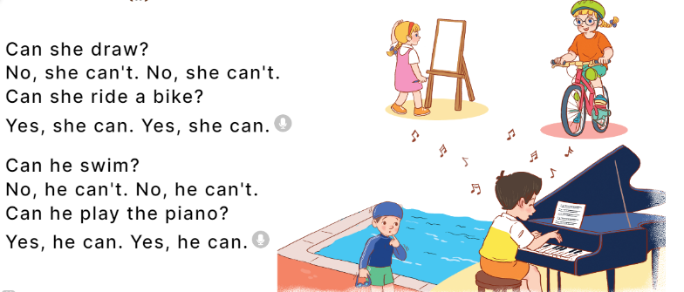  - Play the recording for Ss to listen to the whole chant.  + Have them repeat the title and lyrics line by line.  + Ask Ss to attend to the sounds of the letters y and n and the words yes and no..  - Play the recording all the way through for Ss to listen to pronunciation and melody.  - Play the recording line by line for Ss to listen and repeat  - Play the recording for Ss to chant and clap along.  - Ask Ss to practice chant and clap along in pairs or groups.  - Invite groups to the front of the classroom to perform the chant  -T gives feedback.  *Consolidation  *Aims: Ss will be able consolidate and wrap up the content of the lesson.  *Procedure:  - T asks ss to answer the following questions:  + What have you learnt from the lesson today?  +What are the core values of the lesson? (if the teacher can take from the lesson).  - T praises some Ss who are hardworking / active/ good…. as well as encourage others to try more.  4. Homework. (2’)  - Practice the chant more.  - Prepare the new lesson: Unit 5, Lesson 3 (4,5,6). | - Ss listen  -Ss play game  - Ss open their books  - Ss recognize the differences about color of letter  - - Ss listen  - Ss listen and point  - Ss listen again and repeat  -Ss listen again and repeat  -Ss practice  -Ss listen  -Ss listen and say:  + Number 1: Can he swim?  + Number 2: Can he draw?  -Ss guess the answers  - Ss listen to the tape and circle  - Ss listen again, circle and swap books with their partners.  - Ss check their answers and guessing  -Ss listen and repeat.  -Ss read the sentences  Ss look and listen.  -Ss listen to the chant  - Ss listen and repeat line by line without clap their hands  -Ss note the sounds, words  -Ss listen to melody of the chant  - Ss listen and chant line by line.  - Ss chant and clap along.  - Ss work in groups (two groups) to chant  -Ss perform in front of the class.  -Ss listen  -Ss listen.  -Ss answer the questions  -Ss listen and clap their hands  -Ss listen and take note
D. ADJUSTMENTS (if necessary):
………………………………………………………………………………………….…..……………………………………………………………………………...
---------------------------------------------------------------------
Grade 4: Lớp 4A: Chiều thứ Tư, Ngày 5 tháng 11 năm 2025
ENGLISH
Unit 5: Things we can do - Lesson 3 (4, 5, 6)
A. OBJECTIVES:
By the end of the lesson, Ss will be able to:
1. Knowledge:
- Read and show understanding of a text by deciding if the statements are true or false;
- Complete a gapped text about the abilities and lack of abilities of Lucy, Ben and the pupils themselves;
- Carry out a school club survey, collect the information and present their friends’ abilities and lack of abilities to the class by using the target language.
- Vocabulary: Review
- Skills: speaking, listening, reading and writing.
2. Competences:
- Critical Thinking: self-introduce
- Co-operation: ready to help friends in pair work/ group work.
- Self-control and independent learning: perform listening tasks.
3. Attitude/ Qualities:
- Kindness: Help partners to complete learning tasks.
- Honesty: tell the truth about feelings and emotions.
- Diligence: complete learning tasks.
B. TEACHING AIDS:
- Teacher: Teacher’s guide Pages 78,79,80; website hoclieu.vn, posters, laptop, pictures, textbook, lesson plan, TV or projector.
- Students: Pupil’s book Page 39, notebooks, workbooks, school things.
C. PROCEDURES:
Teacher’s activities | Students’ activities
1.Warm- up: (5’)  Game: Hot seat  *Aims: to review the vocabulary and structure about greet and respond to greetings.  *Procedure:  - Divide the class into 2 or 3 teams.  - Call a pupil to come up to the front and pick a flash card.  - He/ She has to use gestures to show their friends what the word or phrase is.  - A pupil from each team asks a question to find out the answer.  - The team that has the correct answer gets a point.  - Say “Open your book page 39” and look at “Unit 5, Lesson 3 (4, 5, 6)”.  2.Practice: (8’)  Activity 1. Read and tick True or False:  *Aims: Ss will be able to read and show understanding of a text by deciding if the statements are true or false.  *Procedure:  -Tell pupils the goal of the activity and explain that they should read the text and tick if the Sentences 1 to 4 are true or false.  - Do Sentence 1 as an example.  + Have pupils read Sentence 1 and find who the sentence is about (It’s about Ha.) and what Ha can do (Ha can swim.).  + Ask pupils to find the information about Ha in the text.  + Ask them to read carefully to decide if the sentence is true or false.  - Set a time limit for pupils to do the task independently.  - Invite one or two pupils to read the text in front of the class.  Key: 1.False 2.True 3.False 4.True  3.Production: (19’)  Activity 2. Let’s write  *Aims: Ss will be able to complete a gapped text about the abilities and lack of abilities of Lucy, Ben and the pupils themselves.  *Procedure:  - Explain that they should read the gapped text and fill in the gaps using the picture cues and with their own information.  - Explain that the gaps in the text focus on the things that people can or can’t do.  - Have pupils do the first gapped sentence together as an example.  + Ask them to read the sentence, look at the picture about Lucy and complete the sentence. + Have them write the answer in the gap.  - Give pupils time to complete the text independently.  - Get pupils to swap their books with a partner and check their answers before checking as a class.  - Invite one or two pupils to read their completed texts in front of the class.  Example: I have two friends, Lucy and Ben. Lucy can run, but she can’t ride a bike. Ben can swim, but he can’t sing. I can sing, but I can’t play the piano.  Activity 3. Project.  *Aims: Ss will be able to carry out a school club survey, collect the information and present their friends’ abilities and lack of abilities to the class by using the target language.  *Procedure:  - Explain the goal of this activity to Ss.  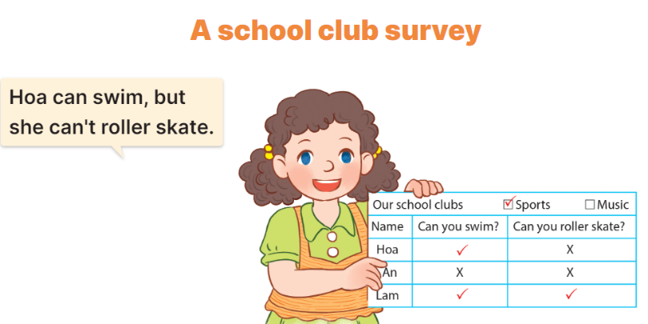  - Explain again that they need to work in groups of four or five to complete a school club survey.  + Each group should choose two clubs such as sports or music.  + Each pupil in a group needs to write questions to ask their friends to find out what they can or can’t do to find members for the club  + Ask pupils presents his / her survey results to the class.  + Ask pupils to show the completed survey that they have prepared at home.  - Have pupils work in their groups.  + Each pupil should hold up their survey results and tell their group about them, ex: Hoa can swim, but she can’t roller skate.  - Invite a few groups to present their surveys to the class.  *Consolidation  *Aims: Ss will be able consolidate and wrap up the content of the lesson.  *Procedure:  - T asks ss to answer the following questions:  + What have you learnt from the lesson today?  +What are the core values of the lesson?  - T praises some Ss who are hardworking / active/ good…. as well as encourage others to try more.  4. Homework. (3’)  - Prepare the new lesson: Review 1 | - Ss listen  -Ss play game  - Ss open their books  - Ss read and answer  -Ss read and tick  -Ss swap books and check  -Ss check the correct their answers  -Ss say  -Ss listen  -Ss listen  -Ss listen and pay attention  -Ss write the first gapped sentence.  -Ss read and complete the sentence  -Ss write the answer in the gap  -Ss complete the text  -Ss swap books and check their answers  -Ss read the completes texts.  -Ss listen  -Ss listen and pay attention.  -Ss work in groups and survey.  -Ss present their surveys  -Ss answer the questions  -Ss listen and clap their hands  -Ss listen and take note
D. ADJUSTMENTS (if necessary):
……………………………………………………………………………………….…..……………………………………………………………………………...
----------------------------------------------------
Grade 4: Lớp 4A: Sáng thứ Sáu, Ngày 7 tháng 11 năm 2025
ENGLISH
Review 1 - Parts 1, 2
A. OBJECTIVES:
By the end of the lesson, Ss will be able to:
1. Knowledge:
- correctly use the following sentence patterns:
+ Where are you from? – I’m from ……..
+ Where’s he / she from? – He’s / She’s from ………
+ What time is it? – It’s…………
+ What time do you ? – I …………at …………
+ What day is it today? – It’s …………..
+ What do you do on …………? – I………….
+ When’s your birthday? – It’s in……………
+ What do you want to eat / drink? – I want .
+ Can you ………….? – Yes, I can. / No, I can’t.
+ Can he / she ………..?– Yes, he / she can. / No, he / she can’t, but he / she can………
- Vocabulary: Review
- Skills: speaking, listening,
2. Competences:
- Critical Thinking: self-introduce
- Co-operation: ready to help friends in pair work/ group work.
- Self-control and independent learning: perform listening tasks.
3. Attitude/ Qualities:
- Kindness: Help partners to complete learning tasks.
- Honesty: tell the truth about feelings and emotions.
- Diligence: complete learning tasks.
B. TEACHING AIDS:
- Teacher: Teacher’s guide Pages 73, 74; Track 56; website hoclieu.vn, posters, laptop, pictures, textbook, lesson plan, TV or projector.
- Students: Pupil’s book Page 40, 41, notebooks, workbooks, school things.
C. PROCEDURES:
Teacher’s activities | Students’ activities
1.Warm- up: (5’)  Game: Whispering  *Aims: to review the vocabulary and structure about greet and respond to greetings.  *Procedure:  - Divide class into 2 groups.  -Ask 5 Ss in each group stand in a straight line.  - T says a word or phrase to the first pupil in this line.  - Then, the first pupil whispers what she/ he hear to the second person in line; the second one whispers what he/ she hears to the third one and so on until the last pupil in group hears the word or phrase.  - The last pupil says the word or phrase out loud.  - The faster group has correct word or phrase is the winner.  - Say “Open your book page 40, and look at Review 1.  2.Practice:  Activity 1. Listen and tick:  *Aims: Ss will be able to listen to and understand five communicative contexts and tick the correct pictures.  *Procedure:  - Elicit the names of the characters in each picture and what they say.  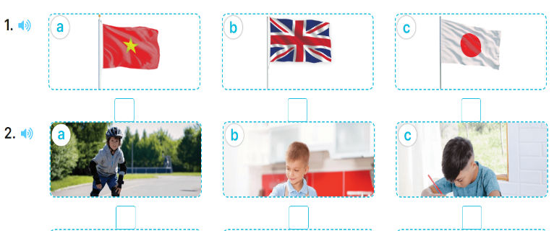  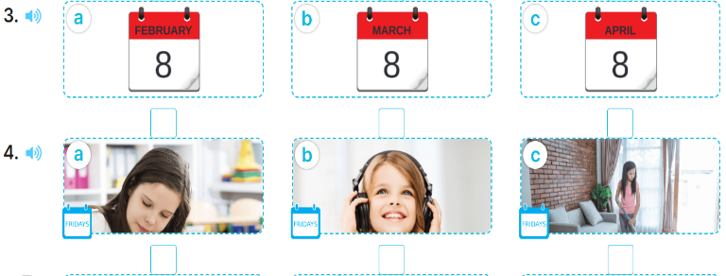  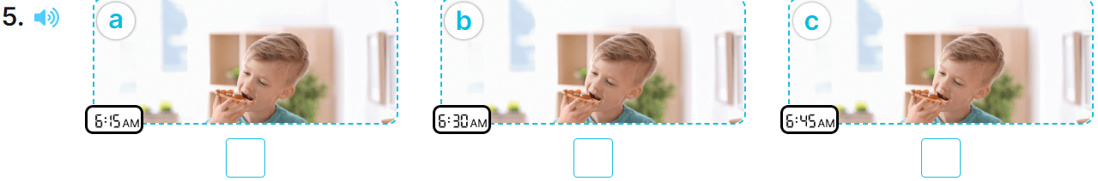  - T ask Ss to guess the answers.  + T writes Ss’guessing on the board.  - Listen to the tape:  + Play the recording  + Play the recording again and get Ss to swap books with their partners.  + Play the recording again to check answers together as a class.  + Write the answers on the board for Ss to correct their answers. Then checks Ss’ guessing.  - Play the recording, sentence by sentence, for the class to listen and repeat in chorus.  Key: 1. c 2. a 3. c 4. b 5. c  Activity 2. Ask and answer:  *Aims: Ss will be able to ask and answer questions using picture cues.  *Procedure:  - Get pupils to look at the clock to identify the time shown on it  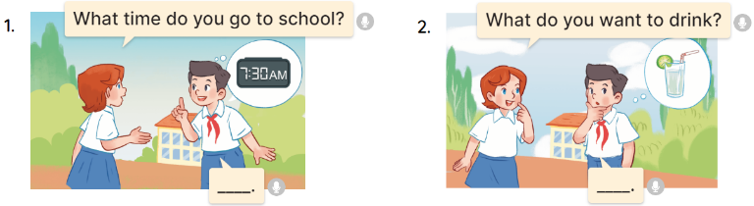  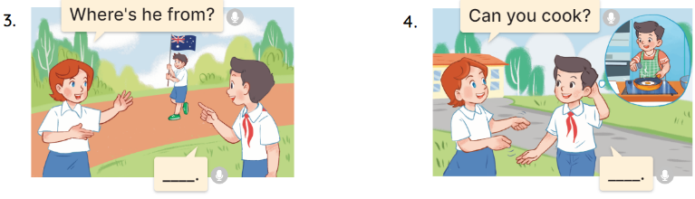  - Draw pupils’ attention to Question 1.  - Have pupils look at the clock in the picture to answer the question.  - Have pupils work in pairs to role-play the four exchanges.  - Invite pairs of pupils to stand up and take it in turns to role-play the target exchanges.  Key: 1. b 2. c 3. d 4. a  4. Homework.  - Prepare the new lesson: Extension activities. | - Ss listen  -Ss play game  - Ss open their books  -Look at the pictures and say:  + Picture 1a: the Vietnamese flag  + Picture 1b: the English flag  + Picture 1c: the Japanese flag  + Picture 2a: a boy roller skating  + Picture 2b: a boy cooking  + Picture 2c: a boy drawing  + Picture 3a: calendar showing 8 February  + Picture 3b. a calendar showing 8 March  + Picture 3c. a calendar showing 8 April  + Picture 4a. a girl studying at school on Fridays  + Picture 4b. a girl listening to music on Fridays  + Picture 4c. a girl doing housework on Fridays  + Picture 5a. a boy having breakfast at 6:15 a.m.  + Picture 5b. a boy having breakfast at 6:30 a.m.  + Picture 5c. a boy having breakfast at 6:45 a.m.  -Ss guess the answers  - Ss listen to the tape and tick  - Ss listen again, tick and swap books with their partners.  - Ss check their answers and guessing  -Ss listen and repeat.  Look at the pictures and say:  + Picture a:  Lucy: What time do you go to school?  Nam: …………….  + Picture b:  Lucy: What do you want to drink?  Nam: …………..  + Picture c:  Lucy: Where’s he from?  Nam: ………….  + Picture d:  Lucy: Can you cook?  Nam: ………..  -Ss listen to the teacher  - Ss look at the clock and answer.  - Ss work in pairs to role play  - Ss role play  -Ss listen and repeat.  -Ss listen and take note
D. ADJUSTMENTS (if necessary):
………………………………………………………………………………………….…..……………………………………………………………………………...
--------------------------------------------------------------------
Grade 4: Lớp 4A: Sáng thứ Sáu, Ngày 7 tháng 11 năm 2025
ENGLISH
Review 1 - Parts 3, 4, 5
A. OBJECTIVES:
By the end of the lesson, Ss will be able to:
1. Knowledge:
- correctly use the following sentence patterns:
+ Where are you from? – I’m from ……..
+ Where’s he / she from? – He’s / She’s from ………
+ What time is it? – It’s…………
+ What time do you ? – I …………at …………
+ What day is it today? – It’s …………..
+ What do you do on …………? – I………….
+ When’s your birthday? – It’s in……………
+ What do you want to eat / drink? – I want .
+ Can you ………….? – Yes, I can. / No, I can’t.
+ Can he / she ………..?– Yes, he / she can. / No, he / she can’t, but he / she can………
- Vocabulary: Review
- Skills: reading and writing.
2. Competences:
- Critical Thinking: self-introduce
- Co-operation: ready to help friends in pair work/ group work.
- Self-control and independent learning: perform listening tasks.
3. Attitude/ Qualities:
- Kindness: Help partners to complete learning tasks.
- Honesty: tell the truth about feelings and emotions.
- Diligence: complete learning tasks.
B. TEACHING AIDS:
- Teacher: Teacher’s guide Pages 73, 74; Track 56; website hoclieu.vn, posters, laptop, pictures, textbook, lesson plan, TV or projector.
- Students: Pupil’s book Page 41, notebooks, workbooks, school things.
C. PROCEDURES:
Teacher’s activities | Students’ activities
1.Warm- up:  Game: Whispering  *Aims: to review the vocabulary and structure about greet and respond to greetings.  *Procedure:  - Divide class into 2 groups.  -Ask 5 Ss in each group stand in a straight line.  - T says a word or phrase to the first pupil in this line.  - Then, the first pupil whispers what she/ he hear to the second person in line; the second one whispers what he/ she hears to the third one and so on until the last pupil in group hears the word or phrase.  - The last pupil says the word or phrase out loud.  - The faster group has correct word or phrase is the winner.  - Say “Open your book page 40, 41” and look at Review 1.  2.Practice:  Activity 4 Read and match  *Aims: Ss will be able to read and match pairs of target sentence patterns  *Procedure:  - Tell Ss about this activity. Point at sentence 1, elicit the answer and models.  - Give Ss work in pairs to do the sentence 2,3,4,5.  - Tell Ss to swap their books with their partners, then check answers together as a class.  - Write the correct answers on the board for Ss to correct their answers.  - Invite some pairs to stand up and read the matched exchanges aloud.  Key:  1. c 2. d 3. b 4. e 5. a  Activity 5 Read and complete  *Aims: Ss will be able to read and complete a gapped passage about Ben.  *Procedure:  - Have pupils read the passage about Ben.  - Have pupils look at the gapped passage.  - Point at the sentence with the first gap and read it as a class.  - Elicit the missing word and give feedback. Complete the sentence and get pupils to read the completed sentence in chorus.  - Get pupils to swap books with a partner, then check answers as a class. Write the correct answer on the board.  - Invite some pupils to stand up and read the completed passage aloud.  Key:  1. Australia 2. Friday  3. guitar 4. Sunday  * Mini game: Comprehension questions  - Ask Ss to read the conversation again  - Give Ss work in pairs and answer the questions:  + Where is Ben from?  He’s from Australia.  + How many days does Ben go to school?  Five days (from Monday to Friday)  + Can he play football?  Yes, he can.  + Can he play the guitar?  Yes, he can.  + Does he go to school on Saturdays?  No, he doesn’t.  3.Production:  Activity 6 Let’s write  *Aims: Ss will be able to complete a gapped text with the help of picture cues.  *Procedure:  - Ask Ss to read the question and elicit the answer  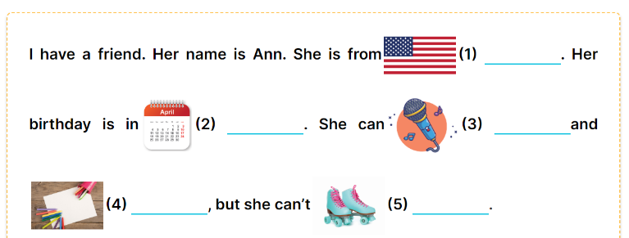  -Tell the class the goal of this activity: to read the gapped text and fill in the gaps using picture cues.  - Write the sentence with the first gap on the board. Read the sentence as a class. When you reach the gap, ask pupils to point at the picture and write (the America).  - Ask pupils complete the other sentences.  - Invite a few pupils to read the sentences they have completed aloud in front of the class.  Key: 1. America 2. April  3. sing 4. draw 5. Roller skate.  *Consolidation  *Aims: Ss will be able consolidate and wrap up the content of the lesson.  *Procedure:  - T asks ss to answer the following questions:  + What have you learnt from the lesson today?  +What are the core values of the lesson?  - T praises some Ss who are hardworking / active/ good…. as well as encourage others to try more.  4. Homework. (3’)  - Prepare the new lesson: Extension activities. | - Ss listen  -Ss play game  - Ss open their books  -Ss swap their books and match  -Ss check their answer  -Ss read aloud  -Ss read the passage  -Ss look at the passage  -Ss point at the first gap and read  -Ss complete the missing word  -Ss swap their books and check their answer.  -Ss read aloud  -Ss read the passage again  -Ss work in pairs and answer  -Ss listen and answer  -Ss pay attention  -Ss point and answer the first gap  -Ss complete the sentences  -Ss read aloud.  -Ss listen and answer  -Ss listen and clap their hands  -Ss listen and take note
D. ADJUSTMENTS (if necessary):
………………………………………………………………………………………….…..……………………………………………………………………………...
---------------------------------------------------
Grade 5: Lớp 5A: Sáng thứ Ba, Ngày 4 tháng 11 năm 2025
Lớp 5B: Chiều thứ Ba, Ngày 4 tháng 11 năm 2025
Lớp 5C: Sáng thứ Ba, Ngày 4 tháng 11 năm 2025
ENGLISH
Unit 5: My future job - Lesson 3 (1, 2, 3)
A. OBJECTIVES:
By the end of the lesson, Ss will be able to:
1. Knowledge:
- correctly pronounce the two-syllable words with the stress on the first syllable as in ꞌteacher and ꞌdentist in isolation and as in the sentences My mother’s a ꞌteacher. and My father’s a ꞌdentist.
- identify the stress on some two-syllable words and circle the word with a different stress pattern from the other two words
- say the chant with the correct pronunciation, word stress and rhythm.
- Vocabulary: Review
- Skills: speaking, listening, reading and writing.
2. Competences:
- Communication and collaboration: work in pairs and groups to complete the learning tasks.
- Self-control and independent learning: perform pronunciation and listening tasks.
3. Attitude/ Qualities:
- Show their interest in their future job.
B. TEACHING AIDS:
- Teacher: Teacher’s guide Pages 85, 86; audio Tracks 52, 53, 54; website hoclieu.vn, posters, laptop, pictures, textbook, lesson plan, TV or projector.
- Students: Students’ book Page 38, notebooks, workbooks, school things.
C. PROCEDURES:
Teacher’s activities | Students’ activities
1.Warm- up and review: (5’)  Chatting  *Aims: to revise the words about jobs.  *Procedure:  - Place different pictures of free time jobs on the board.  - Have Ss say the words related to the pictures.  - Tell Ss they are going to ask and answer the question about someone’s future jobs in a freer context.  - Invite pairs of volunteers to the board. One asks the question, another one answers the question and points to the suitable picture.  - Continue until practicing all the vocabulary set. Praise Ss if they perform well.  - Say “Open your book page 38” and look at “Unit 5, Lesson 3 (1,2,3)”.  2. Presentation (9’)  Activity 1. Listen and repeat:  *Aims: Ss will be able to correctly pronounce the two-syllable words with the stress on the first syllable as in ꞌteacher and ꞌdentist in isolation and as in the sentences My mother’s a ꞌteacher. and My father’s a ꞌdentist.  *Procedure:  - Have Ss point at the words ꞌteacher and ꞌdentist with the stress on the first syllable, in isolation and in the sentences My mother’s a ꞌteacher. and My father’s a ꞌdentist  - Play the recording for Ss to listen and repeat in chorus and individually until they feel confident.  - Let Ss work in pairs or groups, saying the words and reading the sentences.  - T invites some Ss to practice.  3.Practice: (17’)  Activity 2. Circle, listen and check.  *Aims: Ss will be able to identify the stress on some two-syllable words and circle the word with a different stress pattern from the other two words.  *Procedure:  - Tell Ss circle the word having a different stress from each line. Then listen to the recording to check their answers.  - Set a time for Ss to do the task.  - Play the recording, once or twice, for Ss to listen and check their answers.  - Get Ss to swap books with a partner and check their answers before checking as a class.  - Play the recording again for Ss to double-check their answers.  - Invite a few Ss to read aloud all the words in the words.  Key: 1. c 2. a 3. a  Activity 3. Let’s chant  *Aims: Ss will be able to say the chant with the correct pronunciation, word stress and rhythm.  *Procedure:  - Introduce the title and lyrics of the chant.  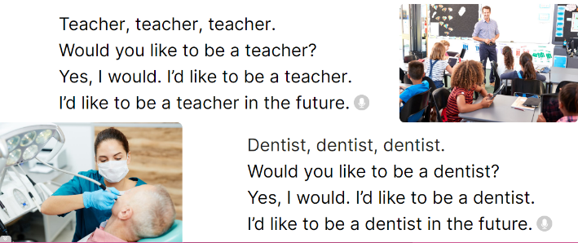  - Play the recording for Ss to listen to the whole chant.  + Have them repeat the title and lyrics line by line.  + Ask Ss to attend to two-syllable words with the stress on the first syllable in the chant, teacher future and dentist.  - Play the recording all the way through for Ss to listen to pronunciation and melody.  - Play the recording line by line for Ss to listen and repeat  - Play the recording for Ss to chant and clap along.  - Ask Ss to practice chant and clap along in pairs or groups.  - Invite groups to the front of the classroom to perform the chant  3. Fun corner and wrap- up (4’)  Game: Chanting game  - Tell Ss to close their book, listen to the chant  - Ask Ss to listen again and clap their hands on the word stress.  - Ask Ss to chant like a robot. | - Follow the T’s instructions.  -Ss pay attention and say  Ex:  A: What would you like to be in the future?  B: I’d like to be a…………..  - Ss open their books  - - Ss point and pay attention  - Ss listen to the recording again and repeat.  -Ss work in pairs and practice  -Ss say the words and sentences  - Ss pay and listen to the teacher’s explanation.  - Ss do the task  - Ss listen to the recording to check their answers (individual)  - Ss swap books with a partner and check the answers  - Ss listen to the recording again and check their answers again.  - Ss stand up and read aloud the words.  - Ss look and listen.  - Ss listen to the chant  - Ss listen and repeat line by line without clap their hands  - Ss note the rhythm and pronunciation.  -Ss listen to melody of the chant  - Ss listen and chant line by line.  - Ss chant and clap along.  - Ss work in groups (two groups) to chant  -Ss perform in front of the class.  -Ss listen  -Ss listen and clap the hands  -Ss chant
D. ADJUSTMENTS (if necessary):
………………………………………………………………………………………….…..……………………………………………………………………………...
---------------------------------------------
Grade 5: Lớp 5A: Sáng thứ Ba, Ngày 4 tháng 11 năm 2025
Lớp 5B: Chiều thứ Ba, Ngày 4 tháng 11 năm 2025
Lớp 5C: Sáng thứ Ba, Ngày 4 tháng 11 năm 2025
ENGLISH
Unit 5: My future job - Lesson 3 (4, 5, 6)
A. OBJECTIVES:
By the end of the lesson, Ss will be able to:
1. Knowledge:
- read an email and complete three gapped sentences about future jobs
- complete a gapped letter about people’s future jobs
- conduct a report about the future jobs that the class members would like to do in the future and use it to practise talking in the class during Project time.
- Vocabulary: Review
- Skills: speaking, listening, reading and writing.
2. Competences:
- Communication and collaboration: work in pairs and groups to complete the learning tasks.
- Self-control and independent learning: perform reading and writing tasks.
3. Attitude/ Qualities:
- Show their interests in their future jobs.
B. TEACHING AIDS:
- Teacher: Teacher’s guide Pages 87, 88; website hoclieu.vn, posters, laptop, pictures, textbook, lesson plan, TV or projector.
- Students: Pupil’s book Page 39, notebooks, workbooks, school things.
C. PROCEDURES:
Teacher’s activities | Students’ activities
1.Warm- up and review: (5’)  Game: Pictionary  *Aims: to revise the new words and structures from previous lessons.  *Procedure:  - Call a member from each team and give them a clue.  - Give a chalkboard or marker for that member to draw a clue so the entire class can see the clue.  - If the team member guessed the word, they would get one point. If the other team member guessed the word, they would get the point.  - Ss clap their hands on the stress of the word that they guess to get extra points for their team.  - Say “Open your book page 39” and look at “Unit 5, Lesson 3 (4,5,6)”.  2.Practice: (8’)  Activity 1. Read and circle:  *Aims: Ss will be able to read and show understanding of a text by answering four questions about Laura’s free-time activities at the weekend  *Procedure:  - Set a time limit and ask Ss to read through the email to get a general idea of it.  - Tell Ss to read the email again to choose the correct answer  - Set a time limit for Ss to do the task independently.  - Get Ss to swap books with a partner and check the answers before checking  as a class.  - Ask a few Ss to read the sentences in front of the class.  - Ask Ss to choose key information about Peter and Mary, ex. firefighter, help people, work in a team, take care of other people, gardener, plant trees, flowers, beautiful gardens. Have Ss work in pairs and talk about them.  Key: 1. b 2. c 3. a  3.Production: (18’)  Activity 2. Let’s write  *Aims: Ss will be able to write an email about future jobs using a gapped paragraph *Procedure:  - Ask Ss to read the rubrics and think about the jobs that they would like to do in the future.  - Ask Ss to read the questions and use them as clues to complete the email.  - Give Ss enough time to write their emails.  (work in pairs or groups)  - Have some Ss read their completed email aloud.  Key: Pupil’s answer  Ex:  Hi Peter,  In the future, I would like to be a gardener. I want to plant a lot of trees and flowers. My brother Minh loves travelling and meeting people. He would like to be a pilot in the future. Bye!  Kitty  Activity 3. Project.  *Aims: Ss will be able to carry out a survey on the jobs that the classmates would like to do in the future and present a report to the class.  *Procedure:  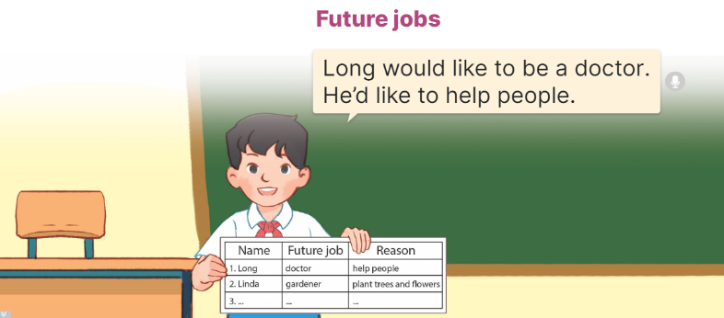  - Point at the sample survey and explain that Ss are going to report the results of their surveys about their classmates’ future jobs and the reasons why they would like to do the jobs.  - Give Ss some time to practise their presentations by themselves and within groups.  - Select a few Ss to give their presentations in front of the class.  4. Fun corner and wrap- up (4’)  Game: Pass the ball  - T gives Ss a ball.  - T asks Ss to listen to music and transfer a ball around the class.  - When the music stops, Ss who keep a ball have to answer the question using: I’d would like to be a teacher in the future.  - T gives feedback. | - Ss listen  - Ss listen to the rules  -Ss play game  - Ss open their books  - Ss pay attention to the email and read  - Ss look at the incomplete sentences and answer options.  - Ss read the text again and circle the correct answers.  - Ss swap books and check answers  - Ss read the sentences  - Ss work in pairs and talk  - Ss read the rubrics and think  - Ss read the questions and complete the email.  - Ss write their emails.  - Ss read their completed email aloud  -Ss listen to the teacher  - Ss work in groups and tell the group about their friend’s future jobs.  - Ss talk about their future jons in front of the class.  -Ss listen to the teacher  -Ss play the game
D. ADJUSTMENTS (if necessary):
………………………………………………………………………………………….…..……………………………………………………………………………...
-------------------------------------------------
Grade 5: Lớp 5A: Sáng thứ Năm, Ngày 6 tháng 11 năm 2025
Lớp 5B: Sáng thứ Năm, Ngày 6 tháng 11 năm 2025
Lớp 5C: Chiều thứ Tư, Ngày 5 tháng 11 năm 2025
ENGLISH
Review 1 - Parts 1, 2
A. OBJECTIVES:
By the end of the lesson, Ss will be able to:
1. Knowledge:
- listen to five questions and circle the correct answers a, b or c.
- ask and answer questions using picture cues.
- Vocabulary: Review
- Skills: speaking, listening, reading and writing.
2. Competences:
- Communication and collaboration: work in pairs and teams to complete the learning tasks.
- Self-control and independent learning: perform reading and writing tasks.
3. Attitude/ Qualities:
- Study hard to review the vocabulary and sentence patterns they have learnt.
- Be honest in the learning tasks.
B. TEACHING AIDS:
- Teacher: Teacher’s guide Pages 84,85, Track 55; website hoclieu.vn, posters, laptop, pictures, textbook, lesson plan, TV or projector.
- Students: Pupil’s book Page 40, notebooks, workbooks, school things.
C. PROCEDURES:
Teacher’s activities | Students’ activities
1.Warm- up:  Game: Whispering  *Aims: to revise the sentence structures they have learnt.  *Procedure:  - Divide class into 2 groups.  -Ask 5 Ss in each group stand in a straight line.  - T says a word or phrase to the first student in this line.  - Then, the first student whispers what she/ he hear to the second person in line; the second one whispers what he/ she hears to the third one and so on until the last student in group hears the word or phrase.  - The last student says the word or phrase out loud.  - The faster group has correct word or phrase is the winner.  - Say “Open your book page 40, 41” and look at Review 1.  2.Practice:  Activity 1. Listen and circle a, b or c:  *Aims: Ss will be able to listen to five questions and circle the correct answers a, b or c.  *Procedure:  - Draw Ss’ attention to the first set of suggested answers and have ss read the answer options.  - Play the recording for Ss to do the task. (three times)  - Get Ss to swap books with a partner, then check answers as a class.  - Write the correct answers on the board.  - Play the recording for S to double-check their answers.  - Play the recording, have Ss listen and repeat in chorus.  Key: 1. b, 2. b, 3. c, 4. c, 5. a  Activity 2. Ask and answer:  *Aims: Ss will be able to ask and answer questions using picture cues.  *Procedure:  - Get Ss to look at the bubble to identify the activity shown in it 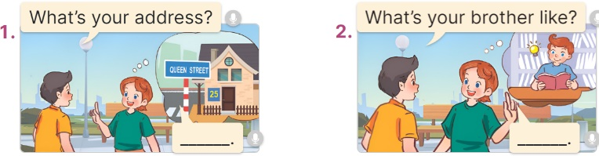  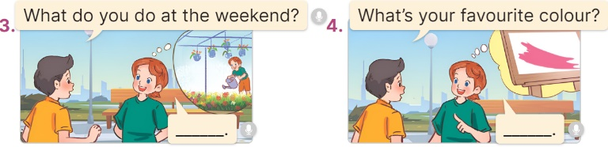  - Have Ss look at the picture to answer the question.  - Have Ss work in pairs to role-play the four exchanges.  - Invite pairs of Ss to stand up and take it in turns to role-play the target exchanges.  Key: 1. It’s 25 Queen Street.  2. He’s clever.  3. I water the flowers.  4. It’s / I like pink. | - Ss listen  -Ss play game  -Ss praise the winner.  - Ss open their books  - Ss read the answer options.  - Ss listen to the recording and do the task.  - Ss swap books with a partner, then check answers as a class.  - Ss listen to the recording to double-check their answers.  - Sls listen to the recording and repeat  -Look at the pictures and say:  + Picture 1:  Nam: What’s your address?  Lucy: …………….  + Picture 2:  Nam: What’s your brother like?  Lucy: …………..  + Picture 3:  Nam: What do you do at the weekend?  Lucy: ………….  + Picture 4:  Nam: What’s your favourite colour?  Lucy: ………..  - Ss look at and answer.  - Ss work in pairs to role play  - Ss role play
D. ADJUSTMENTS (if necessary):
………………………………………………………………………………………….…..……………………………………………………………………………...
-----------------------------------------------
Grade 5: Lớp 5A: Sáng thứ Năm, Ngày 6 tháng 11 năm 2025
Lớp 5B: Sáng thứ Năm, Ngày 6 tháng 11 năm 2025
Lớp 5C: Sáng thứ Sáu, Ngày 7 tháng 11 năm 2025
ENGLISH
Review 1 - Parts 1, 2, 3, 4, 5
A. OBJECTIVES:
By the end of the lesson, Ss will be able to:
1. Knowledge:
- listen to five questions and circle the correct answers a, b or c.
- ask and answer questions using picture cues.
- read and match pairs of target sentence patterns.
- read and complete a gapped table about a boy named Henry.
- read, understand and complete the passage using word cues.
- Vocabulary: Review
- Skills: reading and writing.
2. Competences:
- Communication and collaboration: work in pairs and teams to complete the learning tasks.
- Self-control and independent learning: perform reading and writing tasks.
3. Attitude/ Qualities:
- Study hard to review the vocabulary and sentence patterns they have learnt.
- Be honest in the learning tasks.
B. TEACHING AIDS:
- Teacher: Teacher’s guide Pages 86, 87; Track 55; website hoclieu.vn, posters, laptop, pictures, textbook, lesson plan, TV or projector.
- Students: Pupil’s book Page 41, notebooks, workbooks, school things.
C. PROCEDURES:
Teacher’s activities | Students’ activities
1.Warm- up:  Sing a song  2.Practice:  Activity 3. Read and match  *Aims: Ss will be able to read and match pairs of target sentence patterns.  *Procedure:  - Tell Ss about this activity. Point at sentence 1, elicit the answer and models.  - Give Ss work in pairs to do the sentence 2,3,4,5.  - Tell Ss to swap their books with their partners, then check answers together as a class.  - Write the correct answers on the board for Ss to correct their answers.  - Invite some pairs to stand up and read the matched exchanges aloud.  Key: 1.d, 2. a, 3. e, 4. c, 5. b  Activity 4. Read and complete  *Aims: Ss will be able to read and complete a gapped table about a boy named Henry  *Procedure:  - Have Ss read the passage about Henry.  - Have Ss look at the gapped passage.  - Point at the sentence with the first gap and read it as a class.  - Elicit the missing word and give feedback. Complete the sentence and get Ss to read the completed sentence in chorus.  - Get Ss to swap books with a partner, then check answers as a class. Write the correct answer on the board.  - Invite some Ss to stand up and read the completed passage aloud.  Key:  1. 5 2. Australian 3. 72  4. surfing the Internet 5. gardener  3.Production:  Activity 5. Let’s write  *Aims: Ss will be able to complete a gapped text with the help of picture cues.  *Procedure:  -Tell the class the goal of this activity: to read the gapped text and fill in the gaps using picture cues.  - Write the sentence with the first gap on the board. Read the sentence as a class. When you reach the gap, ask pupils to point at the picture and write (My name is……).  - Ask Ss complete the other sentences.  - Invite a few Ss to read the sentences they have completed aloud in front of the class.  Key: Pupil’s answer  4. Fun corner and wrap- up (3’)  Game: “Pass the ball”  - Give two different colored balls to two pupils, a blue ball (ask the question) and a white ball (answer the question).  - Ask Ss to listen to music and pass the balls.  - Stop music suddenly. Have the student with a blue ball make a question. Have the student with a white ball answer the question.  - Repeat the game several times. | - Listen and sing  -Ss look at the sentence 1 and say  -Ss work in pairs and match  -Ss swap their books and match  -Ss check their answer  -Ss read aloud  -Ss read the passage  -Ss look at the passage  -Ss point at the first gap and read  -Ss complete the missing word  -Ss swap their books and check their answer.  -Ss read aloud  -Ss pay attention  -Ss point and answer the first gap  -Ss complete the sentences  -Ss read aloud.  -Ss listen to the teacher  -Ss play the game  Ex: A: What’s your favourite food?  B: It’s chicken  -Ss continute playing the game.
D. ADJUSTMENTS (if necessary):
………………………………………………………………………………………….…..……………………………………………………………………………...

Duyệt bài, Ngày 31 tháng 10 năm 2025
Phó hiệu trưởng

Nguyễn Thị Hằng

