ĐĂNG KÝ GIẢNG DẠY TUẦN 5 ( Từ ngày 06-10/102025)

Thứ  Ngày | Buổi | Lớp | Tiết | Môn | Tên bài
Hai | Chiều | 5B | 1 | English | Sinh hoạt NGLL: Tổ chức Trung Thu
Hai | Chiều | 5B | 2 | English | Sinh hoạt NGLL: Tổ chức Trung Thu
Ba | Sáng | 5A | 1 | English | Unit 3: My foreign friends  Lesson 1 (1,2,3)
Ba | Sáng | 5A | 2 | English | Unit 3: My foreign friends  Lesson 1 (4,5,6)
Ba | Sáng | 5C | 3 | English | Unit 3: My foreign friends  Lesson 1 (1,2,3)
Ba | Sáng | 5C | 4 | English | Unit 3: My foreign friends  Lesson 1 (4,5,6)
Tư | Sáng | 2C | 1 | English | Unit 3: At the street market - Lesson 1: 1,2
Tư | Sáng | 2C | 2 | English | Unit 3: At the street market - Lesson 2: 3,4,5
Tư | Sáng | 2B | 3 | English | Unit 3: At the street market - Lesson 1: 1,2
Tư | Sáng | 2B | 4 | English | Unit 3: At the street market - Lesson 2: 3,4,5
Tư | Chiều | 4A | 1 | English | Unit 3: My week - Lesson 1 (1,2,3)
Tư | Chiều | 4A | 2 | English | Unit 3: My week - Lesson 1 (4,5,6)
Năm | Sáng | 5B | 1 | English | - Unit 3: My foreign friends  Lesson 1 (1,2,3)  - Unit 3: My foreign friends  Lesson 1 (4,5,6)
Năm | Sáng | 5B | 2 | English | - Unit 3: My foreign friends  Lesson 2 (1,2,3)  - Unit 3: My foreign friends  Lesson 2 (4,5,6)
Năm | Sáng | 5A | 3 | English | Unit 4: Our free-time activities  Lesson 1 (1,2,3)
Năm | Sáng | 5A | 4 | English | Unit 3: My foreign friends  Lesson 2 (1,2,3)
Sáu | Sáng | 4A | 1 | English | Unit 3: My foreign friends  Lesson 2 (4,5,6)
Sáu | Sáng | 4A | 2 | English | Unit 3: My week - Lesson 2 (1,2,3)
Sáu | Sáng | 5C | 3 | English | Unit 3: My foreign friends  Lesson 2 (1,2,3)
Sáu | Sáng | 5C | 4 | English | Unit 3: My foreign friends  Lesson 2 (4,5,6)

Duyệt bài, Ngày 03 tháng 10 năm 2025
Phó hiệu trưởng

WEEK 5
Grade 2 : Lớp 2B, 2C: Sáng thứ tư, Ngày 08 tháng 10 năm 2025
LESSON PLAN
Unit 3. At the seaside
Lesson 1 – Period 1
I. OBJECTIVES
By the end of the lesson, pupils will be able to:
- correctly pronounce the name of the letter S/s (/es/).
- correctly pronounce the sound of the letter S/s (/s/) in isolation and in the words sail, sand and sea.
II. INPUT
Language:
- Sound /s/
- Vocabulary: sail, sand, sea
Resources/Material:
- Student’s book, page 14
- Teacher’s guide, pp. 24 - 26
- hoclieu.vn
- Flashcards for Unit 3
- Flashcards/pictures of seaside
- Flashcards for Fun Corner
- Poster for Unit 3
- Computer, projector
III. PROCEDURE
Warm-up – Listen and repeat – Point and say – Fun corner – Wrap-up

Procedure | Teaching and learning activities | Classroom management
Warm-up | 5 minutes
 | Option 1  Refresh pupils’ memory of the previous unit by having pupils work in pairs to look at the picture in Unit 2, Lesson 3, Activity 8 and ask and answer questions about the actions in progress. | Pair work
 | Option 2  - Introduce the topic of the new unit by showing some pictures of the seaside.  - Find out if pupils have been to the seaside and, if so, what they did there and what they liked most about it. | Whole class
1. Listen and repeat. 10 minutes
Step 1: | Draw pupils’ attention to the picture  (say “Look at the picture.”). Ask questions to help them identify the context (The picture shows the seaside. The sun is shining. A father, son and daughter are sailing on the sea. The father is controlling the sail. The son is fishing. The daughter is looking at the sand on the beach. Sail, sand and sea are labelled, with the letter s in red). | Whole class
Step 2: | Have pupils point to the letter S/s (say “Point to the letter S.”). Explain that the name of the letter S/s is different to its sound (say “Listen. /es/ /s/.”). | Individual work
Step 3: | Play the recording of the name and sound of the letter S/s and encourage pupils to repeat (say “Listen and repeat.”). Do this several times, with pupils repeating both individually and in chorus. Correct their pronunciation if necessary, and praise them when their pronunciation is good. | Whole class  Individual work
Step 4: | Have pupils look at the sail (say “Look at the sail.”). Then have them point to the word sail (say “Point to the word sail.”). Draw their attention to the colour of the letter s (say “Look at the colour of the letter s. It is red.”). | Whole class
Step 5: | Play the recording of sail and encourage pupils to repeat (say “Listen and repeat.”). Do this several times, with pupils repeating both individually and in chorus. Correct their pronunciation if necessary, and praise them when their pronunciation is good. | Whole class  Individual work
Step 6: | Repeat Steps 4 and 5 for sand and sea. | Whole class  Individual work
Step 7: | Play the recording in full and encourage pupils to repeat the name and sound of the letter S/s, sail, sand and sea both individually and in chorus. | Whole class  Individual work
Extension: | For better pupils, let them play Jumbled letters using the new vocabulary. Then ask them say the words aloud. | Individual work
2. Point and say. 7 minutes
Step 1: | Have pupils point to the letter S/s and correctly pronounce its name and sound (say “Point to the letter S. Say /es/. Now say /s/.”). | Whole class
Step 2: | Have pupils point to and correctly pronounce the word sail (say “Point to the sail. Say sail.”). Do this several times, with pupils repeating both individually and in chorus. Correct their pronunciation if necessary, and praise them when their pronunciation is good. | Whole class  Individual work
Step 3: | Repeat Step 2 for sand and sea. | Whole class  Individual work
Step 4: | Put pupils into pairs or groups for further practice of Steps 1 to 3. Go around the class to offer help or correct pupils’ pronunciation, if necessary. | Group/  Pair work
Fun corner: Pelmanism 8 minutes
Step 1: | Divide the class into small teams. Give each team two sets of flashcards. Say “You are going to play Pelmanism.” | Group work
Step 2: | Instruct pupils to shuffle their flashcards and then place them face down on the desk. | Group work
Step 3: | Explain that team members should take it in turns to turn over two cards. Do the word and the picture match? If they do match, the team member scores one point. If they do not match, the team member should turn both cards face down again. | Group work
Step 4: | Play the game! The first team to match all the words and pictures wins. | Group work
Wrap-up: 5 minutes
 | Revise the main teaching point of the lesson: the sound of the letter s and the words sail, sand, sea. | Whole class
 | Option 1  Using hoclieu.vn, have pupils look at the things in the picture and repeat the words after the recording. | Whole class
 | Option 2  Using Poster for Unit 3, ask pupils to point to the things in the picture and say the words. For better pupils, teacher may cover the words and ask them to point to the things and say the words aloud. | Individual work
 | Option 3  Pupils do the project on Page 12 in Workbook. | Individual work
Grade 2 : Lớp 2B, 2C: Sáng thứ tư, Ngày 08 tháng 10 năm 2025
LESSON PLAN
Unit 3. At the seaside
Lesson 2 – Period 2
I. OBJECTIVES
By the end of the lesson, pupils will be able to:
- say the letter S/s, the words sea, sail, sand, the phrases/sentences containing /s/ and sea, sail, sand, the sentence structure I can see the _____. in a chant.
- listen and recognise the words sail, sand and the sentence structure I can see _____.
- write the letter S/s and complete the words _ea, _ail, _and.
II. INPUT
Language:
- Sound /s/
- Vocabulary: sea, sail, sand
- Phrases/sentences with the sound /s/ and the words sea, sail, sand
Resources/Material:
- Student’s book, page 15
- hoclieu.vn
- Teacher’s guide, pp. 26-28
- Workbook, pp. 10-11
- Flashcards to play games in Warm-up
- Computer, projector
III. PROCEDURE
 | Warm-up – Listen and chant – Listen and tick – Look and write – Wrap-up
Procedure |  | Teaching and learning activities | Classroom management
Warm-up |  | 5 minutes
 |  | Option 1  - Ask pupils what letter and sound they learnt in Lesson 1 (S/s, /s/).  - Show pictures of the words that pupils learnt in Lesson 1 (sail, sand, sea) and encourage them to say the words in chorus. More advanced classes can add other words beginning with the letter S/s. | Whole class
 |  | Option 2  Ask the class to play Pelmanism again, using the words in Lesson 1, Unit 1 and those in the previous units, saying Now let us play Pelmanism! | Group work
 |  | Option 3  Get pupils to play What’s Missing? Game, using the pictures and flashcards with the incompleted words _ea, _ail and _and. Pupils should guess the missing letters and say the words correctly. | Group/  Pair work
3. Listen and chant. 10 minutes
Step 1: |  | Draw pupils’ attention to the picture and have them point to the sail (say “Look at the picture. Point to the sail.”). | Whole class
Step 2: |  | Say “I can see the sail.” and encourage pupils to repeat. To reinforce their understanding, use gestures. | Whole class
Step 3: |  | Repeat Steps 1 and 2 for sand and sea. | Whole class
Step 4: |  | Play the recording of the chant to familiarize pupils with the words and rhythm  (say “Listen.”). | Whole class
Step 5: |  | Have pupils point to the each line of the chant (e.g. say “Point to line one.”). Play the recording of each line and encourage pupils to chant (say “Listen and chant.”). | Individual work  Whole class
Step 6: |  | Play the recording in full and encourage pupils to chant (say “Listen and chant.”). Pupils can clap along or do other actions to help them keep the rhythm. | Whole class
Step 7: |  | Divide the class into three teams. Teams take it in turns to chant a line. The whole class can clap along or do other actions. | Group work
Extension: |  | For better pupils, cover or omit some letters/words in the chant and have them guess and say all the lines aloud. For example:  S, s, sea.  S, s, sail.  S, s, _____.  I can see the sea.  I can see the _____.  I can see the _____.  At the seaside. | Individual work
4. Listen and tick. 7 minutes
Step 1: |  | Have pupils look at the pictures and say the words (say “Point and say.”). When pupils answer correctly, confirm by saying “sail/ sun/ sea/ sand”. | Whole class
Step 2: |  | Play the recording and allow pupils time to complete the activity (say “Listen and tick.”). | Individual work
Step 3: |  | Play the recording again, if necessary  (say “Listen again.”). | Individual work
Step 4: |  | Check the answers by asking “a or b?” When pupils answer correctly, confirm by saying  “1a. I can see the sail.”/“2b. I can see the sand.” and encourage them to repeat. | Whole class  Individual work
Audio script: 1. I can see the sail. 2. I can see the sand.
Answers: 1. a 2. b
5. Look and write. 8 minutes
Step 1: |  | Write the letter S (upper case) on the board and say “S” (/es/). | Whole class
Step 2: |  | Write the letter S (upper case) on the board again, but this time more slowly. Invite a few pupils to come to the front of the class and write the letter S (upper case) on the board. | Individual work
Step 3: |  | Repeat Steps 1 and 2 for s (lower case). | Whole class  Individual work
Step 4: |  | Have pupils look at the writing grids. Say “Look and write.” Allow pupils time to complete the activity. Go around the class to offer support and feedback. | Whole class
Step 5: |  | Have pupils look at the picture and labels. Say “Look and write.” Allow pupils time to complete the activity. Go around the class to offer support and feedback. | Individual work
Extension: |  | - For weaker pupils, have them do Activity 3, Unit 3 in their workbooks.  - For better pupils, have them do Activity 4,  Unit 3 in their workbooks. | Individual work
Wrap–up 5 minutes
 |  | Option 1  Have pupils listen to the recording, then say the chant again. | Whole class
 |  | Option 2  Ask pupils to look at the pictures in 4. Listen and tick and say about them, e.g. sail, sun, ... Encourage better pupils to use learnt structures e.g. I can see the sail.; That’s the sun.; ... | Whole class
 |  | Option 3  To reinforce the vocabulary, get pupils to do Activity 1, Unit 3 in their workbooks. | Individual work

---------------------------------------------------
Grade 4: Lớp 4A: Chiều thứ Tư, Ngày 08 tháng 10 năm 2025
ENGLISH
Unit 3: My week
Lesson 1 (1, 2, 3)
A. OBJECTIVES:
By the end of the lesson, Ss will be able to:
1. Knowledge:
- Understand and correctly repeat the sentences in two communicative contexts (pictures) in which pupils ask and answer questions about the days of the week.
- Correctly say the words and use What day is it today? – It’s ………. to ask and answer questions about the days of the week.
- Enhance the correct use of What day is it today? – It’s …….. to ask and answer questions about the days of the week in a freer context.
- Vocabulary: Monday, Tuesday, Wednesday, Thursday, Friday, Saturday, Sunday, today.
- Skills: speaking and listening
2. Competences:
- Critical Thinking: self-introduce
- Co-operation: ready to help friends in pair work/ group work.
- Sociability: Talk to each other, say good words to others.
3. Attitude/ Qualities:
- Kindness: Help partners to complete learning tasks.
- Honesty: tell the truth about feelings and emotions
B. TEACHING AIDS:
- Teacher: Teacher’s guide Pages 43, 44, 45, audio Tracks 26, 27, website hoclieu.vn, posters, laptop, pictures, textbook, lesson plan, TV or projector.
- Students: Pupil’s book Page 22, notebooks, workbooks, school things.
C. PROCEDURES:
Teacher’s activities | Students’ activities
1.Warm- up: (3’)  Sing: What day is it today?  *Aims: to create a friendly and active atmosphere in the class to beginning the lesson.  *Procedure:  - Show the song on the screen.  https://www.youtube.com/watch?v=ij0iWJB2uMo  - Ask pupils to listen, sing and dance the song.  - Say “Open your book page 22” and look at “Unit 3, Lesson 1 (1,2,3)”.  2. Presentation (16’)  Activity 1. Vocabulary.  *Aims: Ss will be able to know the vocabulary in the new lesson.  *Procedure:  -T elicits the new words  + Monday : thứ 2 (situation)  + Tuesday : thứ 3 (situation)  + Wednesday :thứ 4 (situation)  + Thursday : thứ 5 (translation)  + Friday : thứ 6 (translation)  + Saturday : thứ 7 (situation)  + Sunday : chủ nhật (situation)  + today : hôm nay (translation)  - T models (3 times).  - T writes the words on the board.  - Checking: Matching  Activity 2. Look, listen and repeat:  *Aims: Ss will be able to understand and correctly repeat the sentences in two communicative contexts (pictures) in which pupils ask and answer questions about the days of the week.  *Procedure:  - Have Ss look at Pictures a and b and identify the characters in the pictures.  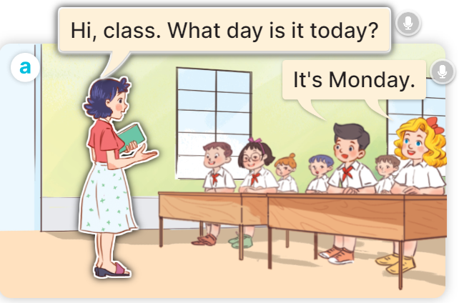  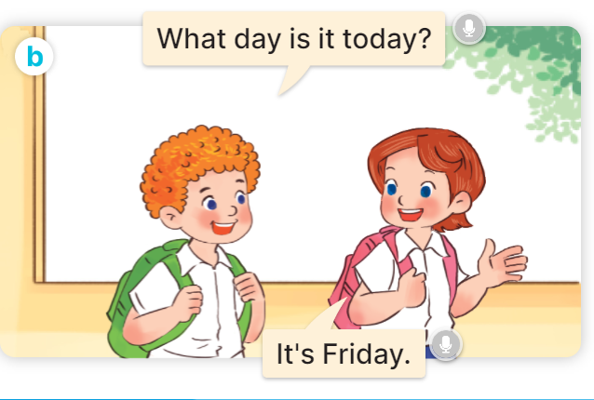  - Play the audio twice (sentence by sentence). Correct their pronunciation where necessary.  - Have Ss to practice the dialogue  - T invites a few pairs to the front of the class to practice.  - T checks pronunciation for ss.  Activity 3 Listen, point and say.  *Aims: Ss will be able to correctly say the words and use What day is it today? – It’s …….. to ask and answer questions about the days of the week.  *Procedure:  * Model sentences:  - T asks Ss look at picture a, b and helps Ss know the structure from the dialogue.  - T introduces new structure for Ss.  - T explains, models and gives meaning.  - Have Ss repeat the model sentences.  A: What day is it today?  B: It’s Monday.  3.Practice: (7’)  *Drill pictures  - Elicit and check comprehension the name of each character.      - Run through all the pictures.  - Run through model sentences.  - Have Ss to practise:  + T says the first picture  + Ss says the second picture  + Group A says the third picture  + Group B say the last picture.  - Ask Ss to work in pairs.  - T controls and corrects.  - Invite a few pairs to come to the front of the classroom, point at the relevant character in each picture, and act out his/her role.  - Encourage Ss to practise speaking English.  - T gives feedbacks.  4.Production: (7’)  Activity 4. Let’s talk.  *Aims: Ss will be able to enhance the correct use of What day is it today? – It’s …….. to ask and answer questions about the days of the week in a freer context.  *Procedure:  - T asks ss to guess each character and what the children say.  + What can you see in the picture?  +Who are they?  +Where are they?  +What are they saying?  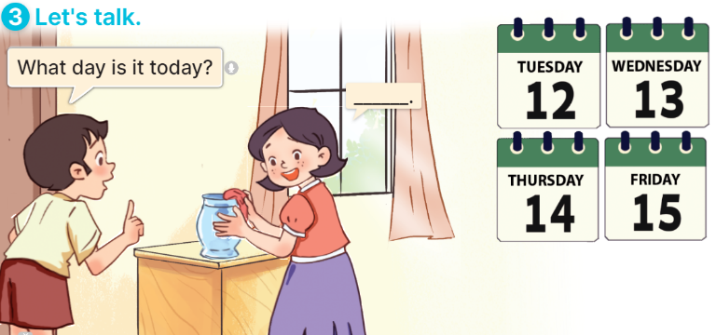  - T fills the gaps and writes the sentences on the board.  - T models  - T asks Ss to greet and introduce someone. (groups of four)  - Invite some groups to perform.  - Give feedbacks  *Consolidation  *Aims: Ss will be able consolidate and wrap up the content of the lesson.  *Procedure:  - T asks ss to answer the following questions:  + What have you learnt from the lesson today?  +What are the core values of the lesson? (if the teacher can take from the lesson).  - T review the vocabulary and model sentences.  - T praises some Ss who are hardworking / active/ good…. as well as encourage others to try more.  5. Homework. (2’)  - Learn the vocabulary and model sentences by heart  - Prepare the new lesson: Unit 3, Lesson 1 (4,5,6). | - Ss sing and dance the song  - Ss open their books  -Ss listen and answer  - - Ss listen and repeat  + Choral repetition (3 times).  + Individual repetition (3 ss)  - Ss take note  - Ss look, remember and match  -Look at the pictures and get to know the characters in the pictures.  + In picture a: Ms Hoa says: Hi, class. What day is it today? And Mr Long says: It’s Monday.  + In picture b: Mai says: That’s Mr Long. And Bill says: Hello, Mr Long.  -Ss listen and repeat in chorus (twice)  -Ss work in pairs to practice  -Ss practice the dialogue  -Ss listen  -Ss look at the picture and answer.  -Ss listen  -Ss listen and repeat  -Ss repeat to the introduce someone.  - Ss look, listen and answer  +Picture a: Monday  + Picture b: Tuesday  + Picture c: Wednesday  + Picture d: Thursday  -Ss listen and repeat  -Ss practice in chorus  -Ss practice  -Ss work in pairs to practice  -Ss point and say  -Ss listen.  -Ss listen  -Ss look at the picture and answer  + a boy asks a girl about the days of the week: Tuesday, Wednesday, Thursday, Friday (illustrated by calendars).  -Ss note  - Ss say the completed sentences.  -Ss pay attention  -Ss work in groups  -Ss perform in front of the class.  -Ss answer the questions  - Ss listen  -Ss listen and clap their hands  -Ss listen and take note
D. ADJUSTMENTS (if necessary):
………………………………………………………………………………………….…..……………………………………………………………………………...
---------------------------------------------------------------------
Grade 4: Lớp 4A: Chiều thứ Tư, Ngày 10 tháng 10 năm 2025
ENGLISH
Unit 3: My week
Lesson 1 (4,5,6)
A. OBJECTIVES:
By the end of the lesson, Ss will be able to:
1. Knowledge:
- listen to and understand two communicative contexts about the days of the week and tick the correct pictures.
- complete four gapped exchanges with the help of picture cues.
- revise target words about the days of the week by playing the game Slap the board.
- Vocabulary: Review
- Skills: speaking, listening, reading and writing.
2. Competences:
- Critical Thinking: self-introduce
- Co-operation: ready to help friends in pair work/ group work.
- Self-control and independent learning: perform listening tasks.
3. Attitude/ Qualities:
- Kindness: Help partners to complete learning tasks.
- Honesty: tell the truth about feelings and emotions.
- Communication and collaboration: work in pairs and groups to complete the learning tasks
B. TEACHING AIDS:
- Teacher: Teacher’s guide Pages 45,46,47; audio Tracks 29; website hoclieu.vn, posters, laptop, pictures, textbook, lesson plan, TV or projector.
- Students: Pupil’s book Page 23, notebooks, workbooks, school things.
C. PROCEDURES:
Teacher’s activities | Students’ activities
1.Warm- up: (5’)  Game: Lucky number  *Aims: to create a friendly and active atmosphere in the class to beginning the lesson.  *Procedure:  - Divide the class into 2 teams (boys and girls).  - Each team takes turns to choose a number.  - They need to ask and answer with the picture corresponding to that number to get points.  - The group with more points at the end of the game will be the winner.  - Praise the winner, encourage the other team.  - Say “Open your book page 23” and look at “Unit 3, Lesson 1 (4,5,6)”.  2.Practice: (27’)  Activity 1. Listen and tick:  *Aims: Ss will be able to listen to and understand two communicative contexts about the days of the week and tick the correct pictures.  *Procedure:  - Elicit the days of the week.  - Point at the pictures respectively to explain the context.  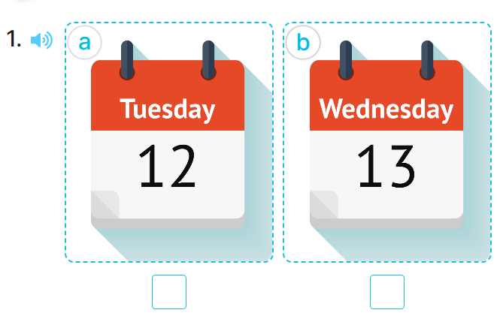  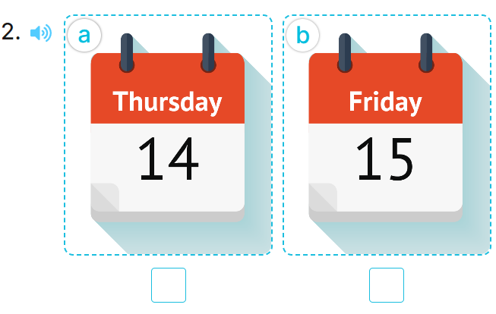  - T ask Ss to guess the answers.  + T writes Ss’guessing on the board.  - Listen to the tape:  + Play the recording  + Play the recording again and get Ss to swap books with their partners.  + Play the recording again to check answers together as a class.  + Write the answers on the board for Ss to correct their answers. Then checks Ss’ guessing.  - Play the recording, sentence by sentence, for the class to listen and repeat in chorus.  Key: 1.b 2.a  Activity 2. Look, complete and read.  *Aims: Ss will be able to complete four gapped exchanges with the help of picture cues.  *Procedure:  - Have pupils look at the pictures and identify the days of the week in the pictures. 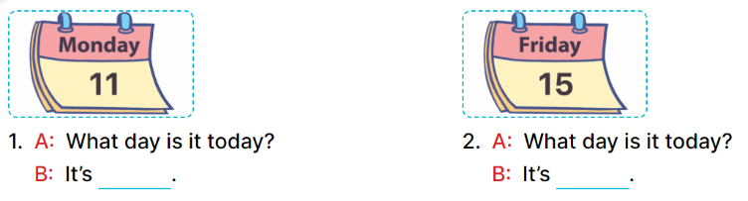  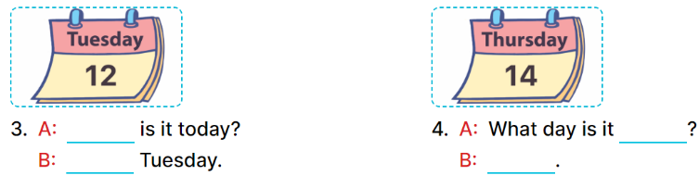  - Have Ss look at the two incomplete dialogue and elicits the missing words in the sentences.  - T models with picture 1  + Ask Ss what is missing in the sentence.  + Have Ss look at the picture and complete the gap, then read the completed sentence in chorus.  -Have Ss work in groups and complete the picture 2.  - Ask a few Ss to stand up and read the completed sentences aloud.  -T gives feedbacks.  Key:  - Monday 2. Friday  - 3. What day; It’s  - 4. today; It’s Thursday  Activity 3. Let’s play: Slap the board  *Aims: Ss will be able to revise target words about the days of the week by playing the game Slap the board. *Procedure:  - Tell pupils that they are going to listen to and slap the correct words as quickly as possible.  - Have them look at the days of the week on the board to recall the days of the week.  - Call two pupils to the front. Get them to stand at a certain distance from the board.  - Say a day of the week using It’s …….with one of the words on the board, for example, It’s Monday.  - The pupil who is the quickest to slap the right word (Monday) gets one point.  - The pupil who slaps the most words is the winner.  - Invite a few pairs to the front of the class to play the game.  - Praise pupils if they perform well.  *Consolidation  *Aims: Ss will be able consolidate and wrap up the content of the lesson.  *Procedure:  - T asks ss to answer the following questions:  + What have you learnt from the lesson today?  +What are the core values of the lesson? (if the teacher can take from the lesson).  - T praises some Ss who are hardworking / active/ good…. as well as encourage others to try more.  3. Homework. (3’)  - Practice part 5 again.  - Prepare the new lesson: Unit 3, Lesson 2 (1,2,3). | - Ss listen to the rule  - Ss play game  Ex: What day is it today?  It’s Tuesday.  -Ss listen  - Ss open their books  -Look at the pictures and say:  + Picture 1a: Tuesday  + Picture 1b: Wednesday  + Picture 2a: Thursday  + Picture 2b: Friday  -Ss guess the answers  - Ss listen to the tape and tick  - Ss listen again, tick and swap books with their partners.  -Ss listen again and check  - Ss check their answers and guessing  -Ss listen and repeat.  -Ss look at the picture and say:  -Ss look and answer  -Ss answer: Monday  -Ss look, complete and read the completed sentence in chorus.  -Ss work in groups and complete the sentences  -Ss read aloud  -Ss listen  - Ss look and listen.  - Ss listen  - Ss pay attention  -Ss play the game  -Ss listen and play games  -Ss listen  -Ss answer the questions  -Ss listen and clap their hands  -Ss listen and take note
D. ADJUSTMENTS (if necessary):
………………………………………………………………………………………….…..……………………………………………………………………………...………………………………………….…..………………………………………
----------------------------------------------------
Grade 4: Lớp 4A: Sáng thứ Sáu, Ngày 10 tháng 10 năm 2025
ENGLISH
Unit 3: My week
Lesson 2 (1, 2, 3)
A. OBJECTIVES:
By the end of the lesson, Ss will be able to:
1. Knowledge:
- understand and correctly repeat the sentences in two communicative contexts focusing on asking and answering questions about what someone does on certain days of the week.
- correctly say the phrases and use What do you do on ……? – I ……... to ask and answer questions about what someone does on certain days of the week.
- enhance the correct use of What do you do on ……? – ………. to ask and answer questions about what someone does on certain days of the week in a freer context.
- Vocabulary: study at school, do housework, listen to music, stay at home
- Skills: speaking and listening
2. Competences:
- Co-operation: ready to help friends in pair work/ group work.
- Sociability: Talk to each other, say good words to others.
3. Attitude/ Qualities:
- Kindness: Help partners to complete learning tasks.
- Honesty: tell the truth about feelings and emotions
B. TEACHING AIDS:
- Teacher: Teacher’s guide Pages 47,48,49; audio Tracks 29,30, website hoclieu.vn, posters, laptop, pictures, textbook, lesson plan, TV or projector.
- Students: Pupil’s book Page 24, notebooks, workbooks, school things.
C. PROCEDURES:
Teacher’s activities | Students’ activities
1.Warm- up: (3’)  Game: Pass the ball  *Aims: to create a friendly and active atmosphere in the class to beginning the lesson.  *Procedure:  - T gives Ss a ball.  - T asks Ss to listen to music and transfer a ball around the class.  - When the music stops, Ss who keep a ball have to look at the picture and answer the question using: What day is it today? and It’s……..  - T gives feedback.  - Say “Open your book page 24” and look at “Unit 3, Lesson 2 (1,2,3)”.  2. Presentation (16’)  Activity 1. Vocabulary.  *Aims: Ss will be able to know the vocabulary in front of starting the new lesson.  *Procedure:  -T elicits the new words  + study at school : học ở trường (situation)  + do housework : làm việc nhà (situation)  + listen to music : nghe nhạc (mime)  + stay at home : ở nhà (translation)  - T models (3 times).  - T writes the words on the board.  - Checking: What and where  Activity 2. Look, listen and repeat:  *Aims: Ss will be able to understand and correctly repeat the sentences in two communicative contexts focusing on asking and answering questions about what someone does on certain days of the week. *Procedure:  - Have Ss look at Pictures a and b and identify the characters in the pictures.  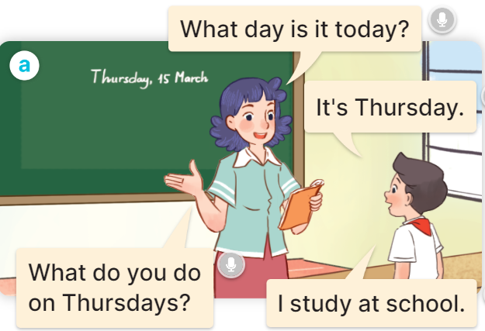  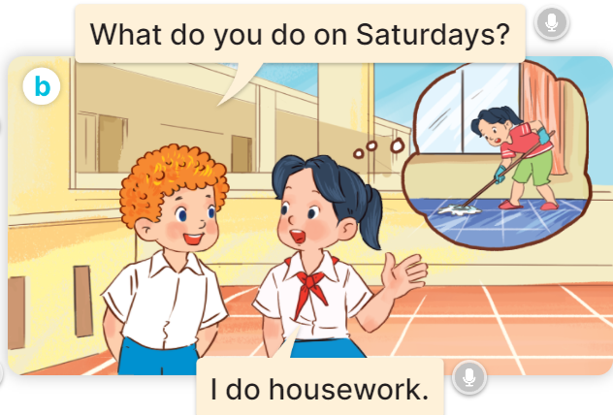  - Play the audio twice (sentence by sentence). Correct their pronunciation where necessary.  - Have Ss to practice the diaguage  - T invites a few pairs to the front of the class to practice.  - T checks pronunciation for ss.  Activity 3. Listen, point and say.  *Aims: Ss will be able to correctly say the phrases and use What do you do on …..? – I …….. to ask and answer questions about what someone does on certain days of the week  *Procedure:  * Model sentences:  - T asks Ss look at picture a, b and helps Ss know the structure from the dialogue.  - T introduces new structure for Ss.  - T explains, models and gives meaning.  - Have Ss repeat the model sentences.  A: What do you do on Mondays?  B: I study at school.  3.Practice: (7’)  *Drill pictures  - Have pupils look at the pictures and elicit the activities and the days of the week.  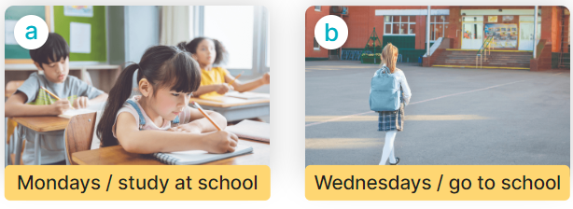  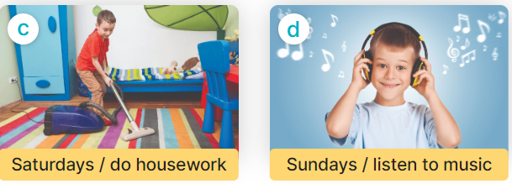  - Run through all the pictures.  - Run through model sentences.  + Run through the questions  + Run through the answers  - Have Ss to practise:  + T asks Ss answer (change role).  + Ss – Ss (change role).  - Ask Ss to work in pairs.  - T controls and corrects.  - Invite a few pairs to come to the front of the classroom, point at the relevant character in each picture, and act out his/her role.  - Invite Ss to go to the board and role play. Encourage Ss to practise speaking English.  - T gives feedbacks.  4.Production: (7’)  Activity 4. Let’s talk.  *Aims: Ss will be able to enhance the correct use of What do you do on …….? – ……. to ask and answer questions about what someone does on certain days of the week in a freer context.  *Procedure:  - Ask questions to help them identify the context.  + What can you see in the picture?  +Who are they?  +Where are they?  +What are they saying?  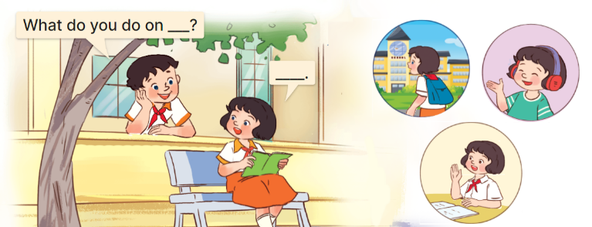  - T fills the gaps and writes the sentences on the board.  - T models  - T asks Ss use of What do you do on….? to ask, and answer (work in pairs)  - Invite some groups to perform.  - Give feedbacks  *Consolidation  *Aims: Ss will be able consolidate and wrap up the content of the lesson.  *Procedure:  - T asks ss to answer the following questions:  + What have you learnt from the lesson today?  +What are the core values of the lesson? (if the teacher can take from the lesson).  - T review the vocabulary and model sentences.  - T praises some Ss who are hardworking / active/ good…. as well as encourage others to try more.  5. Homework. (2’)  - Learn the vocabulary and model sentences by heart  - Prepare the new lesson: Unit 3, Lesson 2 (4,5,6). | - Ss listen  - Ss play the game  - Ss open their books  -Ss listen and answer  - - Ss listen and repeat  + Choral repetition (3 times).  + Individual repetition (3 ss)  - Ss take note  - Ss look, remember and slap  -Look at the pictures and get to know the characters in the pictures.  + In picture a:  Ms Hoa: What day is it today?  Nam: It’s Thursday.  Ms Hoa: What do you do on Thursdays?  Nam: I study at school.  – In picture b:  Bill: What do you do on Saturdays?  Mai: I do housework.  -Ss listen and repeat in chorus (twice)  -Ss work in pairs to practice  -Ss practice the diaguage  -Ss listen  -Ss look at the picture and answer.  -Ss listen  -Ss listen and repeat  -Ss repeat to the introduce someone  -Ss listen and answer  - Ss look, listen and repeat  - Ss practice in chorus  Ex: Mondays/ study at school  A: What do you do on Mondays?  B: I study at school.  -Ss work in pairs to practice  -Ss listen  -Ss point and say  -Ss go to the board and role play.  -Ss listen  -Ss look at the picture and answer  + A boy asks a girl about what she does on Tuesdays, Fridays and Sundays (illustrated by the calendars and her activities)  -Ss note  - Ss say the completed sentences.  -Ss work in pairs  -Ss perform in front of the class.  -Ss listen  -Ss answer the questions  - Ss listen  -Ss listen and clap their hands  -Ss listen and take note
D. ADJUSTMENTS (if necessary):
………………………………………………………………………………………….…..……………………………………………………………………………...………………………………………….…..………………………………………
---------------------------------------------------
Grade 4: Lớp 4A: Sáng thứ Sáu, Ngày 10 tháng 10 năm 2025
ENGLISH
Unit 3: My week
Lesson 2 (4, 5, 6)
A. OBJECTIVES:
By the end of the lesson, Ss will be able to:
1. Knowledge:
- listen to and understand four communicative contexts about days of the week and what someone does on certain days of the week and number the correct pictures.
- complete four gapped exchanges with the help of picture cues.
- sing the song My week with the correct pronunciation, rhythm and melody.
- Vocabulary: Review
- Skills: speaking, listening, reading and writing.
2. Competences:
- Co-operation: ready to help friends in pair work/ group work.
- Self-control and independent learning: perform listening tasks.
3. Attitude/ Qualities:
- Kindness: Help partners to complete learning tasks.
- Honesty: tell the truth about feelings and emotions.
- Diligence: complete learning tasks.
B. TEACHING AIDS:
- Teacher: Teacher’s guide Pages 49, 50,51; audio Tracks 31, 32; website hoclieu.vn, posters, laptop, pictures, textbook, lesson plan, TV or projector.
- Students: Pupil’s book Page 25, notebooks, workbooks, school things.
C. PROCEDURES:
Teacher’s activities | Students’ activities
1.Warm- up: (5’)  Play a game: Guess the pictures  *Aims: to create a friendly and active atmosphere in the class to beginning the lesson.  *Procedure:  - The first Ss has to take the last four or three letters of that word and form a new word.  - The second Ss does the same, and the chain continues until a Ss is unable to form a word.  - The Ss who fails to form a word or misspells it is out of the game.  -T give feedback  - Say “Open your book page 25” and look at “Unit 3, Lesson 2 (4,5,6)”.  2.Practice: (27’)  Activity 1. Listen and number:  *Aims: Ss will be able to listen to and understand four communicative contexts about days of the week and what someone does on certain days of the week and number the correct pictures.  *Procedure:  - Elicit the activities and the days of the week.  - Point at the pictures respectively to explain the context.  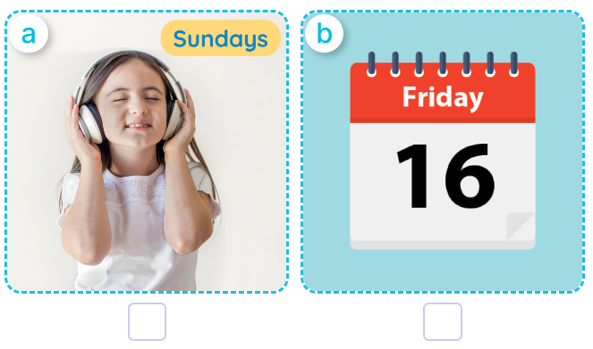  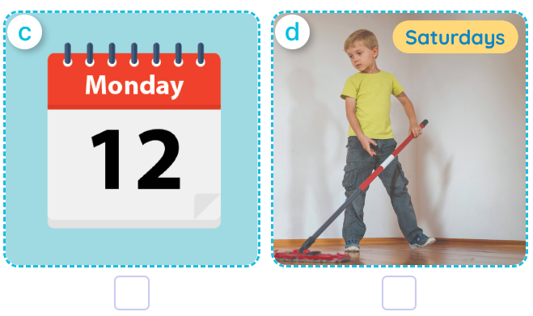  - T ask Ss to guess the answers.  + T writes Ss’guessing on the board.  - Listen to the tape:  + Play the recording  + Play the recording again and get Ss to swap books with their partners.  + Play the recording again to check answers together as a class.  + Write the answers on the board for Ss to correct their answers. Then checks Ss’ guessing.  - Play the recording, sentence by sentence, for the class to listen and repeat in chorus.  Key: 1. c 2. d 3. b 4. a  Activity 2. Look, complete and read  *Aims: Ss will be able to complete four gapped exchanges with the help of picture cues.  *Procedure:  - Have pupils look at the pictures and identify the days of the week and the activities in the pictures.  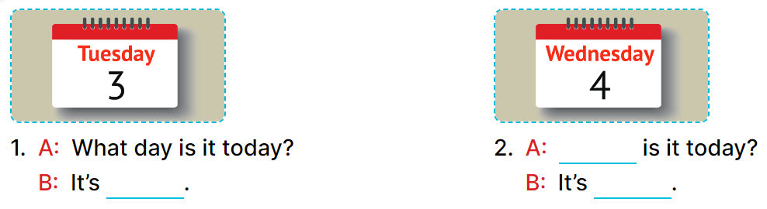  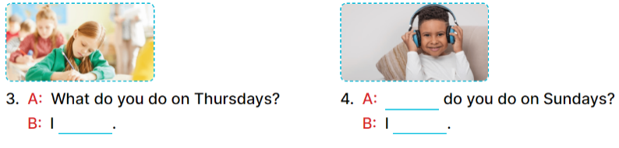  - Have Ss look at the four incomplete dialogue and elicits the missing words in the sentences.  - T models with picture 1  + Ask Ss what is missing in the sentence.  + Have Ss look at the picture and complete the gap, then read the completed sentence in chorus.  -Have Ss work in groups and complete the picture 2, 3 and 4.  - Ask a few Ss to stand up and read the completed sentences aloud.  -T gives feedbacks.  Key: 1. Tuesday  2. What day; Wednesday  3. study at school  4. What; listen to music  Activity 3. Let’s sing.  *Aims: Ss will be able sing the song What day is it today? with the correct pronunciation, rhythm and melody.  *Procedure:  - Draw pupils’ attention to the title and lyrics of the song.  - Encourage pupils to point at the characters’ activities to reinforce their understanding.  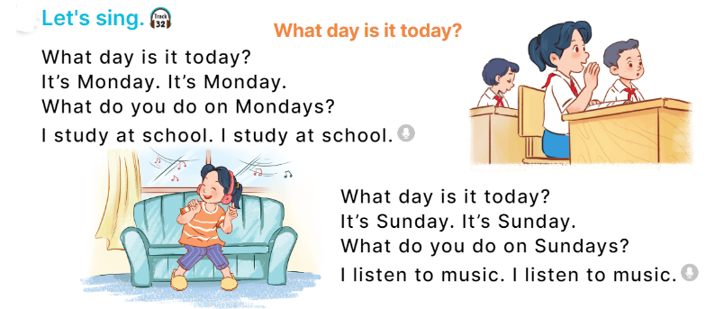  - Play the recording all the way through for pupils to listen to the whole song.  - Play the recording line by line for pupils to listen and repeat.  - Play the recording all the way through for pupils to sing along.  - Play the recording again for pupils to sing and clap along with the recording.  - Pupils can sing the song What day is it today? with the correct pronunciation, rhythm and melody.  *Consolidation  *Aims: Ss will be able consolidate and wrap up the content of the lesson.  *Procedure:  - T asks ss to answer the following questions:  + What have you learnt from the lesson today?  +What are the core values of the lesson? (if the teacher can take from the lesson).  - T praises some Ss who are hardworking / active/ good…. as well as encourage others to try more.  3. Homework. (3’)  - Practice part 5 again.  - Prepare the new lesson: Unit 3, Lesson 3 (1,2,3). | - Sing and dance the song in chorus.  - Ss open their books  -Look at the pictures and say:  a. a girl listening to music on Sundays  b. a calendar: Friday  c. a calendar: Monday  d. a boy doing housework on Saturdays  -Ss guess the answers  - Ss listen to the tape and write number  - Ss listen again, write number and swap books with their partners.  - Ss check their answers and guessing  -Ss listen and repeat.  -Ss look and answer  -Ss answer: It’s Tuesday.  -Ss look, complete and read the completed sentence in chorus.  -Ss work in groups and complete the sentence  -Ss read aloud  - Ss listen  -Ss listen to the song  -Ss listen and repeat line by line  -Ss listen and sing along  -Ss sing and clap along  -Ss sing with the correct pronunciation, rhythm and melody.  -Ss answer the questions  - Ss listen  -Ss listen and clap their hands  -Ss listen
D. ADJUSTMENTS (if necessary):
………………………………………………………………………………………….…..……………………………………………………………………………...
----------------------------------------------------
Grade 5: Lớp 5A: Sáng thứ Ba, Ngày 07 tháng 10 năm 2025
Lớp 5B: Chiều thứ Hai, Ngày 06 tháng 10 năm 2025
Lớp 5C: Sáng thứ Ba, Ngày 07 tháng 10 năm 2025
ENGLISH
Unit 3: My foreign friends - Lesson 1 (1, 2, 3)
A. OBJECTIVES:
By the end of the lesson, Ss will be able to:
1. Knowledge:

- understand and correctly repeat the sentences in two communicative contexts in which characters ask and answer questions about someone’s nationality.

- correctly say the words for nationalities and use What nationality is he / she? - He’s / She’s _____. to ask and answer questions about someone’s nationality.

- enhance the correct use of What nationality is he / she? - _____. to ask and answer questions about someone’s nationality in a freer context.

- Vocabulary: nationality, Australian, Malaysian, American, Japanese

- Structures: A: What nationality is he / she?
B: He’s/ She’s Australian.
- Skills: speaking and listening
2. Competences:
- Critical thinking and creativity: learn how to ask and answer questions about personal information correctly and fluently.
- Self-control and independent learning: perform speaking tasks.
3. Attitude/ Qualities:
- Show their pride in where they come from and great respect for where someone comes from by asking and answering about nationality
B. TEACHING AIDS:
- Teacher: Teacher’s guide Pages 44, 45, 46, audio Tracks 25, 26, website hoclieu.vn, posters, laptop, pictures, textbook, lesson plan, TV or projector.
- Students: Students’ book Page 22, notebooks, workbooks, school things.
C. PROCEDURES:
Teacher’s activities | Students’ activities
1.Warm- up and review: (3’)  Game: Slap the board  *Aims: to revise the vocabulary about different countries that pupils have learnt in English 4.  *Procedure:  - Prepare some flashcards about different countries and stick on the board  (America, Australia, Japan, Viet Nam, Malaysia…)  - Divide class into 2 groups: Tom and Jerry.  - How to play:  + Each group chooses five Ss to play.  + Class will read aloud.  + Look at the picture, listen and slap the picture you heard.  + Who faster will get 1 mark.  + Which group with higher mark is the winner.  - Say “Open your book page 22” and look at “Unit 3, Lesson 1 (1,2,3)”.  2. Presentation (15’)  Activity 1. Vocabulary.  *Aims: Ss will be able to know the vocabulary in the new lesson.  *Procedure:  -T elicits the new words  + American : người Mỹ (explain)  + Australian : người Úc (explain)  + Malaysian : người Ma-lai-xi-a  (explain)  + Japanese : người Nhật (explain )  + nationality: quốc tịch (translation)  - T models (3 times).  - T writes the words on the board.  - Checking: Matching  Activity 2. Look, listen and repeat:  *Aims: Ss will be able to understand and correctly repeat the sentences in two communicative contexts in which characters ask and answer questions about someone’s nationality  *Procedure:  - Have Ss look at Pictures a and b and identify the characters and say what they are talking about.  + Who is he/ she?  + Where is he/ she?  + What are they talking about?    - Play the audio twice (sentence by sentence). Correct their pronunciation where necessary.  - Have Ss to practice the dialogue  - T invites a few pairs to the front of the class to practice.  - T checks pronunciation for ss.  Activity 3 Listen, point and say.  *Aims: Ss will be able to correctly say the words for nationalities and use What nationality is he / she? - He’s / She’s _____. to ask and answer questions about someone’s nationality.  *Procedure:  * Structures:  - T asks Ss look at picture b in activity 1 and helps Ss know the structure from the dialogue.  - T introduces new structures for Ss.  - T explains, models and gives meaning.  - Have Ss repeat the structures  A: What nationality is he / she?  B: He’s/ She’s Australian.  3.Practice: (7’)  *Drill pictures  - Have Ss look at the pictures and say what they can see in the pictures.      - Have Ss point at pictures, listen and run through all the pictures.  - Have Ss point at the bubbles, listen and run through model sentences.  - Have Ss to practise:  + T asks the first picture, Ss answer  + Ss asks the second picture, T answers  + Group A asks the third picture, group B  answers  + Group B asks the last picture, group A  - Ask Ss to work in pairs to practise asking and answering the What nationality is he / she? – He’s/ She’s _____.  - T controls and corrects.  - Invite a few pairs to point at the pictures and say the questions and answers in front of the class.  4. Production: (6’)  Activity 4. Let’s talk.  *Aims: Ss will be able to enhance the correct use of What nationality is he / she? - _____. to ask and answer questions about someone’s nationality in freer contexts.  *Procedure:  - Ask Ss to look at the pictures and elicit the context  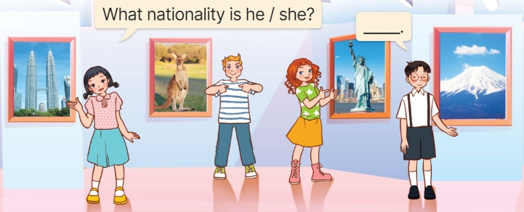  - Point at the ﬁrst building and elicit the question in the ﬁrst speech bubble What nationality is he / she? and the answer in the second speech bubble He’s/ She’s……. as an example.  - Give Ss time to work in pairs and take turns pointing at each picture to ask and answer using What nationality is he / she? - _____.  - Invite a few pairs to come to the front of the classroom and act out the exchanges.  5. Fun corner and wrap- up (4’)  Game: Sentence Puzzle  - Divide the class into groups of four.  - Give each group a sentence that is broken/cut into pieces.  - Ask them to arrange them to make a complete sentence, then read it aloud.  - The group who makes it first will be the winner. | -Ss listen and pay attention  - Ss listen to the teacher  -Ss play the game  -Ss continute playing the game  - Ss listen and open their books  -Ss listen and answer  - - Ss listen and repeat  + Choral repetition (3 times).  + Individual repetition (3 ss)  - Ss take note  - Ss look and match  -Look at the pictures and say.  + In picture a: Minh and mum in the kitchen, talking Minh’s new friend.  Minh: Mum, I have a new foreign friend.  Mum: Do you? Where’s he from?  Minh: He’s from Australia.  + In picture b: Dad joining the conversation, asking about the nationality of Minh’s new friend.  Dad: What nationality is he?  Minh: He’s Australian.  -Ss listen and repeat in chorus (twice)  -Ss work in pairs to practice  -Ss come to the front of the classroom to practice.  -Ss listen  - Ss look at the picture and answer.  -Ss listen  -Ss listen and repeat  -Ss repeat to the structures  - Ss look, listen and repeat  +Picture a: Ben, Australian flag, a kangaroo and the word Australian underneath.  + Picture b: a girl, Malaysian flag, Petronas Twin tower and the word Malaysian underneath.  + Picture c: Mary, American flag, the Statue of Liberty and the word American underneath  + Picture d: a girl, Japanese flag, Sakura blossoms and the word Japanese underneath  -Ss point at pictures, listen and repeat  -Ss point at the bubbles, listen and repeat  -Ss practice in chorus  -Ss practice in chorus  -Ss work in pairs to practise asking and answering the question  - Pairs of Ss point at the pictures and say in front of the class  -Ss look at the picture and say  + Picture of four characters at the exhibition introducing their countries  - Ss look at the first building and elicit the missing words in speech bubbles and say the completed sentences.  - Ss role-play to practise asking and answering questions  - Ss practise asking and answering questions in front of the class.  -Ss listen to the teacher  -Ss play the game  Ex:  is  he?  nationality  What  -Ss congratulate the winner
D. ADJUSTMENTS (if necessary):
………………………………………………………………………………………….…..……………………………………………………………………………...
---------------------------------------------
Grade 5: Lớp 5A: Sáng thứ Ba, Ngày 07 tháng 10 năm 2025
Lớp 5B: Chiều thứ Hai, Ngày 06 tháng 10 năm 2025
Lớp 5C: Sáng thứ Ba, Ngày 07 tháng 10 năm 2025
ENGLISH
Unit 3: My foreign friends - Lesson 1 (4, 5, 6)
A. OBJECTIVES:
By the end of the lesson, Ss will be able to:
1. Knowledge:
- listen to and understand four communicative contexts in which speakers ask and answer questions about someone’s nationality and tick the correct pictures.
- circle correct words in four exchanges with the help of picture cues.
- sing the song My friends with correct pronunciation, rhythm and melody.
- Vocabulary: Review
- Skills: speaking, listening, reading and writing.
2. Competences:
- Communication and collaboration: work in pairs and groups to complete the learning tasks.
- Self-control and independent learning: perform listening and reading tasks.
3. Attitude/ Qualities:
- Show their pride in where they come from and great respect for where someone comes from by asking and answering about nationality.
B. TEACHING AIDS:
- Teacher: Teacher’s guide Pages 47, 48; audio Tracks 27, 28; website hoclieu.vn, posters, laptop, pictures, textbook, lesson plan, TV or projector.
- Students: Student’s book Page 23, notebooks, workbooks, school things.
C. PROCEDURES:
Teacher’s activities | Students’ activities
1.Warm- up and review: (5’)  Game: “Flashcard walk”  *Aims: to revise the learned different nationalities.  *Procedure:  - Divide the class into four groups.  - Place several word cards on the classroom floor.  - Have Ss from each group come up the front.  - Play some music and have the Ss walk around the word cards.  - Stop the music and say the name of one flashcard, ex: she / American  - Have the Ss pick up the correct word card and say a sentence using the word on the word card, ex: she’s American.  - Give the first group to make a correct sentence at one point.  - The group with the most points wins the game.  - Say “Open your book page 23” and look at “Unit 3, Lesson 1 (4,5,6)”.  2.Practice: (25’)  Activity 1. Listen and tick:  *Aims: Ss will be able to listen to and understand four communicative contexts in which speakers ask and answer questions about someone’s nationality and tick the correct pictures.  *Procedure:  - Draw Ss’ attention to the pictures and ask questions  + What nationality is she/ he?  + What’s he/ she doing?  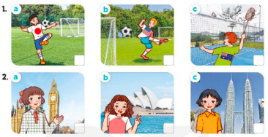  - T ask Ss to guess the answers.  + T writes Ss’guessing on the board.  - Listen to the tape:  + Play the recording  + Play the recording again for pupils to do the task.  + Play the recording a third time for pupils to check their answers.  - Get Ss to swap books with their partner, then check answers as a class.  + Write the answers on the board for Ss to correct their answers. Then checks Ss’ guessing.  - If time allows, play the recording, sentence by sentence, for Ss to listen and repeat individually and in chorus Key: 1. a 2. b  Activity 2. Read and circle  *Aims: Ss will be able to circle correct words in four exchanges with the help of picture cues.  *Procedure:  - Have Ss read the sentences and elicit the answer to fill in the gap. (America)      - Give Ss a time limit to read the gapped dialogues, look at the pictures and do the task independently.  - Get Ss to swap books with a partner and check their answers before checking as a class.  + Invite one student to write the answers on the board.  + Ask questions to have Ss explain why they choose the options. Ex: for picture B, ask why do you choose Malaysian? - Because there’s a flag of Malaysia.  - Invite two pairs of Ss to act out the completed dialogues.  Key: 1. America 2. Malaysian  3. What; Japanese 4. is; Australian  Activity 3. Let’s sing  *Aims: Ss will be able to sing the song My friends with correct pronunciation, rhythm and melody.  *Procedure:  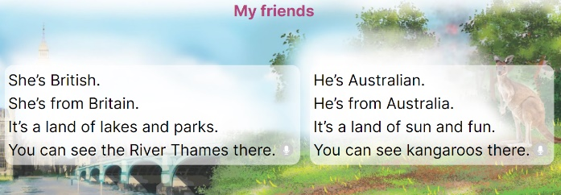  - Draw Ss’ attention to the title and lyrics of the song.  - Have Ss read and listen to the song.  - Play the recording again and let ss listen to and practise singing the song, line by line.  - Ask Ss to listen to and sing the whole song while doing actions or clapping their hands when they hear the keywords such as British, Britain, Australian, Australia, land, see.  - Invite a few groups to the front of the class to sing the song.  3. Fun corner and wrap- up (5’)  Game: Lucky stars  - Divide the class into two groups. Have a student from each group play one, two, three to find the group going first.  - Have two Ss from each group choose a colour star, look at the picture given and ask and answer the question about someone’s nationality.  - Ask the class to check their friends’ pronunciation. If they are correct, they will get points for their group.  - Continue the game until all the words are said.  - The group with more points wins the game. Praise the winner. | -Ss listen to the teacher  -Ss play the game  - Ss open their books  -Look at the pictures and say:  + Picture 1a: a Japanese boy playing football  + Picture 1b: an American boy playing football  + Picture 1c: an Australian boy playing badminton  + Picture 2a: a British girl standing in front of Big Ben  + Picture 2b: an Australian girl standing in front of Sydney Opera House  + Picture 2c: a Malaysian girl standing in front of Petronas twin tower  -Ss guess the answers  - Ss listen to the tape  - Ss listen again and do the task.  - Ss listen and check their answers  - Ss swap books with their partner, then check answers as a class.  +Ss check the guessing  -Ss listen and repeat  Ss look at the picture and read, fill the gap  - Ss do the task independently.  - Ss swap books with a partner and check their answers.  - Ss write the answers on the board  -Ss explain why  - Pairs of Ss read the completed dialogues aloud  - Ss pay attention to the title and lyrics of the song.  - Ss read and listen to the song  - Ss listen to the recording again and practise singing the song  - Ss listen to and sing the whole song while doing actions  - Ss come to the front of the class to sing the song.  -Ss listen to the teacher  - Ss play the game.  - Ss continue playing the game.  - Ss praise the winner.
D. ADJUSTMENTS (if necessary):
………………………………………………………………………………………….…..……………………………………………………………………………...
-------------------------------------------------
Grade 5: Lớp 5A: Sáng thứ Năm, Ngày 09 tháng 10 năm 2025
Lớp 5B: Sáng thứ Năm, Ngày 09 tháng 10 năm 2025
Lớp 5C: Sáng thứ Sáu, Ngày 10 tháng 10 năm 2025
ENGLISH
Unit 3: My foreign friends - Lesson 2 (1, 2, 3)
A. OBJECTIVES:
By the end of the lesson, Ss will be able to:
1. Knowledge:

- understand and correctly repeat the sentences in two communicative contexts in which characters ask and answer questions about someone’s personality.

- correctly say the words and use What’s he / she like? - He’s / She’s ____. to ask and answer questions about someone’s personality.

- enhance the correct use of What’s he / she like? - _____. to ask and answer questions about someone’s personality in freer contexts.

- Vocabulary: friendly, helpful, clever, active
- Structures: A: What’s he / she like?
B: He’s/ She’s friendly.
- Skills: speaking and listening
2. Competences:
- Critical thinking and creativity: learn how to ask and answer questions about personal information correctly and fluently.
- Self-control and independent learning: perform pronunciation and speaking tasks.
3. Attitude/ Qualities:
- Raise their awareness of good personality.
B. TEACHING AIDS:
- Teacher: Teacher’s guide Pages 49, 50, 51, audio Tracks 29, 30, website hoclieu.vn, posters, laptop, pictures, textbook, lesson plan, TV or projector.
- Students: Students’ book Page 24, notebooks, workbooks, school things.
C. PROCEDURES:
Teacher’s activities | Students’ activities
1.Warm- up and review: (3’)  Game: Circle the words  *Aims: to revise the words about different natinalities.  *Procedure:  - Divide the class into groups of three.  - Have each group take out one paper and two pens with different colours.  - Ask one student to write down the eight words of countries and nationality in random order then give it to his/ her friends.  - When he/ she calls out one word (ex: Japanese), the other two pupils try to circle that word as fast as possible.  - The student who circles more words wins.  - Have some groups demonstrate the activity in front of the class. Praise the winner.  - Say “Open your book page 24” and look at “Unit 3, Lesson 2 (1,2,3)”.  2. Presentation (15’)  Activity 1. Vocabulary.  *Aims: Ss will be able to know the vocabulary in the new lesson.  *Procedure:  -T elicits the new words  + friendly : thân thiện (situation)  + helpful : hay giúp đỡ (picture)  + clever : thông minh (situation)  + active : năng động (translation)  - T models (3 times).  - T writes the words on the board.  - Checking: Rub out and remember  Activity 2. Look, listen and repeat:  *Aims: Ss will be able to understand and correctly repeat the sentences in two communicative contexts in which characters ask and answer questions about someone’s personality.  *Procedure:  - Have Ss look at Pictures a and b and identify the characters and predict what Lily’s nationality is.  + What can you see in the picture?  + What are they talking about?  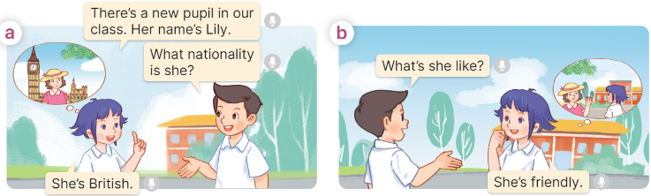  - Play the audio twice (sentence by sentence). Correct their pronunciation where necessary.  - Have Ss to practice the dialogue  - T invites a few pairs to the front of the class to practice.  - T checks pronunciation for ss.  Activity 3 Listen, point and say.  *Aims: Ss will be able to correctly say the words and use What’s he / she like? - He’s / She’s ____. to ask and answer questions about someone’s personality.  *Procedure:  * Structures:  - T asks Ss look at picture b in activity 1 and helps Ss know the structure from the dialogue.  - T introduces new structures for Ss.  - T explains, models and gives meaning.  - Have Ss repeat the structures  A: What’s he / she like?  B: He’s/ She’s friendly.  3.Practice: (7’)  *Drill pictures  - Have Ss look at the pictures and say what they can see in the pictures.      - Have Ss point at pictures, listen and run through all the pictures.  - Have Ss point at the bubbles, listen and run through model sentences.  - Have Ss to practise:  + T asks the first picture, Ss answer  + Ss asks the second picture, T answers  + Group A asks the third picture, group B  answers  + Group B asks the last picture, group A  - Ask Ss to work in pairs to practise asking and answering the question What’s he/ she like? – He’s/ She’s _____.  - T controls and corrects.  - Invite a few pairs to point at the pictures and say the questions and answers in front of the class.  4. Production: (6’)  Activity 4. Let’s talk.  *Aims: Ss will be able to enhance the correct use of What’s he / she like? - _____. to ask and answer questions about someone’s personality in a freer context.  *Procedure:  - Ask Ss to look at the pictures and elicit the personality of each character in the picture.  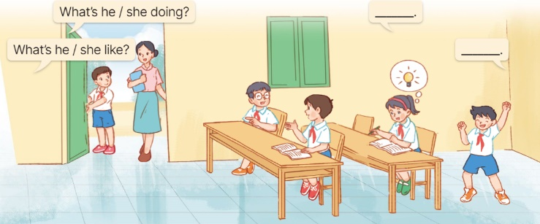  - Remind Ss that What’s he / she like? and - ___. are used to ask and answer questions about someone’s personality.  - Give Ss time to work in pairs and take turns pointing at each picture to ask and answer using What’s he / she like? and - ___.  - Invite a few pairs to come to the front of the classroom and act out the exchanges.  5. Fun corner and wrap- up (4’)  Game: Whisper  - Divide the class into two groups. Have each group stand in a line.  - Model the activity. Give the first studentpupil in each line a flash card.  + Explain that he/she must read the word (without saying it out loud!) and then whisper it to the next pupil in the line.  +The second student must then whisper it to the third, and so on.  + When the word reaches the last student in the line, he/she should call it out. The first group to call out a correct word wins.  - Play the game.  - Praise the winner. | -Ss listen and pay attention  - Ss listen to the teacher  -Ss play the game  -Ss continute playing the game  - Ss listen and open their books  -Ss listen and answer  - - Ss listen and repeat  + Choral repetition (3 times).  + Individual repetition (3 ss)  - Ss take note  - Ss look, remember and write  -Look at the pictures and say.  + In picture a: Linh and Nam talking about a new friend in their class.  Linh: There’s a new pupil in our class. Her name’s Lily.  Nam: What nationality is she?  Linh: She’s British.  + In picture b: Nam asking about the new friend’s personality  Nam: What’s she like?  Linh: She’s friendly.  -Ss listen and repeat in chorus (twice)  -Ss work in pairs to practice  -Ss come to the front of the classroom to practice.  -Ss listen  - Ss look at the picture and answer.  -Ss listen  -Ss listen and repeat  -Ss repeat to the structures  - Ss look, listen and repeat  +Picture a: a friendly girl talking to her friends  + Picture b: a helpful girl doing the dishes  + Picture c: a clever boy reading and thinking of a new idea  + Picture d: an active boy exercising  -Ss point at pictures, listen and repeat  -Ss point at the bubbles, listen and repeat  -Ss practice in chorus  -Ss practice in chorus  -Ss work in pairs to practise asking and answering the question  - Pairs of Ss point at the pictures and say in front of the class  -Ss look at the picture and say  - Ss listen to the teacher  - Ss role-play to practise asking and answering questions  - Ss practise asking and answering questions in front of the class.  -Ss listen to the teacher  -Ss play the game  -Ss play the game  -Ss congratulate the winner.
D. ADJUSTMENTS (if necessary):
………………………………………………………………………………………….…..……………………………………………………………………………...
-----------------------------------------------
Grade 5: Lớp 5A: Sáng thứ Năm, Ngày 09 tháng 10 năm 2025
Lớp 5B: Sáng thứ Năm, Ngày 09 tháng 10 năm 2025
Lớp 5C: Sáng thứ Sáu, Ngày 10 tháng 10 năm 2025
ENGLISH
Unit 3: My foreign friends
Lesson 2 (4, 5, 6)
A. OBJECTIVES:
By the end of the lesson, Ss will be able to:
1. Knowledge:
- listen to and understand two communicative contexts in which pupils ask and answer questions about someone’s personality and number the pictures.
- complete two gapped exchanges with the help of picture cues.
- review the target vocabulary related to the topic “My foreign friends” by playing the game The longest sentence.
- Vocabulary: Review
- Skills: speaking, listening, reading and writing.
2. Competences:
- Communication and collaboration: work in pairs and groups to complete the learning tasks.
- Self-control and independent learning: perform listening and reading tasks.
3. Attitude/ Qualities:
- Raise their awareness of good personality.
B. TEACHING AIDS:
- Teacher: Teacher’s guide Pages 51, 52; audio Tracks 31; website hoclieu.vn, posters, laptop, pictures, textbook, lesson plan, TV or projector.
- Students: Student’s book Page 25, notebooks, workbooks, school things.
C. PROCEDURES:
Teacher’s activities | Students’ activities
1.Warm- up and review: (5’)  Game: Slap the board  *Aims: to revise the words about someone’s appearance and personality.  *Procedure:  - - Divide the class into two groups. Ask Ss to stand in two lines.  - Stick the cards with words on the board.  - Call out a word and have the first student from each group race to slap the correct card on the board and say it correctly.  - The first student to slap the correct card wins a point for their group.  - The group with the most points wins. Praise the winner.  - Say “Open your book page 25” and look at “Unit 3, Lesson 2 (4,5,6)”.  2.Practice: (25’)  Activity 1. Listen and number:  *Aims: Ss will be able to listen to and understand four communicative contexts in which speakers ask and answer questions about someone’s personality and number the pictures.  *Procedure:  - Draw Ss’ attention to the pictures and ask questions to elicit the personalities of the people in the pictures.  + What can you see in this picture?  + Is he friendly?  + Is he active?      - T ask Ss to guess the answers.  + T writes Ss’guessing on the board.  - Listen to the tape:  + Play the recording  + Play the recording again for pupils to do the task.  + Play the recording a third time for pupils to check their answers.  - Get Ss to swap books with their partner, then check answers as a class.  + Write the answers on the board for Ss to correct their answers. Then checks Ss’ guessing.  - If time allows, play the recording, sentence by sentence, for Ss to listen and repeat individually and in chorus Key: 1. b 2. a 3.d 4.c  Activity 2. Read and complete.  *Aims: Ss will be able to complete two gapped exchanges with the help of picture cues.  *Procedure:  - Have Ss read the dialogue and guess the missing words.  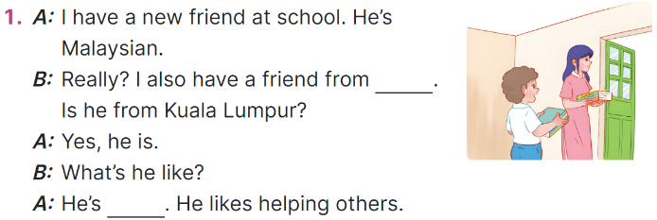  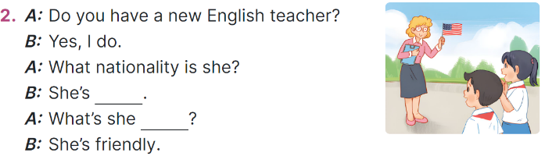  - Model the first gapped  + Elicit the missing word  + Ask What nationality is a new friend? - He’s Malaysian. Where is he from? - He’s from Malaysia.  - Give Ss a time limit to read the gapped dialogues, look at the pictures and fill in the gaps independently.  - Get Ss to swap books with a partner and check their answers before checking as a class.  + Invite one student to write the answers on the board.  - Invite two pairs of Ss to act out the completed dialogues.  Key: 1. Malaysia 2. helpful  3. American 4. like  Activity 3. Let’s play  *Aims: Ss will be able to review the target vocabulary related to the topic My foreign friends by playing the game The longest sentence.  *Procedure:  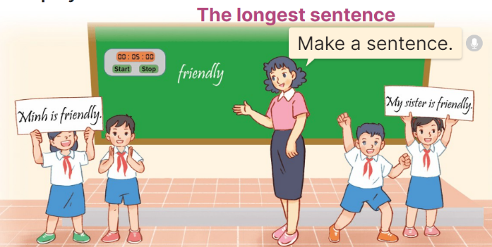  - Divide the class into 8 - 10 groups. Give each group a piece of paper.  - Write a word on the board (ex: friendly) and ask the groups to write a sentence using the word within one minute.  - After one minute, the groups hold up the sentences and say them aloud. The group with the longest sentences wins.  - Play the game with another word.  3. Fun corner and wrap- up (5’)  Game: Spin the wheel!  - Tell Ss they are going to ask and answer the question about their friends’ personality in a freer context.  - Invite pairs of volunteers to the board. One student asks the question about his/ her friend, another one answers the question about him/ her.  - Have pairs of Ss continue practising with other friends.  - Praise Ss if they perform well. | - Ss listen to the teacher  - Ss play the game  -Ss congratulate the winner  - Ss open their books  -Look at the pictures and say:  + Picture a: a friendly boy talking to his friends  + Picture b: a helpful boy helping a child  + Picture c: a clever boy thinking of a new idea  + Picture d: an active boy playing badminton  -Ss guess the answers  - Ss listen to the tape  - Ss listen again and do the task.  - Ss listen and check their answers  - Ss swap books with their partner, then check answers as a class.  -Ss check the guessing  -Ss listen and repeat  -Ss follow the teacher  - Ss follow the teacher’s instruction.  - Ss complete the gapped independently.  - Ss swap books with a partner and check their answers.  -Ss write the answers on the board.  - Pairs of Ss read the completed dialogues aloud  - Ss work in groups.  - Ss look at the word on the board and write a sentence using the word within one minute.  - Ss say the sentences aloud.  - Ss continue playing the game.  -Ss listen to the teacher  - Ss play the game.  Ex: A: What’s she like?  B: She’s friendly.  -Ss congratulate the winner
D. ADJUSTMENTS (if necessary):
………………………………………………………………………………………….…..……………………………………………………………………………...
* Preparation for the project: Tell pupils about the project on page 27. Ask them to spend time outside of the class searching for the names of at least five countries and their nationality adjectives. Then, make a poster to show the names of the countries and the nationalities they have found. They may add some information about the countries such as people, flags, maps. Next, each group gives a presentation to introduce the poster in class at Project time.
Duyệt bài, Ngày 3 tháng 10 năm 2025
Phó hiệu trưởng

Nguyễn Thị Hằng

