ĐĂNG KÝ GIẢNG DẠY TUẦN 4 ( Từ ngày 29/9-3/10/2025)
Thứ  Ngày | Buổi | Lớp | Tiết | Môn | Tên bài
Hai | Chiều | 5B | 1 | English | Unit 2: Our homes- Lesson 2 (1, 2, 3)
Hai | Chiều | 5B | 2 | English | Unit 2: Our homes- Lesson 2 (4,5,6)
Ba | Sáng | 5A | 1 | English | Unit 2: Our homes- Lesson 2 (1, 2, 3)
Ba | Sáng | 5A | 2 | English | Unit 2: Our homes- Lesson 2 (4,5,6)
Ba | Sáng | 5C | 3 | English | Unit 2: Our homes- Lesson 2 (1, 2, 3)
Ba | Sáng | 5C | 4 | English | Unit 2: Our homes- Lesson 2 (4,5,6)
Tư | Sáng | 2C | 1 | English | Fun time 1: 1. Find and circle the words. Then say.  2. Let’s play.
Tư | Sáng | 2C | 2 | English | Fun time 1: 3.Look, read and complete. Then say.  4.Let’s play.
Tư | Sáng | 2B | 3 | English | Fun time 1: 1. Find and circle the words. Then say.  2. Let’s play.
Tư | Sáng | 2B | 4 | English | Fun time 1: 3.Look, read and complete. Then say.  4.Let’s play.
Tư | Chiều | 4A | 1 | English | Unit 2: Time and daily routines  Lesson 2 (1, 2, 3)
Tư | Chiều | 4A | 2 | English | Unit 2: Time and daily routines  Lesson 2 (4,5,6)
Năm | Sáng | 5B | 1 | English | Unit 2: Our homes- Lesson 3 (1, 2, 3)
Năm | Sáng | 5B | 2 | English | Unit 2: Our homes- Lesson 3 (4,5,6)
Năm | Sáng | 5A | 3 | English | Unit 2: Our homes- Lesson 3 (1, 2, 3)
Năm | Sáng | 5A | 4 | English | Unit 2: Our homes- Lesson 3 (4,5,6)
Sáu | Sáng | 4A | 1 | English | Unit 2: Time and daily routines  Lesson 3 (1, 2, 3)
Sáu | Sáng | 4A | 2 | English | Unit 2: Time and daily routines  Lesson 3 (4,5,6)
Sáu | Sáng | 5C | 3 | English | Unit 2: Our homes- Lesson 3 (1, 2, 3)
Sáu | Sáng | 5C | 4 | English | Unit 2: Our homes- Lesson 3 (4,5,6)
Duyệt bài, Ngày 26 tháng 9 năm 2025
Phó hiệu trưởng
Nguyễn Thị Hằng
WEEK 4
Grade 2 : Lớp 2B, 2C: Sáng thứ tư, Ngày 01 tháng 10 năm 2025
LESSON PLAN
FUN TIME 1 - LESSON 1
Time allocation: 1 period
I. OBJECTIVES
- By the end of the lesson, pupils will be able to
- Identify the words pizza, kitten, popcorn, bike;
- Recognize, spell and pronounce correctly the words:pasta, popcorn, pizza, kite, bike and kitten;
II. INPUT
- Language:
Sounds /p/ (letter p) and /k/ (letter k)
Vocabulary: pasta, popcorn, pizza, kite, bike and kitten
- Resources/Material: - Student’s book, page 12
- Teacher’s guide, pp. 21-23
- Website hoclieu.vn
- Flashcards with letter p and k
- Flashcards with the pictures of the words Unit 1 and 2
- Computer, projector
III. PROCEDURE
Warm-up – Find and circle the words. Then say. – Let’s play. – Homelink
Procedure | Teaching and learning activities | Classroom management
Warm-up | 5 minutes
 | Option 1: Revising the sounds and words  - Show flashcards: Show flashcards and ask pupils to say: letters p, k, pasta, popcorn, pizza, kite, bike and kitten.  - Game: What’s missing?  Hide a flashcard, have pupils say the missing one.  Option 2: Singing  - Give some pupils the flashcards of Unit 1 and Unit 2.  - Ask the whole class to sing the songs in  Unit 1 and Unit 2 together.  - Have pupils with the flashcards stand up and show flashcards when they sing the words they have.  Lead to Activity 1, Fun time 1. | Whole class work  Individual work/ Group work  Individual work  Whole class work
1. Find and circle the words. Then say. 12 minutes
Step 1  Step 2  Step 3  Step 4  Extension | Have pupils look at each picture and say the words. Ask What do you see?  Ask pupils to look at the word search, find and circle the words in it individually.  Explain how to do the task. Find and circle the words in the word search. Then say the words.  Model with the first word if necessary. Give further support to those pupils who find it difficult to do the task.  Have pupils exchange their answers in pairs or groups. Ask them to point to the words and say them until they feel confident. Go around and give further support to those pupils who find it difficult to do the task  Call some pupils to show the circled words and say them in front of the class.  If teacher uses hoclieu.vn or slides, he/ she can show the word search and call on one or two pupils to go to the board and point to the words in the word search.  KEY:  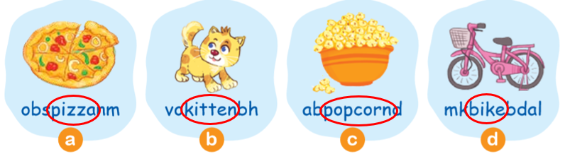  After the pupils find the words and pronounce them, organize a short game. Divide the class into two teams. Call on one pupil from each team to go to the board. Call out a word and the two pupils have to write them on the board. Give a point to each correct word. Pupils from the teams take turns to write the words. | Whole class work  Whole class work  Individual work  Pair work/ Group work  Individual work  Group work  Whole class work
2. Let’s play: Stand up! Sit down! 13 minutes
Step 1  Step 2  Step 3  Step 4  Extension: | Have all pupils sit down.  Teacher holds up a flashcard and say a word.  If the flashcard and the word are the same, pupils stand up; if not, pupils sit still. Call some pupils to say the correct word.  Model the position of the first flashcard. Instruct pupils to follow each position. Help them practise this until they understand.  Follow the same procedure with the other flashcards.  Have the whole class play the game. Call two pupils to be the observers of the game. Hold up the flashcards and have pupils play the game. Model the position of the first flashcard. Instruct pupils to follow each position. Help them practise this until they understand.  Follow the same procedure with the other flashcards  Divide the class into two or four teams.  Each team plays the game. Give stars/points to the winner.  After doing well at this game, increase the difficulty. Ask one pupil to come to the class, hold up a flashcard and say the word for the whole class to stand up/sit down. | Whole class work  Whole class work  Individual work  Whole class work  Group work  Whole class
Home link:5 minutes
 | - Have pupils say the letters b and c together with the sounds /p/ (letter p) and /k/ (letter p) again.  - Then:  Option 1:  Show flashcards and have pupils say the words.  Option 2:  Write letter p and k on the board. Ask pupils to speak out all of the words they have learnt with letter p, k.  - Tell pupils to practise saying the letters, sounds and words at home. | Whole class work/  Individual work
----------------------------------------------
Grade 2 : Lớp 2B, 2C: Sáng thứ tư, Ngày 01 tháng 10 năm 2025
LESSON PLAN
FUN TIME 1
Lesson 2
Time allocation: 1 period
I. OBJECTIVES
By the end of the lesson, pupils will be able to:
- write the words pizza, kite, bike and pasta and complete the sentence structures:
The _____ is yummy
Is he/she _____ (verb + _ing)?
Yes, he/she is. / No, he/she isn’t
II. INPUTResources/
Language: | - Sounds /p/ (letter p) and /k/ (letter k)  Vocabulary: pasta, popcorn, pizza, kite, bike and kitten
Structure: The _____ is yummy., Is he/she _____
(verb + -ing)? and Yes, he/she is. / No, he/she isn’t
Material | :  - Student’s book, page 13  - hoclieu.vn  - Teacher’s guide, pp. 22, 23  - Flashcards to play game  - Computer, projector
III. PROCEDURE
Warm-up – Look, read and write. – Let’s play. – Homelink
Procedure | Teaching and learning activities | Classroom management
Warm-up:5 minutes
 | Option 1:  Guessing game:  Do actions of eating pizza, eating popcorn, riding a bike, flying a kite, playing with a kitten... for pupils to guess.  Pupils say out loud the words when the see the flashcards.  Option 2:  - Have pupils play The Matching Game. Stick the picture flashcards on the board. Write the words from Unit 1 and Unit 2 on the board. Call on some pupils to go to the board and draw lines to match the words and the pictures.  - Lead to Activity 3, Fun time 1 | Whole class work/  Individual work  Whole class work  Individual work
3. Look, read and write. Then say aloud. 13 minutes
Step 1  Step 2  Step 3  Step 4  Step 5  Extension | Have pupils read the words in the first question, then say Read the words, please! Have them look at the pictures and ask them What can you see in the pictures? Have them point to each picture and say the word (pizza, kite, bike and pasta).  Have pupils spell the words pizza, kite, bike and pasta then write on the small boards, check their writing.  Ask them to write the words on their books, say Write the words, please!  Get pupils to check their answers in pairs. Then ask some pairs to give their answers. Give comments and confirm the correct answers.  KEY: 1. pizza 2. kite 3. bike 4. Pasta  Show the pictures in Activity 3 on hoclieu.vn or on the screen. Point to the words randomly and call on some pupils to read the words in front of the class.  Otherwise, show the flashcards and invite some pupils to look at the flashcards and say the words  Have pupils say the completed sentences aloud (say “Now say.”). Do this several times, with pupils saying the sentences both individually and in chorus. Correct their pronunciation if necessary, and praise them when their pronunciation is good.  Ask pupils to work in groups and practise speaking the words by drawing and guessing with the words pasta, popcorn, pizza, kite, bike... in two minutes. Then show their pictures in front of the class. Ask some pupils to go to the board, say and write the words. | Whole class work  Individual work  Whole class work  Individual work  Whole class work  Individual work  Whole class work  Individual work / Pair work  Group work/  Individual work
4. Let’s play: Spelling chain. 12 minutes
Step 1 | Have pupils look at the picture and read the sentences, saying Let’s play: Spelling chain | Whole class work
Step 2 | Give instruction: Divide the class into two (or more) teams. The team plays the game stands in a circle. Give a flashcard with the first letter written to the first team member. The rest of the team work together to spell the word. Take turns to say a letter, move in a clockwise direction from the first pupil to the last one. It is done when all pupils in the team say the word aloud. A correctly spelled and pronounced word scores one point. | Group work
Step 3 | Model the game with one group. | Group work
Step 4  Step 5 | Have pupils play the game in groups one by one.  Support and give them help, when necessary  Ask the whole class to play the game if the time allows. This time pupils can point to any pupil they like in class | Group work  Whole class work
Extended activity: | If there is some time left, ask pupils to create a chant with the sentences. Ask them to say the sentences and clap their hands responsively.  1 team say, the other team say responsively:  The pizza is yummy. / Pizza, pizza, pizza.  The pasta is yummy. / Pasta, pasta, pasta.  Is he flying a kite? / Yes, he is. Yes, he is.  Is she riding a bike? / Yes, she is. Yes, she is | Whole class work
Home link | 5 minutes
 | Option 1:  Show flashcards and have pupils say the words. Ask some pupils to make sentences with the words.  Option 2:  Write incomplete sentences on the board (with pictures). Invite some pupils to go to the board and write the letters to complete the sentences.  The _______ is yummy. / (pizza)  The _______ is yummy. / (pasta)  Is he flying a _______? / (kite)  Is she riding a _______? / (bike)  - Tell pupils to practise saying the words and make sentences at home | Whole class work  Individual work
---------------------------------------------------
Grade 4: Lớp 4A: Chiều thứ Tư, Ngày 01 tháng 10 năm 2025
ENGLISH
Unit 2: Time and daily routines
Lesson 2 (1, 2, 3)
A. OBJECTIVES:
By the end of the lesson, Ss will be able to:
1. Knowledge:
- Understand and correctly repeat the sentences in two communicative contexts focusing on asking and answering questions about the characters’ daily routines.
- Correctly say the phrases and use What time do you…… – I……. at ……. to ask and answer questions about daily routines.
-Enchance the correct use of What time do you ……..? - I …….at ………… to ask and answer about someone’s daily routines.
- Vocabulary: get up, have breakfast, go to school, go to bed, do homework.
- Skills: speaking and listening
2. Competences:
- Oral Communication: speak about names, ask and answer the questions.
- Co-operation: ready to help friends in pair work/ group work.
- Self-control and independent learning: perform learning tasks.
3. Attitude/ Qualities:
- Show their responsibility by noticing the time and follow the timetable on time.
B. TEACHING AIDS:
- Teacher: Teacher’s guide Pages 34, 35, 36, 37, audio Tracks 19,20, website hoclieu.vn, posters, laptop, pictures, textbook, lesson plan, TV or projector.
- Students: Pupil’s book Page 18, notebooks, workbooks, school things.
C. PROCEDURES:
Teacher’s activities | Students’ activities
1.Warm- up: (3’)  Game: Which clocks says…..  *Aims: to create a friendly and active atmosphere in the class to beginning the lesson.  *Procedure:  - Spend a few minutes revising the previous lesson by having the class play the game Which clock says ...?  - Say “Open your book page 18” and look at “Unit 2, Lesson 2 (1,2,3)”.  2. Presentation (16’)  Activity 1. Vocabulary.  *Aims: Ss will be able to know the vocabulary in front of starting the new lesson.  *Procedure:  -T elicits the new words  + get up : thức dậy (situation)  + have breakfast : ăn sáng (situation)  + go to school : đi học (picture)  + go to bed : đi ngủ (picture)  + do homework:làm bài tập về nhà (picture)  +wash face : rửa mặt (mime)  + clean teeth : đánh răng (mime)  - T models (3 times).  - T writes the words on the board.  - Checking: Rub out and remember  Activity 2. Look, listen and repeat:  *Aims: Ss will be able to understand and correctly repeat the sentences in two communicative contexts focusing on asking and answering questions about the characters’ daily routines.  *Procedure:  - Have pupils look at Pictures a and b and identify the characters in the pictures.  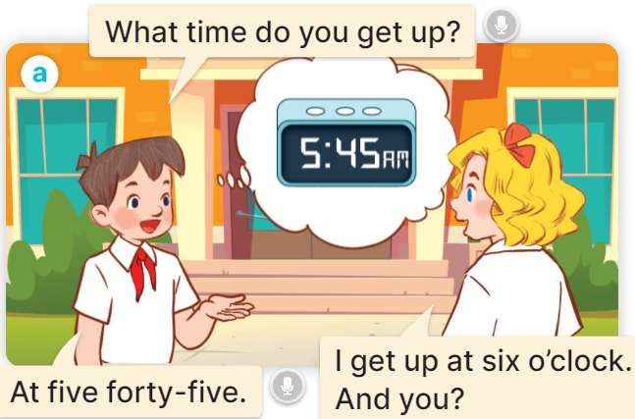  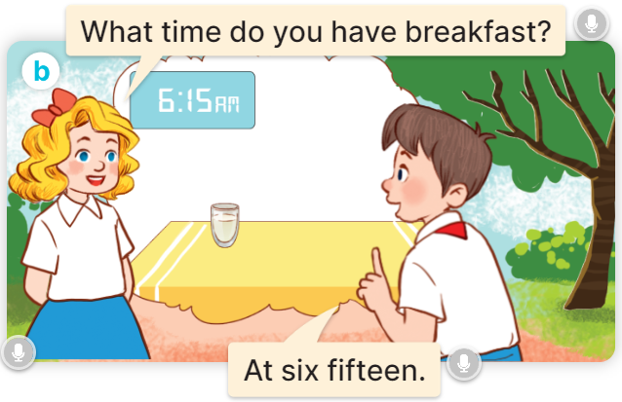  - Play the audio twice (sentence by sentence). Correct their pronunciation where necessary.  - Have Ss to practice the dialogue  - T invites a few pairs to the front of the class to practice.  - T checks pronunciation for ss.  Activity 3 Listen, point and say.  *Aims: Ss will be able to correctly say the phrases and use What time do you ……? – I ……. at ………. to ask and answer questions about daily routines.  *Procedure:  * Model sentences:  - T asks Ss look at picture a and helps Ss know the structure from the dialogue.  - T introduces new structure for Ss.  - T explains, models and gives meaning.  -Have Ss repeat the model sentences.  A: What time do you get up?  B: I get up at six o’clock.  3.Practice: (7’)  *Drill pictures  - Elicit and check comprehension the activities and the time from them.  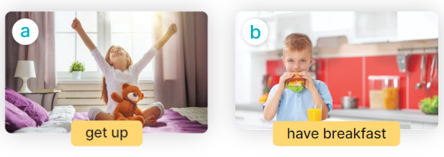  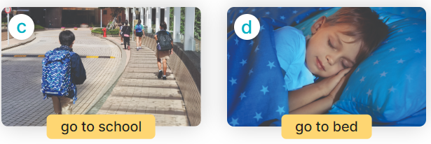  - Run through all the pictures.  - Run through model sentences.  + Run through the questions.  + Run through the answers.  - Have Ss to practise:  + T asks the first – Ss answer (change role).  + Ss – Ss (change role).  - Ask Ss to work in pairs to ask and answer the question What time do you….? I……at…  - T controls and corrects.  - Invite a few pairs to come to the front of the classroom, point at the relevant character in each picture, and act out his/her role.  - Encourage Ss to practise speaking English.  - T gives feedbacks.  4.Production: (7’)  Activity 4. Let’s talk.  *Aims: Ss will be able to enhance the correct use of What time do you …..? – I …… at ……... to ask and answer questions about pupils’ daily routines in a freer context.  *Procedure:  - Have pupils look at the picture and explain that Nam and Lucy are asking and answering questions about Lucy’s daily routines.  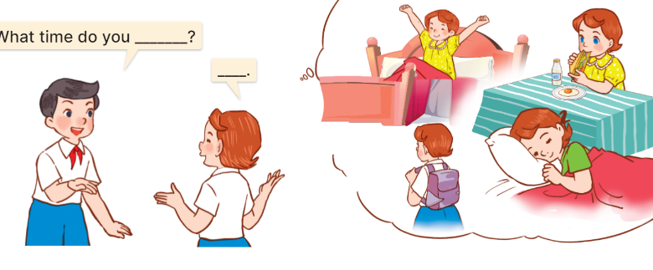  - T asks Ss look at the first speech bubble and ask What time do you get up?  - Get Ss to repeat the question and the answer several times in pairs.  - T models: Go around the classroom, pointing to Ss and asking What time do you……?  - Ask Ss ask and answer the question What time do you …..? – I ……at ………..  - Invite some groups to perform in front of the class.  - Give feedbacks  *Consolidation  *Aims: Ss will be able consolidate and wrap up the content of the lesson.  *Procedure:  - T asks ss to answer the following questions:  + What have you learnt from the lesson today?  +What are the core values of the lesson? (if the teacher can take from the lesson).  - T review the vocabulary and model sentences.  - T praises some Ss who are hardworking / active/ good…. as well as encourage others to try more.  5. Homework. (2’)  - Learn the vocabulary and model sentences by heart  - Prepare the new lesson: Unit 2, Lesson 2 (4,5,6). | - Ss listen.  - Ss play the game  - Ss open their books  -Ss listen and answer  - - Ss listen and repeat  + Choral repetition (3 times).  + Individual repetition (3 ss)  - Ss take note  - Ss look, remember and write  -Look at the pictures and get to know the characters in the pictures.  + In picture a: Minh asks: What time do you get up? And Mary answers: I get up at six o’clock. And you?  Minh answers: At five forty five.  + In pucture b: Mary asks: What time do you have breakfast? And Minh answers: At six fifteen.  -Ss listen and repeat in chorus (twice)  -Ss work in pairs to practice  -Ss practice the dialogue  -Ss listen  -Ss look at the picture and answer.  -Ss listen  -Ss listen and repeat  -Ss repeat to the introduce and respond to greetings.  -Ss look at the picture and answer  + In picture a: a girl is getting up; a clock shows 5:00 AM  + In picture b: a boy is having breakfast; a clock shows 6:15 AM  + In picture c: a pupil is going to school; a clock shows 1:15 PM  + In picture d: a boy is sleeping in bed; a clock shows 9:00 PM  - Ss look, listen and repeat  - Ss practice in chorus  - Ss practice in chorus  -Ss work in pairs to practice  -Ss take turns pointing at the pictures, asking and answering the question in front of the class.  -Ss note  -Ss look at the picture and listen  -Ss look and answer  + I get up at five fifteen.  -Ss repeat the question and answer  -Ss ask and answer  - Ss ask and answer the question  - Ss perform in front of the class.  -Ss answer the questions  - Ss listen  -Ss listen and clap their hands  -Ss listen and take note
D. ADJUSTMENTS (if necessary):
………………………………………………………………………………………….…..……………………………………………………………………………...
---------------------------------------------------------------------
Grade 4: Lớp 4A: Chiều thứ Tư, Ngày 01 tháng 10 năm 2025
ENGLISH
Unit 2: Time and daily routines
Lesson 2 (4,5,6)
A. OBJECTIVES:
By the end of the lesson, Ss will be able to:
1. Knowledge:
- Listen to and understand four communicative contexts in which pupils ask and answer questions about daily routines and number the correct pictures.
- Complete four gapped exchanges with the help of picture cues.
- Sing the song What time do you go to school? with the correct pronunciation, rhythm, and melody.
- Vocabulary: Review
- Skills: speaking, listening, reading and writing.
2. Competences:
- Critical Thinking: self-introduce
- Communication and collaboration: work in pairs and groups to complete the learning tasks.
- Self-control and independent learning: perform listening tasks.
3. Attitude/ Qualities:
- Kindness: Help partners to complete learning tasks.
- Show their responsibility by noticing the time and follow the timetable on time.
- Diligence: complete learning tasks.
B. TEACHING AIDS:
- Teacher: Teacher’s guide Pages 37,38,39; audio Tracks 21, 22; website hoclieu.vn, posters, laptop, pictures, textbook, lesson plan, TV or projector.
- Students: Pupil’s book Page 19, notebooks, workbooks, school things.
C. PROCEDURES:
Teacher’s activities | Students’ activities
1.Warm- up: (5’)  Game: Magic wheel  *Aims: to create a friendly and active atmosphere in the class to beginning the lesson.  *Procedure:  - Press “Spin” to play.  - If pupils have the correct answer, they will get the points shown on the slide.  - The team having higher scores will be the winner at the end of the game.  - Say “Open your book page 19” and look at “Unit 2, Lesson 2 (4,5,6)”.  2.Practice: (27’)  Activity 1. Listen and number:  *Aims: Ss will be able to listen to and understand four communicative contexts in which pupils ask and answer questions about daily routines and number the correct pictures.  *Procedure:  - Elicit the activities and the time in the pictures  - Draw pupils’ attention to the boxes at the bottom right-hand corners of the pictures.  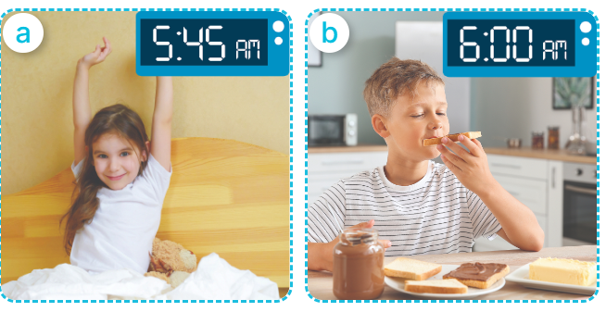  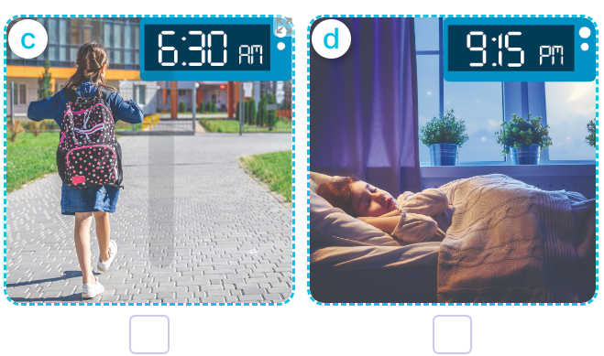  - T ask Ss to guess the answers.  + T writes Ss’guessing on the board.  - Listen to the tape:  + Play the recording  + Play the recording again and get Ss to swap books with their partners.  + Play the recording again to check answers together as a class.  + Write the answers on the board for Ss to correct their answers. Then checks Ss’ guessing.  - Play the recording, sentence by sentence, for the class to listen and repeat in chorus.  Key: 1. d 2. c 3. a 4. b  Activity 2. Look, complete and read.  *Aims: Ss will be able complete four gapped exchanges with the help of picture cues.  *Procedure:  - Get Ss to look at the pictures and identify the ages  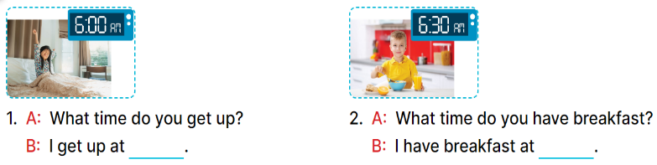  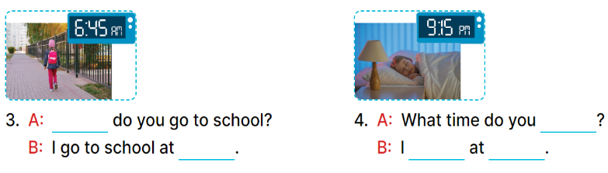  - Have Ss look at the four incomplete sentences and elicits the missing words in the sentences.  - T models with sentence 1  + Ask Ss what is missing in the sentence.  + Have Ss look at the picture and complete the gap, then read the completed sentence in chorus.  -Have Ss work in groups and complete the sentence 2, 3, 4.  - Ask a few Ss to stand up and read the completed sentences aloud.  -T gives feedbacks.  Key:  1. six o’clock 2. six thirty  3. What time; six forty-five  4. go to bed; go to bed; nine fifteen  Activity 3. Let’s sing.  *Aims: Ss will be able to sing the song What time do you go to school? with the correct pronunciation, rhythm, and melody.  *Procedure:  - Introduce the title and lyrics of the song:  “ What time do you go to school?” song.  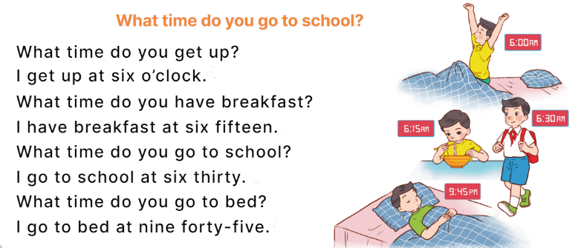  - Play the recording for Ss to listen to the whole song.  + Have them repeat the title and lyrics line by line.  - Play the recording all the way through for Ss to listen to pronunciation and melody of the song.  - Play the recording line by line for Ss to listen, repeat  - Play the recording for Ss to sing and do actions.  - Ask Ss to practice singing and doing actions in pairs or groups.  - Invite groups to the front of the classroom to perform the song  -T gives feedback.  *Consolidation  *Aims: Ss will be able consolidate and wrap up the content of the lesson.  *Procedure:  - T asks ss to answer the following questions:  + What have you learnt from the lesson today?  +What are the core values of the lesson? (if the teacher can take from the lesson).  - T praises some Ss who are hardworking / active/ good…. as well as encourage others to try more.  3. Homework. (3’)  - Prepare the new lesson: Unit 2, Lesson 3 (1,2,3). | - Ss listen  -Ss play game  - Ss open their books  -Look at the pictures and say:  + Picture a: a girl getting up at 5:45 a.m.  + Picture b: a boy having breakfast at 6:00 a.m.  + Picture c: a girl going to school at 6:30 a.m.  + Picture d: a girl is in bed at 9:15 p.m.  -Ss guess the answers  - Ss listen to the tape and write number  - Ss listen again, write and swap books with their partners.  - Ss check their answers together  -Ss write the correct answers and check ss’ answers  -Ss listen and repeat.  -Ss look at the pictures and say:  + A boy is holding a birthday cake with number 7 in picture a  + A girl is holding a birthday cake with number 8 in picture b  +A girl is holding a birthday cake with number 9 in picture b  - Ss listen and answer  -Ss answer: I get up at six o’clock.  -Ss look, complete and read the completed sentence in chorus.  -Ss complete the sentence  -Ss read the sentence aloud  -Ss look and listen to the teacher  -Ss listen to the song  - Ss listen and repeat line by line without the action.  -Ss listen to melody of the song  - Ss listen and sing line by line.  - Ss sing and do actions.  - Ss work in groups (two groups) to sing.  -Ss perform in front of the class.  -Ss listen  -Ss listen to the teacher.  -Ss answer the questions  -Ss listen and clap their hands  -Ss listen and take note
D. ADJUSTMENTS (if necessary):
………………………………………………………………………………………….…..……………………………………………………………………………...………………………………………….…..………………………………………
----------------------------------------------------
Grade 4: Lớp 4A: Sáng thứ Sáu, Ngày 03 tháng 10 năm 2025
ENGLISH
Unit 2: Time and daily routines
Lesson 3 (1, 2, 3)
A. OBJECTIVES:
By the end of the lesson, Ss will be able to:
1. Knowledge:
- Correctly repeat the sounds of the letters t and d in isolation, in the words get and bed, and in the questions What time do you get up? and What time do you go to bed?
- Identify the sounds of the letters t and d in sentences while listening.
- Say the chant with the correct rhythm and pronunciation.
- Vocabulary: Review
- Skills: speaking, listening, reading and writing.
2. Competences:
- Co-operation: ready to help friends in pair work/ group work.
- Sociability: Talk to each other, say good words to others.
3. Attitude/ Qualities:
- Kindness: Help partners to complete learning tasks.
- Honesty: tell the truth about feelings and emotions
B. TEACHING AIDS:
- Teacher: Teacher’s guide Pages 39, 40; audio Tracks 23, 24, 25; website hoclieu.vn, posters, laptop, pictures, textbook, lesson plan, TV or projector.
- Students: Pupil’s book Page 20, notebooks, workbooks, school things.
C. PROCEDURES:
Teacher’s activities | Students’ activities
1.Warm- up: (5’)  Game: Pass the ball  *Aims: to create a friendly and active atmosphere in the class to beginning the lesson.  *Procedure:  - T gives Ss a ball.  - T asks Ss to listen to music and transfer a ball around the class.  - When the music stops, Ss who keep a ball have to answer the question using: What time do you …….and I ……..  - T gives feedback.  - Say “Open your book page 20” and look at “Unit 2, Lesson 3 (1,2,3)”.  2. Presentation (9’)  Activity 1. Listen and repeat:  *Aims: Ss will be able to correctly repeat the sounds of the letters t and d in isolation, in the words get and bed, and in the questions What time do you get up? and What time do you go to bed?  *Procedure:  - T gives instruction to the letter t and d, the word get and bed , and the sentences What time do you get up? and What time do you go to bed?  - Have pupils look at the letter t, d, listen to the recording and repeat the letter until they feel confident.  - Have pupils point at the word get, listen to the recording and repeat the word until they feel confident.  - Get pupils to point at the sentence What time do you get up?, What time do you go to bed?  listen to the recording and repeat it several times.  - Invite a few pupils to stand up to listen to and repeat the sentence.  - Give pupils a time limit to practise pronouncing the letters, saying the words, and reading the sentences in pairs or groups.  3.Practice: (19’)  Activity 2. Listen and circle.  *Aims: Ss will be able to identify the sounds of the letters t and d in sentences while listening.  *Procedure:  - Have pupils read the incomplete sentences.  - Explain that they must listen to the recording and circle the correct options to complete the sentences.  - Play the recording and have pupils listen and circle the correct options.  - Get pupils to swap books with a partner to check their answers before checking as a class.  - Invite a few pupils to stand up and read the completed sentences.  Key: 1.c 2.a  Activity 3. Let’s chant  *Aims: Ss will be able to say the chant with the correct rhythm and pronunciation.  *Procedure:  - Introduce the title and lyrics of the chant.  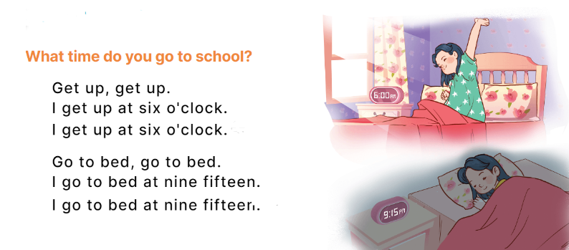  - Play the recording for Ss to listen to the whole chant.  + Have them repeat the title and lyrics line by line.  + Ask Ss to attend to the sounds of the letters t and d and the words get and bed.  - Play the recording all the way through for Ss to listen to pronunciation and melody.  - Play the recording line by line for Ss to listen and repeat  - Play the recording for Ss to chant and clap along.  - Ask Ss to practice chant and clap along in pairs or groups.  - Invite groups to the front of the classroom to perform the chant  -T gives feedback.  *Consolidation  *Aims: Ss will be able consolidate and wrap up the content of the lesson.  *Procedure:  - T asks ss to answer the following questions:  +What are the core values of the lesson? (if the teacher can take from the lesson).  - T review the vocabulary and model sentences.  - T praises some Ss who are hardworking / active/ good…. as well as encourage others to try more.  4. Homework. (2’)  - Practice the chant more.  - Draw and colour a paper birthday cake.  - Prepare the new lesson: Unit 2, Lesson 3 (4,5,6). | - Ss listen  -Ss listen the rules  - Ss play the game  - Ss open their books  - Ss recognize the differences about color of letter  - - Ss listen and repeat  - Ss listen, point and repeat  - Ss listen again and repeat  -Ss listen again and repeat  -Ss practice in pairs/ groups  -Ss listen and say:  + Number 1: I……..at six thirty.  + Number 2:I …..at five forty-five.  -Ss listen  - Ss listen to the tape and circle  - Ss listen again, circle and swap books with their partners.  -Ss read the sentences  - Ss look and listen.  -Ss listen to the chant  - Ss listen and repeat line by line without clap their hands  -Ss note the sounds, word  -Ss listen to melody of the song  - Ss listen and chant line by line.  - Ss chant and clap along.  - Ss work in groups (two groups) to chant  -Ss perform in front of the class.  -Ss listen  -Ss answer the questions  - Ss listen  -Ss listen and clap their hands  -Ss listen and take note
D. ADJUSTMENTS (if necessary):
………………………………………………………………………………………….…..……………………………………………………………………………...………………………………………………………………………………………
---------------------------------------------------
Grade 4: Lớp 4A: Sáng thứ Sáu, Ngày 03 tháng 10 năm 2025
ENGLISH
Unit 2: Time and daily routines
Lesson 3 (4,5,6)
A. OBJECTIVES:
By the end of the lesson, Ss will be able to:
1. Knowledge:
- Read and match the activities in a paragraph with the clocks showing the corresponding time.
- Complete a paragraph about pupils’ daily routines.
- Draw pictures of their daily routines at home and present them to the class by using the target language.
- Vocabulary: Review
- Skills: speaking, listening, reading and writing.
2. Competences:
- Critical Thinking: self-introduce
- Co-operation: ready to help friends in pair work/ group work.
- Self-control and independent learning: perform presentation skill.
3. Attitude/ Qualities:
- Kindness: Help partners to complete learning tasks.
- Honesty: tell the truth about feelings and emotions.
- Diligence: complete learning tasks.
B. TEACHING AIDS:
- Teacher: Teacher’s guide Pages 41,42; website hoclieu.vn, posters, laptop, pictures, textbook, lesson plan, TV or projector.
- Students: Pupil’s book Page 21, notebooks, workbooks, school things.
C. PROCEDURES:
Teacher’s activities | Students’ activities
1.Warm- up: (5’)  Game: “Chant”  *Aims: to review the vocabulary and structure about greet and respond to greetings.  *Procedure:  - Ask Ss chant and do the actions in Unit 2, Lesson 3 page 20 in groups.  - Give point for the groups and encourage them.  - Say “Open your book page 21” and look at “Unit 2, Lesson 3 (4,5,6)”.  2.Practice: (8’)  Activity 1. Read and match:  *Aims: Ss will be able to read and match the activities in a paragraph with the clocks showing the corresponding time.  *Procedure:  - Show the pictures and ask Ss some questions:  + What’s this?  + What time is it?  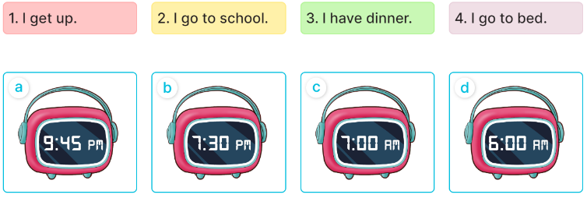  - Have pupils read the paragraph, the sentences, and the time on the clocks.  - Model Sentence 1 (clock d).  - Set a time limit for pupils to do the activity independently.  - Get pupils to swap books with a partner and check their answers before checking as a class.  - Invite some pupils to stand up to read the paragraph aloud.  -Tgives feedback.  Key: 1. d 2. c 3. b 4. a  3.Production: (19’)  Activity 2. Let’s write  *Aims: Ss will be able to complete a paragraph about pupils’ daily routines *Procedure:  - Tell pupils what they are going to do.  - Ask pupils what the paragraph is about (daily routines).  - Set a time limit for pupils to complete the paragraph independently.  - Get pupils to swap books and check their answers in pairs or groups before checking as a class.  - T gives feedback.  .Key: Pupil’s answer  Ex: I get up at six o’clock. I have breakfast at seven o’clock. I go to school at seven fifteen. What about you? What time do you go to school?  Activity 3. Project.  *Aims: Ss will be able to draw pictures of their daily routines at home and present them to the class by using the target language.  *Procedure:  - Ask Ss to draw pictures of their daily routines at home as homework before learning Unit 2 -Lesson 3 (4,5,6)  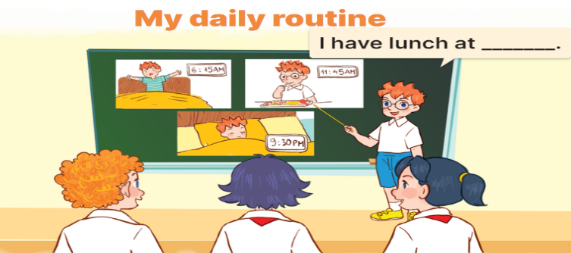  - Explain that pupils have to show simple pictures of their daily routines (getting up, having breakfast, etc.)  - Invite a pupil to the front of the class to model the presentation.  - Put the key presentation language on the board (ex: I get up at six fifteen.).  - Have pupils repeat the key presentation language a few times to make them feel confident when they present their daily routines before an audience.  - Set a time limit for pupils to work in groups.  - Invite a few pupils to the front of the class to present the project.  *Consolidation  *Aims: Ss will be able consolidate and wrap up the content of the lesson.  *Procedure:  - T asks ss to answer the following questions:  + What have you learnt from the lesson today?  +What are the core values of the lesson? (if the teacher can take from the lesson).  - T praises some Ss who are hardworking / active/ good…. as well as encourage others to try more.  4. Homework. (3’)  - Prepare the new lesson: Unit 3, Lesson 1 (1,2,3). | - Ss listen and chant  - Ss open their books  - Ss look at the pictures and answer  -Ss read and match  -Ss listen  -Ss do the activity and match  -Ss swap books and check their answer  -Ss read the paragraph aloud.  -Ss listen  -Ss listen to the teacher  -Ss listen and answer  -Ss complete the paragraph  -Ss swap books and check their answers  -Ss listen  - Ss draw pictures of their daily routines at home.  -Ss listen to the teacher  -Ss pay attention  -Ss repeat the key presentation  -Ss work in groups  -Ss present the project  -Ss answer the questions  -Ss listen and clap their hands  -Ss listen and take note
D. ADJUSTMENTS (if necessary):
………………………………………………………………………………………….…..……………………………………………………………………………...
----------------------------------------------------
Grade 5: Lớp 5A: Sáng thứ Ba, Ngày 30 tháng 9 năm 2025
Lớp 5B: Chiều thứ Hai, Ngày 29 tháng 9 năm 2025
Lớp 5C: Sáng thứ Ba, Ngày 30 tháng 9 năm 2025
ENGLISH
Unit 2: Our homes - Lesson 2 (1, 2, 3)
A. OBJECTIVES:
By the end of the lesson, Ss will be able to:
1. Knowledge:

- Understand and correctly repeat the sentences in two communicative contexts focusing on asking and answering questions about someone’s home and address

- Correctly say the words and use What’s your address? – It’s ____. to ask and answer questions about someone’s address

- Use What’s your address? – It’s __________. to ask and answer questions about someone’s address.

- Vocabulary: address, 45, 23, 38, 93 and 116
- Structures: A: What’s your address?
B: It’s 45 Ba Trieu Street.
- Skills: speaking and listening
2. Competences:
- Critical thinking and creativity: learn how to ask and answer questions about personal information correctly and fluently.
- Self-control and independent learning: perform pronunciation and speaking tasks.
3. Attitude/ Qualities:
- Show their pride in their personal information and where they live.
B. TEACHING AIDS:
- Teacher: Teacher’s guide Pages 38, 39, 40, audio Tracks 18, 19, website hoclieu.vn, posters, laptop, pictures, textbook, lesson plan, TV or projector.
- Students: Students’ book Page 18, notebooks, workbooks, school things.
C. PROCEDURES:
Teacher’s activities | Students’ activities
1.Warm- up and review: (3’)  Game: Roll the dice  *Aims: to revise the words about different types of homes.  *Procedure:  - Divide the class into groups of six. Have each student count the numbers from one to six.  - Ask a student from each group to roll the dice to choose a student asking the question.  - Ask that student to put up a picture and ask the question and invite another student of the group to answer the question about their homes.  - The student who answers the correct answers will continue rolling the dice.  - Say “Open your book page 18” and look at “Unit 2, Lesson 2 (1,2,3)”.  2. Presentation (15’)  Activity 1. Vocabulary.  *Aims: Ss will be able to know the vocabulary in the new lesson.  *Procedure:  -T elicits the new words  + address : địa chỉ (situation)  + twenty- three : số 23 (picture)  + thirty- eight : số 38 (picture)  +ninety- three : số 93 (picture)  +forty- five : số 45 (picture)  - T models (3 times).  - T writes the words on the board.  - Checking: Rub out and remember  Activity 2. Look, listen and repeat:  *Aims: Ss will be able to understand and correctly repeat the sentences in two communicative contexts (pictures) focusing on asking and answering questions about someone’s home and address.  *Procedure:  - Have Ss look at Pictures a and b and identify the characters and say what they are talking about.  + Who is he/ she?  + Where is he/ she?  + What are they talking about?  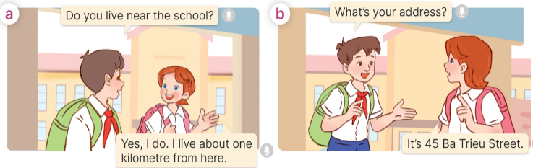  - Play the audio twice (sentence by sentence). Correct their pronunciation where necessary.  - Have Ss to practice the dialogue  - T invites a few pairs to the front of the class to practice.  - T checks pronunciation for ss.  Activity 3 Listen, point and say.  *Aims: Ss will be able to correctly say the words and use What’s your address? – It’s _____. to ask and answer questions about someone’s address.  *Procedure:  * Structures:  - T asks Ss look at picture b in activity 1 and helps Ss know the structure from the dialogue.  - T introduces new structures for Ss.  - T explains, models and gives meaning.  - Have Ss repeat the model sentences.  A: What’s your address??  B: It’s 45 Ba Trieu Street.  3.Practice: (7’)  *Drill pictures  - Have Ss look at the pictures and say what they can see in the pictures.  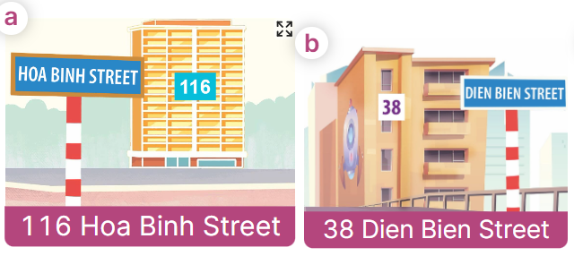  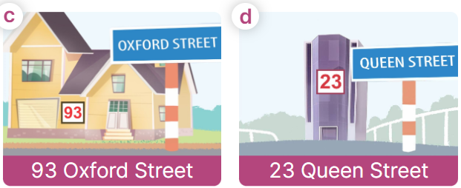  - Have Ss point at pictures, listen and run through all the pictures.  - Have Ss point at the bubbles, listen and run through model sentences.  - Have Ss to practise:  + T asks the first picture, Ss answer  + Ss asks the second picture, T answers  + Group A asks the third picture, group B  answers  + Group B asks the last picture, group A  - Ask Ss to work in pairs to practise asking and answering the question What’s your address? – It’s _____.  - T controls and corrects.  - Invite a few pairs to point at the pictures and say the questions and answers in front of the class.  4. Production: (6’)  Activity 4. Let’s talk.  *Aims: Ss will be able to use Do you live in ___? – Yes, / No, ___. and What’s your address? – It’s___. to ask and answer questions about someone’s address in a freer context.  *Procedure:  - Ask Ss to look at the pictures and elicit the addresses.  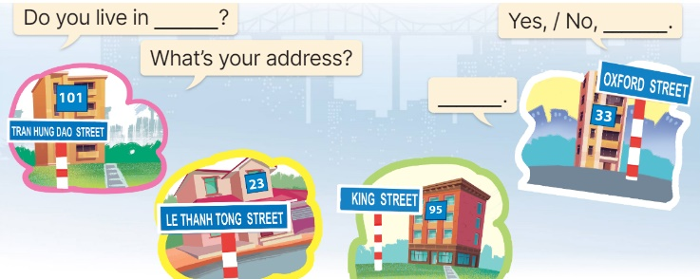  - Point at the ﬁrst building and elicit the question in the ﬁrst speech bubble Do you live in __? and the answer in the second speech bubble Yes, / No, ____. as an example. If the answer is No, then point at the question What’s your address?  - Give Ss time to work in pairs and take turns pointing at each picture to ask and answer using Do you live in ___? Yes, / No, __. and What’s your address? – ___.  - Invite a few pairs to come to the front of the classroom and act out the exchanges.  5. Fun corner and wrap- up (4’)  Game: Racing  - Divide the class into three groups. Each group has equal numbers of Ss.  - Ask Ss to stand in lines. Set the timer.  - Ask the first pupil from each line What’s your address? he/ she must answer and in turn ask the second student in the line. The second pupil then answers and asks the third, and so on.  - The group which has the shortest time to finish asking and answering wins the game. | -Ss listen and pay attention  - Ss listen to the teacher  -Ss play the game  Ex: A: Do you live in this house?  B: Yes, I do.  -Ss continute playing the game  - Ss listen and open their books  -Ss listen and answer  - - Ss listen and repeat  + Choral repetition (3 times).  + Individual repetition (3 ss)  - Ss take note  - Ss look, remember and write  -Look at the pictures and say.  + In picture a:  Nam: Do you live near the school?  Lucy: Yes, I do. I live about one kilometre from here.  + In picture b:  Nam: What’s your address?  Lucy: It’s 45 Ba Trieu Street.  -Ss listen and repeat in chorus (twice)  -Ss work in pairs to practice  -Ss come to the front of the classroom to practice.  -Ss listen  - Ss look at the picture and answer.  -Ss listen  -Ss listen and repeat  -Ss repeat to the structures  - Ss look, listen and repeat  +Picture a: 116 Hoa Binh Street  + Picture b: 38 Dien Bien Street  + Picture c: 93 Oxford Street  + Picture d: 23 Queen Street  Notes:  We say: 116: one-sixteen or one-one-six.  Don’t say: one hundred and sixteen  -Ss point at pictures, listen and repeat  -Ss point at the bubbles, listen and repeat  -Ss practice in chorus  -Ss practice in chorus  -Ss work in pairs to practise asking and answering the question  - Pairs of Ss point at the pictures and say in front of the class  -Ss look at the picture and say  - Ss look at the first building and elicit the missing words in speech bubbles and say the completed sentences.  - Ss role-play to practise asking and answering questions  - Ss practise asking and answering questions in front of the class.  -Ss listen to the teacher  -Ss play the game  -Ss congratulate the winner
D. ADJUSTMENTS (if necessary):
………………………………………………………………………………………….…..……………………………………………………………………………...
---------------------------------------------
Grade 5: Lớp 5A: Sáng thứ Ba, Ngày 30 tháng 9 năm 2025
Lớp 5B: Chiều thứ Hai, Ngày 29 tháng 9 năm 2025
Lớp 5C: Sáng thứ Ba, Ngày 30 tháng 9 năm 2025
ENGLISH
Unit 2: Our homes
Lesson 2 (4, 5, 6)
A. OBJECTIVES:
By the end of the lesson, Ss will be able to:
1. Knowledge:
- Listen to and understand two communicative contexts in which speakers ask and answer questions about their addresses and circle the correct pictures.
- Complete two gapped dialogues with the help of picture cues.
- Listen to and complete the song Homes and to sing it with the correct pronunciation, rhythm and melody.
- Vocabulary: Review
- Skills: speaking, listening, reading and writing.
2. Competences:
- Communication and collaboration: work in pairs and groups to complete the learning tasks.
- Self-control and independent learning: perform listening and reading tasks.
3. Attitude/ Qualities:
- Show their pride in their personal information and where they live.
B. TEACHING AIDS:
- Teacher: Teacher’s guide Pages 40, 41, 42; audio Tracks 20, 21; website hoclieu.vn, posters, laptop, pictures, textbook, lesson plan, TV or projector.
- Students: Student’s book Page 19, notebooks, workbooks, school things.
C. PROCEDURES:
Teacher’s activities | Students’ activities
1.Warm- up and review: (5’)  “Listen and choose the number”  *Aims: to revise the learned numbers.  *Procedure:  - Ask Ss to take out the board and chalk or marker.  - Play the audio and have Ss listen to the audio and write the number they hear in 5 seconds.  - Ask Ss to hold the board up to show the answer.  - Check the answer with the whole class.  - Say “Open your book page 19” and look at “Unit 2, Lesson 2 (4,5,6)”.  2.Practice: (25’)  Activity 1. Listen and circle:  *Aims: Ss will be able to listen to and understand two communicative contexts in which speakers ask and answer questions about their addresses and circle the correct pictures.  *Procedure:  - Draw Ss’ attention to the pictures and ask questions to elicit the addresses  + What can you see in this picture?  + Is it at 67 Tay Son street?  + Is it a flat?  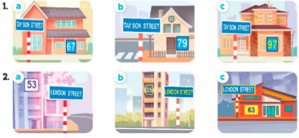  - T ask Ss to guess the answers.  + T writes Ss’guessing on the board.  - Listen to the tape:  + Play the recording  + Play the recording again for pupils to do the task.  + Play the recording a third time for pupils to check their answers.  - Get Ss to swap books with their partner, then check answers as a class.  + Write the answers on the board for Ss to correct their answers. Then checks Ss’ guessing.  - Play the recording, sentence by sentence, for Ss to listen and repeat individually and in chorus  Key: 1. b 2. a  Activity 2. Read and complete.  *Aims: Ss will be able to read and complete two gapped dialogues with the help of picture cues.  *Procedure:  - Have Ss read the dialogue. Draw Ss’ attention to the address and the distance from the address to the place.  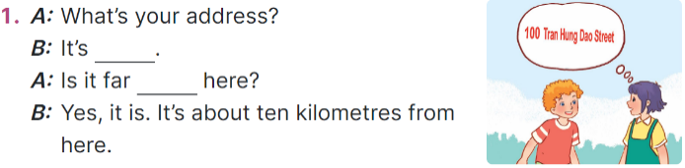  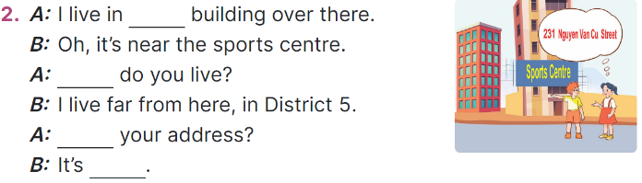  - Read the second dialogue. Point at the building and draw Ss’ attention to the boy’s hand toward the building on the left-hand side.  + Elicit the missing word (that).  - Give Ss a time limit to read the gapped dialogues, look at the pictures and fill in the gaps independently.  - Get Ss to swap books with a partner and check their answers before checking as a class.  + Invite one student to write the answers on the board.  - Invite two pairs of Ss to act out the completed dialogues.  Key: 1.100 Tran Hung Dao Street; from  2. that; Where; What’s;  231 Nguyen Van Cu Street  Activity 3. Listen, complete and sing.  *Aims: Ss will be able to listen to and complete the song Homes and to sing it with the correct pronunciation, rhythm and melody.  *Procedure:  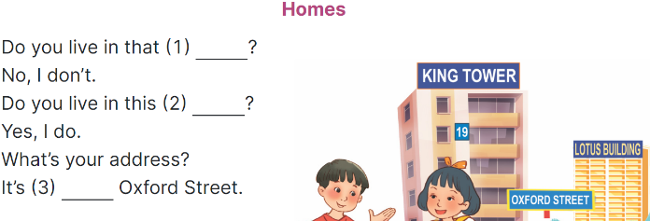  - Have Ss read the song lyrics and guess the missing words with the help of the picture.  + Give Number 1 as an example (building).  - Give a time limit for Ss to read and fill the gaps.  - Play the recording again for  Ss to check the answers.  - Play the recording again for Ss to listen and sing along before they practise singing the song.  3. Fun corner and wrap- up (5’)  Game: Lucky number  - Divide the class into 2 teams.  - Each team takes turns to choose the number and answer the question.  - T checks the answer with the whole class.  - Ss get the point(s) if they answer the question correctly.  - The team with more points is the winner. | - Ss take out the board and chalk or marker.  - Ss listen and write the numbers.  - Ss show the answer and check.  - Ss open their books  -Look at the pictures and say:  + Picture 1a: a private house at 67 Tay Son Street  + Picture 1b: a private house at 79 Tay Son Street  + Picture 1c: a private house at 97 Tay Son Street  + Picture 2a: a block of flats at 53 London Street  + Picture 2b: a block of flats at 35 London Street  + Picture 2c: a block of flats at 63 London Street  -Ss guess the answers  - Ss listen to the tape  - Ss listen again and do the task.  - Ss listen and check their answers  - Ss swap books with their partner, then check answers as a class.  -Ss check the guessing  -Ss listen and repeat  -Ss look at the picture and say  - Ss read the second dialogue.  - Ss follow the teacher’s instruction.  - Ss complete gapped independently.  - Ss swap books with a partner and check their answers.  +Ss write the answers  - Ss read the completed dialogues aloud  - Ss read the song and guess the missing words.  - Ss follow the teacher's instructions.  - Ss work individually, listen and complete.  - Ss listen to the recording to check their answers again.  - Ss listen and sing along.  -Ss listen to the teacher  - Ss play the game.  - Ss cheer up whenever the guess is correct.
D. ADJUSTMENTS (if necessary):
………………………………………………………………………………………….…..……………………………………………………………………………...
-------------------------------------------------
Grade 5: Lớp 5A: Sáng thứ Năm, Ngày 02 tháng 10 năm 2025
Lớp 5B: Sáng thứ Năm, Ngày 02 tháng 10 năm 2025
Lớp 5C: Sáng thứ Sáu, Ngày 03 tháng 10 năm 2025
ENGLISH
Unit 2: Our homes - Lesson 3 (1, 2, 3)
A. OBJECTIVES:
By the end of the lesson, Ss will be able to:
1. Knowledge:
- Correctly pronounce the two-syllable words with the stress on the second syllable as in ﬁf’teen and six’teen in isolation and as in the sentences I live at fifteen Ba Dinh Street; She lives at sixteen London Street
- Identify the stress on some two-syllable words and circle the word with a diﬀerent stress pattern from the other two words
- Say the chant with the correct pronunciation, word stress and rhythm.
- Vocabulary: Review
- Skills: speaking, listening, reading and writing.
2. Competences:
- Communication and collaboration: work in pairs and groups to complete the learning tasks.
- Self-control and independent learning: perform pronunciation and listening tasks.
3. Attitude/ Qualities:
- Show their pride in their personal home and address.
B. TEACHING AIDS:
- Teacher: Teacher’s guide Pages 42, 43, 44; audio Tracks 22, 23, 24; website hoclieu.vn, posters, laptop, pictures, textbook, lesson plan, TV or projector.
- Students: Students’ book Page 20, notebooks, workbooks, school things.
C. PROCEDURES:
Teacher’s activities | Students’ activities
1.Warm- up and review: (5’)  Game: Matching game  *Aims: to revise the number.  *Procedure:  - Explain how to play the game:  + Ss take turns to open two cards, trying to find the pairs of numbers (as numbers and words).  + If the cards don’t match, teacher clicks to turn them back.  + If the cards match, praise Ss and give them points for their team.  - Say “Open your book page 20” and look at “Unit 2, Lesson 3 (1,2,3)”.  2. Presentation (9’)  Activity 1. Listen and repeat:  *Aims: Ss will be able to correctly pronounce the two-syllable words with the stress on the second syllable as in ﬁf’teen and six’teen in isolation and as in the sentences I live at fif'teen Ba Dinh Street and She lives at six'teen London Street.  *Procedure:  - Have Ss point at the words ‘ﬁf’teen and six’teen and the sentences I live at fif'teen Ba Dinh Street and She lives at six'teen London Street.  - Play the recording for Ss to listen and repeat in chorus and individually until they feel confident.  - Let Ss work in pairs or groups, saying the words and reading the sentences.  - T invites some Ss to practice.  3.Practice: (17’)  Activity 2. Circle, listen and check.  *Aims: Ss will be able to identify the stress on some two-syllable words and circle the word with a diﬀerent stress pattern from the other two words  *Procedure:  - Tell Ss circle the word having a different stress from each line. Then listen to the recording to check their answers.  - Set a time for Ss to do the task.  - Play the recording, once or twice, for Ss to listen and check their answers.  - Get Ss to swap books with a partner and check their answers before checking as a class.  - Play the recording again for Ss to double-check their answers.  - Invite a few Ss to read aloud all the words in the three lines.  Key: 1.c 2.a 3.a  Activity 3. Let’s chant  *Aims: Ss will be able to say the chant with the correct pronunciation, word stress and rhythm.  *Procedure:  - Introduce the title and lyrics of the chant.  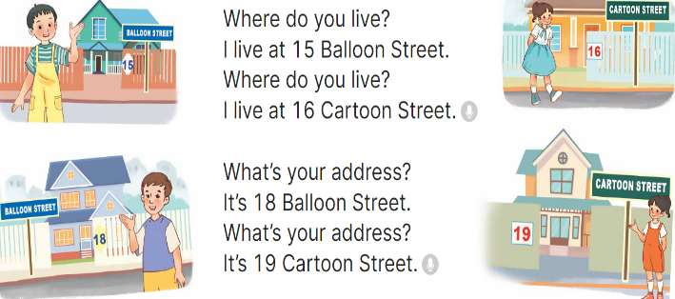  - Play the recording for Ss to listen to the whole chant.  + Have them repeat the title and lyrics line by line.  + Ask Ss to attend to two-syllable words with the stress on the first syllable in the chant, fifteen, sixteen, eighteen, nineteen, balloon and cartoon.  - Play the recording all the way through for Ss to listen to pronunciation and melody.  - Play the recording line by line for Ss to listen and repeat  - Play the recording for Ss to chant and clap along.  - Ask Ss to practice chant and clap along in pairs or groups.  - Invite groups to the front of the classroom to perform the chant  3. Fun corner and wrap- up (4’)  Game: Jumping  - Tell Ss they are going to play the game Jumping.  + If teacher reads a word that is the same as what she writes on the board, Ss jump. + If it is not, they keep still.  + Ask Ss to say the word written on the board.  - Ask Ss to stand at their desks.  - Write a number from the lesson and say a word. Have Ss play the game. | - Ss listen  -Ss listen the rules  - Ss play the game  - Ss open their books  - - Ss pay attention  - Ss listen to the recording again and repeat.  -Ss work in pairs and practice  -Ss say the language in front of the class  - Ss pay and listen to the teacher’s explanation.  - Ss do the task  - Ss listen to the recording to check their answers (individual)  - Ss swap books with a partner and check the answers  - Ss listen to the recording again and check their answers again.  - Ss stand up and read aloud the words.  - Ss look and listen.  - Ss listen to the chant  - Ss listen and repeat line by line without clap their hands  - Ss note the rhythm and pronunciation.  -Ss listen to melody of the chant  - Ss listen and chant line by line.  - Ss chant and clap along.  - Ss work in groups (two groups) to chant  -Ss perform in front of the class.  -Ss listen  -Ss listen  -Ss play the game
D. ADJUSTMENTS (if necessary):
………………………………………………………………………………………….…..……………………………………………………………………………...………………………………………….…..………………………………………
-----------------------------------------------
Grade 5: Lớp 5A: Sáng thứ Năm, Ngày 02 tháng 10 năm 2025
Lớp 5B: Sáng thứ Năm, Ngày 02 tháng 10 năm 2025
Lớp 5C: Sáng thứ Sáu, Ngày 03 tháng 10 năm 2025
ENGLISH
Unit 2: Our homes
Lesson 3 (4, 5, 6)
A. OBJECTIVES:
By the end of the lesson, Ss will be able to:
1. Knowledge:
- Read a letter and show understanding by deciding if the sentences are true or false
- Write the answers to the guiding questions based on their personal information
- present the results of a survey of pupils’ homes to the class.
- Vocabulary: Review
- Skills: speaking, listening, reading and writing.
2. Competences:
- Communication and collaboration: work in pairs and groups to complete the learning tasks.
- Self-control and independent learning: perform reading and writing tasks.
3. Attitude/ Qualities:
- Show their knowledge about houses and addresses.
B. TEACHING AIDS:
- Teacher: Teacher’s guide Pages 44, 45; website hoclieu.vn, posters, laptop, pictures, textbook, lesson plan, TV or projector.
- Students: Student’s book Page 21, notebooks, workbooks, school things.
C. PROCEDURES:
Teacher’s activities | Students’ activities
1.Warm- up and review: (5’)  Game: “Board race”  *Aims: to create a friendly and active atmosphere in the class to beginning the lesson.  *Procedure:  - T numbers the students in each team.  - T plays the recording then calls out the number, the ss of that number from each team comes to the board, write the number they hear and read it aloud.  - Say “Open your book page 21” and look at “Unit 2, Lesson 3 (4,5,6)”.  2.Practice: (8’)  Activity 1. Read and tick True or False:  *Aims: Ss will be able to read a letter and show understanding by deciding if the sentences are True or False.  *Procedure:  - Tell Ss the goal of the activity and explain that they should read the letter and tick True or False for the sentences provided.  - Model number 1. Have Ss read the sentence number 1; then scan the letter above quickly to find the correct fact (Sydney). Then tell them to compare with the information given in the sentence provided (London). Tell the Ss to tick the box False.  - Set a time limit for Ss to do the task independently.  - Get Ss to swap books with a partner and check their answers before checking as a class.  - Invite one or two Ss to read aloud the letter.  Key: 1. F 2. T 3. T 4. F 5. F  3.Production: (18’)  Activity 2. Let’s write  *Aims: Ss will be able to write the answers to guiding questions based on their personal information  *Procedure:  - Tell the class the goal of the activity and explain that they should read the questions and write the answers based on their personal information.  - Model question 1.  - Give Ss time to do the writing task independently.  - Get Ss to swap books with a partner and check their answers before checking as a class.  - Invite one or two Ss to stand up and read aloud their answers.  Key: Pupil’s answer  Ex: 1. Where do you live?  I live in the countryside.  2. What’s your address?  It’s Nghia Lam Village.  3. Where does your best friend live?  She lives in the city.  4. What’s his/her address?  It's 77 Nghia Lam Road.  Activity 3. Project.  *Aims: Ss will be able to present the results of a survey of pupils’ homes to the class.  *Procedure:  - Check Ss’ preparation of their survey.  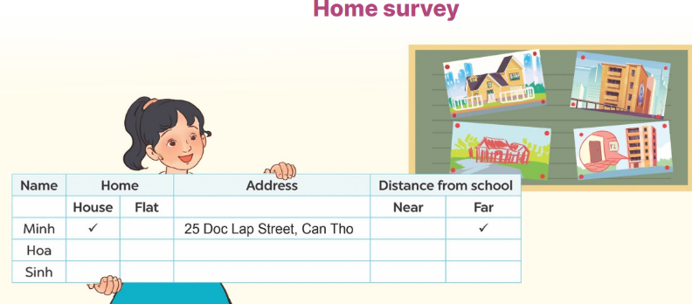  - Invite a student to report his / her survey with your help.  - Have Ss work in groups to practise reporting their own surveys.  - Invite a few Ss to report their surveys in front of the class.  - Praise Ss when they do a good job.  4. Fun corner and wrap- up (4’)  Game: Mystery Box  - Divide the class into two groups: Boys and Girls.  - In teams, Ss take turns to choose the letters and answer the questions.  + If they have the correct answers, they can give the mystery box or keep it to the other teams.  +The group with more points wins the game. | - Ss listen  - Ss listen to the rules  -Ss play game  - Ss open their books  - Ss listen to the teacher’s instruction.  - Ss read the letter as a class.  - Ss do sentence number 1  - Ss do the task individually.  - Ss swap books with a partner, and check answers  - One or two Ss read aloud the letter.  - Ss listen to the teacher’s explanation.  - Ss follow the teacher’s instructions.  - Ss do the task individually.  - Ss swap books and check their answers  - Ss read aloud their answers.  - Ss listen to the teacher’s instruction.  - One student does an example with the teacher’s help.  - Ss show their posters that they have made at home and tell the group about different types of homes.  - Ss show their work and talk  -Ss congratulate  -Ss listen to the teacher  -Ss play the game  -Ss congratulate the winner
D. ADJUSTMENTS (if necessary):
………………………………………………………………………………………….…..……………………………………………………………………………...

Duyệt bài, Ngày 26 tháng 9 năm 2023
Phó hiệu trưởng

Nguyễn Thị Hằng

