ĐĂNG KÝ GIẢNG DẠY TUẦN 3 ( Từ ngày 22-26/9/2025)

Thứ  Ngày | Buổi | Lớp | Tiết | Môn | Tên bài
Hai | Chiều | 5B | 1 | English | Unit 1: All about me - Lesson 3 (1,2,3)
Hai | Chiều | 5B | 2 | English | Unit 1: All about me - Lesson 3 (4,5,6)
Ba | Sáng | 5A | 1 | English | Unit 1: All about me - Lesson 3 (1,2,3)
Ba | Sáng | 5A | 2 | English | Unit 1: All about me - Lesson 3 (4,5,6)
Ba | Sáng | 5C | 3 | English | Unit 1: All about me - Lesson 3 (1,2,3)
Ba | Sáng | 5C | 4 | English | Unit 1: All about me - Lesson 3 (4,5,6)
Tư | Sáng | 2C | 1 | English | Unit 2: In the backyard - Lesson 2: 3,4,5
Tư | Sáng | 2C | 2 | English | Unit 2: In the backyard - Lesson 3: 6,7,8
Tư | Sáng | 2B | 3 | English | Unit 2: In the backyard - Lesson 2: 3,4,5
Tư | Sáng | 2B | 4 | English | Unit 2: In the backyard - Lesson 3: 6,7,8
Tư | Chiều | 4A | 1 | English | Unit 1: My friends - Lesson 3 (1,2,3)
Tư | Chiều | 4A | 2 | English | Unit 1: My friends - Lesson 3 (4,5,6)
Năm | Sáng | 5B | 1 | English | Unit 2: Our homes- Lesson 1 (1,2,3)
Năm | Sáng | 5B | 2 | English | Unit 2: Our homes- Lesson 1 (4,5,6)
Năm | Sáng | 5A | 3 | English | Unit 2: Our homes- Lesson 1 (1,2,3)
Năm | Sáng | 5A | 4 | English | Unit 2: Our homes- Lesson 1 (4,5,6)
Sáu | Sáng | 4A | 1 | English | Unit 2: Time and daily routines  Lesson 1 (1,2,3)
Sáu | Sáng | 4A | 2 | English | Unit 2: Time and daily routines  Lesson 1 (4,5,6)
Sáu | Sáng | 5C | 3 | English | Unit 2: Our homes- Lesson 1 (1,2,3)
Sáu | Sáng | 5C | 4 | English | Unit 2: Our homes- Lesson 1 (4,5,6)

Duyệt bài, Ngày 19 tháng 9 năm 2025
Phó hiệu trưởng

Nguyễn Thị Hằng

WEEK 3
Grade 2 : Lớp 2B, 2C: Sáng thứ tư, Ngày 24 tháng 9 năm 2025
LESSON PLAN
Unit 2. In the backyard
Lesson 2 – Period 2
I. OBJECTIVES
By the end of the lesson, pupils will be able to:
- say the letter K/k, the words kite, bike, kitten, the phrases/sentences containing /k/ and kite, bike, kitten, the sentence structure He’s/She’s _____ (verb + –ing). in a chant.
- listen and recognise the words kite, bite, kitten and the sentence structure He’s/She’s _____ (verb + –ing).
- write the letter K/k and complete the words __ite, bi__e, __itten.
II. INPUT
Language:
- Sound /k/
- Vocabulary: kite, bike, kitten
- Phrases/sentences with the sound /k/ and the words kite, bike, kitten
Resources/Material:
- Student’s book, page 10
- hoclieu.vn
- Teacher’s guide, pp. 16- 18
- Workbook, pp. 7-8
- Flashcards to play games in Warm-up
- Computer, projector

III. PROCEDURE
 | Warm-up – Listen and chant – Listen and circle – Look and write – Wrap-up
Procedure |  | Teaching and learning activities | Classroom management
Warm-up |  | 5 minutes
 |  | Option 1  - Ask pupils what letter and sound they learnt in Lesson 1.  - Show pictures of the words that pupils learnt in Lesson 1 (kite, bike, kitten) and encourage them to say the words aloud.  - For more advanced classes, ask pupils to find other words having the letter K/k (book, cake, duck, …). | Whole class
 |  | Option 2  Ask two groups of three to play Red words, green words with the target vocabulary they have learnt. | Group work
 |  | Option 3  Ask two groups of three to play Pelmanism with the words kite, bike, kitten in front of the class. | Group work
3. Listen and chant. 10 minutes
Step 1: |  | Draw pupils’ attention to the picture and have them point to the kite (say “Look at the picture. Point to the kite.”). | Whole class
Step 2: |  | Say “He’s ﬂying a kite.” and encourage pupils to repeat (say “Repeat, please!”). | Whole class
Step 3: |  | Repeat Steps 1 and 2 for He’s riding a bike. and She’s playing with a kitten. | Whole class
Step 4: |  | Play the recording of the chant to familiarize pupils with the words and rhythm  (say “Listen.”). | Whole class
Step 5: |  | Have pupils point to each line of the chant  (e.g. say “Point to line one.”). Play the recording of each line and encourage pupils to chant (say “Listen and chant.”). | Individual work  Whole class
Step 6: |  | Play the recording in full and encourage pupils to chant (say “Listen and chant.”). Pupils can clap along or do other actions to help them keep the rhythm. | Whole class
Step 7: |  | Divide the class into two teams. Teams take it in turns to chant a line. The whole class can clap along or do other actions. | Group work
Extension: |  | With better classes, help pupils change some line in the chant and sing it in front of the class. E.g.  K, k, kite.  A kite, a kite.  He’s flying a kite.  K, k, bike.  A bike, a bike.  She’s riding a bike. | Individual work
4. Listen and circle. 7 minutes
Step 1: |  | Have pupils look at the pictures and say the words (say “Point and say.”). When pupils answer correctly, confirm by saying “kite/ bike/ kitten/ puppy”. | Whole class
Step 2: |  | Play the recording and allow pupils time to complete the activity (say “Listen and circle.”). | Individual work
Step 3: |  | Play the recording again, if necessary (say “Listen again.”). | Individual work
Step 4: |  | Check the answers by asking “a or b?” When pupils answer correctly, confirm by saying  “1b. I have a bike.”/“2a. I have a kitten.” and encourage them to repeat. | Whole class  Individual work
Audio script: 1. I have a bike. 2. I have a kitten.
Answers: 1. b 2. a
5. Look and write. 8 minutes
Step 1: |  | Write the letter K (upper case) on the board and say “K” (/keɪ/). | Whole class
Step 2: |  | Write the letter K (upper case) on the board again, but this time more slowly. Invite a few pupils to come to the front of the class and write the letter K (upper case) on the board. | Individual work
Step 3: |  | Repeat Steps 1 and 2 for k (lower case). | Whole class  Individual work
Step 4: |  | Have pupils look at the writing grids (say “Look and write.”) Allow pupils time to complete the activity. Go around the class to offer support and feedback. | Whole class
Step 5: |  | Have pupils look at the picture and labels (say “Look and write.”). Allow pupils time to complete the activity. Go around the class to offer support and feedback. | Individual work
Extension: |  | For better pupils, have them do Activity 4,  Unit 2 in their workbooks. | Individual work
Wrap–up 5 minutes
 |  | Option 1  Have pupils listen to the recording, then say the chant again. | Whole class
 |  | Option 2  Ask pupils to look at the pictures in 4. Listen and circle and say about them, e.g. kite, kitten, ... Encourage better pupils to use learnt structure He’s/She’s _____ (verb + –ing). | Whole class
 |  | Option 3  To reinforce the vocabulary, get pupils to do Activity 1, Unit 1 in their workbooks. | Individual work
----------------------------------------------
Grade 2 : Lớp 2B, 2C: Sáng thứ tư, Ngày 24 tháng 9 năm 2025
LESSON PLAN
Unit 2. In the backyard - Lesson 3 – Period 3
I. OBJECTIVES
By the end of the lesson, pupils will be able to:
- Use the sentence structures Is he/ she _____ (verb + -ing)? and Yes, he/ she is. /No, he/ she isn’t. to ask and answer about actions in progress.
- Sing a song with the sentence structures Is he/she _____ (verb + -ing)? and Yes, he/ she is. /No, he/ she isn’t.
II. INPUT
Language:
- Is he/ she _____ (verb + -ing)?
- Yes, he/ she is. /No, he/ she isn’t.
Resources/Material:
- Student’s book, page 11
- hoclieu.vn
- Teacher’s guide, pp. 18 – 20
- Pictures/ Flashcards for Warm-up and Extension
- Workbook, page 9
- Computer, projector
III. PROCEDURE
 | Warm-up – Listen and repeat – Let’s talk – Let’s sing – Wrap-up
Procedure |  | Teaching and learning activities | Classroom management
Warm-up |  | 5 minutes
 |  | Option 1  - Have pupils listen to the recording, then sing the chant on Page 10.  - Select some better pupils to sing the chant in front of class. The class listens to them and claps hands along. | Whole class  Individual work
 |  | Option 2  Let two or three pupils point to the pictures in Listen and circle (Page 10) and say the sentences, e.g. 1a: I have a kite. 1b: I have a bike. | Individual work
 |  | Option 3  Get pupils to play What’s Missing? Game, using the pictures and flashcards with the incompleted words _ite, _itten and bi_e. Have pupils guess the missing letters and say the words correctly. | Group work
6. Listen and repeat. 5 minutes
Step 1: |  | Draw pupils’ attention to the picture (say “Look at the picture.”). | Whole class
Step 2: |  | Have pupils point to the sentence (say “Point to the sentence.”). Play the recording and encourage pupils to repeat (say “Listen and repeat.”). | Whole class
Step 3: |  | Ask pupils to repeat the sentence both individually and in chorus several times. Correct their pronunciation if necessary, and praise them when their pronunciation is good. | Whole class  Individual work
Step 4: |  | Ask pupils to work in pairs, repeat the questions and answers of the boy and the girl in the pictures. Go around and correct pronunciation to make sure pupils can repeat the sentence correctly. | Pair work
7. Let’s talk. 10 minutes
Step 1: |  | Write Is he/she _____? on the board. Underneath the question, write Yes, he/ she is. and No, he/ she isn’t. | Whole class
Step 2: |  | Draw pupils’ attention to Picture a. Say “Is he…?” and encourage them to complete the sentence with “ﬂying a kite”. | Whole class
Step 3: |  | Say “Is he ﬂying a kite?”. Point to each of the possible answers written on the board and encourage pupils to choose the correct one. When they answer correctly, confirm by saying “Yes, he is.” | Whole class
Step 4: |  | Repeat Steps 2 and 3 for Pictures b and c | Whole class
Step 5: |  | Have pupils work in pairs to look at each picture and practice asking and answering questions about the actions in progress. Go around the class to oﬀer support and feedback. | Pair work
Extension: |  | Show some pictures of action verbs (some pictures in Tiếng Anh 1 such as the boy is running, the girl is having noodles, ...). Have pupils ask and answer about the actions in progress, using the structures Is he/she _____ (verb + -ing)? and Yes, he/she is. /No, he/she isn’t. | Whole class  Group work
8. Let’s sing. 10 minutes
Step 1: |  | Draw pupils’ attention to the picture (say “Look at the picture.”). Say “Is she riding a bike?” and encourage pupils to answer “Yes, she is.” Say “Is he riding a bike?” and encourage pupils to answer “No, he isn’t.” | Whole class
Step 2: |  | Play the recording of the song to familiarize pupils with the rhythm and melody (say “Listen.”). | Whole class
Step 3: |  | Read the song line by line and encourage pupils to repeat (say “Listen and repeat.”). Do this several times, with pupils repeating both individually and in chorus. Correct their pronunciation if necessary, and praise them when their pronunciation is good. | Whole class  Individual work
Step 4: |  | Say “Let’s sing!”. Play the recording line by line and encourage pupils to sing along. | Group work
Step 5: |  | Have pupils work in groups to make up actions for the song. Invite a few groups to perform the song for the class. | Group work
Wrap–up 5 minutes
 |  | Revise the main teaching point of the lesson: the structures Is he/she _____ (verb + -ing)? and Yes, he/she is. /No, he/she isn’t. to talk about actions in progress. | Whole class
 |  | Option 1: Ask pupils to mime and talk about actions in progress, using the structures  Is he/she _____ (verb + -ing)? and Yes, he/she is. /No, he/she isn’t. | Whole class  Group work
 |  | Option 2: Have pupils do Activity 6, Unit 2 in their workbooks. | Individual work
 |  | Option 3: Show pupils the lyrics of the song with some missing words, e.g.:  Where’s Kate?  She’s in the yard.  Is she ______ a bike?  Yes, she is. Yes, she is.  Then ask some advanced pupils to guess the missing words and sing the complete song aloud. | Individual work
---------------------------------------------------
Grade 4: Lớp 4A: Chiều thứ Tư, Ngày 24 tháng 9 năm 2025
ENGLISH
Unit 1: My friends - Lesson 3 (1, 2, 3)
A. OBJECTIVES:
By the end of the lesson, Ss will be able to:
1. Knowledge:
-Ccorrectly pronounce the sounds of the letters a and ia in isolation, in the words America and Australia, and in the sentences I’m from America. and She’s from Australia.
- Use the words America, Australia, Britain, Japan, Malaysia, Singapore,
Thailand, and Viet Nam in relation to the topic “My friends”.
- Use Where are you from? – I’m from ……….. and Where’s he / she from?
– He’s / She’s from …………. to ask and answer questions about where someone comes from
- Listen to and demonstrate understanding of simple communicative contexts in relation to the topic “My friends”.
- Read and write about where someone comes from.
- Vocabulary: Review
- Skills: speaking, listening, reading and writing.
2. Competences:
- Communication and collaboration: work in pairs and groups to complete the learning tasks.
- Self-control & independent learning: perform listening tasks.
3. Attitude/ Qualities:
- Kindness: Help partners to complete learning tasks.
- Honesty: tell the truth about feelings and emotions
B. TEACHING AIDS:
- Teacher: Teacher’s guide Pages 26, 27, 28; audio Tracks 13, 14, 15; website hoclieu.vn, posters, laptop, pictures, textbook, lesson plan, TV or projector.
- Students: Pupil’s book Page 14, notebooks, workbooks, school things.
C. PROCEDURES:
Teacher’s activities | Students’ activities
1.Warm- up: (5’)  Game: Slap the board  *Aims: to create a friendly and active atmosphere in the class to beginning the lesson.  *Procedure:  - Divide class into 2 groups  - How to play:  + Each group chooses five Ss to play.  + Class will read aloud.  + Look at the picture, listen and slap the picture you heard.  + Who faster will get 1 mark.  + Which group with higher mark is the winner.  - T gives feedback.  - Say “Open your book page 14” and look at “Unit 1, Lesson 3 (1,2,3)”.  2. Presentation (9’)  Activity 1. Listen and repeat:  *Aims: Ss will be able to correctly pronounce the sounds of the letters a and ia in isolation, in the words America and Australia, and in the sentences I’m from America. and She’s from Australia.  *Procedure:  - T gives instruction to the letter a and ia, the word America and Australia the sentence I’m from America. and She’s from Australia  - Play the recording for the letter a, ia  - Encourage Ss to point at the letter/ word/ sentence while listening.  - Play the recording again and encourage Ss to listen and repeat.  - Have pupils work in pairs or groups to do this several times until Ss feel confident.  - T calls some Ss to practice.  - T gives feedbacks.  3.Practice: (19’)  Activity 2. Listen and circle.  *Aims: Ss will be able to identify the target words America and Australia while listening.  *Procedure:  - Elicit the sentences and the gap-fill options.  - T ask Ss to guess the answers.  + T writes Ss’guessing on the board.  - Listen to the tape:  + Play the recording  + Play the recording again and get Ss to swap books with their partners.  + Play the recording again to check answers together as a class.  + Write the answers on the board for Ss to correct their answers. Then checks Ss’ guessing.  - Play the recording, sentence by sentence, for the class to listen and repeat in chorus.  - Invite one or two Ss to stand up and read the completed sentences.  Key: 1.a 2.b  Activity 3. Let’s chant  *Aims: Ss will be able to say the chant with the correct rhythm and pronunciation.  *Procedure:  - Introduce the title and lyrics of the chant.    - Play the recording for Ss to listen to the whole chant.  + Have them repeat the title and lyrics line by line.  + Ask Ss to attend to the sounds of the letters a and ia and the words America and Australia.  - Play the recording all the way through for Ss to listen to pronunciation and melody.  - Play the recording line by line for Ss to listen and repeat  - Play the recording for Ss to chant and clap along.  - Ask Ss to practice chant and clap along in pairs or groups.  - Invite groups to the front of the classroom to perform the chant  -T gives feedback.  *Consolidation  *Aims: Ss will be able consolidate and wrap up the content of the lesson.  *Procedure:  - T asks ss to answer the following questions:  + What have you learnt from the lesson today?  +What are the core values of the lesson? (if the teacher can take from the lesson).  - T review the vocabulary and model sentences.  - T praises some Ss who are hardworking / active/ good…. as well as encourage others to try more.  4. Homework. (2’)  - Practice the chant more.  - Prepare the new lesson: Unit 1, Lesson 3 (4,5,6). | - Ss listen  -Ss listen the rules  - Ss play the game  - Ss open their books  - Ss recognize the differences about color of letter  - - Ss listen  - Ss listen and point  - Ss listen again and repeat  -Ss work in pairs and practice  -Ss practice in font of the class  -Ss listen  -Ss listen and say:  + Number 1: I’m from…..  + Number 2: He’s from…..  -Ss guess the answers  - Ss listen to the tape and circle  - Ss listen again, circle and swap books with their partners.  - Ss check their answers and guessing  -Ss listen and repeat.  -Ss read the sentences  - Ss read aloud the completed sentences.  - Ss look and listen.  -Ss listen to the chant  - Ss listen and repeat line by line without clap their hands  -Ss note the sounds, words  -Ss listen to melody of the song  - Ss listen and chant line by line.  - Ss chant and clap along.  - Ss work in groups (two groups) to chant  -Ss perform in front of the class.  -Ss listen  -Ss answer the questions  - Ss listen  -Ss listen and clap their hands  -Ss listen and take note
D. ADJUSTMENTS (if necessary):
………………………………………………………………………………………….…..……………………………………………………………………………...
---------------------------------------------------------------------
Grade 4: Lớp 4A: Chiều thứ Tư, Ngày 24 tháng 9 năm 2025
ENGLISH
Unit 1: My friends - Lesson 3 (4,5,6)
A. OBJECTIVES:
By the end of the lesson, Ss will be able to:
1. Knowledge:
- Correctly pronounce the sounds of the letters a and ia in isolation, in the words America and Australia, and in the sentences I’m from America. and She’s from Australia.
- Use the words America, Australia, Britain, Japan, Malaysia, Singapore,
Thailand, and Viet Nam in relation to the topic “My friends”.
- Use Where are you from? – I’m from ……….. and Where’s he / she from?
– He’s / She’s from …………. to ask and answer questions about where someone comes from
- Read and write about where someone comes from.
- Vocabulary: Review
- Skills: speaking, listening, reading and writing.
2. Competences:
- Critical Thinking: self-introduce
- Co-operation: ready to help friends in pair work/ group work.
- Self-control and independent learning: perform listening tasks.
3. Attitude/ Qualities:
- Kindness: Help partners to complete learning tasks.
- Honesty: tell the truth about feelings and emotions.
- Diligence: complete learning tasks.
B. TEACHING AIDS:
- Teacher: Teacher’s guide Pages 25, 26; website hoclieu.vn, posters, laptop, pictures, textbook, lesson plan, TV or projector.
- Students: Pupil’s book Page 15, notebooks, workbooks, school things.
C. PROCEDURES:
Teacher’s activities | Students’ activities
1.Warm- up: (5’)  Game: “ Backward spelling”  *Aims: to review the vocabulary and structure about greet and respond to greetings.  *Procedure:  - T divides class into teams.  - Each team takes turns to have a pupil stand in front of the board.  - The rest spell the word written by the teacher on the board backwards.  - The team that guesses the word first gets 1 point. The team with the most points is the winner.  Ex: N-A-P-A-J JAPAN  M-A-N-T-E-I-V VIETNAM  E-R-O-P-A-G-N-I-S SINGAPORE  - Say “Open your book page 15” and look at “Unit 1, Lesson 3 (4,5,6)”.  2.Practice: (8’)  Activity 1. Read and tick True or False:  *Aims: Ss will be able to read and show understanding the sentences by deciding if the  statements are true or false  *Procedure:  - Tell pupils the goal of the activity and explain that they should read the sentences and tick True or False.  - Model the first sentence. First, have pupils read the sentence and identify Minh’s age.  -Then have them read the text and find the correct information to tick the appropriate  box  - Set a time limit for pupils to do the task independently.  - Get pupils to swap their books with a partner and check their answers before checking as a class.  - Correct the answers where necessary.  - Invite one or two pupils to read the text and the sentences in front of the class.  -T gives feedbacks.  Key: 1. True 2. True 3. False 4. False  3.Production: (19’)  Activity 2. Let’s write  *Aims: Ss will be able to complete a gapped text about themselves and their friends  *Procedure:  - Tell and explain the class the goal of the activity.  - Explain that the gaps in the text focus on  their names and age(s), their friends’ names and where they are from  - Have pupils do the first gapped sentence together as an example.  - Give pupils time to complete the text independently.  - Get pupils to swap their books with a partner and check their answers before checking as a class.  - Invite one or two pupils to read their completed texts in front of the class.  Key:  1. Pupil’s answer  Activity 3. Project.  *Aims: Ss will be able to make pupil cards at home and present them to the class by using the target language  *Procedure:  - Stick the pupil card sample on the board and model with the name, age and country.  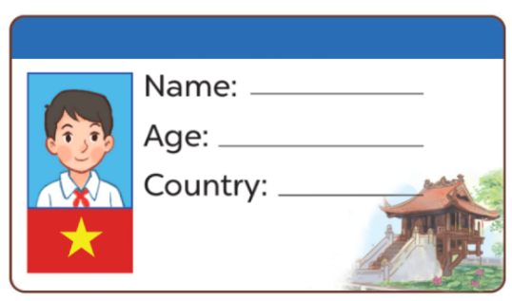  - T asks Ss to make their name cards and present them to their class.  - T asks ss to work in groups of five and do the project in class.  - Invite a few pupils to show their cards and tell the class about them.  - T gives feedback.  *Consolidation  *Aims: Ss will be able consolidate and wrap up the content of the lesson.  *Procedure:  - T asks ss to answer the following questions:  + What have you learnt from the lesson today?  +What are the core values of the lesson? (if the teacher can take from the lesson).  - T praises some Ss who are hardworking / active/ good…. as well as encourage others to try more.  4. Homework. (3’)  - Read again the text.  - Prepare the new lesson: Unit 2, Lesson 1 (1,2,3). | - Ss listen and answer  - Ss listen to the rules  -Ss play game  - Ss open their books  - Ss look at the sentences and listen  -Ss read and circle  -Ss read the text and tick  -Ss read again and tick  -Ss swap books and check  -Ss check the correct their answers  -Ss read the text in front of the class  -Ss listen  -Ss listen and pay attention  -Ss look, listen and pay attention  -Ss write their names in the gap.  -Ss complete the text  -Ss swap books and check their answers  -Ss read the completed texts in font of the class  - Ss look and listen  -Ss prepare necessary school things to carry out the project (paper, pens, pencils, coloured pencils, scissors , glue,…..)  -Ss make their name cards and present them to their class.  -Ss work in groups  -Ss present their cards  Ex: Hi. My name’s Huong. I’m from Viet Nam. This is Jenny. She’s nine years old. She’s from England. And this is Kate. He’s ten years old. He’s from Australia.  -Ss answer the questions  -Ss listen and clap their hands  -Ss listen and take note
D. ADJUSTMENTS (if necessary):
………………………………………………………………………………………….…..…………………………………………………………………………...
----------------------------------------------------
Grade 4: Lớp 4A: Sáng thứ Sáu, Ngày 26 tháng 9 năm 2025
ENGLISH
ENGLISH
Unit 2: Time and daily routines - Lesson 1 (1, 2, 3)
A. OBJECTIVES:
By the end of the lesson, Ss will be able to:
1. Knowledge:
- Understand and correctly repeat the sentences in two communicative contexts focusing on asking and telling the time.
- Correctly say the phrases and use What time is it? – It’s …….. to ask and tell the time.
- Enhance the correct use of What time is it? – It’s ………. to ask and tell the time in a freer context.
- Vocabulary: o’clock, thirty, forty five.
- Skills: speaking and listening
2. Competences:
- Oral Communication: speak about names, ask and answer the questions
- Co-operation: ready to help friends in pair work/ group work.
- Sociability: Talk to each other, say good words to others.
3. Attitude/ Qualities:
- Kindness: Help partners to complete learning tasks.
- Honesty: tell the truth about feelings and emotions
- Diligence: complete learning tasks
B. TEACHING AIDS:
- Teacher: Teacher’s guide Pages 30,31,32, audio Tracks 16,17, website hoclieu.vn, posters, laptop, pictures, textbook, lesson plan, TV or projector.
- Students: Pupil’s book Page 16, notebooks, workbooks, school things.
C. PROCEDURES:
Teacher’s activities | Students’ activities
1.Warm- up: (3’)  Game: Slap the board (with numbers)  *Aims: to create a friendly and active atmosphere in the class to beginning the lesson.  *Procedure:  - Divide the class into 3 teams. For each turn, invite 1 member from each team.  - Teacher says the numbers for the pupils to slap and say aloud.  - Give points to the pupils with the correct choice and encourage them.  - Sum up and lead in to the lesson.  - Say “Open your book page 16” and look at “Unit 2, Lesson 1 (1,2,3)”.  2. Presentation (16’)  Activity 1. Vocabulary.  *Aims: Ss will be able to know the vocabulary in the new lesson.  *Procedure:  -T elicits the new words  + o’clock : giờ đúng (translation)  + thirty : số 30 (picture)  + forty five : số 45 (picture)  + time : thời gian, giờ (translation)  - T models (3 times).  - T writes the words on the board.  - Checking: Rub out and remember  Activity 2. Look, listen and repeat:  *Aims: Ss will be able to understand and correctly repeat the sentences in two communicative contexts focusing on asking and telling the time.  *Procedure:  - Have pupils look at Pictures a and b and identify the characters in the pictures.  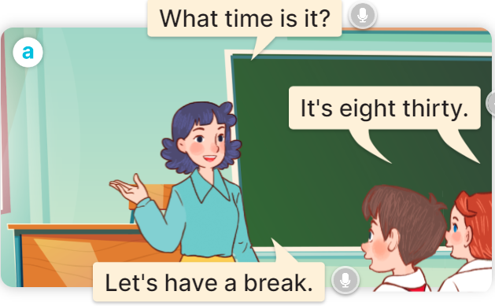  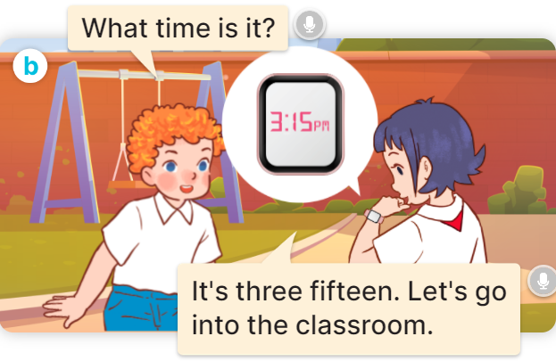  - Play the audio twice (sentence by sentence). Correct their pronunciation where necessary.  - Have Ss to practice the dialogue  - T invites a few pairs to the front of the class to practice.  - T checks pronunciation for ss.  Activity 3 Listen, point and say.  *Aims: Ss will be able to correctly say the phrases and use What time is it? – It’s …… to ask and tell the time.  *Procedure:  * Model sentences:  - T asks Ss look at picture a and helps Ss know the structure from the dialogue.  - T introduces new structure for Ss.  - T explains, models and gives meaning.  - Have Ss repeat the model sentences.  A: What time is it?  B: It’s six o’clock.  * Note:  - a.m. is used to tell the time in the morning, from 00:00 to 12:00;  - p.m. is used to tell the time in the afternoon and evening (afternoon is from 12:00:01 to 17:00 or 18:00, and evening is from 17:00 or 18:00 to 23:59:59).  3.Practice: (7’)  *Drill pictures  - Elicit and check comprehension to tell the time  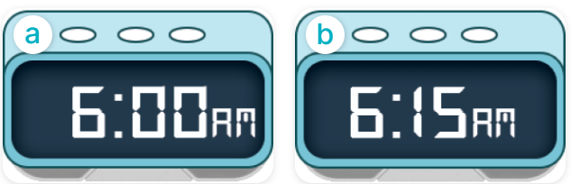  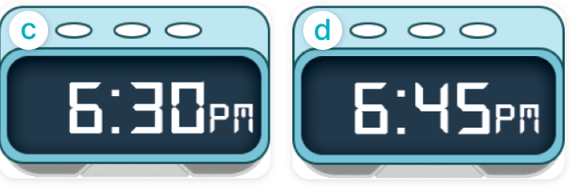  - Run through all the pictures.  - Run through model sentences.  + Run through the questions.  + Run through the answers.  - Have Ss to practise:  + T asks the first – Ss answer (change role).  + Ss – Ss (change role).  - Ask Ss to work in pairs to ask and answer the question What time is it? It’s…….  - T controls and corrects.  - Invite a few pairs to the front of the class to take turns pointing at the pictures and saying the questions and answers.  - Encourage Ss to practise speaking English.  - T gives feedbacks.  4.Production: (7’)  Activity 4. Let’s talk.  *Aims: Ss will be able to enhance the correct use of What time is it? – It’……. to ask and tell the time in a freer context.  *Procedure:  - T asks ss look at the two speech bubbles and ask:  +Who are they?  + What are they talking about?  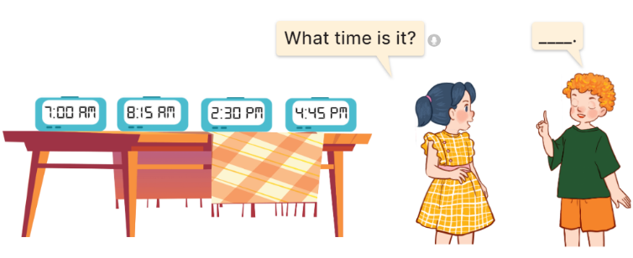  - Get Ss to repeat the question and the answer several times in pairs: It’s seven o’clock.  - T models: Go around the classroom, pointing to Ss and asking What time is it?  - Ask Ss ask and answer about their own names in pairs.  - Invite some groups to perform in front of the class.  - Give feedbacks  *Consolidation  *Aims: Ss will be able consolidate and wrap up the content of the lesson.  *Procedure:  - T asks ss to answer the following questions:  + What have you learnt from the lesson today?  +What are the core values of the lesson? (if the teacher can take from the lesson).  - T review the vocabulary and model sentences.  - T praises some Ss who are hardworking / active/ good…. as well as encourage others to try more.  5. Homework. (2’)  - Learn the vocabulary and model sentences by heart  - Prepare the new lesson: Unit 2, Lesson 1 (4,5,6). | - Ss listen.  -Ss look at the board  - Ss play the game  - Ss listen and clap their hands  - Ss open their books  -Ss listen and answer  - - Ss listen and repeat  + Choral repetition (3 times).  + Individual repetition (3 ss)  - Ss take note  - Ss look, remember and write  -Look at the pictures and get to know the characters in the pictures.  + In picture a: Ms Hoa asks: What time is it?  Class answer: It’s eight thirty.  Ms Hoa says: Let’s have a break.  + In pucture b: Bill asks: What time is it?  Linh answers: It’s three fifteen. Let’s go into the classroom.  -Ss listen and repeat in chorus (twice)  -Ss work in pairs to practice  -Ss practice the dialogue  -Ss listen  -Ss look at the picture and answer.  -Ss listen  -Ss listen and repeat  -Ss repeat to the introduce and respond to greetings.  - Ss look, listen and repeat  -Ss practice in chorus  -Ss practice in chorus  - Ss point at the pictures and repeat the time a few times.  -Ss work in pairs to practice  -Ss point and ask and answer  -Ss listen.  -Ss listen  -Ss look at the picture and answer  + Two pupils ask and tell the time shown on different clocks: 7:00 AM, 8:15 AM, 2:30 PM and 4:45 PM.  -Ss listen and say  - Ss answer  -Ss work in pairs  -Ss perform in front of the class.  - Ss listen  -Ss answer the questions  - Ss listen  -Ss listen and clap their hands  -Ss listen and take note
D. ADJUSTMENTS (if necessary):
………………………………………………………………………………………….…..……………………………………………………………………………...
---------------------------------------------------
Grade 4: Lớp 4A: Sáng thứ Sáu, Ngày 26 tháng 9 năm 2025
ENGLISH
Unit 2: Time and daily routines - Lesson 1 (4,5,6)
A. OBJECTIVES:
By the end of the lesson, Ss will be able to:
1. Knowledge:
- Listen to and understand two communicative contexts in which two pupils play a game asking and telling the time and tick the correct pictures.
- Complete four gapped exchanges with the help of picture cues.
- review telling the time by playing the game Which clock says ...?
- Vocabulary: Review
- Skills: speaking, listening, reading and writing.
2. Competences:
- Critical Thinking: self-introduce
- Co-operation: ready to help friends in pair work/ group work.
- Self-control and independent learning: perform listening tasks.
3. Attitude/ Qualities:
- Kindness: Help partners to complete learning tasks.
- Honesty: tell the truth about feelings and emotions.
- Diligence: complete learning tasks.
B. TEACHING AIDS:
- Teacher: Teacher’s guide Pages 32,33,34; audio Tracks 18; website hoclieu.vn, posters, laptop, pictures, textbook, lesson plan, TV or projector.
- Students: Pupil’s book Page 17, notebooks, workbooks, school things.
C. PROCEDURES:
Teacher’s activities | Students’ activities
1.Warm- up: (5’)  Sing a song: What time is it?  *Aims: to create a friendly and active atmosphere in the class to beginning the lesson.  *Procedure:  - Show the song on the screen.  https://www.youtube.com/watch?v=0Yq_rztquuU  - Ask pupils to listen, sing and dance the song.  - Say “Open your book page 17” and look at “Unit 2, Lesson 1 (4,5,6)”.  2.Practice: (27’)  Activity 1. Listen and tick:  *Aims: Ss will be able to listen to and understand two communicative contexts in which two pupils play a game asking and telling the time and tick the correct pictures.  *Procedure:  - Elicit the names of the characters in the pictures.  - Point at the pictures respectively to explain the context.  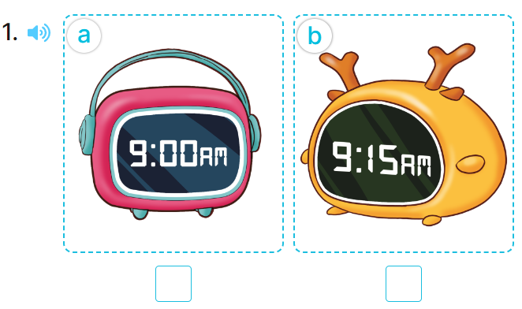  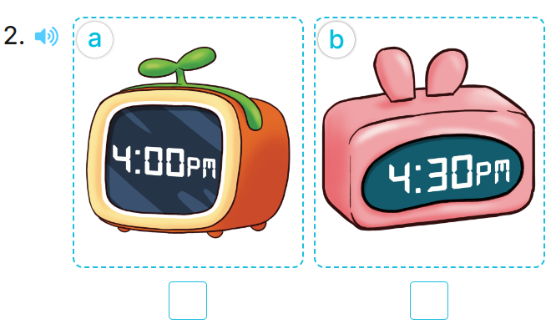  - T ask Ss to guess the answers.  + T writes Ss’guessing on the board.  - Listen to the tape:  + Play the recording  + Play the recording again and get Ss to swap books with their partners.  + Play the recording again to check answers together as a class.  - Play the recording, sentence by sentence, for the class to listen and repeat in chorus.  Key: 1.b 2.b  Activity 2. Look, complete and read.  *Aims: Ss will be able to complete four gapped exchanges with the help of picture cues.  *Procedure:  - Get Ss to look at the pictures and identify the time on the four clocks.  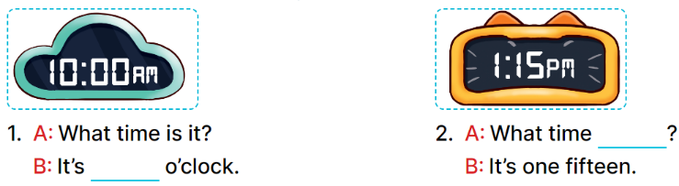  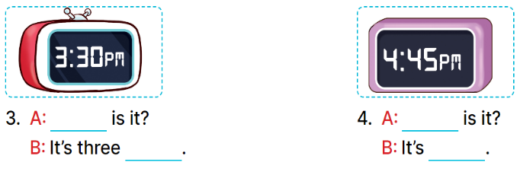  - Ask pupils to look at each gapped exchange. Draw their attention to the missing words and time.  - Have pupils look at Picture 1. Ask them what is missing in the answer (ten).  + Then have them complete the gap (It’s ten o’clock.).  + Repeat the same procedure with Pictures 2, 3 and 4.  - Set a time limit for pupils to complete the gapped exchanges individually  - Invite a few pairs to stand up to ask and tell the time on the clock faces.  Key:  1. ten 2. is it  3. What time; thirty  4. What time; four forty-five  Activity 3. Let’s play.  *Aims: Ss will be able to review telling the time by playing the game Which clock says ...?  *Procedure:  - Divide class into 2 groups  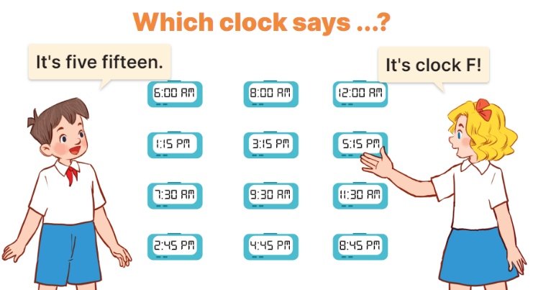  - Tell pupils that they are going to play a game that involves finding and saying which clock shows the time told by another player.  - Invite two volunteers to stand in front of the board.  +Tell them to decide who is the time teller and who is the clock finder.  - The time teller will tell a certain time.  - When the game is over, the player who has the most points is the winner.  *Consolidation  *Aims: Ss will be able consolidate and wrap up the content of the lesson.  *Procedure:  - T asks ss to answer the following questions:  + What have you learnt from the lesson today?  +What are the core values of the lesson? (if the teacher can take from the lesson).  - T praises some Ss who are hardworking / active/ good…. as well as encourage others to try more.  3. Homework. (3’)  - Ask and answer about the pictures in part 5.  - Prepare the new lesson: Unit 2, Lesson 2 (1,2,3). | - Ss listen  -Ss sing and dance  - Ss open their books  -Look at the pictures and say:  + Picture 1a: a clock showing 9:00 AM + Picture 1b: a clock showing 9:15 AM + Picture 2a: a clock showing 4:00 PM + Picture 2b: a clock showing 4:30 PM  -Ss guess the answers  - Ss listen to the tape and tick  - Ss listen again, tick and swap books with their partners.  - Ss check their answers and guessing  -Ss listen and repeat.  -Ss look at the picture and say  -Ss listen and answer  -Ss answer: It’s ten o’clock.  -Ss look and complete  .  -Ss complete the sentence  -Ss ask and tell the time on the clock faces.  - Ss look and listen.  -Ss play game  Example: 5:15, for the other player to find the clock which shows the correct time by saying its letter.  + If it is correct, the correct finder will get one point.  +Every player has eight times to try. +After the first round, the time teller will become the clock finder.  +All the clocks on the board are kept for later use  -Ss listen to the teacher  -Ss answer the questions  -Ss listen and clap their hands  -Ss listen and take note
----------------------------------------------------
Grade 5: Lớp 5A: Sáng thứ Ba, Ngày 23 tháng 9 năm 2025
Lớp 5B: Chiều thứ Hai, Ngày 22 tháng 9 năm 2025
Lớp 5C: Sáng thứ Ba, Ngày 23 tháng 9 năm 2025
ENGLISH
Unit 1: All about me! - Lesson 3 (1, 2, 3)
A. OBJECTIVES:
By the end of the lesson, Ss will be able to:
1. Knowledge:
- correctly pronounce the two-syllable words with the stress on the first syllable as ‘dolphin and ‘tennis in isolation and as in the sentences I like ‘dolphins. and He plays ‘tennis on Sundays.
- say the chant with the correct pronunciation, word stress and rhythm.
- Vocabulary: Review
- Skills: speaking, listening, reading and writing.
2. Competences:
- Communication and collaboration: work in pairs and groups to complete the learning tasks.
- Self-control and independent learning: perform pronunciation and listening tasks.
3. Attitude/ Qualities:
- Show their love and interest in sports, colours, animals and food.
B. TEACHING AIDS:
- Teacher: Teacher’s guide Pages 29, 30; audio Tracks 12, 13, 14; website hoclieu.vn, posters, laptop, pictures, textbook, lesson plan, TV or projector.
- Students: Students’ book Page 14, notebooks, workbooks, school things.
C. PROCEDURES:
Teacher’s activities | Students’ activities
1.Warm- up and review: (5’)  Game: Who is faster?  *Aims: to revise the words about countries, sports and animals.  *Procedure:  - Tell Ss they are going to look at the picture and choose the correct answer a, b or c.  - Divide the class into two teams.  - Have each team look at the picture and choose the correct answer a, b or c to fill in the blank.  - If they choose the correct answer, they get points for their team. The team with more points is the winner.  - Have pairs of pupils read the questions and answers aloud.  - Say “Open your book page 14” and look at “Unit 1, Lesson 3 (1,2,3)”.  2. Presentation (9’)  Activity 1. Listen and repeat:  *Aims: Ss will be able to correctly pronounce the two-syllable words with the stress on the first syllable as ‘dolphin and ‘tennis in isolation and in the sentences I like ‘dolphins. and He plays ‘tennis on Sundays. with the correct pronunciation and intonation.  *Procedure:  - T gives instruction to the word ‘dolphin and ‘tennis, in the sentences as I like ‘dolphins. and He plays ‘tennis on Sundays.  - Play the recording and encourage Ss to point to the word and sentence while listening  - Play the recording again and encourage Ss to listen and repeat.  - Have Ss work in pairs or groups to do this several times until Ss feel confident.  - T invites some Ss to practice.  3.Practice: (17’)  Activity 2. Circle, listen and check.  *Aims: Ss will be able to identify the stress on some two-syllable words and circle the word with a different stress pattern from the other two words.  *Procedure:  - Draw Ss’ attention to the three sets or two-syllable words.  - Tell Ss to look at the words, read them aloud and circle the word that has the stress on the first syllable.  - Tell Ss to swap books with a partner, then check the answers as a class. Write the correct answers on the board.  - Play the recording again for Ss to listen and check their answers again.  - Invite one or two Ss to stand up, listen to and repeat the words.  Key: 1.a 2.c 3.a  Activity 3. Let’s chant  *Aims: Ss will be able to say the chant with the correct pronunciation, word stress and rhythm.  *Procedure:  - Introduce the title and lyrics of the chant.  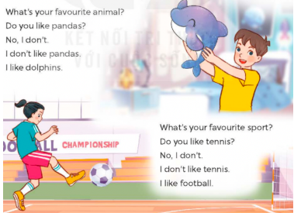  - Play the recording for Ss to listen to the whole chant.  + Have them repeat the title and lyrics line by line.  + Ask Ss to attend to two-syllable words with the stress on the first syllable in the chant, pandas, dolphins, tennis and football.  - Play the recording all the way through for Ss to listen to pronunciation and melody.  - Play the recording line by line for Ss to listen and repeat  - Play the recording for Ss to chant and clap along.  - Ask Ss to practice chant and clap along in pairs or groups.  - Invite groups to the front of the classroom to perform the chant  3. Fun corner and wrap- up (4’)  Game: Put the sentences in the correct order  - Ask the Ss to work in four groups.  - Give each group a different set of sentences and ask them to make a meaningful conversation.  - Give them enough time to do the task.  - Invite each group to present their conversation. Have the class vote the best presentation. Praise the winner. | - Ss listen  -Ss listen the rules  - Ss play the game  -Ss ask and answer  - Ss open their books  - - Ss pay attention  - Ss listen and point  - Ss listen again and repeat  -Ss work in pairs and practice  -Ss say the language in front of the class  - Ss pay attention  - Ss look at the words, read them aloud and circle the word  - Ss swap books and check the answers  - Ss listen again and check the answers again.  -Ss listen and repeat.  - Ss look and listen.  - Ss listen to the chant  - Ss listen and repeat line by line without clap their hands  - Ss note the rhythm and pronunciation.  -Ss listen to melody of the chant  - Ss listen and chant line by line.  - Ss chant and clap along.  - Ss work in groups (two groups) to chant  -Ss perform in front of the class.  -Ss listen  -Ss play the game  Ex:  Nam: Do you like pandas?  Mai: No, I don’t.  Nam: What’s your favourite animal?  Mai: It’s a dolphin.
D. ADJUSTMENTS (if necessary):
………………………………………………………………………………………….…..……………………………………………………………………………...
---------------------------------------------
Grade 5: Lớp 5A: Sáng thứ Ba, Ngày 23 tháng 9 năm 2025
Lớp 5B: Chiều thứ Hai, Ngày 22 tháng 9 năm 2025
Lớp 5C: Sáng thứ Ba, Ngày 23 tháng 9 năm 2025
ENGLISH
Unit 1: All about me! - Lesson 3 (4, 5, 6)
A. OBJECTIVES:
By the end of the lesson, Ss will be able to:
1. Knowledge:
- read two paragraphs and circle the correct options.
- make questions and answers about personal information and favourite things.
- revise the target language by making a poster and presenting it to the class.
- Vocabulary: Review
- Skills: speaking, listening, reading and writing.
2. Competences:
- Communication and collaboration: work in pairs and groups to complete the learning tasks.
- Self-control and independent learning: perform reading and writing tasks.
3. Attitude/ Qualities:
- Show their love and interest in sports, colours, animals and food.
B. TEACHING AIDS:
- Teacher: Teacher’s guide Pages 31, 32; website hoclieu.vn, posters, laptop, pictures, textbook, lesson plan, TV or projector.
- Students: Student’s book Page 15, notebooks, workbooks, school things.
C. PROCEDURES:
Teacher’s activities | Students’ activities
1.Warm- up and review: (5’)  Game: “Jumping”  *Aims: to review the vocabulary and structure about greet and respond to greetings.  *Procedure:  - Stick the flash cards (football, table tennis, Japan, England, dolphin, giraffe) on the board.  - Tell Ss they are going to play the game “Jumping”.  + If the teacher reads a word that is the same as a flash card on the board, Ss jump.  + If it is not, they keep still. Ask them to say the word on the flash card.  - Ask Ss to stand at their desks.  - Hold up a flash card from the vocabulary set and say a word. Have Ss play the game.  - Afterwards, raise all the flash cards for Ss to say the words.  - Say “Open your book page 15” and look at “Unit 1, Lesson 3 (4,5,6)”.  2.Practice: (8’)  Activity 1. Read and circle:  *Aims: Ss will be able to read two paragraphs and circle the correct options.  *Procedure:  - Draw Ss’ attention to the two paragraphs and read them as a class. 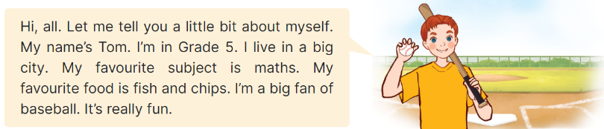  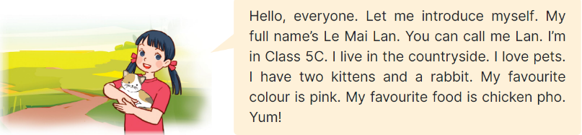  - Draw Ss’ attention to the incomplete sentences and answer options.  + Have Ss pay attention to the sentences about personal information of Tom and Lan. + Have Ss read the text again and circle the correct answers.  - Tell Ss to swap books with a partner, then check answers as a class. Write the correct answers on the board.  - Get Ss to look at the board and check their answers again.  + If time allows, ask Ss to read the paragraph aloud in front of the class.  Key: 1. b 2. c, 3. b, 4. a  3.Production: (18’)  Activity 2. Let’s write  *Aims: Ss will be able to complete a paragraph with pupils’ personal information and favourite things  *Procedure:  - Tell Ss the goal of this activity  - Write the sentence with the first gap on the board: My name is ____, ask Ss to identify the information needed to complete the gap (their names) and encourage Ss to say the whole sentence (ex: My name is Huong.).  - Give Ss time to complete the sentences.  - If time allows, invite a few Ss to read the sentences they have completed in front of the class.  Key: Pupil’s answer  Ex: My name is Huong. I live in the countryside. I am in Class 5D. My favourite sport is running. My favourite food is fish and vegetables. My favourite colour is yellow. My favourite animal is a rabbit.  What about you? What are your favourite things?  Activity 3. Project.  *Aims: Ss will be able to revise the target language by making a poster about favourite things and presenting it to the class.  *Procedure:  - Tell Ss the goal of this activity.  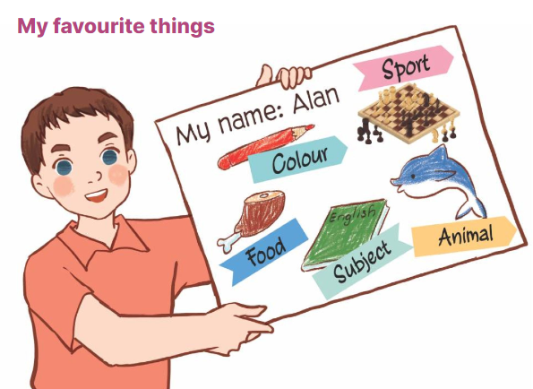  - Have Ss work in groups of five.  + Each student shows his / her poster that he / she has made at home and tells the group about their favourite things, ex: My favourite sport is chess. My favourite food is chicken.  - Invite some Ss to show their work and talk about their favourite things in front of the class.  4. Fun corner and wrap- up (4’)  Game: Number race  - Divide the class into two groups.  - Give each pupil in one group a number so that each group has equal numbers.  - Ask the questions, ex: What’s your favourite animal, and allow time for Ss to think.  + Then call out a number, have Ss with that number from each group stand up and say the answers, ex: It’s a monkey. Ss are not allowed to give the same answers as their friends.  - Praise and give points for the groups.  - The group with more points wins the game. | - Ss listen  - Ss listen to the rules  -Ss play game  Ex: if the word “England” is the same as the flash card “the flag of England”, pupils jump. If it isn’t, they keep still.  - Ss open their books  - Ss pay attention to the two paragraphs and read them as a class.  - Ss look at the incomplete sentences and answer options.  - Ss read the text again and circle the correct answers.  - Ss swap books with a partner, then check answers as a class.  - Ss look at the board and check their answers again.  -Ss read the paragraph aloud  -Ss listen and pay attention  - Ss read the sentence and identify the information needed to complete.  - Ss complete the other sentences.  - A few Ss read the sentences they have completed in front of the class.  - Ss listen  - Ss work in groups of five.  + Ss show his / her poster and tells the group about their favourite things.  - Ss show their work and talk about their favourite things in front of the class.  -Ss listen to the teacher  -Ss play the game  -Ss congratulate the winner
D. ADJUSTMENTS (if necessary):
………………………………………………………………………………………….…..……………………………………………………………………………...
-------------------------------------------------
Grade 5: Lớp 5A: Sáng thứ Năm, Ngày 25 tháng 9 năm 2025
Lớp 5B: Sáng thứ Năm, Ngày 25 tháng 9 năm 2025
Lớp 5C: Sáng thứ Sáu, Ngày 26 tháng 9 năm 2025
ENGLISH
Unit 2: Our homes - Lesson 1 (1, 2, 3)
A. OBJECTIVES:
By the end of the lesson, Ss will be able to:
1. Knowledge:

- use the words building, flat, house, tower and the numbers 23, 38, 93, and 116 in relation to the topic “Our homes”

- correctly say the words and use Do you live in this / that……...? – Yes, I do. / No, I don’t. to ask and answer questions about someone’s home

- use Do you live in ____? – Yes, / No, ____. in a freer context.
- Vocabulary: flat, tower.
- Structures:
A: Do you live in this / that building?
B: Yes, I do. / No, I don’t
- Skills: speaking and listening
2. Competences:
- Critical thinking and creativity: learn how to ask and answer questions about personal information correctly and fluently.
- Self-control and independent learning: perform pronunciation and speaking tasks.
3. Attitude/ Qualities:
- Show their pride in their personal information and where they live.
B. TEACHING AIDS:
- Teacher: Teacher’s guide Pages 33, 34 35, audio Tracks 15, 16, website hoclieu.vn, posters, laptop, pictures, textbook, lesson plan, TV or projector.
- Students: Students’ book Page 16, notebooks, workbooks, school things.
C. PROCEDURES:
Teacher’s activities | Students’ activities
1.Warm- up and review: (3’)  Sing a song: Where do you live?  *Aims: to create a friendly and active atmosphere in the class to beginning the lesson.  *Procedure:  - Show the song on the screen.  https://www.youtube.com/watch?v=GlYJKcbpVdw  - Ask Ss to listen, sing and dance the song  - Say “Open your book page 16” and look at “Unit 2, Lesson 1 (1,2,3)”.  2. Presentation (15’)  Activity 1. Vocabulary.  *Aims: Ss will be able to know the vocabulary in the new lesson.  *Procedure:  -T elicits the new words  + flat : căn hộ (picture)  + tower : tòa tháp (picture)  - T models (3 times).  - T writes the words on the board.  - Checking: Rub out and remember  Activity 2. Look, listen and repeat:  *Aims: Ss will be able to understand and correctly repeat the sentences in two communicative contexts focusing on greetings, and asking and answering questions about someone’s home.  *Procedure:  - Have Ss look at Pictures a and b and identify the characters in the pictures.  + Who is he/ she?  + Where is he/ she?  + What are they talking about?  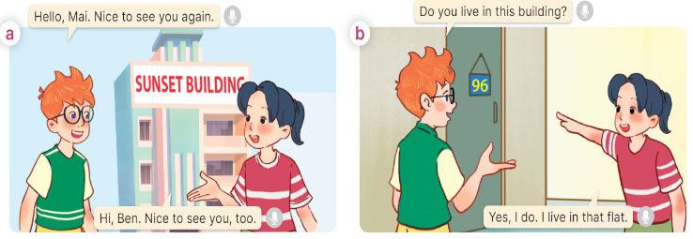  - Play the audio twice (sentence by sentence). Correct their pronunciation where necessary.  - Have Ss to practice the dialogue  - T invites a few pairs to the front of the class to practice.  - T checks pronunciation for ss.  Activity 3 Listen, point and say.  *Aims: Ss will be able to correctly say the words and use Do you live in this / that...? – Yes, I do. / No, I don’t. to ask and answer questions about someone’s home.  *Procedure:  * Structures:  - T asks Ss look at picture b in activity 1 and helps Ss know the structure from the dialogue.  - T introduces new structures for Ss.  - T explains, models and gives meaning.  - Have Ss repeat the model sentences.  A: Do you live in this / that building?  B: Yes, I do. / No, I don’t  3.Practice: (7’)  *Drill pictures  - Have Ss look at the pictures and say what they can see in the pictures.  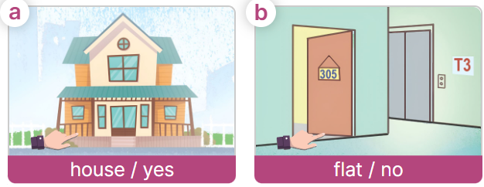  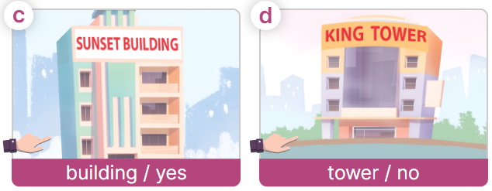  - Have Ss point at pictures, listen and run through all the pictures.  - Have Ss point at the bubbles, listen and run through model sentences.  - Have Ss to practise:  + T asks the first picture, Ss answer  + Ss asks the second picture, T answers  + Group A asks the third picture, group B  answers  + Group B asks the last picture, group A  - Ask Ss to work in pairs to practise asking and answering the question Do you live in this / that ……….?- Yes, I do. / No, I don’t  - T controls and corrects.  - Invite a few pairs to point at the pictures and say the questions and answers in front of the class.  4. Production: (6’)  Activity 4. Let’s talk.  *Aims: Ss will be able to use Do you live in this / that …..?- Yes, I do. / No, I don’t in a freer context.  *Procedure:  - Draw Ss’ attention to the picture  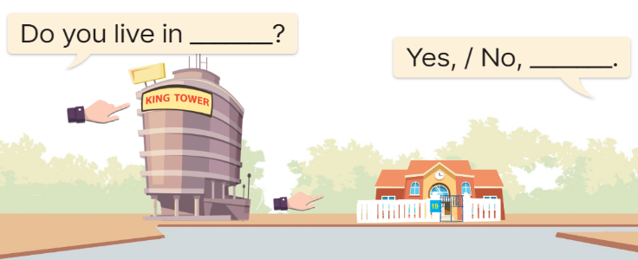  - Elicit the answer in the speech bubble and write it on the board. Get Ss to say the completed sentences.  - Have Ss role-play to practise asking the questions and giving their answers in pairs, using the picture cue.  - Invite a few pairs to point at the pictures and ask and answer questions.  5. Fun corner and wrap- up (4’)  Game: Lucky Letter  - Divide the class into 2 teams.  - Each team takes turns to choose a letter, then asks and answers using the clues shown on the screen and gets points for their teams. | - Sing and dance the song together.  - Ss listen and open their books  -Ss listen and answer  - - Ss listen and repeat  + Choral repetition (3 times).  + Individual repetition (3 ss)  - Ss take note  - Ss look, remember and write  -Look at the pictures and say.  + In picture a:  Ben: Hello, Mai. Nice to see you again.  Mai: Hi, Ben. Nice to see you, too.  + In picture b:  Ben: Do you live in this building?  Mai: Yes, I do. I live in that flat.  -Ss listen and repeat in chorus (twice)  -Ss work in pairs to practice  -Ss come to the front of the classroom to practice.  -Ss listen  - Ss look at the picture and answer.  -Ss listen  -Ss listen and repeat  -Ss repeat to the structures  - Ss look, listen and repeat  +Picture a: a ﬁnger pointing to a nearby house  + Picture b: a ﬁnger pointing to a nearby ﬂat.  + Picture c: a ﬁnger pointing to a building far away  + Picture d: a ﬁnger pointing to a tower far away  -Ss point at pictures, listen and repeat  -Ss point at the bubbles, listen and repeat  -Ss practice in chorus  -Ss practice in chorus  -Ss work in pairs to practise asking and answering the question  - Pairs of Ss point at the pictures and say in front of the class  -Ss look at the picture and say  + Types of homes: a tower and a house  - Ss say the completed sentences.  -Ss work in pairs to ask and answer  A: (points at King Tower)  Do you live in this tower?  B: No, I don’t. I live in a house in the countryside.  A: (points at the house)  Do you live in that house?  B: Yes, I do. It’s my house.  -Ss perform in front of the class.  - Ss listen  -Ss listen and play the game
D. ADJUSTMENTS (if necessary):
………………………………………………………………………………………….…..……………………………………………………………………………...
-----------------------------------------------
Grade 5: Lớp 5A: Sáng thứ Năm, Ngày 25 tháng 9 năm 2025
Lớp 5B: Sáng thứ Năm, Ngày 25 tháng 9 năm 2025
Lớp 5C: Sáng thứ Sáu, Ngày 26 tháng 9 năm 2025
ENGLISH
Unit 2: Our homes - Lesson 1 (4, 5, 6)
A. OBJECTIVES:
By the end of the lesson, Ss will be able to:
1. Knowledge:
- Listen to and understand four communicative contexts in which speakers ask and answer questions about their homes and number the pictures
- Complete four gapped exchanges with the help of picture cues
- Reinforce understanding of the words and sentences related to the topic “Our homes” by playing Guessing game.
- Vocabulary: Review
- Skills: speaking, listening, reading and writing.
2. Competences:
- Communication and collaboration: work in pairs and groups to complete the learning tasks.
- Self-control and independent learning: perform listening and reading tasks.
3. Attitude/ Qualities:
- Show their pride in their personal home and address.
B. TEACHING AIDS:
- Teacher: Teacher’s guide Pages 36, 37; audio Tracks 17; website hoclieu.vn, posters, laptop, pictures, textbook, lesson plan, TV or projector.
- Students: Student’s book Page 17, notebooks, workbooks, school things.
C. PROCEDURES:
Teacher’s activities | Students’ activities
1.Warm- up and review: (5’)  Game: “Pass the teddy bears”  *Aims: to revise the learned sentence structures.  *Procedure:  - Give two different colored teddy bears to two Ss, a black teddy bear (ask the question) and a white teddy bear (answer the question).  - Ask Ss to listen to music and pass the teddy bears.  - Stop music suddenly. Have the student with a black teddy bear make a question. Have the student with a white teddy bear answer the question.  - Repeat the game several times.  - Say “Open your book page 17” and look at “Unit 2, Lesson 1 (4,5,6)”.  2.Practice: (25’)  Activity 1. Listen and number:  *Aims: Ss will be able to listen to and understand four communicative contexts in which speakers ask and answer questions about their homes and number the pictures.  *Procedure:  - Elicit and ask questions to elicit the home in the pictures  + What can you see in this picture?  + Is it a house?  + Is it a tower?    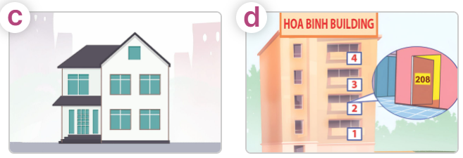  - T ask Ss to guess the answers.  + T writes Ss’guessing on the board.  - Listen to the tape:  + Play the recording  + Play the recording again for pupils to do the task.  + Play the recording a third time for pupils to check their answers.  - Get Ss to swap books with their partner, then check answers as a class.  + Write the answers on the board for Ss to correct their answers. Then checks Ss’ guessing.  - If time allows, play the recording, sentence by sentence, for Ss to listen and repeat individually and in chorus Key: 1. c 2. d 3. b 4. a  Activity 2. Read and complete.  *Aims: Ss will be able to read and complete four gapped exchanges with the help of picture cues.  *Procedure:  - Have Ss read the question and answer, and guess the missing word in the question.  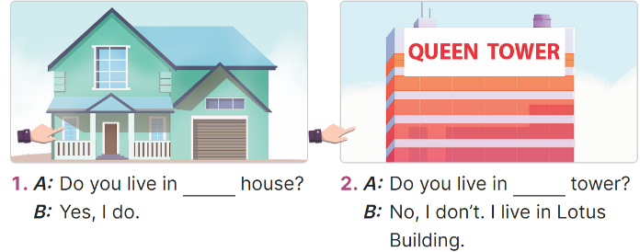  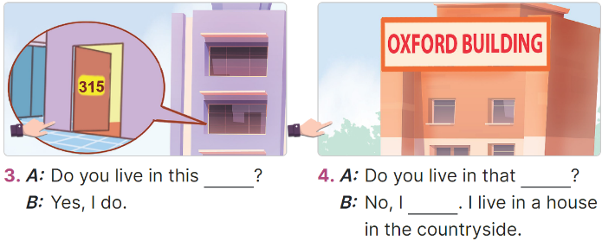  - Have Ss look at the four incomplete exchanges and elicits the missing words in the sentences.  - T models with sentence 1  + Have Ss look at the picture and identify the needed information (this).  - Have Ss work in groups and complete the exchanges 2, 3 and 4.  - Get Ss to swap books with a partner and check their answers before checking as a class.  - Invite four pairs of Ss to act out the four completed exchanges in front of the class  Key: 1. this 2. that 3. flat  4. building; don’t  Activity 3. Let’s play.  *Aims: Ss will be able to play a guessing game to reinforce the words and sentences related to the topic. *Procedure:  - Introduce and explain how to play the game.  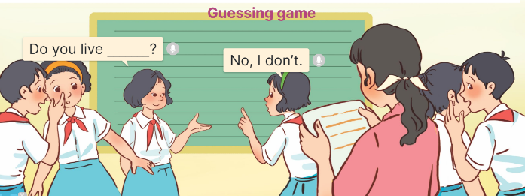  + The class is divided into groups A and B. Each member in Group A and B writes a question to guess the home type that his / her counterpart in the other group lives in. Their work should be written on paper slips and handed to the teacher when the time limit is over.  + After that, the teacher invites two groups at random to interact using the questions and answers.  - Give Ss a time limit for the class to prepare for the game.  - When the time is over, nominate a pair from different groups to check their interaction. Have the counterpart group stand up at their places, make the guesses, and encourage the rest of pupils to cheer up whenever the guess is correct.  3. Fun corner and wrap- up (5’)  Game: Slap the board  - Ask Ss if they remember the words and sentence structures to ask and answer questions about someone’s homes.  - Show the questions and answer choices on the screen.  - If the screen is not big enough, teachers write A, B, C on the board. | - Ss listen  - Ss play the game  - Ask and answer the question  Ex: A: Do you live in this house?  B: Yes, I do.  - Continue playing the game.  - Ss open their books  -Look at the pictures and say:  + Picture a: Sunset Building  + Picture b: King Tower  + Picture c: a two-floor private house  + Picture d: Hoa Binh Building  -Ss guess the answers  - Ss listen to the tape  - Ss listen again and do the task.  - Ss listen and check their answers  - Ss swap books with their partner, then check answers as a class and guessing  -Ss listen and repeat  -Ss look at the picture and identify personal information in each picture.  -Ss look and follow the teacher demonstrating the exchange 1.  -Ss answer: (Do you live in this house?)  -Ss complete the sentences  -Ss swap books with a partner and check their answers before checking as a class.  -Ss read the completed exchanges aloud.  - Ss listen and pay attention  - Ss work into groups A and B.  - Ss follow the teacher’s instructions.  - Ss prepare for the game.  - Ss play the game.  - Ss cheer up whenever the guess is correct.  - Ss say the words and sentence structures.  - Ss look at the questions, read and slap the correct answers.  - Ss continue playing the game.
D. ADJUSTMENTS (if necessary):
………………………………………………………………………………………….…..……………………………………………………………………………...

Duyệt bài, Ngày 19 tháng 9 năm 2023
Phó hiệu trưởng

Nguyễn Thị Hằng

