GRADE 2
The date of preparing: 26/09/2025
The date of teaching:
Class 2A: Afternoon Tuesday (Period 1st + Period 2nd )

WEEK 4:
FUN TIME 1
Part 1-2-3-4
I. Class description
1. Levels of students: most of the students are good, about some students are not very good.
2. Other features/ characteristics of this group of students: most of the students are active, some of them are quiet in the classroom.
II. Aims and Objectives
By the end of the lesson, students will be able to:
1.Knowledge
- Identify some learnt words (pizza, kitten, popcorn, bike
- Recognize, spell and pronounce correctly the words pasta, popcorn, pizza, kite, bike and kitten;
2. Skills
- Produce a short conversation of saying about food and toy
3. Attitude
- Obtain positive attitude to learn the lesson
- Work in individual, pairs and groups effectively
4. Forming competence:
- Self-study ability, communication
III.Timing: 40 minutes
IV. Anticipated problems and Possible solutions
- Students may forget to say the new words so the teacher models first and correct ss’ pronunciation mistakes.
V.Teaching Aids
-Teacher’s book, students’ book, ppt slides
VI.Teaching Procedure
Step/ Activity | Aims and mode of interaction | Teacher’s activities | Students’ activities
1. Warm up  (5’) | Aim: Arouse ss interests revise words and phrases related to previous lesson  Whole class  Individuals | Revising the sounds and words  Show flashcards: Show flashcards and ask pupils to say: letters p, k, pasta, popcorn, pizza, kite, bike and kitten. | - Ask and answer  - Listen to the teacher and open the book.
2. Find and circle (8’) | Aim: Arouse ss interests revise words about  and structure: I have….. to practice reading skill.  Whole class | Ask pupils to look at the word search, find and circle the words in it individually.  Explain how to do the task.Find and circle the words in the word search. Then say the words.  Model with the first word if necessary. Give further support to those pupils who find it difficult to do the task.  Call some pupils to show the circled words and say them in front of the class.  If teacher uses sachmem.vn or slides, he/ she can show the word search and call on one or two pupils to go to the board and point to the words in the word search.  Extension:  After the pupils find the words and pronounce them, organize a short game. Divide the class into two teams. Call on one pupil from each team to go to the board. Call out a word and the two pupils have to write them on the board. Give a point to each correct word. Pupils from the teams take turns to write the words. | - Listen to the teacher and answer.  - Read and circle the correct pictures.  KEY:  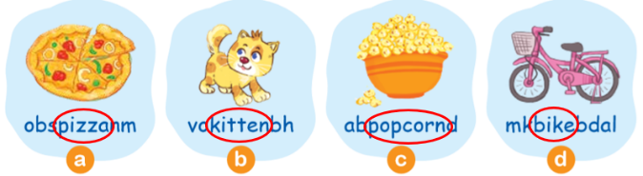
3. Let’s play: Stand up! Sit down (8’) | Aim: Arouse ss interests revise words to develop reading skill  Individuals | Have all pupils sit down.  Teacher holds up a flashcard and say a word.  If the flashcard and the word are the same, pupils stand up; if not, pupils sit still. Call some pupils to say the correct word.  Model the position of the first flashcard. Instruct pupils to follow each position. Help them practise this until they understand.  Follow the same procedure with the other flashcards. | - Look at the screen  - Play a game  - Look at the pictures and answer using the structure:
4. Look, read and write. Then say aloud ( 8’) | - Aim: Arouse ss interests revise words about your name and structure: The _____ is yummy.  Is he/she _____ (verb + _ing)?  Yes, he/she is. / No, he/she isn’t. to develop listening skill  Individuals | Have pupils read the words in the first question, then say Read thewords, please!Have them look at the pictures and ask them What can you see in the pictures?Have them point to each picture and say the word (pizza, kite, bike and pasta).  Have pupils spell the words pizza, kite, bike and pasta then write on the small boards, check their writing.  Ask them to write the words on their books, say Write the words, please!  Get pupils to check their answers in pairs. Then ask some pairsto give their answers. Give comments and confirm the correct answers. | - Listen to the teacher.  - Raise the hand and give their answers  KEY: 1. pizza 2. kite 3. bike 4. pasta
5.Home - link 2’ |  | Values: do morning exercise and do sports regularly to have a good healthy  Practise furthermore and do exercises on their workbook

