Grade 5: Lớp 5A: Sáng thứ Năm, Ngày 18 tháng 9 năm 2025
Lớp 5B: Sáng thứ Năm, Ngày 18 tháng 9 năm 2025
Lớp 5C: Sáng thứ Sáu, Ngày 19 tháng 9 năm 2025
ENGLISH
Unit 1: All about me! - Lesson 2 (4, 5, 6)
A. OBJECTIVES:
By the end of the lesson, Ss will be able to:
1. Knowledge:
- Listen to and understand three communicative contexts in which speakers ask and answer questions about favourite things and match the characters with the right pictures.
- Complete two target gapped exchanges with the help of picture cues.
- Revise the target vocabulary items and structures through the game.
- Vocabulary: Review
- Skills: speaking, listening, reading and writing.
2. Competences:
- Communication and collaboration: work in pairs and groups to complete the learning tasks.
3. Attitude/ Qualities:
- Show their love and interest in sports, colours, animals and food.
B. TEACHING AIDS:
- Teacher: Teacher’s guide Pages 26, 27, 28; audio Tracks 11; website hoclieu.vn, posters, laptop, pictures, textbook, lesson plan, TV or projector.
- Students: Student’s book Page 13, notebooks, workbooks, school things.
C. PROCEDURES:
Teacher’s activities | Students’ activities
1.Warm- up and review: (4’)  Play a game: “Whisper ”  *Aims: torevise the sentence structure What’s your favourite ___? - It’s ____. to ask and answer questions about someone’s favourite things.  *Procedure:  - Divide the class into two teams. Tell each team to form a line.  - Explain that when you whisper a sentence to the first pupil in each line, he/ she must in turn whisper it to the second pupil in the line. The second pupil then whispers it to the third, and so on. When the sentence reaches the last pupil in the line, he / she should call it out. A correct sentence scores one point.  - Have Ss play the game.  - Count the points for each team and announce the winner. The team with more points wins.  - Say “Open your book page 13” and look at “Unit 1, Lesson 2 (4,5,6)”.  2. Practice: (27’)  Activity 1. Listen and match:  *Aims: Ss will be abletolisten to and understand three communicative contexts in which speakers ask and answer questions about favourite things and match the characters with the right pictures *Procedure:  - Elicit the names of the characters in the pictures and the favourite things  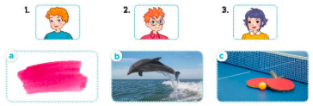  - T ask Ss to guess the answers.  + T writes Ss’guessing on the board.  - Listen to the tape:  + Play the recording  + Play the recording again and get Ss to swap books with their partners.  + Play the recording again to check answers together as a class.  + Write the answers on the board for Ss to correct their answers. Then checks Ss’ guessing.  - Play the recording, sentence by sentence, for the class to listen and repeat in chorus.  Key: 1.b 2. c 3.a  Activity 2.Read and complete  *Aims: Ss will be abletocomplete two target gapped exchanges with the help of picture cues.  *Procedure:  - Ask Ss to identify the characters and their favourite things (animal / food) in the pictures. 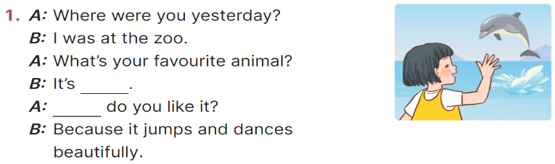  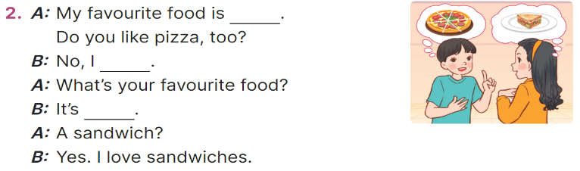  - Have Ss look at the 2 incomplete exchanges and elicits the missing words in the sentences.  - T models with exchange 1  + Ask Ss what is missing in the sentence (favourite animal).  + Have Ss look at the picture and identify the needed information (It’s a dolphin.).).  - Have Ss work in pairs and complete the sentences 2, 3 and 4.  - Get Ss to swap books with a partner and check their answers before checking as a class.  Key:  1. a dolphin, Why  2. pizza, don’t, a sandwich  Activity 3. Let’s play.  *Aims: Ss will be able to revise the target vocabulary items and structures through the game Find someone who…  *Procedure:  - Tell Ss that they are going to play Find someone who … using the language learnt in Lesson 2.  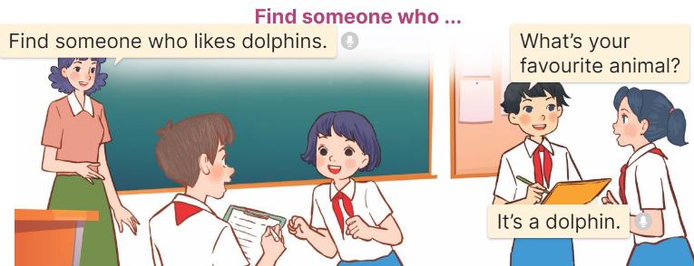  - Divide the class into four teams.  + Give each team a task: Ex: Find someone who likes dolphins/ table tennis / pink / sandwiches.  + The members of each team should walk around the classroom, ask their classmates questions ex. What’s your favourite animal / colour / sport / food? to get information about their favourite things.  + When they find someone they write the name in the blank provided.  - Set time for Ss to play the game.  - The team that finds the most Ss at the end of the game wins.  3. Fun corner and wrap- up (4’)  Game: Guessing game  - Stick different pictures of sports, colours, animals and food on the board.  - Have Ss say the words related to the pictures.  - Invite pairs of volunteers to the board. One student asks the question, another one answers the question and points to the suitable picture.  - Continue until practicing all the vocabulary set. | - Ss pay attention.  -Ss play the game  -Ss play the game  Ex. My favourite sport is badminton.  -My favourite colour is yellow. -My favourite animal is a rabbit.  -My favourite food is a sandwich.  - Ss congratulate to the winner  - Ss open their books  - Look at the pictures and say:  1. a picture of Bill  2. a picture of Ben  3. a picture of Linh  a. an image of pink colour  b. a picture of a dolphin  c. a picture of a ping pong table and two racquets  -Ss guess the answers  - Ss listen to the tape and match  - Ss listen again, match and swap books with their partners.  - Ss check their answers and guessing  - Ss answer and check  -Ss listen and repeat.  -Ss look at the picture and say  -Ss follow the teacher demonstrating the exchange 1.  -Ss read and answer  -Ss work in pairs and fill in the gaps  - Ss swap books and check  - Ss listen  -Ss listen and pay attention  - Ss work in four teams. Ss find someone, and write the name in the blank provided  -Ss play the game  -Ss play the game  -Ss play the game  Ex:  A: What’s your favourite colour?  B: It’s green.
D. ADJUSTMENTS (if necessary):
………………………………………………………………………………………….…..……………………………………………………………………………...
* Preparation for the project: Tell Ss about the project at page 15. Ask them to prepare for it at home by making posters about their favourite things. Remind Ss to bring the posters to class to present them at Project time.

