Grade 5: Lớp 5A: Sáng thứ Năm, Ngày 18 tháng 9 năm 2025
Lớp 5B: Sáng thứ Năm, Ngày 18 tháng 9 năm 2025
Lớp 5C: Sáng thứ Sáu, Ngày 19 tháng 9 năm 2025
ENGLISH
Unit 1: All about me! - Lesson 2 (1, 2, 3)
A. OBJECTIVES:
By the end of the lesson, Ss will be able to:
1. Knowledge:
- understand and correctly repeat the sentences in two communicative contexts focusing on asking and answering questions about someone’s favourite things.
- correctly say the words and use What’s your favourite ……..? - It’s ……... to ask and answer questions about someone’s favourite things.
- use What’s your favourite ……….? - It’s ………. in freer contexts.
- Vocabulary: dolphin, pink, sandwich
- Structures: A: What’s your favourite colour?
B: It’s pink.
- Skills: speaking and listening
2. Competences:
- Critical thinking and creativity: learn how to ask and answer questions about someone’s favourite things correctly and fluently.
- Communication and collaboration: work in pairs and groups to complete the learning tasks.
3. Attitude/ Qualities:
- Show their love and interest in sports, colours, animals and food.
B. TEACHING AIDS:
- Teacher: Teacher’s guide Pages 23, 24, 25, 26; audio Tracks 9, 10, website hoclieu.vn, posters, laptop, pictures, textbook, lesson plan, TV or projector.
- Students: Student’s book Page 12, notebooks, workbooks, school things.
C. PROCEDURES:
Teacher’s activities | Students’ activities
1.Warm- up and review: (4’)  Game: Pass the ball  *Aims: to revise the words about sports, colours, animals and food.  *Procedure:  - T gives Ss a ball.  - T asks Ss to listen to music and transfer a ball around the class.  - When the music stops, Ss who keep a ball have to look at the picture and answer the question about colours, animals, food and sports.  - T gives feedback.  - Say “Open your book page 12” and look at “Unit 1, Lesson 2 (1,2,3)”.  2. Presentation (16’)  Activity 1. Vocabulary.  *Aims: Ss will be ableto know the vocabulary in the new lesson.  *Procedure:  -T elicits the new words  + dolphin : cá heo (picture)  + pink: màu hồng (realia)  + sandwich: bánh mì kẹp (realia)  - T models (3 times).  - T writes the words on the board.  - Checking: Rub out and remember  Activity 2. Look, listen and repeat:  *Aims: Ss will be ableto provide context and get pupils interested.  *Procedure:  - Have Ss look at Pictures a and b and identify the characters in the pictures.  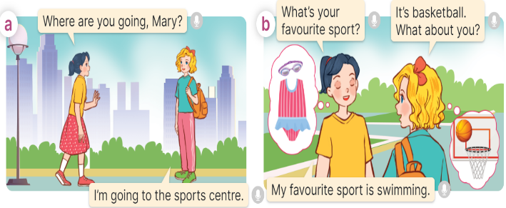  - Play the recording for them to listen.  - Play the recording again (sentence by sentence) for Ss to listen and repeat Correct their pronunciation where necessary.  - Invite a few pairs to the front of the classroom to listen to and repeat the sentences.  - T checks pronunciation for ss.  Activity 3. Listen, point and say.  *Aims: Ss will be ableto correctly say the words and use What’s your favourite ……….? - It’s ………. to ask and answer questions about someone’s favourite things.  *Procedure:  * Structures:  - T asks Ss look at picture b and helps Ss know the structure from the dialogue.  - T introduces new structure for Ss.  - T explains, models and gives meaning.  - Have Ss repeat the structures.  A: What’s your favourite colour?  B: It’s pink.  3.Practice: (6’)  *Drill pictures  - Have Ss look at the pictures and elicit the names of the things in the pictures.  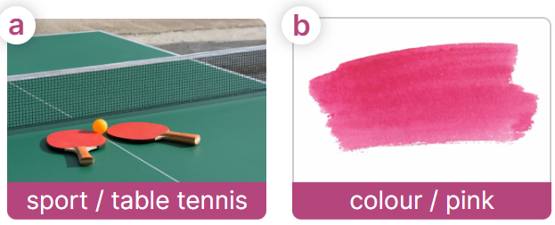  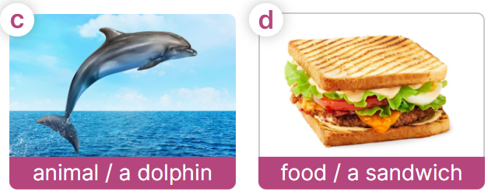  - Have Ss point at pictures, listen and run through all the pictures.  - Have Ss point at the bubbles, listen and run through model sentences.  - Have Ss to practise:  + T asks the first picture, Ss answer  + Ss asks the second picture, T answers  + Group A asks the third picture, group B  answers  + Group B asks the last picture, group A  - Ask Ss to work in pairs to practise asking and answering the question What’s you favourite sports? – It’s table tennis.  - T controls and corrects.  - Invite a few pairs to point at the pictures and say the questions and answers in front of the class.  - T gives feedbacks.  4.Production: (5’)  Activity 4. Let’s talk.  *Aims: Ss will be able touse Can you tell me about yourself? - I’m in ___. I live in ___. and What’s your favourite ___? - It’s ____. in freer contexts.  *Procedure:  - Ask questions to help Ss identify favourite things of the characters  + What does Linh playing?  +What colour does Lucy wearing and holding a teddy bear?  +What does Minh watching?  +What does Bill eating?  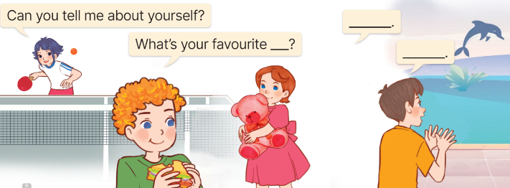  - Elicit the answer in the speech bubble and write it on the board. Get Ss to say the completed sentences.  - Have Ss role-play to practise asking the questions and giving their answers in pairs, using the picture cue.  - Invite a few pairs to point at the pictures and ask and answer questions.  - Have Ss ask and answer questions about their favourite things (toys / colour / food / animal / school subject / book …), using the structures and vocabulary learnt.  5. Fun corner and wrap- up (4’)  Game: Lucky windows  - Prepare pictures of the words (table tennis, pink, a dolphin, a sandwich).  - Show the windows on the board/ slide. Each window contains a picture and different points. And there are two lucky windows with two lucky stars.  - Divide the class into two groups.  - Explain how the game is played. Have a pair of Ss from each group choose a window, look at the picture, then ask and answer questions about someone’s favourite things.  Ex: A: What’s your favourite sport?  B: It’s table tennis.  - Give points to the group having the correct answer.  - Continue with the other Ss.  - The group that gets more points wins. Praise the winner. | - Ss listen and keep the ball  - Ss listen to music and play the game  Ex: T: What colour is it?  Ss: It’s red.  - Ss open their books  -Ss listen and answer  - - Ss listen and repeat  + Choral repetition (3 times).  + Individual repetition (3 ss)  - Ss take note  - Ss look, remember and write  -Look at the pictures and get to know the characters in the pictures.  + In picture a:  Mai: Where are you going, Mary?  Mary: I’m going to the sports centre.  – In picture b:  Mai: What’s your favourite sport?  Mary: It’s basketball. What about you?  Mai: My favourite sport is swimming.  -Ss listen  -Ss listen and repeat in chorus  - Pairs of Ss listen and repeat  -Ss listen  -Ss look at the picture and answer.  -Ss listen  -Ss listen and repeat  -Ss repeat to the structures.  - Ss look, listen and answer  a. a ping pong table and racquets  b. pink colour  c. a dolphin  d. a sandwich  -Ss point at pictures, listen and repeat  -Ss point at the bubbles, listen and repeat  -Ss practice in chorus  -Ss practice in chorus  -Ss work in pairs to practise asking and answering the question  - Pairs of Ss point at the pictures and say in front of the class  -Ss look at the picture and answer  + Linh is playing table tennis  + Lucy is wearing a pink dress and holding a pink teddy bear  +Minh is watching a dolphin dancing in the lake  +Bill is eating a sandwich  - Ss say the completed sentences.  -Ss work in pairs to ask and answer  Can you tell me about yourself?  - My name’s ……. I’m in ………….  What’s your favourite……..? It’s …..  -Ss perform in front of the class.  - Ss ask and answer  - Work in two groups.  - Listen to the teacher’s explanation. - Play the game  - Continue playing the game.
D. ADJUSTMENTS (if necessary):
………………………………………………………………………………………….…..……………………………………………………………………………...

