Grade 4: Lớp 4A: Sáng thứ Sáu, Ngày 19 tháng 9 năm 2025
ENGLISH
Unit 1: My friends
Lesson 2 (4, 5, 6)
A. OBJECTIVES:
By the end of the lesson, Ss will be able to:
1. Knowledge:
- Use the words Japan, Malaysia, Singapore and Thailand in relation to the
topic “My friends”.
- Use Where’s he / she from? – He’s / She’s from ………. to ask and answer questions about where someone comes from.
- Listen to and demonstrate understanding of simple communicative contexts
in relation to the topic “My friends”.
- Read and write about where someone comes from.
- Vocabulary: Review
- Skills: speaking, listening, reading and writing.
2. Competences:
- Critical Thinking: self-introduce
-Co-operation: ready to help friends in pair work/ group work.
- Self-control and independent learning: perform listening tasks.
3. Attitude/ Qualities:
- Kindness: Help partners to complete learning tasks.
- Honesty: Show pride in where they come from and great respect for where someone comes from
- Diligence: complete learning tasks.
B. TEACHING AIDS:
- Teacher: Teacher’s guide Pages 24, 25, 26; audio Tracks 12; website hoclieu.vn, posters, laptop, pictures, textbook, lesson plan, TV or projector.
- Students: Pupil’s book Page 13, notebooks, workbooks, school things.
C. PROCEDURES:
Teacher’s activities | Students’ activities
1.Warm- up: (5’)  Play a game: “Slap the board”  *Aims: to create a friendly and active atmosphere in the class to beginning the lesson.  *Procedure:  - Divide the class into two or three teams.  - Teacher puts up a set of pictures or words on a board  - A pupil from each team come up to the board with fly swatters  - They listen as the teacher calls out a word or a sentence and they race to slap the correct picture  - Whoever is the fastest with the correct slap gets a point for their team  - Team with the most points is the winner.  - Say “Open your book page 13” and look at “Unit 1, Lesson 2 (4,5,6)”.  2.Practice: (27’)  Activity 1. Listen and tick:  *Aims: Ss will be abletolisten to and understand two communicative contexts in which pupils ask and answer questions about where someone comes from and tick the  correct pictures  *Procedure:  - Elicit the names of the characters in the pictures.  - Point at the pictures respectively to explain the context.  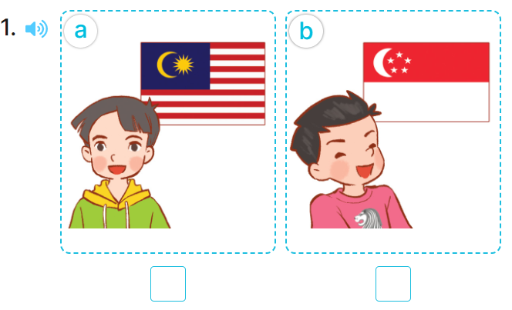  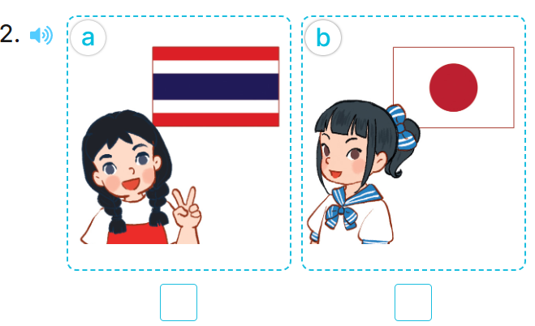  - T ask Ss to guess the answers.  + T writes Ss’guessing on the board.  - Listen to the tape:  + Play the recording  + Play the recording again and get Ss to swap books with their partners.  + Play the recording again to check answers together as a class.  + Write the answers on the board for Ss to correct their answers. Then checks Ss’ guessing.  - Play the recording, sentence by sentence, for the class to listen and repeat in chorus.  Key: 1.a 2. a  Activity 2.Look, complete and read  *Aims: Ss will be abletocorrectly two gapped sentences and two gapped exchanges with the help of picture cues.  *Procedure:  - Have pupils read the exchange and guess the missing word.  - Elicit the name of country that can be used to fill the gap.  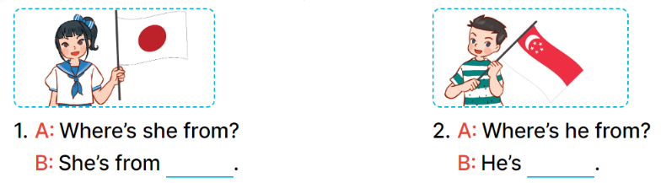  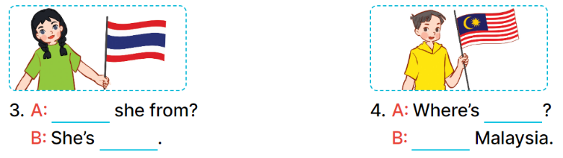  - T models with sentence 1.  - Have Ss work in pairs and look at the pictures and fill in the gaps  - Get pupils to swap books with a partner and check their answers before checking as a class.  - Invite pairs of pupils to write the answers on the board.  -T gives feedbacks.  Key: 1. Japan 2. from Singapore  3. Where’s; from Thailand  4. he from; He’s from  Activity 3. Let’s play.  *Aims: Ss will be able to revise the target vocabulary items through the game Find someone who is from …  *Procedure:  - Tell pupils that they are going to revise the target vocabulary items they have learnt in Lessons 1 and 2.  - Explain how the game is played.  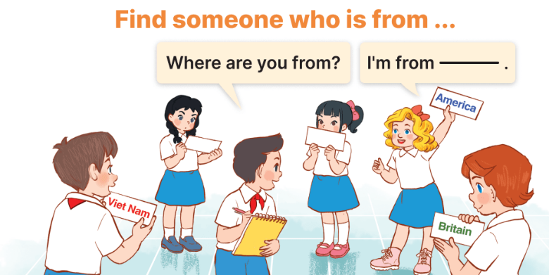  - Divide pupils into groups of six and give each group a set of five flashcards.  + One player in each group points to  the other players and asks Where are you from?  + The other players take turns looking at the flash cards and answering (ex: I’m from Britain.).  + If the player has the correct answer,  he / she gets a point / star.  + If the answer does not match the  flash card, he / she will be out  - The game ends when all the flashcards are gone.  - Give feedbacks  *Consolidation  *Aims: Ss will be able consolidate and wrap up the content of the lesson.  *Procedure:  - T asks ss to answer the following questions:  + What have you learnt from the lesson today?  +What are the core values of the lesson? (if the teacher can take from the lesson).  - T praises some Ss who are hardworking / active/ good…. as well as encourage others to try more.  3. Homework. (3’)  - Prepare the new lesson: Unit 1, Lesson 3 (1,2,3). | - Ss listen and do action  - Ss pay attention.  -Ss play the game  -Ss play the game  - Ss open their books  -Look at the pictures and say:  + Number 1:  Picture a: a boy and the Malaysian flag  Picture b: a boy and the Singaporean flag  + Number 2:  Picture a: a girl and the Thai flag Picture b: a girl and the Japanese flag  -Ss guess the answers  - Ss listen to the tape and tick  - Ss listen again, tick and swap books with their partners.  - Ss check their answers and guessing  - Ss answer and check  -Ss listen and repeat.  -Ss read and guess  -Ss read and complete  -Ss read and answer  -Ss work in pairs and fill in the gaps  - Ss swap books and check  -Ss write on the board  -Ss listen  - Ss listen and remember  -Ss listen and pay attention  - Ss listen  - Ss play the game  -Ss play the game  -Ss listen  -Ss answer the questions  - Ss listen  -Ss listen and clap their hands  -Ss listen and take note

