Grade 4: Lớp 4A: Sáng thứ Sáu, Ngày19tháng 9 năm 2025
ENGLISH
Unit 1: My friends
Lesson 2 (1, 2, 3)
A. OBJECTIVES:
By the end of the lesson, Ss will be able to:
1. Knowledge:
- Use the words Japan, Malaysia, Singapore and Thailand in relation to the
topic “My friends”.
- Use Where’s he / she from? – He’s / She’s from …………. to ask and answer questions about where someone comes from.
- Listen to and demonstrate understanding of simple communicative contexts
in relation to the topic “My friends”.
- Vocabulary: Japan, Malaysia, Singapore and Thailand
- Skills: speaking and listening
2. Competences:
- Communication and collaboration: work in pairs and groups to complete the learning tasks
- Self-control and independent learning: perform listening tasks
3. Attitude/ Qualities:
- Kindness: Help partners to complete learning tasks.
- Honesty: tell the truth about feelings and emotions
B. TEACHING AIDS:
- Teacher: Teacher’s guide Pages 22, 23; audio Tracks 10,11, website hoclieu.vn, posters, laptop, pictures, textbook, lesson plan, TV or projector.
- Students: Pupil’s book Page 12, notebooks, workbooks, school things.
C. PROCEDURES:
Teacher’s activities | Students’ activities
1.Warm- up: (3’)  ame: Pass the ball  *Aims: to create a friendly and active atmosphere in the lesson.  *Procedure:  - T gives Ss a ball.  - T asks Ss to listen to music and transfer a ball around the class.  - When the music stops, Ss who keep a ball have to practice with partner using: Where are you from? and I’m from……..  - T gives feedback.  - Say “Open your book page 12” and look at “Unit 1, Lesson 2 (1,2,3)”.  2. Presentation (16’)  Activity 1. Vocabulary.  *Aims: Ss will be ableto know the vocabulary in the new lesson.  *Procedure:  -T elicits the new words  + Japan : nước Nhật Bản (picture)  + Thailand: nước Thái Lan (picture)  + Malaysia: nước Ma-lai-xi-a (picture)  + Singapore : nước Xin-ga-po (picture)  - T models (3 times).  - T writes the words on the board.  - Checking: Rub out and remember  Activity 2. Look, listen and repeat:  *Aims: Ss will be ableto understand and correctly repeat the sentences in two communicative contexts (pictures) in which pupils ask and answer questions about where someone is from.  *Procedure:  - Have Ss look at Pictures a and b and identify the characters in the pictures.  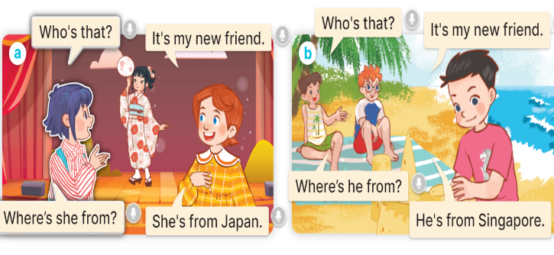  - Play the audio twice (sentence by sentence). Correct their pronunciation where necessary.  - Have Ss to practice the diaguage  - T invites a few pairs to the front of the class to practice.  - T checks pronunciation for ss.  Activity 3. Listen, point and say.  *Aims: Ss will be ableto correctly say the words and use Where’s he / she from? – He’s / She’s from ……. to ask and answer questions about where someone is from.  *Procedure:  * Model sentences:  - T asks Ss look at picture a, b and helps Ss know the structure from the dialogue.  - T introduces new structure for Ss.  - T explains, models and gives meaning.  - Have Ss repeat the model sentences.  A: Where’s he / she from?  B: He’s / She’s from …….  3.Practice: (7’)  *Drill pictures  - Elicit and check comprehension the name of each character and the name of the country.    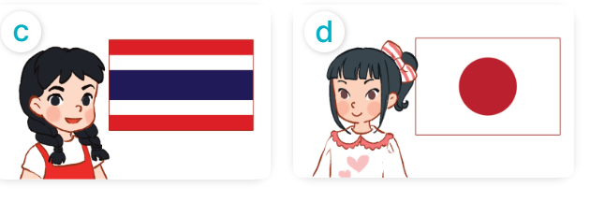  - Run through all the pictures.  - Run through model sentences.  - Have Ss to practise:  + T asks the first picture, Ss answer  + Ss asks the second picture, T answers  + Group A asks the third picture, group B  answers  + Group B asks the last picture, group A  - Ask Ss to work in pairs.  - T controls and corrects.  - Invite a few pairs to come to the front of the classroom,point at the relevant character in each picture, and act out his/her role.  - Invite Ss to go to the board and role play. Encourage Ss to practise speaking English.  - T gives feedbacks.  4.Production: (7’)  Activity 4. Let’s talk.  *Aims: Ss will be able to enhance the correct use of Where’s he / she from? – He’s/ she’s from……….. to ask and answer questions about where someone is from in a freer context.  *Procedure:  - T asks ss to guess each character and what the children say.  + What can you see in the picture?  +Who are they?  +Where are they?  +What are they saying?  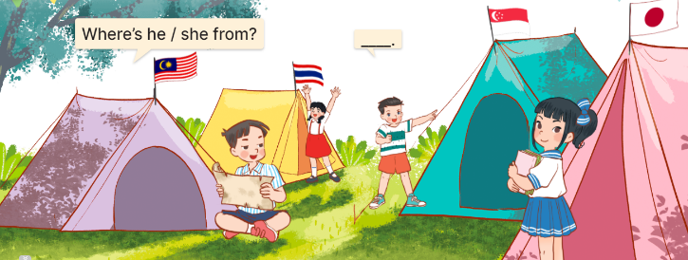  - T fills the gaps and writes the sentences on the board.  - T models  - Give pupils time to work in pairs and take turns saying the role of each character in the picture  - Invite a few pairs to come to the front of the classroom and act out the roles  - Give feedbacks  *Consolidation  *Aims: Ss will be able consolidate and wrap up the content of the lesson.  *Procedure:  - T asks ss to answer the following questions:  + What have you learnt from the lesson today?  +What are the core values of the lesson? (if the teacher can take from the lesson).  - T review the vocabulary and model sentences.  - T praises some Ss who are hardworking / active/ good…. as well as encourage others to try more.  5. Homework. (2’)  - Learn the vocabulary by heart  - Prepare the new lesson: Unit 1, Lesson 2 (4,5,6). | - Ss listen and keep the ball  - Ss listen to music and play the game  - Ss open their books  -Ss listen and answer  - - Ss listen and repeat  + Choral repetition (3 times).  + Individual repetition (3 ss)  - Ss take note  - Ss look, remember and write  -Look at the pictures and get to know the characters in the pictures.  + In picture a:  Linh: Who’s that? Lucy: It’s my new friend.  Linh: Where’s she from? Lucy: She’s from Japan.  – In picture b:  Minh: Who’s that? Ben: It’s my new friend.  Minh: Where’s he from? Ben: He’s from Singapore.  -Ss listen and repeat in chorus (twice)  -Ss work in pairs to practice  -Ss practice the diaguage  -Ss listen  -Ss look at the picture and answer.  -Ss listen  -Ss listen and repeat  -Ss repeat to the introduce and respond to greetings.  - Ss look, listen and answer  a. a boy with the Singaporean flag  b. a boy with the Malaysian flag  c. a girl with the Thai flag  d. a girl with the Japanese flag  - Ss listen and repeat  - Ss practice in chorus  - Ss practice in chorus  - Ss work in pairs to practice  -Ss listen  -Ss point and say  -Ss go to the board and role play.  -Ss listen  -Ss look at the picture and answer  + four pupils at a campsite, standing in front of their tents with their national flags  -Ss note  - Ss say the completed sentences.  -Ss work in pairs  -Ss perform in front of the class.  -Ss listen  -Ss answer the questions  - Ss listen  -Ss listen and clap their hands  -Ss listen and take note
D. ADJUSTMENTS (if necessary):
………………………………………………………………………………………….…..……………………………………………………………………………...

