Grade 4: Lớp 4A: Chiều thứ Tư, Ngày17 tháng 9 năm 2025
ENGLISH
Unit 1: My friends
Lesson 1 (1, 2, 3)
A. OBJECTIVES:
By the end of the lesson, Ss will be able to:
1. Knowledge:
- Use the words America, Australia, Britain and Viet Nam in relation to the topic “My friends”
- Use Where are you from? – I’m from _____. to ask and answer questions about where someone comes from
- Vocabulary:America, Australia, Britain and Viet Nam
- Skills: speaking and listening
2. Competences:
-Co-operation: ready to help friends in pair work/ group work.
- Sociability: Talk to each other, say good words to others.
3. Attitude/ Qualities:
- Kindness: Help partners to complete learning tasks.
- Honesty: Show pride in where they come from and great respect for where someone
comes from by using appropriate gestures and intonation when asking and
answering about nationality.
B. TEACHING AIDS:
- Teacher: Teacher’s guide Pages 17, 18, 19, audio Tracks 6,7, website hoclieu.vn, posters, laptop, pictures, textbook, lesson plan, TV or projector.
- Students: Pupil’s book Page 10, notebooks, workbooks, school things.
C. PROCEDURES:
Teacher’s activities | Students’ activities
1.Warm- up: (5’)  Game: Find the flags  *Aims: to create a friendly and active atmosphere in the class to beginning the lesson.  *Procedure:  - Elicit that there are many countries around the world.    - Ask pupils to say the name as many countries as they know.  - Say “Open your book page 10” and look at “Unit 1, Lesson 1 (1,2,3)”.  2. Presentation (16’)  Activity 1. Vocabulary.  *Aims: Ss will be ableto know the vocabulary in the new lesson.  *Procedure:  -T elicits the new words  + America : nước Mỹ (picture)  + Australia : nước Úc (picture)  + Britain : nước Anh (picture)  + Viet Nam: nước Việt Nam (picture)  - T models (3 times).  - T writes the words on the board.  - Checking: Rub out and remember  Activity 2. Look, listen and repeat:  *Aims: Ss will be ableto understand and correctly repeat the sentences in two communicative contexts (pictures) in which pupils ask and answer questions about where someone is from  *Procedure:  - Have Ss look at Pictures a and b and identify the characters in the pictures.  + Who is he/ she?  + Where is he/ she?  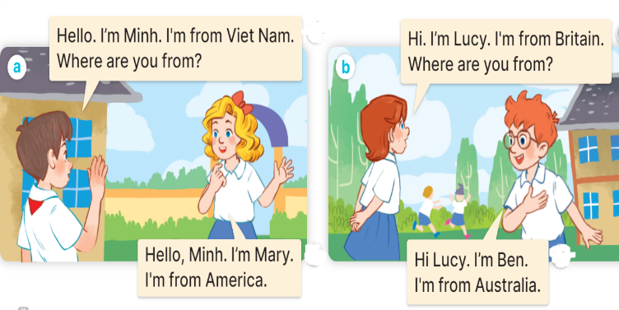  - Play the audio twice (sentence by sentence). Correct their pronunciation where necessary.  - Have Ss to practice the dialogue  - T invites a few pairs to the front of the class to practice.  - T checks pronunciation for ss.  Activity 3 Listen, point and say.  *Aims: Ss will be ableto correctly say the words and use Where are you from? – I’m from _____. to ask and answer questions about where someone is from.  *Procedure:  * Model sentences:  - T asks Ss look at picture a and helps Ss know the structure from the dialogue.  - T introduces new structure for Ss.  - T explains, models and gives meaning.  -Have Ss repeat the model sentences.  A: Where are you from?  B: I’m fromAmerica.  3.Practice: (7’)  *Drill pictures  - Elicit and check comprehension the name of each character and countries.      - Run through all the pictures.  - Run through model sentences.  - Have Ss to practise:  + T asks the first picture, Ss answer  + Ss asks the second picture, T answers  + Group A asks the third picture, group B  answers  + Group B asks the last picture, group A  - Ask Ss to work in pairs.  - T controls and corrects.  - Invite a few pairs to come to the front of the classroom,point at the relevant character in each picture, and act out his/her role.  - Encourage Ss to practise speaking English.  - T gives feedbacks.  4.Production: (7’)  Activity 4. Let’s talk.  *Aims: Ss will be able to enhance the correct use of Where are you from? – I’m……….. to ask and answer questions about where someone is from in a freer context  *Procedure:  - T asks ss to guess each character and what the children say.  + What can you see in the picture?  +Who are they?  +Where are they?  +What are they saying?  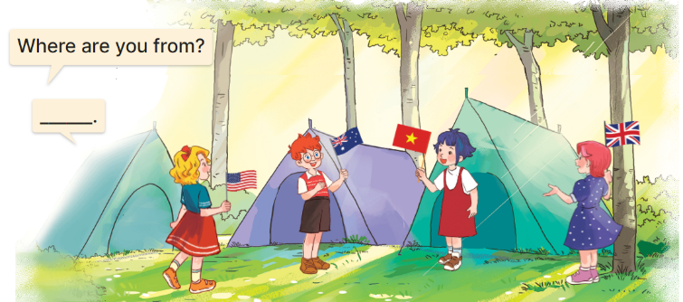  - Elicit the answer in the speech bubble and write it on the board. Get pupils to say the completed sentences.  - Put pupils into pairs to practise the exchanges.  - Invite a few pairs to point at the pictures and ask and answer questions about where the pupils are from.  - Give feedbacks  *Consolidation  *Aims: Ss will be able consolidate and wrap up the content of the lesson.  *Procedure:  - T asks ss to answer the following questions:  + What have you learnt from the lesson today?  +What are the core values of the lesson? (if the teacher can take from the lesson).  - T review the vocabulary and model sentences.  - T praises some Ss who are hardworking / active/ good…. as well as encourage others to try more.  5. Homework. (2’)  - Learn the number by heart  - Prepare the new lesson: Unit 1, Lesson 1 (4,5,6). | - Ss listen and say some countries  - Ss open their books  -Ss listen and answer  - - Ss listen and repeat  + Choral repetition (3 times).  + Individual repetition (3 ss)  - Ss take note  - Ss look, remember and write  -Look at the pictures and get to know the characters in the pictures.  +In picture a:  Minh says and asks: Hello. I’m Minh. I’m from Viet Nam. Where are you from?  Mary answers: Hello, Minh. I’m Mary. I’m from America.  + In picture b:  Lucy says and asks: Hi. I’m Lucy. I’m from Britain. Where are you from?  Ben answers: Hi, Lucy. I’m Ben. I’m from Australia.  -Ss listen and repeat in chorus (twice)  -Ss work in pairs to practice  -Ss practice the dialogue  -Ss listen  -Ss look at the picture and answer.  -Ss listen  -Ss listen and repeat  -Ss repeat to the introduce and respond to greetings.  - Ss look, listen and repeat  +Picture a: Britain  + Picture b: Viet Nam  + Picture c: America  + Picture d: Australia  -Ss practice in chorus  -Ss practice in chorus  -Ss work in pairs to practice  -Ss point and say  -Ss listen.  -Ss listen  Ss look at the picture and answer  + They are four pupils at a campsite and holding their national flags.  - Ss say the completed sentences.  -Ss work in pairs  -Ss perform in front of the class.  -Ss listen.  -Ss answer the questions  - Ss listen  -Ss listen and clap their hands  -Ss listen and take note
D. ADJUSTMENTS (if necessary):
………………………………………………………………………………………

