Lớp 5A: Sáng thứ Năm, Ngày 11 tháng 9 năm 2025
Lớp 5B: Sáng thứ Năm, Ngày 11 tháng 9 năm 2025
Lớp 5C: Sáng thứ Sáu, Ngày 12 tháng 9 năm 2025
ENGLISH
STARTER - C. Classroom instructions
A. OBJECTIVES:
By the end of the lesson, Ss will be able to:
1. Knowledge:
- Say the chant with the correct pronunciation, word stress and rhythm.
- Listen to and understand two instructions and choose the correct pictures.
- Review some classroom instructions by playing the game Do as I say.
- Vocabulary: Review
- Skills: listening, speaking and reading.
2. Competences:
- Critical thinking and creativity: learn how to ask and answer questions about someone’s favourite things correctly and fluently.
- Communication and collaboration: work in pairs and groups to complete the learning tasks.
3. Attitude/ Qualities:
- Show pride in the instructions in classroom.
- Show their love and interest in classroom instructions.
B. TEACHING AIDS:
- Teacher: Teacher’s guide Page 16, 17, website hoclieu.vn, posters, laptop, pictures, textbook, lesson plan, TV or projector.
- Students: Student’s book Page 9, notebooks, workbooks, school things.
C. PROCEDURES:
Teacher’s activities | Students’ activities
1.Warm- up: (4’)  Game: Yes or No  *Aims: to create a friendly and active atmosphere in the class to beginning the lesson.  *Procedure:  - Ask Ss to play the game individually.  - Give each student two boards, Yes and No.  - Show a question and pictures on the board. Ss read the question and look at the pictures. Then raise the correct board, Yes or No and shout the correct answer as fast as they can. If the answer is No, they have to add more words to tell the correct idea.  Example:  Was the weather hot yesterday?  * raising the No board.  * saying “No, it wasn’t. It was rainy.”  - Give scores to the fastest student with the correct answer.  - Say “Open your book page 9” and look at “Starter, Last summer”.  2. Practice (27’)  Activity 1. Let’s chant  *Aims: Ss will be ableto say the chant with the correct pronunciation, word stress and rhythm.  *Procedure:  - Have Ss look at the picture and state activity the characters are doing.  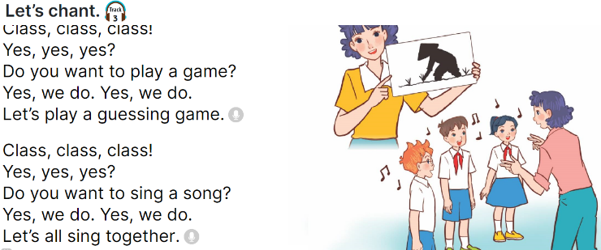  - Have Ss read the first verse of the chant.  - Play the recording of the first verse for pupils to listen.  + Play it again, line by line, for Ss to listen and repeat.  - Repeat Steps 2 and 3 for the second verse of the chant.  - Play the recording all the way through for Ss to chant and clap their hands.  Activity 2:Listen and tick  *Aims: Ss will be abletolisten to and understand two instructions and choose the correct pictures.  *Procedure:  - Draw Ss’ attention to the pictures and ask questions to elicit the activities in the pictures.  + What are they doing?  + What activity are they doing?  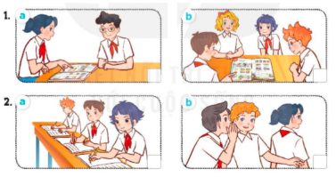  - Play the recording all the way through. Then play the recording again for Ss to listen and tick the correct pictures.  - Get Ss to swap books with a partner and check their answers before checking as a class.  - Give feedback  * Key: 1. a 2. b  Activity 3: Let’s play  *Aims: Ss will be abletoreview some classroom instructions by playing the game Do as I say.  *Procedure:  - Ask each student to prepare three instructions.  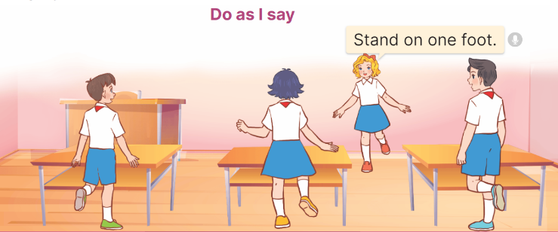  - Divide the class into two teams. Invite one student to the front to share their instructions.  + While giving each instruction, the student also acts out.  + The action may be the same or different from the instruction.  + The rest of the pupils listen and follow the given instructions.  - Any Ss who cannot follow the instruction correctly will be out of the game. The team with more remaining players gets a star.  - Keep going with other pupils. After five minutes, the team with more stars wins.  3. Fun corner and wrap- up (4’)  Game: Whisper  - Use phrases of classroom instructions: stand up, sit down, open your book, close your book, raise your hand, close your eyes, face down, sit nicely, ...  - Divide the class into two teams. Tell each team to form a line.  - Explain that when you whisper a phrase of classroom instructions to the first pupil in each line, he/ she must inturn whisper it to the second pupil in the line. The second pupil then whispers it to the third, and so on. When the phrase reaches the last pupil in the line, he/ she should call it out. A correct phrase scores one point.  - Count the points for each team andannounce the winner. The team who has more points wins the game. | - Play the game individually.  - Get two boards from the teacher.  - Read the question and look at the pictures.  - Follow the teacher’s instructions.  - The fastest student with the correct answer gets scores.  - Ss listen and open their books.  - Ss look at the picture and state the activity the characters are doing.  - Ss read the first verse of the chant.  - Ss listen to the recording of the first verse.  + Ss listen to the recording again, line by line, and repeat. Ss clap or do actions while chanting.  - Ss follow the teacher’s instructions.  - Ss listen to the recording all the way through to chant and clap their hands.  - Ss look at the pictures and answer the questions.  - Ss listen and tick the correct pictures.  - Ss swap books with a partner and check their answers.  - Check again  - Each student prepares three instructions.  - Ss work in two teams and play the game.  - Ss play the game.  - Ss continue playing the game.  - Ss listen  -Ss listen and play the game  -Ss play the game
D. ADJUSTMENTS (if necessary):
………………………………………………………………………………………….…..……………………………………………………………….……………...

