Lớp 5A: Sáng thứ Năm, Ngày 11 tháng 9 năm 2025
Lớp 5B: Sáng thứ Năm, Ngày 11 tháng 9 năm 2025
Lớp 5C: Sáng thứ Sáu, Ngày 12 tháng 9 năm 2025
ENGLISH
STARTER - B. Last summer
A. OBJECTIVES:
By the end of the lesson, Ss will be able to:
1. Knowledge:
- Review the vocabulary and structure items related to the topic Last summer by playing Guessing game.
- Listen to and understand four communicative contexts in which speakers ask and answer questions about the places they were last summer and match the speakers with the right pictures.
- Correctly use key structures to ask and answer questions about someone’s last summer in a freer context.
- Vocabulary: Review
- Skills: speaking and listening
2. Competences:
- Oral communication: work in pairs and groups to complete the learning tasks.
-Self-control & independent learning: perform listening and speaking tasks.
3. Attitude/ Qualities:
- Show pride in where they went last summer.
- Show their love and interest in the places they went to last summer.
B. TEACHING AIDS:
- Teacher: Teacher’s guide Page 14,15, 16 audio Track 2, website hoclieu.vn, posters, laptop, pictures, textbook, lesson plan, TV or projector.
- Students: Student’s book Page 8, notebooks, workbooks, school things.
C. PROCEDURES:
Teacher’s activities | Students’ activities
1.Warm- up and review: (4’)  Sing a song: Hello summer  *Aims: to create a friendly and active atmosphere in the class to beginning the lesson.  *Procedure:  - Show the song on the screen.  https://www.youtube.com/watch?v=J8DftSKKXGE  - Ask Ss to listen, sing and dance the song.  - Say “Open your book page 8” and look at “Starter, Last summer”.  2. Practice (27’)  Activity 1. Let’s play:  *Aims: Ss will be ableto review the vocabulary and structure items related to the topic Last summer by playing Guessing game.  *Procedure:  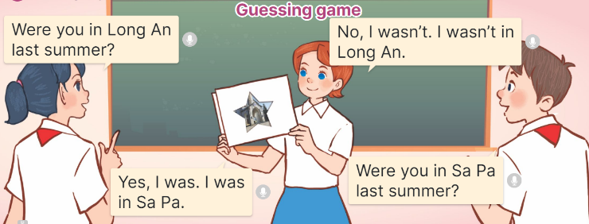  - Ss prepare pictures of the places they went to last summer.  - Divide the class into two teams.  + A student from one team holds up a picture covered by another piece of paper so everyone can only see one part of it.  + The other team guesses what place it is by asking Yes / No questions.  - If the team can guess the correct place with fewer than three questions, the team gets one star.  - Continue the game. The team with more stars will be the winner.  Activity 2:Listen and match  *Aims: Ss will be abletolisten to and understand four communicative contexts in which speakers ask and answer questions about the places they were last summer and match the speakers with the right pictures  *Procedure:  - Draw Ss’ attention to the pictures of the four characters, the places and the weather and ask the questions:  +Who are they?  +What’s the weather like in….?  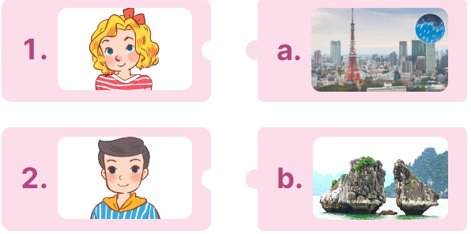  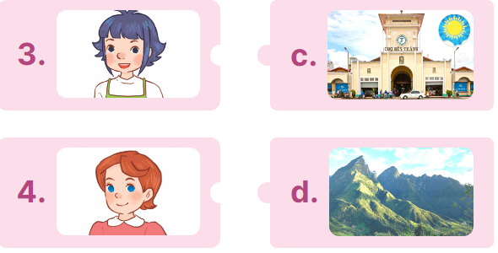  - Play the recording all the way through for Ss to listen and familiarise themslves with the speaker’s voice.  - Play the recording again for Ss to listen and number the pictures.  - Get pupils to swap books with a partner to check their answers before checking as a class.  - Check the correct answer and give feedback.  - Play the recording, sentence by sentence, for pupils to listen and repeat in chorus.  Key: 1.b 2.a 3.d 4.c  Activity 3. Let’s talk  *Aims: Ss will be able to correctly use key structures to ask and answer questions about someone’s last summer in a freer context.  *Procedure:  - Draw Ss’ attention to the picture and ask the questions:  +Where were you last summer?  +What was the weather like there?  +Was it fun?  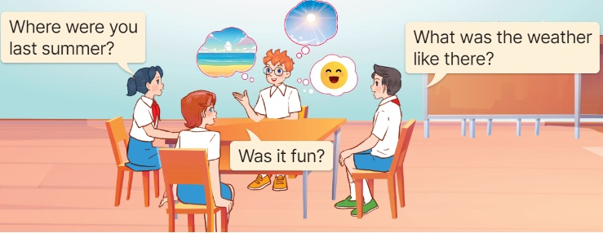  - Get Ss to read the speech bubbles and elicit possible answers.  - Put Ss into groups of four to ask and answer questions about their last summers.  - Invite a few groups to the front of the classroom to ask and answer questions about their last summers.  3. Fun corner and wrap- up (4’)  Game: Pass the ball  - Choose a song Back to school (Track 1) and 2 balls: 1 red and 1 green.  - While the music plays, Ss pass the balls around the class.  - When the music stops, the student with the red ball asks a question: Where were you last summer?  - The student with the green ballanswers the question: I was on the beach.  - Continue the game with other students. | - Sing and dance the song in chorus.  - Ss listen and open their books.  - Ss prepare pictures of the places they went to last summer.  - Ss play the game  - Ss get one star for one correct place.  - Ss continue playing the game.  -Look at the pictures and answer  -Ss listen to the tape  - Ss listen again and match  -Ss swap books with the partner and check.  -Ss check the answer together.  - Ss listen and repeat, sentence by sentence.  -Ss listen and answer  - Ss read the speech bubbles and elicit possible answers.  - Ss work into groups of four to ask and answer questions.  - Groups of Ss come to the front of the classroom to ask and answer questions.  - Ss listen  - Ss play the game  - Ss continue to play the game
D. ADJUSTMENTS (if necessary):
………………………………………………………………………………………….…..……………………………………………………………………………...

