ĐĂNG KÝ GIẢNG DẠY TUẦN 28 ( Từ 31/03 – 04/4/2025)
Thứ  Ngày | Buổi | Lớp | Tiết | Môn | Tên bài
Hai | Chiều | 4C | 1 | English | Unit 16: Weather - Lesson 2 (4,5,6)
 |  | 4C | 2 | English | Unit 16: Weather - Lesson 3 (1,2,3)
Ba | Sáng | 4A | 1 | English | Unit 16: Weather - Lesson 2 (4,5,6)
 |  | 4A | 2 | English | Unit 16: Weather - Lesson 3 (1,2,3)
 |  | 5B | 3 | English | Unit 16: Seasons and the weather  Lesson 2 (4,5,6)
 |  | 5B | 4 | English | Unit 16: Seasons and the weather  Lesson 3 (1,2,3)
Tư | Sáng | 4C | 1 | English | Unit 16: Weather - Lesson 3 (4,5,6)
 |  | 4C | 2 | English | Unit 17: In the city - Lesson 1(1,2,3)
 |  | 4B | 3 | English | Unit 16: Weather - Lesson 2 (4,5,6)
 |  | 4B | 4 | English | Unit 16: Weather - Lesson 3 (1,2,3)
 | Chiều
 |  | 3A | 1 | English | Unit 16: My pets - Lesson 2 (4,5,6)
 |  | 3A | 2 | English | Unit 16: My pets - Lesson 3 (1,2,3)
Năm | Sáng | 5B | 1 | English | Unit 16: Seasons and the weather  Lesson 3 (4,5,6)
 |  | 5B | 2 | English | Unit 17: Stories for children  Lesson 1(1,2,3)
 |  | 4B | 3 | English | Unit 16: Weather - Lesson 3 (4,5,6)
 |  | 4B | 4 | English | Unit 17: In the city - Lesson 1(1,2,3)
 | Chiều
 |  | 1C | 1 | English | Unit 13: In the school canteen - Lesson 3: 6,7,8
 |  | 1C | 2 | English | Unit 14: In the toy shop - Lesson 1: 1,2
Sáu | Sáng | 3A | 1 | English | Unit 16: My pets - Lesson 3 (4,5,6)
 |  | 3A | 2 | English | Unit 17: Our toys - Lesson 1(1,2,3)
 |  | 4A | 3 | English | Unit 16: Weather - Lesson 3 (4,5,6)
 |  | 4A | 4 | English | Unit 17: In the city - Lesson 1(1,2,3)

Duyệt bài, Ngày 28 tháng 3 năm 2025
Phó hiệu trưởng

Nguyễn Thị Hằng

WEEK 28
Grade 1: Lớp 1C: Chiều thứ năm, Ngày 03 tháng 4 năm 2025
ENGLISH
UNIT 13: IN THE SCHOOL CANTEEN
Lesson 3

I. OBJECTIVES
By the end of this lesson, pupils will be able to:
1. Knowledge and skills:
- Listen and repeat the sentences “He’s having nuts.” and “She’s having noodles.”
- Say what someone is having/ eating now/ at the moment, using “He’s having _____.” and “She’s having ______.”
- Sing a song using the structures “There’s ___.” and “He’s having ___.”
2. Competences
- Communication and collaboration: work in pairs and groups to complete the learning tasks
3. Attributes
- Show active participation in learning activities.
- Show confidence in playing games.
II. MATERIALS
- Student’s book, p. 59
- Audio track 77, 78
- hoclieu.vn
- Flashcards for Unit 13
- Poster for Unit 13
- Teacher’s guide p. 113, 114, 115
- Computer, projector, …
III. PROCEDURES
1. WARM-UP & REVIEW (5 mins)
a. Objectives:
- To create a friendly and lively atmosphere in the classroom.
- To revise the previous lesson.
b. Content:
- Let’s chant/Who’s faster?
c. Expected outcomes:
- Pupils recall vocabulary from the previous unit by singing the chant.
d. Organization:
TEACHER’S ACTIVITIES | PUPILS’ ACTIVITIES | CONTENT
Option 1: Let’s chant.  - T greets the class.  - Have a few pupils sing the chant, page 58, in front of the class.  - Get pupils to open their books and look at Lesson 3, p.59.  Option 2: Who’s faster? (PPT slides)  - Show the slide of food or fruit.  - Have pupils say the word.  - Give marks for the group that has a member say the word correctly and quickly. | - Pupils greet the teacher.  - All pupils sing the chant on page 58.  - Pupils open their books and look at Lesson 3, p. 59.  - Look at the screen and guess the word. | Pupils’ practise.
e. Assessment
- Teacher observes and gives feedback.
2. ACTIVITY 1: KNOWLEDGE CONSTRUCTION (8 mins)
a. Objectives:
- To help pupils listen and repeat the sentences “He’s having nuts.” and “She’s having noodles.”
b. Content:
- Activity 6. Listen and repeat.
c. Expected outcomes:
- Pupils can listen and repeat the sentences “He’s having nuts.” and “She’s having noodles.”
d. Organization
TEACHER’S ACTIVITIES | PUPILS’ ACTIVITIES | CONTENT
Step 1: Have pupils look at the picture, saying Look at the picture, please! Point to the boy, saying What is he doing? He’s having nuts. Point to the girl, saying What is the girl doing? She’s having noodles. Point to the sentences, saying He’s having nuts. She’s having noodles. Play the recording for pupils to listen.  Step 2: Get pupils to look at the sentence He’s having nuts, play the recording several times for them to listen and repeat. Say Now listen and repeat, please! Correct pronunciation, if necessary.  Step 3: Follow the same procedure with the sentence: “She’s having noodles.”  Step 4: Play the recording again and let pupils listen and say the sentences in front of the class. Invite a few pupils to say the sentences in front of the class. Correct pronunciation, if necessary or praise them if they said the sentences correctly, saying Well done! | - Pupils look at the picture and listen.  - Pupils look at the first sentence, listen and repeat.  - Pupils look at the pictures and listen.  - Pupils look at the second sentence, listen and repeat.  - Pupils listen and repeat in front of the class. | - The sentences “He’s having nuts.” and “She’s having noodles.” are used to express the action of eating something at the moment.  - A picture of a boy having nuts and a girl having noodles.
e. Assessment
- Performance products: Pupils’ pronunciation.
- Assessment tools: Observation and help.
3. ACTIVITY 2: PRACTICE (10 mins)
a. Objectives:
- To help pupils say what someone is having/eating now/at the moment, using “He’s having _____.” and “She’s having ______.”
b. Content:
Activity 7. Let’s talk.
c. Expected outcomes:
- Pupils can say what the boys and the girls are having/eating correctly.
d. Organization
TEACHER’S ACTIVITIES | PUPILS’ ACTIVITIES | CONTENT
Step 1: Have pupils look at the bubbles to understand how the structure (He’s having _____; She’s having _______) is used (to talk about what someone is having/ eating now/ at the moment).  Step 2: Ask them to look at the pictures to identify the food that the girls and the boys are having. Then let them point to the pictures and say the words. Check comprehension.  Step 3: Point to Picture a and model the task, using the expression in the bubble and the Picture a. E.g. He’s having nuts.  Step 4: Ask pupils to say the sentence “He’s having nuts.” in chorus and individually, saying Point to the picture and say “He’s having nuts”, please! Correct pronunciation, if necessary. Step 5: Follow the same procedure with other pictures by getting pupils to point to the pictures and say what they are having/ eating. Go around and offer help, if necessary.  Step 6: Ask pupils to work in pairs or in groups to practise the structure again. Give further support to pupils who find it difficult to do the task, if necessary. If time allows, invite some pupils to point to the pictures and say the sentences in front of the class.  Extension: T can have pupils further practise by playing lucky numbers on PPT slides. | - Pupils look at the bubble.  - Pupils listen to the teacher.  - Pupils point to the pictures to identify the food that the girl and the boy are having.  - Pupils point to the pictures and say the words.  - Pupils say the sentence “He’s having nuts” in chorus and individually.  - Pupils point to the pictures and say what they are having/ eating.  - Pupils say the sentences in pairs or in groups to practice the structure again. | There are two parts in the activity. In part 1, the structures “He’s having _____.” and “She’s having ______.” are introduced in the bubbles. In part 2, four pictures (a. The boy’s having nuts, b. The boy’s having chips; a. The girl’s having noodles, b. The girl’s having bananas) are mentioned.
e. Assessment
- Performance products: Pupils’ speaking results
- Assessment tools: Observation, TPR
4. ACTIVITY 3: PRACTICE (10 mins)
a. Objectives:
- To help pupils sing a song using the structures “There’s ___.” and “He’s having ___.”
b. Content:
Activity 8. Let’s sing.
c. Expected outcomes:
- Pupils can sing the song with correct pronunciation, natural tune/rhythm and sweet
melody
d. Organization
TEACHER’S ACTIVITIES | PUPILS’ ACTIVITIES | CONTENT
Step 1: Have pupils read the lyrics to get familiarised themselves with the first verse of the song, saying Now look at the first verse, listen and repeat please! Play the recording several times for pupils to listen and repeat line after line. Check comprehension.  Step 2: Follow the same procedure with the second verse of the song.  Step 3: Have pupils listen to the whole song, drawing their attention to the pronunciation, the stress, and the melody of the song, saying Now listen to the whole song, please!  Step 4: Let pupils practise singing the whole song. If there is time, ask some pupils to sing the song individually. Praise them when they perform well.  Step 5: Have the class sing the whole song and clap hands to reinforce the tune, the rhythm and the melody. Go around and offer help, if necessary.  Extension: T can have pupils further practise by letting them compose new lyrics for the song. | - Pupils read the lyrics of the first verse.  - Pupils listen and repeat after the recording.  - Pupils read the lyrics of the first verse.  - Pupils listen and repeat after the recording.  - Pupils listen to the whole song, pay attention to the pronunciation, the stress, and the melody of the song.  - Pupils practise singing the whole song.  - Pupils sing the song individually.  - Pupils sing the whole song and clap hands. | There are two verses in the song. The first one includes three lines with the structures “There’s Nam. He’s having ___.” In the second verse, the structure “There’s Nick. He’s having ___.” are mentioned
e. Assessment:
- Performance products: Pupils’ performance
- Assessment tools: Observation, TPR
5. FUN CORNER AND WRAP-UP (5 mins)
Game: Hidden picture
- Show the screen with colourful blocks.
- Have pupils take turns to choose one block to reveal a picture. Pupils have to say aloud the word for that picture.
- Praise for each correct answer.
------------------------------------------------
Grade 1: Lớp 1C: Chiều thứ năm, Ngày 03 tháng 4 năm 2025
ENGLISH
UNIT 14: IN THE TOY SHOP
Lesson 1

I. OBJECTIVES
By the end of this lesson, pupils will be able to:
1. Knowledge and skills
- Pronounce the sound of the letter T/t and say the words teddy bear, top, tiger and turtle.
- Point to the letter T/t, the toys in the picture and say the sound of the letter T/t and the words teddy bear, top, tiger and turtle.
2. Competences
- Communication and collaboration: work in pairs and groups to complete the learning tasks
- Self-control & independent learning: perform pointing and saying task
3. Attributes
- Show confidence in pronouncing the sound of the letter T/t and saying the words: teddy bear, top, tiger and turtle.
II. MATERIALS
- Student’s book: Page 60
- Audio track 79
- Teacher’s guide: Pages 116, 117, 118
- Website hoclieu.vn
- Flash cards/ pictures and posters (Unit 14)
- Computer, projector, …
III. PROCEDURES
1. WARM-UP & REVIEW (5 mins)
a. Objectives:
- To create a friendly and lively atmosphere in the classroom.
b. Content:
- Game: Hangman/ Sing a song
c. Expected outcomes:
- Pupils can revise the letters and the sound N/n.
- Pupils get an overview about the topic of toy.
d. Organisation:
TEACHER’S ACTIVITIES | PUPILS’ ACTIVITIES | CONTENT
Option 1: Hangman  - Greet the class. Encourage pupils to respond to your greeting.  - Give the rules of the game: Pupils have to guess the letters to make words. If pupils guess the letter correctly will get stars for their teams. Which team has the most stars will be the winner.  - Ask pupils to introduce themselves  - Introduce the new Unit 14: In the toy shop.  Option 2: Sing a song  - Have pupils listen to the song twice.  - Ask: What can you see in the song? What is the song about? (Vietnamese is accepted).  - Point out the topic of the song: TOY.  - Write the word TOY on the board and have pupils repeat the word 3 times.  - Have pupils sing along to the song. | - Greet teacher.  - Play game: listen to the rules and guess the letter to make the right words.  - Say the words have the sound N/n.  - Look at the book and listen to the teacher.  - Listen to the song and guess the topic.  - Sing along the song. | Flashcards: nuts, noodles, nose, bananas,  Link: https://www.youtube.com/watch?v=BoJBeGUHGv8
e. Assessment
- Teacher observes and gives feedback.
2. ACTIVITY 2: EXPLORATION (10 mins)
a. Objectives:
- To help pupils pronounce the sound of the letter T/t and say the words teddy bear, top, tiger and turtle.
b. Content:
- Activity 1. Listen and repeat.
c. Expected outcomes:
- Pupils can listen and repeat the sound of the letter T/t and all the words teddy bear, top, tiger, turtle correctly and confidently.
d. Organisation
TEACHER’S ACTIVITIES | PUPILS’ ACTIVITIES | CONTENT
Activity 1. Listen and repeat.
Step 1: Have pupils look at the picture, saying Look at the picture, please! and describe it. Draw pupils’ attention to the letter T/t, the words next to the toys and the colour of the letter T/t. Check comprehension.  Step 2: Ask pupils to point to the letter T/t, saying Point to the letter T/t. Have them listen and repeat the sound of the letter T/t more than once, if necessary. Say Listen and repeat, please!  Step 3: Tell pupils to point to the teddy bear and the word teddy bear, saying Point to the teddy bear and the word “teddy bear”. Ask them to listen and repeat the word, saying Listen and repeat, please!  Step 4: Follow the same procedure with the words top, tiger and turtle. Correct pronunciation, if necessary.  Step 5: Play the recording again and have them listen, point to the letter T/t and the words teddy bear, top, tiger, turtle and repeat until they feel confident. Give further support to those pupils who find it difficult to do the task.  Step 6: Play the recording again and call a few pupils to say the letter T/t and the words teddy bear, top, tiger and turtle in front of the class, saying Well done! when they perform well. | - Pupils look at the picture and answer the question: What can you see in the picture?  Where is the boy?  - Pupils point to the letter T/t and say the sound after the teacher.  - Pupils listen and repeat the sound twice.  - Pupils point to the word teddy bear, listen and repeat.  - Pupils listen and repeat: top, tiger, turtle.  - Pupils listen carefully to the recording, and point to the words and repeat several times.  - Pupils listen again and repeat the sound and the words in front of the class. | The picture is about the two shelves in the toy shop. On the left-hand shelf is a display of some plastic and stuffed animal models. On the right-hand shelf are a teddy bear, a turtle, etc. Beneath the window is a tiger. A boy, holding a top in his hand, has his nose pressed to the window and is looking at the animal models. The word top is next to the top, the word tiger is next to the tiger, the word teddy bear is next to the teddy bear, and the word turtle is next to the turtle. The letter t in the words teddy bear, top, tiger and turtle is in red.
e. Assessment
- Performance products: Pupils’ answers
- Assessment tools: Observation; Questions & answers
3. ACTIVITY 3: KNOWLEDGE CONSTRUCTION (10 mins)
a. Objectives:
- Pupils will be able to point to the letter T/t and the things and say the sound of the letter T/t and the words teddy bear, top, tiger, turtle.
b. Content:
Activity 2. Point and say.
c. Expected outcomes:
- Pupils can point to the letter T/t, the toys and say the sound of the letter T/t and the words teddy bear, top, tiger and turtle correctly.
d. Organisation
TEACHER’S ACTIVITIES | PUPILS’ ACTIVITIES | CONTENT
Activity 2. Point and say.
Step 1: Have pupils look at the picture again, saying Look at the picture on Page 60, please! Ask them to describe it. Draw their attention to the letter T/t, and the toys, if necessary.  Step 2: Get them to point to the letter T/t and say it, saying Point to the letter T/t and say, please!  Step 3: Let them point to the teddy bear and say the word teddy bear, saying Point to the teddy bear and say “teddy bear”, please! Give further support to those pupils who find it difficult to do the task.  Step 4: Follow the same procedure with other things. Go around and correct pronunciation, if necessary.  Step 5: Ask pupils to work in pairs or in groups to point to the picture and say the sound of the letter T/t and the words. Go around, offer help and correct pronunciation, if necessary. Step 6: Invite some pupils to point to the picture and say the sound of the letter and the words in front of the class. If they performed well, praise them, saying Well done! or Very good! | - Pupils look at the pictures and listen to the teacher.  Look at the letter T/t, the words and things.  - Pupils point to the letter T/t and say the sound.  - Pupils point to teddy bear and say the word teddy bear.  - Pupils point to other things and say the word.  - Pupils work in pairs: One points to the words, one says the sound and the words.  - Pupils point and say the words in front of the class. | The picture is about the two shelves in the toy shop. On the left-hand shelf is a display of some plastic and stuffed animal models. On the right-hand shelf are a teddy bear, a turtle, etc. Beneath the window is a tiger. A boy, holding a top in his hand, has his nose pressed to the window and is looking at the animal models. The word top is next to the top, the word tiger is next to the tiger, the word teddy bear is next to the teddy bear, and the word turtle is next to the turtle. The letter t in the words teddy bear, top, tiger and turtle is in red.
e. Assessment
- Performance products: Pupils’ talks and interaction
- Assessment tools: Observation, Questions & answers
5. FUN CORNER AND WRAP-UP
Option 1: Chinese whispers
- Tell pupils how the game is played. The game is played with two teams of four pupils for each group. The pupils are going to listen to the message their friends whisper and then pass the message to the next pupil. The team wins if the last person in the team can speak out the words he/ she heard correctly. Check comprehension.
- Choose two groups of pupils with four in each group. Ask pupils in the groups to stand in a queue. Say OK, now we will start the game!
- Whisper one of the words they have learnt (top, tiger, turtle, teddy bear) to the first pupil in each group and have him/ her whisper the word to the pupil standing next to him/ her quickly.
- The game goes on until the last pupil says the word correctly. The group that says the word the fastest and the most correctly will win.
- Continue to play the game with two other groups.
Option 2: Hidden picture
- Show the screen with colourful blocks.
- Have pupils take turns to choose one block to reveal a picture. Pupils have to say aloud the word for that picture.
- Praise for each correct answer.
---------------------------------------------------------
Grade 3: Lớp 3A: Chiều thứ ba ngày 01 tháng 4 năm 2025
ENGLISH
Unit 16: My pets - Lesson 2 (4, 5, 6)
A. OBJECTIVES:
By the end of the lesson, Ss will be able to:
1. Knowledge:
- Listen to and demonstrate understanding of simple communicative contexts in relation to the topic "Pets"
- Complete the four gapped exchanges with the help of picture cues.
- Play the game How many ...? to review vocabulary and structure words related to the topic “Pets”
- Vocabulary: Review
- Skills: speaking, listening, reading and writing.
2. Competences:
- Critical Thinking: talk about someone’s pets
- Co-operation: ready to help friends in pair work/ group work.
- Self-control and independent learning: perform listening tasks.
3. Attitude/ Qualities:
- Kindness: Help partners to complete learning tasks.
- Honesty: tell the truth about feelings and emotions.
- Diligence: complete learning tasks.
B. TEACHING AIDS:
- Teacher: Teacher’s guide Pages 205, 206; audio Tracks 60; website sachmem.vn, posters, laptop, pictures, textbook, lesson plan, TV or projector.
- Students: Pupil’s book Page 43, notebooks, workbooks, school things.
C. PROCEDURES:
Teacher’s activities | Students’ activities
1.Warm- up: (5’)  Sing a song: “throw the ball”  *Aims: to create a friendly and active atmosphere in the class to beginning the lesson.  *Procedure:  - Divide the class into 2 teams.  - Stick the pictures of things in the room on the board.  + T says a word, a pupil from each team has to point/throw the ball to the right picture and says the word three times.  + The one says faster will get points.  - Encourage Ss to take part in the game.  - Give points for Ss.  - Say “Open your book page 43” and look at “Unit 16, Lesson 2 (4,5,6)”.  2.Practice: (27’)  Activity 1. Listen and number:  *Aims: Ss will be able to listen to and understand four communicative contexts in which pupils ask and answer questions about the quantity of rabbits.  *Procedure:  - Have Ss look at the pictures and ask them some questions such as What pets? and How many…? 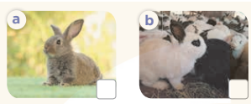  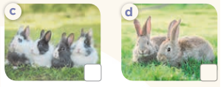  - T ask Ss to guess the answers.  + T writes Ss’guessing on the board.  - Listen to the tape:  + Play the recording  + Play the recording again and get Ss to swap books with their partners.  + Play the recording again to check answers together as a class.  + Write the answers on the board for Ss to correct their answers. Then checks Ss’ guessing.  - Play the recording, sentence by sentence, for the class to listen and repeat in chorus.  Key: 1.b 2. c 3. d 4. a  Activity 2. Look, complete and read.  *Aims: Ss will be able to complete four gapped dialogues with the help of picture cues.  *Procedure:  - Have Ss look at the pictures and ask identify pets in the pictures.  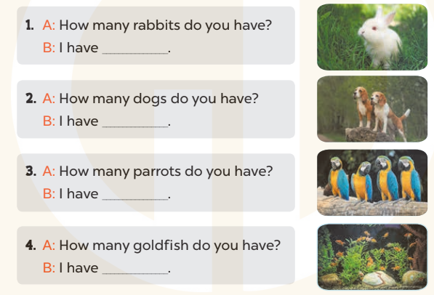  - T models with sentence 1.  + Have Ss look at the sentence.  + Ask them what is missing in the answer ( one).  + Have Ss complete the gap.  + Have Ss read the completed sentence in chorus.  -Have Ss work in pairs and complete the sentences 2, 3 and 4.  - Invite pairs of pupils to stand up and read aloud the sentences.  -T gives feedbacks.  Key: 1. one 2. two 3. some 4. many  Activity 3. Let’s play.  *Aims: Ss will be able to play the game How many ...? to review vocabulary and structure words related to the topic “Pets”.  *Procedure:  - Ask Ss to look at the picture carefully, then listen to the questions to find the right answers.  - Invite a group of four to the front of the class to demonstrate the game. - Two Ss compete as a pair in one round.  + A teacher asks the question How many_________do you have? and the player who first correctly answers I have________. wins one point for his / her group.  - Give Ss time to play the game in groups of four.  *Consolidation  *Aims: Ss will be able consolidate and wrap up the content of the lesson.  *Procedure:  - T asks ss to answer the following questions:  + What have you learnt from the lesson today?  +What are the core values of the lesson? (if the teacher can take from the lesson).  - T praises some Ss who are hardworking / active/ good…. as well as encourage others to try more.  3. Homework. (3’)  - Prepare the new lesson: Unit 16, Lesson 3 (1,2,3). | - Ss listen and play the game  - Ss open their books  -Look at the pictures and say:  + Picture a: one rabbit  + Picture b: many rabbits  + Picture c: four rabbits  + Picture d: two rabbits  -Ss guess the answers  - Ss listen to the tape and write number  - Ss listen again, write number and swap books with their partners.  - Ss check their answers and guessing  -Ss listen and repeat.  -Ss look at the pictures and say  -Ss listen and answer  -Ss read and complete  -Ss work in pairs  -Ss read  - Ss look and listen.  -Ss play the game  -Ss listen and answer  -Ss listen and take note
D. ADJUSTMENTS (if necessary):
………………………………………………………………………………………….…..……………………………………………………………………………...
---------------------------------------------------------------
Grade 3: Lớp 3A: Chiều thứ ba ngày 01 tháng 4 năm 2025
ENGLISH
Unit 16: My pets - Lesson 3 (1, 2, 3)
A. OBJECTIVES:
By the end of the lesson, Ss will be able to:
1. Knowledge:
- Correctly repeat the sounds of the letters o in isolation, the words dog and goldfish and the sentences Do you have any dogs? and How many goldfish do you have? with the correct pronunciation and intonation.
- Identify the target words dog and goldfish while listening.
- Say the chant with the correct rhythm and pronunciation.
- Vocabulary: Review
- Skills: speaking, listening, reading and writing.
2. Competences:
- Co-operation: ready to help friends in pair work/ group work.
- Self-control and independent learning: perform listening tasks.
3. Attitude/ Qualities:
- Kindness: Help partners to complete learning tasks.
- Honesty: tell the truth about feelings and emotions
B. TEACHING AIDS:
- Teacher: Teacher’s guide Pages 207, 208; audio Tracks 61, 62, 63; website sachmem.vn, posters, laptop, pictures, textbook, lesson plan, TV or projector.
- Students: Pupil’s book Page 44, notebooks, workbooks, school things.
C. PROCEDURES:
Teacher’s activities | Students’ activities
1.Warm- up: (5’)  Game: Find and circle the words  *Aims: to create a friendly and active atmosphere in the class to beginning the lesson.  *Procedure:  D B K K E P S C P T  O E T E E D D C A H  G E U A A E C O R I  R A M M F C C S R N  T A B N N N L S O K  G O L D F I S H T B  S R O O R C V T A H  M M T O H R S T A Y  D P P R E S E R S M  A C E B F A Z Y W  - Divide class into 2 groups  - Ask Ss to find and circle the words that they learnt.  - Which groups find the best correct words is winner.  - Give Ss time to play the game.  Rows: goldfish  Columns: dog, door, parrot  -T checks who’s winner?  - Say “Open your book page 44” and look at “Unit 16, Lesson 3 (1,2,3)”.  2. Presentation(9’)  Activity 1. Listen and repeat:  *Aims: Ss will be able to correctly pronounce the sounds of the letters o in isolation, the words dog and goldfish and the sentences Do you have any dogs? and How many goldfish do you have? with correct pronunciation and intonation.  *Procedure:  - T gives instruction to the letters o in isolation, the words dog and goldfish and the sentences Do you have any dogs? and How many goldfish do you have?  - Play the recording for the letter o  - Encourage Ss to point at the letter/ word/ sentence while listening.  - Play the recording again and encourage Ss to listen and repeat.  - Do this several times until Ss feel confident.  - T calls some Ss to practice.  - T gives feedbacks.  3.Practice: (19’)  Activity 2. Listen and circle.  *Aims: Ss will be able to identify the target words dog and goldfish while listening.  *Procedure:  - Elicit the sentences and explain that they have to listen.  - T ask Ss to guess the answers.  + T writes Ss’guessing on the board.  - Listen to the tape:  + Play the recording  + Play the recording again and get Ss to swap books with their partners.  + Play the recording again to check answers together as a class.  + Write the answers on the board for Ss to correct their answers. Then checks Ss’ guessing.  - Play the recording, sentence by sentence, for the class to listen and repeat in chorus.  - Invite one or two Ss to stand up and read the completed sentences.  Key: 1.b 2.a  Activity 3. Let’s chant  *Aims: Ss will be able to say the chant with the correct rhythm and pronunciation.  *Procedure:  - Introduce the title and lyrics of the chant.  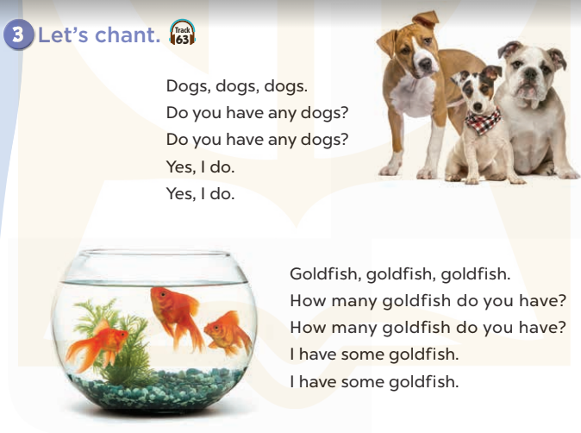  - Play the recording for Ss to listen to the whole chant.  + Have them repeat the title and lyrics line by line.  + Ask Ss to attend to the sounds of the letters o and the words dog and goldfish.  - Play the recording all the way through for Ss to listen to pronunciation and melody.  - Play the recording line by line for Ss to listen and repeat  - Play the recording for Ss to chant and clap along.  - Ask Ss to practice chant and clap along in pairs or groups.  - Invite groups to the front of the classroom to perform the chant  -T gives feedback.  *Consolidation  *Aims: Ss will be able consolidate and wrap up the content of the lesson.  *Procedure:  - T asks ss to answer the following questions:  + What have you learnt from the lesson today?  +What are the core values of the lesson? (if the teacher can take from the lesson).  - T praises some Ss who are hardworking / active/ good…. as well as encourage others to try more.  4. Homework. (2’)  - Practice the chant more.  - Prepare the new lesson: Unit 16, Lesson 3 (4,5,6). | - Ss listen  -Ss play game  - Ss open their books  - Ss recognize the differences about color of letter  - - Ss listen  - Ss listen and point  - Ss listen again and repeat  -Ss listen again and repeat  -Ss practice  -Ss listen  -Ss listen and say:  + Number 1: How many…do you have?  + Number 2: Do you have any….?  -Ss guess the answers  - Ss listen to the tape and circle  - Ss listen again, circle and swap books with their partners.  - Ss check their answers and guessing  -Ss listen and repeat.  -Ss read the sentences  - Ss look and listen.  -Ss listen to the chant  - Ss listen and repeat line by line without clap their hands  -Ss note the sounds, words  -Ss listen to melody of the chant  - Ss listen and chant line by line.  - Ss chant and clap along.  - Ss work in groups (two groups) to chant  -Ss perform in front of the class.  -Ss listen  -Ss listen.  -Ss answer the questions  -Ss listen and clap their hands  -Ss listen and take note
D. ADJUSTMENTS (if necessary):
………………………………………………………………………………………….…..……………………………………………………………………………...
-----------------------------------------------------------
Grade 3: Lớp 3A: Sáng thứ sáu, ngày 04 tháng 4 năm 2025
ENGLISH
Unit 16: My pets - Lesson 3 (4, 5, 6)
A. OBJECTIVES:
By the end of the lesson, Ss will be able to:
1. Knowledge:
- Listen to and demonstrate understanding of simple communicative contexts in relation to the topic "Pets"
- Read and write about pets.
- Use the target language items they have learnt in a real context by showing the photos of their pets and telling the class about them.
- Vocabulary: Review
- Skills: speaking, listening, reading and writing.
2. Competences:
- Co-operation: ready to help friends in pair work/ group work.
- Self-control and independent learning: perform reading tasks.
3. Attitude/ Qualities:
- Kindness: Help partners to complete learning tasks.
- Honesty: tell the truth about feelings and emotions.
- Diligence: complete learning tasks.
B. TEACHING AIDS:
- Teacher: Teacher’s guide Pages 208, 209, website sachmem.vn, posters, laptop, pictures, textbook, lesson plan, TV or projector.
- Students: Pupil’s book Page 45, notebooks, workbooks, school things.
C. PROCEDURES:
Teacher’s activities | Students’ activities
1.Warm- up: (5’)  Game: Brainstorming  *Aims: to review the vocabulary and structure about greet and respond to greetings.  *Procedure:  - Divide the class into four groups.  - Each group chooses one pupil to be the 'runner'. The runners go to the teacher's desk and read the category.  Ex: Find pets  - The runners then go back to their group and tell their group members the category. Their group brainstorm words from that category and write them down.  - The first group to finish shouts 'stop' and then calls out their answers. If their answers are correct, they score one point for each word in the category.  - The group with the highest score at the end of the game wins.  - Say “Open your book page 45” and look at “Unit 16, Lesson 3 (4, 5, 6)”.  2.Practice: (8’)  Activity 1. Read and complete:  *Aims: Ss will be able to read and complete a target paragraph using the four words provided.  *Procedure:  - Tell Ss how to complete the task.  - Point at the words provided in the box and the five gaps in the passage - Ask Ss attend to the blank in number 1 and find the missing word.  - Write the missing word on the board and get the class to read the completeed sentence together.  - Have Ss work in pairs and complete  - Tell Ss to swap books with a partner, then check answers together as a class.  - Write the correct answers on the board for pupils to correct their answers.  - Invite Ss to read the complete text aloud  -T gives feedbacks.  Key: 1. many 2. have 3. and 4. Do  3.Production: (19’)  Activity 2. Let’s write  *Aims: Ss will be able read, understand and complete a gapped text about pets.  *Procedure:  - Explain to the class the goal of this activity.  - Ask Ss to read each gapped sentence, look at the picture and fill in the gap.  - Give Ss time to write their answers  - Ask Ss to swap and correct their answers in pairs.  - Check the answers as a class.  Key: Pupils’ own answers  Activity 3. Project.  *Aims: Ss will be able to use the target language items they have learnt in a real context by showing the photos of their pets and telling the class about them  *Procedure:  - Point at the prompt picture and explain what they should do to complete the project.  - Prepare two photos to share with pupils. Point at one photo and say: I have some…. and point at the other photo and say: I have some ….  - Have Ss work in groups. Each pupil shares his / her photos and says what pets he / she has in the photos.  - Give the class time to complete the project.  - Invite some Ss to the front of the class to present the photos.  *Consolidation  *Aims: Ss will be able consolidate and wrap up the content of the lesson.  *Procedure:  - T asks ss to answer the following questions:  + What have you learnt from the lesson today?  - T praises some Ss who are hardworking / active/ good…. as well as encourage others to try more.  4. Homework. (3’)  - Prepare the new lesson: Unit 17- Lesson 1 (1,2,3). | - Ss listen  -Ss play game  - Ss open their books  -Ss listen  - Ss read and answer  -Ss read and complete  -Ss write the first word  -Ss work in pairs  -Ss swap books and check  -Ss check the correct their answers  -Ss read  -Ss listen  -Ss listen  -Ss read and answer  -Ss write  My name………I love pets. I have a cat. It is big. I have….  It is ……………..Do you have  any……….?  -Ss swap books and check their answers  -Ss check  -Ss listen  -Ss listen and say  -Ss work in groups  -Ss complete the project  -Ss perform in front of the class.  -Ss answer the questions  -Ss listen and clap their hands  -Ss listen and take note
D. ADJUSTMENTS (if necessary):
………………………………………………………………………………………….…..……………………………………………………………………………...
---------------------------------------------------------
Grade 3: Lớp 3A: Sáng thứ sáu, ngày 04 tháng 4 năm 2025
ENGLISH
Unit 17: Our toys - Lesson 1 (1, 2, 3)
A. OBJECTIVES:
By the end of the lesson, Ss will be able to:
1. Knowledge:
- Use the words car, kite, train, plane, in relation to the topic “Our toys”
- Understand and correctly repeat the sentences in two communicative contexts (pictures) to identify someone’s toys.
- Correctly say the words and use He / She has …….. to identify someone’s toys.
- enhance the correct use of He / She has …... to identify someone’s toys in a freer context.
- Vocabulary: car, kite, train, plane, doll, toy.
- Model sentences:
He/ she has ………..
- Skills: speaking and listening
2. Competences:
- Co-operation: ready to help friends in pair work/ group work.
- Sociability: Talk to each other, say good words to others.
3. Attitude/ Qualities:
- Kindness: Help partners to complete learning tasks.
- Honesty: tell the truth about feelings and emotions
B. TEACHING AIDS:
- Teacher: Teacher’s guide Pages 179, 180, audio Tracks 54, 55, website sachmem.vn, posters, laptop, pictures, textbook, lesson plan, TV or projector.
- Students: Pupil’s book Page 40, notebooks, workbooks, school things.
C. PROCEDURES:
Teacher’s activities | Students’ activities
1.Warm- up: (3’)  Sing: Jigsaw puzzle  *Aims: to create a friendly and active atmosphere in the class to beginning the lesson.  *Procedure:  - Divide class into 4 groups: Tom, Jerry, Miu and Chit.  - Ask Ss look at the pieces of picture.    - Ask Ss go to the board and jigsaw puzzle into the correct picture.  -T checks who’s the winner?  - Say “Open your book page 40” and look at “Unit 17, Lesson 1 (1,2,3)”.  2. Presentation(16’)  Activity 1. Vocabulary.  *Aims: Ss will be able to know the vocabulary in front of starting the new lesson.  *Procedure:  -T elicits the new words  + car : xe ô tô (visual)  + kite : con diều (realia)  + train :tàu lửa (visual)  + plane : máy bay (visual)  + doll :búp bê (realia)  + toy : đồ chơi (translation)  - T models (3 times).  - T writes the words on the board.  - Checking: Matching  Activity 2. Look, listen and repeat:  *Aims: Ss will be able to understand and correctly repeat the sentences in two communicative contexts (pictures) to identify someone’s toys  *Procedure:  - Have Ss look at Pictures a and b and identify names of the speakers in the pictures.  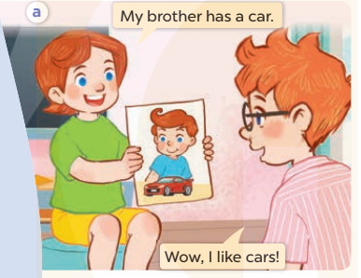  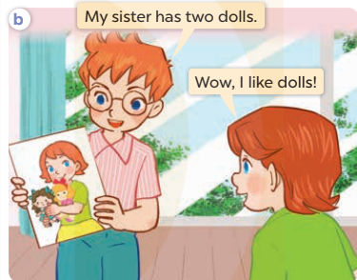  - Play the audio twice (sentence by sentence). Correct their pronunciation where necessary.  - Have Ss to practice the dialogue  - T invites a few pairs to the front of the class to practice.  - T checks pronunciation for ss.  Activity 3 Listen, point and say.  *Aims: Ss will be able to correctly say the words and use He / She has …….. to identify someone’s toys.  *Procedure:  * Model sentences:  - T asks Ss look at picture a, b and helps Ss know the structure from the dialogue.  - T introduces new structure for Ss.  - T explains, models and gives meaning.  -Have Ss repeat the model sentences.  He/ she has a car.  3.Practice: (7’)  *Drill pictures  - Elicit the character and the quantity of toys in each picture.  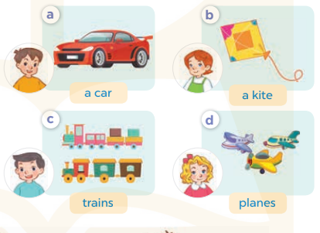  - Run through all the pictures.  - Run through model sentences.  - Have Ss to practise:  - Ask Ss to work in pairs.  - T controls and corrects.  - Invite a few pairs to come to the front of the classroom and point at the pictures and say the questions and answers in front of the class.  - T gives feedbacks.  4.Production: (7’)  Activity 4. Let’s talk.  *Aims: Ss will be able to enhance the correct use of He / She has ….. to identify someone’s toys in a freer context.  *Procedure:  - Have Ss look at the picture and elicit the question and the answer in context.  + What can you see in the picture?  + How many toys are there?  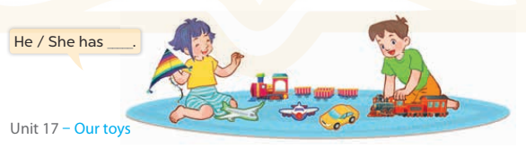  - Put Ss into groups of four.  - Ask Ss to say using He/ she has…..  - Invite some Ss to the front of the class to say about their toys  *Consolidation  *Aims: Ss will be able consolidate and wrap up the content of the lesson.  *Procedure:  - T asks ss to answer the following questions:  + What have you learnt from the lesson today?  +What are the core values of the lesson? (if the teacher can take from the lesson).  - T review the vocabulary and model sentences.  - T praises some Ss who are hardworking / active/ good…. as well as encourage others to try more.  5. Homework. (2’)  - Learn the vocabulary and model sentences by heart  - Prepare the new lesson: Unit 17, Lesson 1 (4,5,6). | - Ss listen  -Ss look at the pieces of the picture  -Ss put into the correct picture  -Ss check  - Ss open their books  -Ss listen and answer  - - Ss listen and repeat  + Choral repetition (3 times).  + Individual repetition (3 ss)  - Ss take note  - Ss look, remember and match  -Look at the pictures and say  + In picture a: Lucy says: My brother has a car. Ben says: Wow, I like cars!  + In picture b: Ben says: My sister has two dolls. Lucy says: Wow, I like dolls!  -Ss listen and repeat in chorus (twice)  -Ss work in pairs to practice  -Ss practice the dialogue  -Ss listen  -Ss look at the picture and answer.  -Ss listen  -Ss listen and repeat  -Ss repeat  - Ss look, listen and answer  + Picture a: a boy and a car  + Picture b: a girl and a kite  + Picture c: a boy and two trains  + Picture d: a girl and three planes  -Ss listen and repeat  -Ss practice in chorus  -Ss work in pairs to practice  -Ss point and say  -Ss listen.  -Ss look at the picture and answer  + A girl and a boy are playing with some toys.  -Ss look and answer  -Ss perform in front of the class.  -Ss answer the questions  - Ss listen  -Ss listen and clap their hands  -Ss listen and take note
D. ADJUSTMENTS (if necessary):
………………………………………………………………………………………….…..……………………………………………………………………………...………………………………………….…..………………………………………
Grade 4: Lớp 4A: Sáng thứ Ba, Ngày 01 tháng 4 năm 2025
Lớp 4C: Chiều thứ Hai, Ngày 31 tháng 3 năm 2025
Lớp 4B: Sáng thứ tư , Ngày 02 tháng 4 năm 2025
ENGLISH
Unit 16: Weather - Lesson 2 (4, 5, 6)
A. OBJECTIVES:
By the end of the lesson, Ss will be able to:
1. Knowledge:
- Listen to and demonstrate understanding of simple communicative contexts in relation to the topic “Weather”.
- Read and write about the weather and suggestions to go somewhere”.
- Vocabulary: Review
- Skills: speaking, listening, reading and writing.
2. Competences:
- Co-operation: ready to help friends in pair work/ group work.
- Self-control and independent learning: perform listening tasks.
3. Attitude/ Qualities:
- Kindness: Help partners to complete learning tasks.
- Diligence: complete learning tasks.
B. TEACHING AIDS:
- Teacher: Teacher’s guide Pages 235, 236; audio Tracks 58; website hoclieu.vn, posters, laptop, pictures, textbook, lesson plan, TV or projector.
- Students: Pupil’s book Page 43, notebooks, workbooks, school things.
C. PROCEDURES:
Teacher’s activities | Students’ activities
1.Warm- up: (5’)  Game: “Guessing game”  *Aims: to create a friendly and active atmosphere in the class to beginning the lesson.  *Procedure:  - Ask Ss to draw a place they want to go into the air, their friends try to guess and say Let’s go…. and respond accordingly.  - Say “Open your book page 43” and look at “Unit 16, Lesson 2 (4,5,6)”.  2.Practice: (27’)  Activity 1. Listen and match:  *Aims: Ss will be able to listen to and understand two communicative contexts in which pupils make suggestions to go somewhere and respond, and match the characters with the right pictures. *Procedure:  - Have Ss look at the pictures and identify the two characters and the places 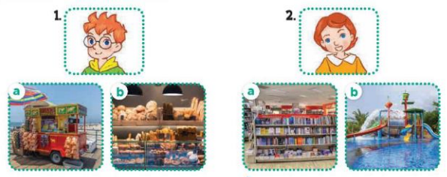  - T ask Ss to guess the answers.  + T writes Ss’guessing on the board.  - Listen to the tape:  + Play the recording  + Play the recording again and get Ss to swap books with their partners.  + Play the recording again to check answers together as a class.  + Write the answers on the board for Ss to correct their answers. Then checks Ss’ guessing.  - Play the recording, sentence by sentence, for the class to listen and repeat in chorus.  Key: 1.b 2. a  Activity 2. Look, complete and read.  *Aims: Ss will be able to complete two gapped exchanges with the help of picture cues.  *Procedure:  - Have Ss look at the pictures and identify the weather in the pictures.  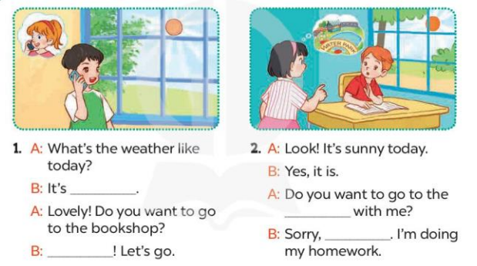  - T models with sentence 1.  + Have Ss look at the sentence.  + Ask them what is missing in the answer (sunny).  + Have Ss complete the gap.  + Have Ss read the completed sentence in chorus.  -Have Ss work in pairs and complete the other sentences.  - Invite pairs of pupils to stand up and read aloud the sentences.  -T gives feedbacks.  Key: 1. sunny; Great 2. water park; I can't  Activity 3. Let’s play  Slap the board and say  *Aims: Ss will be able to revise the target vocabulary items and structures by playing Slap the board and say game.  *Procedure:  - Tell Ss how to play the game.  + Put five flashcards or write the names of five places on the board.  + Divide the class into four teams.  + Ask one representative of each team to come to the front.  - Example: I want to go to the bookshop.  + The pupil who is the quickest to slap the correct picture / word gets one point for his / her team.  + Repeat the same procedure with the other pictures / words on the board.  - The team that gets the most points at the end of the game wins.  *Consolidation  *Aims: Ss will be able consolidate and wrap up the content of the lesson.  *Procedure:  - T asks ss to answer the following questions:  + What have you learnt from the lesson today?  +What are the core values of the lesson? (if the teacher can take from the lesson).  - T praises some Ss who are hardworking / active/ good…. as well as encourage others to try more.  3. Homework. (3’)  - Prepare the new lesson: Unit 16, Lesson 3 (1,2,3). | - Ss listen and play the game  - Ss open their books  -Look at the pictures and say:  Number 1: a picture of Ben  - a picture of a food stall (a)  - a picture of a bakery (b)  Number 2: a picture of Lucy  + a picture of a bookshop (a  + a picture of a water park (b)  -Ss guess the answers  - Ss listen to the tape and draw the line  - Ss listen again, match and swap books with their partners.  - Ss check their answers and guessing  -Ss write he correct anwer  -Ss listen and repeat.  -Ss look at the pictures and say  -Ss listen and answer  -Ss say the missing word  -Ss read and complete  -Ss work in pairs and complete  -Ss read aloud the sentences  - Ss listen.  - Ss listen the rule of the game  -Ss play the game  -Ss listen and answer  -Ss listen and take note
D. ADJUSTMENTS (if necessary):
………………………………………………………………………………………….…..……………………………………………………………………………...………………………………………….…..………………………………………
-------------------------------------------------------------------
Grade 4: Lớp 4A: Sáng thứ Ba, Ngày 01 tháng 4 năm 2025
Lớp 4C: Chiều thứ Hai, Ngày 31 tháng 3 năm 2025
Lớp 4B: Sáng thứ tư , Ngày 02 tháng 4 năm 2025
ENGLISH
Unit 16: Weather
Lesson 3 (1, 2, 3)
A. OBJECTIVES:
By the end of the lesson, Ss will be able to:
1. Knowledge:
- correctly repeat correctly pronounce the words 'sunny and 'rainy with the stress on the first syllable in isolation and in the sentences It’s 'sunny today. and I don’t like 'rainy weather.
– listen to and demonstrate understanding of simple communicative contexts in relation to the topic “Weather”.
- Vocabulary: Review
- Skills: speaking, listening, reading and writing.
2. Competences:
- Co-operation: ready to help friends in pair work/ group work.
- Self-control and independent learning: perform listening tasks.
3. Attitude/ Qualities:
- Kindness: Help partners to complete learning tasks.
- Honesty: tell the truth about feelings and emotions
B. TEACHING AIDS:
- Teacher: Teacher’s guide Pages 237, 238; audio Tracks 59, 60, 61; website hoclieu.vn, posters, laptop, pictures, textbook, lesson plan, TV or projector.
- Students: Pupil’s book Page 44, notebooks, workbooks, school things.
C. PROCEDURES:
Teacher’s activities | Students’ activities
1.Warm- up: (5’)  Game: Find and circle the words  *Aims: to create a friendly and active atmosphere in the class to beginning the lesson.  *Procedure:  S B K K E P S C C T  U E T E E D D C L H  N E U A A E C O O I  N A M W F C C S U N  Y A B I N N L S D K  R A I N Y I S F Y B  S R O D R C V T A H  M M T Y H R S T A Y  D P P B E S E R S M  A C E B F A Z Y W  - Divide class into 2 groups  - Ask Ss to find and circle the words that they learnt.  - Which groups find the best correct words is winner.  - Give Ss time to play the game.  Rows: rainy  Columns: cloudy, windy, sunny  -T checks who’s winner?  - Say “Open your book page 44” and look at “Unit 16, Lesson 3 (1,2,3)”.  2. Presentation(9’)  Activity 1. Listen and repeat:  *Aims: Ss will be able to correctly pronounce the words 'sunny and 'rainy with the stress on the first syllable in isolation and in the sentences It’s 'sunny today. and I don’t like 'rainy weather. with correct pronunciation and intonation.  *Procedure:  - T gives instruction to the words 'sunny and 'rainy with the stress on the first syllable in isolation and in the sentences It’s 'sunny today. and I don’t like 'rainy weather.  - Play the recording for the words 'sunny and 'rainy and the sentence.  - Play the recording and encourage Ss to point at the word and sentence while listening  - Play the recording again and encourage Ss to listen and repeat.  - Do this several times until Ss feel confident.  - T calls some Ss to practice.  - T gives feedbacks.  3.Practice: (19’)  Activity 2. Listen and circle.  *Aims: Ss will be able to identify the target words sunny and rainy while listening.  *Procedure:  - Explain what pupils have to do and check comprehension.  - Play the recording for Ss to listen.  - Play the recording again for pupils to listen and circle the correct options.  - Have Ss to swap books with a partner, then check the answers as a class.  - Write the correct answers on the board.  - Invite one or two pupils to stand up, listen to and repeat the sentences  Key: 1.c 2.a  Activity 3. Let’s chant  *Aims: Ss will be able to say the chant with the correct rhythm and pronunciation.  *Procedure:  - Introduce the title and lyrics of the chant.  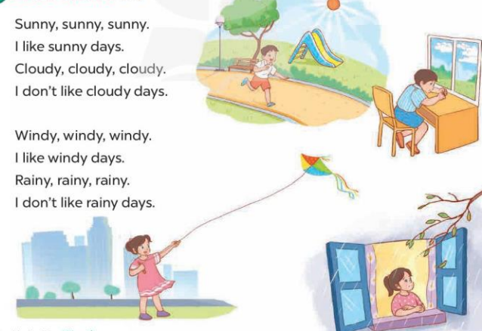  - Play the recording for Ss to listen to the whole chant.  + Have them repeat the title and lyrics line by line.  + Ask Ss to attend to two-syllable words with the stress on the first syllable in the chant, ex: sunny, cloudy, windy and rainy  - Play the recording all the way through for Ss to listen to pronunciation and melody.  - Play the recording line by line for Ss to listen and repeat  - Play the recording for Ss to chant and clap along.  - Ask Ss to practice chant and clap along in pairs or groups.  - Invite groups to the front of the classroom to perform the chant  -T gives feedback.  *Consolidation  *Aims: Ss will be able consolidate and wrap up the content of the lesson.  *Procedure:  - T asks ss to answer the following questions:  + What have you learnt from the lesson today?  +What are the core values of the lesson? (if the teacher can take from the lesson).  - T praises some Ss who are hardworking / active/ good…. as well as encourage others to try more.  4. Homework. (2’)  - Prepare the new lesson: Unit 16, Lesson 3 (4,5,6). | - Ss listen  -Ss play game  - Ss open their books  - Ss recognize the what word stress is  - - Ss listen  - Ss listen and point  - Ss listen again and repeat  -Ss listen again and repeat  -Ss practice  -Ss listen  -Ss pay attention and say  - Ss listen to the tape  - Ss listen again and circle  - Ss swap books and check their answers  -Write the correct answer  -Ss listen and repeat.  - Ss look and listen.  -Ss listen to the chant  - Ss listen and repeat line by line without clap their hands  -Ss note the words  -Ss listen to melody of the chant  - Ss listen and chant line by line.  - Ss chant and clap along.  - Ss work in groups (two groups) to chant  -Ss perform in front of the class.  -Ss listen  -Ss listen.  -Ss answer the questions  -Ss listen and clap their hands  -Ss listen and take note
D. ADJUSTMENTS (if necessary):

Grade 4: Lớp 4A: Sáng thứ Sáu Ngày 04 tháng 4 năm 2025
Lớp 4B: Sáng thứ Năm, Ngày 03 tháng 4 năm 2025
Lớp 4C: Sáng thứ Tư , Ngày 02 tháng 4 năm 2025
ENGLISH
Unit 16: Weather - Lesson 3 (4, 5, 6)
A. OBJECTIVES:
By the end of the lesson, Ss will be able to:
1. Knowledge:
- Read and write about the weather and suggestions to go somewhere.
- Make a weather chart, then tell the class about it at Project time.
- Vocabulary: Review
- Skills: speaking, listening, reading and writing.
2. Competences:
- Co-operation: ready to help friends in pair work/ group work.
- Self-control and independent learning: perform reading tasks.
3. Attitude/ Qualities:
- Kindness: Help partners to complete learning tasks.
- Honesty: tell the truth about feelings and emotions.
- Diligence: complete learning tasks.
B. TEACHING AIDS:
- Teacher: Teacher’s guide Pages 238, 239, website hoclieu.vn, posters, laptop, pictures, textbook, lesson plan, TV or projector.
- Students: Pupil’s book Page 45, notebooks, workbooks, school things.
C. PROCEDURES:
Teacher’s activities | Students’ activities
1.Warm- up: (5’)  Game: Miming game  *Aims: to review the vocabulary and structure about greet and respond to greetings.  *Procedure:  - Guide Ss to act the weather (sunny- wearing glasses/ pretend to wear a hat)  - Divide them into groups to take turns to mime and guess if their friends like or dislike the weather they mime.  - Say “Open your book page 45” and look at “Unit 16, Lesson 3 (4, 5, 6)”.  2.Practice: (8’)  Activity 1. Read and circle:  *Aims: Ss will be able to text about the weather, activities and places  – Four incomplete sentences, each with three answer options  *Procedure:  - Draw Ss’ attention to the text and read it as a class.  - Draw Ss’ attention to the incomplete sentences and answer options.  - Have Ss pay attention to the sentences about the weather and the places the characters go to.  - Ask S s to read the text again and circle the correct answers.  - Tell Ss to swap books with a partner, then check answers as a class.  - Write the correct answers on the board.  - Ask Ss to read the text aloud in front of the class.  Key: 1. c 2. c 3. a 4. a  3.Production: (19’)  Activity 2. Let’s write  *Aims: Ss will be able to complete a gapped paragraph about weather and suggestions to go somewhere. .  *Procedure:  - Explain to the class the goal of this activity.  - Ask Ss to read each gapped sentence, look at the picture and fill in the gap.  - Give Ss time to write their answers  - Ask Ss to swap and correct their answers in pairs.  - Check the answers as a class.  Key: Pupils’ own answers  Example: The weather is sunny today. My family want to go to the supermarket. My mother wants clothes. She is at the clothes shop. My father wants some food. He is at food stall. I want some books. I am at the bookshop. My brother wants some toys. He is at the toy store.  Activity 3. Project.  *Aims: Ss will be able to make a weather chart and present it to the class by using the target language.  *Procedure:  - Explain that they are going to show weather charts that they have made at home and tell the class about the weather last weekend and today in different places..  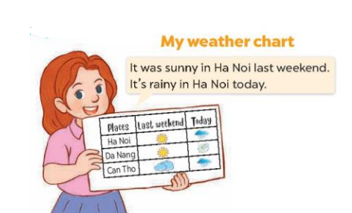  - Have Ss work in groups of five.  + Each pupil shows his / her chart that they have made at home and tells the group about the weather last weekend and today in different places, ex: It was sunny in Ha Noi last weekend. It’s rainy in Ha Noi today. It was sunny in Da Nang last weekend. It’s windy in Da Nang today.  - Invite some Ss to show their work and talk about the weather in front of the class.  *Consolidation  *Aims: Ss will be able consolidate and wrap up the content of the lesson.  *Procedure:  - T asks ss to answer the following questions:  + What have you learnt from the lesson today?  - T praises some Ss who are hardworking / active/ good…. as well as encourage others to try more.  4. Homework. (3’)  - Prepare the new lesson: Unit 17- Lesson 1 (1,2,3). | - Ss listen  -Ss play game  - Ss open their books  - Ss read the text  -Ss attention to the incomplete sentences and answer  -Ss read the text again and circle  -Ss swap books and check answer  -Ss write the correct answers  -Ss read the text aloud  -Ss listen  -Ss read and answer  -Ss write  -Ss swap books and check their answers  -Ss check the answer  -Ss listen  -Ss work in groups and tell about their chart  -Ss perform in front of the class.  -Ss answer the questions  -Ss listen and clap their hands  -Ss listen and take note
D. ADJUSTMENTS (if necessary):
………………………………………………………………………………………….…..……………………………………………………………………………...
-------------------------------------------------------------------
Grade 4: Lớp 4A: Sáng thứ Sáu Ngày 04 tháng 4 năm 2025
Lớp 4B: Sáng thứ Năm, Ngày 03 tháng 4 năm 2025
Lớp 4C: Sáng thứ Tư , Ngày 02 tháng 4 năm 2025
ENGLISH
Unit 17: In the city - Lesson 1 (1, 2, 3)
A. OBJECTIVES:
By the end of the lesson, Ss will be able to:
1. Knowledge:
- use the words and phrases go straight, stop, turn left, turn right in relation to the topic “In the city”.
-use What does it say? – It says ʽ……..ʼ. ask and answer questions to identify road signs.
- Vocabulary: go straight, stop, turn left, turn right
- Model sentences:
A: What does it say?
B: It says “stop”
- Skills: speaking and listening
2. Competences:
- Co-operation: ready to help friends in pair work/ group work.
- Sociability: Talk to each other, say good words to others.
3. Attitude/ Qualities:
- Raise pupils’ awareness about their neighborhood and traffic safety.
B. TEACHING AIDS:
- Teacher: Teacher’s guide Pages 1241, 242, 243; audio Tracks 62, 63, website hoclieu.vn, posters, laptop, pictures, textbook, lesson plan, TV or projector.
- Students: Pupil’s book Page 46, notebooks, workbooks, school things.
C. PROCEDURES:
Teacher’s activities | Students’ activities
1.Warm- up: (3’)  Game: Jigsaw puzzle  *Aims: to create a friendly and active atmosphere in the class to beginning the lesson.  *Procedure:  - Divide class into 4 groups: Tom, Jerry, Miu and Chit.  - Ask Ss look at the pieces of picture.  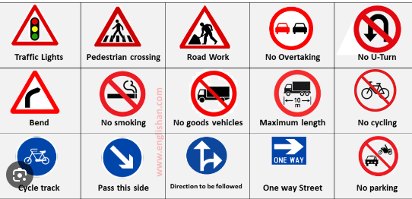  - Ask Ss go to the board and jigsaw puzzle into the correct picture.  -T checks who’s the winner?  - Say “Open your book page 46” and look at “Unit 17, Lesson 1 (1,2,3)”.  2. Presentation(16’)  Activity 1. Vocabulary.  *Aims: Ss will be able to know the vocabulary in the new lesson.  *Procedure:  -T elicits the new words  + stop : dừng lại (situation)  + go straight : đi thẳng (situation)  + turn right : rẽ phải (picture)  + turn left : rẽ trái (picture)  + cross the road :qua đường (picture)  - T models (3 times).  - T writes the words on the board.  - Checking: Matching  Activity 2. Look, listen and repeat:  *Aims: Ss will be able to understand and correctly repeat the sentences in two communicative contexts (pictures) focusing on asking and answering questions to identify some road signs.  *Procedure:  - Have Ss look at Pictures a and b and identify the characters and say what they can see in the pictures.  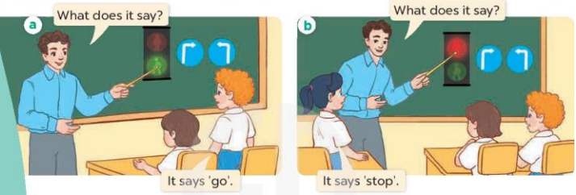  - Play the audio twice (sentence by sentence). Correct their pronunciation where necessary.  - Have Ss to practice the dialogue  - T invites a few pairs to the front of the class to practice.  - T checks pronunciation for ss.  Activity 3 Listen, point and say.  *Aims: Ss will be able to correctly say the words and phrases and use What does it say? – It says ʽ…….ʼ. to ask and answer questions to identify some road signs.  *Procedure:  * Model sentences:  - T asks Ss look at picture b and helps Ss know the structure from the dialogue.  - T introduces new structure for Ss.  - T explains, models and gives meaning.  -Have Ss repeat the model sentences.  A: What does it say?  B: It says “stop”  3.Practice: (7’)  *Drill pictures  - Have Ss look at picture and identify the meaning of the road signs using gestures.  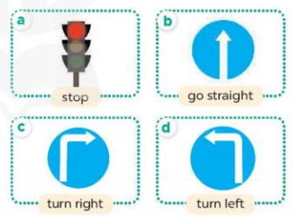  - Run through all the pictures.  - Run through model sentences.  - Have Ss to practise:  - Ask Ss to work in pairs.  - T controls and corrects.  - Invite a few pairs to come to the front of the classroom and point at the pictures and say the questions and answers in front of the class.  - T gives feedbacks.  4.Production: (7’)  Activity 4. Let’s talk.  *Aims: Ss will be able to enhance the correct use of What does it say? – It says ʽ……ʼ. to ask and answer questions to identify some road signs in a freer context.  *Procedure:  - Have Ss look at the picture and ask questions to help them understand the context.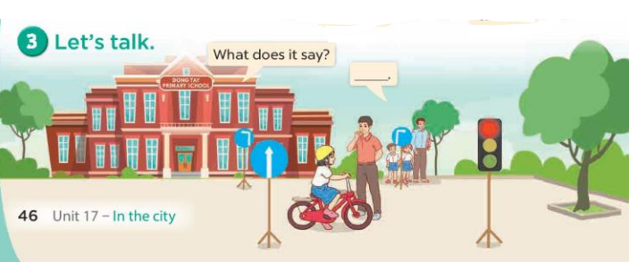  - Put Ss into groups of four.  - Ask Ss to say using What does it say?  - Invite a few pairs to the front of the classroom to ask and answer questions to identify road signs.  *Consolidation  *Aims: Ss will be able consolidate and wrap up the content of the lesson.  *Procedure:  - T asks ss to answer the following questions:  + What have you learnt from the lesson today?  +What are the core values of the lesson? (if the teacher can take from the lesson).  - T review the vocabulary and model sentences.  - T praises some Ss who are hardworking / active/ good…. as well as encourage others to try more.  5. Homework. (2’)  - Learn the vocabulary and model sentences by heart  - Prepare the new lesson: Unit 17, Lesson 1 (4,5,6). | - Ss listen  -Ss look at the pieces of the picture  -Ss put into the correct picture  -Ss check  - Ss open their books  -Ss listen and answer  - - Ss listen and repeat  + Choral repetition (3 times).  + Individual repetition (3 ss)  - Ss take note  - Ss look, remember and match  -Look at the pictures and say  + In picture a:  Teacher: What does it say?  Bill: It says ʽgoʼ.  + In picture b:  Teacher: What does it say?  Mai: It says ʽstopʼ.  -Ss listen and repeat in chorus (twice)  -Ss work in pairs to practice  -Ss practice the dialogue  -Ss listen  -Ss look at the picture and answer.  -Ss listen  -Ss listen and repeat  -Ss repeat  - Ss look, listen and answer  + Picture a: a red traffic light  + Picture b: a road sign for go straight  + Picture c: a road sign for turn right  + Picture d: a road sign for turn left  -Ss listen and repeat  -Ss practice in chorus  -Ss practice in chorus  -Ss work in pairs to practice  -Ss point and say  -Ss listen.  -Ss look at the picture and answer  + Teacher and some pupils in a traffic safety lesson with some road signs in the school yard.  -Ss look and answer  -Ss perform in front of the class.  -Ss answer the questions  - Ss listen  -Ss listen and clap their hands  -Ss listen and take note
D. ADJUSTMENTS (if necessary):
………………………………………………………………………………………….…..……………………………………………………………………………...
-----------------------------------------------------------------
Grade 5 : Lớp 5B : Sáng thứ ba, Ngày 01 tháng 4 năm 2025
ENGLISH
Unit 16: Seasons and the weather - Lesson 2 (4, 5, 6)
A. OBJECTIVES:
By the end of the lesson, Ss will be able to:
1. Knowledge:
- Listen to and understand two exchanges about the seasons and clothing, and circle the correct options
- Complete two gapped exchanges with the help of picture cues
- Revise the target vocabulary and structures related to the topic “Seasons and the weather” by playing the game Who’s faster?
- Vocabulary: Review
- Skills: speaking, listening, reading and writing.
2. Competences:
- Communication and collaboration: work in pairs and groups to complete the learning tasks.
3. Attitude/ Qualities:
- Express their feelings about the weather of each season.
- Show their knowledge of choosing suitable clothes in different seasons.
B. TEACHING AIDS:
- Teacher: Teacher’s guide Pages 265 266, 267; audio Tracks 58; website hoclieu.vn, posters, laptop, pictures, textbook, lesson plan, TV or projector.
- Students: Student’s book Page 43, notebooks, workbooks, school things.
C. PROCEDURES:
Teacher’s activities | Students’ activities
1.Warm- up and review: (4’)  Play a game: Board race  *Aims: to revise the learnt structure *Procedure:  - Divide the class into two teams.  - Arrange the flash cards on the board.  - Invite a student from each team to go to the board.  - Teacher says a word and the ss run to tap the right card as quickly as possible.  - If they tap the right card, they will get 1 point for their team.  - The team with more points wins.  - Say “Open your book page 43” and look at “Unit 16, Lesson 2 (4,5,6)”.  2. Practice: (27’)  Activity 1. Listen and circle:  *Aims: Ss will be able to listen to and understand two exchanges about the seasons and clothing, and circle the correct options.  *Procedure:  - Have ss read the questions and answers  - T ask Ss to guess the answers.  + T writes Ss’guessing on the board.  - Listen to the tape:  + Play the recording  + Play the recording again and get Ss to swap books with their partners.  + Play the recording again to check answers together as a class.  + Write the answers on the board for Ss to correct their answers. Then checks Ss’ guessing.  - Play the recording, sentence by sentence, for the class to listen and repeat in chorus.  Key: 1A.b 1B.a ; 2A.a 2B.b  Activity 2. Read and complete  *Aims: Ss will be able to complete two gapped exchanges with the help of picture cues.  *Procedure:  - Ask Ss to look at the pictures and identify the season 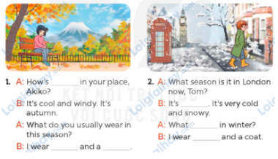  - Have Ss look at the 2 incomplete exchanges and elicits the missing words in the sentences.  - T models with the first sentence  + Ask Ss what is missing in the sentence (the weather).  + Have Ss look at the picture and identify the needed information (How’s the weather in your place, Akiko?)  - Have Ss work in pairs and complete  - Get Ss to swap books with a partner and check their answers before checking as a class.  Key:1. the weather, jeans; jumper  2. winter; do you usually wear; jeans Activity 3. Let’s play.  *Aims: Ss will be able to revise the target vocabulary and structures related to the topic “Seasons and the weather” by playing the game Who’s faster?  *Procedure:  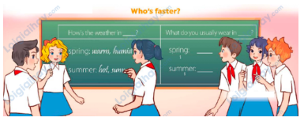  - Divided class into pairs or teams A and B. The two team members must make the questions and answers about the weather for each season and what outfits people usually wear as fast as possible.  - Give ss a time limit to play the game and go around the class to offer help where necessary.  - When the time limit is over, nominate pairs of teams to check the questions and answers. Have the teams stand up at their desk, make the sentences and encourage the rest of ss to cheer up when the sentences are made and spoken correctly.  - Invite a few teams to read aloud their sentences.  3. Fun corner and wrap- up (4’)  Game: Jump or clap  - Ask ss to stand at their desks.  - Hold up a flash card from the vocabulary set (spring, summer, autumn, winter, blouse, trousers, jeans, jumper) and say a word. The student who does the wrong action will be out of the game.  - If the word is the same as the flash card, they clap. If it isn’t, they jump. Ask them to say the word again on the flash card.  - Continue to play the game until all the vocabulary sets are said.  - Praise ss if they do the game well. | - Ss pay attention.  -Ss play the game  - Ss congratulate to the winner  - Ss open their books  - Ss read the questions and answers.  -Ss guess the answers  - Ss listen to the tape  - Ss listen again, circle and swap books with their partners.  - Ss check their answers and guessing  - Ss answer and check  -Ss listen and repeat.  -Ss look at the picture and say  -Ss follow the teacher.  -Ss read and answer  -Ss work in pairs and fill in the gaps  - Ss swap books and check  - Ss look at the four pictures in Let’s talk on page 42 and listen to the teacher’s explanation to play the game.  - Ss play the game.  - Ss check the questions and answers.  - A few teams read aloud their sentences.  -Ss listen to the teacher  -Ss play the game  -Ss praise the winner.
D. ADJUSTMENTS (if necessary):
………………………………………………………………………………………….…..……………………………………………………………………………...
------------------------------------------------------------
Grade 5 : Lớp 5B : Sáng thứ ba, Ngày 01 tháng 4 năm 2025
ENGLISH
Unit 16: Seasons and the weather - Lesson 3 (1, 2, 3)
A. OBJECTIVES:
By the end of the lesson, Ss will be able to:
1. Knowledge:
- Correctly repeat two sentences with falling intonation
- Listen and correctly repeat four sentences paying attention to the word stress and falling intonation
- Say the chant with the correct pronunciation, rhythm and intonation.
- Vocabulary: Review
- Skills: speaking, listening, reading and writing.
2. Competences:
- Communication and collaboration: work in pairs and groups to complete the learning tasks.
- Self-control and independent learning: perform pronunciation and listening tasks.
3. Attitude/ Qualities:
- Show their love and interest in the weather and seasons.
- Express their feelings about the weather of each season.
- Show their knowledge of choosing suitable clothes in different seasons.
B. TEACHING AIDS:
- Teacher: Teacher’s guide Pages 268, 269; audio Tracks 59, 60, 61; website hoclieu.vn, posters, laptop, pictures, textbook, lesson plan, TV or projector.
- Students: Students’ book Page 44, notebooks, workbooks, school things.
C. PROCEDURES:
Teacher’s activities | Students’ activities
1.Warm- up and review: (5’)  Gane: Find the clothes  *Aims: to revise the words and structure about clothes  *Procedure:  - Tell ss the goal of the game and how to play it. Five ss hold different flash cards (Flash card 1: jeans, Flash card 2: T-shirt; Flash card 3: jumper; Flash card 4: shirt; Flash card 5: shorts).  - Invite five ss to the front of the class to demonstrate how to play the game.  - Teacher calls out “T-shirt”, the student with the T-shirt flash card steps up and shows his / her flash card to the whole class.  - Repeat the procedure with other flash cards. If a student fails to show his / her flash card or shows the wrong flash card, he / she is “out” of the game.  - Praise ss if they do the game well.  - Say “Open your book page 44” and look at “Unit 16, Lesson 3 (1,2,3)”.  2. Presentation (9’)  Activity 1. Listen and repeat:  *Aims: Ss will be able to correctly repeat two sentences with falling intonation.  *Procedure:  - Have ss point at Sentence 1 and 2 and play the recording for them to listen and repeat in chorus and individually until they feel confident.  - Let ss work in pairs or groups to practise saying the sentences.  - Invite a few ss to listen to and repeat the sentences. Praise them when they have good pronunciation, stress, rhythm and intonation.  - Ask ss to use other words to replace the noun autumn and jeans in the sentences, practise reading the new sentences aloud, and pay attention to the correct word stress and falling intonation.  3.Practice: (17’)  Activity 2. Listen and repeat. Pay attention to the intonation.  *Aims: Ss will be able to listen and say four sentences with falling intonation.  *Procedure:  - Tell ss the goal of the activity and explain that they have to listen to the recording and repeat, paying attention to the word stress and falling intonation.  - Play the recording, once or twice, for ss to listen and repeat until they feel confident  - Invite a few ss to say aloud these sentences. Correct their pronunciation and word stress where necessary.  Activity 3. Let’s chant  *Aims: Ss will be able to say the chant with the correct pronunciation, rhythm and intonation.  *Procedure:  - Introduce the title and lyrics of the chant.  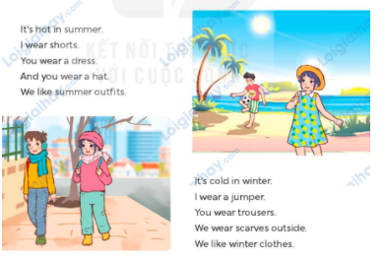  - Play the recording for Ss to listen to the whole chant.  + Have them repeat the title and lyrics line by line.  - Play the recording all the way through for Ss to listen to pronunciation and word stress, rhythm, and intonation.  - Play the recording line by line for Ss to listen and repeat  - Play the recording for Ss to chant and clap along.  - Ask Ss to practice chant and clap along in pairs or groups.  - Invite groups to the front of the classroom to perform the chant  3. Fun corner and wrap- up (4’)  Game: Memory chain  - Tell ss they are going to remember the four sentences in a chain.  - Divide the class into two groups. Each group has eight ss.  - Ask eight ss from each group to take turns playing the game.  - Have student A say the first sentence, then have student B say the next sentence and so on.  - If a pupil forgets a sentence, the group must start from Pupil A again.  - The winning group is the first one to have all members finish speaking. Praise the winner. | - Ss follow the teacher’s instructions.  -Ss play the game  - Ss open their books  - Ss point, listen and repeat in chorus and individually.  - Ss work in pairs or teams to practise saying the sentences.  - Ss listen to and repeat the sentences.  - Ss use other words to replace the noun autumn and jeans in the sentences, practise reading the new sentences aloud.  - Ss listen to the teacher’s explanation.  - Ss listen to the recording, once or twice, and repeat.  - Ss say these sentences aloud.  Ss look and listen.  - Ss listen to the chant  - Ss listen and repeat line by line without clap their hands  -Ss listen to melody of the chant  - Ss listen and chant line by line.  - Ss chant and clap along.  - Ss work in groups (two groups) to chant  -Ss perform in front of the class.  -Ss listen  -Ss play the game  Ex:  I wear a blouse in spring.  I wear a jumper in winter.  I wear trousers in summer.  I wear jeans in autumn.  -Ss continute play the game  -Ss listen
D. ADJUSTMENTS (if necessary):
………………………………………………………………………………………….…..……………………………………………………………………………...
----------------------------------------------------------------
Grade 5 : Lớp 5B : Sáng thứ năm, Ngày 03 tháng 4 năm 2025
ENGLISH
Unit 16: Seasons and the weather - Lesson 3 (4, 5, 6)
A. OBJECTIVES:
By the end of the lesson, Ss will be able to:
1. Knowledge:
- Read and show understanding of a paragraph by completing a table about the weather and seasons in Viet Nam
- Write correct sentences about the weather and seasons and what people usually do in different seasons
- Present posters about pupils’ favourite seasons and the clothes they wear.
- Vocabulary: Review
- Skills: speaking, listening, reading and writing.
2. Competences:
- Communication and collaboration: work in pairs and groups to complete the learning tasks.
- Self-control and independent learning: perform reading and writing tasks.
3. Attitude/ Qualities:
- Express their feelings about the weather of each season.
- Show their knowledge of choosing suitable clothes in different seasons.
B. TEACHING AIDS:
- Teacher: Teacher’s guide Pages 269, 270, 271; website hoclieu.vn, posters, laptop, pictures, textbook, lesson plan, TV or projector.
- Students: Student’s book Page 45, notebooks, workbooks, school things.
C. PROCEDURES:
Teacher’s activities | Students’ activities
1.Warm- up and review: (5’)  Game: Slap the board  *Aims: to revise the new words and structures from previous lessons.  *Procedure:  - Divide class into 2 groups: Tom and Jerry.  - How to play:  + Each group chooses five Ss to play.  + Class will read aloud.  + Look at the picture, listen and slap the picture you heard (spring, autumn, winter, summer, jeans, trousers, dress…)  + Who faster will get 1 mark.  + Which group with higher mark is the winner.  - Say “Open your book page 45” and look at “Unit 16, Lesson 3 (4,5,6)”.  2.Practice: (8’)  Activity 1. Read and complete:  *Aims: Ss will be able to read and show understanding of a paragraph by completing a table about the weather and seasons in Viet Nam.  *Procedure:  - Tell ss the goal of the activity and explain that they should read the paragraph and complete the table provided.  - Model the first gap. Have ss read the table, focusing on the seasons and the missing weather conditions in the north of Viet Nam; then quickly scan the paragraph above to find the correct words (sunny and hot). Tell them to complete the table and read their answers aloud.  - Set a time limit for ss to do the task independently.  - Get ss to swap books with a partner and check their answers before checking as a class.  Key:  1. sunny and hot  2. cool and cloudy  3. cold and dry  4. the dry season  5. the rainy season  3.Production: (18’)  Activity 2. Let’s write  *Aims: Ss will be able to write a paragraph about the local weather and typical outfits for each season.  *Procedure:  - Tell the class the goal of the activity and explain that they should answer the questions based on the true facts.  - Model Question 1: There are four seasons in Quang Ngai: spring, summer, autumn and winter.  - Give ss time to do the writing task independently.  - Get ss to swap books with a partner and check their answers before checking as a class.  - Invite one or two ss to stand up and read aloud their paragraphs.  Suggested answer:  I live in Quang Ngai, a city in the central of Viet Nam. There are four seasons: spring, summer, autumn and winter. In spring, it’s warm and cool. I usually wear dress and jacket. In summer, it’s sunny and hot. I usually wear skirt and a coat….  Activity 3. Project.  *Aims: Ss will be able to present posters about pupils’ favourite seasons and the clothes they wear.  *Procedure: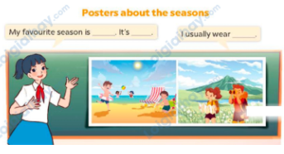  - Check ss’ posters.  - Invite a student to present his / her posters with your help.  - Have ss work in groups to present their posters. Go around the classroom and offer help where necessary.  - Organize a poster display to vote for the best posters and presenters. Have the class praise the presenters of the voted posters.  Suggested answer:  Hello, everyone! My name’s Long. I live in Nha Trang, a coastal city in the south of Viet Nam. There are only two seasons in my place: the dry season and the rainy season. My favourite season is the dry season. The weather is dry and cool. I usually wear summer outfits in this season. Look at my poster - l wear shorts when  I go swimming in the  sea. And I wear jeans and a T-shirt when I take photos in the mountains. The dry season is really cool for me! Thank you for your listening. Your questions are welcomed!  4. Fun corner and wrap- up (4’)  Game: Circle the words  - Divide the class into groups of three.  - Have each group take out one paper and two pens with different colors.  - Ask one student to write down the eight words of seasons and clothes in random order then give it to his / her friends.  - When he / she calls out one word (ex: summer), the other two pupils try to circle that word as fast as possible.  - The student who circles more words wins.  - Have some groups demonstrate the activity in front of the class. Praise the winner. | - Ss listen  - Ss listen to the rules  -Ss play game  - Ss open their books  - Ss listen to the teacher’s explanation.  - Ss read the table, focusing on the seasons and the missing weather conditions in the north of Viet Nam and complete the table  and read them aloud.  - Ss do the task independently.  - Ss swap books and check their answers before checking as a class.  - Ss listen to the teacher’s explanation.  - Ss follow the teacher  - Ss do the writing task independently.  - Ss swap books with a partner and check their answers before checking as a class.  - Ss stand up and read aloud their paragraphs.  - Ss show their posters.  - Ss presents his / her poster with the teacher’s help.  - Ss work in groups to present their posters.  - Ss vote for the best posters and presenters and praise the presenters of the voted posters.  -Ss listen to the teacher  -Ss play the game  -Ss play the game
D. ADJUSTMENTS (if necessary):
………………………………………………………………………………………….…..……………………………………………………………………………...
---------------------------------------------------------------
Grade 5 : Lớp 5B : Sáng thứ năm, Ngày 03 tháng 4 năm 2025
ENGLISH
Unit 17: Stories for children - Lesson 1 (1, 2, 3)
A. OBJECTIVES:
By the end of the lesson, Ss will be able to:
1. Knowledge:

- Understand and correctly repeat the sentences in two communicative contexts in which characters ask and answer questions about the main characters in a story.

- Correctly say the characters in a story and use Who are the main characters in the story? - They’re_____. to ask and answer questions about the main characters in a story.

- use Who are the main characters in the story? - They’re ____. in a freer context.

- Vocabulary: Snow White, dwarfs, ant, grasshpper, tortoise, hare, fox, crow, fairy tale, character.

- Structures: A: Who are the main characters in the story?

B: They’re Snow White and the seven dwarfs.
- Skills: speaking and listening
2. Competences:
- Critical thinking and creativity: learn how to ask and answer questions about the main characters in a story correctly and fluently.
- Self-control and independent learning: perform speaking tasks.
3. Attitude/ Qualities:
- Show their pride in school things they have and great respect for other people’s school things by using appropriate gestures and intonation when asking and answering about school things.
B. TEACHING AIDS:
- Teacher: Teacher’s guide Pages 272, 273, 274, audio Tracks 62, 63, website hoclieu.vn, posters, laptop, pictures, textbook, lesson plan, TV or projector.
- Students: Students’ book Page 46, notebooks, workbooks, school things.
C. PROCEDURES:
Teacher’s activities | Students’ activities
1.Warm- up and review: (3’)  Game: Guessing  *Aims: to identify the names of the stories correctly.  *Procedure:  - Tell ss they are going to look at the picture and guess the name of a story.  - Show lots of colorful boxes on the screen. There is a picture behind them.  - Have ss work in teams, choose the colours to make it disappear, then guess the story’s name. (ss can talk in Vietnamese if they cannot use English.)  - Praise ss and give comments.  - Use these stories to lead into the new lesson.  - Say “Open your book page 46” and look at “Unit 17, Lesson 1 (1,2,3)”.  2. Presentation (15’)  Activity 1. Vocabulary.  *Aims: Ss will be able to know the vocabulary in the new lesson.  *Procedure:  -T elicits the new words  +Snow White: nàng Bạch Tuyết (picture)  + dwarf: chú lùn (picture)  + ant: con kiến (realia)  + grasshopper: con châu chấu (realia )  + tortoise: con rùa (visual)  + hare: con thỏ (visual)  + fox: con cáo (picture)  + crow: con quạ (picture)  + fairy tale:truyện cổ tích (example)  + character: nhân vật (translation)  - T models (3 times).  - T writes the words on the board.  - Checking: Matching  Activity 2. Look, listen and repeat:  *Aims: Ss will be able to understand and correctly repeat the sentences in two communicative contexts in which characters ask and answer questions about the main characters in a story.  *Procedure:  - Have Ss look at Pictures a and b and guess what the characters are talking about  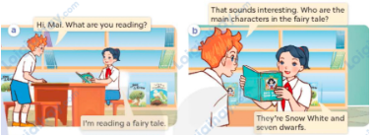  - Play the audio twice (sentence by sentence). Correct their pronunciation where necessary.  - Have Ss to practice the dialogue  - T invites a few pairs to the front of the class to practice.  - T checks pronunciation for ss.  Activity 3 Listen, point and say.  *Aims: Ss will be able to correctly say the characters in a story and use Who are the main characters in the story? -They’re___. to ask and answer questions about the main characters in a story.  *Procedure:  * Structures:  - T asks Ss look at picture b in activity 1 and helps Ss know the structure from the dialogue.  - T introduces new structures for Ss.  - T explains, models and gives meaning.  - Have Ss repeat the structures  A: Who are the main characters in the story?  B: They’re Snow White and the seven dwarfs.  3.Practice: (7’)  *Drill pictures  - Have Ss look at the pictures and identify the main characters and / or the titles of the stories.  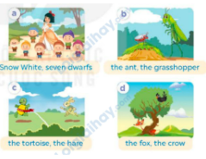  - Have Ss point at pictures, listen and run through all the pictures.  - Have Ss point at the bubbles, listen and run through structures  - Have Ss to practise:  + T asks the first picture, Ss answer  + Ss asks the second picture, T answers  + Group A asks the third picture, group B  answers  + Group B asks the last picture, group A  - Ask Ss to work in pairs to practise asking and answering the Who are the main characters in the story?- They’re___.  - T controls and corrects.  - Invite a few pairs to point at the pictures and say the questions and answers in front of the class.  4. Production: (6’)  Activity 4. Let’s talk.  *Aims: Ss will be able to use Who are the main characters in the story? - They’re _____. in a freer context  *Procedure:  - Ask Ss to look at the pictures and ask questions to help them identify the main characters 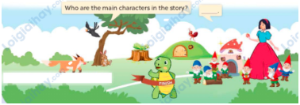  - Point at the ﬁrst picture and elicit the question in the ﬁrst speech bubble Who are the main characters in the story? and the answer in the second speech bubble - They’re _____.as an example.  - Give Ss time to work in pairs and take turns pointing at each picture to ask and answer using structures.  - Invite a few pairs to come to the front of the classroom and act out the exchanges.  5. Fun corner and wrap- up (4’)  Game: Who’s faster?  - Divide the class into groups.  - Arrange the flash cards about the main characters on the board (Snow White, the seven dwarfs, the ant, the grasshopper, the tortoise, the hare, the fox, the crow)  - Invite a student from each group to go to the board.  - Teacher says a word and the ss run to tap the right card. Give points for them.  - The group with more points wins the game. | -Ss listen and pay attention  - Ss listen to the teacher  -Ss play the game  .  -Ss continute playing the game  - Ss listen and open their books  -Ss listen and answer  - - Ss listen and repeat  + Choral repetition (3 times).  + Individual repetition (3 ss)  - Ss take note  - Ss look and match  -Look at the pictures and say.  + In picture a:  Ben: Hi, Mai. What are you reading?  Mai: I’m reading a fairy tale  + In picture b:  Mai: That sounds interesting. Who are the main characters in the fairy tale?  Ben: They’re Snow White and the seven dwarfs.  -Ss listen and repeat in chorus (twice)  -Ss work in pairs to practice  -Ss come to the front of the classroom to practice.  -Ss listen  - Ss look at the picture and answer.  -Ss listen  -Ss listen and repeat  -Ss repeat to the structures  - Ss look, listen and repeat  +Picture a: Snow White and the seven dwarfs  + Picture b: The ant and the grasshopper  + Picture c: The tortoise and the hare  + Picture d: The fox and the crow  -Ss point at pictures, listen and repeat  -Ss point at the bubbles, listen and repeat  -Ss practice in chorus  -Ss practice in chorus  -Ss work in pairs to practise asking and answering the question  - Pairs of Ss point at the pictures and say in front of the class  -Ss look at the picture and say  + A picture with different characters in four stories  - Ss look at the first picture and elicit the missing words in speech bubbles and say the completed sentences.  - Ss role-play to practise asking and answering questions  - Ss practise asking and answering questions in front of the class.  -Ss listen to the teacher  -Ss play the game  -Ss play the game  -Ss praise the winner.
D. ADJUSTMENTS (if necessary):
………………………………………………………………………………………….…..……………………………………………………………………………...

Duyệt bài, Ngày 28 tháng 3 năm 2025
Phó hiệu trưởng

Nguyễn Thị Hằng

