ĐĂNG KÝ GIẢNG DẠY TUẦN 27 ( Từ 24-28/03/2025)
Thứ  Ngày | Buổi | Lớp | Tiết | Môn | Tên bài
Hai | Chiều | 4B | 1 | English | Extension activities
 |  | 4B | 2 | English | Unit 16: Weather - Lesson 1 (1,2,3)
Ba | Sáng | 4A | 1 | English | Extension activities
 |  | 4A | 2 | English | Unit 16: Weather - Lesson 1 (1,2,3)
 |  | 5B | 1 | English | Extension activities
 |  | 5B | 2 | English | Unit 16: Seasons and the weather  Lesson 1 (1,2,3)
 | Chiều |  | 1
 |  | 3A | 1 | English | Fun time
 |  | 3A | 2 | English | Unit 16: My pets - Lesson 1 (1,2,3)
Tư | Sáng | 4C | 1 | English | Extension activities
 |  | 4C | 2 | English | Unit 16: Weather - Lesson 1 (1,2,3)
 |  | 4B | 3 | English | Unit 16: Weather - Lesson 1 (4,5,6)
 |  | 4B | 4 | English | Unit 16: Weather - Lesson 2 (1,2,3)
Năm | Sáng | 4C | 1 | English | Unit 16: Weather - Lesson 1 (4,5,6)
 |  | 4C | 2 | English | Unit 16: Weather - Lesson 2 (1,2,3)
 |  | 5B | 3 | English | Unit 16: Seasons and the weather  Lesson 1 (4,5,6)
 |  | 5B | 4 | English | Unit 16: Seasons and the weather  Lesson 2 (1,2,3)
 | Chiều
 |  | 1C | 2 | English | Unit 13: In the school canteen - Lesson 1: 1,2
 |  | 1C | 3 | English | Unit 13: In the school canteen - Lesson 1: 3,4,5
Sáu | Sáng | 3A | 1 | English | Unit 16: My pets - Lesson 1 (4,5,6)
 |  | 3A | 2 | English | Unit 16: My pets - Lesson 2 (1,2,3)
 |  | 4A | 3 | English | Unit 16: Weather - Lesson 1 (4,5,6)
 |  | 4A | 4 | English | Unit 16: Weather - Lesson 2 (1,2,3)
Duyệt bài, Ngày 21 tháng 3 năm 2025
Phó hiệu trưởng

Nguyễn Thị Hằng

WEEK 27
Grade 1: Lớp 1C: Chiều thứ năm, Ngày 27 tháng 3 năm 2025
ENGLISH
UNIT 13: IN THE SCHOOL CANTEEN
Lesson 1

I. OBJECTIVES
By the end of this lesson, pupils will be able to:
1. Knowledge and skills:
- pronounce the sound of the letter N/n in isolation and in the words Nick, nuts, noodles, bananas correctly.
- point to the letter N/n, the boy (Nick) and the food (noodles, nuts and bananas) in the picture and say the sound of the letter N/n the words Nick, noodles, nuts, bananas.
2. Competences
- Communication and collaboration: work in pairs and groups to complete the learning tasks
3. Attributes
- Show active participation in learning activities.
- Show confidence in playing games.
II. MATERIALS
- Student’s book, p. 57
- Audio track 74
- hoclieu.vn
- Flashcards for Unit 13
- Poster for Unit 13
- Teacher’s guide, p. 109, 110, 111
- Computer, projector, …
III. PROCEDURES
1. WARM-UP (5 mins)
a. Objectives:
- To create a friendly and lively atmosphere in the classroom.
- To revise the previous lesson.
b. Content:
- Kim’s game/ Sing a song
c. Expected outcomes:
- Pupils recall vocabulary from Unit 12.
- Pupils get an overview about the topic of food.
d. Organization:
TEACHER’S ACTIVITIES | PUPILS’ ACTIVITIES | CONTENT
Option 1: Kim’s game  - T greets the class.  - Invite one group of pupils to play Kim’s game with the target vocabulary items they have learnt.  - Have pupils open the books and look at Unit 13, Lesson 1 (page 57).  Option 2: Sing a song  - Play a song and have pupils sing along and clap hands.  - Introduce to pupils that they will learn about food. | - Pupils greet the teacher.  - Pupils play the game  - Pupils open the books and look at Unit 13, Lesson 1 (page 57).  - Listen to the song, sing along and clap hands. | Link:  Song 1: https://www.youtube.com/watch?v=UaqISEs_uj0  Song 2: https://www.youtube.com/watch?v=nqwxYlix7Fw
e. Assessment
- Teacher observes and gives feedback.
2. ACTIVITY 1: EXPLORATION (10 mins)
a. Objectives:
- To help pupils pronounce the sound of the letter N/n in isolation and in the words Nick, nuts, noodles, bananas correctly.
b. Content:
- Activity 1. Listen and repeat.
c. Expected outcomes:
- Pupils can listen and repeat the sound of the letter N/n in isolation and in the words Nick, noodles, nuts and bananas correctly.
d. Organization
TEACHER’S ACTIVITIES | PUPILS’ ACTIVITIES | CONTENT
Step 1: Have pupils look at the picture, saying Look at the picture, please! and describe the picture. Draw pupils’ attention to the words next to the things/boy and the colour of the letter N/n. Check comprehension.  Step 2: Ask pupils to point to the letter N/n. Have them listen and repeat the sound of the letter N/n, saying Point to the letter N/n, listen and repeat, please! more than once, if necessary.  Step 3: Tell pupils to point to the packet of nuts and/or the word nuts in the picture, to listen to the recording and repeat the word nuts, saying Point to the nuts, listen and say the word “nuts”. Ask them to listen to the recording again and repeat the word, saying Listen and repeat, please! Then play the recording again, if necessary, for pupils to do choral and individual repetition. Correct pronunciation, if necessary.  Step 4: Repeat the same procedure with Nick, the noodles and the bananas. Correct pronunciation, if necessary. Step 5: Play the recording again and have them listen, point to the letter N/n, the pictures and say the sound of the letter and the words until they feel confident. Give further support to those pupils who find it difficult to do the task, if necessary.  Step 6: Call a few pupils to say the letter N/n and the words Nick, noodles, nuts and bananas in front of the class, saying Good job! when they perform well. | - Pupils look at the picture and describe it.  - Pupils pay attention to the words next to the things/boy and the colour of the letter N/n .  - Pupils point to the letter N/n, listen to the recording carefully and repeat.  - Pupils point to the packet of nuts and/or the word nuts in the picture, listen to the recording and repeat the word nuts.  - Pupils listen and repeat individually and in chorus.  - Pupils listen to the recording and repeat.  - Pupils point to the letter N/n, the pictures and say the sound of the letter and the words in pairs or groups.  - Pupils say the letter N/n and the words Nick, noodles, nuts and bananas in front of the class. | The picture is about the school canteen. Nick and Nam are sitting next to each other at a table. Nick is eating noodles and Nam is eating nuts. There are two bananas next to Nick’s bowl of noodles. The word Nick is next to Nick, the word nuts is next to the packet of nuts, the word noodles is next to the bowl of noodles, the word bananas is next to the bananas. The letter N/n in the words Nick, nuts, noodles and bananas is in red. The sound of the letter N/n is the focus of Unit 13.
e. Assessment
- Performance products: Pupils’ answers and pronunciation.
- Assessment tools: Observation and help.
3. ACTIVITY 2: KNOWLEDGE CONSTRUCTION (10 mins)
a. Objectives:
- To encourage pupils to point to the letter N/n, the boy (Nick) and the food (noodles, nuts
and bananas) in the picture and say the sound of the letter N/n the words Nick, noodles,
nuts, bananas.
b. Content:
Activity 2. Point and say.
c. Expected outcomes:
- Pupils can point to the letter N/n, Nick and the food; say the sound of the letter N/n and the words Nick, nuts, noodles, bananas correctly.
d. Organization
TEACHER’S ACTIVITIES | PUPILS’ ACTIVITIES | CONTENT
Step 1: Have pupils look at the picture again, saying Look at the picture, please! Ask them to describe the picture. E.g. Nick is eating the noodles. Nam is eating the nuts. Draw their attention to the letter N/n, Nick and the food, if necessary.  Step 2: Get them to point to the letter N/n and say it, saying Point to the letter N/n and say it, please!  Step 3: Let them point to Nick and say Nick, saying Point to Nick and say, please! Remind them of the sound of the letter N in the word Nick. Then ask one pupil to point to Nick and to say the word Nick in front of the class. Go around and offer help, if necessary.  Step 4: Do the same procedure with the other things. Go around and correct pronunciation, if necessary. Give further support to those pupils who find it difficult to do the task.  Step 5: Ask pupils to work in pairs or in groups to look at the picture, point to the letter N/n, the boy and the food and say the sound of the letter N/n and the words Nick, noodles, nuts and bananas. Go around and offer help or correct pronunciation, if necessary.  Step 6: Invite some pupils to point to the picture and say the sound of the letter and the words in front of the class. If they performed well, praise them, saying Good job! or Great! | - Pupils look at the picture and describe it.  - Pupils pay attention to the letter N/n, Nick and the food.  - Pupils point to the letter N/n and say it.  - Pupils point to Nick and say Nick.  - Pupils follow the teacher's instructions.  - Pupils work in pairs or in groups to look at the picture, point to the letter N/n, the boy and the food and say the sound of the letter N/n and the words Nick, noodles, nuts, and bananas.  - Pupils point to the picture and say the sound of the letter and the words in front of the class. | The same picture as mentioned in Activity 1.
e. Assessment
- Performance products: Pupils’ pronunciation.
- Assessment tools: Observation, TPR.
4. FUN CORNER AND WRAP-UP (5 mins)
Option 1: Labelling
Step 1:
Tell pupils that they are going to look at the flashcards/objects for 60 seconds and then write down the names of the objects as quickly and correctly as possible.
Explain how the game is played.
Check comprehension.
Step 2:
Arrange the flashcards/objects on the desk and cover them with a piece of cloth.
Do not let pupils see what is beneath the cloth.
Divide the class into groups.
Do not allow pupils to write anything down.
Step 3:
Show the flashcards/ objects under the piece of cloth for 60 seconds. Then cover them again.
In their groups, the pupils try to write down the name of as many objects as they can remember.
Step 4:
Have the groups swap their answers and count the number of items they have written with correct spelling.
Groups get a point for one correct item.
Extension:
When pupils become experts of the game, reduce the time to 50 seconds for pupils to look at the flashcards/ objects before writing down their names.

Option 2: Pokémon (PPT slides)
- Have pupils play in 5 groups (each group is a Pokémon ball in the game).
- Show a flashcard to pupils, which group can say the word quickly and correctly can get 1 Pokémon (click on the ball of the group to add one).
- Group with 6 Pokémons wins the game.
------------------------------------------------
Grade 1: Lớp 1C: Chiều thứ năm, Ngày 27 tháng 3 năm 2025
ENGLISH
UNIT 13: IN THE SCHOOL CANTEEN
Lesson 2

I. OBJECTIVES
By the end of this lesson, pupils will be able to:
1. Knowledge and skills
- say the sound of the letter N/n and the words Nick, nuts, noodles and the structure He’s having ____. in a chant.
- listen, recognise the words and tick the correct boxes
- trace the letter N/n (upper case and lower case) and complete the words __ick, ba__anas, __oodles, __uts.
2. Competences
- Communication and collaboration: work in pairs and groups
3. Attributes
- Show confidence in telling the story by using appropriate gestures and intonation to recall the words from the learning tasks.
II. MATERIALS
- Student’s book, p. 58
- Audio track 75, 76
- hoclieu.vn
- Flashcards for Unit 13
- Poster for Unit 13
- Teacher’s guide pp. 111, 112, 113
- Computer, projector, …
III. PROCEDURES
1. WARM-UP (5 mins)
a. Objectives:
- To create a friendly and lively atmosphere in the classroom.
b. Content:
- Labelling
c. Expected outcomes:
- Pupils review words from previous lessons.
d. Organization:
TEACHER’S ACTIVITIES | PUPILS’ ACTIVITIES | CONTENT
- Greet the class. Encourage pupils to respond to your greeting.  - Ask a group of four to play Labelling with the words they have learnt (e.g. noodles, nuts, lake, lemons, leaf, Lucy, truck, bus, sun, ...)  - Get pupils to open their books and look at Unit 13, Lesson 2, p. 58. | - Pupils greet the teacher.  - Pupils play the game.  - Pupils open their books and look at Unit 13, Lesson 2, p. 58. | Flashcards for Unit 13
e. Assessment:
- Teacher observes and gives feedback.
2. ACTIVITY 1: PRACTICE (10 mins)
a. Objectives:
- To help pupils say the sound of the letter N/n and the words Nick, nuts, noodles and the structure He’s having ____. in a chant.
b. Content:
- Activity 3. Listen and chant.
c. Expected outcomes:
- Pupils can listen and sing the chant with correct pronunciation, natural stress and
rhythm.
d. Organization
TEACHER’S ACTIVITIES | PUPILS’ ACTIVITIES | CONTENT
Step 1: Have pupils look at the chant, saying Look at the chant, please! Draw pupils’ attention to the first line and explain its meaning. Ask them to pay attention to the letter N/n and the word Nam. Check comprehension.  Step 2: Play the recording of the first line for pupils to listen and to get familiarised with the tune, saying Listen to the first line, please!  Step 3: Play the recording again, ask pupils to listen and repeat the first line, saying Listen again and repeat, please! Then play the recording for them to listen and repeat until they feel confident, saying Listen and repeat, please!  Step 4: Follow the same procedure with the other lines. Show pupils how to chant and clap their hands. Correct pronunciation, if necessary.  Step 5: Play the recording all the way through. Ask pupils to listen and repeat the chant individually and in chorus, saying Listen to the recording and chant, please! Go around and offer help, if necessary.  Step 6: Select some pupils to the front of the class to chant and clap their hands. The rest of the class may sing along the chant and clap their hands. If they sang the chant well, praise them, saying Well done! or Very good! | - Pupils look at the chant.  - Pupils listen to the recording.  - Pupils listen to the recording.  - Pupils listen and chant and clap hands.  - Pupils listen and chant individually.  - Pupils listen and repeat the chant in front of the class. | There are two verses in the chant. The words Nam, nuts and the sentence Nam’s having nuts are introduced in the first verse. In the second one, the words Nick, noodles and the sentence Nick’s having noodles are mentioned. The letter N/n is in red.
e. Assessment:
- Performance products: Pupils’ chant
- Assessment tools: Observation and help
3. ACTIVITY 2: PRACTICE (7 mins)
a. Objectives:
- To entourage pupils to listen, recognise the words and tick the correct boxes.
b. Content:
Activity 5. Listen and tick.
c. Expected outcomes:
- Pupils can listen, recognise the words and tick the correct boxes.
d. Organization
TEACHER’S ACTIVITIES | PUPILS’ ACTIVITIES | CONTENT
Step 1: Have pupils look at the pictures, saying Look at the pictures, please! and say what they can see. Draw pupils’ attention to the boxes next to the letters a and b. Check comprehension.  Step 2: Invite some pupils to point to the pictures in Question 1 and say the words in front of the class, saying Point to the pictures and say the words, please! Eg: 1a: noodles, 1b: nuts.  Step 3: Play the recording of the first sentence for pupils to listen and tick the box. Say Listen to the sentence and tick the box, please!  Step 4: Have pupils look at the pictures in Question 2. Before playing the recording, say Are you ready? OK, now listen to the recording, please! Play the recording (several times if needed) for pupils to tick the correct box.  Step 5: Ask pupils to say what they have heard and ticked. E.g. 1a: I like noodles. 2a: He’s having bananas. | - Pupils look at the pictures and say what they can see.  - Pupils point to the pictures in Question 1 and say the words in front of the class.  - Pupils listen and tick the box.  - Pupils listen and tick the box.  - Pupils show their answers. | The activity consists of two questions (1 and 2). Question 1 includes two pictures: a. a bowl of noodles, b. a packet of nuts. Question 2 consists of two pictures: a. two bananas, b. nuts.  Audio script:  1. I like noodles.  2. He’s having bananas.  Key:  1. a  2. a
e. Assessment:
- Performance products: Pupils’ answers.
- Assessment tools: Observation and help.
4. ACTIVITY 3: PRACTICE (10 mins)
a. Objectives:
- To help pupils trace the letter N/n (upper case and lower case) and complete the words __ick, ba__anas, __oodles, __uts.
b. Content:
Activity 5. Look, trace and write.
c. Expected outcomes:
- Pupils can trace the letter N/n (upper case and lower case) and complete the words __ick, ba__anas, __oodles, __uts.
d. Organization
TEACHER’S ACTIVITIES | PUPILS’ ACTIVITIES | CONTENT
Step 1: Have pupils look at the letter N (upper case) and n (lower case). Point to the upper case N and say This is the upper case of the letter N. Then point to the lower case n and say And this is the lower case of the letter n. Ask some pupils to make sure if they recognise the two forms of the letter.  Step 2: Tell pupils to trace the letter N/n, saying Now trace the letter N/n with your pencils. You can demonstrate by air tracing or tracing the broken line letter N/n. Then let pupils do the tracing. Go around and offer help, if necessary.  Step 3: Check the results of pupils’ tracing and give feedback. Ask pupils to work in pairs and swap their answers, saying Now work in pairs and check each other’s answer. Give pupils time to work. Go around and offer help, if necessary.  Step 4: Have pupils look at the pictures and the unfinished words __ick, ba__anas, __oodles, __uts in the books. Explain how to complete the words. Remind pupils that the word Nick is completed with the capital letter N. Check comprehension.  Step 5: Give pupils time to complete the words independently, saying Look at the pictures and complete the words, please! Go around and offer help, if necessary.  Step 6: If there is enough time, invite some pupils to point to the letter N/n and say its sound. Then let them point to the pictures and say the complete words (Nick, bananas, noodles, nuts). | - Pupils look at the letter N/n.  - Pupils answer the question.  - Pupils trace the letter N/n independently.  - Pupils look at the pictures and complete the words independently.  - Pupils work in pairs and swap their answers.  - Pupils look at the pictures and the unfinished words __ick, ba__anas, __oodles, __uts in the books.  - Pupils complete the words independently.  - Pupils point to the letter N/n and say its sound.  - Pupils point to the pictures and say the complete words (Nick, bananas, noodles, nuts). | There are two parts in the activity: The letter N/n (upper case and lower case), and the unfinished words __ick, ba__anas, __oodles, __uts with the pictures of Nick, the bananas, the noodles and the nuts.
e. Assessment:
- Performance products: Pupils’ tracing results.
- Assessment tools: Observation and help.
5. FUN CORNER AND WRAP-UP
Game: What’s missing? (PPT slides)
- Show the slide.
- At the 2nd time showing, there’s something missing in the picture.
- Encourage pupils to guess what is missing.
- The fastest pupil who can find out what the missing picture is and say out loud the word gets points for his/her team.
---------------------------------------------------------
Grade 3: Lớp 3A: Chiều thứ ba ngày 25 tháng 3 năm 2025
ENGLISH
Fun time 3
A. OBJECTIVES:
By the end of the lesson, Ss will be able to:
1. Knowledge:
- Revise the spelling of five words: teacher, brother, driver, mother and worker.
- Improve their speed and flexibility when checking vocabulary.
- Use the target vocabulary and sentence patterns to carry out a survey.
- Identify healthy and unhealthy foods.
- Vocabulary: Review
- Skills: speaking, writing and listening
2. Competences:
- Co-operation: ready to help friends in pair work/ group work.
- Sociability: Talk to each other, say good words to others.
3. Attitude/ Qualities:
- Kindness: Help partners to complete learning tasks.
- Honesty: tell the truth about feelings and emotions
B. TEACHING AIDS:
- Teacher: Teacher’s guide Pages 197; website sachmem.vn, posters, laptop, pictures, textbook, lesson plan, TV or projector.
- Students: Pupil’s book Page 38, 39, notebooks, workbooks, school things.
C. PROCEDURES:
Teacher’s activities | Students’ activities
1.Warm- up: (3’)  Sing: Head, shoulders, knees and toes  *Aims: to create a friendly and active atmosphere in the class to beginning the lesson.  *Procedure:  - Show the song on the screen.  https://www.youtube.com/watch?v=WX8HmogNyCY  - Ask Ss to listen, sing and dance the song.  - Say “Open your book page 38” and look at “Fun time”.  2. Practice(30’)  Activity 1. Do the puzzle:  *Aims: Ss will be able to revise the spelling of five words: teacher, brother, driver, mother and worker.  and improve pupils’ speed and flexibility when checking vocabulary.  *Procedure:  - Have Ss look at the puzzle and ask: Who do you see in the pictures?  - Stick the flash cards of the words, one by one, on the board.  - Point to each word on the board, and have Ss say the word as a class.  - Point at Picture 1, elicit the word, write it in the crossword as an example.  - Ask Ss to repeat the same procedure with the other picture cues.  - Check the answers as a class.  Key:  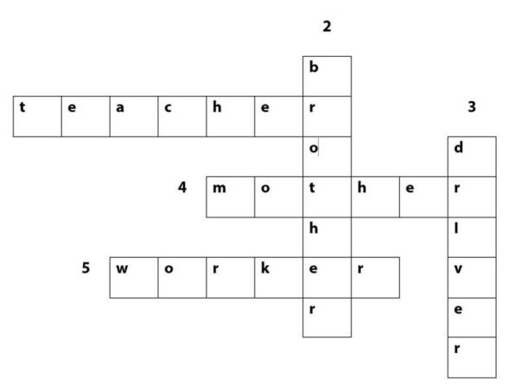  Activity 2. Quiz time  *Aims: Ss will be able to use the target vocabulary and sentence patterns to carry out a survey  *Procedure:  -Tell Ss that each of them needs to interview three different classmates to find out their favourite food or drinks.  - Give Ss 10 minutes to circulate and complete their survey tables  - After Ss have interviewed their classmates and taken notes, give them another 5 to 10 minutes to prepare to share their findings.  - Invite different Ss to come to the front of the class and share their findings.  Activity 3. Circle the healthy foods.  *Aims: Ss will be able to identify healthy and unhealthy foods.  *Procedure:  - T elicits the names of the foods: apple, chips, water, rice, fish, noodles, cake.  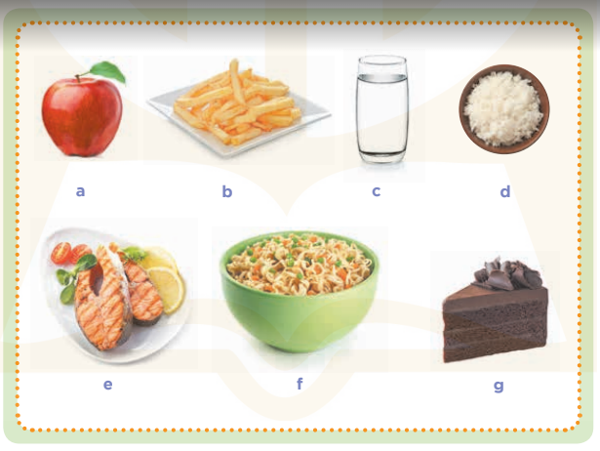  - Put Ss into pairs and tell them to work together to circle the healthy foods.  - Display a picture of an apple on the board.  - Ask Ss if it is healthy or unhealthy. When they answer correctly, write healthy under the picture and model it for Ss to repeat.  - Repeat the same procedure for the other foods. If a food is unhealthy, write unhealthy under the picture.  Key: Ss’ own answer  *Consolidation  *Aims: Ss will be able consolidate and wrap up the content of the lesson.  *Procedure:  - T asks ss to answer the following questions:  + What have you learnt from the lesson today?  +What are the core values of the lesson? (if the teacher can take from the lesson).  - T praises some Ss who are hardworking / active/ good…. as well as encourage others to try more.  3. Homework. (2’)  - Prepare the new lesson: Unit 16, Lesson 1 (1,2,3). | - Ss listen  - Ss sing a song  -Ss look at the puzzle and answer  - - Ss note  - Ss say the word  - Ss look and write  -Ss find the words  -Ss check their answer  -Ss listen  -Ss interview and complete the survey tables.  -Ss prepare to share their findings.  -Ss come to the front of the class and share their findings.  - Ss look, listen and answer  - Ss answer  -Ss look  -Ss listen and repeat  -Ss repeat  -Ss answer the questions  -Ss listen and clap their hands  -Ss listen and take note
D. ADJUSTMENTS (if necessary):
………………………………………………………………………………………….…..……………………………………………………………………………...………………………………………….…..………………………………………
---------------------------------------------------------------
Grade 3: Lớp 3A: Chiều thứ ba ngày 25 tháng 3 năm 2025
ENGLISH
Unit 16: My pets - Lesson 1 (1, 2, 3)
A. OBJECTIVES:
By the end of the lesson, Ss will be able to:
1. Knowledge:
- Use the words birds, cats, parrots, rabbits in relation to the topic "Pets".
- Use some and many to identify the quantity of pets
- Use Do you have any…….? – Yes, I do. / No, I don’t. to ask and answer questions about pets
- Listen to and demonstrate understanding of simple communicative contexts in relation to the topic "Pets".
- Vocabulary: bird, cat, dog, parrot, rabbit, pet, any.
- Model sentences:
A: Do you have any cats?
B: Yes, I do. / No, I don’t.
- Skills: speaking and listening
2. Competences:
- Co-operation: ready to help friends in pair work/ group work.
- Sociability: Talk to each other, say good words to others.
3. Attitude/ Qualities:
- Kindness: Help partners to complete learning tasks.
- Honesty: tell the truth about feelings and emotions
B. TEACHING AIDS:
- Teacher: Teacher’s guide Pages 179, 180, audio Tracks 54, 55, website sachmem.vn, posters, laptop, pictures, textbook, lesson plan, TV or projector.
- Students: Pupil’s book Page 40, notebooks, workbooks, school things.
C. PROCEDURES:
Teacher’s activities | Students’ activities
1.Warm- up: (3’)  Sing: Jigsaw puzzle  *Aims: to create a friendly and active atmosphere in the class to beginning the lesson.  *Procedure:  - Divide class into 4 groups: Tom, Jerry, Miu and Chit.  - Ask Ss look at the pieces of picture.  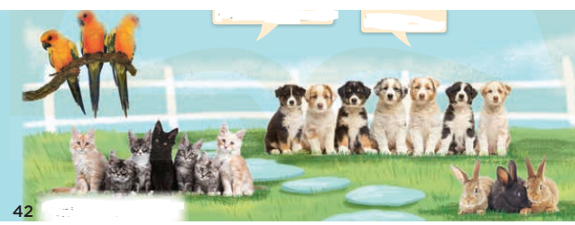  - Ask Ss go to the board and jigsaw puzzle into the correct picture.  -T checks who’s the winner?  - Say “Open your book page 40” and look at “Unit 16, Lesson 1 (1,2,3)”.  2. Presentation(16’)  Activity 1. Vocabulary.  *Aims: Ss will be able to know the vocabulary in front of starting the new lesson.  *Procedure:  -T elicits the new words  + cat : con mèo (picture)  + dog : con chó (picture)  + parrot :con vẹt (picture)  + rabbit : con thỏ (picture)  + bird :con chim (picture)  + any : bất cứ (translation)  - T models (3 times).  - T writes the words on the board.  - Checking: Matching  Activity 2. Look, listen and repeat:  *Aims: Ss will be able to understand and correctly repeat the sentences in two communicative contexts (pictures) focusing on pets.  *Procedure:  - Have Ss look at Pictures a and b and identify names of the speakers in the pictures.  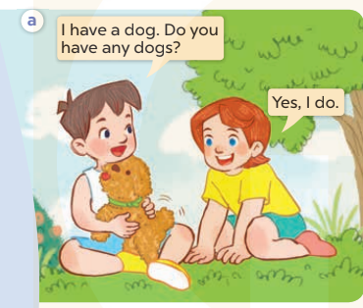  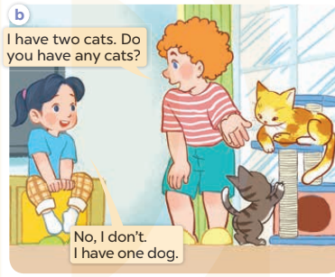  - Play the audio twice (sentence by sentence). Correct their pronunciation where necessary.  - Have Ss to practice the dialogue  - T invites a few pairs to the front of the class to practice.  - T checks pronunciation for ss.  Activity 3 Listen, point and say.  *Aims: Ss will be able to correctly say the words birds, parrots, rabbits, cats and use Do you have any….? – Yes, I do./ No, I don’t. to ask and answer questions about pets  *Procedure:  * Model sentences:  - T asks Ss look at picture a, b and helps Ss know the structure from the dialogue.  - T introduces new structure for Ss.  - T explains, models and gives meaning.  -Have Ss repeat the model sentences.  A: Do you have any cats?  B: Yes, I do. / No, I don’t.  3.Practice: (7’)  *Drill pictures  - Elicit and check comprehension the places of school  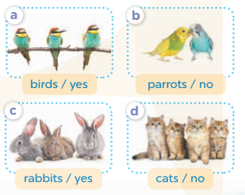  - Run through all the pictures.  - Run through model sentences.  +Run through the question sentences  +Run through the answer sentences  - Have Ss to practise:  + T asks, Ss answer picture a  + Ss ask, T answers picture b  + Group A ask, group B answer picture c  + Group B ask, group A answer picture d  - Ask Ss to work in pairs.  - T controls and corrects.  - Invite a few pairs to come to the front of the classroom and point at the pictures and say the questions and answers in front of the class.  - T gives feedbacks.  4.Production: (7’)  Activity 4. Let’s talk.  *Aims: Ss will be able to enhance the correct use of Do you have any….? − Yes, / No,….. to ask and answer questions about pets.  *Procedure:  - Have Ss look at the picture and elicit the question and the answer in context.  + What can you see in the picture?  + How many pets are there?  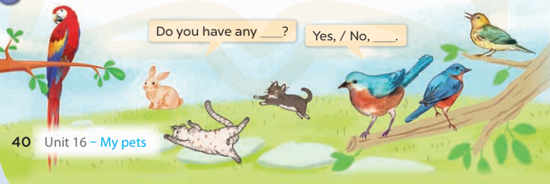  - Put Ss into groups of four.  - Tell them to ask and answer questions using Do you have any…..? – Yes, / No,…..  - Invite some Ss to the front of the class to ask and answer questions about their pets.  *Consolidation  *Aims: Ss will be able consolidate and wrap up the content of the lesson.  *Procedure:  - T asks ss to answer the following questions:  + What have you learnt from the lesson today?  +What are the core values of the lesson? (if the teacher can take from the lesson).  - T review the vocabulary and model sentences.  - T praises some Ss who are hardworking / active/ good…. as well as encourage others to try more.  5. Homework. (2’)  - Learn the vocabulary and model sentences by heart  - Prepare the new lesson: Unit 16, Lesson 1 (4,5,6). | - Ss listen  -Ss look at the pieces of the picture  -Ss put into the correct picture  -Ss check  - Ss open their books  -Ss listen and answer  - - Ss listen and repeat  + Choral repetition (3 times).  + Individual repetition (3 ss)  - Ss take note  - Ss look, remember and match  -Look at the pictures and say  + In picture a: Minh says: I have a dog. Do you have any dogs? Lucy answers: Yes, I do.  + In picture b: Bill: I have two cats. Do you have any cats? Mai answers: No, I don’t. I have one dog.  -Ss listen and repeat in chorus (twice)  -Ss work in pairs to practice  -Ss practice the dialogue  -Ss listen  -Ss look at the picture and answer.  -Ss listen  -Ss listen and repeat  -Ss repeat to the place  - Ss look, listen and answer  + Picture a: birds / yes  + Picture b: parrots / no  + Picture c: rabbits / yes  + Picture d: cats / no  -Ss listen and repeat  -Ss practice in chorus  -Ss work in pairs to practice  -Ss point and say  -Ss listen.  -Ss look at the picture and answer  + I can see the pets  + There are 4  -Ss look and answer  -Ss work in pairs  -Ss perform in front of the class.  -Ss answer the questions  - Ss listen  -Ss listen and clap their hands  -Ss listen and take note
D. ADJUSTMENTS (if necessary):
………………………………………………………………………………………….…..……………………………………………………………………………...………………………………………….…..………………………………………
-----------------------------------------------------------
Grade 3: Lớp 3A: Sáng thứ sáu, ngày 28 tháng 3 năm 2025
ENGLISH
Unit 16: My pets - Lesson 1 (4, 5, 6)
A. OBJECTIVES:
By the end of the lesson, Ss will be able to:
1. Knowledge:
- Listen to and understand two communicative contexts in which pupils ask and answer questions about pets and tick the correct pictures.
- Read and complete four target gapped dialogues with the help of the picture cues.
- Sing the song My pets with the correct pronunciation and melody.
- Vocabulary: Review
- Skills: speaking, listening, reading and writing.
2. Competences:
- Critical Thinking: talk about names of the pets.
- Co-operation: ready to help friends in pair work/ group work.
- Self-control and independent learning: perform listening tasks.
3. Attitude/ Qualities:
- Kindness: Help partners to complete learning tasks.
- Honesty: tell the truth about feelings and emotions.
- Diligence: complete learning tasks.
B. TEACHING AIDS:
- Teacher: Teacher’s guide Pages 201, 202; audio Tracks 56, 57; website sachmem.vn, posters, laptop, pictures, textbook, lesson plan, TV or projector.
- Students: Pupil’s book Page 41, notebooks, workbooks, school things.
C. PROCEDURES:
Teacher’s activities | Students’ activities
1.Warm- up: (5’)  Game: Pass the ball  *Aims: to create a friendly and active atmosphere in the class to beginning the lesson.  *Procedure:  - Divide class into 3 teams.  - Each team has 1 sticky ball.  - Play the music, students in each team take turn to pass the ball. After the music ends, 3 Ss have the ball – stand up and say the name, using the sentence model.  - Say “Open your book page 41” and look at “Unit 16, Lesson 1 (4,5,6)”.  2.Practice: (27’)  Activity 1. Listen and tick:  *Aims: Ss will be able to listen to and understand two communicative contexts in which pupils ask and answer questions about pets and tick the correct pictures.  *Procedure:  - Elicit the word for the pets in each picture  - Point at the pictures respectively to explain the context.  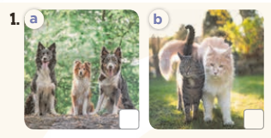  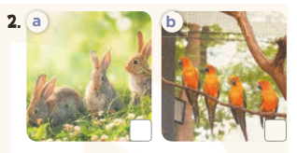  - T ask Ss to guess the answers.  + T writes Ss’guessing on the board.  - Listen to the tape:  + Play the recording  + Play the recording again and get Ss to swap books with their partners.  + Play the recording again to check answers together as a class.  + Write the answers on the board for Ss to correct their answers. Then checks Ss’ guessing.  - Play the recording, sentence by sentence, for the class to listen and repeat in chorus.  Key: 1. b 2. a  Activity 2. Look, complete and read  *Aims: Ss will be able to read and complete four target gapped dialogues with the help of the picture cues.  *Procedure:  - Get Ss to look at the pictures and identify the pets in the pictures.  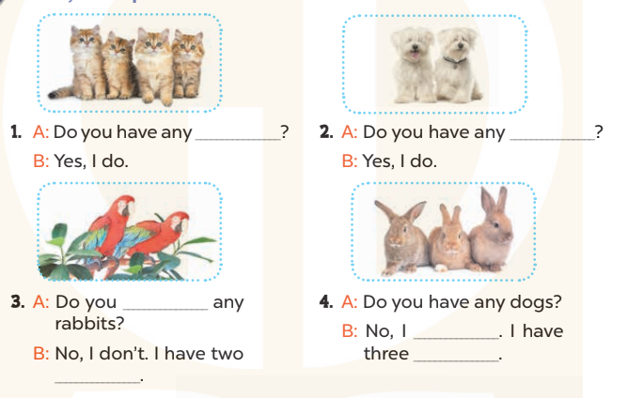  - Have Ss look at the four dialogue and the pictures. Elicit and model with picture 1  + Ask Ss to read the sentence 1 in chorus.  + Ask them what is missing in the question (cats). Then have them complete the gap (Do you have any cats?).  -Have Ss work in pairs and complete the dialogue 2, 3, 4.  - Ask a few Ss to stand up and read the sentences aloud.  -T gives feedbacks.  Key:  1. cats 2. dogs 3. have; parrots  4. don’t; rabbits  Activity 3. Let’s sing  *Aims: Ss will be able to sing the song My pets with the correct pronunciation and melody.  *Procedure:  - Introduce the title and lyrics of the song: “My pets”  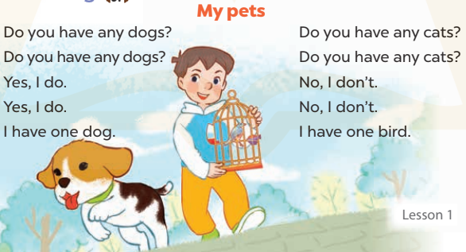  - Play the recording for Ss to listen to the whole song.  + Have them repeat the title and lyrics line by line.  + Tell Ss to point at the pictures while singing.  - Play the recording all the way through for Ss to listen to pronunciation and melody of the song.  - Play the recording line by line for Ss to listen, repeat and point to the pictures  - Play the recording for Ss to sing and do actions.  - Ask Ss to practice singing and doing actions in pairs or groups.  - Invite groups to the front of the classroom to perform the song  -T gives feedback.  *Consolidation  *Aims: Ss will be able consolidate and wrap up the content of the lesson.  *Procedure:  - T asks ss to answer the following questions:  + What have you learnt from the lesson today?  +What are the core values of the lesson? (if the teacher can take from the lesson).  - T praises some Ss who are hardworking / active/ good…. as well as encourage others to try more.  3. Homework. (3’)  - Practice part 5 again.  - Prepare the new lesson: Unit 16, Lesson 2 (1,2,3). | - Ss listen  - Ss play game  - Ss open their books  -Look at the pictures and say:  + Picture 1a: three dogs + Picture 1b: two cats  + Picture 2a: three rabbits  + Picture 2b: four parrots  -Ss guess the answers  - Ss listen to the tape and tick  - Ss listen again, tick and swap books with their partners.  - Ss check their answers and guessing  -Ss listen and repeat.  -Ss look at the picture and say  -Ss look and answer  -Ss read  -Ss say and complete  -Ss work in pairs and complete  -Ss read aloud  - Ss listen  -Ss listen to the song  - Ss listen and repeat line by line without the action.  -Ss point to the pictures while singing  -Ss listen to melody of the song  - Ss listen and sing line by line.  - Ss sing and do actions.  + Ss work in groups (two groups) to sing.  -Ss perform in front of the class.  -Ss listen  -Ss answer the questions  -Ss listen and clap their hands  -Ss listen and take note
D. ADJUSTMENTS (if necessary):
………………………………………………………………………………………….…..……………………………………………………………………………...
---------------------------------------------------------
Grade 3: Lớp 3A: Sáng thứ sáu, ngày 28 tháng 3 năm 2025
ENGLISH
Unit 16: My pets - Lesson 2 (1, 2, 3)
A. OBJECTIVES:
By the end of the lesson, Ss will be able to:
1. Knowledge:
- Use some and many to identify the quantity of pets
- Use How many…..do you have? – I have………. to ask and answer questions about the quantity of pets
- Vocabulary: goldfish, some, many, how many
- Model sentences:
A: How many cats do you have?
B: I have some
- Skills: speaking and listening
2. Competences:
- Critical Thinking: talk about someone’s pets
- Co-operation: ready to help friends in pair work/ group work.
- Sociability: Talk to each other, say good words to others.
3. Attitude/ Qualities:
- Kindness: Help partners to complete learning tasks.
- Honesty: tell the truth about feelings and emotions
B. TEACHING AIDS:
- Teacher: Teacher’s guide Pages 203, 204; audio Tracks 58, 59, website sachmem.vn, posters, laptop, pictures, textbook, lesson plan, TV or projector.
- Students: Pupil’s book Page 42, notebooks, workbooks, school things.
C. PROCEDURES:
Teacher’s activities | Students’ activities
1.Warm- up: (3’)  Game: Guessing and Choosing  *Aims: to create a friendly and active atmosphere in the class to beginning the lesson.  *Procedure:  - T shows 4 pictures of places and calls 4 Ss to come to the board and choose.  - T asks 4 Ss to come to the board and choose 1 picture of place and keep them in secret by covering them.  - The others will write their place in the board at their desks and keep their ides in secret.  - The Ss on the board will 1 by 1 show their pictures they chose.  - When the teacher says the word of the pictures 1 by 1 shown on the board, who has the same places will raise their board or raise their hands.  - The Ss on the board will get the same points as the numbers of Ss raising their hands.  - Say “Open your book page 42” and look at “Unit 16, Lesson 2 (1,2,3)”.  2. Presentation(16’)  Activity 1. Vocabulary.  *Aims: Ss will be able to know the vocabulary in front of starting the new lesson.  *Procedure:  -T elicits the new words  + goldfish : con cá vàng (picture)  + some: một vài (example)  + many : nhiều (example)  + how many : bao nhiêu (translation)  - T models (3 times).  - T writes the words on the board.  - Checking: What and where  Activity 2. Look, listen and repeat:  *Aims: Ss will be able to understand and correctly repeat How many …..do you have? − I have….. to ask and answer questions about the quantity of pets.  *Procedure:  - Have Ss look at Pictures a and b and identify the characters in the pictures.  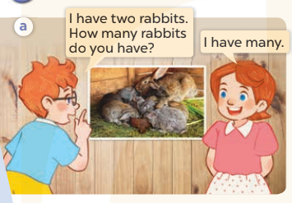  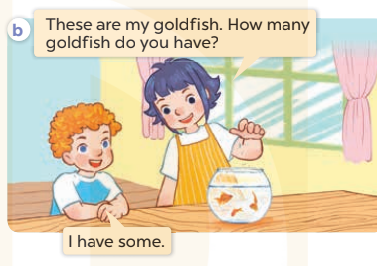  - Play the audio twice (sentence by sentence). Correct their pronunciation where necessary.  - Have Ss to practice the diaguage  - T invites a few pairs to the front of the class to practice.  - T checks pronunciation for ss.  Activity 3. Listen, point and say.  *Aims: Ss will be able to correctly say the words and use How many…..do you have? − I have….. to ask and answer questions about the quantity of pets.  *Procedure:  * Model sentences:  - T asks Ss look at picture a, b and helps Ss know the structure from the dialogue.  - T introduces new structure for Ss.  - T explains, models and gives meaning.  - Have Ss repeat the model sentences.  A: How many cats do you have?  B: I have some  3.Practice: (7’)  *Drill pictures  - Have Ss look at the pictures and elicit the names of the pets  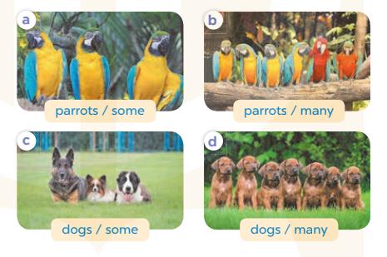  - Run through all the pictures.  - Run through model sentences.  +Run through the question sentences  +Run through the answer sentences  - Have Ss to practise:  + T asks, Ss answer picture a  + Ss ask, T answers picture b  + Group A ask, group B answer picture c  + Group B ask, group A answer picture d  - Ask Ss to work in pairs.  - T controls and corrects.  - Invite a few pairs to come to the front of the classroom, point at the pictures and say the questions and answers in front of the class.  - T gives feedbacks.  4.Production: (7’)  Activity 4. Let’s talk.  *Aims: Ss will be able to enhance the correct use of How many……? − I have…… to ask and answer questions about the quantity of pets.  *Procedure:  - Tell Ss about the activity  + What can you see in the picture?  +Let’s count the pets.  +Where are the pets?  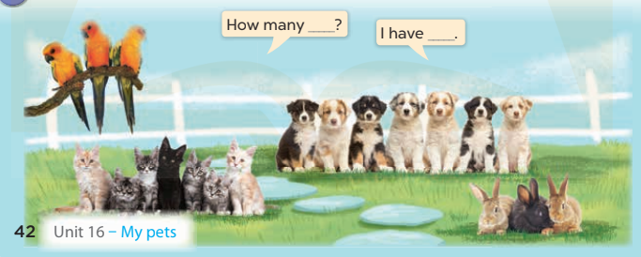  - Put Ss into pairs and encourage them to ask and answer questions using How many……? − I have……  - Invite some pairs to stand up to perform their exchanges.  *Consolidation  *Aims: Ss will be able consolidate and wrap up the content of the lesson.  *Procedure:  - T asks ss to answer the following questions:  + What have you learnt from the lesson today?  - T review the vocabulary and model sentences.  - T praises some Ss who are hardworking / active/ good…. as well as encourage others to try more.  5. Homework. (2’)  - Learn the vocabulary and model sentences by heart  - Prepare the new lesson: Unit 16, Lesson 2 (4,5,6). | - Ss listen  - Ss play the game  -Ss play game  - Ss open their books  -Ss listen and answer  - Ss listen and repeat  + Choral repetition (3 times).  + Individual repetition (3 ss)  - Ss take note  - Ss look, remember and write  -Look at the pictures and get to know the characters in the pictures.  + In picture a: Ben says: I have two rabbits. How many rabbits do you have? And Lucy says: I have many.  – In picture b: Linh says: These are my goldfish. How many goldfish do you have? And Bill says: I have some  -Ss listen and repeat in chorus (twice)  -Ss work in pairs to practice  -Ss practice the diaguage  -Ss listen  -Ss look at the picture and answer.  -Ss listen  -Ss listen and repeat  -Ss repeat  -Ss listen and answer  +Picture a: three parrots (some)  +Picture b. six parrots (many)  +Picture c. three dogs (some)  +Picture d. seven dogs (many)  - Ss look, listen and repeat  - Ss practice in chorus  -Ss work in pairs to practice  -Ss listen  -Ss go to the board and point and say  -Ss listen  -Ss look at the picture and answer  + Three parrots, seven cats, three rabbits and seven puppies are in the garden.  -Ss work in pairs  -Ss ask and answer  -Ss answer the questions  - Ss listen  -Ss listen and clap their hands  -Ss listen and take note
D. ADJUSTMENTS (if necessary):
………………………………………………………………………………………….…..……………………………………………………………………………...
---------------------------------------------------------------
Grade 4: Lớp 4A: Sáng thứ Ba, Ngày 25 tháng 3 năm 2025
Lớp 4B: Chiều thứ Hai, Ngày 24 tháng 3 năm 2025
Lớp 4C: Sáng thứ tư , Ngày 26 tháng 3 năm 2025
ENGLISH - Extension activities
A. OBJECTIVES:
By the end of the lesson, Ss will be able to:
1. Knowledge:
- Take part in extension activities to apply their language knowledge and competences.
- Vocabulary: Review
- Skills: speaking, writing and listening
2. Competences:
- Co-operation: ready to help friends in pair work/ group work.
- Sociability: Talk to each other, say good words to others.
3. Attitude/ Qualities:
- Kindness: Help partners to complete learning tasks.
- Honesty: tell the truth about feelings and emotions
B. TEACHING AIDS:
- Teacher: Teacher’s guide Pages 226, 227; website hoclieu.vn, posters, laptop, pictures, textbook, lesson plan, TV or projector.
- Students: Pupil’s book Page 38, 39, notebooks, workbooks, school things.
C. PROCEDURES:
Teacher’s activities | Students’ activities
1.Warm- up: (3’)  Sing: Review game (ppt)  *Aims: to create a friendly and active atmosphere in the class to beginning the lesson.  *Procedure:  - T reminds Ss of 4 topics (Jobs, Appearance, Daily activities, My family’s weekend) they will review in this lesson.  - T calls 1 pupil from each team choose a topic and the points they want to get.  - Have Ss to answer the questions.  - If the Ss answers correctly, they will get the chosen points for that question.  - After 16 numbers, the team with the most points is the winner.  - Say “Open your book page 38” and look at “Extension activities”.  2. Practice(30’)  Activity 1. Work in pairs. Take turns to describe and draw a family member  *Aims: Ss will be able to correctly describe the appearance of a family member for a partner to draw  *Procedure:  - Have Ss look at the picture and ask: What is the girl / boy doing? 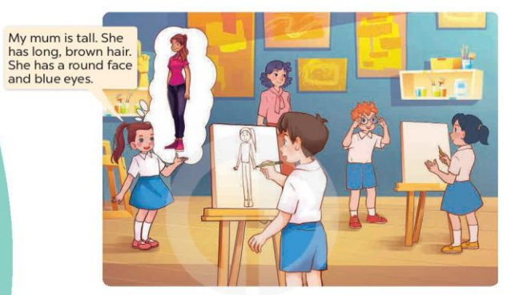  - Write the following prompts on the board: tall or short?, hair?, face?, eyes?  -Tell Ss to choose a family member and think about how he or she looks.  - Have Ss work in pairs and describe a family member for their partner to draw.  - When all the ss have had a turn, tell them to swap their drawings with their partners.  Activity 2. Tell the class about your partner’s family  *Aims: Ss will be able to correctly describe the appearance of someone’s family member.  *Procedure:  -Have Ss look at the picture and answer the question:  +What is the boy doing?  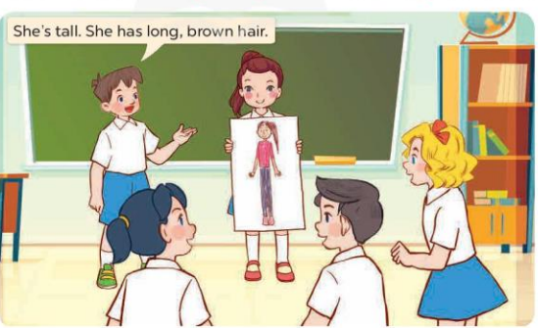  - Invite a few pairs to come to the front of the class and share their drawings and descriptions with the class.  Activity 3. Read and match. Then say what the animals are  *Aims: Ss will be able to read and match four descriptions with four pictures of animals, then say what the animals in the pictures are.  *Procedure:  - Explain any new words and check comprehension.  - Ask Ss to look at the pictures on the right and elicit the answer. Get them to read the sentences in Description 1 again and draw a line to match it to the correct picture (Picture c)  - Have Ss time to do the task  - Get Ss to swap books with a partner, then check answers as a class.  - Write the correct answers on the board for Ss to correct their answers.  - Have Ss say the names of the animals in the pictures by asking them questions, ex: What is it? or What can you see in the picture?  Key: 1. c 2. d 3. a 4. b  1. It’s an elephant. 2. It’s a parrot.  3. It’s a monkey. 4. It’s a fish  *Consolidation  *Aims: Ss will be able consolidate and wrap up the content of the lesson.  *Procedure:  - T asks ss to answer the following questions:  + What have you learnt from the lesson today?  - T praises some Ss who are hardworking / active/ good…. as well as encourage others to try more.  3. Homework. (2’)  - Prepare the new lesson: Unit 16, Lesson 1 (1,2,3). | - Ss listen  - Ss play the game  -Ss look at the picture and answer  + The girl is describing her mum.  + The boy is drawing the girl’s mum  - - Ss note  - Ss choose the family member and think  - Ss work in pairs and describe to draw  -Ss swap their drawing with the partner  -Ss look at the picture and answer  + He is describing the girl’s mum.  -Ss come to the front of the class and share their drawings and descriptions.  - Ss pay attention and answer  - Ss look at the picture, the description and match  -Ss do the task  -Ss swap books and check answers  -Ss write the answer  -Ss say the names os the animals  -Ss answer the questions  -Ss listen and clap their hands  -Ss listen and take note
D. ADJUSTMENTS (if necessary):
………………………………………………………………………………………….…..……………………………………………………………………………...
-------------------------------------------------------------------
Grade 4: Lớp 4A: Sáng thứ Ba, Ngày 25 tháng 3 năm 2025
Lớp 4B: Chiều thứ Hai, Ngày 24 tháng 3 năm 2025
Lớp 4C: Sáng thứ tư , Ngày 26 tháng 3 năm 2025
ENGLISH
Unit 16: Weather - Lesson 1 (1, 2, 3)
A. OBJECTIVES:
By the end of the lesson, Ss will be able to:
1. Knowledge:
- Use What was the weather like yesterday / last weekend? – It was ……. to ask and answer questions about the weather in the past.
- Listen to and demonstrate understanding of simple communicative contexts in relation to the topic “Weather”
- Vocabulary: rainy, sunny, cloudy, windy, weather.
- Model sentences:
A: What was the weather like last weekend?
B: It was sunny.
- Skills: speaking and listening
2. Competences:
- Co-operation: ready to help friends in pair work/ group work.
- Sociability: Talk to each other, say good words to others.
3. Attitude/ Qualities:
- Kindness: Help partners to complete learning tasks.
- Honesty: tell the truth about feelings and emotions
B. TEACHING AIDS:
- Teacher: Teacher’s guide Pages 228, 229, audio Tracks 52,53, website hoclieu.vn, posters, laptop, pictures, textbook, lesson plan, TV or projector.
- Students: Pupil’s book Page 40, notebooks, workbooks, school things.
C. PROCEDURES:
Teacher’s activities | Students’ activities
1.Warm- up: (3’)  Sing: How’s the weather?  *Aims: to create a friendly and active atmosphere in the class to beginning the lesson.  *Procedure:  https://www.youtube.com/watch?v=rD6FRDd9Hew  -Show the video on the screen and ask Ss sing and dance together.  - Say “Open your book page 40” and look at “Unit 16, Lesson 1 (1,2,3)”.  2. Presentation(16’)  Activity 1. Vocabulary.  *Aims: Ss will be able to know the vocabulary in the new lesson.  *Procedure:  -T elicits the new words  + rainy : có mưa (mime)  + sunny : có nắng (picture)  + cloudy :có mây (picture)  + windy : có gió (picture)  + weather : thời tiết (translation)  - T models (3 times).  - T writes the words on the board.  - Checking: Matching  Activity 2. Look, listen and repeat:  *Aims: Ss will be able to understand and correctly repeat the sentences in two communicative contexts focusing on asking and answering questions about the weather in the past.  *Procedure:  - Have Ss look at Pictures a and b and identify names of the speakers in the pictures.  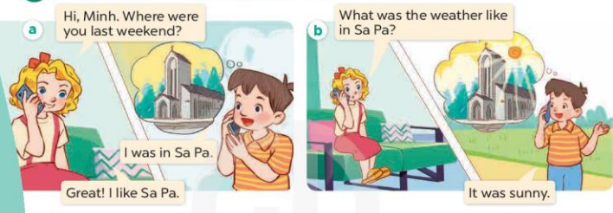  - Play the audio twice (sentence by sentence). Correct their pronunciation where necessary.  - Have Ss to practice the dialogue  - T invites a few pairs to the front of the class to practice.  - T checks pronunciation for ss.  Activity 3 Listen, point and say.  *Aims: Ss will be able to correctly say the words and use What was the weather like last weekend? – It was …to ask and answer questions about the weather in the past.  *Procedure:  * Model sentences:  - T asks Ss look at picture b and helps Ss know the structure from the dialogue.  - T introduces new structure for Ss.  - T explains, models and gives meaning.  -Have Ss repeat the model sentences.  A: What was the weather like last weekend?  B: It was sunny.  3.Practice: (7’)  *Drill pictures  - Have pupils look at the pictures and elicit the weather in each picture.  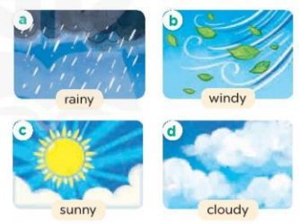  - Run through all the pictures.  - Run through model sentences.  +Run through the question sentences  +Run through the answer sentences  - Have Ss to practise:  + T asks, Ss answer picture a  + Ss ask, T answers picture b  + Group A ask, group B answer picture c  + Group B ask, group A answer picture d  - Ask Ss to work in pairs.  - T controls and corrects.  - Invite a few pairs to come to the front of the classroom and point at the pictures and say the questions and answers in front of the class.  4.Production: (7’)  Activity 4. Let’s talk.  *Aims: Ss will be able to enhance the correct use of What was the weather like yesterday? – It was ….. to ask and answer questions about the weather in a freer context.  *Procedure:  - Have them look at the weather icons and identify the weather in each place.  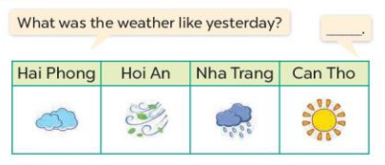  - Put Ss into groups of four.  - Tell them to ask and answer questions using What was the weather like yesterday? – It was …..  - Invite some Ss to the front of the class to ask and answer questions.  *Consolidation  *Aims: Ss will be able consolidate and wrap up the content of the lesson.  *Procedure:  - T asks ss to answer the following questions:  + What have you learnt from the lesson today?  - T review the vocabulary and model sentences.  5. Homework. (2’)  - Learn the vocabulary and model sentences by heart  - Prepare the new lesson: Unit 16, Lesson 1 (4,5,6). | - Ss listen, sing and dance  - Ss open their books  -Ss listen and answer  - - Ss listen and repeat  + Choral repetition (3 times).  + Individual repetition (3 ss)  - Ss take note  - Ss look, remember and match  -Look at the pictures and say  + In picture a:  Mary: Hi, Minh. Where were you last weekend?  Minh: I was in Sa Pa.  Mary: Great! I like Sa Pa.  + In picture b:  Mary: What was the weather like in Sa Pa?  Minh: It was sunny.  -Ss listen and repeat in chorus (twice)  -Ss work in pairs to practice  -Ss practice the dialogue  -Ss listen  -Ss look at the picture and answer.  -Ss listen  -Ss listen and repeat  -Ss repeat  - Ss look, listen and answer  + Picture a: a rainy weather icon  + Picture b: a windy weather icon  + Picture c: a sunny weather icon  + Picture d: a cloudy weather icon  -Ss listen and repeat  -Ss practice in chorus  -Ss practice in chorus  -Ss work in pairs to practice  -Ss point and say  -Ss listen.  -Ss look at the picture and answer  -Ss work in groups to ask and answer the questions  -Ss perform in front of the class.  -Ss answer the questions  - Ss listen  -Ss listen and take note
D. ADJUSTMENTS (if necessary):
………………………………………………………………………………………
---------------------------------------------------------------------
Grade 4: Lớp 4A: Sáng thứ Sáu Ngày 28 tháng 3 năm 2025
Lớp 4B: Sáng thứ tư, Ngày 26 tháng 3 năm 2025
Lớp 4C: Sáng thứ năm , Ngày 27 tháng 3 năm 2025
ENGLISH
Unit 16: Weather - Lesson 1 (4, 5, 6)
A. OBJECTIVES:
By the end of the lesson, Ss will be able to:
1. Knowledge:
- Use What was the weather like yesterday / last weekend? – It was …….. to ask and answer questions about the weather in the past.
– Listen to and demonstrate understanding of simple communicative contexts in relation to the topic “Weather”
- Vocabulary: Review
- Skills: speaking, listening, reading and writing.
2. Competences:
- Co-operation: ready to help friends in pair work/ group work.
- Self-control and independent learning: perform listening tasks.
3. Attitude/ Qualities:
- Kindness: Help partners to complete learning tasks.
- Honesty: tell the truth about feelings and emotions.
- Diligence: complete learning tasks.
B. TEACHING AIDS:
- Teacher: Teacher’s guide Pages 230, 231; audio Tracks 54, 55; website hoclieu.vn, posters, laptop, pictures, textbook, lesson plan, TV or projector.
- Students: Pupil’s book Page 41, notebooks, workbooks, school things.
C. PROCEDURES:
Teacher’s activities | Students’ activities
1.Warm- up: (5’)  Game: Miming game  *Aims: to create a friendly and active atmosphere in the class to beginning the lesson.  *Procedure:  - Divide S into groups  - One pupil acts to show his favourite weather, he/she is not allowed to say or write but acts or uses body language.  - Groups get more answers win and get stickers  - Change and give the miming pupil cues if necessary.  - Say “Open your book page 41” and look at “Unit 16, Lesson 1 (4,5,6)”.  2.Practice: (27’)  Activity 1. Listen and number:  *Aims: Ss will be able to listen to and understand four communicative contexts in which pupils ask and answer questions about the weather and number the correct pictures.  *Procedure:  - Elicit the weather in each picture.    - T ask Ss to guess the answers.  + T writes Ss’guessing on the board.  - Listen to the tape:  + Play the recording  + Play the recording again and get Ss to swap books with their partners.  + Play the recording again to check answers together as a class.  + Write the answers on the board for Ss to correct their answers. Then checks Ss’ guessing.  - Play the recording, sentence by sentence, for the class to listen and repeat in chorus.  Key: 1. d 2. a 3.c 4.b  Activity 2. Look, complete and read  *Aims: Ss will be able to complete four gapped exchanges with the help of picture cues.  *Procedure:  - Get Ss to look at the pictures and identify the weather in the pictures.  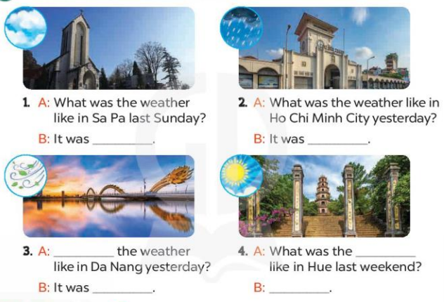  - Have Ss look at the four dialogue and the pictures. Elicit and model with picture 1  + Ask Ss to read the sentence 1 in chorus.  + Ask them what is missing in the question (cloudy). Then have them complete the gap (It was cloudy.).  -Have Ss work in pairs and complete the dialogue 2, 3, 4.  - Ask a few Ss to stand up and read the sentences aloud.  -T gives feedbacks.  Key:  1. cloudy 2. rainy 3. What was; windy  4. weather; It was sunny  Activity 3. Let’s sing  *Aims: Ss will be able to sing the song What was the weather like yesterday? with the correct pronunciation and melody.  *Procedure:  - Introduce the title and lyrics of the song: “ What was the weather like yesterday? ”  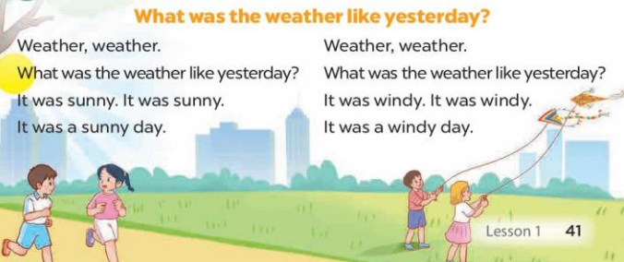  - Play the recording for Ss to listen to the whole song.  + Have them repeat the title and lyrics line by line.  + Tell Ss to point at the pictures while singing.  - Play the recording all the way through for Ss to listen to pronunciation and melody of the song.  - Play the recording line by line for Ss to listen, repeat and point to the pictures  - Play the recording for Ss to sing and do actions.  - Ask Ss to practice singing and doing actions in pairs or groups.  - Invite groups to the front of the classroom to perform the song  -T gives feedback.  *Consolidation  *Aims: Ss will be able consolidate and wrap up the content of the lesson.  *Procedure:  - T asks ss to answer the following questions:  + What have you learnt from the lesson today?  +What are the core values of the lesson? (if the teacher can take from the lesson).  - T praises some Ss who are hardworking / active/ good…. as well as encourage others to try more.  3. Homework. (3’)  - Practice part 5 again.  - Prepare the new lesson: Unit 16, Lesson 2 (1,2,3) | - Ss listen  - Ss play game  - Ss open their books  -Look at the pictures and say:  + Picture 1: a rainy weather icon  + Picture 2: a sunny weather icon  + Picture 3: a cloudy weather icon  + Picture 4: a windy weather icon  -Ss guess the answers  - Ss listen to the tape and write number  - Ss listen again, write and swap books with their partners.  - Ss check their answers and guessing  -Ss write the correct answer  -Ss listen and repeat.  -Ss look at the picture and say  -Ss look and answer  -Ss read  -Ss say and complete  -Ss work in pairs and complete  -Ss read the sentences aloud  - Ss listen  -Ss listen to the song  - Ss listen and repeat line by line without the action.  -Ss point to the pictures while singing  -Ss listen to melody of the song  - Ss listen and sing line by line.  - Ss sing and do actions.  + Ss work in groups (two groups) to sing.  -Ss perform in front of the class.  -Ss listen  -Ss answer the questions  -Ss listen and clap their hands  -Ss listen and take note
D. ADJUSTMENTS (if necessary):
………………………………………………………………………………………….…..……………………………………………………………………………...………………………………………….…..………………………………………
-------------------------------------------------------------------
Grade 4: Lớp 4A: Sáng thứ Sáu Ngày 28 tháng 3 năm 2025
Lớp 4B: Sáng thứ tư, Ngày 26 tháng 3 năm 2025
Lớp 4C: Sáng thứ năm , Ngày 27 tháng 3 năm 2025
ENGLISH
Unit 16: Weather - Lesson 2 (1, 2, 3)
A. OBJECTIVES:
By the end of the lesson, Ss will be able to:
1. Knowledge:
- Use the words bakery, bookshop, food stall, supermarket and water park in relation to the topic “Weather”.
- Use Do you want to go to the ……..? – Great! Let’s go./ Sorry, I can’t. to make suggestions to go somewhere and respond
- Vocabulary: bakery, bookshop, food stall, supermarket and water park.
- Model sentences:
A: Do you want to go to the water park?
B: Great! Let’s go./ Sorry, I can’t.
- Skills: speaking and listening
2. Competences:
- Co-operation: ready to help friends in pair work/ group work.
- Sociability: Talk to each other, say good words to others.
3. Attitude/ Qualities:
- Kindness: Help partners to complete learning tasks.
- Honesty: tell the truth about feelings and emotions
B. TEACHING AIDS:
- Teacher: Teacher’s guide Pages 232, 233; audio Tracks 56, 57, website sachmem.vn, posters, laptop, pictures, textbook, lesson plan, TV or projector.
- Students: Pupil’s book Page 42, notebooks, workbooks, school things.
C. PROCEDURES:
Teacher’s activities | Students’ activities
1.Warm- up: (3’)  Game: Who says faster  *Aims: to create a friendly and active atmosphere in the class to beginning the lesson.  *Procedure:  - Hold a weather card, then reveal it slowly.  - Ask What’s the weather?  - Ask the Ss guess the answer as fast as possible.  - Then have Ss do the same with the rest.  - This can be played in groups to make it more interesting.  - Say “Open your book page 42” and look at “Unit 16, Lesson 2 (1,2,3)”.  2. Presentation(16’)  Activity 1. Vocabulary.  *Aims: Ss will be able to know the vocabulary the new lesson.  *Procedure:  -T elicits the new words  + food stall : cửa hàng thực phẩm (picture)  + bookshop : hiệu sách (example)  + supermarket : siêu thị (example)  + bakery : tiệm bánh mì (translation)  + water park : công viên nước (picture)  - T models (3 times).  - T writes the words on the board.  - Checking: What and where  Activity 2. Look, listen and repeat:  *Aims: Ss will be able to understand and correctly repeat the sentences in two communicative contexts focusing on making suggestions to go somewhere and responding. *Procedure:  - Have Ss look at Pictures a and b and identify the characters in the pictures.  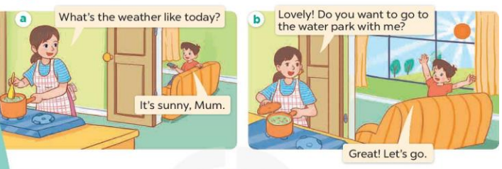  - Play the audio twice (sentence by sentence). Correct their pronunciation where necessary.  - Have Ss to practice the diaguage  - T invites a few pairs to the front of the class to practice.  - T checks pronunciation for ss.  Activity 3. Listen, point and say.  *Aims: Ss will be able to correctly say the words and use Do you want to go to the …….? – Great! Let’s go. / Sorry, I can’t. to make suggestions to go somewhere and respond.  *Procedure:  * Model sentences:  - T asks Ss look at picture b and helps Ss know the structure from the dialogue.  - T introduces new structure for Ss.  - T explains, models and gives meaning.  - Have Ss repeat the model sentences.  A: Do you want to go to the water park?  B: Great! Let’s go./ Sorry, I can’t.  3.Practice: (7’)  *Drill pictures  - Have Ss look at the pictures and elicit the names of the places.  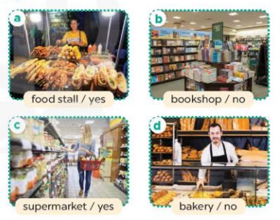  - Run through all the pictures.  - Run through model sentences.  +Run through the question sentences  +Run through the answer sentences  - Have Ss to practise:  + T asks, Ss answer picture a  + Ss ask, T answers picture b  + Group A ask, group B answer picture c  + Group B ask, group A answer picture d  - Ask Ss to work in pairs.  - T controls and corrects.  - Invite a few pairs to come to the front of the classroom, point at the pictures and say the questions and answers in front of the class.  - T gives feedbacks.  4.Production: (7’)  Activity 4. Let’s talk.  *Aims: Ss will be able to enhance the correct use of Do you want to go to the ……? – Great! Let’s go. / Sorry, I can’t. to make suggestions to go somewhere and respond in a freer context.  *Procedure:  - Have Ss look at the picture and say the names of the places in the picture.  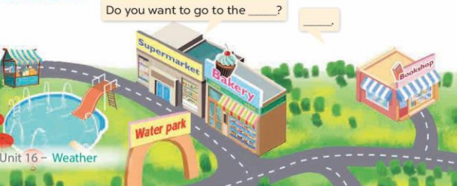  - Put Ss into pairs and encourage them to ask and answer questions using Do you want to go to the……? − …….  - Invite some pairs to stand up to perform their exchanges.  *Consolidation  *Aims: Ss will be able consolidate and wrap up the content of the lesson.  *Procedure:  - T asks ss to answer the following questions:  + What have you learnt from the lesson today?  - T review the vocabulary and model sentences.  - T praises some Ss who are hardworking / active/ good…. as well as encourage others to try more.  5. Homework. (2’)  - Learn the vocabulary and model sentences by heart  - Prepare the new lesson: Unit 16, Lesson 2 (4,5,6). | - Ss listen  - Ss play the game  - Ss open their books  -Ss listen and answer  - - Ss listen and repeat  + Choral repetition (3 times).  + Individual repetition (3 ss)  - Ss take note  - Ss look, remember and write  -Look at the pictures and get to know the characters in the pictures.  + In picture a:  Minh’s mother: What’s the weather like today?  Minh: It’s sunny, Mum  – In picture b:  Minh’s mother: Lovely! Do you want to go to the water park with me?  Minh: Great! Let’s go.  -Ss listen and repeat in chorus (twice)  -Ss work in pairs to practice  -Ss practice the diaguage  -Ss listen  -Ss look at the picture and answer.  -Ss listen  -Ss listen and repeat  -Ss repeat  -Ss listen and answer  +Picture a: a food stall  +Picture b. a bookshop  +Picture c. a supermarket  +Picture d. a bakery  - Ss look, listen and repeat  - Ss practice in chorus  - Ss practice in chorus  -Ss work in pairs to practice  -Ss listen  -Ss go to the board and point and say  -Ss listen  -Ss look at the picture and answer  + a map of an area with a supermarket, bakery, water park, bookshop and food stall.  -Ss work in pairs to ask and answer the question  -Ss perform in front of the class  -Ss answer the questions  - Ss listen  -Ss listen and clap their hands  -Ss listen and take note
D. ADJUSTMENTS (if necessary):
………………………………………………………………………………………….…..……………………………………………………………………………...
-----------------------------------------------------------------
Grade 5 : Lớp 5B : Sáng thứ ba, Ngày 25 tháng 3 năm 2025
ENGLISH
Extension activities
A. OBJECTIVES:
By the end of the lesson, Ss will be able to:
1. Knowledge:
- Show understanding of food types by colouring in a picture.
- Categorise a wider range of food and drink items by their food types.
- Vocabulary: Review
- Skills: speaking, writing and listening
2. Competences:
- Co-operation: ready to help friends in pair work/ group work.
- Sociability: Talk to each other, say good words to others.
3. Attitude/ Qualities:
- Kindness: Help partners to complete learning tasks.
B. TEACHING AIDS:
- Teacher: Teacher’s guide Pages 254, 255, 256; website hoclieu.vn, posters, laptop, pictures, textbook, lesson plan, TV or projector.
- Students: Student’s book Page 38, 39, notebooks, workbooks, school things.
C. PROCEDURES:
Teacher’s activities | Students’ activities
1.Warm- up: (3’)  Sing: Head, shoulders, knees and toes  *Aims: to create a friendly and active atmosphere in the class to beginning the lesson.  *Procedure:  - Show the song on the screen.  https://www.youtube.com/watch?v=WX8HmogNyCY  - Ask Ss to listen, sing and dance the song.  - Say “Open your book page 38, 39” and look at “Extension activites”.  2. Practice (28’)  Activity 1. Look, read and colour  *Aims: Ss will be able to show understanding of food types by colouring in a picture.  *Procedure:  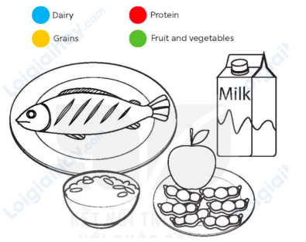  - Tell the class the goal of this activity: They need to identify the food types by colouring in the picture, according to the key above.  - Have ss say them aloud and elicit some examples of each food type.  + Ask questions to check comprehension, such as What colour is protein? (red) and What colour should bread be? (yellow).  - Make sure that ss each have access to blue, red, yellow and green crayons.  - Put ss into pairs and have them decide which colour each food / drink item should be.  - Set a time for ss to complete the activity independently.  - Check answers as a class by pointing to the food / drink items and having ss call out the food, the correct food type and the colour (ex: fish, protein, red).  - Invite a few ss to the front of the class and have them present their work to the class. Model what they need to say, ex: Fish is protein. Rice is grains.  Key:  fish: protein / red  milk: dairy / blue  rice: grains / yellow  apple and peas: fruit and vegetables / green  Activity 2. Look and write  *Aims: Ss will be able to categorise a wider range of food and drink items by their food types.  *Procedure:    - Tell the class the goal of this activity: They need to categorise the foods by writing the names of the food and drink items in the correct columns of the table.  - Write the table on the board and have ss say the four headings aloud.  - Set a time limit for ss to complete the activity.  - Have check answers in pairs.  - Check answers as a class by pointing to the pictures and having ss call out the correct food type.  - Invite a few ss to the front of the class and have them present their work to the class.  Key:  Grains: noodles, rice, bread.  Protein: chicken, egg, fish, meat  Dairy: butter, cheese, yogurt, milk  Fruit and vegetables: apple, grapes, green beans, carrot, corn.  Activity 3. Write and say  *Aims: Ss will be able to create a healthy breakfast and present it to the class.  *Procedure:  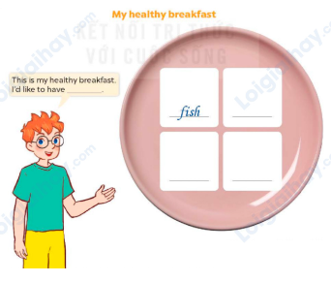  - Tell the class that they are going to create a healthy breakfast and present it to the class. They need to think of four food and drink items to create the breakfast.  - Draw Ss’ attention to the picture and have them identify the bowl and the blank spaces.  - Ask Ss what they usually eat for breakfast. Make a list of their answers on the board. Ask Is this food/drink healthy? And allow Ss to respond.  - Have ss create their healthy breakfast by writing down the food and drink items  - Have ss check their answers in pairs. Go around the classroom to check that the foods/drinks used are healthy and that the words are spelt correctly.  - Invite a few ss to share their healthy breakfasts with the class.  - Have ss create a healthy lunch and dinner and present them to the class.  Suggested answers:  This is my healthy breakfast. I’d like to have noodles, green beans and fish. I’d like to drink milk.  3. Fun corner and wrap- up (4’)  Game: “Kim’s game”  - Divide the class into two teams.  - Display many words and phrases on the board. Give sls two minutes to memorise these words and phrases.  - Turn the word cards face down on the board. In their teams, the ss try to write down many words as they can remember.  - Check the answers as the class.  - Count the points for each team and announce the winner. The team with the most points wins. | - Ss listen  - Ss sing a song  -Ss open the book  - Ss listen to the teacher’s explanation.  - Ss look at the four food types given in the activity on the board.  - Ss answer the questions.  - Ss pay attention and follow the teacher’s instructions.  - Ss complete the activity independently.  - Ss check the answers and call out the food, the correct food type and the colour.  - Ss come to the front of the class and present their work to the class.  - Ss listen to the teacher’s explanation.  - Ss say the four headings aloud.  - Ss complete the table independently  - Ss check answers in pairs.  - Ss check answers as a class and call out the correct food type.  - Ss come to the front of the class and present their work to the class.  - Ss listen to the teacher’s explanation.  - Ss look at the picture, identify the bowl and the blank spaces.  - Ss listen and answer the questions.  - Ss write down the food and drink items.  - Ss check the answer  -Ss share their healthy breakfasts  -Ss come to the front of the class and present their work to the class.  - Ss listen to the teacher  -Ss play the game  Ex: bread, apple, chicken, grapes, egg, noodles, yogurt, green beans, cheese, carrot, milk, water, apple juice, corn, rice, fish,  -Ss praise the winner
D. ADJUSTMENTS (if necessary):
………………………………………………………………………………………….…..……………………………………………………………………………...
------------------------------------------------------------
Grade 5 : Lớp 5B : Sáng thứ ba, Ngày 25 tháng 3 năm 2025
ENGLISH
Unit 16: Seasons and the weather - Lesson 1 (1, 2, 3)
A. OBJECTIVES:
By the end of the lesson, Ss will be able to:
1. Knowledge:

- Understand and correctly repeat the sentences in two communicative contexts

focusing on asking and answering questions about the weather in different seasons;

- Correctly say the words summer, autumn, winter, spring, hot, cool, cold and warm and use How’s the weather in Ha Noi in ___? - It’s____. to ask and answer questions about the weather in Ha Noi in different seasons;

- Use How’s the weather in Ha Noi in ___? – It’s ___. in a freer context.

- Vocabulary: summer, autumn, winter, spring, hot, cool, cold and warm

- Structures:
A: How’s the weather in Ha Noi in summer?
B: It’s hot
- Skills: speaking and listening
2. Competences:
- Critical thinking and creativity: learn how to ask and answer questions about the weather in Ha Noi in different seasons correctly and fluently.
- Self-control and independent learning: perform speaking tasks.
3. Attitude/ Qualities:
- Show their love and interest in the weather and seasons.
- Express their knowledge about the weather of each season.
B. TEACHING AIDS:
- Teacher: Teacher’s guide Pages 257, 258, 259, audio Tracks 52, 53, website hoclieu.vn, posters, laptop, pictures, textbook, lesson plan, TV or projector.
- Students: Students’ book Page 40, notebooks, workbooks, school things.
C. PROCEDURES:
Teacher’s activities | Students’ activities
1.Warm- up and review: (3’)  Game: Slap the board  *Aims: to revise the vocabulary about different weather that pupils have learnt in English 3.  *Procedure:  - Prepare some flashcards about different jobs and stick on the board  (sunny, rainy, windy, cloudy)  - Divide class into 2 groups: Tom and Jerry.  - How to play:  + Each group chooses five Ss to play.  + Class will read aloud.  + Look at the picture, listen and slap the picture you heard.  + Who faster will get 1 mark.  + Which group with higher mark is the winner.  - Say “Open your book page 40” and look at “Unit 16, Lesson 1 (1,2,3)”.  2. Presentation (15’)  Activity 1. Vocabulary.  *Aims: Ss will be able to know the vocabulary in the new lesson.  *Procedure:  -T elicits the new words  + summer: mùa hè (picture)  + autumn: mùa thu (picture)  + winter: mùa đông (picture)  + spring: mùa xuân (picture )  + hot: nóng (situation)  + cold: lạnh (mime)  + cool: mát mẻ (mime)  + warm: ấm áp (translation  - T models (3 times).  - T writes the words on the board.  - Checking: Matching  Activity 2. Look, listen and repeat:  *Aims: Ss will be able to understand and correctly repeat the sentences in two communicative contexts focusing on asking and answering questions about the weather in different seasons.  *Procedure:  - Have Ss look at Pictures a and b and identify the characters and say what they can see in the pictures.  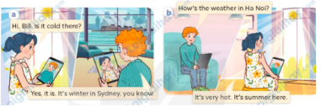  - Play the audio twice (sentence by sentence). Correct their pronunciation where necessary.  - Have Ss to practice the dialogue  - T invites a few pairs to the front of the class to practice.  - T checks pronunciation for ss.  Activity 3 Listen, point and say.  *Aims: Ss will be able to correctly say the words and use How’s the weather in Ha Noi in ___? - It’s ____.to ask and answer questions about the weather in Ha Noi in different seasons.  *Procedure:  * Structures:  - T asks Ss look at picture b in activity 1 and helps Ss know the structure from the dialogue.  - T introduces new structures for Ss.  - T explains, models and gives meaning.  - Have Ss repeat the structures  A: How’s the weather in Ha Noi in summer?  B: It’s hot  3.Practice: (7’)  *Drill pictures  - Have Ss look at the pictures and say what they can see in the pictures.  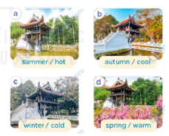  - Have Ss point at pictures, listen and run through all the pictures.  - Have Ss point at the bubbles, listen and run through model sentences.  - Have Ss to practise:  + T asks the first picture, Ss answer  + Ss asks the second picture, T answers  + Group A asks the third picture, group B  answers  + Group B asks the last picture, group A  - Ask Ss to work in pairs to practise asking and answering the How’s the weather in Ha Noi in ___? - It’s ___  - T controls and corrects.  - Invite a few pairs to point at the pictures and say the questions and answers in front of the class.  4. Production: (6’)  Activity 4. Let’s talk.  *Aims: Ss will be able to use How’s the weather in Ha Noi in ___? - _It’s ______.in a freer context.  *Procedure:  - Ask Ss to look at the pictures and ask questions to revise the relevant seasons and the weather concepts.    - Point at the ﬁrst picture and elicit the question in the ﬁrst speech bubble How’s the weather in Ha Noi in ___? and the answer in the second speech bubble It’s ___ as an example.  - Give Ss time to work in pairs and take turns pointing at each picture to ask and answer using structures.  - Invite a few pairs to come to the front of the classroom and act out the exchanges.  5. Fun corner and wrap- up (4’)  Game: Guess the picture  - Tell the class they are going to take turns looking at a part of the picture and guess the name of the season.  - Use pictures (spring, summer, autumn, winter).  - In turn, show a part of the picture. Ask ss to raise their hand to say the name of the season.  - If they say the correct word, they will get stickers from the teacher.  - Praise ss. | -Ss listen and pay attention  - Ss listen to the teacher  -Ss play the game  .  -Ss continute playing the game  - Ss listen and open their books  -Ss listen and answer  - - Ss listen and repeat  + Choral repetition (3 times).  + Individual repetition (3 ss)  - Ss take note  - Ss look and match  -Look at the pictures and say.  + In picture a:  Linh: Hi, Bill. Is it cold there?  Bill: Yes, it is. It’s winter in Sydney, you know.  + In picture b:  Bill: How’s the weather in Ha Noi?  Linh: It’s very hot. It’s summer here.  -Ss listen and repeat in chorus (twice)  -Ss work in pairs to practice  -Ss come to the front of the classroom to practice.  -Ss listen  - Ss look at the picture and answer.  -Ss listen  -Ss listen and repeat  -Ss repeat to the structures  - Ss look, listen and repeat  +Picture a: Ha Noi’s One-Pillar Pagoda in summer  + Picture b: Ha Noi’s One-Pillar Pagoda in autumn  + Picture c: Ha Noi’s One-Pillar Pagoda in winter  + Picture d: Ha Noi’s One-Pillar Pagoda in spring  -Ss point at pictures, listen and repeat  -Ss point at the bubbles, listen and repeat  -Ss practice in chorus  -Ss practice in chorus  -Ss work in pairs to practise asking and answering the question  - Pairs of Ss point at the pictures and say in front of the class  -Ss look at the picture and say  + the Huc Bridge across Hoan Kiem Lake, Ha Noi, in different seasons: winter, spring, summer and autumn.  - Ss look at the first picture and elicit the missing words in speech bubbles and say the completed sentences.  - Ss role-play to practise asking and answering questions  - Ss practise asking and answering questions in front of the class.  -Ss listen to the teacher  -Ss play the game  -Ss continue the game
D. ADJUSTMENTS (if necessary):
………………………………………………………………………………………….…..……………………………………………………………………………...
Grade 5 : Lớp 5B : Sáng thứ năm, Ngày 27 tháng 3 năm 2025
ENGLISH
Unit 16: Seasons and the weather - Lesson 1 (4, 5, 6)
A. OBJECTIVES:
By the end of the lesson, Ss will be able to:
1. Knowledge:
- Listen to and understand four communicative contexts in which characters ask and answer questions about different seasons and weather conditions, and number the pictures
- Complete four exchanges with the help of picture cues
- Sing the song How’s the weather in Ha Noi? with the correct pronunciation, rhythm and melody.
- Vocabulary: Review
- Skills: speaking, listening, reading and writing.
2. Competences:
- Communication and collaboration: work in pairs and groups to complete the learning tasks.
- Self-control and independent learning: perform listening and reading tasks.
3. Attitude/ Qualities:
- Show their love and interest in the weather and seasons.
- Express their feelings about the weather of each season.
- Show their knowledge of choosing suitable clothes in different seasons.
B. TEACHING AIDS:
- Teacher: Teacher’s guide Pages 260, 261, 262; audio Tracks 54, 55; website hoclieu.vn, posters, laptop, pictures, textbook, lesson plan, TV or projector.
- Students: Student’s book Page 41, notebooks, workbooks, school things.
C. PROCEDURES:
Teacher’s activities | Students’ activities
1.Warm- up and review: (5’)  Game: Slap the board  *Aims: to create a friendly and active atmosphere in the class to beginning the lesson.  *Procedure:  - Divide the class into two teams. Each team has eight ss.  - Have each team stand in a line.  - Tell ss how the game is played. Give an example.  - Stick the flashcards (spring, summer, autumn, winter) on the board.  - Teacher says a word. Ask two ss from two teams to listen to the word and slap the flash card as correctly and quickly as possible.  - The first student who slaps the correct flash card gets one point and continues playing the game.  - The student who gets the highest points will be the winner. Praise the winner.  - Say “Open your book page 41” and look at “Unit 16, Lesson 1 (4,5,6)”.  2.Practice: (25’)  Activity 1. Listen and number:  *Aims: Ss will be able to listen to and understand four communicative contexts in which characters ask and answer questions about different seasons and weather conditions, and number the pictures.  *Procedure:  - Draw ss’ attention to each picture and ask questions to elicit the place and the season illustrated by the sceneries.    - T ask Ss to guess the answers.  + T writes Ss’guessing on the board.  - Listen to the tape:  + Play the recording  + Play the recording again for ss to do the task.  + Play the recording a third time for ss to check their answers.  - Get Ss to swap books with their partner, then check answers as a class.  + Write the answers on the board for Ss to correct their answers. Then checks Ss’ guessing.  - If time allows, play the recording, sentence by sentence, for Ss to listen and repeat individually and in chorus Key: 1. b, 2. d, 3. a, 4. c  Activity 2. Read and complete  *Aims: Ss will be able to complete four exchanges with the help of picture cues. *Procedure:  - Draw ss’ attention to the season in the picture, particularly the peach blossom  (ex: spring).  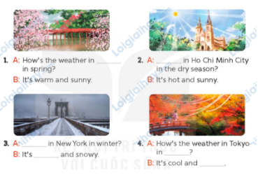  - Give Ss a time limit to read the gapped dialogues, look at the pictures and do the task independently.  - Get Ss to swap books with a partner and check their answers before checking as a class.  + Invite one student to write the answers on the board.  - Invite two pairs of Ss to act out the completed dialogues.  Key:  1. in spring  2. How’s the weather  3. How’s the weather, cold  4. autumn, windy  Activity 3. Let’s sing  *Aims: Ss will be able to sing the song How’s the weather in Ha Noi? with the correct pronunciation, rhythm and melody.  *Procedure:  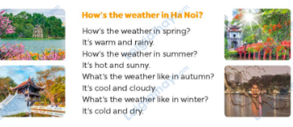  - Introduce the title and lyrics of the song: How’s the weather in Ha Noi?  - Play the recording for Ss to listen to the whole song.  + Have them repeat the title and lyrics line by line.  - Play the recording all the way through for Ss to listen to pronunciation and melody of the song.  - Play the recording line by line for Ss to listen, repeat  - Play the recording for Ss to sing and do actions.  - Ask Ss to practice singing and doing actions in pairs or groups.  - Invite groups to the front of the classroom to perform the song  -T gives feedback.  3. Fun corner and wrap- up (5’)  Game: A matching game  - Tell the class that they are going to play a matching game. Tell them that the aim of the game is to review vocabulary and structures about asking and answering the question about the weather in different seasons.  - Explain how to play the game: ask ss to work in teams of five. T gives the same sets of word cards for groups to make sentences  - Set a time limit for the teams to play the game. Monitor the activity.  - Call on two teams to play the game in front of the class. Remember to praise ss who do well. | -Ss listen to the teacher  -Ss play the game  -Ss continue playing the game  - Ss open their books  -Look at the pictures and say:  + Picture 1: Hoan Kiem Lake in summer  + Picture 2: Hoan Kiem Lake in spring  + Picture 3: Hoan Kiem Lake in winter  + Picture 4: Hoan Kiem Lake in summer  -Ss guess the answers  - Ss listen to the tape  - Ss listen again and do the task.  - Ss listen and check their answers  - Ss swap books with their partner, then check answers as a class  -Ss check the guessing  -Ss listen and repeat  -Ss look at the picture and read, fill the gap  - Ss do the task independently.  - Ss swap books with a partner and check their answers.  - Ss write the answers in the notebook  - Pairs of Ss read the completed dialogues aloud  -Ss look and listen to the teacher  -Ss listen to the song  - Ss listen and repeat line by line without the action.  -Ss listen to melody of the song  - Ss listen and sing line by line.  - Ss sing and do actions.  - Ss work in groups (two groups) to sing.  -Ss perform in front of the class.  -Ss listen  -Ss listen to the teacher  - Ss play the game.  - Ss continue playing the game.  - Ss praise the winner.
D. ADJUSTMENTS (if necessary):
………………………………………………………………………………………….…..……………………………………………………………………………...
---------------------------------------------------------------
Grade 5 : Lớp 5B : Sáng thứ năm, Ngày 27 tháng 3 năm 2025
ENGLISH
Unit 16: Seasons and the weather - Lesson 2 (1, 2, 3)
A. OBJECTIVES: By the end of the lesson, Ss will be able to:
1. Knowledge:

- Understand and correctly repeat the sentences in two communicative contexts related to the weather and clothing choices during a specific season

- Correctly say the words blouse, trousers, jeans and jumper and use What do you usually wear in ____? - I wear _____. to ask and answer questions about what someone wears in different seasons

- use What do you usually wear in ___? - I wear _____. in a freer context.

- Vocabulary: blouse, trousers, jeans and jumper
- Structures:
A: What do you usually wear in winter?
B: I wear a jumper.
- Skills: speaking and listening
2. Competences:
- Critical thinking and creativity: learn how to ask and answer questions about what someone wears in different seasons correctly and fluently
- Self-control and independent learning: perform pronunciation and speaking tasks.
3. Attitude/ Qualities:
- Express their feelings about the weather of each season.
- Show their knowledge of choosing suitable clothes in different seasons.
B. TEACHING AIDS:
- Teacher: Teacher’s guide Pages 262, 263, 264, audio Tracks 56, 57; website hoclieu.vn, posters, laptop, pictures, textbook, lesson plan, TV or projector.
- Students: Students’ book Page 42, notebooks, workbooks, school things.
C. PROCEDURES:
Teacher’s activities | Students’ activities
1.Warm- up and review: (3’)  Game: Questions and answers  *Aims: to create a friendly and active atmosphere in the class to beginning the lesson.  *Procedure:  - Tell ss that they are going to look at the pictures and ask and answer questions about the weather in different seasons.  - Model the activity. Stick a picture (summer) on the board. Invite a pair of volunteers to ask and answer the question about the picture, ex: How’s the weather in spring? - It’s hot and sunny.  - Divide the class into teams of four. Give them a set of pictures. Have them practice asking and answering questions about the weather in different seasons.  - Call some teams to perform in front of the class.  - Say “Open your book page 42” and look at “Unit 16, Lesson 2 (1,2,3)”.  2. Presentation (15’)  Activity 1. Vocabulary.  *Aims: Ss will be able to know the vocabulary in the new lesson.  *Procedure:  -T elicits the new words  + blouse: áo cánh nữ (realia)  + trousers: quần dài (realia)  + jeans: quần bằng vải bông (realia)  + jumper: áo len cao cổ (realia)  + coat: áo khoác, áo choàng (realia)  + wear ; mặc (mime)  - T models (3 times).  - T writes the words on the board.  - Checking: Rub out and remember  Activity 2. Look, listen and repeat:  *Aims: Ss will be able to understand and correctly repeat the sentences in two communicative contexts related to the weather and clothing choices during a specific season.  *Procedure:  - Have Ss look at Pictures a and b and identify the characters and say what they are talking about.  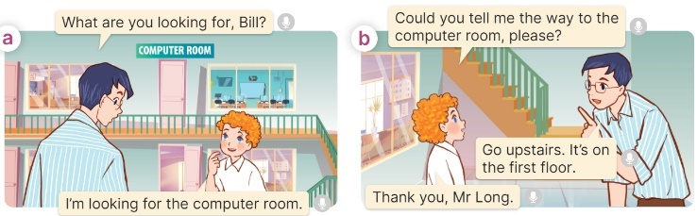  - Play the audio twice (sentence by sentence). Correct their pronunciation where necessary.  - Have Ss to practice the dialogue  - T invites a few pairs to the front of the class to practice.  - T checks pronunciation for ss.  Activity 3 Listen, point and say.  *Aims: Ss will be able to correctly say the words and use What do you usually wear in ____? - I wear ____. to ask and answer questions about what someone wears in a season.  *Procedure:  * Structures:  - T asks Ss look at picture b in activity 1 and helps Ss know the structure from the dialogue.  - T introduces new structures for Ss.  - T explains, models and gives meaning.  - Have Ss repeat the structures  A: What do you usually wear in winter?  B: I wear a jumper.  3.Practice: (7’)  *Drill pictures  - Have Ss look at the pictures and say what they can see in the pictures.  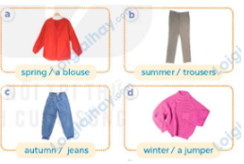  - Have Ss point at pictures, listen and run through all the pictures.  - Have Ss point at the bubbles, listen and run through model sentences.  - Have Ss to practise:  + T asks the first picture, Ss answer  + Ss asks the second picture, T answers  + Group A asks the third picture, group B  answers  + Group B asks the last picture, group A  - Ask Ss to work in pairs to practise asking and answering the question What do you usually wear in ____? - I wear ____.  - T controls and corrects.  - Invite a few pairs to point at the pictures and say the questions and answers in front of the class.  4. Production: (6’)  Activity 4. Let’s talk.  *Aims: Ss will be able to use How’s the weather in Ha Noi in ____? – It’s ____. and What do you usually wear in ____? - I wear ____. in a freer context.  *Procedure:  - Ask Ss to look at the pictures and elicit the seasons and pieces of clothing.  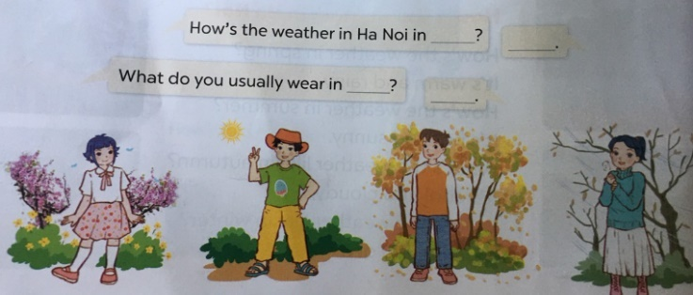  - Remind Ss that How’s the weather in Ha Noi in ____? What do you usually wear in ____? are used to talk about the weather and clothing choices in different seasons in Ha Noi.  - Give Ss time to work in pairs and take turns pointing at each picture to ask and answer using How’s the weather in Ha Noi in __? What do you usually wear in ___?  - Invite a few pairs to come to the front of the classroom and act out the exchanges.  5. Fun corner and wrap- up (4’)  Game: Who’s faster?  - Tell the ss the goal of the game and how to play it. Ask them to revise all vocabulary about clothes.  - Divide the class into groups of four ss. Each group has 30 seconds to write as many words as possible about pieces of clothing in four seasons.  - The groups with more correct words will be the winner. | -Ss listen and pay attention  -Ss play the game  -Ss play the game  - Ss listen and open their books  -Ss listen and answer  - Ss listen and repeat  + Choral repetition (3 times).  + Individual repetition (3 ss)  - Ss take note  - Ss look, remember and write  Look at the pictures and say.  + In picture a:  Ben: How’s the weather in Ha Noi in winter?  Nam: It’s cold and dry.  + In picture b:  Minh: What do you usually wear in winter?  Ben: I wear a jumper.  -Ss listen and repeat in chorus (twice)  -Ss work in pairs to practice  -Ss come to the front of the classroom to practice.  -Ss listen  - Ss look at the picture and answer.  -Ss listen  -Ss listen and repeat  -Ss repeat to the structures  - Ss look, listen and repeat  +Picture a: a blouse  + Picture b: a pair of trousers  + Picture c: a pair of jeans  + Picture d: a jumper  -Ss point at pictures, listen and repeat  -Ss point at the bubbles, listen and repeat  -Ss practice in chorus  -Ss practice in chorus  -Ss work in pairs to practise asking and answering the question  - Pairs of Ss point at the pictures and say in front of the class  -Ss look at the picture and say  - Ss listen to the teacher  - Ss role-play to practise asking and answering questions about address  - Ss practise asking and answering questions in front of the class.  -Ss listen to the teacher  -Ss play the game  -Ss play the game  -Ss congratulate the winner.
D. ADJUSTMENTS (if necessary):
……………………………………………………………………………………….…..……………………………………………………………………………...……
Duyệt bài, Ngày 21 tháng 3 năm 2025
Phó hiệu trưởng

Nguyễn Thị Hằng

