ĐĂNG KÝ GIẢNG DẠY TUẦN 25 ( Từ 10-14/03/2025)

Thứ  Ngày | Buổi | Lớp | Tiết | Môn | Tên bài
Hai | Chiều | 4B | 1 | English | Unit 15: My family’s weekend - Lesson 1 (1,2,3)
 |  | 4B | 2 | English | Unit 15: My family’s weekend - Lesson 1 (4,5,6)
Ba | Sáng | 4A | 1 | English | Unit 15: My family’s weekend - Lesson 1 (1,2,3)
 |  | 4A | 2 | English | Unit 15: My family’s weekend - Lesson 1 (4,5,6)
 |  | 5B | 1 | English | Unit 15: Our health- Lesson 1 (1,2,3)
 |  | 5B | 2 | English | Unit 15: Our health- Lesson 1 (4,5,6)
 | Chiều |  | 1
 |  | 3A | 1 | English | Unit 15: At the dining table - Lesson 1 (1,2,3)
 |  | 3A | 2 | English | Unit 15: At the dining table - Lesson 1 (4,5,6)
Tư | Sáng | 4C | 1 | English | Unit 15: My family’s weekend - Lesson 1 (1,2,3)
 |  | 4C | 2 | English | Unit 15: My family’s weekend - Lesson 1 (4,5,6)
 |  | 4B | 3 | English | Unit 15: My family’s weekend - Lesson 2 (1,2,3)
 |  | 4B | 4 | English | Unit 15: My family’s weekend - Lesson 2 (4,5,6)
Năm | Sáng | 4C | 1 | English | Unit 15: My family’s weekend - Lesson 2 (1,2,3)
 |  | 4C | 2 | English | Unit 15: My family’s weekend - Lesson 2 (4,5,6)
 |  | 5B | 3 | English | Unit 15: Our health- Lesson 2 (1,2,3)
 |  | 5B | 4 | English | Unit 15: Our health- Lesson 2 (4,5,6)
 | Chiều |  | 1
 |  | 1C | 2 | English | Unit 12: At the lake – Lesson 3: 6,7,8
 |  | 1C | 3 | English | Review 3. Phil and Sue  1. Listen and read.  2. Look and circle
Sáu | Sáng | 3A | 1 | English | Unit 15: At the dining table - Lesson 2 (1,2,3)
 |  | 3A | 2 | English | Unit 15: At the dining table - Lesson 2 (4,5,6)
 |  | 4A | 3 | English | Unit 15: My family’s weekend - Lesson 2 (1,2,3)
 |  | 4A | 4 | English | Unit 15: My family’s weekend - Lesson 2 (4,5,6)

Duyệt bài, Ngày 7 tháng 3 năm 2025
Phó hiệu trưởng

Nguyễn Thị Hằng

WEEK 25
Grade 1: Lớp 1C: Chiều thứ năm, Ngày 13 tháng 3 năm 2025
ENGLISH
UNIT 12: AT THE LAKE - Lesson 3

I. OBJECTIVES
By the end of this lesson, pupils will be able to:
1. Knowledge and skills:
- Listen and repeat the sentences “Look at Lucy.” and “Look at the lemons.”
- give a command, using “Look at (the) _____.”
- sing a song with the structure that expresses a command (Look at (the) _____.) and what someone/ something is doing (She’s running ___. It’s falling ____
2. Competences
- Communication and collaboration: work in pairs and groups to complete the learning tasks
3. Attributes
- Show active participation in learning activities.
- Show confidence in playing games.
II. MATERIALS
- Student’s book, p. 53
- Audio tracks 68, 69
- Poster for Unit 12
- hoclieu.vn
- Teacher’s guide, p. 102, 103
- Computer, projector, …
III. PROCEDURES
1. WARM-UP & REVIEW (5 mins)
a. Objectives:
- To create a friendly and lively atmosphere in the classroom.
- To revise the previous lesson.
b. Content:
- Let’s chant!
c. Expected outcomes:
- Pupils recall vocabulary from the previous unit by singing the chant.
d. Organization:
TEACHER’S ACTIVITIES | PUPILS’ ACTIVITIES | CONTENT
- Greet the class.  - Have a group of pupils sing the chant on page 52 in front of the class.  - Get pupils to open their books and look at Lesson 3, p. 53. | - Pupils greet the teacher.  - All pupils sing the chant on page 52.  - Pupils open their books and look at Lesson 3, p. 53. | Pupils’ practise
e. Assessment
- Teacher observes and gives feedback.
2. ACTIVITY 1: KNOWLEDGE CONSTRUCTION (8 mins)
a. Objectives:
- To help pupils listen and repeat the sentences “Look at Lucy.”and “Look at the lemons.”
b. Content:
- Activity 6. Listen and repeat.
c. Expected outcomes:
- Pupils can listen and repeat the sentences “Look at Lucy.”and “Look at the lemons.”
d. Organization
TEACHER’S ACTIVITIES | PUPILS’ ACTIVITIES | CONTENT
Step 1: Have pupils look at the picture, saying Look at the picture, please! Ask them who the girl is, saying Who is she? Is she Lucy? Yes, she’s Lucy. Then let them point to Lucy and say Look at Lucy. Play the recording several times for pupils to listen and repeat the sentence. Explain the meaning of the sentence and how it is used, if necessary. Give more support to those pupils who find it difficult to do the task.  Step 2: Invite a few pupils to listen and repeat Look at Lucy in front of the class. Correct their pronunciation, if necessary or praise them if they pronounced the sentence correctly, saying Very good!  Step 3: Repeat the same procedure with Look at the lemons. Go around and offer help, if necessary.  Step 4: Play the recording again and let pupils listen and repeat Look at Lucy and Look at the lemons. Encourage some pupils to repeat the sentences in front of the class. Go around and praise them if they performed well, saying Well done! Correct pronunciation to make sure pupils can repeat the two sentences correctly. | - Pupils look at the pictures and answer the questions.  - Pupils point to the first sentence, listen and repeat in front of the class.  - Pupils point to the second sentence, listen and repeat in front of the class.  - Pupils repeat the sentences in front of the class. | - The sentence “Look at Lucy.” or “Look at the lemons.” is used to express a command.  - The picture of Lucy holding some lemons
e. Assessment
- Performance products: Pupils’ pronunciation.
- Assessment tools: Observation and help.
3. ACTIVITY 2: PRACTICE (8 mins)
a. Objectives:
- To encourage pupils to give a command, using “Look at (the) _____.”
b. Content:
Activity 7. Let’s talk.
c. Expected outcomes:
- Pupils can give commands, using “Look at (the) _____.” confidently.
d. Organization
TEACHER’S ACTIVITIES | PUPILS’ ACTIVITIES | CONTENT
Step 1: Have pupils look at the bubbles. Explain the difference between Look at + name of people and Look at the + name of things. Check comprehension.  Step 2: Point to Picture a and model the task, using the expression in the bubble and the word for the picture. E.g. Look at Lucy.  Step 3: Ask pupils to say Look at Lucy in chorus and individually. Correct pronunciation, if necessary.  Step 4: Get pupils to work in pairs or in groups to point to the pictures (a and b) and give commands, saying Point to the pictures and say, please! Go around and offer help, if necessary.  Step 5: Repeat the same procedure with the second structure “Look at the _____.”  Step 6: If there is enough time, invite some pupils to point to their friends and things in the classroom and say the sentences in front of the class (E.g. Look at Mai. Look at the book.) | - Pupils look at the bubble.  - Pupils listen to the teacher.  - Pupils look at the first picture, listen to the teacher and repeat.  - Pupils say Look at Lucy in chorus and individually.  - Pupils work in pairs or in groups to point to the first pictures and give commands.  - Pupils work in pairs or in groups to point to the second pictures and give commands.  - Pupils say the sentences in front of the class. | There are two parts in the activity. Part 1 contains the bubble with the structure “Look at _____.” and the pictures of Lucy (a) and Bill (b). Part 2 consists of the bubble with the structure “Look at the _____.” and some lemons (a) and a lake (b).

e. Assessment
- Performance products: Pupils’ talk.
- Assessment tools: Observation, TPR.
4. ACTIVITY 3: PRACTICE (10 mins)
a. Objectives:
- To help pupils sing a song with the structure that expresses a command (Look at (the) _____.) and what someone/something is doing (She’s running ___. It’s falling _____.)
b. Content:
Activity 8. Let’s sing.
c. Expected outcomes:
- Pupils can sing the song with correct pronunciation, natural tune/rhythm and sweet
melody.
d. Organization
TEACHER’S ACTIVITIES | PUPILS’ ACTIVITIES | CONTENT
Step 1: Have pupils look at the first three sentences “Look at Lucy.” of the first verse of the lyric. Explain their meaning. Check comprehension.  Step 2: Play the recording for pupils to listen and repeat three sentences, saying Listen and repeat, please! Show them how to sing and clap their hands or do actions.  Step 3: Ask pupils to look at the sentence “She’s running around the lake.” Explain its meaning. Check comprehension.  Step 4: Play the recording for pupils to listen and repeat She’s running around the lake. Correct pronunciation, if necessary.  Step 5: Repeat the same procedure with the second verse of the lyrics.  Step 6: Play the recording all the way through and ask pupils to do choral and individual repetition of the song, saying Listen and sing the whole song, please! Go around and offer help, if necessary.  Step 7: Select some pairs or groups to the front of the class to sing the song. The class may sing along and clap their hands or do actions. | - Pupils look at the first three sentences “Look at Lucy.” of the first verse of the lyrics.  - Pupils listen and repeat three sentences and clap their hands.  - Pupils look at the sentence and explain its meaning.  - Pupils listen and repeat after the recording.  - Pupils point to the second verse, listen to the recording and repeat individually and in chorus.  - Pupils do choral and repeat the song individually.  - Pupils sing the song in pairs or groups.  - Pupils sing the song in front of the class. | There are two verses in the song. The first one includes the sentences “Look at Lucy.” and “She’s running around the lake.” In the second verse, “Look at the leaf.” and “It’s falling to the ground.” are introduced.
e. Assessment:
- Performance products: Pupils’ performance.
- Assessment tools: Observation, TPR
5. FUN CORNER AND WRAP-UP (5 mins)
Chair Game
- Have pupils play the game in groups. Each group sends 1 representative.
- Put one flashcard on each chair.
- Say 1 word.
- Pupils have to find the flashcard and sit on the chair that has that flashcard. Then hold the flashcard and say Look at____.
- The group has 1 point if their representative is the fastest and says the correct sentence.
-----------------------------------------------
Grade 1: Lớp 1C: Chiều thứ năm, Ngày 13 tháng 3 năm 2025
ENGLISH
REVIEW 3 - Period 1

I. OBJECTIVES
By the end of this lesson, pupils will be able to:
1. Knowledge and skills
- Repeat and understand a short story.
- Identify the words sun, mouse, girl, lemon for the pictures by circling them.
- Identify and say the letters, sounds and words they have learnt with correct pronunciation.
- Imitate the upper-case letters O and M and the lower-case letters o and m, using body positions.
- Pronounce the sound /ɒ/, /m/, /ʌ/, /l/ of the letters O/o, M/m, U/u, L/l in isolation and in words clocks, locks, mops, pots, mango, monkey, mother, mouse, bus, running, sun, truck, Lucy, lake, leaf, lemons correctly.
- read the learnt words and structures.
+ Vocabulary: clocks, locks, mops, pots
mango, monkey, mother, mouse
bus, running, sun, truck
Lucy, lake, leaf, lemons
+ Structures:
How many _____? – _____. (ask and answer questions about the quantity of things)
That’s a _____. (introducing one thing)
____’s running. (describing what someone is doing)
Look at _____. (using imperatives)
2. Competences
- Communication and collaboration: work in pairs and groups to complete the learning tasks
3. Attributes
- Show active participation in learning activities.
- Show confidence in playing games.
II. MATERIALS
- Student’s book: Page 54
- Teacher’s guide: Pages 104 - 108
- Website hoclieu.vn
- Flashcards with the pictures of the words from Unit 9 to Unit 12
- Computer, projector, …
III. PROCEDURES
1. WARM-UP & REVIEW (5 mins)
a. Objectives:
- To create a friendly and lively atmosphere in the classroom.
- To revise the previous lesson.
b. Content:
- Game: Mystery box
c. Expected outcomes:
- Pupils recall vocabulary from Units 9 and 12 by playing the game Hidden pictures.
d. Organization:
TEACHER’S ACTIVITIES | PUPILS’ ACTIVITIES | CONTENT
Game: Mystery box  - Greet the class.  - Have pupils play Mystery box game to revise the sounds and words they learnt in the 4 previous units.  clocks, locks, mops, pots  mango, monkey, mother, mouse  bus, running, sun, truck  Lucy, lake, leaf, lemons  - Ask pupils to read the word each time a thing falls out of the box.  - Leads to Activity 1, Review 1. | - Greet the teacher.  - Look at the pictures and guess what they are.  - Read the words by themselves.
e. Assessment
- Teacher observes and gives feedback.
2. ACTIVITY 1: PRACTICE (15 mins)
a. Objectives:
- To help pupils learn by heart and understand the words.
b. Content:
- Activity 1. Listen and repeat.
c. Expected outcomes:
- Pupils can identify the words and read them with correct pronunciation.
d. Organization
TEACHER’S ACTIVITIES | PUPILS’ ACTIVITIES | CONTENT
Step 1: Have them open the books and look at the story Phil and Sue. Have pupils look at the pictures. Ask them some questions, such as: Who are in the pictures? What are they doing?... Then have pupils guess the content of the story.  Step 2: Have pupils look at Picture 1 and describe the picture. Draw pupils’ attention to the boy, the girl, and the bubbles.  Step 3: Let pupils listen to the recording, point to the sentence in the speech bubble and repeat.  Step 4: Follow the same procedure with Pictures 2, 3 and 4. Correct pronunciation, if necessary.  Step 5: Play the recording of the whole story several times and have pupils listen, point to the speech bubbles, and repeat. Go around and oﬀer help, if necessary.  Step 6: Play the recording again and invite some pairs of pupils to listen to the recording and repeat the story in front of the class.  Step 7: After pupils have remembered the story, have them role play it. | - Look at the pictures.  - Answer teacher’s questions.  - Look at Picture 1 and describe the picture.  - Listen to the recording carefully and repeat.  - Follow teachers’ instructions.  - Listen to the recording again and repeat.  - Some pairs of pupils listen to the recording and repeat the story in front of the class.  - Role play the story. | Phil and Sue are in the garden.  There are four pictures in the story.  Picture 1. Phil and Sue are in the garden. They see Mary. Picture 2. Mary is running. Picture 3. Phil and Sue see a mouse running after Mary. Picture 4. Mary is running towards Phil and Sue. They are afraid and ready to run.
e. Assessment
- Performance products: Pupils’ answers and role play
- Assessment tools: Observation and help.
3. ACTIVITY 2: PRACTICE (8 mins)
a. Objectives:
- To help pupils identify things and animals
b. Content:
- Activity 2. Look and circle.
c. Expected outcomes:
- Pupils can identify things and animals.
d. Organization
TEACHER’S ACTIVITIES | PUPILS’ ACTIVITIES | CONTENT
Step 1: Have pupils look at the four pictures. Ask pupils to identify the things/ animals/ actions by asking them some questions: What can you see in the pictures? Can you see the sun? Ask pupils to repeat the words several times and circle the sun.  Step 2: Ask pupils to look at the other pictures and circle the words in the chain. Give pupils time to work. Give further support to those pupils who find it difficult to do the task.  Step 3: Ask pupils to swap and check the answers. Invite some pupils to show their answers. Ask pupils to repeat the words several times.  Step 4: After the pupils have finished circling the words, ask them to look at the story again and circle the sun, the mouse, the lemons, and running in the pictures of the story. Then ask them what things they can see in the pictures and have them circle the other things that they have learnt. Have pupils read all the names of the things they have circled. | - Look at the pictures.  - Say the name of things that they are seeing.  - Answer the questions.  - Look at the other pictures and circle the words in the chain.  - Swap and check the answers. Show their answers. Repeat the words several times.  - Finish the task.  - Look at the story again and circle the sun, the mouse, the lemons, and running in the pictures of the story. Circle the other things that they have learnt. Read all the names of the things they have circled. | Four pictures of the sun, the mouse, Mary and the lemons. A chain of the eight words pupils have learnt from Unit 9 to Unit 12: bus, monkey, lake, mouse, locks, running, lemons, sun.
e. Assessment
- Performance products: Pupils’ answers.
- Assessment tools: Observation, TPR.
4. FUN CORNER AND WRAP-UP (5 mins)
TEACHER’S ACTIVITIES | PUPILS’ ACTIVITIES | CONTENT
* Option 1: (ppt)  - Show the pictures of the story then, ask pupils to fill in the blanks and tell the story from their memory.  - Tell pupils to practise telling the story at home.  * Option 2:  - Show flashcards of the words that appear in the story and have pupils say the words. | - Fill in the blanks and tell the story from their memory.  - Practise telling the story at home.  - Say the words. | - The story of Phil and Sue in Activity 1  - Flashcards of the words run, mouse

---------------------------------------------------------
Grade 3: Lớp 3A: Chiều thứ ba ngày 11 tháng 3 năm 2025
ENGLISH
Unit 15: At the dining table
Lesson 1 (1, 2, 3)
A. OBJECTIVES:
By the end of the lesson, Ss will be able to:
1. Knowledge:
- Use the words bean, fish, meat, juice in relation to the topic “Food and drinks”
- Use Would you like some ………? – Yes, please. / No, thanks. To offer someone food or drinks and accept or decline someone’s offer.
-Understand and correctly repeat the sentences in two communicative contexts (pictures) focusing on offering someone food or drinks and accepting or declining someone’s offer.
-Correctly use Would you like some ……..? – Yes, please. / No, thanks. to offer someone food or drinks and accept or decline someone’s offer.
-Enhance the correct use of Would you like some ……..? – Yes, please. / No, thanks. to offer someone food or drinks and accept or decline someone’s offer.
- Vocabulary: bean, fish, meat, juice, rice, would like
- Model sentences:
A: Would you like some rice?
B: Yes, please. / No, thanks.
- Skills: speaking and listening
2. Competences:
- Critical Thinking: talk about friends
- Co-operation: ready to help friends in pair work/ group work.
- Sociability: Talk to each other, say good words to others.
3. Attitude/ Qualities:
- Kindness: Help partners to complete learning tasks.
- Honesty: tell the truth about feelings and emotions
B. TEACHING AIDS:
- Teacher: Teacher’s guide Pages 183, audio Tracks 42, 43, website sachmem.vn, posters, laptop, pictures, textbook, lesson plan, TV or projector.
- Students: Pupil’s book Page 30, notebooks, workbooks, school things.
C. PROCEDURES:
Teacher’s activities | Students’ activities
1.Warm- up: (3’)  Game: jigsaw puzzle  *Aims: to create a friendly and active atmosphere in the class to beginning the lesson.  *Procedure:  - Divide class into 4 groups: Doreamon, Nobita, Xuka and Xeko.  - Ask Ss look at the pieces of picture.  - Ask Ss go to the board and jigsaw puzzle into the correct picture  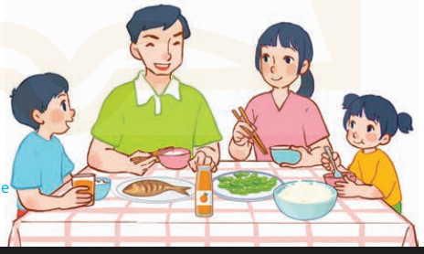  -T checks who’s the winner?  - Ask Ss look at the pieces of picture  - Say “Open your book page 30” and look at “Unit 15, Lesson 1 (1,2,3)”.  2. Presentation(16’)  Activity 1. Vocabulary.  *Aims: Ss will be able to know the vocabulary in front of starting the new lesson.  *Procedure:  -T elicits the new words  + rice : cơm (realia)  + bean : đậu quả, hạt đậu (realia)  + fish : cá (visual)  + meat : thịt (picture)  + juice : nước hoa quả (picture)  + would like : muốn (situation)  - T models (3 times).  - T writes the words on the board.  - Checking: Rub out and remember  Activity 2. Listen, point and repeat:  *Aims: Ss will be able to understand and correctly repeat the sentences in two communicative contexts (pictures) focusing on offering someone food or drinks and accepting or declining someone’s offer.  *Procedure:  - Have Ss look at Pictures a and b and identify the characters in the pictures.  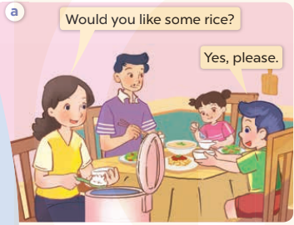  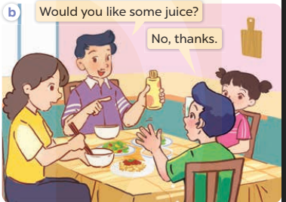  - Play the audio twice (sentence by sentence). Correct their pronunciation where necessary.  - Have Ss to practice the dialogue  - T invites a few pairs to the front of the class to practice.  - T checks pronunciation for ss.  Activity 3 Listen, point and say.  *Aims: Ss will be able to correctly use Would you like some ……? – Yes, please. / No, thanks. to offer someone food or drinks and accept or decline someone’s offer.  *Procedure:  * Model sentences:  - T asks Ss look at picture a , b and helps Ss know the structure from the dialogue.  - T introduces new structure for Ss.  - T explains, models and gives meaning.  -Have Ss repeat the model sentences.  A: Would you like some rice?  B: Yes, please. / No, thanks.  3.Practice: (7’)  *Drill pictures  - Elicit and check comprehension the name of the rooms.  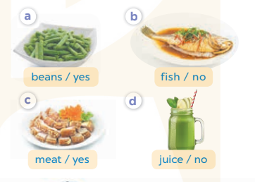  - Run through all the pictures.  - Run through model sentences.  + Run through the questions.  + Run through the answers  - Have Ss to practise:  + T says asks and Ss answer (change role).  + Ss – Ss (change role).  - Ask Ss to work in pairs.  - T controls and corrects.  - Invite a few pairs to come to the front of the classroom, point at the relevant character in each picture, and act out his/her role.  - Encourage Ss to practise speaking English.  - T gives feedbacks.  4.Production: (7’)  Activity 4. Let’s talk.  *Aims: Ss will be able to enhance the correct use of Would you like some ……..? – Yes, please. / No, thanks. to offer someone food or drinks and accept or decline someone’s offer.  *Procedure:  - T asks ss to guess each character and what the children say.  + What can you see in the picture?  +What food and drinks can you see on the table?  - T fills the gaps and writes the sentences on the board.  - T models  - T asks Ss to work in pairs to ask and answer  - Invite some pupils to the front of the class to present their exchanges.  - Give feedbacks  *Consolidation  *Aims: Ss will be able consolidate and wrap up the content of the lesson.  *Procedure:  - T asks ss to answer the following questions:  + What have you learnt from the lesson today?  - T review the vocabulary and model sentences.  - T praises some Ss who are hardworking / active/ good…. as well as encourage others to try more.  5. Homework. (2’)  - Learn the number by heart  - Prepare the new lesson: Unit 15, Lesson 1 (4,5,6). | - Ss listen  - Ss play the game  - Ss open their books  -Ss listen and answer  - - Ss listen and repeat  + Choral repetition (3 times).  + Individual repetition (3 ss)  - Ss take note  - Ss look, remember and write  -Look at the pictures and get to know the characters in the pictures.  + Mother asks Would you like some rice? Nam answers Yes, please. in picture a.  + F ather asks Would you like some juice? Nam answers No, thanks. in picture b.  -Ss listen and repeat in chorus (twice)  -Ss work in pairs to practice  -Ss practice the dialogue  -Ss listen  -Ss look at the picture and answer.  -Ss listen  -Ss listen and repeat  -Ss repeat  - Ss look, listen and answer  + Picture a: beans/ yes  + Picture b: fish/ no  + Picture c: meat/ yes  + Picture d: juice/ no  -Ss practice in chorus  -Ss work in pairs to practice  -Ss point and say  -Ss listen.  -Ss listen  -Ss look at the picture and answer  +I can see a family at the dining table: father, mother, their son and daughter are having lunch.  + There some food and drinks on the table such as rice, fish, beans and juice.  -Ss note  - Ss say the completed sentences.  -Ss work in pairs  -Ss perform in front of the class.  -Ss answer the questions  - Ss listen  -Ss listen and clap their hands  -Ss listen and take note
D. ADJUSTMENTS (if necessary):
………………………………………………………………………………………….…..……………………………………………………………………………...
---------------------------------------------------------------
Grade 3: Lớp 3A: Chiều thứ ba ngày 11 tháng 3 năm 2025
ENGLISH
Unit 15: At the dining table -Lesson 1 (4, 5, 6)
A. OBJECTIVES:
By the end of the lesson, Ss will be able to:
1. Knowledge:
- Listen to and understand two communicative contexts about food and drinks.
- Look, complete and read six target sentences with the help of picture cues.
- Sing the song Would you like some …? with the correct pronunciation, rhythm and melody.
- Vocabulary: Review
- Skills: speaking, listening, reading and writing.
2. Competences:
- Co-operation: ready to help friends in pair work/ group work.
- Self-control and independent learning: perform listening tasks.
3. Attitude/ Qualities:
- Kindness: Help partners to complete learning tasks.
- Honesty: tell the truth about feelings and emotions.
- Diligence: complete learning tasks.
B. TEACHING AIDS:
- Teacher: Teacher’s guide Pages 185; audio Tracks 44, 45; website sachmem.vn, posters, laptop, pictures, textbook, lesson plan, TV or projector.
- Students: Pupil’s book Page 31, notebooks, workbooks, school things.
C. PROCEDURES:
Teacher’s activities | Students’ activities
1.Warm- up: (5’)  Game: “Passing the ball”  *Aims: to create a friendly and active atmosphere in the class to beginning the lesson.  *Procedure:  - Divide class into 3 teams.  - Each team has 1 sticky ball.  - Play the music, ss in each team take turn to pass the ball.  - After the music ends, 3 ss have the ball – stand up and say the name, using the sentence model.  - Say “Open your book page 31” and look at “Unit 15, Lesson 1 (4,5,6)”.  2.Practice: (27’)  Activity 1. Listen and tick:  *Aims: Ss will be able to listen to and understand two communicative contexts about food and drinks  *Procedure:  - Elicit the name of the food in each picture 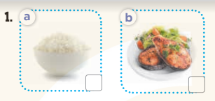  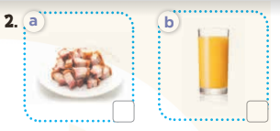  - T ask Ss to guess the answers.  + T writes Ss’guessing on the board.  - Listen to the tape:  + Play the recording  + Play the recording again and get Ss to swap books with their partners.  + Play the recording again to check answers together as a class.  + Write the answers on the board for Ss to correct their answers. Then checks Ss’ guessing.  - Play the recording, sentence by sentence, for the class to listen and repeat in chorus.  Key: 1.b 2.b  Activity 2. Look, complete and read.  *Aims: Ss will be able to look, complete and read six target sentences with the help of picture cues.  *Procedure:  - Have Ss look at the pictures and identify the food (rice, beans, fish, juice).  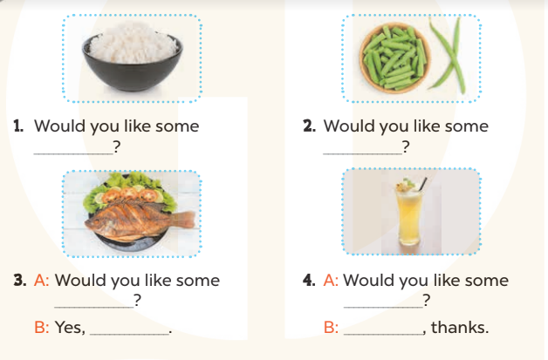  - Have Ss look at the four incomplete exchanges and elicits the missing words in the sentences.  - T models with sentence 1  + Ask Ss what is missing in the sentence.  + Have Ss look at the picture and complete the gap, then read the completed sentence in chorus.  -Have Ss work in groups and complete the sentences 2,3 and 4.  - Ask a few Ss to stand up and read the completed sentences aloud.  -T gives feedbacks.  Key:  - rice 2. beans 3. fish; please  4. juice; No  - Activity 3. Let’s sing.  *Aims: Ss will be able to sing the song Would you like some…? with the correct melody and pronunciation.  *Procedure:  - Introduce the title and lyrics of the song: “ Would you like some…? ” song.  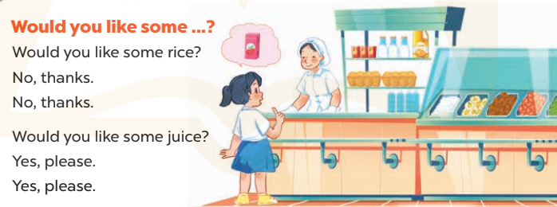  - Play the recording for Ss to listen to the whole song.  + Have them repeat the title and lyrics line by line.  + Tell Ss to point at the relevant character while singing his or her name.  - Play the recording all the way through for Ss to listen to pronunciation and melody of the song.  - Play the recording line by line for Ss to listen, repeat and point at the relevant character.  - Play the recording for Ss to sing and do actions.  - Ask Ss to practice singing and doing actions in pairs or groups.  - Invite groups to the front of the classroom to perform the song  -T gives feedback.  *Consolidation  *Aims: Ss will be able consolidate and wrap up the content of the lesson.  *Procedure:  - T asks ss to answer the following questions:  + What have you learnt from the lesson today?  +What are the core values of the lesson? (if the teacher can take from the lesson).  - T praises some Ss who are hardworking / active/ good…. as well as encourage others to try more.  3. Homework. (3’)  - Learn the sing by heart  - Prepare the new lesson: Unit 15, Lesson 2 (1,2,3). | - Ss listen and keep the puppet  - Ss listen to music and play the game  -Ss listen  - Ss open their books  -Look at the pictures and say:  + Picture 1a: a bowl of rice  + Picture 1b: a plate of fish  + Picture 2a: a plate of meat  + Picture 2b: a glass of juice  -Ss guess the answers  - Ss listen to the tape and tick  - Ss listen again, tick and swap books with their partners.  - Ss check their answers and guessing  -Ss listen and repeat.  -Ss look at the picture and say  -Ss look and answer  -Ss answer: rice  -Ss look, complete and read the completed sentence in chorus.  -Ss complete the sentence  -Ss read aloud  - Ss look and listen.  -Ss listen to the song  - Ss listen and repeat line by line without the action.  -Ss point to the character while singing  -Ss listen to melody of the song  - Ss listen and sing line by line.  - Ss sing and do actions.  - Ss work in groups (two groups) to sing.  -Ss perform in front of the class.  -Ss listen  -Ss answer the questions  -Ss listen and clap their hands  -Ss listen and take note
D. ADJUSTMENTS (if necessary):
………………………………………………………………………………………….…..……………………………………………………………………………...
-----------------------------------------------------------
Grade 3: Lớp 3A: Sáng thứ sáu, ngày 14 tháng 3 năm 2025
ENGLISH
Unit 15: At the dining table - Lesson 2 (1, 2, 3)
A. OBJECTIVES:
By the end of the lesson, Ss will be able to:
1. Knowledge:
-Use What would you like to eat/drink? – I’d like some…….., please. To ask and answer questions about food and drinks
- Understand and correctly repeat the sentences in two communicative contexts (pictures). focusing on what someone would like to eat or drink.
- Correctly use What would you like to eat / drink? - I’d like some ……, please. to ask and answer questions about what someone would like to eat or drink.
- Enhance the correct use of What would you like to eat / drink? – I’d like some ….., please. to ask and answer questions about what someone would like to eat or drink.
- Vocabulary: egg, chicken, water, milk, bread, eat, drink.
- Model sentences:
A: What would you like to eat / drink?
B: I’d like some bread/ milk, please
- Skills: speaking and listening
2. Competences:
- Critical Thinking: talk about someone
- Co-operation: ready to help friends in pair work/ group work.
- Oral Communication: speak about someone, ask and answer the questions
3. Attitude/ Qualities:
- Kindness: Help partners to complete learning tasks.
- Honesty: tell the truth about feelings and emotions
B. TEACHING AIDS:
- Teacher: Teacher’s guide Pages 187 audio Tracks 46, 47, website sachmem.vn, posters, laptop, pictures, textbook, lesson plan, TV or projector.
- Students: Pupil’s book Page 32, notebooks, workbooks, school things.
C. PROCEDURES:
Teacher’s activities | Students’ activities
1.Warm- up: (3’)  Game: Board Race!  *Aims: to create a friendly and active atmosphere in the class to beginning the lesson.  *Procedure:  - Divide the class into two teams  - Give each team a colored marker.  - Draw a line down the middle of the board and write a topic at the top.  - Have Ss write as many words related to the topic in a relay.  - The first pupil will write the first word and pass the colored marker to the one next in line.  - Score each team with one point for each correct word.  - Unreadable or misspelled words are not counted.  - Say “Open your book page 32” and look at “Unit 13, Lesson 2 (1,2,3)”.  2. Presentation(16’)  Activity 1. Vocabulary.  *Aims: Ss will be able to know the vocabulary in front of starting the new lesson.  *Procedure:  -T elicits the new words  + bread : bánh mì (realia)  + milk : sữa (realia)  + egg : trứng (realia)  + chicken : thịt gà (visual)  + water : nước (realia)  + eat : ăn (mime)  + drink : uống (mime)  - T models (3 times).  - T writes the words on the board.  - Checking: Rub out and remember  Activity 2. Listen, point and repeat:  *Aims: Ss will be able to understand and correctly repeat the sentences in two communicative contexts (pictures). focusing on what someone would like to eat or drink.  *Procedure:  - Have Ss look at Pictures a and b and identify the characters in the pictures.  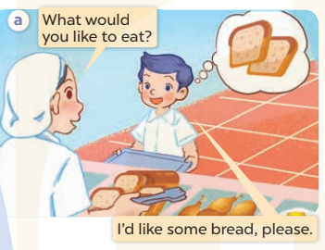  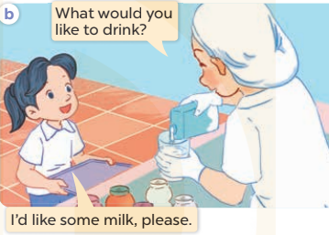  - Play the audio twice (sentence by sentence). Correct their pronunciation where necessary.  - Have Ss to practice the diaguage  - T invites a few pairs to the front of the class to practice.  - T checks pronunciation for ss.  Activity 3. Listen, point and say.  *Aims: Ss will be able to correctly use What would you like to eat / drink? - I’d like some ………,, please. to ask and answer questions about what someone would like to eat or drink.  *Procedure:  * Model sentences:  - T asks Ss look at picture b and helps Ss know the structure from the dialogue.  - T introduces new structure for Ss.  - T explains, models and gives meaning.  - Have Ss repeat the model sentences.  A: What would you like to eat / drink?  B: I’d like some bread/ milk, please  3.Practice: (7’)  *Drill pictures  - Elicit and check comprehension the name of each character.  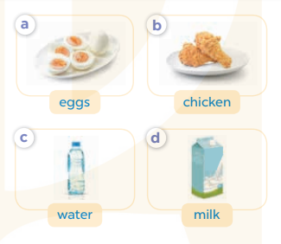  - Run through all the pictures.  - Run through model sentences.  +Run through the question sentences  +Run through the answer sentences  - Have Ss to practise:  + T asks, Ss answer picture a  + Ss ask, T answers picture b  + Group A ask, group B answer picture c  + Group B ask, group A answer picture d  - Ask Ss to work in pairs.  - T controls and corrects.  - Invite a few pairs to come to the front of the classroom, point at the relevant character in each picture, and act out his/her role.  - T gives feedbacks.  4.Production: (7’)  Activity 4. Let’s talk.  *Aims: Ss will be able to enhance the correct use of What would you like to eat / drink? – I’d like some …., please. to ask and answer questions about what someone would like to eat or drink.  *Procedure:  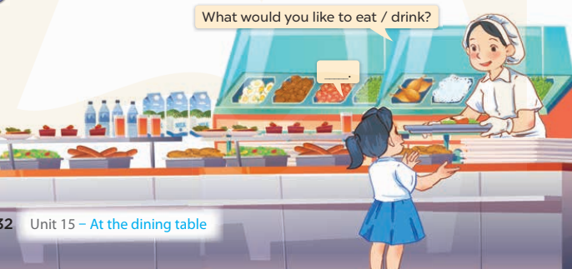  - T asks ss to attend to the picture.  + What can you see in the picture?  +Where are they?  + What would she like to eat/ drink?  - T fills the gaps and writes the sentences on the board.  - T models  - T asks Ss use of What would you like to eat / drink? – I’d like some …., please. to ask and answer (groups of four)  - Invite some groups to perform.  - Give feedbacks  *Consolidation  *Aims: Ss will be able consolidate and wrap up the content of the lesson.  *Procedure:  - T asks ss to answer the following questions:  + What have you learnt from the lesson today?  +What are the core values of the lesson? (if the teacher can take from the lesson).  - T review the vocabulary and model sentences.  - T praises some Ss who are hardworking / active/ good…. as well as encourage others to try more.  5. Homework. (2’)  - Learn the vocabulary by heart  - Prepare the new lesson: Unit 15, Lesson 2 (4,5,6). | - Ss listen  - Ss play the game  - Ss open their books  -Ss listen and answer  - - Ss listen and repeat  + Choral repetition (3 times).  + Individual repetition (3 ss)  - Ss take note  - Ss look, remember and write  -Look at the pictures and get to know the characters in the pictures.  + In picture a: Staff asks What would you like to eat?  Nam answers I’d like some bread, please.  + In picture b: Staff asks What would you like to drink? And Mai answers I’d like some milk, please.  -Ss listen and repeat in chorus (twice)  -Ss work in pairs to practice  -Ss practice the diaguage  -Ss listen  -Ss look at the picture and answer.  -Ss listen  -Ss listen and repeat  -Ss repeat  - Ss look, listen and answer  + Picture a: some eggs  + Picture b: some chicken  + Picture c: a bottle of water  + Picture d: a box of milk  -Ss practice in chorus  - Ss practice in chorus  -Ss work in pairs to practice  -Ss listen  -Ss go to the board and role play.  -Ss listen  -Ss look at the picture and answer  + Mai is at the school canteen. A member of staff serves food like rice, bread, fish, chicken, meat, eggs, beans, and some drinks like water, milk and juice. Mai wants something to eat or drink.  -Ss note  - Ss say the completed sentences.  -Ss work in groups  -Ss perform in front of the class.  -Ss answer the questions  - Ss listen  -Ss listen and clap their hands  -Ss listen and take note
D. ADJUSTMENTS (if necessary):
………………………………………………………………………………………….…..……………………………………………………………………………...
---------------------------------------------------------
Grade 3: Lớp 3A: Sáng thứ sáu, ngày 14 tháng 3 năm 2025
ENGLISH
Unit 15: At the dining table - Lesson 2 (4, 5, 6)
A. OBJECTIVES:
By the end of the lesson, Ss will be able to:
1. Knowledge:
- Listen to and understand four communicative contexts in relation to food and drinks.
- Look, complete and read four target sentences with the help of picture cues.
- Revise target words about food and drinks by playing the game Board race.
- Vocabulary: Review
- Skills: speaking, listening, reading and writing.
2. Competences:
- Critical Thinking: talk about rooms in a house and things in a room.
- Co-operation: ready to help friends in pair work/ group work.
- Self-control and independent learning: perform listening tasks.
3. Attitude/ Qualities:
- Kindness: Help partners to complete learning tasks.
- Honesty: tell the truth about feelings and emotions.
- Diligence: complete learning tasks.
B. TEACHING AIDS:
- Teacher: Teacher’s guide Pages 188; audio Tracks 48; website sachmem.vn, posters, laptop, pictures, textbook, lesson plan, TV or projector.
- Students: Pupil’s book Page 33, notebooks, workbooks, school things.
C. PROCEDURES:
Teacher’s activities | Students’ activities
1.Warm- up: (5’)  Sing a song: “My house”  *Aims: to create a friendly and active atmosphere in the class to beginning the lesson.  *Procedure:  - Show the song on the screen.  https://www.youtube.com/watch?v=qZyJPZxsmZk  - Ask pupils to listen, sing and dance the song.  - Say “Open your book page 33” and look at “Unit 15, Lesson 2 (4,5,6)”.  2.Practice: (27’)  Activity 1. Listen and number:  *Aims: Ss will be able to listen to and understand four communicative contexts in relation to food and drinks.  *Procedure:  - Elicit the names and ages of the characters in the pictures.  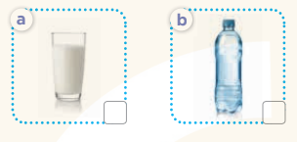    - T ask Ss to guess the answers.  + T writes Ss’guessing on the board.  - Listen to the tape:  + Play the recording  + Play the recording again and get Ss to swap books with their partners.  + Play the recording again to check answers together as a class.  + Write the answers on the board for Ss to correct their answers. Then checks Ss’ guessing.  - Play the recording, sentence by sentence, for the class to listen and repeat in chorus.  Key: 1.c 2. d 3. a 4. b  Activity 2. Look, complete and read.  *Aims: Ss will be able to look, complete and read four target sentences with the help of picture cues.  *Procedure:- Have Ss look at the pictures and identify food and drink in the pictures. 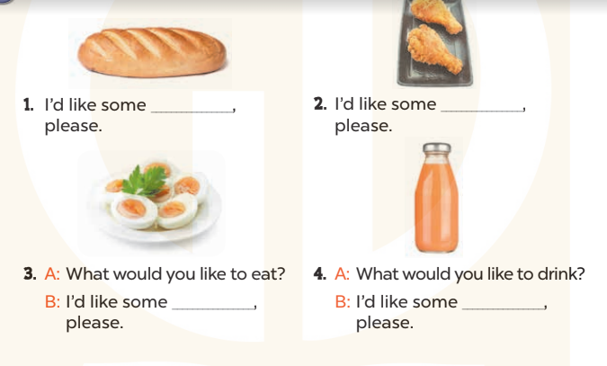  - T models with sentence 1.  + Have Ss look at the sentence.  + Ask them what is missing in the answer (bread)  + Have Ss circle the correct options  + Have Ss read the completed sentence in chorus.  -Have Ss work in pairs and circle the sentences 2, 3 and 4.  - Invite pairs of pupils to stand up and read aloud the sentences.  -T gives feedbacks.  Key: 1. b 2. b 3. a 4. b  Activity 3. Let’s play.  *Aims: Ss will be able to revise target words about food and drinks by playing the game Board race.  *Procedure:  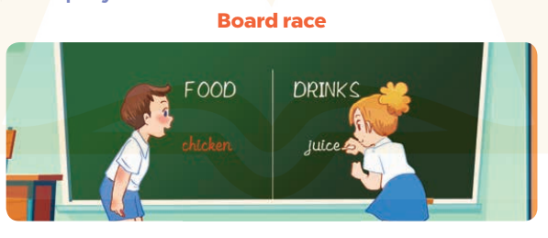  - Tell Ss that they are going to play the game Board race. Write Food and Drinks on opposite sides of the board.  - Have two teams play the game. When you say “Go”, the teams have to race to write the name of a food or drinks. Each pupil writes one word at a time, before passing the marker /chalk to the next pupil and going to the back of the line.  - Explain that a pupil who makes spelling mistakes or writes a word of food or drink under the wrong category will be out of the game.  - At the end of the game, announce the winner for the team that has written more correct words.  *Consolidation  *Aims: Ss will be able consolidate and wrap up the content of the lesson.  *Procedure:  - T asks ss to answer the following questions:  + What have you learnt from the lesson today?  +What are the core values of the lesson? (if the teacher can take from the lesson).  - T praises some Ss who are hardworking / active/ good…. as well as encourage others to try more.  3. Homework. (3’)  - Prepare the new lesson: Unit 15, Lesson 3 (1,2,3). | - Sing and dance the song in chorus.  - Ss open their books  -Look at the pictures and say:  + Picture a: a glass of milk  + Picture b: a bottle of water  + Picture c: some beans  + Picture d: some meat  -Ss guess the answers  - Ss listen to the tape and write number  - Ss listen again, write number and swap books with their partners.  - Ss check their answers and guessing  -Ss listen and repeat.  -Ss look at the pictures and say  -Ss listen and answer  -Ss read and complete  -Ss work in pairs  -Ss read  - Ss listen  -Ss play the game  - Ss play the game  -Ss listen and answer  -Ss listen and take note
D. ADJUSTMENTS (if necessary):
………………………………………………………………………………………….…..……………………………………………………………………………...………………………………………….…..………………………………………
---------------------------------------------------------------
Grade 4: Lớp 4A: Sáng thứ Ba, Ngày 11 tháng 3 năm 2025
Lớp 4B: Chiều thứ Hai, Ngày 10 tháng 3 năm 2025
Lớp 4C: Sáng thứ tư , Ngày 12 tháng 3 năm 2025
ENGLISH
Unit 15: My family’s weekend - Lesson 1 (1, 2, 3)
A. OBJECTIVES:
By the end of the lesson, Ss will be able to:
1. Knowledge:
- use the words and phrases cinema, shopping centre, sports centre, swimming pool in relation to the topic “My family’s weekends”
– use Where does he / she go on Saturdays? – He / She goes to the ………to ask and answer questions about where someone goes
- Vocabulary: cinema, shopping centre, sports centre, swimming pool
- Model sentences:
A: Where does he / she go on Saturdays?
B: He/ She goes to the gym.
- Skills: speaking and listening
2. Competences:
- Co-operation: ready to help friends in pair work/ group work.
- Sociability: Talk to each other, say good words to others.
3. Attitude/ Qualities:
- Kindness: Help partners to complete learning tasks.
- Honesty: tell the truth about feelings and emotions
B. TEACHING AIDS:
- Teacher: Teacher’s guide Pages 209, 210; audio Tracks 41, 42, website hoclieu.vn, posters, laptop, pictures, textbook, lesson plan, TV or projector.
- Students: Pupil’s book Page 30, notebooks, workbooks, school things.
C. PROCEDURES:
Teacher’s activities | Students’ activities
1.Warm- up: (3’)  Sing: weekend song  *Aims: to create a friendly and active atmosphere in the class to beginning the lesson.  *Procedure:  https://www.youtube.com/watch?v=Fz8weSgTBiA  -Show the song on the screen  -Ask Ss sing and dance  - Say “Open your book page 30” and look at “Unit 15, Lesson 1 (1,2,3)”.  2. Presentation(16’)  Activity 1. Vocabulary.  *Aims: Ss will be able to know the vocabulary in the new lesson.  *Procedure:  -T elicits the new words  + sports centre : trung tâm thể thao  (picture)  + shoppping center: trung tâm mua sắm  (situation)  + swimming pool : hồ bơi (picture)  + cinema : rạp chiếu phim (picture)  - T models (3 times).  - T writes the words on the board.  - Checking: Rub out and remember  Activity 2. Look, listen and repeat:  *Aims: Ss will be able to understand and correctly repeat the sentences in two communicative contexts in which the characters ask and answer questions about where a family member goes at the weekend.  *Procedure:  - Have Ss look at Pictures a and b and identify the characters in the pictures.  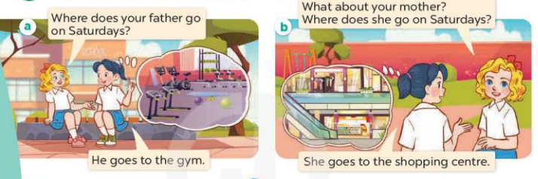  - Play the audio twice (sentence by sentence). Correct their pronunciation where necessary.  - Have Ss to practice the dialogue  - T invites a few pairs to the front of the class to practice.  - T checks pronunciation for ss.  Activity 3 Listen, point and say.  *Aims: Ss will be able to correctly say the words and use Where does he / she go on Saturdays?– He / She goes to the …... to ask and answer questions about where a family member goes at the weekend.  *Procedure:  * Model sentences:  - T asks Ss look at picture a and helps Ss know the structure from the dialogue.  - T introduces new structure for Ss.  - T explains, models and gives meaning.  -Have Ss repeat the model sentences.  A: Where does he / she go on Saturdays?  B: He’ She goes to the gym.  3.Practice: (7’)  *Drill pictures  - Elicit and check comprehension the name of the rooms.  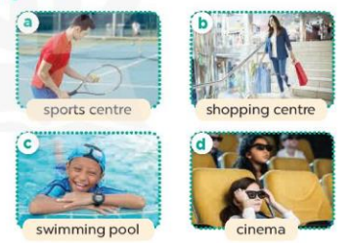  - Run through all the pictures.  - Run through model sentences.  + Run through the questions.  + Run through the answers  - Have Ss to practise:  + T says asks and Ss answer (change role).  + Ss – Ss (change role).  - Ask Ss to work in pairs.  - T controls and corrects.  - Invite a few pairs to come to the front of the classroom, point at the relevant character in each picture, and act out his/her role.  - Encourage Ss to practise speaking English.  - T gives feedbacks.  4.Production: (7’)  Activity 4. Let’s talk.  *Aims: Ss will be able to enhance the correct use of Where does he / she go on Saturdays? – He /She goes to the …….. to ask and answer questions about where a family member goes at the weekend in a freer context.  *Procedure:  - Ask questions to help them identify the context 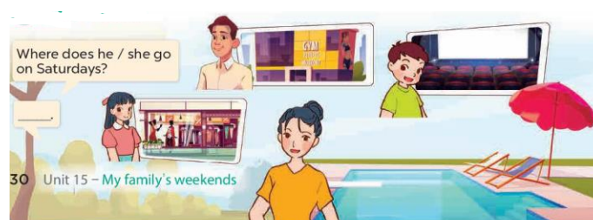  - T fills the gaps and writes the sentences on the board.  - T models  - T asks Ss to work in pairs to ask and answer  - Invite some pupils to the front of the class to present their exchanges.  - Give feedbacks  *Consolidation  *Aims: Ss will be able consolidate and wrap up the content of the lesson.  *Procedure:  - T asks ss to answer the following questions:  + What have you learnt from the lesson today?  - T review the vocabulary and model sentences.  - T praises some Ss who are hardworking / active/ good…. as well as encourage others to try more.  5. Homework. (2’)  - Prepare the new lesson: Unit 15, Lesson 1 (4,5,6). | - Ss listen  - Ss sing and dance  - Ss open their books  -Ss listen and answer  - - Ss listen and repeat  + Choral repetition (3 times).  + Individual repetition (3 ss)  - Ss take note  - Ss look, remember and write  -Look at the pictures and get to know the characters in the pictures.  + Picture a:  Mary: Where does your father go on Saturdays?  Mai: He goes to the gym.  + Picture b  Mary: What about your mother? Where does she go on Saturdays?  Mai: She goes to the shopping centre.  -Ss listen and repeat in chorus (twice)  -Ss work in pairs to practice  -Ss practice the dialogue  -Ss listen  -Ss look at the picture and answer.  -Ss listen  -Ss listen and repeat  -Ss repeat  - Ss look, listen and answer  + Picture a: father at the sports centre  + Picture b. a mother at the shopping centre  + Picture c. a brother at the swimming pool  + Picture d. a sister at the cinema  -Ss practice in chorus  -Ss practice in chorus  -Ss practice in chorus  -Ss work in pairs to practice  -Ss point and say  -Ss listen.  -Ss listen  -Ss look at the picture and answer  + a father at the gym, a brother at the cinema, a sister at the shopping centre, a mother at the swimming pool.  -Ss note  - Ss say the completed sentences.  -Ss work in pairs  -Ss perform in front of the class.  -Ss answer the questions  - Ss listen  -Ss listen and clap their hands  -Ss listen and take note
D. ADJUSTMENTS (if necessary):
………………………………………………………………………………………….…..……………………………………………………………………………...
-------------------------------------------------------------------
Grade 4: Lớp 4A: Sáng thứ Ba, Ngày 11 tháng 3 năm 2025
Lớp 4B: Chiều thứ Hai, Ngày 10 tháng 3 năm 2025
Lớp 4C: Sáng thứ tư , Ngày 12 tháng 3 năm 2025
ENGLISH
Unit 15: My family’s weekend
Lesson 1 (4, 5, 6)
A. OBJECTIVES:
By the end of the lesson, Ss will be able to:
1. Knowledge:
- Use the words and phrases cinema, shopping centre, sports centre, swimming pool in relation to the topic “My family’s weekends”
- Listen to and demonstrate understanding of simple communicative contexts in relation to the topic “My family’s weekends”
- Vocabulary: Review
- Skills: speaking, listening, reading and writing.
2. Competences:
- Co-operation: ready to help friends in pair work/ group work.
- Self-control and independent learning: perform listening tasks.
3. Attitude/ Qualities:
- Kindness: Help partners to complete learning tasks.
- Diligence: complete learning tasks.
B. TEACHING AIDS:
- Teacher: Teacher’s guide Pages 212,213 audio Tracks 43, 44; website hoclieu.vn, posters, laptop, pictures, textbook, lesson plan, TV or projector.
- Students: Pupil’s book Page 31, notebooks, workbooks, school things.
C. PROCEDURES:
Teacher’s activities | Students’ activities
1.Warm- up: (5’)  Game: slap the board  *Aims: to create a friendly and active atmosphere in the class to beginning the lesson.  *Procedure:  - Divides class into 2 teams.  - T calls 1 pupil from each team to come to the board.  - T shows clues (picture and some given letters) on the slides, pupils need to slap the board as quickly as possible to choose the missing letters.  - The first pupils slapping at the correct answer will get 1 point for their team.  - Say “Open your book page 31” and look at “Unit 15, Lesson 1 (4,5,6)”.  2.Practice: (27’)  Activity 1. Listen and tick:  *Aims: Ss will be able to listen to and understand two communicative contexts about where a family member goes at the weekend and tick the correct pictures.  *Procedure:  - Elicit the name of the food in each picture 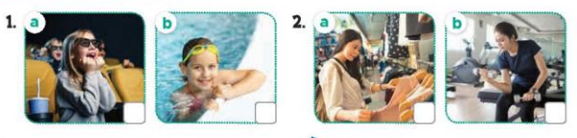  - T ask Ss to guess the answers.  + T writes Ss’guessing on the board.  - Listen to the tape:  + Play the recording  + Play the recording again and get Ss to swap books with their partners.  + Play the recording again to check answers together as a class.  + Write the answers on the board for Ss to correct their answers. Then checks Ss’ guessing.  - Play the recording, sentence by sentence, for the class to listen and repeat in chorus.  Key: 1.b 2.a  Activity 2. Look, complete and read.  *Aims: Ss will be able to complete two gapped sentences and two gapped exchanges with the help of picture cues.  *Procedure:  - Have Ss look at the pictures and identify the places and characters in the pictures. 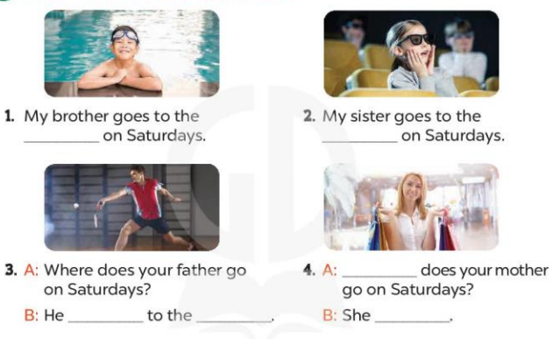  - Have Ss look at the four incomplete exchanges and elicits the missing words in the sentences.  - T models with sentence 1  + Ask Ss what is missing in the sentence.  + Have Ss look at the picture and complete the gap, then read the completed sentence in chorus.  -Have Ss work in groups and complete the sentences 2,3 and 4.  - Ask a few Ss to stand up and read the completed sentences aloud.  -T gives feedbacks.  Key:  - : 1. swimming pool  - 2. cinema  - 3. goes; sports centre  4. Where; goes to the shopping centre  Activity 3. Let’s sing.  *Aims: Ss will be able to sing the song Where do they go on Saturdays? with the correct pronunciation, rhythm and melody.  *Procedure:  - Introduce the title and lyrics of the song: “ Where do they go on Saturdays? ” song.  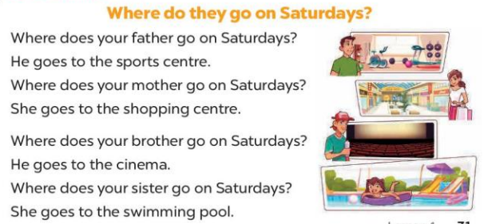  - Play the recording for Ss to listen to the whole song.  + Have them repeat the title and lyrics line by line.  + Tell Ss to point at the relevant character while singing his or her name.  - Play the recording all the way through for Ss to listen to pronunciation and melody of the song.  - Play the recording line by line for Ss to listen, repeat and point at the relevant character.  - Play the recording for Ss to sing and do actions.  - Ask Ss to practice singing and doing actions in pairs or groups.  - Invite groups to the front of the classroom to perform the song  -T gives feedback.  *Consolidation  *Aims: Ss will be able consolidate and wrap up the content of the lesson.  *Procedure:  - T asks ss to answer the following questions:  + What have you learnt from the lesson today?  +What are the core values of the lesson? (if the teacher can take from the lesson).  - T praises some Ss who are hardworking / active/ good…. as well as encourage others to try more.  3. Homework. (3’)  - Learn the sing by heart  - Prepare the new lesson: Unit 15, Lesson 2 (1,2,3). | - Ss listen  -Ss play the game  - Ss open their books  -Look at the pictures and say:  + Picture 1a: a sister at the cinema  + Picture 1b: a sister at the swimming pool  + Picture 2a: a mother at the shopping centre  + Picture 2b: a mother at the gym  -Ss guess the answers  - Ss listen to the tape and tick  - Ss listen again, tick and swap books with their partners.  - Ss check their answers and guessing  -Ss write the answers  -Ss listen and repeat.  -Ss look at the picture and say  -Ss look and answer  -Ss answer: swimming pool  -Ss look, complete and read the completed sentence in chorus.  -Ss complete the sentence  -Ss read aloud  - Ss look and listen.  -Ss listen to the song  - Ss listen and repeat line by line without the action.  -Ss point to the character while singing  -Ss listen to melody of the song  - Ss listen and sing line by line.  - Ss sing and do actions.  - Ss work in groups (two groups) to sing.  -Ss perform in front of the class.  -Ss listen  -Ss answer the questions  -Ss listen and clap their hands  -Ss listen and take note
D. ADJUSTMENTS (if necessary):
………………………………………………………………………………………….…..……………………………………………………………………………...
---------------------------------------------------------------------
Grade 4: Lớp 4A: Sáng thứ Sáu Ngày 14 tháng 3 năm 2025
Lớp 4B: Sáng thứ tư, Ngày 12 tháng 3 năm 2025
Lớp 4C: Sáng thứ năm , Ngày 13 tháng 3 năm 2025
ENGLISH
Unit 15: My family’s weekend - Lesson 2 (1, 2, 3)
A. OBJECTIVES:
By the end of the lesson, Ss will be able to:
1. Knowledge:
- Use the words and phrases cook meals, do yoga, play tennis and watch films in relation to the topic “My family’s weekends”
- use What does he / she do on Sundays? – He / She ……. to ask and answer questions about what someone does;
- Vocabulary: cook meals, do yoga, play tennis and watch films
- Model sentences:
A: What does he / she do on Sundays?
B: He/ She plays tennis.
- Skills: speaking and listening
2. Competences:
- Co-operation: ready to help friends in pair work/ group work.
- Oral Communication: speak about someone, ask and answer the questions
3. Attitude/ Qualities:
- Kindness: Help partners to complete learning tasks.
- Honesty: tell the truth about feelings and emotions
B. TEACHING AIDS:
- Teacher: Teacher’s guide Pages 214, 215; audio Tracks 45, 46, website hoclieu.vn, posters, laptop, pictures, textbook, lesson plan, TV or projector.
- Students: Pupil’s book Page 32, notebooks, workbooks, school things.
C. PROCEDURES:
Teacher’s activities | Students’ activities
1.Warm- up: (3’)  Game: Lucky Wheel game (ppt)  *Aims: to create a friendly and active atmosphere in the class to beginning the lesson.  *Procedure:  - Divide the class into 2 teams.  - Have Ss from each team choose a number, then answer the questions.  - If the Ss answer correctly, T spins the wheel on the slide to get the points for that question.  - After 6 numbers, the team with the most points is the winner.  - Say “Open your book page 32” and look at “Unit 13, Lesson 2 (1,2,3)”.  2. Presentation(16’)  Activity 1. Vocabulary.  *Aims: Ss will be able to know the vocabulary in the new lesson.  *Procedure:  -T elicits the new words  + cook meals : nấu các bữa ăn (realia)  + play tennis : chơi quần vợt (realia)  + watch films : xem phim (realia)  + do yoga : tập yoga (visual)  - T models (3 times).  - T writes the words on the board.  - Checking: Rub out and remember  Activity 2. Look, listen and repeat:  *Aims: Ss will be able to understand and correctly repeat the sentences in two communicative contexts focusing on asking and answering questions about what a family member does at the weekend  *Procedure:  - Have Ss look at Pictures a and b and identify the places, characters and their activities in the pictures.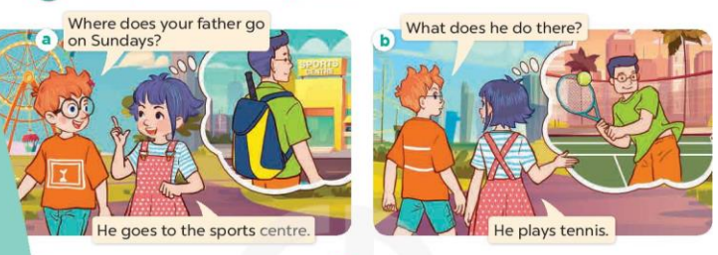  - Play the audio twice (sentence by sentence). Correct their pronunciation where necessary.  - Have Ss to practice the diaguage  - T invites a few pairs to the front of the class to practice.  - T checks pronunciation for ss.  Activity 3. Listen, point and say.  *Aims: Ss will be able to correctly say the phrases and use What does he / she do on Sundays? – He / She …... to ask and answer questions about what a family member does at the weekend.  *Procedure:  * Model sentences:  - T asks Ss look at picture b and helps Ss know the structure from the dialogue.  - T introduces new structure for Ss.  - T explains, models and gives meaning.  - Have Ss repeat the model sentences.  A: What does he / she do on Sundays?  B: He/ She plays tennis  3.Practice: (7’)  *Drill pictures  - Elicit the activities of the people.  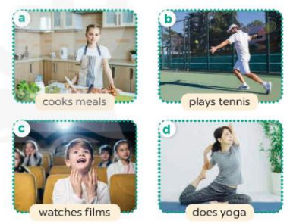  - Run through all the pictures.  - Run through model sentences.  +Run through the question sentences  +Run through the answer sentences  - Have Ss to practise:  + T asks, Ss answer picture a  + Ss ask, T answers picture b  + Group A ask, group B answer picture c  + Group B ask, group A answer picture d  - Ask Ss to work in pairs.  - T controls and corrects.  - Invite a few pairs to come to the front of the classroom, point at the relevant character in each picture, and act out his/her role.  - T gives feedbacks.  4.Production: (7’)  Activity 4. Let’s talk.  *Aims: Ss will be able to enhance the correct use of What does he / she do on Sundays? – He / She …….. to ask and answer questions about what a family member does at the weekend in a freer context.  *Procedure:  - Ask questions to help them identify the context.  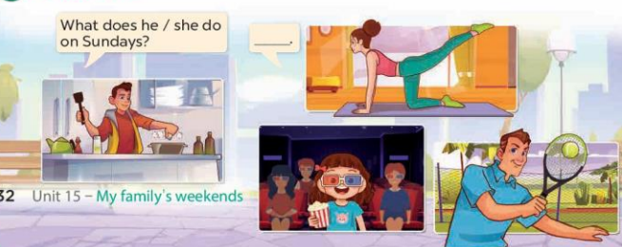  - Put pupils into pairs and encourage them to ask and answer questions about what a family member does at the weekend.  - Invite a few pairs to practise asking and answering questions about what a family member does at the weekend.  - Invite a few pairs to the front of the class to perform their conversations.  *Consolidation  *Aims: Ss will be able consolidate and wrap up the content of the lesson.  *Procedure:  - T asks ss to answer the following questions:  +What are the core values of the lesson? (if the teacher can take from the lesson).  - T review the vocabulary and model sentences.  - T praises some Ss who are hardworking / active/ good…. as well as encourage others to try more.  5. Homework. (2’)  - Learn the vocabulary by heart  - Prepare the new lesson: Unit 15, Lesson 2 (4,5,6). | - Ss listen  - Ss play the game  - Ss open their books  -Ss listen and answer  - - Ss listen and repeat  + Choral repetition (3 times).  + Individual repetition (3 ss)  - Ss take note  - Ss look, remember and write  -Look at the pictures and get to know the characters in the pictures.  + In picture a:  Ben: Where does your father go on Sundays?  Linh: He goes to the sports centre  + In picture b:  Ben: What does he do there?  Linh: He plays tennis  -Ss listen and repeat in chorus (twice)  -Ss work in pairs to practice  -Ss practice the diaguage  -Ss listen  -Ss look at the picture and answer.  -Ss listen  -Ss listen and repeat  -Ss repeat  - Ss look, listen and answer  + Picture a: a sister cooking  + Picture b: a father playing tennis  + Picture c: a brother watching a film  + Picture d: a mother doing yoga  -Ss practice in chorus  -Ss practice in chorus  - Ss practice in chorus  -Ss work in pairs to practice  -Ss listen  -Ss go to the board and role play.  -Ss listen  -Ss look at the picture and answer  + a mother doing yoga, a brother cooking a meal, a sister watching a film, a father playing tennis  -Ss work in pairs to ask and answer  -Ss ask and answer  -Ss perform in front of the class.  -Ss answer the questions  - Ss listen  -Ss listen and clap their hands  -Ss listen and take note
D. ADJUSTMENTS (if necessary):
………………………………………………………………………………………….…..……………………………………………………………………………...
-------------------------------------------------------------------
Grade 4: Lớp 4A: Sáng thứ Sáu Ngày 14 tháng 3 năm 2025
Lớp 4B: Sáng thứ tư, Ngày 12 tháng 3 năm 2025
Lớp 4C: Sáng thứ năm , Ngày 13 tháng 3 năm 2025
ENGLISH
Unit 15: My family’s weekend - Lesson 2 (4, 5, 6)
A. OBJECTIVES:
By the end of the lesson, Ss will be able to:
1. Knowledge:
- use the words and phrases cinema, shopping centre, sports centre, swimming pool in relation to the topic “My family’s weekends”
-listen to and demonstrate understanding of simple communicative contexts in relation to the topic “My family’s weekends”
- Vocabulary: Review
- Skills: speaking, listening, reading and writing.
2. Competences:
- Co-operation: ready to help friends in pair work/ group work.
- Self-control and independent learning: perform listening tasks.
3. Attitude/ Qualities:
- Kindness: Help partners to complete learning tasks.
- Honesty: tell the truth about feelings and emotions.
B. TEACHING AIDS:
- Teacher: Teacher’s guide Pages 216, 217; audio Tracks 47; website hoclieu.vn, posters, laptop, pictures, textbook, lesson plan, TV or projector.
- Students: Pupil’s book Page 33, notebooks, workbooks, school things.
C. PROCEDURES:
Teacher’s activities | Students’ activities
1.Warm- up: (5’)  Game: “Lucky wheel”  *Aims: to create a friendly and active atmosphere in the class to beginning the lesson.  *Procedure:  - Teacher divides the class into 2 teams (boys and girls).  - Each team takes turns to choose the flag and answer the question.  - The team that has more points is the winner.  - Say “Open your book page 33” and look at “Unit 15, Lesson 2 (4,5,6)”.  2.Practice: (27’)  Activity 1. Listen and match:  *Aims: Ss will be able to listen to and understand four communicative contexts aboutwhat a family member does at the weekend and match the correct pictures  *Procedure:  - Ask questions to help Ss identify the people in the pictures and the icons.  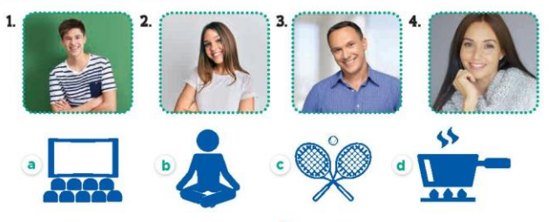  - T ask Ss to guess the answers.  + T writes Ss’guessing on the board.  - Listen to the tape:  + Play the recording  + Play the recording again and get Ss to swap books with their partners.  + Play the recording again to check answers together as a class.  + Write the answers on the board for Ss to correct their answers. Then checks Ss’ guessing.  - Play the recording, sentence by sentence, for the class to listen and repeat in chorus.  Key: 1.c 2. d 3. a 4. b  Activity 2. Look, complete and read.  *Aims: Ss will be able to complete two gapped exchanges with the help of picture cues.  *Procedure:  - Have Ss look at the pictures and identify the people and their activities in the pictures 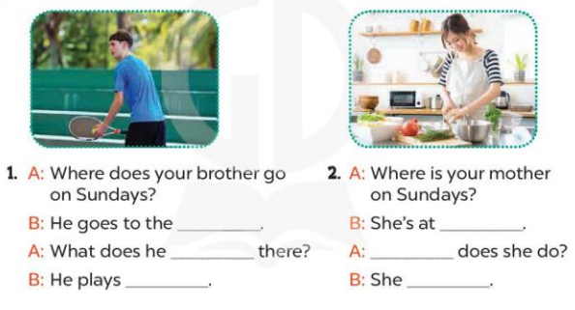  - Have Ss look at the two gapped exchanges. Draw their attention to the missing words.  - Have Ss look at the first gap. Ask them what word is missing (sports centre). Then have them complete the sentence (He goes to the sports centre.).  +Get them to guess the missing words in the following sentences (do; tennis).  - Repeat the same procedure with Exchange 2.  - Get Ss to swap books with a partner and check their answers before checking as a class.  - Ask a few pairs to read the completed exchanges aloud.  -T gives feedbacks.  Key: 1. sports centre; do; tennis  2. home; What; cooks meals  Activity 3. Let’s play.  *Aims: Ss will be able to revise target words about family weekend activities by playing Matching game  *Procedure:  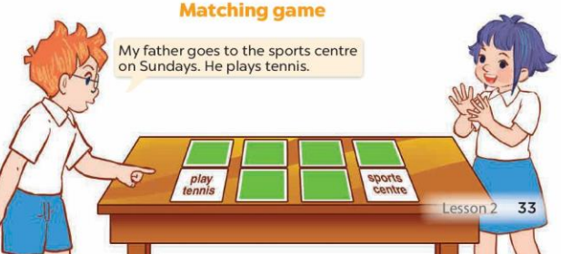  - Tell Ss that they are going to play Matching game in pairs.  - The player turns over a pair of cards.  +If the cards show an activity and a place that matches, the player scores a point, ex: the card play tennis matches the card sports centre.  - The player continues to turn over pairs of cards.  + If the cards do not match, the other player has a turn.  + The player who gets more points is the winner.  - Have Ss work in pairs. Invite one or two pairs to the front of the class to play the game.  - Ask Ss to make sentences with the words on the cards they have, ex: My father goes to the sports centre on Sundays. He plays tennis.  *Consolidation  *Aims: Ss will be able consolidate and wrap up the content of the lesson.  *Procedure:  - T asks ss to answer the following questions:  + What have you learnt from the lesson today?  +What are the core values of the lesson? (if the teacher can take from the lesson).  - T praises some Ss who are hardworking / active/ good…. as well as encourage others to try more.  3. Homework. (3’)  - Prepare the new lesson: Unit 15, Lesson 3 (1,2,3). | - Sing and dance the song in chorus.  - Ss open their books  -Look at the pictures and say:  + Picture a: cinema icon  + Picture b: yoga icon  + Picture c: tennis icon  + Picture d: cooking icon  -Ss guess the answers  - Ss listen to the tape and match  - Ss listen again, match and swap books with their partners.  - Ss check their answers and guessing  -Ss write the answer  -Ss listen and repeat.  -Ss look at the pictures and say  -Ss look at the gap and pay attention  -Ss answer and complete the sentence  -Ss read and complete  -Ss do the task with exchange 2  -Ss swap books and check answer  -Ss read the completed  - Ss listen  - Ss listen  -Ss play the game  - Ss play the game  -Ss listen and answer  -Ss listen and take note
D. ADJUSTMENTS (if necessary):
………………………………………………………………………………………….…..……………………………………………………………………………...
-----------------------------------------------------------------
Grade 5 : Lớp 5B : Sáng thứ ba, Ngày 11 tháng 3 năm 2025
ENGLISH
Unit 15: Our health - Lesson 1 (1, 2, 3)
A. OBJECTIVES:
By the end of the lesson, Ss will be able to:
1. Knowledge:
- Understand and correctly repeat the sentences in two communicative contexts focused on asking and answering questions about someone’s health.
- Correctly use the words and phrases toothache, headache, sore throat and stomach ache and the sentence patterns What’s the matter? - I have _____. to ask and answer questions about someone’s health.
- Correctly use the words for health problems in Act 2 and sentence patterns What’s the matter? and I have _____. to ask and answer questions about someone’s health in a freer context.
- Vocabulary: toothache, headache, sore throat and stomach ache
- Structures: A: What’s the matter?
B: I have a headache.
- Skills: speaking and listening
2. Competences:
- Critical thinking and creativity: learn how to ask and answer questions about someone’s health correctly and fluently.
- Communication and collaboration: work in pairs and groups to complete the learning tasks.
- Self-control and independent learning: perform pronunciation and speaking tasks.
3. Attitude/ Qualities:
- Raise their knowledge of health.
- Show ss how to take care of themselves and prevent of common diseases.
B. TEACHING AIDS:
- Teacher: Teacher’s guide Pages 237, 238, 239, audio Tracks 41, 42, website hoclieu.vn, posters, laptop, pictures, textbook, lesson plan, TV or projector.
- Students: Students’ book Page 30, notebooks, workbooks, school things.
C. PROCEDURES:
Teacher’s activities | Students’ activities
1.Warm- up: (3’)  Sing a song: Head, shoulders, knees and toes  *Aims: to create a friendly and active atmosphere in the class to beginning the lesson.  *Procedure:  - Show the video on the screen.  https://www.youtube.com/watch?v=WX8HmogNyCY  - Ask Ss to listen, sing and dance the song.  - Say “Open your book page 30” and look at “Unit 15, Lesson 1 (1,2,3)”.  2. Presentation (15’)  Activity 1. Vocabulary.  *Aims: Ss will be able to know the vocabulary in the new lesson.  *Procedure:  -T elicits the new words  + toothache: đau răng (mime)  + headache: đau đầu (mime  + sore throat: đau họng (mime)  + stomach ache: đau dạ dày (mime)  + matter: vấn đề (translation)  + feel: cảm thấy (translation)  - T models (3 times).  - T writes the words on the board.  - Checking: Rub out and remember  Activity 2. Look, listen and repeat:  *Aims: Ss will be able to understand and correctly repeat the sentences in two communicative contexts focused on asking and answering questions about someone’s health.  *Procedure:  - Have Ss look at Pictures a and b and identify the characters and other details.  + Who are they?  + Where are they?  + What are they talking about?  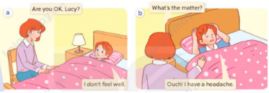  - Play the audio twice (sentence by sentence). Correct their pronunciation where necessary.  - Have Ss to practice the dialogue  - T invites a few pairs to the front of the class to practice.  - T checks pronunciation for ss.  Activity 3 Listen, point and say.  *Aims: Ss will be able to correctly use the words and phrases toothache, headache, sore throat and stomach ache and the sentence patterns What’s the matter? - I have _____. to ask and answer questions about someone’s health.  *Procedure:  * Structures:  - T asks Ss look at picture b in activity 1 and helps Ss know the structure from the dialogue.  - T introduces new structures for Ss.  - T explains, models and gives meaning.  - Have Ss repeat the model sentences.  A: What’s the matter?  B: I have a headache.  3.Practice: (7’)  *Drill pictures  - Have Ss look at the picture and elicit  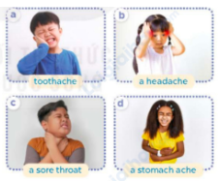  - Have Ss point at pictures, listen and run through all the pictures.  - Have Ss point at the bubbles, listen and run through model sentences.  - Have Ss to practise:  + T asks the first picture, Ss answer  + Ss asks the second picture, T answers  + Group A asks the third picture, group B  answers  + Group B asks the last picture, group A  - Ask Ss to work in pairs to practise asking and answering the question What’s the matter? - I have _____.  - T controls and corrects.  - Invite a few pairs to point at the pictures and say the questions and answers in front of the class.  4. Production: (6’)  Activity 4. Let’s talk.  *Aims: Ss will be able to correctly use the words for health problems in Act 2 and sentence patterns What’s the matter? and I have _____. to ask and answer questions about someone’s health in a freer context.  *Procedure:  - Have ss look at the picture and ask them the health problems that the characters may have.  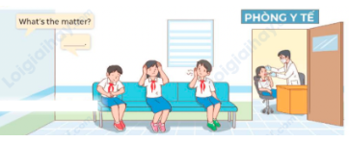  - Elicit the answer in the speech bubble and write it on the board. Get Ss to say the completed sentences.  - Have Ss role-play to practise asking the questions and giving their answers in pairs, using the structures What’s the matter? and I have _____.  - Invite a few pairs to point at the pictures and ask and answer questions.  5. Fun corner and wrap- up (4’)  Game: Board race  - Explain how to play the game. Give an example.  - Divide the class into two groups.  - Stick the flashcards (toothache, headache, sore throat, stomach ache) on the board.  - Say the word twice so that the ss can hear.  - Say “Run” and then the student from each group has to run quickly to find and choose the flashcard the teacher said. Ask the student with the correct flashcard to say the word.  - The group with the most flashcards at the end is the winner. Praise the winner. | - Sing and dance the song together.  - Ss listen and open their books  -Ss listen and answer  - - Ss listen and repeat  + Choral repetition (3 times).  + Individual repetition (3 ss)  - Ss take note  - Ss look, remember and write  -Look at the pictures and say  +In picture a:  Lucy’s mother: Are you OK, Lucy?  Lucy: I don’t feel well.  + In picture b:  Lucy’s mother: What’s the matter?  Lucy: Ouch! I have a headache.  -Ss listen and repeat in chorus (twice)  -Ss work in pairs to practice  -Ss come to the front of the classroom to practice.  -Ss listen  - Ss look at the picture and answer.  -Ss listen  -Ss listen and repeat  -Ss repeat to the structures  - Ss look, listen and repeat  +Picture a: a boy with toothache  + Picture b: a girl with a headache  + Picture c: a boy with a sore throat  + Picture d: a girl with a stomach ache  -Ss point at pictures, listen and repeat  -Ss point at the bubbles, listen and repeat  -Ss practice in chorus  -Ss practice in chorus  -Ss work in pairs to practise asking and answering the question  - Pairs of Ss point at the pictures and say in front of the class  -Ss look at the picture and answer  + A clinic at a primary school where some pupils are waiting to have their health problems checked by the doctor.  - Ss say the completed sentences.  -Ss work in pairs to ask and answer  -Ss perform in front of the class.  - Ss listen  -Ss listen and play the game  -Ss praise the winner.
D. ADJUSTMENTS (if necessary):
………………………………………………………………………………………….…..……………………………………………………………………………...
* Start preparing for the Project: Ask pupils to prepare for the project on page 35 by doing a survey about the health problems that their surrounding people have and giving some advice to them. Ask pupils to do the survey while they learn Unit 15 so that they can present a report during Project time.
------------------------------------------------------------
Grade 5 : Lớp 5B : Sáng thứ ba, Ngày 11 tháng 3 năm 2025
ENGLISH
Unit 15: Our health - Lesson 1 (4, 5, 6)
A. OBJECTIVES:
By the end of the lesson, Ss will be able to:
1. Knowledge:
- Listen to and understand four communicative contexts in which characters ask and answer questions about someone’s health problems, and number the picture in the order.
- Complete the target sentence patterns about health problems with the help of picture cues.
- Sing the song What’s the matter? with the correct pronunciation and melody.
- Vocabulary: Review
- Skills: speaking, listening, reading and writing.
2. Competences:
- Communication and collaboration: work in pairs and groups to complete the learning tasks.
- Self-control and independent learning: perform listening and reading tasks.
3. Attitude/ Qualities:
- Show ss how to take care of themselves and prevent common diseases.
B. TEACHING AIDS:
- Teacher: Teacher’s guide Pages 240, 241, 242; audio Tracks 43, 44; website hoclieu.vn, posters, laptop, pictures, textbook, lesson plan, TV or projector.
- Students: Student’s book Page 31, notebooks, workbooks, school things.
C. PROCEDURES:
Teacher’s activities | Students’ activities
1.Warm- up and review: (5’)  Game: Yes or No  *Aims: to revise the learned structures.  *Procedure:  - Tell the class how to play the game.  - Prepare Yes and No boards for ss.  - Show a picture and a sentence on the board. Have ss look at the picture and the sentence.  - Ask ss to raise the Yes board if the picture and sentence are matched.  - Ask ss to raise the No board if the picture and sentence are not matched. Have ss say the correct sentence aloud.  Ex: (picture of a girl with headhache) - I have a headache.  The class raise the Yes board.  Ex: (picture of a boy with a sore throat) - I have a toothache.  The class raise the No board.  - Give stickers to the fastest student with the correct answer.  - Say “Open your book page 31” and look at “Unit 15, Lesson 1 (4,5,6)”.  2.Practice: (25’)  Activity 1. Listen and number:  *Aims: Ss will be able to listen to and understand four communicative contexts in which characters ask and answer questions about someone’s health problems, and number the picture in the order.  *Procedure:  - Have ss look at the picture and elicit the someone’s health problems in the pictures.  + How many pictures are there?  + What health problems can you see in each picture?    - T ask Ss to guess the answers.  + T writes Ss’guessing on the board.  - Listen to the tape:  + Play the recording  + Play the recording again for pupils to do the task.  + Play the recording a third time for pupils to check their answers.  - Get Ss to swap books with their partner, then check answers as a class.  + Write the answers on the board for Ss to correct their answers. Then checks Ss’ guessing.  - Have ss explain the answers.  Key: a. 3, b. 1, c. 2, d .4  Activity 2. Read and complete.  *Aims: Ss will be able to complete the target sentence patterns about health problems with the help of picture cues.  *Procedure:  - Get Ss to look at the pictures and identify the health problems that the characters have.  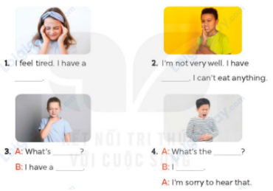  - Have Ss look at the four incomplete exchanges and elicits the options  - T models with sentence 1  + Have Ss circle the correct answer (headache)  + Have Ss look at the picture and identify the needed information (I have a headache).  - Have Ss work in groups and complete the sentences 2, 3 and 4.  - Get Ss to swap books with a partner and check their answers before checking as a class.  -T gives feedbacks.  Key:  1. headache  2. toothache  3. the matter; sore throat  4. What’s ; have a stomach ache Activity 3. Let’s sing  *Aims: Ss will be able to sing the song What’s the matter? with the correct pronunciation and melody.  *Procedure:  - Introduce the title and lyrics of the song: What’s the matter? 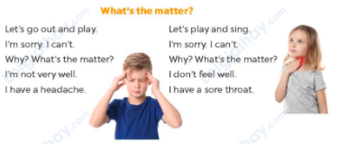  - Play the recording for Ss to listen to the whole song.  + Have them repeat the title and lyrics line by line.  - Play the recording all the way through for Ss to listen to pronunciation and melody of the song.  - Play the recording line by line for Ss to listen, repeat  - Play the recording for Ss to sing and do actions.  - Ask Ss to practice singing and doing actions in pairs or groups.  - Invite groups to the front of the classroom to perform the song  -T gives feedback.  3. Fun corner and wrap- up (5’)  Game: Pass the bag  - Explain that ss are going to look at the picture and say the sentence about health.  - Put some flashcards (toothache, headache, sore throat, stomach ache) in a bag.  - Have ss make two circles.  - Ask ss to pass the bag around the circle while music plays.  - When the music stops, ask the student holding the bag to take out a flashcard in the bag and say a sentence, ex. I have a stomach ache.  - Praise ss to encourage their performance. | - Ss listen to the teacher’s instruction  - Ss play the game  - Continue playing the game.  - Ss open their books  -Look at the pictures and say:  + Picture a: a boy with a sore throat  + Picture b: a boy with a stomach ache  + Picture c: a boy with a headache  + Picture d: a boy with toothache  -Ss guess the answers  - Ss listen to the tape  - Ss listen again and do the task.  - Ss listen and check their answers  - Ss swap books with their partner, then check answers as a class  -Ss check the guessing  -Ss explain the answers  -Ss look at the picture and say  -Ss look at the exchanged and pay attention  -Ss look and say the correct answer  -Ss listen and pay attention  -Ss complete the sentences  -Ss swap books with a partner and check their answers before checking as a class.  -Ss listen  - Ss listen and pay attention  -Ss listen to the song  - Ss listen and repeat line by line without the action.  -Ss listen to melody of the song  - Ss listen and sing line by line.  - Ss sing and do actions.  + Ss work in groups (two groups) to sing.  -Ss perform in front of the class.  -Ss listen  - Ss listen  -Ss listen and play the game  -Ss praise the winner.
D. ADJUSTMENTS (if necessary):
………………………………………………………………………………………….…..……………………………………………………………………………...
----------------------------------------------------------------
Grade 5 : Lớp 5B : Sáng thứ năm, Ngày 13 tháng 3 năm 2025
ENGLISH
Unit 15: Our health - Lesson 2 (1, 2, 3)
A. OBJECTIVES:
By the end of the lesson, Ss will be able to:
1. Knowledge:
- Understand and correctly repeat the sentences in two communicative contexts focused on giving advice for health problems.
- Correctly use the given phrases and sentence patterns You should _____. - Thanks for your advice and response to advice about health problems.
- Correctly use the sentence patterns You should ____. and Thanks for your advice to advise and respond to advice about health problems in a freer context.
- Vocabulary: go to the dentist, have a rest, drink warm water, take some medicine, advice, rinse your mouth, salt water.
- Structures: A: You should go to the dentist.
B: Thanks for your advice.
- Skills: speaking and listening
2. Competences:
- Critical thinking and creativity: learn how to ask and answer questions about health problems correctly and fluently.
- Communication and collaboration: work in pairs and groups to complete the learning tasks.
3. Attitude/ Qualities:
- Raise their knowledge of health.
- Show ss how to give advice about health problems.
B. TEACHING AIDS:
- Teacher: Teacher’s guide Pages 242, 243, 244; audio Tracks 45, 46, website hoclieu.vn, posters, laptop, pictures, textbook, lesson plan, TV or projector.
- Students: Students’ book Page 32, notebooks, workbooks, school things.
C. PROCEDURES:
Teacher’s activities | Students’ activities
1.Warm- up and review: (4’)  Game: Lucky gift boxes  *Aims: to revise the sentence structures about health.  *Procedure:  - Tell ss they are going to look at the picture and ask and answer about health.  - Prepare pictures of common diseases (toothache, headache, sore throat, stomach ache) and gift boxes.  - Have the class play the game in pairs.  - Each pair chooses a gift box they like, then asks and answers questions about health.  - If they ask and answer correctly, they will get gifts from the gift boxes.  - Continue with other pairs.  - Say “Open your book page 32” and look at “Unit 15, Lesson 2 (1,2,3)”.  2. Presentation (16’)  Activity 1. Vocabulary.  *Aims: Ss will be able to know the vocabulary in the new lesson.  *Procedure:  -T elicits the new words  + go to the dentist: đi khám nha sĩ  (picture)  + have a rest: nghỉ ngơi (situation)  + drink warm water: uống nước ấm (example)  + take some medicine: uống thuốc (mime)  + advice: lời khuyên (translation)  + rinse your mouth: súc miệng (mime)  + salt water: nước muối (realia)  - T models (3 times).  - T writes the words on the board.  - Checking: Rub out and remember  Activity 2. Look, listen and repeat:  *Aims: Ss will be able to understand and correctly repeat the sentences in two communicative contexts focused on giving advice for health problems  *Procedure:  - Have Ss look at Pictures a and b and identify the characters in the pictures.  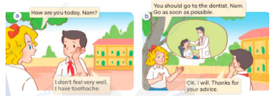  - Play the recording for them to listen.  - Play the recording again (sentence by sentence) for Ss to listen and repeat Correct their pronunciation where necessary.  - Invite a few pairs to the front of the classroom to listen to and repeat the sentences.  - T checks pronunciation for ss.  Activity 3. Listen, point and say.  *Aims: Ss will be able to correctly use the given phrases and sentence patterns You should _____. - Thanks for your advice and respond to advice about health problems.  *Procedure:  * Structures:  - T asks Ss look at picture b and helps Ss know the structure from the dialogue.  - T introduces new structure for Ss.  - T explains, models and gives meaning.  - Have Ss repeat the structures.  A: You should go to the dentist.  B: Thanks for your advice.  3.Practice: (6’)  *Drill pictures  - Have Ss look at the pictures and check comprehension.  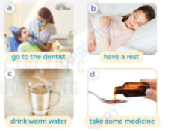  - Have Ss point at pictures, listen and run through all the pictures.  - Have Ss point at the bubbles, listen and run through model sentences.  - Have Ss to practise:  + T asks the first picture, Ss answer  + Ss asks the second picture, T answers  + Group A asks the third picture, group B answers  + Group B asks the last picture, group A  - Ask Ss to work in pairs to practise asking and answering the question You should _____. - Thanks for your advice  - T controls and corrects.  - Invite a few pairs to point at the pictures and say the questions and answers in front of the class.  - T gives feedbacks.  4.Production: (5’)  Activity 4. Let’s talk.  *Aims: Ss will be able to correctly use the sentence patterns You should ____. and Thanks for your advice. to advise and respond to advice about health problems in a freer context.  *Procedure:  - Ask questions to help them identify the context.  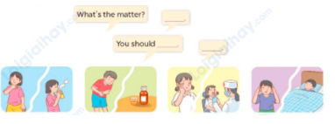  - Elicit the answer in the speech bubble and write it on the board. Get Ss to say the completed sentences.  - Have Ss role-play to practise advising and responding to the advice in pairs, using the picture cue: What’s the matter? - ____ and You should ___.- Thanks for your advice  - Invite a few pairs to point at the pictures and ask and answer questions.  - Invite some pairs of ss to ask and answer questions about health problems  5. Fun corner and wrap- up (4’)  Game: Questions and answers  - Tell ss how the game is played. Give an example.  - Put ss into pairs.  - Encourage the ss to play rock, paper, scissors. The loser gives advice. The winner replies for the advice.  - Praise ss to encourage their performance. | - Ss listen to teacher’s instruction  - Ss play the game  Ex:  A: What’s the matter?  B: I have a toothache.  - Ss open their books  -Ss listen and answer  - - Ss listen and repeat  + Choral repetition (3 times).  + Individual repetition (3 ss)  - Ss take note  - Ss look, remember and write  -Look at the pictures and get to know the characters in the pictures.  + In picture a:  Mary: How are you today, Nam?  Nam: I don’t feel very well. I have a toothache.  – In picture b:  Mai: You should go to the dentist, Nam. You should go as soon as possible.  Nam: Okay, I will. Thanks for your advice.  -Ss listen  -Ss listen and repeat in chorus  - Pairs of Ss listen and repeat  -Ss listen  -Ss look at the picture and answer.  -Ss listen  -Ss listen and repeat  -Ss repeat to the structures.  - Ss look, listen and answer  a: a dentist checking her patient’s teeth  b: a girl having a rest  c: a cup of warm water  d: some medicine  -Ss point at pictures, listen and repeat  -Ss point at the bubbles, listen and repeat  -Ss practice in chorus  -Ss practice in chorus  -Ss work in pairs to practise asking and answering the question  - Pairs of Ss point at the pictures and say in front of the class  -Ss look at the picture and answer  + a group of characters with some health problems  - Ss say the completed sentences.  -Ss work in pairs to ask and answer  -Ss perform in front of the class.  - Ss ask and answer  -Ss listen to the teacher  - Ss play the game  Ex:  A: You should drink warm water.  B: Thanks for your advice.
D. ADJUSTMENTS (if necessary):
………………………………………………………………………………………….…..……………………………………………………………………………...
---------------------------------------------------------------
Grade 5 : Lớp 5B : Sáng thứ năm, Ngày 13 tháng 3 năm 2025
ENGLISH
Unit 15: Our health - Lesson 2 (4, 5, 6)
A. OBJECTIVES:
By the end of the lesson, Ss will be able to:
1. Knowledge:
- Listen to and understand the communicative contexts in which characters talk about health problems in the correct pictures.
- Complete the target sentence patterns in two conversations about health problems and advice for them with the help of picture cues.
- Role-play by asking and giving advice about health problems
- Vocabulary: Review
- Skills: speaking, listening, reading and writing.
2. Competences:
- Communication and collaboration: work in pairs and groups to complete the learning tasks.
3. Attitude/ Qualities:
- Show pupils how to give advice about health problems.
B. TEACHING AIDS:
- Teacher: Teacher’s guide Pages 245, 246; audio Tracks 47; website hoclieu.vn, posters, laptop, pictures, textbook, lesson plan, TV or projector.
S- Students: Pupil’s book Page 33, notebooks, workbooks, school things.
C. PROCEDURES:
Teacher’s activities | Students’ activities
1.Warm- up and review: (4’)  Play a game: Quiz Time  *Aims: to revise the sentence structure *Procedure:  - Place some gapped sentences and pictures.  - Have ss play the game individually.  - Show a gapped sentence, a picture and three options A, B or C.  Ex: picture of “headache”/ You should ____. - Thanks for your advice.  A. play football B. take a rest C. watch TV  - Invite a student to give the answer.  - Continue with other sentences.  - Praise ss if they do the game well.  - Say “Open your book page 33” and look at “Unit 15, Lesson 2 (4,5,6)”.  2. Practice: (27’)  Activity 1. Listen and tick:  *Aims: Ss will be able to listen to and understand the communicative contexts in which characters talk about health problems in the correct pictures *Procedure:  - Have ss look at the pictures and ask  + What health problems can you see in each picture?  + What advice can you see in each picture?  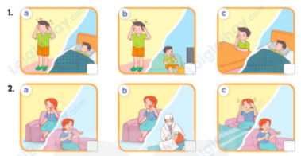  - T ask Ss to guess the answers.  + T writes Ss’guessing on the board.  - Listen to the tape:  + Play the recording  + Play the recording again and get Ss to swap books with their partners.  + Play the recording again to check answers together as a class.  + Write the answers on the board for Ss to correct their answers. Then checks Ss’ guessing.  - Play the recording, sentence by sentence, for the class to listen and repeat in chorus.  Key: 1.a 2. b  Activity 2. Read and complete  *Aims: Ss will be able to complete the target sentence patterns in two conversations about health problems and advice for them with the help of picture cues.  *Procedure:  - Ask Ss to look at the pictures and identify the health problems that the characters have 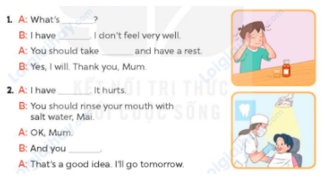  - Have Ss look at the 2 incomplete exchanges and elicits the missing words in the sentences.  - T models with the first sentence  + Ask Ss what is missing in the sentence (the matter).  + Have Ss look at the picture and identify the needed information (What’s the matter?)  - Have Ss work in pairs and complete  - Get Ss to swap books with a partner and check their answers before checking as a class.  Key:  1. the matter; a headache; some medicine  2. toothache; should go to the dentist Activity 3. Let’s play.  *Aims: Ss will be able to role-play by asking and giving advice about health problems  *Procedure:  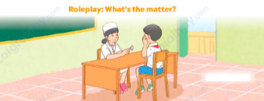  - Tell ss to role- play in pairs as a doctor and a patient within 3 minutes. Encourage them to ask and give advice about health problems.  - When the time is up, ask 3 pairs to perform their roles in front of the class. Ask the class to vote for the best performance.  - Reward the pair with the most votes.  3. Fun corner and wrap- up (4’)  Game: Pass the balls  - Give two different colored balls to two pupils, a red ball (ask the question) and a yellow ball (answer the question).  - Ask ss to listen to music and pass the balls.  - Stop music suddenly.  - Have the student with a red ball make a question. Have the student with a yellow ball answer the question.  - Praise ss if they do the activity well. | - Ss pay attention.  -Ss play the game  - Ss congratulate to the winner  - Ss open their books  - Look at the pictures and say:  1. a. Nam with a headache and Nam having a rest in a bed  1.b. Nam with a headache and Nam watching TV  1.c. Nam with toothache and Nam having a rest in a bed  2. a. Lucy with toothache and Lucy taking some medicine  2.b. Lucy with toothache and Lucy having her teeth checked by the dentist  2.c. Lucy with a headache and Lucy taking some medicine  -Ss guess the answers  - Ss listen to the tape  - Ss listen again, tick and swap books with their partners.  - Ss check their answers and guessing  - Ss answer and check  -Ss listen and repeat.  -Ss look at the picture and say  -Ss follow the teacher.  -Ss read and answer  -Ss work in pairs and fill in the gaps  - Ss swap books and check  -Ss listen and pay attention  - Ss ask and give advice about health problems  Ss perform their roles  -Ss listen to the teacher  -Ss play the game  Ex:  A: You should take a rest.  B: Thanks for your advice.  -Ss congratulate
D. ADJUSTMENTS (if necessary):
………………………………………………………………………………………….…..……………………………………………………………………………...
Duyệt bài, Ngày 7 tháng 3 năm 2025
Phó hiệu trưởng

Nguyễn Thị Hằng

