ĐĂNG KÝ GIẢNG DẠY TUẦN 24 ( Từ ngày 03-07/03/2025)

Thứ  Ngày | Buổi | Lớp | Tiết | Môn | Tên bài
Hai | Chiều | 4B | 1 | English | Unit 14: Daily activities - Lesson 2 (1,2,3)
 |  | 4B | 2 | English | Unit 14: Daily activities - Lesson 2 (4,5,6)
Ba | Sáng | 4A | 1 | English | Unit 14: Daily activities - Lesson 2 (1,2,3)
 |  | 4A | 2 | English | Unit 14: Daily activities - Lesson 2 (4,5,6)
 |  | 5B | 1 | English | Unit 14: Staying healthy  Lesson 2 (1,2,3)
 |  | 5B | 2 | English | Unit 14: Staying healthy  Lesson 2 (4,5,6)
 | Chiều |  | 1
 |  | 3A | 1 | English | Unit 14: My bedroom - Lesson 2 (1,2,3)
 |  | 3A | 2 | English | Unit 14: My bedroom - Lesson 2 (4,5,6)
Tư | Sáng | 4C | 1 | English | Unit 14: Daily activities - Lesson 2 (1,2,3)
 |  | 4C | 2 | English | Unit 14: Daily activities - Lesson 2 (4,5,6)
 |  | 4B | 3 | English | Unit 14: Daily activities - Lesson 3 (1,2,3)
 |  | 4B | 4 | English | Unit 14: Daily activities - Lesson 3 (4,5,6)
Năm | Sáng | 4C | 1 | English | Unit 14: Daily activities - Lesson 3 (1,2,3)
 |  | 4C | 2 | English | Unit 14: Daily activities - Lesson 3 (4,5,6)
 |  | 5B | 3 | English | Unit 14: Staying healthy  Lesson 3 (1,2,3)
 |  | 5B | 4 | English | Unit 14: Staying healthy  Lesson 3 (4,5,6)
 | Chiều |  | 1
 |  | 1C | 2 | English | Unit 12: At the lake - Lesson 1: 1,2
 |  | 1C | 3 | English | Unit 12: At the lake - Lesson 2: 3,4,5
Sáu | Sáng | 3A | 1 | English | Unit 14: My bedroom - Lesson 3 (1,2,3)
 |  | 3A | 2 | English | Unit 14: My bedroom - Lesson 3 (4,5,6)
 |  | 4A | 3 | English | Unit 14: Daily activities - Lesson 3 (1,2,3)
 |  | 4A | 4 | English | Unit 14: Daily activities - Lesson 3 (4,5,6)

Duyệt bài, Ngày 21 tháng 02 năm 2025
Phó hiệu trưởng

Nguyễn Thị Hằng

WEEK 24
Grade 1: Lớp 1C: Chiều thứ năm, Ngày 06 tháng 3 năm 2025
ENGLISH
UNIT 12: AT THE LAKE - Lesson 1
I. OBJECTIVES
By the end of this lesson, pupils will be able to:
1. Knowledge and skills:
- Pronounce the sound of the letter L/l in isolation and in the words lake, leaf, lemons and Lucy correctly.
- Point to the letter L/l, the character (Lucy), the things (lake, leaf, lemons) and say the sound of the letter L/l and the words Lucy, lake, leaf, lemons.
2. Competences
- Communication and collaboration: work in pairs and groups to complete the learning tasks
3. Attributes
- Show active participation in learning activities.
- Show confidence in playing games.
II. MATERIALS
- Student’s book, p. 51
- Audio track 65
- hoclieu.vn
- Flashcards for Unit 12
- Poster for Unit 12
- Teacher’s guide, p. 98, 99, 100
- Computer, projector, …
III. PROCEDURES
1. WARM-UP (5 mins)
a. Objectives:
- To create a friendly and lively atmosphere in the classroom.
- To revise the previous lesson.
b. Content:
- Let’s chant/ Let’s sing
c. Expected outcomes:
- Pupils recall vocabulary from Unit 11 by playing “Kim’s game”
d. Organization:
TEACHER’S ACTIVITIES | PUPILS’ ACTIVITIES | CONTENT
- T. greet the class.  - Access hoclieu.vn. Have one pair of pupils sing the chant on page 49 (Student’s book).  - Then, invite one group of pupils to sing the song on page 50 (Student’s book).  - Have pupils open the books and look at Unit 12, Lesson 1 p. 51 (page 51). | - Pupils greet the teacher.  - Pupils sing the chant.  - Pupils sing the song.  - Pupils open the books and look at Unit 12, Lesson 1 (page 51).
e. Assessment
- Teacher observes and gives feedback.
2. ACTIVITY 1: EXPLORATION (15 mins)
a. Objectives:
- To help pupils pronounce the sound of the letter L/l in isolation and in the words lake, leaf, lemons and Lucy correctly.
b. Content:
- Activity 1. Listen and repeat.
c. Expected outcomes:
- Pupils can listen and repeat the sound of the letter L/l in isolation and in the words Lucy, lake, leaf, lemons correctly.
d. Organization
TEACHER’S ACTIVITIES | PUPILS’ ACTIVITIES | CONTENT
Step 1: Have pupils look at the picture and answer some questions, such as Who are they? Where are they? What are they doing? Can you see the lake? Can you see the leaf? Can you see the lemons? Draw pupil’s attention to the letter L/l, the words next to the character and things, and the colour of the letter L/l. Check comprehension.  Step 2: Have pupils point to the letter L/l, listen to the recording and repeat the sound of the letter L/l. Say Point to the letter L/l, listen and repeat, please! Play the recording several times for pupils to listen and repeat the sound of the letter.  Step 3: Have them point to the lake and/ or the word lake, listen to the recording and repeat the word lake, saying Point to the lake, listen and repeat, please! Then play the recording again, if necessary, for pupils to listen and repeat individually and in chorus. Correct pronunciation, if necessary. If they repeated well, praise them, saying Well done!  Step 4: Repeat the same procedure with Lucy, the leaf and the lemons. Correct pronunciation, if necessary.  Step 5: Have pupils point to the letter L/l, Lucy and the things or the words, listen to the recording again and say the sound of the letter and the words again. Give further support to those pupils who find it difficult to do the task, if necessary.  Step 6: Play the recording again and invite a few pupils to say the letter L/l and the words Lucy, lake, leaf, lemons in front of the class. | - Pupils look at the picture and answer the questions.  - Pupils pay attention to the letter L/l, the words next to the character and things, and the sound of the letter L/l.  - Pupils point to the picture, listen to the recording carefully and repeat.  - Pupils point to the lake and/ or the word lake, listen to the recording and repeat the word lake.  - Pupils listen and repeat individually and in chorus.  - Pupils listen to the recording and repeat.  - Pupils point to the letter L/l, the pictures, listen to the recording again and say the sound of the letter and the words again.  - Pupils listen to the recording again and say the letter L/l and the words Lucy, lake, leaf, lemons in front of the class. | The picture is about a family having a picnic lunch by the lake in the park. Lucy is drinking. The mother is eating. The father is reading. The son is trying to catch a large leaf that is falling from a nearby tree. Some lemons are visible in the hamper. The word Lucy is next to Lucy, the word lake is on the lake, the word leaf is next to the leaf, and the word lemons is next to the lemons. The letter L/l in the words Lucy, lake, leaf, lemons is in red.  The sound of the letter L/l is the focus of Unit 12.
e. Assessment
- Performance products: Pupils’ answers and pronunciation.
- Assessment tools: Observation and help.
3. ACTIVITY 2: KNOWLEDGE CONSTRUCTION (10 mins)
a. Objectives:
- To encourage pupils to point to the letter L/l, the character (Lucy), the things (lake, leaf, lemons) and say the sound of the letter L/l and the words Lucy, lake, leaf, lemons.
b. Content:
Activity 2. Point and say.
c. Expected outcomes:
- Pupils can point to the letter L/l, the character/the things and say the sound of the letter L/l and the words Lucy, lake, leaf, lemons correctly.
d. Organization
TEACHER’S ACTIVITIES | PUPILS’ ACTIVITIES | CONTENT
Step 1: Have pupils look at the picture again and explain the situation in which the language is used, saying Look at the picture and describe it, please! E.g. Lucy is drinking. The mother is eating. The father is reading. Draw their attention to the letter L/l and the words they have learnt in Activity 1.  Step 2: Tell pupils to point to the letter L/l and say its sound, saying Point to the letter L/l and say it, please!  Step 3: Let them point to the lake and say the word lake as a model. Say Point and say, please! Remind them of the sound of the letter l in the word lake. Then ask one pupil to point to the lake and say the word lake in front of the class. Check comprehension.  Step 4: Follow the same procedure with other things. Correct pronunciation, if necessary. Give further support to those pupils who find it difficult to do the task.  Step 5: Get pupils to work in pairs or groups, one pupil points to the character and things in the picture and the other one says the words. Go around to offer help or correct pronunciation, if necessary.  Step 6: Select some better pupils or some pairs to point to the picture and say the sound of the letter and the words in front of the class. Correct pronunciation, if necessary. | - Pupils look at the pictures and explain the situation.  - Pupils describe the picture.  - Pupils point and say the letter L/l and say its sound.  - Pupils point and say the word in front of the class.  - Pupils point to the letter L/l, the lake, the things, say the sound of the letter and the words aloud.  - Pupils work in pairs or in groups to look at the picture, point to the letter L/l, the lake, the things and say the sound of the letter and the words aloud.  - Pupils point to the picture and say the sound of the letter and the words in front of the class. | The same picture in Activity 1.
e. Assessment
- Performance products: Pupils’ pronunciation.
- Assessment tools: Observation, TPR.
4. FUN CORNER AND WRAP-UP (5 mins)
Option 1: Kim’s game
Step 1: Tell pupils that they are going to look at the flashcards/ objects (the leaf, lemon, bus, truck, car, book, bag, box, ....) for 60 seconds and then write down the names of the objects as quickly and correctly as possible. Explain how the game is played. Check comprehension.
Step 2: Arrange the objects on the desk and cover them with a piece of cloth. Do not let pupils see what is beneath the piece of cloth.
Step 3: Divide the class into groups. Do not allow pupils to write anything down.
Step 4: Show the objects under the piece of cloth for 60 seconds. Then cover them again. In their groups, the pupils try to write down the name of as many objects as they can remember. Step 5: Have the groups swap their answers and count the number of items they have written with correct spelling. Groups get a point for one correct item.
Option 2: Whisper game
- Divide the class into 4 teams.
- Have pupils stand in 4 lines.
- Have the first pupils in the line look at the picture and whisper to the next one until the last pupil in the line. He/she will come to the board, point to the picture and say the word out loud.
- Repeat the game until all pupils come to the board, point and say.
- After the game, have the whole class repeat the words in chorus.
------------------------------------------------
Grade 1: Lớp 1C: Chiều thứ năm, Ngày 06 tháng 3 năm 2025
ENGLISH
UNIT 12: AT THE LAKE - Lesson 2

I. OBJECTIVES
By the end of this lesson, pupils will be able to:
1. Knowledge and skills
- say the sound of the letter L/l and the words Lucy, lake, lemons in a chant.
- listen, recognise the words Lucy, lake, lemons and tick the correct boxes.
- write the letter L/l and complete the words __ucy, __ake, __eaf and __emons.
2. Competences
- Communication and collaboration: work in pairs and groups
3. Attributes
- Show confidence in performing a chant by using appropriate gestures and intonation to recall the words from the learning tasks.
II. MATERIALS
- Student’s book p. 52
- Audio tracks 66, 67
- hoclieu.vn
- Teacher’s guide p. 100, 101, 102
- Computer, projector, …
III. PROCEDURES
1. WARM-UP (5 mins)
a. Objectives:
- To create a friendly and lively atmosphere in the classroom.
b. Content:
- Game: Who’s faster?
c. Expected outcomes:
- Pupils review words from the previous lesson.
d. Organization:
TEACHER’S ACTIVITIES | PUPILS’ ACTIVITIES | CONTENT
Game: Who’s faster?  - Greet the class. Encourage pupils to respond to your greeting.  - Give each group a set of words (from recent lessons).  - Say Find words with letter L  - Encourage pupils to find words having letter L and stick them on the board.  - The fastest is the winner.  - Have pupils say all the correct words found. | - Pupils greet the teacher.  - Pupils find words with the letter L and stick them on the board.  - Pupils say the words aloud. | The flashcards of the words from Units 10-12
e. Assessment:
- Teacher observes and gives feedback.
2. ACTIVITY 1: PRACTICE (10 mins)
a. Objectives:
- To help pupils say the sound of the letter L/l and the words Lucy, lake, lemons in a chant
b. Content:
- Activity 3. Listen and chant.
c. Expected outcomes:
- Pupils can listen and sing the chant with correct pronunciation, natural stress and rhythm.
d. Organization
TEACHER’S ACTIVITIES | PUPILS’ ACTIVITIES | CONTENT
Step 1: Have pupils look at the first verse of the chant, saying Look at the first verse of the chant, please! Explain the meaning of each line. Draw their attention to the letter L/l in the words Lucy, lake and lemons. Check comprehension.  Step 2: Play the recording of the first verse for pupils to listen and to get familiarised with the tune, saying Listen to the first verse, please!  Step 3: Get pupils to point to the first line. Play the recording and ask them to listen and repeat, saying Point to the first line, listen and repeat, please! Show them how to chant and clap their hands or do actions.  Step 4: Get pupils to point to the last two lines. Play the recording, ask pupils to listen and repeat the last two lines. Show them how to chant and clap their hands.  Step 5: Follow the same procedure with the second verse.  Step 6: Play the recording again (more than once, if necessary) for pupils to listen and repeat the chant individually and in chorus. Give further support to those pupils who find it difficult to do the task.  Step 7: Select one or two groups to the front of the class to chant and clap their hands. The rest of the class may clap along to the rhythm. | - Pupils look at the first verse of the chant.  - Pupils listen to the recording of the first verse and repeat.  - Pupils point to the first line, listen and repeat. Pupils chant and clap their hands or do actions.  - Pupils point to the last two lines, listen and repeat. Pupils chant and clap their hands.  - Pupils point to the second verse, listen and repeat. Pupils chant and clap their hands.  - Pupils listen and repeat the chant individually and in chorus.  - Pupils chant in groups and clap hands. | The chant contains two verses. The letter L/l and the words Lucy, lake, lemons are introduced in the first verse. The sentences “Look at Lucy.”, “Look at the lake.”, “Look at the lemons.” are introduced in the second verse. The letter L/l is in red.
e. Assessment:
- Performance products: Pupils’ chant
- Assessment tools: Observation and help
3. ACTIVITY 2: PRACTICE (7 mins)
a. Objectives:
- Tp help pupils listen, recognise the words and tick the correct boxes.
b. Content:
Activity 4. Listen and tick.
c. Expected outcomes:
- Pupils can listen, recognise the words and tick the correct boxes.
d. Organization
TEACHER’S ACTIVITIES | PUPILS’ ACTIVITIES | CONTENT
Step 1: Have pupils look at the pictures and say what they can see, saying Point to the pictures and say, please! Pupils may point to the lemons and say, e.g. lemons. Draw pupils’ attention to the boxes next to the letters a and b. Check comprehension.  Step 2: Select a few pupils to point to the pictures in Question 1 and say the words in front of the class. Say Point to the pictures and say the words, please! E.g. 1a: some lemons, 1b: some apples. Step 3: Play the recording of the first sentence for pupils to listen, saying Now listen to the recording, please! Play the recording of the first sentence again for pupils to listen and tick, saying Listen and tick, please! Ask pupils to say what they have heard and ticked.  Step 4: Follow the same procedure with the pictures in Question 2. Before playing the recording, say Are you ready? OK, now listen to the recording and tick, please! Play the recording (several times if needed) for pupils to listen and tick the correct box.  Step 5: Call a few pupils to the front of the class to point to the pictures and say what they have heard. If they said correct words or sentences, praise them, saying Well done! or Very good! | - Pupils to the lemons and say.  - Pupils point to the pictures in Question 1 and say the words in front of the class.  - Pupils listen to the recording of the first sentence and tick the box.  - Pupils listen to the recording of the second sentence and tick the box.  - Pupils show their answers. | The activity consists of two questions. Question 1 includes two pictures: a. some lemons, b. some apples. Question 2 consists of two pictures: a. a leaf,  b. a lake.  Audio script:  1. Look at the lemons.  2. Look at the lake.  Key:  1. a 2. b.
e. Assessment:
- Performance products: Pupils’ answers.
- Assessment tools: Observation and help.
4. ACTIVITY 3: PRACTICE (10 mins)
a. Objectives:
- To encourage pupils to
b. Content:
Activity 5. Look, trace and write the letter L/l and complete the words __ucy, __ake, __eaf and __emons.
c. Expected outcomes:
- Pupils can trace the letter L/l neatly and complete the words correctly.
d. Organization
TEACHER’S ACTIVITIES | PUPILS’ ACTIVITIES | CONTENT
Step 1: Have pupils look at the letter L (upper case) and l (lower case). Explain how L and l are traced. Ask some pupils to make sure if they recognise the two forms of the letter.  Step 2: Tell pupils to trace the letter L/l, saying Now use your pencil to trace the letter L/l. You can demonstrate by air tracing or tracing the broken lines of the letter L/l on the board. Then let pupils do the tracing. Give further support to those pupils who find it difficult to do the task.  Step 3: Check the results of pupils’ tracing and give feedback. Ask pupils to work in pairs and swap their answers, saying Now work in pairs and check each other’s answer. Give pupils time to work. Go around and offer help, if necessary.  Step 4: Have pupils look at the pictures and the incomplete words __ucy, __ake, __eaf and __emons. Explain how to complete the words. Check comprehension. Draw pupil’s attention to the letter L (upper case) in the word Lucy.  Step 5: Give pupils time to complete the words independently, saying Look at the pictures and complete the words, please! Go around and offer help, if necessary.  Step 6: If there is enough time, invite some pupils to point to the letter L/l and say its sound. Say Point to the letter and say, please! Then let them point to the pictures and say the complete words aloud, saying Point to the pictures and say the words, please! | - Pupils look at the letter L/l.  - Pupils answer the question.  - Pupils trace the letter L/l independently.  - Pupils work in pairs and swap their answers.  - Pupils look at the pictures and know how to complete the words.  - Pupils look at the pictures and complete the words independently.  - Pupils point to the letter L/l and say its sound. | There are two parts in the activity: the upper case and lower case of the letter l, and the incomplete words __ucy, __ake, __eaf and __emons with the pictures of Lucy, the lake, the leaf and the lemons.
e. Assessment:
- Performance products: Pupils’ tracing results.
- Assessment tools: Observation and help.
5. FUN CORNER AND WRAP-UP
Game: Slap the slide
- Show 4 pictures on the screen.
- Say a word and have pupils slap on the word they heard.
- Praise pupils for correct answers.
---------------------------------------------------------
Grade 3: Lớp 3A: Chiều thứ ba ngày 04 tháng 3 năm 2025
ENGLISH
Unit 14: My bedroom - Lesson 2 (1, 2, 3)
A. OBJECTIVES:
By the end of the lesson, Ss will be able to:
1. Knowledge:
-Understand and correctly repeat the sentences in two communicative contexts (pictures) to describe things in the room.
- Correctly say the words and use The …….. is ……. / The …… are …….. to describe things in the room.
- Enhance the correct use of The ……..is ……….. / The ……..are ……….to describe things in the room in a freer context.
- Vocabulary: big, small, old, new
- Model sentences:
The door is big.
The chairs are new.
- Skills: speaking and listening
2. Competences:
- Co-operation: ready to help friends in pair work/ group work.
- Oral Communication: speak about someone, ask and answer the questions
3. Attitude/ Qualities:
- Kindness: Help partners to complete learning tasks.
- Honesty: tell the truth about feelings and emotions
B. TEACHING AIDS:
- Teacher: Teacher’s guide Pages 176, 177; audio Tracks 35,36, website sachmem.vn, posters, laptop, pictures, textbook, lesson plan, TV or projector.
- Students: Pupil’s book Page 26, notebooks, workbooks, school things.
C. PROCEDURES:
Teacher’s activities | Students’ activities
1.Warm- up: (3’)  Game: Who says fast?  *Aims: to create a friendly and active atmosphere in the class to beginning the lesson.  *Procedure:  - T holds a school thing card and a sentence with a missing word.  - Ask Ss to guess the answer as fast as possible.  - Then have Ss do the same with the rest.  - This can be played in groups to make it more interesting.  - Say “Open your book page 26” and look at “Unit 14, Lesson 2 (1,2,3)”.  2. Presentation(16’)  Activity 1. Vocabulary.  *Aims: Ss will be able to know the vocabulary in front of starting the new lesson.  *Procedure:  -T elicits the new words  + big : to, lớn (picture)  + small : nhỏ, bé (picture)  + new : mới (picture)  + old : cũ (picture)  - T models (3 times).  - T writes the words on the board.  - Checking: Rub out and remember  Activity 2. Listen, point and repeat:  *Aims: Ss will be able to understand and correctly repeat the sentences in two communicative contexts (pictures) to describe things in the room.  *Procedure:  - Have Ss look at Pictures a and b and identify the characters in the pictures.  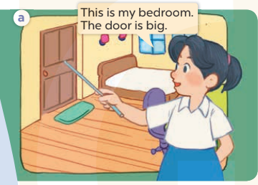  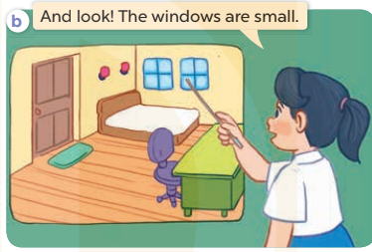  - Play the audio twice (sentence by sentence). Correct their pronunciation where necessary.  - Have Ss to practice the diaguage  - T invites a few pairs to the front of the class to practice.  - T checks pronunciation for ss.  Activity 3. Listen, point and say.  *Aims: Ss will be able to correctly say the words and use The …. is …... / The …….are ……. to describe things in the room.  *Procedure:  * Model sentences:  - T asks Ss look at picture a, b and helps Ss know the structure from the dialogue.  - T introduces new structure for Ss.  - T explains, models and gives meaning.  - Have Ss repeat the model sentences.  The door is big.  The chairs are new.  3.Practice: (7’)  *Drill pictures  - Have Ss look at the pictures and elicit the things in the room.  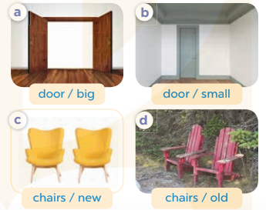  - Run through all the pictures.  - Run through model sentences.  - Have Ss to practise:  - Ask Ss to work in pairs.  - T controls and corrects.  - Invite a few pairs to come to the front of the classroom, point at the relevant character in each picture, and act out his/her role.  - T gives feedbacks.  4.Production: (7’)  Activity 4. Let’s talk.  *Aims: Ss will be able to enhance the correct use of The …… is ……. / The……. are ……..to describe things in the room in a freer context.  *Procedure:  - Have Ss look at the things in a bedroom and say their names. 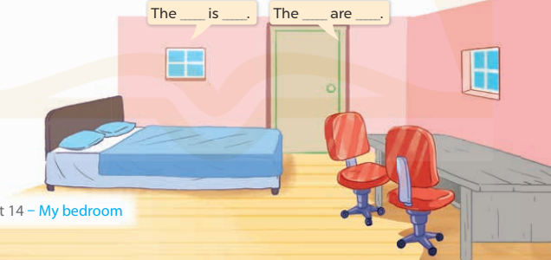  + What can you see in the picture?  +What are they?  - T fills the gaps and writes the sentences on the board.  - T models  - T asks Ss use of The bed is new. The chair are new. to introduce the things in the room.  - Invite some groups to perform.  - Give feedbacks  *Consolidation  *Aims: Ss will be able consolidate and wrap up the content of the lesson.  *Procedure:  - T asks ss to answer the following questions:  + What have you learnt from the lesson today?  +What are the core values of the lesson? (if the teacher can take from the lesson).  - T review the vocabulary and model sentences.  - T praises some Ss who are hardworking / active/ good…. as well as encourage others to try more.  5. Homework. (2’)  - Learn the number by heart  - Prepare the new lesson: Unit 14, Lesson 2 (4,5,6). | - Ss listen  - Ss play the game  - Ss open their books  -Ss listen and answer  - Ss listen and repeat  + Choral repetition (3 times).  + Individual repetition (3 ss)  - Ss take note  - Ss look, remember and write  -Look at the pictures and get to know the characters in the pictures.  + In picture a: Mai says This is my bedroom. The door is big.  – In picture b: Mai says And look! The windows are small.  -Ss listen and repeat in chorus (twice)  -Ss work in pairs to practice  -Ss practice the diaguage  -Ss listen  -Ss look at the picture and answer.  -Ss listen  -Ss listen and repeat  -Ss repeat  - Ss look, listen and answer  + Picture a: a big door  + Picture b: a small door  + Picture c: two new chairs + Picture d: two old chairs  -Ss practice in chorus  - Ss practice in chorus  -Ss work in pairs to practice  -Ss listen  -Ss point and sa  -Ss go to the board and role play.  -Ss listen  -Ss look at the picture and answer  + A bedroom with a bed, a desk, a door, two chairs and two windows  -Ss note  - Ss say the completed sentences.  -Ss work in groups  -Ss perform in front of the class.  -Ss answer the questions  - Ss listen  -Ss listen and clap their hands  -Ss listen and take note
D. ADJUSTMENTS (if necessary):
………………………………………………………………………………………….…..……………………………………………………………………………...
---------------------------------------------------------------
Grade 3: Lớp 3A: Chiều thứ ba ngày 04 tháng 3 năm 2025
ENGLISH
Unit 14: My bedroom - Lesson 2 (4, 5, 6)
A. OBJECTIVES:
By the end of the lesson, Ss will be able to:
1. Knowledge:
- Listen to and understand four communicative contexts in which characters introduce and describe things in a bedroom and number the correct pictures.
- Complete four gapped sentences with the help of picture cues.
- Sing the song My bedroom with the correct pronunciation, rhythm and melody.- Vocabulary: Review
- Skills: speaking, listening, reading and writing.
2. Competences:
- Co-operation: ready to help friends in pair work/ group work.
- Self-control and independent learning: perform listening tasks.
3. Attitude/ Qualities:
- Kindness: Help partners to complete learning tasks.
- Honesty: tell the truth about feelings and emotions.
- Diligence: complete learning tasks.
B. TEACHING AIDS:
- Teacher: Teacher’s guide Pages 178, 179; audio Tracks 37, 38; website sachmem.vn, posters, laptop, pictures, textbook, lesson plan, TV or projector.
- Students: Pupil’s book Page 27, notebooks, workbooks, school things.
C. PROCEDURES:
Teacher’s activities | Students’ activities
1.Warm- up: (5’)  Sing a song: “throw the ball”  *Aims: to create a friendly and active atmosphere in the class to beginning the lesson.  *Procedure:  - Divide the class into 2 teams.  - Stick the pictures of things in the room on the board.  + T says a word, a pupil from each team has to point/throw the ball to the right picture and says the word three times.  + The one says faster will get points.  - Encourage Ss to take part in the game.  - Give points for Ss.  - Say “Open your book page 27” and look at “Unit 14, Lesson 2 (4,5,6)”.  2.Practice: (27’)  Activity 1. Listen and number:  *Aims: Ss will be able to listen to and understand four communicative contexts in which characters introduce and describe things in a bedroom and number the correct pictures  *Procedure:  - Have Ss look at the pictures and ask them some questions such as What is this? and What are these? 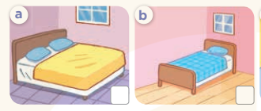  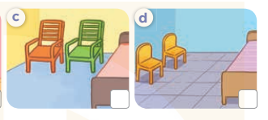  - T ask Ss to guess the answers.  + T writes Ss’guessing on the board.  - Listen to the tape:  + Play the recording  + Play the recording again and get Ss to swap books with their partners.  + Play the recording again to check answers together as a class.  + Write the answers on the board for Ss to correct their answers. Then checks Ss’ guessing.  - Play the recording, sentence by sentence, for the class to listen and repeat in chorus.  Key: 1.b 2. a 3. c 4. d  Activity 2. Look, complete and read.  *Aims: Ss will be able to complete four gapped dialogues with the help of picture cues.  *Procedure:  - Have Ss look at the pictures and ask identify things in the room in the pictures.  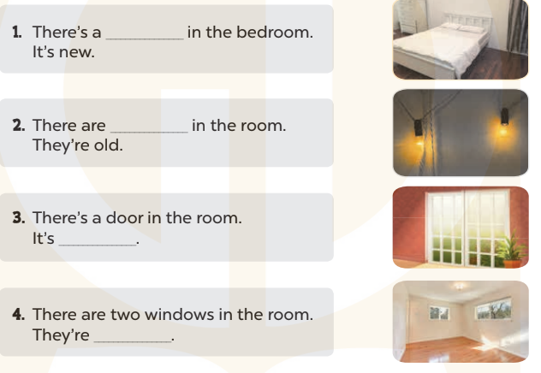  - T models with sentence 1.  + Have Ss look at the sentence.  + Ask them what is missing in the answer ( bed ).  + Have Ss complete the gap.  + Have Ss read the completed sentence in chorus.  -Have Ss work in pairs and complete the sentences 2, 3 and 4.  - Invite pairs of pupils to stand up and read aloud the sentences.  -T gives feedbacks.  Key: 1. bed 2. two lamps 3. big 4. small  Activity 3. Let’s sing.  *Aims: Ss will be able to sing the song My bedroom with the correct pronunciation, rhythm and melody *Procedure:  - Introduce the title and lyrics of the song: “My bedroom? ” song.  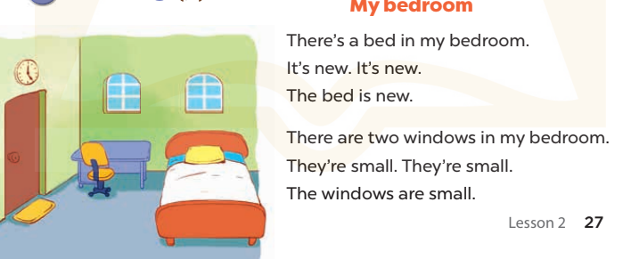  - Play the recording for Ss to listen to the whole song.  + Have them repeat the title and lyrics line by line.  + Tell Ss to point at the relevant character while singing his or her name.  - Play the recording all the way through for Ss to listen to pronunciation and melody of the song.  - Play the recording line by line for Ss to listen, repeat and point at the relevant character.  - Play the recording for Ss to sing and do actions.  - Ask Ss to practice singing and doing actions in pairs or groups.  - Invite groups to the front of the classroom to perform the song  -T gives feedback.  *Consolidation  *Aims: Ss will be able consolidate and wrap up the content of the lesson.  *Procedure:  - T asks ss to answer the following questions:  + What have you learnt from the lesson today?  +What are the core values of the lesson? (if the teacher can take from the lesson).  - T praises some Ss who are hardworking / active/ good…. as well as encourage others to try more.  3. Homework. (3’)  - Prepare the new lesson: Unit 14, Lesson 3 (1,2,3). | - Ss listen and play the game  - Ss open their books  -Look at the pictures and say:  + Picture a: a big bed in a bedroom  + Picture b: a small bed in a bedroom  + Picture c: two big chairs in a bedroom  + Picture d: two small chairs in a bedroom  -Ss guess the answers  - Ss listen to the tape and write number  - Ss listen again, write number and swap books with their partners.  - Ss check their answers and guessing  -Ss listen and repeat.  -Ss look at the pictures and say  -Ss listen and answer  -Ss read and complete  -Ss work in pairs  -Ss read  - Ss look and listen.  -Ss listen to the song  - Ss listen and repeat line by line without the action.  -Ss point to the character while singing  -Ss listen to melody of the song  - Ss listen and sing line by line.  - Ss sing and do actions.  + Ss work in groups (two groups) to sing.  -Ss perform in front of the class.  -Ss listen  -Ss listen and answer  -Ss listen and take note
D. ADJUSTMENTS (if necessary):
………………………………………………………………………………………….…..……………………………………………………………………………...
-----------------------------------------------------------
Grade 3: Lớp 3A: Sáng thứ sáu, ngày 07 tháng 3 năm 2025
ENGLISH
Unit 14: My bedroom - Lesson 3 (1, 2, 3)
A. OBJECTIVES:
By the end of the lesson, Ss will be able to:
1. Knowledge:
- Correctly repeat the sounds of the letters oo in isolation, the words room and door and the sentences There’s the bed in the room and The doors are big. with the correct pronunciation and intonation.
- Identify the target words room and door while listening.
- Say the chant with the correct rhythm and pronunciation.
- Vocabulary: Review
- Skills: speaking, listening, reading and writing.
2. Competences:
- Co-operation: ready to help friends in pair work/ group work.
- Self-control and independent learning: perform listening tasks.
3. Attitude/ Qualities:
- Kindness: Help partners to complete learning tasks.
- Honesty: tell the truth about feelings and emotions
B. TEACHING AIDS:
- Teacher: Teacher’s guide Pages 179, 180; audio Tracks 39, 40, 41; website sachmem.vn, posters, laptop, pictures, textbook, lesson plan, TV or projector.
- Students: Pupil’s book Page 28, notebooks, workbooks, school things.
C. PROCEDURES:
Teacher’s activities | Students’ activities
1.Warm- up: (5’)  Game: Find and circle the words  *Aims: to create a friendly and active atmosphere in the class to beginning the lesson.  *Procedure:  D B K K E P S C F T  O C T H N E C C A H  O L U A A E H O A I  R O O M F C O S H N  T A W K F I O S E K  R T O O R C L S E B  S R O E R C V T A H  M M T H H R S T A Y  D T S S R S O R S M  A C E B F A Z Y W  - Divide class into 2 groups  - Ask Ss to find and circle the words that they learnt.  - Which groups find the best correct words is winner.  - Give Ss time to play the game.  Rows: room, too  Columns: door, school.  -T checks who’s winner?  - Say “Open your book page 17” and look at “Unit 12, Lesson 3 (1,2,3)”.  2. Presentation(9’)  Activity 1. Listen and repeat:  *Aims: Ss will be able to correctly pronounce the sounds of the letters oo in isolation, in the words room and door, and in the sentences There’s the bed in the room. and The doors are big with correct pronunciation and intonation.  *Procedure:  - T gives instruction to the letters oo in isolation, in the words room and door, and in the sentences There’s the bed in the room. and The doors are big.  - Play the recording for the letter oo.  - Encourage Ss to point at the letter/ word/ sentence while listening.  - Play the recording again and encourage Ss to listen and repeat.  - Do this several times until Ss feel confident.  - T calls some Ss to practice.  - T gives feedbacks.  3.Practice: (19’)  Activity 2. Listen and circle.  *Aims: Ss will be able to identify the target words room and door while listening.  *Procedure:  - Elicit the sentences and explain that they have to listen.  - T ask Ss to guess the answers.  + T writes Ss’guessing on the board.  - Listen to the tape:  + Play the recording  + Play the recording again and get Ss to swap books with their partners.  + Play the recording again to check answers together as a class.  + Write the answers on the board for Ss to correct their answers. Then checks Ss’ guessing.  - Play the recording, sentence by sentence, for the class to listen and repeat in chorus.  - Invite one or two Ss to stand up and read the completed sentences.  Key: 1.b 2.c  Activity 3. Let’s chant  *Aims: Ss will be able to say the chant with the correct rhythm and pronunciation.  *Procedure:  - Introduce the title and lyrics of the chant.  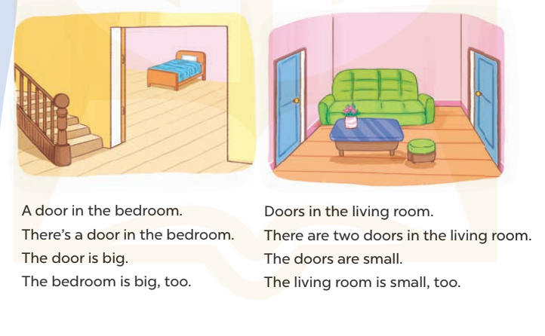  - Play the recording for Ss to listen to the whole chant.  + Have them repeat the title and lyrics line by line.  + Ask Ss to attend to the sounds of the letters oo and the words room and door.  - Play the recording all the way through for Ss to listen to pronunciation and melody.  - Play the recording line by line for Ss to listen and repeat  - Play the recording for Ss to chant and clap along.  - Ask Ss to practice chant and clap along in pairs or groups.  - Invite groups to the front of the classroom to perform the chant  -T gives feedback.  *Consolidation  *Aims: Ss will be able consolidate and wrap up the content of the lesson.  *Procedure:  - T asks ss to answer the following questions:  + What have you learnt from the lesson today?  +What are the core values of the lesson? (if the teacher can take from the lesson).  - T praises some Ss who are hardworking / active/ good…. as well as encourage others to try more.  4. Homework. (2’)  - Practice the chant more.  - Find a photo of a bedroom in a newspaper or a magazine.  - Prepare the new lesson: Unit 14, Lesson 3 (4,5,6). | - Ss listen  -Ss play game  - Ss open their books  - Ss recognize the differences about color of letter  - - Ss listen  - Ss listen and point  - Ss listen again and repeat  -Ss listen again and repeat  -Ss practice  -Ss listen  -Ss listen and say:  + Number 1: The….is there  + Number 2: The…..is big.  -Ss guess the answers  - Ss listen to the tape and circle  - Ss listen again, circle and swap books with their partners.  - Ss check their answers and guessing  -Ss listen and repeat.  -Ss read the sentences  - Ss look and listen.  -Ss listen to the chant  - Ss listen and repeat line by line without clap their hands  -Ss note the sounds, words  -Ss listen to melody of the chant  - Ss listen and chant line by line.  - Ss chant and clap along.  - Ss work in groups (two groups) to chant  -Ss perform in front of the class.  -Ss listen  -Ss listen.  -Ss answer the questions  -Ss listen and clap their hands  -Ss listen and take note
D. ADJUSTMENTS (if necessary):
………………………………………………………………………………………….…..……………………………………………………………………………...
---------------------------------------------------------
Grade 3: Lớp 3A: Sáng thứ sáu, ngày 07 tháng 3 năm 2025
ENGLISH
Unit 14: My bedroom - Lesson 3 (4, 5, 6)
A. OBJECTIVES:
By the end of the lesson, Ss will be able to:
1. Knowledge:
- Read the text and complete the gapped sentences.
- Read the text and complete the gapped sentences.
- Complete a gapped paragraph with the help of the picture cue.
- Vocabulary: Review
- Skills: speaking, listening, reading and writing.
2. Competences:
- Co-operation: ready to help friends in pair work/ group work.
- Self-control and independent learning: perform reading tasks.
3. Attitude/ Qualities:
- Kindness: Help partners to complete learning tasks.
- Honesty: tell the truth about feelings and emotions.
- Diligence: complete learning tasks.
B. TEACHING AIDS:
- Teacher: Teacher’s guide Pages 181, 182, website sachmem.vn, posters, laptop, pictures, textbook, lesson plan, TV or projector.
- Students: Pupil’s book Page 29, notebooks, workbooks, school things.
C. PROCEDURES:
Teacher’s activities | Students’ activities
1.Warm- up: (5’)  Game: Brainstorming  *Aims: to review the vocabulary and structure about greet and respond to greetings.  *Procedure:  - Divide the class into four groups.  - Each group chooses one pupil to be the 'runner'. The runners go to the teacher's desk and read the category.  Ex: Find objects/things in your bedroom/living room.  - The runners then go back to their group and tell their group members the category. Their group brainstorm words from that category and write them down.  - The first group to finish shouts 'stop' and then calls out their answers. If their answers are correct, they score one point for each word in the category.  - The group with the highest score at the end of the game wins.  - Say “Open your book page 29” and look at “Unit 14, Lesson 3 (4, 5, 6)”.  2.Practice: (8’)  Activity 1. Read and complete:  *Aims: Ss will be able to read the text and complete the gapped sentences  *Procedure:  - Tell Ss how to complete the task.  - Point at the table and elicit the type of information they need to find in the texts.  - Ask Ss attend to the blank in number 1 and find the missing word.  - Write the missing word on the board and get the class to read the completeed sentence together.  - Have Ss work in pairs and complete  - Tell Ss to swap books with a partner, then check answers together as a class.  - Write the correct answers on the board for pupils to correct their answers.  - Invite Ss to read the complete text aloud  -T gives feedbacks.  Key: 1. desk 2. Chairs  3. big 4. small  3.Production: (19’)  Activity 2. Let’s write  *Aims: Ss will be able to complete a gapped paragraph with the help of the picture cue.  *Procedure:  - Explain to the class the goal of this activity.  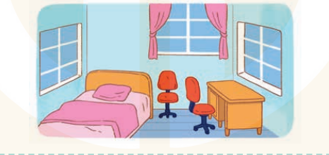  - Ask Ss to read each gapped sentence, look at the picture and fill in the gap.  - Give Ss time to write their answers  - Ask Ss to swap and correct their answers in pairs.  - Check the answers as a class.  Key: first gap: small  second gap: bed / desk  third gap: small / old  fourth gap: chairs  fifth gap: old / new  Activity 3. Project.  *Aims: Ss will be able to find a picture of a bedroom and tell the class about things in the room.  *Procedure:  - Tell Ss to find a photo of a bedroom in a newspaper or a magazine as homework. They should bring their photos to class.  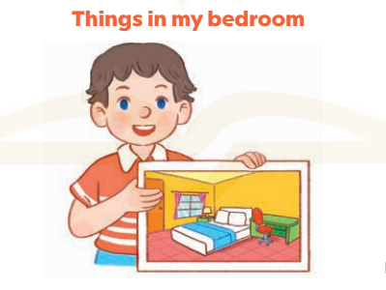  - Have Ss work in groups. Each member introduces the picture of the bedroom using the structures they have learnt in the unit.  - Invite one or two Ss to show their photos and describe them in front of the class.  +Example: Hello, everyone. My name’s Huong. I’m nine years old. This is my bedroom. There is a bed. It is bag. There are two windows. They are new.  - Create a class display of the projects and organise a vote to find the most beautiful ones.  *Consolidation  *Aims: Ss will be able consolidate and wrap up the content of the lesson.  *Procedure:  - T asks ss to answer the following questions:  + What have you learnt from the lesson today?  +What are the core values of the lesson?  - T praises some Ss who are hardworking / active/ good…. as well as encourage others to try more.  4. Homework. (3’)  - Prepare the new lesson: Unit 15: Lesson 1 (1,2,3). | - Ss listen  -Ss play game  - Ss open their books  -Ss listen  - Ss read and answer  -Ss read and complete  -Ss write the first word  -Ss work in pairs  -Ss swap books and check  -Ss check the correct their answers  -Ss read  -Ss listen  -Ss listen  -Ss read and answer  -Ss write  This is my bedroom. It is……..  There is a…………………….  It is……..There are two……….  They are……………………..  -Ss swap books and check their answers  -Ss check  -Ss listen  -Ss work in groups  -Ss show the picture and say.  -Ss perform in front of the class.  -Ss vote the most beautiful ones  -Ss answer the questions  -Ss listen and clap their hands  -Ss listen and take note
D. ADJUSTMENTS (if necessary):
………………………………………………………………………………………….…..……………………………………………………………………………...
---------------------------------------------------------------
Grade 4: Lớp 4A: Sáng thứ Ba, Ngày 04 tháng 3 năm 2025
Lớp 4B: Chiều thứ Hai, Ngày 03 tháng 3 năm 2025
Lớp 4C: Sáng thứ tư , Ngày 05 tháng 3 năm 2025
ENGLISH
Unit 14: Daily activities - Lesson 2 (1, 2, 3)
A. OBJECTIVES:
By the end of the lesson, Ss will be able to:
1. Knowledge:
- use the phrases wash the clothes, clean the ﬂoor, help with the cooking and wash the dishes in relation to the topic “Daily activities”.
- use What do you do in the morning? – I …..to ask and answer questions about what daily activities someone does in the morning;
- Vocabulary: wash the clothes, clean the floor, help with the cooking, wash the dishes
- Model sentences:
A: What do you do in the morning?
B: I clean the floor.
- Skills: speaking and listening
2. Competences:
- Co-operation: ready to help friends in pair work/ group work.
- Oral Communication: speak about someone, ask and answer the questions
3. Attitude/ Qualities:
- Kindness: Help partners to complete learning tasks.
- Honesty: tell the truth about feelings and emotions
B. TEACHING AIDS:
- Teacher: Teacher’s guide Pages 201, 202; audio Tracks 35, 36; website hoclieu.vn, posters, laptop, pictures, textbook, lesson plan, TV or projector.
- Students: Pupil’s book Page 26, notebooks, workbooks, school things.
C. PROCEDURES:
Teacher’s activities | Students’ activities
1.Warm- up: (3’)  Game: Play game (PPT)  *Aims: to create a friendly and active atmosphere in the class to beginning the lesson.  *Procedure:  - Divide the class into 3 teams.  - Have Ss from each team take turns choose a letter and answer a question  - If Ss answer correctly get some points  - Say “Open your book page 26” and look at “Unit 14, Lesson 2 (1,2,3)”.  2. Presentation(16’)  Activity 1. Vocabulary.  *Aims: Ss will be able to know the vocabulary in starting the new lesson.  *Procedure:  -T elicits the new words  + clean the floor : lau sàn nhà (picture)  + wash the clothes: giặt quần áo (picture)  + wash the dishes : rửa chén bát (picture)  + help with the cooking : giúp đỡ việc nấu ăn  (picture)  - T models (3 times).  - T writes the words on the board.  - Checking: Rub out and remember  Activity 2. Look, listen and repeat:  *Aims: Ss will be able to understand and correctly repeat the sentences in two communicative contexts focusing on asking and answering questions about what daily activity someone does.  *Procedure:  - Have Ss look at Pictures a and b and identify what activities Linh does on Sundays.  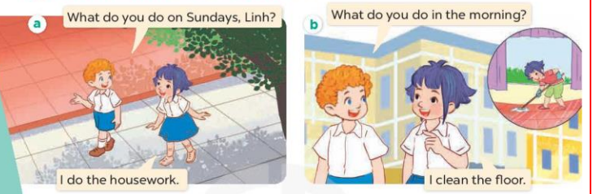  - Play the audio twice (sentence by sentence). Correct their pronunciation where necessary.  - Have Ss to practice the diaguage  - T invites a few pairs to the front of the class to practice.  - T checks pronunciation for ss.  Activity 3. Listen, point and say.  *Aims: Ss will be able to correctly say the phrases and use What do you do in the morning? - I ………. to ask and answer questions about what activity someone does in the morning.  *Procedure:  * Model sentences:  - T asks Ss look at picture b and helps Ss know the structure from the dialogue.  - T introduces new structure for Ss.  - T explains, models and gives meaning.  - Have Ss repeat the model sentences.  A: What do you do in the morning? B: I clean the floor.  3.Practice: (7’)  *Drill pictures  - Have Ss look at the pictures and elicit what activity each child is doing.  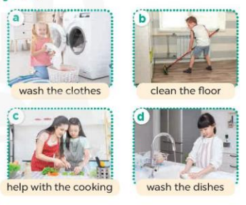  - Run through all the pictures.  - Run through model sentences.  - Have Ss to practise:  - Ask Ss to work in pairs.  - T controls and corrects.  - Invite a few pairs to come to the front of the classroom, point at the relevant character in each picture, and act out his/her role.  - T gives feedbacks.  4.Production: (7’)  Activity 4. Let’s talk.  *Aims: Ss will be able to enhance the correct use of What do you do in the morning / afternoon / evening? – I …….. to ask and answer questions about what activity someone does in the morning / afternoon / evening in a freer context.  *Procedure:  - Explain that each picture shows the members of a family doing the housework together  . 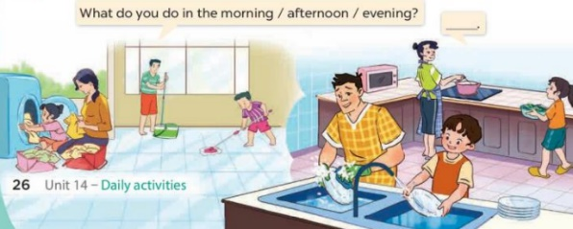  - Ask Ss to repeat the question a few times: What do you do in the morning / afternoon / evening?  - Point at the boy who is cleaning the floor to elicit the answer (I clean the floor.).  - Have Ss repeat it a few times.  - Split the class into two groups to take turns pointing at each activity that a character is doing, asking and answering in chorus.  - Ask S to practise asking and answering What do you do in the morning / afternoon / evening? – I ……..  - Invite some pairs of pupils to the front of the class to take turns asking and answering  *Consolidation  *Aims: Ss will be able consolidate and wrap up the content of the lesson.  *Procedure:  - T asks ss to answer the following questions:  +What are the core values of the lesson? (if the teacher can take from the lesson).  - T review the vocabulary and model sentences.  - T praises some Ss who are hardworking / active/ good…. as well as encourage others to try more.  5. Homework. (2’)  - Prepare the new lesson: Unit 14, Lesson 2 (4,5,6). | - Ss listen  - Ss play the game  - Ss open their books  -Ss listen and answer  - - Ss listen and repeat  + Choral repetition (3 times).  + Individual repetition (3 ss)  - Ss take note  - Ss look, remember and write  -Look at the pictures and get to know the characters in the pictures.  + In picture a:  Bill: What do you do on Sundays, Linh?  Linh: I do the housework.  – In picture b:  Bill:What do you do in the morning? Mai: I clean the floor  -Ss listen and repeat in chorus (twice)  -Ss work in pairs to practice  -Ss practice the diaguage  -Ss listen  -Ss look at the picture and answer.  -Ss listen  -Ss listen and repeat  -Ss repeat  - Ss look, listen and answer  + Picture a: wash the clothes  + Picture b: clean the floor  + Picture c: help with the cooking  + Picture d: wash the dishes  -Ss practice in chorus  - Ss practice in chorus  -Ss work in pairs to practice  -Ss listen  -Ss point and say  -Ss go to the board and role play.  -Ss listen  -Ss look at the picture and answer  + Family members doing the housework together (washing the clothes, cleaning the floor, washing the dishes, helping with the cooking)  -Ss repeat a few times the questions  - Ss answer  -Ss reapeat the answer  -Ss pay attention  -Ss work in groups to ask and answer  -Ss ask and answer in front of the class.  -Ss answer the questions  - Ss listen  -Ss listen and clap their hands  -Ss listen and take note

D. ADJUSTMENTS (if necessary):
………………………………………………………………………………………….…..……………………………………………………………………………...
-------------------------------------------------------------------
Grade 4: Lớp 4A: Sáng thứ Ba, Ngày 04 tháng 3 năm 2025
Lớp 4B: Chiều thứ Hai, Ngày 03 tháng 3 năm 2025
Lớp 4C: Sáng thứ tư , Ngày 05 tháng 3 năm 2025
ENGLISH
Unit 14: Daily activities - Lesson 2 (4, 5, 6)
A. OBJECTIVES:
By the end of the lesson, Ss will be able to:
1. Knowledge:
- Use the phrases wash the clothes, clean the ﬂoor, help with the cooking and wash the dishes in relation to the topic “Daily activities”
- Listen to and demonstrate understanding of simple communicative contexts in relation to the topic “Daily activities”
- Vocabulary: Review
- Skills: speaking, listening, reading and writing.
2. Competences:
- Co-operation: ready to help friends in pair work/ group work.
- Self-control and independent learning: perform listening tasks.
3. Attitude/ Qualities:
- Kindness: Help partners to complete learning tasks.
- Diligence: complete learning tasks.
B. TEACHING AIDS:
- Teacher: Teacher’s guide Pages 203, 204; audio Tracks 37, website hoclieu.vn, posters, laptop, pictures, textbook, lesson plan, TV or projector.
- Students: Pupil’s book Page 27, notebooks, workbooks, school things.
C. PROCEDURES:
Teacher’s activities | Students’ activities
1.Warm- up: (5’)  “Listen and draw” (ppt)  *Aims: to create a friendly and active atmosphere in the class to beginning the lesson.  *Procedure:  - Teacher plays the audios, ss listen and draw pictures in their white board/ paper.  - Say “Open your book page 27” and look at “Unit 14, Lesson 2 (4,5,6)”.  2.Practice: (27’)  Activity 1. Listen and number:  *Aims: Ss will be able to listen to and understand four exchanges about what activities characters do at a specific time of the day and number the correct pictures.  *Procedure:  - Elicit the activity that the girl is doing in each picture.  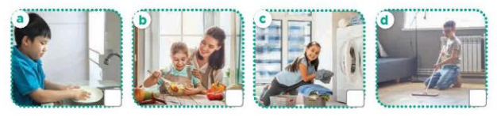  - T ask Ss to guess the answers.  + T writes Ss’guessing on the board.  - Listen to the tape:  + Play the recording  + Play the recording again and get Ss to swap books with their partners.  + Play the recording again to check answers together as a class.  + Write the answers on the board for Ss to correct their answers. Then checks Ss’ guessing.  - Play the recording, sentence by sentence, for the class to listen and repeat in chorus.  Key: 1.c 2. a 3. d 4. b  Activity 2. Look, complete and read.  *Aims: Ss will be able to complete two gapped exchanges with the help of picture cues and sentences  *Procedure:  - Elicit the missing words in the question and answer from the picture cue and sentence.  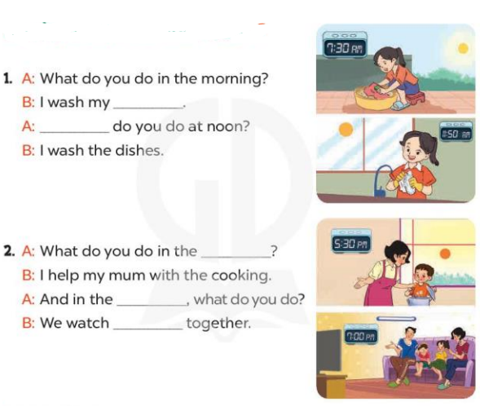  - T models with sentence 1.  + Have Ss look at the sentence.  + Ask them what is missing in the answer ( clothes).  + Have Ss complete the gap.  + Have Ss read the completed sentence in chorus.  -Have Ss work in pairs and complete the sentences 2.  - Invite pairs of pupils to stand up and read aloud the sentences.  -T gives feedbacks.  Key: 1. Clothes; What  2. afternoon; evening; TV  Activity 3. Let’s play- Miming game  *Aims: Ss will be able to review asking and answering questions about what activity someone does at a specific time of the day by playing Miming game.  *Procedure:  - Explain how the game is played.  + Write the question on the board What do you do in the ...?  +Ask one player from each team to come to the front of the class and whisper the answer to the question he / she wants to revise to the two players.  +They take turns miming the sentences they are told for their team to guess.  +The team gets one point if their guess is correct.  +The game continues until the time is up. + The team with the most points at the end of the game wins.  - Write all correct answers on the board, under the question What do you do in the …?  - When the game is over, get pairs of pupils to take turns asking and answering the question What do you do in the morning / afternoon / evening? using the answers on the board.  *Consolidation  *Aims: Ss will be able consolidate and wrap up the content of the lesson.  *Procedure:  - T asks ss to answer the following questions:  + What have you learnt from the lesson today?  +What are the core values of the lesson? (if the teacher can take from the lesson).  - T praises some Ss who are hardworking / active/ good…. as well as encourage others to try more.  3. Homework. (3’)  - Prepare the new lesson: Unit 14, Lesson 3 (1,2,3). | - Ss listen and play the game  - Ss open their books  -Look at the pictures and say:  + Picture a. a boy washing dishes  + Picture b. a girl helping her mum with the cooking  + Picture c. a girl washing clothes  + Picture d. a boy cleaning the floor  -Ss guess the answers  - Ss listen to the tape and write number  - Ss listen again, write number and swap books with their partners.  - Ss check their answers and guessing  - Ss write the correct answer  -Ss listen and repeat.  -Ss look at the pictures and say  -Ss listen and answer  -Ss complete the gap  -Ss read and complete  -Ss work in pairs  -Ss read aloud the sentence  - Ss look and listen.  -Ss listen to the rule of the game  -Ss listen  -Ss play the game  -Ss ask and answer  -Ss answer the questions  -Ss listen and take note
D. ADJUSTMENTS (if necessary):
………………………………………………………………………………………….…..……………………………………………………………………………...
---------------------------------------------------------------------
Grade 4: Lớp 4A: Sáng thứ Sáu Ngày 07 tháng 3 năm 2025
Lớp 4B: Sáng thứ tư, Ngày 05 tháng 3 năm 2025
Lớp 4C: Sáng thứ năm , Ngày 06 tháng 3 năm 2025
ENGLISH
Unit 14: Daily activities - Lesson 3 (1, 2, 3)
A. OBJECTIVES:
By the end of the lesson, Ss will be able to:
1. Knowledge:
- Correctly repeat the sounds of the letters tch and sh in isolation, the words watch and wash and the sentences When do you watch TV? and I wash my clothes in the evening. with the correct pronunciation and intonation.
- Identify the target words watch and wash while listening.
- Say the chant with the correct rhythm and pronunciation.
- Vocabulary: Review
- Skills: speaking, listening, reading and writing.
2. Competences:
- Co-operation: ready to help friends in pair work/ group work.
- Self-control and independent learning: perform listening tasks.
3. Attitude/ Qualities:
- Kindness: Help partners to complete learning tasks.
- Honesty: tell the truth about feelings and emotions
B. TEACHING AIDS:
- Teacher: Teacher’s guide Pages 206, 207; audio Tracks 38, 39, 40; website hoclieu.vn, posters, laptop, pictures, textbook, lesson plan, TV or projector.
- Students: Pupil’s book Page 28, notebooks, workbooks, school things.
C. PROCEDURES:
Teacher’s activities | Students’ activities
1.Warm- up: (5’)  Game: Pass the bomb game (ppt)  *Aims: to create a friendly and active atmosphere in the class to beginning the lesson.  *Procedure:  - Teacher gives students an object to pass around.  - Whoever got the object when the bomb goes off will have to answer the question  - Say “Open your book page 28” and look at “Unit 14, Lesson 3 (1,2,3)”.  2. Presentation(9’)  Activity 1. Listen and repeat:  *Aims: Ss will be able to correctly pronounce the sounds of the letters tch and sh in isolation, in the words watch and wash, and in the sentences When do you watch TV? and I wash my clothes in the evening with correct pronunciation and intonation.  *Procedure:  - T gives instruction to the letters tch and sh in isolation, in the words watch and wash, and in the sentencesWhen do you watch TV? and I wash my clothes in the evening.  - Play the recording for the letter tch, sh  - Encourage Ss to point at the letter/ word/ sentence while listening.  - Play the recording again and encourage Ss to listen and repeat.  - Do this several times until Ss feel confident.  - T calls some Ss to practice.  - T gives feedbacks.  3.Practice: (19’)  Activity 2. Listen and circle.  *Aims: Ss will be able to identify the target words watch and wash while listening.  *Procedure:  - Elicit the sentences and explain that they have to listen.  - T ask Ss to guess the answers.  + T writes Ss’guessing on the board.  - Listen to the tape:  + Play the recording  + Play the recording again and get Ss to swap books with their partners.  + Play the recording again to check answers together as a class.  + Write the answers on the board for Ss to correct their answers. Then checks Ss’ guessing.  - Play the recording, sentence by sentence, for the class to listen and repeat in chorus.  - Invite one or two Ss to stand up and read the completed sentences.  Key: 1.c 2.b  Activity 3. Let’s chant  *Aims: Ss will be able to say the chant with the correct rhythm and pronunciation.  *Procedure:  - Introduce the title and lyrics of the chant.  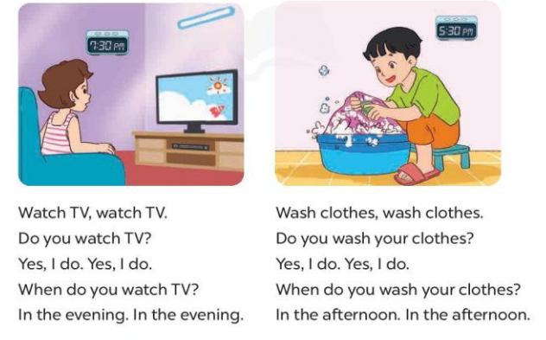  - Play the recording for Ss to listen to the whole chant.  + Have them repeat the title and lyrics line by line.  + Ask Ss to attend to the sounds of the letters tch and sh and the words watch and wash.  - Play the recording all the way through for Ss to listen to pronunciation and melody.  - Play the recording line by line for Ss to listen and repeat  - Play the recording for Ss to chant and clap along.  - Ask Ss to practice chant and clap along in pairs or groups.  - Invite groups to the front of the classroom to perform the chant  -T gives feedback.  *Consolidation  *Aims: Ss will be able consolidate and wrap up the content of the lesson.  *Procedure:  - T asks ss to answer the following questions:  + What have you learnt from the lesson today?  +What are the core values of the lesson? (if the teacher can take from the lesson).  - T praises some Ss who are hardworking / active/ good…. as well as encourage others to try more.  4. Homework. (2’)  - Practice the chant more.  - Prepare the new lesson: Unit 14, Lesson 3 (4,5,6). | - Ss listen  -Ss play game  - Ss open their books  - Ss recognize the differences about color of letter  - - Ss listen  - Ss listen and point  - Ss listen again and repeat  -Ss listen again and repeat  -Ss practice  -Ss listen  -Ss listen and say  -Ss guess the answers  - Ss listen to the tape and circle  - Ss listen again, circle and swap books with their partners.  - Ss check their answers and guessing  -Ss write the answer  -Ss listen and repeat.  -Ss read the sentences  - Ss look and listen.  -Ss listen to the chant  - Ss listen and repeat line by line without clap their hands  -Ss note the sounds, words  -Ss listen to melody of the chant  - Ss listen and chant line by line.  - Ss chant and clap along.  - Ss work in groups (two groups) to chant  -Ss perform in front of the class.  -Ss listen  -Ss listen.  -Ss answer the questions  -Ss listen and clap their hands  -Ss listen and take note
D. ADJUSTMENTS (if necessary):
………………………………………………………………………………………….…..……………………………………………………………………………...
-------------------------------------------------------------------
Grade 4: Lớp 4A: Sáng thứ Sáu Ngày 07 tháng 3 năm 2025
Lớp 4B: Sáng thứ tư, Ngày 05 tháng 3 năm 2025
Lớp 4C: Sáng thứ năm , Ngày 06 tháng 3 năm 2025
ENGLISH
Unit 14: Daily activities - Lesson 3 (4, 5, 6)
A. OBJECTIVES:
By the end of the lesson, Ss will be able to:
1. Knowledge:
- Use the phrases wash the clothes, clean the ﬂoor, help with the cooking and wash the dishes in relation to the topic “Daily activities”
- Read and write about someone’s daily activities.
- Draw pictures or take notes of what daily activities pupils do at home and present the results to the class at Project time.
- Vocabulary: Review
- Skills: speaking, listening, reading and writing.
2. Competences:
- Co-operation: ready to help friends in pair work/ group work.
- Self-control and independent learning: perform reading tasks.
3. Attitude/ Qualities:
- Kindness: Help partners to complete learning tasks.
- Diligence: complete learning tasks.
B. TEACHING AIDS:
- Teacher: Teacher’s guide Pages 207, 208, website hoclieu.vn, posters, laptop, pictures, textbook, lesson plan, TV or projector.
- Students: Pupil’s book Page 29, notebooks, workbooks, school things.
C. PROCEDURES:
Teacher’s activities | Students’ activities
1.Warm- up: (5’)  Game: Brainstorming  *Aims: to review the vocabulary and structure about greet and respond to greetings.  *Procedure:  - Hold a activity card, then reveal it slowly.  - Ask What’s activity?  - Ask the Ss guess the answer as fast as possible.  - Then have Ss do the same with the rest.  - This can be played in groups to make it more interesting.  - Say “Open your book page 29” and look at “Unit 14, Lesson 3 (4, 5, 6)”.  2.Practice: (8’)  Activity 1. Read and match:  *Aims: Ss will be able to read a paragraph and show understanding of it by matching time phrases with the appropriate activities  *Procedure:  - Have Ss read all the phrases under the paragraph. Tell them to read Phrase 1: in the morning.  - Ask Ss scan the paragraph for the appropriate activity related to the phrase.  -Have Ss to do the activity independently.  - Get Ss to swap books with their partners and check their answers before checking as a class.  - Invite some Ss to stand up and read the paragraph aloud.  Key: 1.a 2. a, d 3. b  3.Production: (19’)  Activity 2. Let’s write  *Aims: Ss will be able to complete a paragraph about pupils’ activities on Sundays.  *Procedure:  - Explain to the class the goal of this activity.  - Ask Ss to read each gapped sentence, look at the picture and fill in the gap.  - Give Ss time to write their answers  - Ask Ss to swap and correct their answers in pairs.  - Check the answers as a class.  Example: I do a lot of housework on Sundays. In the morning, I wake up and have breakfast. In the afternoon, I watch TV and play games. In the evening, I have dinner with my family.  Activity 3. Project.  *Aims: Ss will be able to draw pictures or take notes of what daily activities pupils do on Sundays and present the results to the class, using the target language *Procedure:  - Explain that they have to look at the pictures or notes they have prepared at home and present the results to the class.  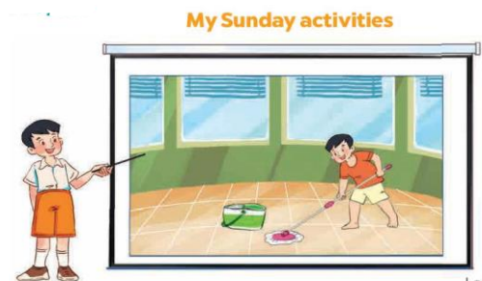  - Have Ss work in groups of five.  + Each pupil looks at their pictures or notes and tells the group about what daily activities he / she does on Sundays.  - Invite a few Ss to look at their pictures or notes and tell the class about them  - Have the rest of class applaud if pupils perform well  +Example: Hello, everyone. My name’s Huong. I’m nine years old. This is my picture. I do a lot of housework on Sundays. In the morning, I wake up and have breakfast. In the afternoon, I watch TV and play games. In the evening, I have dinner with my family.  *Consolidation  *Aims: Ss will be able consolidate and wrap up the content of the lesson.  *Procedure:  - T asks ss to answer the following questions:  + What have you learnt from the lesson today?  +What are the core values of the lesson?  - T praises some Ss who are hardworking / active/ good…. as well as encourage others to try more.  4. Homework. (3’)  - Prepare the new lesson: Unit 15: Lesson 1 (1,2,3). | - Ss listen  -Ss play game  - Ss open their books  - Ss read and answer  -Ss scan the paragraph  -Ss do the task  -Ss swap books and check  -Ss read the paragraph aloud  -Ss listen  -Ss read and answer  -Ss write  -Ss swap books and check their answers  -Ss check the answer  -Ss listen  -Ss work in groups  -Ss show the picture and say.  -Ss perform in front of the class.  -Ss answer the questions  -Ss listen and clap their hands  -Ss listen and take note
D. ADJUSTMENTS (if necessary):
………………………………………………………………………………………….…..……………………………………………………………………………...
-----------------------------------------------------------------
Grade 5 : Lớp 5B : Sáng thứ ba, Ngày 05 tháng 3 năm 2025
ENGLISH
Unit 14: Staying healthy -Lesson 2 (1, 2, 3)
A. OBJECTIVES:
By the end of the lesson, Ss will be able to:
1. Knowledge:
- Understand and correctly repeat the sentences in two communicative contexts in which characters ask and answer questions about the frequency of an activity
- Correctly say the phrases and use How often does he / she ____? -____. to ask and answer questions about the frequency of an activity
- Use How does your ____ stay healthy? – He / She ____. and How often does your ____? – He / She ____. in a freer context;
- Vocabulary: once a week, twice a week, three times a week and every day
- Structures: A: How often does he / she swim?
B: Every day.
- Skills: speaking and listening
2. Competences:
- Critical thinking and creativity: learn how to ask and answer questions about the frequency of an activity correctly and fluently.
- Critical thinking and creativity: learn how to ask and answer questions about personal information correctly and fluently.
- Self-control and independent learning: perform pronunciation and speaking tasks.
3. Attitude/ Qualities:
- Raise their knowledge of using healthy food and drink.
- Show their awareness of doing morning exercise regularly.
B. TEACHING AIDS:
- Teacher: Teacher’s guide Pages 227, 228, 229, 230, audio Tracks 35, 36, website hoclieu.vn, posters, laptop, pictures, textbook, lesson plan, TV or projector.
- Students: Students’ book Page 26, notebooks, workbooks, school things.
C. PROCEDURES:
Teacher’s activities | Students’ activities
1.Warm- up and review: (3’)  Game: Whisper game  *Aims: to create a friendly and active atmosphere in the class to beginning the lesson.  *Procedure:  - Divide the class into two groups. Each group chooses five ss.  - Ask the ss to form two lines.  - Whisper a sentence to the first student from each group. Then ask them to whisper the sentence into the ear of the student standing next to them. They continue whispering the sentence until the end of the line. The last student has to say it out loud.  - The student saying the correct sentence wins a point for their group. The group with more points will win the game.  - Say “Open your book page 26” and look at “Unit 14, Lesson 2 (1,2,3)”.  2. Presentation (15’)  Activity 1. Vocabulary.  *Aims: Ss will be able to know the vocabulary in the new lesson.  *Procedure:  -T elicits the new words  + eat vegetables: ăn rau (picture)  + once a week: một lần một tuần(explain)  + twice a week: hai lần một tuần (explain)  + three times a week: ba lần một tuần (translation)  + every day: mỗi ngày (explain)  - T models (3 times).  - T writes the words on the board.  - Checking: Rub out and remember  Activity 2. Look, listen and repeat:  *Aims: Ss will be able to understand and correctly repeat the sentences in two communicative contexts in which characters ask and answer questions about the frequency of an activity.  *Procedure:  - Have Ss look at Pictures a and b and identify the characters and predict who they are talking about.  + Who are they?  + Where are they?  + What are they talking about?  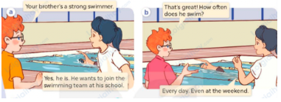  - Play the audio twice (sentence by sentence). Correct their pronunciation where necessary.  - Have Ss to practice the dialogue  - T invites a few pairs to the front of the class to practice.  - T checks pronunciation for ss.  Activity 3 Listen, point and say.  *Aims: Ss will be able to correctly say the phrases and use How often does he / she ____? -____. to ask and answer questions about the frequency of an activity.  *Procedure:  * Structures:  - T asks Ss look at picture b in activity 1 and helps Ss know the structure from the dialogue.  - T introduces new structures for Ss.  - T explains, models and gives meaning.  - Have Ss repeat the model sentences.  A: How often does he / she swim?  B: Every day.  3.Practice: (7’)  *Drill pictures  - Have Ss look at the pictures and say what they can see in the pictures.  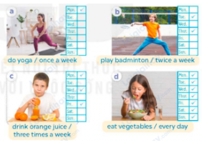  - Have Ss point at pictures, listen and run through all the pictures.  - Have Ss point at the bubbles, listen and run through model sentences.  - Have Ss to practise:  + T asks the first picture, Ss answer  + Ss asks the second picture, T answers  + Group A asks the third picture, group B  answers  + Group B asks the last picture, group A  - Ask Ss to work in pairs to practise asking and answering the question How often does he / she ____? -____.  - T controls and corrects.  - Invite a few pairs to point at the pictures and say the questions and answers in front of the class.  4. Production: (6’)  Activity 4. Let’s talk.  *Aims: Ss will be able to use How does your __ stay healthy? – He / She ___. and How often does your __? – He / She ____. in a freer context.  *Procedure:  - Ask ss to look at the pictures and elicit the activities  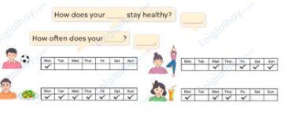  - Point at the ﬁrst building and elicit the question in the ﬁrst speech bubble How does your __ stay healthy? and How often does your __? and the answer in the second speech – He/ she ____ as an example.  - Give Ss time to work in pairs and take turns pointing at each picture to ask and answer using bubble How does your __ stay healthy? – He / She ___. and How often does your __? –____.  - Invite a few pairs to come to the front of the classroom and act out the exchanges.  5. Fun corner and wrap- up (4’)  Game: Slap the board  - Divide the class into two groups. Ask ss to stand in two lines.  - Stick the cards (drink fresh juice, eat healthy food, play badminton, drink orange juice, eat vegetables) on the board.  - Call out a word and have the first student from each group race to slap the correct card on the board and say it correctly.  - The first student to slap the correct card wins a point for their group.  - The group with the most points wins. Praise the winner. | - Ss listen to the teacher  - Ss play the game  Ex.  Round 1: My mother does morning exercise every day.  Round 2: My father plays sports every day. Round 3: My grandmother drinks fresh juice every day.  Round 4: My grandfather eats healthy food every day.  - Ss listen and open their books  -Ss listen and answer  - - Ss listen and repeat  + Choral repetition (3 times).  + Individual repetition (3 ss)  - Ss take note  - Ss look, remember and write  -Look at the pictures and say.  + In picture a:  Ben: Your brother’s a strong swimmer.  Mai: Yes, he is. He wants to join the swimming team at his school.  + In picture b:  Ben: That’s great! How often does he swim?  Mai: Every day. Even at the weekend.  -Ss listen and repeat in chorus (twice)  -Ss work in pairs to practice  -Ss come to the front of the classroom to practice.  -Ss listen  - Ss look at the picture and answer.  -Ss listen  -Ss listen and repeat  -Ss repeat to the structures  - Ss look, listen and repeat  +Picture a: a girl doing yoga  + Picture b: a boy playing badminton  + Picture c: a boy drinking orange juice  + Picture d:a girl eating vegetables  -Ss point at pictures, listen and repeat  -Ss point at the bubbles, listen and repeat  -Ss practice in chorus  -Ss practice in chorus  -Ss work in pairs to practise asking and answering the question  - Pairs of Ss point at the pictures and say in front of the class  -Ss look at the picture and say  + four pictures, each containing a character, an activity  and a timetable  - Ss look at the first building and elicit the missing words in speech bubbles and say the completed sentences.  - Ss role-play to practise asking and answering questions  - Ss practise asking and answering questions in front of the class.  - Ss listen  -Ss listen and play the game  -Ss praise the winner.
D. ADJUSTMENTS (if necessary):
………………………………………………………………………………………….…..……………………………………………………………………………...
------------------------------------------------------------
Grade 5 : Lớp 5B : Sáng thứ ba, Ngày 05 tháng 3 năm 2025
ENGLISH
Unit 14: Staying healthy - Lesson 2 (4, 5, 6)
A. OBJECTIVES:
By the end of the lesson, Ss will be able to:
1. Knowledge:
- Listen to and understand a conversation in which the speakers talk about someone’s healthy activities and circle the correct answers
- Complete two gapped exchanges with the help of picture cues;
- Review the target vocabulary related to the topic “Staying healthy” by playing Frequency Game.
- Vocabulary: Review
- Skills: speaking, listening, reading and writing.
2. Competences:
- Communication and collaboration: work in pairs and groups to complete the learning tasks.
- Self-control and independent learning: perform listening and reading tasks.
3. Attitude/ Qualities:
- Raise their knowledge of using healthy food and drink.
- Show their awareness of doing morning exercise regularly.
B. TEACHING AIDS:
- Teacher: Teacher’s guide Pages 230, 231, 232; audio Tracks 37; website hoclieu.vn, posters, laptop, pictures, textbook, lesson plan, TV or projector.
- Students: Pupil’s book Page 27, notebooks, workbooks, school things.
C. PROCEDURES:
Teacher’s activities | Students’ activities
1.Warm- up and review: (5’)  Game: Pass the teddy bears  *Aims: to revise the learned sentence structures.  *Procedure:  - Give two different coloured teddy bears to two ss, a black teddy bear (ask the question) and a white teddy bear (answer the question).  - Ask ss to listen to music and pass the teddy bears.  - Stop music suddenly. Have the student with a black teddy bear make a question. Have the student with a white teddy bear answer the question.  - Repeat the game several times.  - Say “Open your book page 27” and look at “Unit 14, Lesson 2 (4,5,6)”.  2.Practice: (25’)  Activity 1. Listen and circle:  *Aims: Ss will be able to listen to and understand a conversation in which the speakers talk about someone’s healthy activities and circle the correct answers *Procedure:  - Ask ss to read the questions and the answer options  - T ask Ss to guess the answers.  + T writes Ss’guessing on the board.  - Listen to the tape:  + Play the recording  + Play the recording again for pupils to do the task.  + Play the recording a third time for pupils to check their answers.  - Get Ss to swap books with their partner, then check answers as a class.  + Write the answers on the board for Ss to correct their answers. Then checks Ss’ guessing.  - Play the recording, sentence by sentence, for Ss to listen and repeat individually and in chorus.  Key: 1. b 2. a 3. b 4. a  Activity 2. Read and complete.  *Aims: Ss will be able to complete two gapped exchanges with the help of picture cues.  *Procedure:  - Have ss look at the pictures and elicit  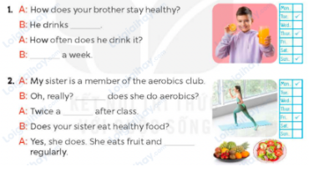  - Have Ss look at the two incomplete exchanges and elicits the missing words in the sentences.  - T models with the first gap  + Have Ss look at the picture and identify the needed information (orange juice).  - Have Ss work in groups and complete  - Get Ss to swap books with a partner and check their answers before checking as a class.  - Invite two pairs of Ss to act out the two completed exchanges in front of the class  Key:  1. orange juice; three times  2 How often; week; vegetables  Activity 3. Let’s play  *Aims: Ss will be able to revise the target vocabulary and structures related to the topic “Staying healthy”  by playing Frequency Game.  *Procedure:  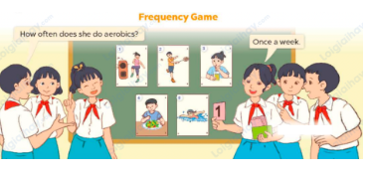  - Invite two teams, A and B, to play the game.  +Team A asks a question using How often _____?  +Team B picks a piece of paper with a number on it, and uses the number to answer the question.  Ex: the number one means once a week or once a month. If the question is asked correctly, Team A gets one point. If the answer is correct, Team B gets one point. If Team A fails to ask the question correctly, Team A does not get a point, and the teacher then asks the question correctly to Team B so that they can still earn a point. Then the teams swap roles – Team B  asks and Team A answers.  - After two minutes, the team with the most points wins.  - The game continues with other teams.  3. Fun corner and wrap- up (5’)  Game: Quiz time  - Tell s they are going to answer different kinds of questions.  - Show the questions for the class in turns.  - Ask ss to answer the questions individually.  - If they answer the questions correctly, they will get gifts.  - Praise ss if they play the game well. | - Ss listen  - Ss play the game  Ex:  A: How often does he/ she swim?  B: Every day.  - Continue playing the game.  - Ss open their books  -Ss read  -Ss guess the answers  - Ss listen to the tape  - Ss listen again and do the task.  - Ss listen and check their answers  - Ss swap books with their partner, then check answers as a class  + Ss check the answer and the guessing  -Ss listen and repeat  -Ss look at the picture and say  -Ss look and follow the teacher demonstrating the exchange 1.  -Ss answer: (He drink orange juice.)  -Ss complete the sentences  -Ss swap books with a partner and check their answers before checking as a class.  -Ss read the completed exchanges aloud.  - Ss follow the teacher’s instructions  - Ss play the game  - Ss continue playing the game.  -Ss praise the winner  -Ss listen  -Ss play a game  -Ss praise the winner
D. ADJUSTMENTS (if necessary):
………………………………………………………………………………………….…..……………………………………………………………………………...
----------------------------------------------------------------
Grade 5 : Lớp 5B : Sáng thứ năm, Ngày 06 tháng 3 năm 2025
ENGLISH
Unit 14: Staying healthy - Lesson 3 (1, 2, 3)
A. OBJECTIVES:
By the end of the lesson, Ss will be able to:
1. Knowledge:
- Stress the correct words in Yes / No questions Does she 'eat 'healthy 'food? and Is your 'brother a 'strong 'swimmer?
- Identify and underline the missing stressed word in four questions, and to say the questions with the correct sentence stress while listening
- Say the chant with the correct pronunciation, word stress and rhythm.
- Vocabulary: Review
- Skills: speaking, listening, reading and writing.
2. Competences:
- Communication and collaboration: work in pairs and groups to complete the learning tasks.
- Self-control and independent learning: perform pronunciation and listening tasks.
3. Attitude/ Qualities:
- Raise their knowledge of using healthy food and drink.
- Show their awareness of doing morning exercise regularly.
B. TEACHING AIDS:
- Teacher: Teacher’s guide Pages 232, 233, 234; audio Tracks 38, 39, 40; website hoclieu.vn, posters, laptop, pictures, textbook, lesson plan, TV or projector.
- Students: Students’ book Page 28, notebooks, workbooks, school things.
C. PROCEDURES:
Teacher’s activities | Students’ activities
1.Warm- up and review: (5’)  Game: Whisper  *Aims: to revise the learnt words and structures.  *Procedure:  - Divide the class into two groups.  - Ask ss in each group to stand closely in a straight line.  - Teacher says a sentence to the first student in each line, ex: My sister eats vegetables every day.  - Then, the first student whispers what she/ he hears to the second person in the line and so on until the last student.  - The last student will say the sentence out loud. If they say the sentence correctly, they will get points for their group.  - The group with more points wins the game.  - Say “Open your book page 28” and look at “Unit 14, Lesson 3 (1,2,3)”.  2. Presentation (9’)  Activity 1. Listen and repeat:  *Aims: Ss will be able to stress the correct words in Yes / No questions Does she 'eat 'healthy 'food? and Is your 'brother a 'strong 'swimmer?  *Procedure:  - T gives instruction the sentences Does she 'eat 'healthy 'food? and Is your 'brother a 'strong 'swimmer?  - Play the recording and encourage Ss to point at the stressed words (eat, healthy food, brother, strong, swimmer) in the sentence while listening.  - Play the recording again and encourage Ss to listen and repeat.  - Have Ss work in pairs or groups to do this several times until Ss feel confident.  - T invites some Ss to practice.  3.Practice: (17’)  Activity 2. Listen and underline one more stressed word. Then repeat  *Aims: Ss will be able to identify and underline the missing stressed word in four questions, and to say the questions with the correct sentence stress while listening.  *Procedure:  - Explain what ss have to do and tell ss that the two underlined words in each question are stressed but that one additional stress is missing.  - Play the recording for ss to listen.  - Play the recording again for ss to listen and underline one more stressed word in each sentence.  - Tell ss to swap books with a partner, then check the answers as a class.  - Write the correct answers on the board.  - Play the recording again for ss to listen and check their answers again.  - Get some ss to say the sentences aloud in front of the class. Praise them if they do a good job.  Key: 1. once 2. week  3. have 4. chips  Activity 3. Let’s chant  *Aims: Ss will be able to say the chant with the correct pronunciation, word stress and rhythm  *Procedure:  - Introduce the title and lyrics of the chant.  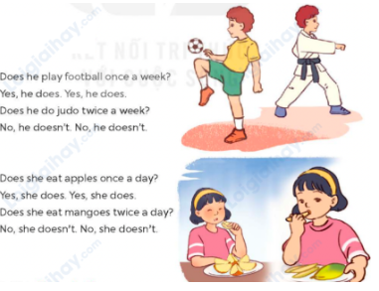  - Play the recording for Ss to listen to the whole chant.  + Have them repeat the title and lyrics line by line.  + Ask Ss to atten the word stress in the sentences  - Play the recording all the way through for Ss to listen to pronunciation and melody.  - Play the recording line by line for Ss to listen and repeat  - Play the recording for Ss to chant and clap along.  - Ask Ss to practice chant and clap along in pairs or groups.  - Invite groups to the front of the classroom to perform the chant  3. Fun corner and wrap- up (4’)  Game: Pass the bag  - Explain that ss are going to look at the picture and say the sentence about staying healthy and the frequency of an activity.  - Put some flash cards (play sports, drink fresh juice, eat healthy food, do yoga, play badminton, drink orange juice) in a bag.  - Have ss make two circles.  - Ask ss to pass the bag around the circle while music plays.  - When the music stops, have the student holding the bag take out a flash card in the bag and ask a question, ex. How does your mother stay healthy? or How often does your mother eat vegetables?  - Teacher invites another ss to answer the question.  - Praise ss to encourage their performance. Give gifts if they ask and answer the question correctly. | - Ss listen  -Ss listen the rules  - Ss play the game  - Ss open their books  - - Ss pay attention  - Ss listen and point  - Ss listen again and repeat  -Ss work in pairs and practice  -Ss say the language in front of the class  - Ss follow the teacher’s explanation.  - Ss listen and underline one more stressed word in each sentence.  - Ss swap books and check their answers as a class.  - Ss write the answer into notebooks  - Ss listen to the recording and check the correct answers again.  - Ss say the sentences aloud  - Ss listen to the chant  - Ss listen and repeat line by line without clap their hands  - Ss note the rhythm and pronunciation.  -Ss listen to melody of the chant  - Ss listen and chant line by line.  - Ss chant and clap along.  - Ss work in groups (two groups) to chant  -Ss perform in front of the class.  -Ss listen  -Ss play the game  -Ss play the game  -Ss play the game  -Ss praise
D. ADJUSTMENTS (if necessary):
………………………………………………………………………………………….…..……………………………………………………………………………...
---------------------------------------------------------------
Grade 5 : Lớp 5B : Sáng thứ năm, Ngày 06 tháng 3 năm 2025
ENGLISH
Unit 14: Staying healthy - Lesson 3 (4, 5, 6)
A. OBJECTIVES:
By the end of the lesson, Ss will be able to:
1. Knowledge:
- Read and show understanding of the text by choosing the correct answer options to complete the sentences
- Write a paragraph of about 40 words about healthy habits
- Make a healthy circle and present their healthy lifestyles to the class.
- Vocabulary: Review
- Skills: speaking, listening, reading and writing.
2. Competences:
- Communication and collaboration: work in pairs and groups to complete the learning tasks.
- Self-control and independent learning: perform reading and writing tasks.
3. Attitude/ Qualities:
- Raise their knowledge of using healthy food and drink.
- Show their awareness of doing morning exercise regularly.
B. TEACHING AIDS:
- Teacher: Teacher’s guide Pages 234, 235, 236; website hoclieu.vn, posters, laptop, pictures, textbook, lesson plan, TV or projector.
- Students: Pupil’s book Page 29, notebooks, workbooks, school things.
C. PROCEDURES:
Teacher’s activities | Students’ activities
1.Warm- up and review: (5’)  Game: Discussion  *Aims: to create a friendly and active atmosphere in the class to beginning the lesson.  *Procedure:  - Divide the class into four groups.  - Have ss from each group discuss what activities they do to stay healthy.  - Give time for ss to do the task.  - Have the presenter of each group come to the front to present what they have discussed.  - Give comments and praise ss.  - Say “Open your book page 29” and look at “Unit 14, Lesson 3 (4,5,6)”.  2.Practice: (8’)  Activity 1. Read and circle:  *Aims: Ss will be able to read and show understanding of the text by choosing the correct answer options to complete the sentences.  *Procedure:  - Draw ss’ attention to the text and read it as a class.  - Model sentence 1. First, have ss read the gapped sentence and find the information about the food Peter eats in the text. (fish and vegetables). Then, have ss find the information  + Ask ss to choose the correct option to complete Sentence 1.  - Ask Ss circle with Sentences 2, 3, 4.  - Tell Ss to swap books with a partner, then check answers as a class.  - Get Ss to look at the board and check their answers again.  + Have ss read the words / sentences in the reading text that help them find the information they need to circle  - Invite some Ss to say four or five sentences about Peter’s healthy lifestyle  Ex: Peter likes fish and vegetables. Peter drinks lots of water and fresh juice. He exercises every morning. He does judo on Tuesdays and Thursdays.  Key:  1. a 2. b 3. c 4. b  3.Production: (18’)  Activity 2. Let’s write  *Aims: Ss will be able to write a paragraph of about 40 words about healthy habits.  *Procedure:  - Tell the class the goal of the activity and explain that they should read and complete the table before writing a paragraph about their healthy habits.  - Have ss read the first row and elicit some activities they usually do to stay healthy and the frequency of these activities. Have them read the healthy habit in the second row and complete the first gap with their own answers.  - Give s time to complete the table independently.  - Have ss use the information in the table to write about their healthy habits.  - Have some ss read their paragraphs aloud. Give feedback where necessary.  Key: Pupil’s answer  Ex I have some healthy habits. I eat vegetables every day. My favourite vegetables are carrots and tomatoes. I like drinking fresh juice. I drink orange juice twice a week. I play basketball three times a week. I want to stay healthy.  Activity 3. Project.  *Aims: Ss will be able to make a healthy habit circle and present their healthy lifestyle to the class  *Procedure:  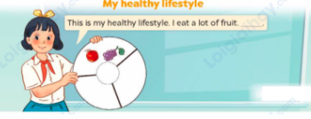  - Tell ss about the goal of the activity and explain that they have prepared a healthy habit circle. In the healthy habit circle, there is information about what they eat, drink and do to stay healthy. Ask them to show their healthy habit circle and share it to their friends.  - Have ss work in groups to practise their presentation.  - Invite a few ss to show their healthy habit circle and give presentations in front of the class. Praise good performances.  Suggested presentation:  This is my healthy habit circle. I eat fruit every day. I like apples, grapes and mangoes. I drink lots of water and fresh juice. I like coconut water and apple juice. I do morning exercise with my parents every day. I play badminton with my sister three times a week. I want to stay healthy.  4. Fun corner and wrap- up (4’)  Game: Lucky balloons  - Tell ss they are going to look at the picture, then ask and answer the question about staying healthy or the frequency of an activity.  - Divide the class into two groups.  - Have two ss from each group choose a balloon in turn.  - Have them look at the pictures and ask and answer the questions suitable with the pictures.  - If they ask and answer correctly, they get corresponding points for their group.  - Continue playing the game with the other ss.  - The group that gets more points wins. Praise the winner. | - Ss listen  - Ss listen to the rules  -Ss play game  - Ss open their books  - S pay attention to the text and read it as a class.  - Ss follow the teacher’s instruction with sentence 1.  +Ss choose the correct option  - Ss do the task  - Ss swap books and check the answers  - Ss look at the board and check their answers again.  + Ss read the words / sentences in the reading text  - Ss say about Peter’s healthy lifestyle  - Ss listen to the teacher’s explanation.  - Ss read and elicit some activities  - Ss complete the table independently.  - Ss use the information in the table to write about their healthy habits.  - Some ss read their paragraphs aloud.  - Ss listen to the teacher’s explanation.  - Ss work in groups to practise their presentation.  - Ss show their healthy habit circle and give presentations in front of the class.  -Ss listen to the teacher  - Ss play the game  Ex:  A: How does he stay healthy?  B: He eats vegetables.  -Ss praise the winner
D. ADJUSTMENTS (if necessary):
………………………………………………………………………………………….…..……………………………………………………………………………...
Duyệt bài, Ngày 28 tháng 02 năm 2025
Phó hiệu trưởng

Nguyễn Thị Hằng

