ĐĂNG KÝ GIẢNG DẠY TUẦN 23 ( Từ ngày 24-28/02/2025)

Thứ  Ngày | Buổi | Lớp | Tiết | Môn | Tên bài
Hai | Chiều | 4B | 1 | English | Unit 13: Appearance - Lesson 3 (1,2,3)
 |  | 4B | 2 | English | Unit 13: Appearance - Lesson 3 (4,5,6)
Ba | Sáng | 4A | 1 | English | Unit 13: Appearance - Lesson 3 (1,2,3)
 |  | 4A | 2 | English | Unit 13: Appearance - Lesson 3 (4,5,6)
 |  | 5B | 1 | English | Unit 13: Our special days  Lesson 3 (1,2,3)
 |  | 5B | 2 | English | Unit 13: Our special days  Lesson 3 (4,5,6)
 | Chiều |  | 1
 |  | 3A | 1 | English | Unit 13: My house - Lesson 3 (1,2,3)
 |  | 3A | 2 | English | Unit 13: My house - Lesson 3 (4,5,6)
Tư | Sáng | 4C | 1 | English | Unit 13: Appearance - Lesson 3 (1,2,3)
 |  | 4C | 2 | English | Unit 13: Appearance - Lesson 3 (4,5,6)
 |  | 4B | 3 | English | Unit 14: Daily activities - Lesson 1 (1,2,3)
 |  | 4B | 4 | English | Unit 14: Daily activities - Lesson 1 (4,5,6)
Năm | Sáng | 4C | 1 | English | Unit 14: Daily activities - Lesson 1 (1,2,3)
 |  | 4C | 2 | English | Unit 14: Daily activities - Lesson 1 (4,5,6)
 |  | 5B | 3 | English | Unit 14: Staying healthy  Lesson 1 (1,2,3)
 |  | 5B | 4 | English | Unit 14: Staying healthy  Lesson 1 (4,5,6)
Sáu | Sáng | 3A | 1 | English | Unit 14: My bedroom - Lesson 1 (1,2,3)
 |  | 3A | 2 | English | Unit 14: My bedroom - Lesson 1 (4,5,6)
 |  | 4A | 3 | English | Unit 14: Daily activities - Lesson 1 (1,2,3)
 |  | 4A | 4 | English | Unit 14: Daily activities - Lesson 1 (4,5,6)
Duyệt bài, Ngày 21 tháng 02 năm 2025
Phó hiệu trưởng

Nguyễn Thị Hằng
WEEK 23
Grade 3: Lớp 3A: Chiều thứ ba ngày 25 tháng 02 năm 2025
ENGLISH
Unit 13: My house - Lesson 3 (1, 2, 3)
A. OBJECTIVES:
By the end of the lesson, Ss will be able to:
1. Knowledge:
- Correctly repeat the sounds of the letters ou and ow in isolation, the words house and brown and the sentences Wow, it’s a big house! and Wow, it’s a brown house! with the correct pronunciation and intonation.
- Identify the target words house and brown while listening.
- Say the chant with the correct rhythm and pronunciation.
- Vocabulary: Review
- Skills: speaking, listening, reading and writing.
2. Competences:
- Co-operation: ready to help friends in pair work/ group work.
- Self-control and independent learning: perform listening tasks.
3. Attitude/ Qualities:
- Kindness: Help partners to complete learning tasks.
- Honesty: tell the truth about feelings and emotions
B. TEACHING AIDS:
- Teacher: Teacher’s guide Pages 169, 170; audio Tracks 29, 30, 31; website sachmem.vn, posters, laptop, pictures, textbook, lesson plan, TV or projector.
- Students: Pupil’s book Page 22, notebooks, workbooks, school things.
C. PROCEDURES:
Teacher’s activities | Students’ activities
1.Warm- up: (5’)  Game: Find and circle the words  *Aims: to create a friendly and active atmosphere in the class to beginning the lesson.  *Procedure:  H B K K E P M C F T  O C T H S N O W F H  U L U A A E U O T I  S E L N F C S S T N  E A W K R I E S E K  R C O O R C I S R B  S R O E M C V T A H  B R O W N R S T A Y  D T S S R S O R S M  A C E B K N W O W  - Divide class into 2 groups  - Ask Ss to find and circle the words that they learnt.  - Which groups find the best correct words is winner.  - Give Ss time to play the game.  Rows: brown, snow, wow  Columns: house, mouse  -T checks who’s winner?  - Say “Open your book page 22” and look at “Unit 13, Lesson 3 (1,2,3)”.  2. Presentation(9’)  Activity 1. Listen and repeat:  *Aims: Ss will be able to correctly pronounce the sounds of the letters ou and ow in isolation, in the words house and brown, and in the sentences Wow, it’s a big house! and Wow, it’s a brown house! with correct pronunciation and intonation.  *Procedure:  - T gives instruction to the ou and ow in isolation, in the words house and brown, and in the sentences Wow, it’s a big house! and Wow, it’s a brown house!  - Play the recording for the letter ou, ow.  - Encourage Ss to point at the letter/ word/ sentence while listening.  - Play the recording again and encourage Ss to listen and repeat.  - Do this several times until Ss feel confident.  - T calls some Ss to practice.  - T gives feedbacks.  3.Practice: (19’)  Activity 2. Listen and circle.  *Aims: Ss will be able to identify the target words house and brown while listening.  *Procedure:  - Elicit the sentences and explain that they have to listen.  - T ask Ss to guess the answers.  + T writes Ss’guessing on the board.  - Listen to the tape:  + Play the recording  + Play the recording again and get Ss to swap books with their partners.  + Play the recording again to check answers together as a class.  + Write the answers on the board for Ss to correct their answers. Then checks Ss’ guessing.  - Play the recording, sentence by sentence, for the class to listen and repeat in chorus.  - Invite one or two Ss to stand up and read the completed sentences.  Key: 1.b 2.b  Activity 3. Let’s chant  *Aims: Ss will be able to say the chant with the correct rhythm and pronunciation.  *Procedure:  - Introduce the title and lyrics of the chant.  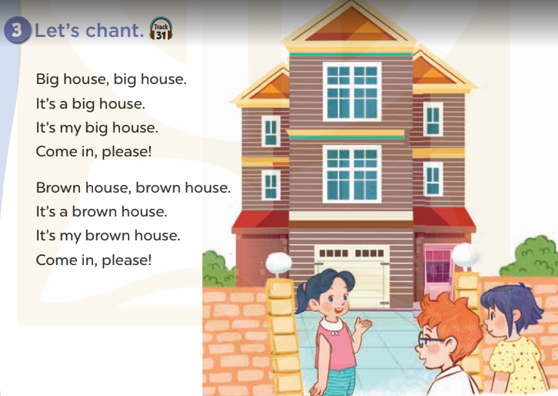  - Play the recording for Ss to listen to the whole chant.  + Have them repeat the title and lyrics line by line.  + Ask Ss to attend to the sounds of the letters ou and ow and the words house and brown.  - Play the recording all the way through for Ss to listen to pronunciation and melody.  - Play the recording line by line for Ss to listen and repeat  - Play the recording for Ss to chant and clap along.  - Ask Ss to practice chant and clap along in pairs or groups.  - Invite groups to the front of the classroom to perform the chant  -T gives feedback.  *Consolidation  *Aims: Ss will be able consolidate and wrap up the content of the lesson.  *Procedure:  - T asks ss to answer the following questions:  + What have you learnt from the lesson today?  +What are the core values of the lesson? (if the teacher can take from the lesson).  - T praises some Ss who are hardworking / active/ good…. as well as encourage others to try more.  4. Homework. (2’)  - Practice the chant more.  - Prepare the new lesson: Unit 13, Lesson 3 (4,5,6). | - Ss listen  -Ss play game  - Ss open their books  - Ss recognize the differences about color of letter  - - Ss listen  - Ss listen and point  - Ss listen again and repeat  -Ss listen again and repeat  -Ss practice  -Ss listen  -Ss listen and say:  + Number 1:  a. I like a big house.  b. I like a brown house.  + Number 2:  a. I don’t like a big house  b. I don’t like a brown house  -Ss guess the answers  - Ss listen to the tape and circle  - Ss listen again, circle and swap books with their partners.  - Ss check their answers and guessing  -Ss listen and repeat.  -Ss read the sentences  - Ss look and listen.  -Ss listen to the chant  - Ss listen and repeat line by line without clap their hands  -Ss note the sounds, words  -Ss listen to melody of the chant  - Ss listen and chant line by line.  - Ss chant and clap along.  - Ss work in groups (two groups) to chant  -Ss perform in front of the class.  -Ss listen  -Ss listen.  -Ss answer the questions  -Ss listen and clap their hands  -Ss listen and take note
D. ADJUSTMENTS (if necessary):
………………………………………………………………………………………….…..……………………………………………………………………………...
---------------------------------------------------------------
Grade 3: Lớp 3A: Chiều thứ ba ngày 25 tháng 02 năm 2025
ENGLISH
Unit 13: My house - Lesson 3 (4, 5, 6)
A. OBJECTIVES:
By the end of the lesson, Ss will be able to:
1. Knowledge:
- Read a paragraph and complete sentences with the words from the paragraph
- Read, understand and complete a gapped text using the information from a picture cue
- Make a model house and tell the class about it.
- Vocabulary: Review
- Skills: speaking, listening, reading and writing.
2. Competences:
- Critical Thinking: talk about things in the house.
- Co-operation: ready to help friends in pair work/ group work.
- Self-control and independent learning: perform reading tasks.
3. Attitude/ Qualities:
- Kindness: Help partners to complete learning tasks.
- Honesty: tell the truth about feelings and emotions.
- Diligence: complete learning tasks.
B. TEACHING AIDS:
- Teacher: Teacher’s guide Pages 170, 171, website sachmem.vn, posters, laptop, pictures, textbook, lesson plan, TV or projector.
- Students: Pupil’s book Page 23, notebooks, workbooks, school things.
C. PROCEDURES:
Teacher’s activities | Students’ activities
1.Warm- up: (5’)  Game: Guessing  *Aims: to review the vocabulary and structure about greet and respond to greetings.  *Procedure:  - Divide the class into 4 teams.  - Look at the cards (1-8), there are pictures behind them.  + Let Ss guess the pictures then say aloud the rooms and things in the house.  + Who can make it will have points for the team. (Spin the lucky wheel to get the points)  - Encourage Ss to take part in the game and practice speaking English.  - Give points for Ss.  - Say “Open your book page 11” and look at “Unit 13, Lesson 3 (4, 5, 6)”.  2.Practice: (8’)  Activity 1. Read and complete:  *Aims: Ss will be able to read a paragraph and complete sentences with the words from the paragraph  *Procedure:  - Tell Ss about this activity.  - Get Ss to scan the paragraph and find the missing words.  - Ask Ss attend to the blank in sentence 1 and find the missing word.  - Write the missing word on the board and get the class to read the completed sentence together.  - Have Ss work in pairs and complete  - Tell Ss to swap books with a partner, then check answers together as a class.  - Write the correct answers on the board for pupils to correct their answers.  - Invite Ss to read the complete sentences aloud  -T gives feedbacks.  Key: 1.the bedroom  2. the kitchen  3. the kitchen 4. the table  3.Production: (19’)  Activity 2. Let’s write  *Aims: Ss will be able to read, understand and complete a gapped text using the information from a picture cue  *Procedure:  - Explain to the class the goal of this activity.  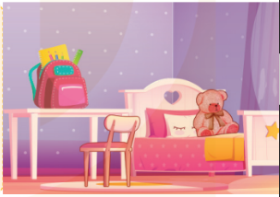  - Ask Ss to read each gapped sentence, guess the missing information and complete the sentence with their own personal information.  - Give Ss time to write their answers  - Ask Ss to swap and correct their answers in pairs.  - Check the answers as a class.  Key: Pupils’ answer.  Activity 3. Project.  *Aims: Ss will be able to make a model house and tell the class about it.  *Procedure:  - Tell Ss about this activity. Check their dool’s houses.  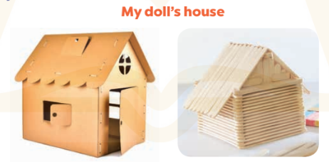  - Stick a sample of a doll’s house on the board and write the presentation language under it.  -Give Ss repeat the sentences until they can say them by themselves.  - Give Ss time to practise their presentations by themselves.  - Invite a student to the front of the classroom to model the presentation.  - Give Ss work in groups to present their doll’s houses.  - Invite a few SS from different groups to present their doll’s houses in front of the classroom.  -Give Ss display of doll’s houses and vote for the best decorated one.  *Consolidation  *Aims: Ss will be able consolidate and wrap up the content of the lesson.  *Procedure:  - T asks ss to answer the following questions:  + What have you learnt from the lesson today?  +What are the core values of the lesson?  - T praises some Ss who are hardworking / active/ good…. as well as encourage others to try more.  4. Homework. (3’)  - Prepare the new lesson: Unit 14: Lesson 1 (1,2,3). | - Ss listen  -Ss play game  - Ss open their books  -Ss listen  - Ss read and answer  -Ss read and complete  -Ss write the first word  -Ss work in pairs  -Ss swap books and check  -Ss check the correct their answers  -Ss read  -Ss listen  -Ss listen  -Ss read and answer  -Ss write  Look at my bedroom. The table is………the bedroom. My school bag is……….the table. The teddy bear is……………..  -Ss swap books and check their answers  -Ss check  -Ss listen  -Ss note  -Ss repeat the sentences  -Ss practice  -Ss present  -Ss work in groups  -Ss present in front of class.  -Ss vote the most beautiful ones  -Ss answer the questions  -Ss listen and clap their hands  -Ss listen and take note
D. ADJUSTMENTS (if necessary):
………………………………………………………………………………………….…..……………………………………………………………………………...
-----------------------------------------------------------------
Grade 3: Lớp 3A: Sáng thứ sáu, ngày 28 tháng 02 năm 2025
ENGLISH
Unit 14: My bedroom - Lesson 1 (1, 2, 3)
A. OBJECTIVES:
By the end of the lesson, Ss will be able to:
1. Knowledge:
- Understand and correctly repeat the sentences in two communicative contexts (pictures) focusing on quantities of things in a room
- Correctly say the words and use There’s / There are……… in the room. to talk about quantities of things in a room;
- Enhance the correct use of There’s / There are…….. in the room. to talk about quantities of things in a room in a freer context.
- Vocabulary: desk, bed, door, window
- Model sentences:
There’s a desk in the room.
There are two doors in the room.
- Skills: speaking and listening
2. Competences:
- Critical Thinking: talk about things in bedroom.
- Co-operation: ready to help friends in pair work/ group work.
- Sociability: Talk to each other, say good words to others.
3. Attitude/ Qualities:
- Kindness: Help partners to complete learning tasks.
- Honesty: tell the truth about feelings and emotions
B. TEACHING AIDS:
- Teacher: Teacher’s guide Pages 172, 173, audio Tracks 32, 33, website sachmem.vn, posters, laptop, pictures, textbook, lesson plan, TV or projector.
- Students: Pupil’s book Page 24, notebooks, workbooks, school things.
C. PROCEDURES:
Teacher’s activities | Students’ activities
1.Warm- up: (3’)  Game: jigsaw puzzle  *Aims: to create a friendly and active atmosphere in the class to beginning the lesson.  *Procedure:  - Divide class into 4 groups: Doreamon, Nobita, Xuka and Xeko.  - Ask Ss look at the pieces of picture.  - Ask Ss go to the board and jigsaw puzzle into the correct picture    -T checks who’s the winner?  - Ask Ss look at the pieces of picture  - Say “Open your book page 24” and look at “Unit 14, Lesson 1 (1,2,3)”.  2. Presentation(16’)  Activity 1. Vocabulary.  *Aims: Ss will be able to know the vocabulary in front of starting the new lesson.  *Procedure:  -T elicits the new words  + desk : cái bàn học sinh (realia)  + bed : cái giường (picture)  + door : cửa ra vào (realia)  + window : cửa sổ (realia)  - T models (3 times).  - T writes the words on the board.  - Checking: Rub out and remember  Activity 2. Listen, point and repeat:  *Aims: Ss will be able to understand and correctly repeat the sentences in two communicative contexts (pictures) focusing on quantities of things in a room.  *Procedure:  - Have Ss look at Pictures a and b and identify the characters in the pictures.  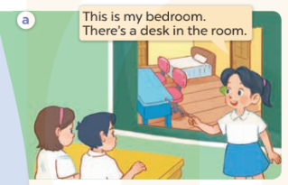  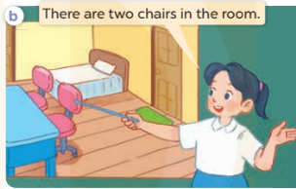  - Play the audio twice (sentence by sentence). Correct their pronunciation where necessary.  - Have Ss to practice the dialogue  - T invites a few pairs to the front of the class to practice.  - T checks pronunciation for ss.  Activity 3 Listen, point and say.  *Aims: Ss will be able to correctly say the words and use There’s / There are ……. in the room. to talk about quantities of things in a room.  *Procedure:  * Model sentences:  - T asks Ss look at picture a , b and helps Ss know the structure from the dialogue.  - T introduces new structure for Ss.  - T explains, models and gives meaning.  -Have Ss repeat the model sentences.  There’s a desk in the room.  There are two doors in the room  3.Practice: (7’)  *Drill pictures  - Elicit and check comprehension the name of the thing in the room.  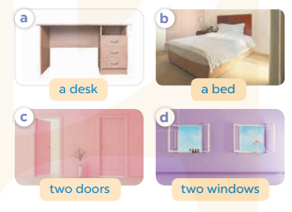  - Run through all the pictures.  - Run through model sentences.  - Have Ss to practise  - Ask Ss to work in pairs.  - T controls and corrects.  - Invite a few pairs to come to the front of the classroom, point at the relevant character in each picture, and act out his/her role.  - Encourage Ss to practise speaking English.  - T gives feedbacks.  4.Production: (7’)  Activity 4. Let’s talk.  *Aims: Ss will be able to enhance the correct use of There’s / There are ……… in the room. to talk about quantities of things in a room in a freer context.  *Procedure:  - T asks ss to look at the things in the bedroom and elicit their names  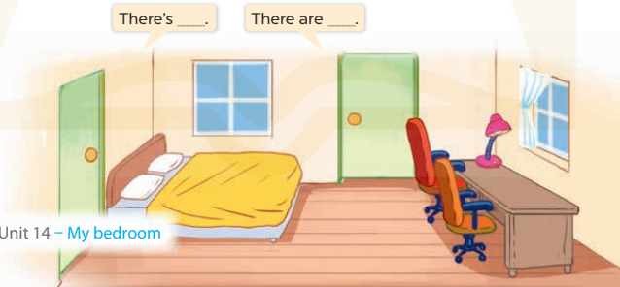  + What can you see in the picture?  - T fills the gaps and writes the sentences on the board.  - T models  - T asks Ss to work in pairs to ask and answer  - Invite some pupils to the front of the class to present their exchanges.  - Give feedbacks  *Consolidation  *Aims: Ss will be able consolidate and wrap up the content of the lesson.  *Procedure:  - T asks ss to answer the following questions:  + What have you learnt from the lesson today?  - T review the vocabulary and model sentences.  - T praises some Ss who are hardworking / active/ good…. as well as encourage others to try more  5. Homework. (2’)  - Learn the number by heart  - Prepare the new lesson: Unit 14, Lesson 1 (4,5,6). | - Ss listen  - Ss play the game  - Ss open their books  -Ss listen and answer  - - Ss listen and repeat  + Choral repetition (3 times).  + Individual repetition (3 ss)  - Ss take note  - Ss look, remember and write  -Look at the pictures and get to know the characters in the pictures.  + Mai says This is my bedroom. There’s a desk in the room. in picture a.  + Mai says There are two chairs in the room. in picture b.  -Ss listen and repeat in chorus (twice)  -Ss work in pairs to practice  -Ss practice the dialogue  -Ss listen  -Ss look at the picture and answer.  -Ss listen  -Ss listen and repeat  -Ss repeat  - Ss look, listen and repeat  -Ss practice in chorus  -Ss work in pairs to practice  -Ss point and say  -Ss listen.  -Ss listen  -Ss look at the picture and answer  + singular things (ex: a bed, a desk)  + multiple things (ex: two chairs, two windows).  -Ss note  - Ss say the completed sentences.  -Ss work in pairs  -Ss perform in front of the class.  -Ss answer the questions  - Ss listen  -Ss listen and clap their hands  -Ss listen and take note
D. ADJUSTMENTS (if necessary):
………………………………………………………………………………………….…..……………………………………………………………………………...
---------------------------------------------------------
Grade 3: Lớp 3A: Sáng thứ sáu, ngày 28 tháng 02 năm 2025
ENGLISH
Unit 14: My bedroom - Lesson 1 (4, 5, 6)
A. OBJECTIVES:
By the end of the lesson, Ss will be able to:
1. Knowledge:
- Listen to and understand two communicative contexts in which pupils describe things in the bedroom and tick the correct pictures.
- Complete the four gapped sentence patterns with the help of picture cues.
- Revise the target vocabulary items through the game Memory game.
- Vocabulary: Review
- Skills: speaking, listening, reading and writing.
2. Competences:
- Co-operation: ready to help friends in pair work/ group work.
- Self-control and independent learning: perform listening tasks.
3. Attitude/ Qualities:
- Kindness: Help partners to complete learning tasks.
- Honesty: tell the truth about feelings and emotions.
- Diligence: complete learning tasks.
B. TEACHING AIDS:
- Teacher: Teacher’s guide Pages 174; audio Tracks 34; website sachmem.vn, posters, laptop, pictures, textbook, lesson plan, TV or projector.
- Students: Pupil’s book Page 25, notebooks, workbooks, school things.
C. PROCEDURES:
Teacher’s activities | Students’ activities
1.Warm- up: (5’)  Sing a song: “If you happy and you know it”  *Aims: to create a friendly and active atmosphere in the class to beginning the lesson.  *Procedure:  - Show the song on the screen.  https://www.youtube.com/watch?v=zyMWcWqmhRc  - Ask pupils to listen, sing and dance the song.  - Say “Open your book page 25” and look at “Unit 14, Lesson 1 (4,5,6)”.  2.Practice: (27’)  Activity 1. Listen and tick:  *Aims: Ss will be able to listen to and understand two communicative contexts in which pupils describe things in the bedroom and tick the correct pictures.  *Procedure:  - Elicit the name of the things in the room in each picture 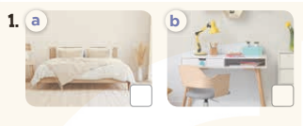  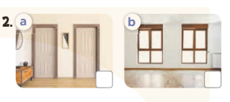  - T ask Ss to guess the answers.  + T writes Ss’guessing on the board.  - Listen to the tape:  + Play the recording  + Play the recording again and get Ss to swap books with their partners.  + Play the recording again to check answers together as a class.  + Write the answers on the board for Ss to correct their answers. Then checks Ss’ guessing.  - Play the recording, sentence by sentence, for the class to listen and repeat in chorus.  Key: 1.a 2.b  Activity 2. Look, complete and read.  *Aims: Ss will be able to complete the four gapped sentence patterns with the help of picture cues.  *Procedure:  - Have Ss look at the first picture and ask them some questions such as What’s this? and Where is it?  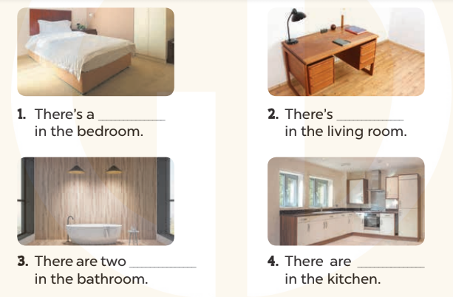  - Have Ss look at the four incomplete sentnces and elicits the missing words in the sentences.  - T models with sentence 1  + Ask Ss what is missing in the sentence.  + Have Ss look at the picture and complete the gap, then read the completed sentence in chorus.  -Have Ss work in groups and complete the sentences 2,3 and 4.  - Ask a few Ss to stand up and read the completed sentences aloud.  -T gives feedbacks.  Key:  1. bed 2. a desk  3. lamps 4. two windows  Activity 3. Let’s play  *Aims: Ss will be able to revise the target vocabulary items through the game Memory game.  *Procedure:  - Tell Ss that they are going to look at the cards for 60 seconds, memorise the words, then remember as many of the words as possible.  -Explain how the game is played.  - Put the cards on a desk or stick them on the board. Then cover them with a piece of cloth  - Divide the class into groups. Remove the cloth and show the cards for 60 seconds. Then cover them again.  - Have the groups say the names of the things aloud. For each correct word, give them a star or a point.  -The group with the most stars / points wins.  *Consolidation  *Aims: Ss will be able consolidate and wrap up the content of the lesson.  *Procedure:  - T asks ss to answer the following questions:  + What have you learnt from the lesson today?  +What are the core values of the lesson? (if the teacher can take from the lesson).  - T praises some Ss who are hardworking / active/ good…. as well as encourage others to try more.  3. Homework. (3’)  - Prepare the new lesson: Unit 14, Lesson 2 (1,2,3). | - Sing and dance the song in chorus.  - Ss open their books  -Look at the pictures and say:  + Picture 1a: a bed in the bedroom  + Picture 1b: a desk in the bedroom  + Picture 2a: two doors in the bedroom  + Picture 2b: two windows in the bedroom  -Ss guess the answers  - Ss listen to the tape and circle  - Ss listen again, circle and swap books with their partners.  - Ss check their answers and guessing  -Ss listen and repeat.  -Ss look at the picture and answer  -Ss look and answer  -Ss answer: bed  -Ss look, complete and read the completed sentence in chorus.  -Ss complete the sentence  -Ss read aloud  - Ss look and listen.  - Ss listen  -Ss look and listen  -Ss play the game  -Ss answer the questions  -Ss listen and clap their hands  -Ss listen and take note
D. ADJUSTMENTS (if necessary):
………………………………………………………………………………………….…..……………………………………………………………………………...
---------------------------------------------------------------
Grade 4: Lớp 4A: Sáng thứ Ba, Ngày 25 tháng 02 năm 2025
Lớp 4B: Chiều thứ Hai, Ngày 24 tháng 02 năm 2025
Lớp 4C: Sáng thứ tư , Ngày 26 tháng 02 năm 2025
ENGLISH
Unit 13: Appearance - Lesson 3 (1, 2, 3)
A. OBJECTIVES:
By the end of the lesson, Ss will be able to:
1. Knowledge:
- Correctly repeat the sounds of the letters l and r in isolation, the words long and round and the sentences My sister has long hair and My brother has round eyes with the correct pronunciation and intonation.
- Identify the target words long and round while listening.
- Say the chant with the correct rhythm and pronunciation.
- Vocabulary: Review
- Skills: speaking, listening, reading and writing.
2. Competences:
- Co-operation: ready to help friends in pair work/ group work.
- Self-control and independent learning: perform listening tasks.
3. Attitude/ Qualities:
- Kindness: Help partners to complete learning tasks.
- Honesty: tell the truth about feelings and emotions
B. TEACHING AIDS:
- Teacher: Teacher’s guide Pages 192, 193; audio Tracks 28,29,30; website hoclieu.vn, posters, laptop, pictures, textbook, lesson plan, TV or projector.
- Students: Pupil’s book Page 22, notebooks, workbooks, school things.
C. PROCEDURES:
Teacher’s activities | Students’ activities
1.Warm- up: (5’)  Game: play the Doraemon game (PPT)  *Aims: to create a friendly and active atmosphere in the class to beginning the lesson.  *Procedure:  - Divide the class into 3 teams.  - Pupils from each team choose a number, then ask and answer with the picture in that number.  - If the Ss answer correctly, they get the points (dorayaki) for that question.  - After 9 numbers, the team with the most points is the winner.  - Say “Open your book page 22” and look at “Unit 13, Lesson 3 (1,2,3)”.  2. Presentation(9’)  Activity 1. Listen and repeat:  *Aims: Ss will be able to correctly pronounce the sounds of the letters l and r in isolation, in the words long and house, and in the sentences My sister has long hair and My brother has round eyes with correct pronunciation and intonation.  *Procedure:  - T gives instruction to the l and r in isolation, in the words long and round, and in the sentences My sister has long hair and My brother has round eyes.  - Play the recording for the letter l, r.  - Encourage Ss to point at the letter/ word/ sentence while listening.  - Play the recording again and encourage Ss to listen and repeat.  - Do this several times until Ss feel confident.  - T calls some Ss to practice.  - T gives feedbacks.  3.Practice: (19’)  Activity 2. Listen and circle.  *Aims: Ss will be able to identify the target words long and round while listening.  *Procedure:  - Elicit the sentences and explain that they have to listen.  - T ask Ss to guess the answers.  + T writes Ss’guessing on the board.  - Listen to the tape:  + Play the recording  + Play the recording again and get Ss to swap books with their partners.  + Play the recording again to check answers together as a class.  + Write the answers on the board for Ss to correct their answers. Then checks Ss’ guessing.  - Play the recording, sentence by sentence, for the class to listen and repeat in chorus.  - Invite one or two Ss to stand up and read the completed sentences.  Key: 1.b 2.b  Activity 3. Let’s chant  *Aims: Ss will be able to say the chant with the correct rhythm and pronunciation.  *Procedure:  - Introduce the title and lyrics of the chant.  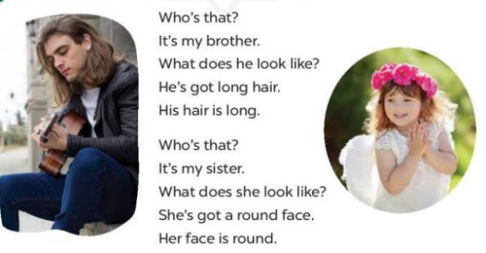  - Play the recording for Ss to listen to the whole chant.  + Have them repeat the title and lyrics line by line.  + Ask Ss to attend to the sounds of the letters l and r and the words long and round.  - Play the recording all the way through for Ss to listen to pronunciation and melody.  - Play the recording line by line for Ss to listen and repeat  - Play the recording for Ss to chant and clap along.  - Ask Ss to practice chant and clap along in pairs or groups.  - Invite groups to the front of the classroom to perform the chant  -T gives feedback.  *Consolidation  *Aims: Ss will be able consolidate and wrap up the content of the lesson.  *Procedure:  - T asks ss to answer the following questions:  + What have you learnt from the lesson today?  +What are the core values of the lesson? (if the teacher can take from the lesson).  - T praises some Ss who are hardworking / active/ good…. as well as encourage others to try more.  4. Homework. (2’)  - Practice the chant more.  - Prepare the new lesson: Unit 13, Lesson 3 (4,5,6). | - Ss listen  -Ss play game  - Ss open their books  - Ss recognize the differences about color of letter  - - Ss listen  - Ss listen and point  - Ss listen again and repeat  -Ss listen again and repeat  -Ss practice  -Ss listen  -Ss listen and say  -Ss guess the answers  - Ss listen to the tape and circle  - Ss listen again, circle and swap books with their partners.  - Ss check their answers and guessing  -Ss write the correct answer  -Ss listen and repeat.  -Ss read the sentences  - Ss look and listen.  -Ss listen to the chant  - Ss listen and repeat line by line without clap their hands  -Ss note the sounds, words  -Ss listen to melody of the chant  - Ss listen and chant line by line.  - Ss chant and clap along.  - Ss work in groups (two groups) to chant  -Ss perform in front of the class.  -Ss listen  -Ss listen.  -Ss answer the questions  -Ss listen and clap their hands  -Ss listen and take note
D. ADJUSTMENTS (if necessary):
………………………………………………………………………………………….…..……………………………………………………………………………...
-------------------------------------------------------------------
Grade 4: Lớp 4A: Sáng thứ Ba, Ngày 25 tháng 02 năm 2025
Lớp 4B: Chiều thứ Hai, Ngày 24 tháng 02 năm 2025
Lớp 4C: Sáng thứ tư , Ngày 26 tháng 02 năm 2025
ENGLISH
Unit 13: Appearance - Lesson 3 (4, 5, 6)
A. OBJECTIVES:
By the end of the lesson, Ss will be able to:
1. Knowledge:
- Read and write about someone’s appearance.
- Do a survey about the appearance of family members and use it to practise talking in the classroom at Project time.
- Vocabulary: Review
- Skills: speaking, listening, reading and writing.
2. Competences:
- Co-operation: ready to help friends in pair work/ group work.
- Self-control and independent learning: perform reading tasks.
3. Attitude/ Qualities:
- Kindness: Help partners to complete learning tasks.
- Honesty: tell the truth about feelings and emotions.
- Diligence: complete learning tasks.
B. TEACHING AIDS:
- Teacher: Teacher’s guide Pages 194, 195, website hoclieu.vn, posters, laptop, pictures, textbook, lesson plan, TV or projector.
- Students: Pupil’s book Page 23, notebooks, workbooks, school things.
C. PROCEDURES:
Teacher’s activities | Students’ activities
1.Warm- up: (5’)  Game: Slap the board  *Aims: to review the vocabulary and structure about greet and respond to greetings.  *Procedure:  - Divide pupils into 2-3 teams.  - Each team sends one representative to the board. Teacher draws two boxes and writes l and r in each box.  - Teacher reads a word and the representatives slap the box containing letters l or r according to the sound that they hear.  - The first pupil to touch the box gets one point.  - Say “Open your book page 23” and look at “Unit 13, Lesson 3 (4, 5, 6)”.  2.Practice: (8’)  Activity 1. Read and complete:  *Aims: Ss will be able to read a text and complete four gapped sentences about appearance.  *Procedure:  - Have pupils look at the picture and guess what the text is about.  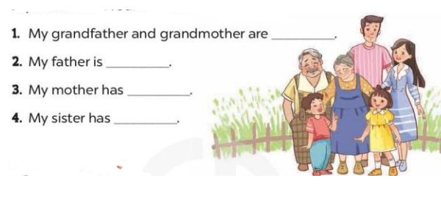  - Have Ss look at four incomplete sentences below the text.  - Ask Ss to read through the text to find the information and complete four sentences  - Ask Ss to do the task individually.  - Have Ss swap their books with a partner and check the answers.  Key: 1. big 2. very tall 3. long hair  4. a round face and big eyes  3.Production: (19’)  Activity 2. Let’s write  *Aims: Ss will be able to complete a gapped paragraph with personal information about family members.  *Procedure:  - Have Ss read through the paragraph to get the general idea.  - Ask Ss to read each gapped sentence, guess the missing information and complete the sentence with their own personal information.  - Give Ss time to write their answers  - Ask Ss to swap and correct their answers in pairs.  - Check the answers as a class.  Key: Pupils’ answer.  Example: There are four people in my family. My father is tall. He has short hair. My mother is slim. She has long hair. My brother is big. We love our family  Activity 3. Project.  *Aims: Ss will be able to carry out a survey on the appearance of pupils’ family members and present it to the class.  *Procedure:  - Explain that pupils are going to report the results of their surveys about their family members’ appearance.  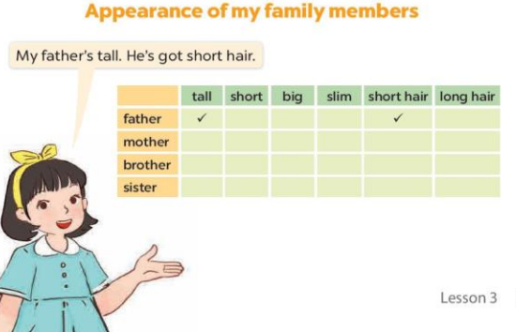  - Have Ss hold up their completed surveys. - Revise some words and sentence patterns that pupils can use for their presentations.  - Give Ss some time to practise their presentations by themselves and within groups.  - Select a few pupils to give their presentations in front of the class.  - Have the rest of the class give comments and praise pupils if they perform well.  *Consolidation  *Aims: Ss will be able consolidate and wrap up the content of the lesson.  *Procedure:  - T asks ss to answer the following questions:  + What have you learnt from the lesson today?  +What are the core values of the lesson?  - T praises some Ss who are hardworking / active/ good…. as well as encourage others to try more.  4. Homework. (3’)  - Prepare the new lesson: Unit 14: Lesson 1 (1,2,3). | - Ss listen  -Ss play game  - Ss open their books  -Ss listen  - Ss read and answer  -Ss read and complete  -Ss read the text and do the task  -Ss swap books and check  -Ss listen  -Ss read and answer  -Ss write  -Ss swap books and check their answers  -Ss check  -Ss listen  -Ss note  -Ss pay attention  -Ss practice  -Ss present in front of class.  -Ss vote the most pesenter ones  -Ss answer the questions  -Ss listen and clap their hands  -Ss listen and take note
D. ADJUSTMENTS (if necessary):
………………………………………………………………………………………….…..……………………………………………………………………………...

---------------------------------------------------------------------
Grade 4: Lớp 4A: Sáng thứ Sáu Ngày 28 tháng 02 năm 2025
Lớp 4B: Sáng thứ tư, Ngày 26 tháng 02 năm 2025
Lớp 4C: Sáng thứ năm , Ngày 27 tháng 02 năm 2025
ENGLISH
Unit 14: Daily activities
Lesson 1 (1, 2, 3)
A. OBJECTIVES:
By the end of the lesson, Ss will be able to:
1. Knowledge:
- use the phrases in the morning, at noon, in the afternoon, in the evening in relation to the topic “Daily activities”
- use When do you watch TV? – I watch TV ………. to ask and answer questions about when someone watches TV;
- Vocabulary: in the morning, in the afternoon, in the evening, at noon
- Model sentences:
A: When do you watch TV?
B: I watch TV in the evening.
- Skills: speaking and listening
2. Competences:
- Co-operation: ready to help friends in pair work/ group work.
- Sociability: Talk to each other, say good words to others.
3. Attitude/ Qualities:
- Kindness: Help partners to complete learning tasks.
- Honesty: tell the truth about feelings and emotions
B. TEACHING AIDS:
- Teacher: Teacher’s guide Pages 196,197, audio Tracks 31, 32, website hoclieu.vn, posters, laptop, pictures, textbook, lesson plan, TV or projector.
- Students: Pupil’s book Page 24, notebooks, workbooks, school things.
C. PROCEDURES:
Teacher’s activities | Students’ activities
1.Warm- up: (3’)  Game: Guessing game (PPT)  *Aims: to create a friendly and active atmosphere in the class to beginning the lesson.  *Procedure:  - Look at the picture and guess the answer for the question.  - Say “Open your book page 24” and look at “Unit 14, Lesson 1 (1,2,3)”.  2. Presentation(16’)  Activity 1. Vocabulary.  *Aims: Ss will be able to know the vocabulary in the new lesson.  *Procedure:  -T elicits the new words  + in the morning : vào buổi sáng (explain)  + in the afternoon: vào buổi chiều (situation)  + in the evening: vào buổi tối (situation)  + at noon : vào buổi trưa (example)  - T models (3 times).  - T writes the words on the board.  - Checking: Rub out and remember  Activity 2. Look, listen and repeat:  *Aims: Ss will be able to understand and correctly repeat the sentences in two communicative contexts focusing on asking and answering questions about when someone watches TV.  *Procedure:  - Have Ss look at Pictures a and b and identify the time of the day in the pictures.  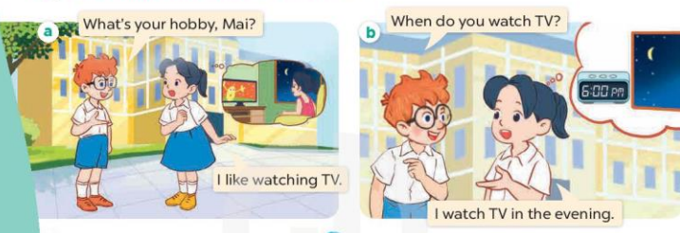  - Play the audio twice (sentence by sentence). Correct their pronunciation where necessary.  - Have Ss to practice the dialogue  - T invites a few pairs to the front of the class to practice.  - T checks pronunciation for ss.  Activity 3 Listen, point and say.  *Aims: Ss will be able to correctly say the phrases and use When do you watch TV? – I watch TV ……….to ask and answer questions about when someone watches TV.  *Procedure:  * Model sentences:  - T asks Ss look at picture b and helps Ss know the structure from the dialogue.  - T introduces new structure for Ss.  - T explains, models and gives meaning.  -Have Ss repeat the model sentences.  A: When do you watch TV?  B: I watch TV in the evening.  3.Practice: (7’)  *Drill pictures  - Elicit the time of the day from pupils (looking at the clock and the sun in the pictures).  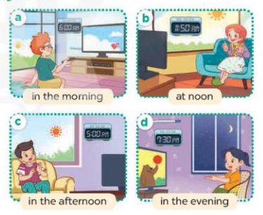  - Run through all the pictures.  - Run through model sentences.  - Have Ss to practise  - Ask Ss to work in pairs.  - T controls and corrects.  - Invite a few pairs to come to the front of the classroom, point at the relevant character in each picture, and act out his/her role.  - Encourage Ss to practise speaking English.  - T gives feedbacks.  4.Production: (7’)  Activity 4. Let’s talk.  *Aims: Ss will be able to enhance the correct use of When do you watch TV? – I watch TV ……..to ask and answer questions about when someone watches TV in a freer context.  *Procedure:  - Draw Ss’ attention to the clocks and the sun for the answers I watch TV in the morning / at noon / in the afternoon / in the evening.  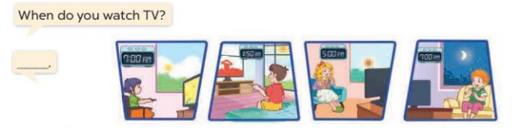  - Get pupils to repeat the questions and answers several times.  - Have Ss to work in pairs, point at the diﬀerent pictures in this section, ask and answer the question When do you watch TV?  - Invite some pairs to take turns asking and answering questions about when someone watches TV in front of the class.  *Consolidation  *Aims: Ss will be able consolidate and wrap up the content of the lesson.  *Procedure:  - T asks ss to answer the following questions:  + What have you learnt from the lesson today?  - T review the vocabulary and model sentences.  - T praises some Ss who are hardworking / active/ good…. as well as encourage others to try more  5. Homework. (2’)  - Prepare the new lesson: Unit 14, Lesson 1 (4,5,6). | - Ss play the game  - Ss open their books  -Ss listen and answer  - - Ss listen and repeat  + Choral repetition (3 times).  + Individual repetition (3 ss)  - Ss take note  - Ss look, remember and write  -Look at the pictures and get to know the time of day in the pictures.  + Picture a:  Ben: What’s your hobby, Mai?  Mai: I like watch TV.  + Picture b:  Ben: When do you watch TV?  Mai: I watch TV in the evening.  -Ss listen and repeat in chorus (twice)  -Ss work in pairs to practice  -Ss practice the dialogue  -Ss listen  -Ss look at the picture and answer.  -Ss listen  -Ss listen and repeat  -Ss repeat  - Ss look, listen and answer  + Picture a. a boy watching TV in the morning  + Picture b. a girl watching TV at noon  + Picture c. a boy watching TV in the afternoon  + Picture d. a girl watching TV in the evening  -Ss practice in chorus  -Ss practice in chorus  -Ss work in pairs to practice  -Ss point and say, ask and answer  -Ss listen.  -Ss listen  -Ss look at the picture and answer  -Ss repeat the questions and answers  -Ss work in pairs, point and ask and answer  -Ss perform in front of the class.  -Ss answer the questions  - Ss listen  -Ss listen and clap their hands  -Ss listen and take note
D. ADJUSTMENTS (if necessary):
………………………………………………………………………………………….…..……………………………………………………………………………...
-------------------------------------------------------------------
Grade 4: Lớp 4A: Sáng thứ Sáu Ngày 28 tháng 02 năm 2025
Lớp 4B: Sáng thứ tư, Ngày 26 tháng 02 năm 2025
Lớp 4C: Sáng thứ năm , Ngày 27 tháng 02 năm 2025
ENGLISH
Unit 14: Daily activities - Lesson 1 (4, 5, 6)
A. OBJECTIVES:
By the end of the lesson, Ss will be able to:
1. Knowledge:
- Use the phrases in the morning, at noon, in the afternoon, in the evening in relation to the topic “Daily activities”.
- Listen to and demonstrate understanding of simple communicative contexts in relation to the topic “Daily activities”.
- Vocabulary: Review
- Skills: speaking, listening, reading and writing.
2. Competences:
- Co-operation: ready to help friends in pair work/ group work.
- Self-control and independent learning: perform listening tasks.
3. Attitude/ Qualities:
- Kindness: Help partners to complete learning tasks.
- Honesty: tell the truth about feelings and emotions.
B. TEACHING AIDS:
- Teacher: Teacher’s guide Pages 199, 200; audio Tracks 33, 34; website hoclieu.vn, posters, laptop, pictures, textbook, lesson plan, TV or projector.
- Students: Pupil’s book Page 25, notebooks, workbooks, school things.
C. PROCEDURES:
Teacher’s activities | Students’ activities
1.Warm- up: (5’)  Game: “pass the ball”  *Aims: to create a friendly and active atmosphere in the class to beginning the lesson.  *Procedure:  - T gives Ss a ball.  - T asks Ss to listen to music and transfer a ball around the class.  - When the music stops, Ss who keep a ball have to answer the question using: When do you watch TV? and I watch TV…….  - Say “Open your book page 25” and look at “Unit 14, Lesson 1 (4,5,6)”.  2.Practice: (27’)  Activity 1. Listen and tick or cross:  *Aims: Ss will be able to listen to and understand four communicative contexts in which pupils ask and answer questions about when someone does an activity, and tick or cross the pictures  *Procedure:  - Elicit and identify the activities and the time of the day by looking at the clocks and the sun or moon.  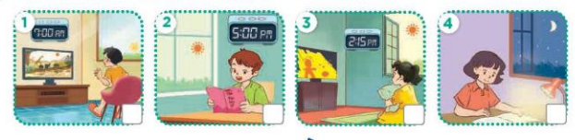  - T ask Ss to guess the answers.  + T writes Ss’guessing on the board.  - Listen to the tape:  + Play the recording  + Play the recording again and get Ss to swap books with their partners.  + Play the recording again to check answers together as a class.  + Write the answers on the board for Ss to correct their answers. Then checks Ss’ guessing.  - Play the recording, sentence by sentence, for the class to listen and repeat in chorus.  Key: 1.x 2.v 3.x 4.x  Activity 2. Look, complete and read.  *Aims: Ss will be able to complete four gapped exchanges about when someone does an activity with the help of picture cues *Procedure:  - Ask Ss to look at the pictures and identify the activities and time of the day.  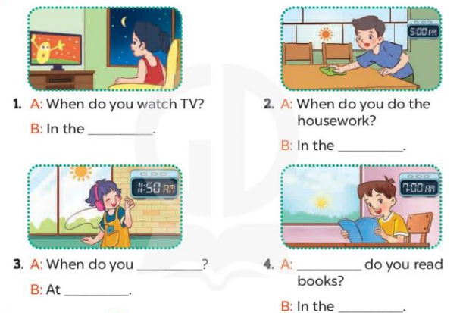  - Have Ss look at the four incomplete sentnces and elicits the missing words in the sentences.  - T models with sentence 1  + Ask Ss what is missing in the sentence.  + Have Ss look at the picture and complete the gap, then read the completed sentence in chorus.  -Have Ss work in groups and complete the sentences 2,3 and 4.  - Ask a few Ss to stand up and read the completed sentences aloud.  -T gives feedbacks.  Key:  1. evening 2. afternoon  3. listen to music; room  4. When; morning  Activity 3. Let’s sing  *Aims: Ss will be able to sing the song When do you watch TV and read books? with the correct pronunciation, rhythm and melody  *Procedure:  - Have pupils read the lyrics to familiarise themselves with the questions and answers.  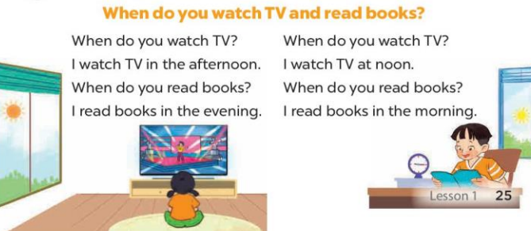  - Encourage them to identify two activities (watch TV; read books) and time of the day in the pictures.  - Have Ss listen to the whole song, drawing their attention to the pronunciation and tune.  - Play the recording of the song once or twice for pupils to listen and repeat, line after line, and do related actions.  - Ask Ss to sing the whole song while doing actions or clapping hands.  - Invite a few groups to the front of the class to sing the song.  *Consolidation  *Aims: Ss will be able consolidate and wrap up the content of the lesson.  *Procedure:  - T asks ss to answer the following questions:  + What have you learnt from the lesson today?  +What are the core values of the lesson? (if the teacher can take from the lesson).  - T praises some Ss who are hardworking / active/ good…. as well as encourage others to try more.  3. Homework. (3’)  - Prepare the new lesson: Unit 14, Lesson 2 (1,2,3). | - Ss listen and pay attention  -Ss play the game.  - Ss open their books  -Look at the pictures and say:  + Picture 1. a boy watching TV in the morning  + Picture 2. a boy reading a book in the afternoon  + Picture 3. a girl watching TV in the afternoon  + Picture 4. a girl reading a book in the evening  -Ss guess the answers  - Ss listen to the tape and tick/ cross  - Ss listen again, tick/ cross and swap books with their partners.  - Ss check their answers and guessing  -Ss write the correct answer  -Ss listen and repeat.  -Ss look at the picture and answer  -Ss look and answer  -Ss answer: evening  -Ss look, complete and read the completed sentence in chorus.  -Ss complete the sentence  -Ss read the completed sentences aloud  - Ss look and listen.  - Ss pay attention and say  -Ss listen the whole song  -Ss listen and repeat, line by line  -Ss sing the whole song  -Ss sing the song in front of the class  -Ss answer the questions  -Ss listen and clap their hands  -Ss listen and take note
D. ADJUSTMENTS (if necessary):
………………………………………………………………………………………….…..……………………………………………………………………………...………………………………………….…..………………………………………
-----------------------------------------------------------------
Grade 5 : Lớp 5B : Sáng thứ ba, Ngày 25 tháng 02 năm 2025
ENGLISH
Unit 13: Our special days - Lesson 3 (1, 2, 3)
A. OBJECTIVES:
By the end of the lesson, Ss will be able to:
1. Knowledge:
- Correctly say the stressed words in the questions ‘What ‘food will you ‘have at the ‘party? and ‘What ‘drinks will you ’have at the ‘party?
- Identify and underline the stressed words in four questions while listening
- Say the chant with the correct stressed words, pronunciation and rhythm.
- Vocabulary: Review
- Skills: speaking, listening, reading and writing.
2. Competences:
- Communication and collaboration: work in pairs and groups to complete the learning tasks.
- Self-control and independent learning: perform pronunciation and listening tasks.
3. Attitude/ Qualities:
- Enhance understanding of different kinds of food and drinks at different styles of events.
B. TEACHING AIDS:
- Teacher: Teacher’s guide Pages 218, 219; audio Tracks 28, 29, 30; website hoclieu.vn, posters, laptop, pictures, textbook, lesson plan, TV or projector.
- Students: Students’ book Page 22, notebooks, workbooks, school things.
C. PROCEDURES:
Teacher’s activities | Students’ activities
1.Warm- up and review: (5’)  Game: Pass the balls  *Aims: to revise the learnt words and structures.  *Procedure:  - Give two different coloured balls to two ss, a red ball (ask the question) and a yellow ball (answer the question).  - Ask ss to listen to music and pass the balls.  - Stop music suddenly.  - The teacher raises a picture. Have the student with a red ball make a question. Have the student with a yellow ball answer the question.  - Praise ss if they do the activity well.  - Say “Open your book page 22” and look at “Unit 13, Lesson 3 (1,2,3)”.  2. Presentation (9’)  Activity 1. Listen and repeat:  *Aims: Ss will be able to correctly say the stressed words in the questions ‘What ‘food will you ‘have at the ‘party? and ‘What ‘drinks will you ’have at the ‘party?  *Procedure:  - Have ss look at the first question and draw their attention to the stress on the words in the sentences ‘What ‘food will you ‘have at the ‘party? and ‘What ‘drinks will you ’have at the ‘party?  - Play the recording and encourage Ss to point to the word and sentence while listening  - Play the recording again and encourage Ss to listen and repeat.  - Have Ss work in pairs or groups to do this several times until Ss feel confident.  - T invites some Ss to practice.  3.Practice: (17’)  Activity 2. Listen and underline one more stressed word. Then repeat  *Aims: Ss will be able to identify and underline the stressed words in four questions while listening  *Procedure:  - Tell ss the goal of the activity and explain that they have to listen to the recording and underline one more stressed word.  - Play the recording all the way through for ss to listen to the questions.  - Play the recording again for ss to underline one more stressed word of the questions.  - Tell ss to swap books with a partner, then check the answers together as a class.  - Have ss read aloud the questions in pairs or groups. Go around the classroom and correct the stress in the questions if necessary.  - Invite one or two ss to stand up and repeat the correct answers.  Key:  1.‘What ‘food will you ‘have at the ‘party?  2. ‘What ‘drinks will they ‘have at the ‘party?  3. ‘What will you ‘do at the ‘party?  4. ‘What will we ‘do at their ‘party?  Activity 3. Let’s chant  *Aims: Ss will be able to say the chant with the correct stressed words, pronunciation and rhythm  *Procedure:  - Introduce the title and lyrics of the chant.  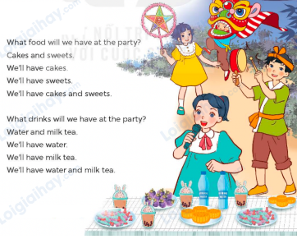  - Play the recording for Ss to listen to the whole chant.  + Have them repeat the title and lyrics line by line.  + Ask Ss to attend the stressed words' pronunciation and rhythm  - Play the recording all the way through for Ss to listen to the stressed words' pronunciation and melody.  - Play the recording line by line for Ss to listen and repeat  - Play the recording for Ss to chant and clap along.  - Ask Ss to practice chant and clap along in pairs or groups.  - Invite groups to the front of the classroom to perform the chant  3. Fun corner and wrap- up (4’)  Game: Odd one out  - Tell ss that they are going to look at some pictures with food and drinks.  - Ask them to choose the odd by looking at the pictures.  - Teacher checks their pronunciation and asks the whole class to repeat. | - Ss listen  -Ss listen the rules  - Ss play the game  Ex:  A: What food will you have at the party?  B: We’ll have pizza.  - Ss open their books  - - Ss pay attention  - Ss listen and point  - Ss listen again and repeat  -Ss work in pairs and practice  -Ss say in front of the class  - Ss listen to the teacher’s explanation.  - Ss listen to the questions  - Ss listen again and underline one more stressed word of the questions.  - Ss swap books and check the answers as a class.  -Ss work in pairs/ groups.  - Ss stand up and repeat the correct answers.  - Ss listen to the chant  - Ss listen and repeat line by line without clap their hands  - Ss note the rhythm and pronunciation.  -Ss listen to melody of the chant  - Ss listen and chant line by line.  - Ss chant and clap along.  - Ss work in groups (two groups) to chant  -Ss perform in front of the class.  -Ss listen  -Ss play the game  Suggested answers:  Chips burger milk tea bread  Key: milk tea (because it’s a drink and we can’t eat it)
D. ADJUSTMENTS (if necessary):
………………………………………………………………………………………….…..……………………………………………………………………………...
------------------------------------------------------------
Grade 5 : Lớp 5B : Sáng thứ ba, Ngày 25 tháng 02 năm 2025
ENGLISH
Unit 13: Our special days - Lesson 3 (4, 5, 6)
A. OBJECTIVES:
By the end of the lesson, Ss will be able to:
1. Knowledge:
- Listen to and demonstrate understanding of simple communicative contexts in relation to the topic “Our special days”
- Read and write about what people will do and have at an event
- Make a menu s for a class party and present it to the class at Project time.
- Vocabulary: Review
- Skills: speaking, listening, reading and writing.
2. Competences:
- Communication and collaboration: work in pairs and groups to complete the learning tasks.
- Self-control and independent learning: perform reading and writing tasks.
3. Attitude/ Qualities:
- Enhance understanding of different kinds of food and drinks at different styles of events.
B. TEACHING AIDS:
- Teacher: Teacher’s guide Pages 219, 220, 221; website hoclieu.vn, posters, laptop, pictures, textbook, lesson plan, TV or projector.
- Students: Pupil’s book Page 23, notebooks, workbooks, school things.
C. PROCEDURES:
Teacher’s activities | Students’ activities
1.Warm- up and review: (5’)  Game: Food party game  *Aims: to create a friendly and active atmosphere in the class to beginning the lesson.  *Procedure:  - Tell ss that they are going to play in 2 teams.  - Choose a chips pack and answer the questions about food / drinks they will have at the party.  - If their answers are correct, click on the sellers and serve some burgers. If not, click on the burglar to go back to the questions board.  - Teams with more points will be the winner.  - Say “Open your book page 23” and look at “Unit 13, Lesson 3 (4,5,6)”.  2.Practice: (8’)  Activity 1. Read and answer:  *Aims: Ss will be able to read and show the understanding of the letter by answering the questions.  *Procedure:  - Tell ss the goal of the activity and explain that they should read the letter and answer the questions.  - Model the first question.  + Have ss look at the first question and explain that the word When in the question When is Mai’s birthday? expresses the time of the birthday.  + Then let ss read the letter and find the appropriate information /sentence to match the question (It’s my birthday on Sunday).  - Set a time limit for ss to do the task independently.  - Get ss to swap their books with a partner and check their answers before checking as a class.  - Invite one or two pupils to read the letter in front of the class.  Key:  1. It’s Mai’s birthday on Sunday.  2. Her party will be at 15 Quang Trung Street.  3. They’ll have pizza, burgers and chips.  4. They’ll drink lemonade, apple juice and milk tea.  3.Production: (18’)  Activity 2. Let’s write  *Aims: Ss will be able to write a text about food and drinks pupils will have at their birthday parties with the  help of the suggested questions and gapped sentences.  *Procedure:  - Ask ss to read the gapped sentences and fill in the gaps with their own information  - Ask Ss to read the first sentence, then elicit the time of their birthday (Ex: October) and write the first sentence (My birthday is in October)  - Give Ss time to complete the rest of the paragraph independently.  - Get Ss to swap their books with a partner and check their spelling.  - Invite a student to read his / her completed paragraph aloud  - In groups, have ss share the activities that their family did last weekend.  - Ask Ss share with the class.  Key: Pupil’s answer  Ex: My birthday is in May (It’s my birthday in May). I will invite some friends to my party. It will be at my home. We’ll have cakes, candies and fruit. I’ll have mineral water,  lemonade and milk tea. We’ll sing and dance. I think we’ll have a lot of fun.  Activity 3. Project.  *Aims: Ss will be able to make a menu for the class party and present it to the class *Procedure:  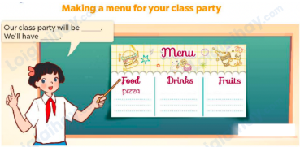  - Tell ss about the goal of the activity and explain that they have to look at the menu they have prepared at home and oresent it to the class.  - Have ss work in groups of three or four. Each pupil shows the menu and tells the group about it.  Ex: Our class party will be next Saturday. We’ll have burgers, pizza, apples and grapes. We’ll drink mineral water and milk tea. We’ll have apples and grapes. Thank you for listening.  - Invite one student to hold up her / his menu and present it to the class. Praise ss when they do the task well.  4. Fun corner and wrap- up (4’)  Game: Lucky number  - Divide the class into two teams.  - Each team takes turns choosing the number and answering the question to get the stars.  - At the end of the game, the team with more stars is the winner. | - Ss listen  - Ss listen to the rules  -Ss play game  Ex:  water, chicken and rice, vegetables, milk tea, chips, lemonade  - Ss open their books  -. Ss pay attention to the letter and read them as a class.  - Ss answer the first question with the whole class.  - Ss answer the question  - Ss swap their books and check.  -Ss read the letter aloud  - Ss read the gapped sentences and fill in the gaps.  - Ss do the first gapped sentence.  - Ss complete the paragraph independently.  - Ss swap their books and check their spelling.  - Ss read their completed paragraphs in front of the class.  - Ss share the activities that their family did last weekend.  -Ss share with the class.  - Ss listen to the teacher’s explanation.  - Ss work in groups and tell the group about their menu.  - Ss show their work and talk about their menu in front of the class.  -Ss listen to the teacher  -Ss play the game  -Ss congratulate the winner
D. ADJUSTMENTS (if necessary):
………………………………………………………………………………………….…..……………………………………………………………………………...
----------------------------------------------------------------
Grade 5 : Lớp 5B : Sáng thứ năm, Ngày 27 tháng 02 năm 2025
ENGLISH
Unit 14: Staying healthy - Lesson 1 (1, 2, 3)
A. OBJECTIVES:
By the end of the lesson, Ss will be able to:
1. Knowledge:
- Understand and correctly repeat the sentences in two communicative contexts in which characters ask and answer questions about a family member’s lifestyle
- Correctly say the phrases and use How does he / she stay healthy? - He / She _____. to ask and answer questions about someone’s lifestyle.
- Use How does your _____ stay healthy? – He / She _____. in a freer context.
- Vocabulary: do morning exercise, play sports, drink fresh juice and eat healthy food
- Structures: A: How does he / she stay healthy?
B: He/ she does morning exercise every day.
- Skills: speaking and listening
2. Competences:
- Critical thinking and creativity: learn how to ask and answer questions about a family member’s lifestyle correctly and fluently.
- Critical thinking and creativity: learn how to ask and answer questions about personal information correctly and fluently.
- Self-control and independent learning: perform pronunciation and speaking tasks.
3. Attitude/ Qualities:
- Raise their knowledge of using healthy food and drinks.
- Show their awareness of doing morning exercise regularly.
B. TEACHING AIDS:
- Teacher: Teacher’s guide Pages 222, 223, 224, 225 audio Tracks 31, 32, website hoclieu.vn, posters, laptop, pictures, textbook, lesson plan, TV or projector.
- Students: Students’ book Page 24, notebooks, workbooks, school things.
C. PROCEDURES:
Teacher’s activities | Students’ activities
1.Warm- up and review: (3’)  Sing a song: Yes yes stay healthy  *Aims: to create a friendly and active atmosphere in the class to beginning the lesson.  *Procedure:  - Show the song on the screen.  https://www.youtube.com/watch?v=WZJAIkmT3Rg&t=10s  - Ask Ss to listen, sing and dance the song  - Say “Open your book page 24” and look at “Unit 14, Lesson 1 (1,2,3)”.  2. Presentation (15’)  Activity 1. Vocabulary.  *Aims: Ss will be able to know the vocabulary in the new lesson.  *Procedure:  -T elicits the new words  + do morning exercise: tập thể dục buổi sáng (situation)  + play sports: chơi thể thao (picture)  + drink fresh juice: uống nước ép trái cây tươi (picture)  + eat healthy food: ăn thức ăn có lợi cho sức khỏe (translation)  + stay healthy: giữ gìn sức khỏe(situation)  + regularly: thường xuyên (translation)  - T models (3 times).  - T writes the words on the board.  - Checking: Rub out and remember  Activity 2. Look, listen and repeat:  *Aims: Ss will be able to understand and correctly repeat the sentences in two communicative contexts in which characters ask and answer questions about a family member’s lifestyle.  *Procedure:  - Have Ss look at Pictures a and b and identify the characters and say what they can see in the pictures. .  + Who are they?  + Where are they?  + What are they talking about?  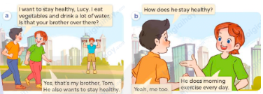  - Play the audio twice (sentence by sentence). Correct their pronunciation where necessary.  - Have Ss to practice the dialogue  - T invites a few pairs to the front of the class to practice.  - T checks pronunciation for ss.  Activity 3 Listen, point and say.  *Aims: Ss will be able to correctly say the phrases and use How does he / she stay healthy? - He / She ___. to ask and answer questions about someone’s lifestyle.  *Procedure:  * Structures:  - T asks Ss look at picture b in activity 1 and helps Ss know the structure from the dialogue.  - T introduces new structures for Ss.  - T explains, models and gives meaning.  - Have Ss repeat the model sentences.  A: How does he / she stay healthy?  B: He/ she does morning exercise every day.  3.Practice: (7’)  *Drill pictures  - Have Ss look at the pictures and say what they can see in the pictures.  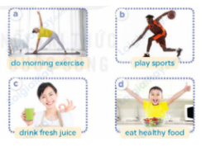  - Explain that in the answer we change in verb form  + do – does + play – plays  + drink – drinks + eat - eats  - Have Ss point at pictures, listen and run through all the pictures.  - Have Ss point at the bubbles, listen and run through model sentences.  - Have Ss to practise:  + T asks the first picture, Ss answer  + Ss asks the second picture, T answers  + Group A asks the third picture, group B  answers  + Group B asks the last picture, group A  - Ask Ss to work in pairs to practise asking and answering the question How does he / she stay healthy? - He / She ___.  - T controls and corrects.  - Invite a few pairs to point at the pictures and say the questions and answers in front of the class.  4. Production: (6’)  Activity 4. Let’s talk.  *Aims: Ss will be able to use How does your ____ stay healthy? - He / She ____. in a freer context  *Procedure:  - Draw Ss’ attention to the picture  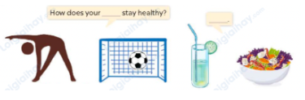  - Point at the ﬁrst building and elicit the question in the ﬁrst speech bubble How does your ____ stay healthy? Ex: sister, brother and the answer in the second speech he/ she ___ as an example.  - Give Ss time to work in pairs and take turns pointing at each picture to ask and answer using bubble How does your ____ stay healthy? He/ she___.  - Invite a few pairs to come to the front of the classroom and act out the exchanges.  5. Fun corner and wrap- up (4’)  Game: Musical cards  - Stick the cards on the board. Ask ss to say the words related to the cards.  - Hand out the cards to different ss around the class.  - Play the song and ask ss to pass the cards to the ss next to them while the music is playing.  - Stop the music suddenly. Invite a student to ask the question “How does she stay healthy?”. Ask a student who is holding the card to answer the question, ex: She drink fresh juice.  - Play the music again and repeat the activity.  - Ask ss to check their friends’ pronunciation. | - Sing and dance the song together.  - Ss listen and open their books  -Ss listen and answer  - - Ss listen and repeat  + Choral repetition (3 times).  + Individual repetition (3 ss)  - Ss take note  - Ss look, remember and write  -Look at the pictures and say.  + In picture a:  Nam: I want to stay healthy, Lucy. I eat vegetables and drink a lot of water. Is that your brother over there?  Lucy: Yes, that’s my brother, Tom. He also wants to stay healthy.  + In picture b:  Nam: How does he stay healthy? Lucy: He does morning exercise every day.  Nam: Nam: Yeah, me too.  -Ss listen and repeat in chorus (twice)  -Ss work in pairs to practice  -Ss come to the front of the classroom to practice.  -Ss listen  - Ss look at the picture and answer.  -Ss listen  -Ss listen and repeat  -Ss repeat to the structures  - Ss look, listen and repeat  +Picture a: a woman doing morning exercise  + Picture b: a man playing sports  + Picture c: a woman holding a glass of fresh juice  + Picture d: a boy with a bowl of healthy food  -Ss listen to the teacher’s instructions  -Ss point at pictures, listen and repeat  -Ss point at the bubbles, listen and repeat  -Ss practice in chorus  -Ss practice in chorus  -Ss work in pairs to practise asking and answering the question  - Pairs of Ss point at the pictures and say in front of the class  -Ss look at the picture and say  + activities people do to stay healthy and healthy food and  Drinks  - Ss look at the first building and elicit the missing words in speech bubbles and say the completed sentences.  - Ss role-play to practise asking and answering questions  - Ss practise asking and answering questions in front of the class.  - Ss listen  -Ss listen and play the game  -Ss continute playing the game
D. ADJUSTMENTS (if necessary):
………………………………………………………………………………………….…..……………………………………………………………………………...
---------------------------------------------------------------
Grade 5 : Lớp 5B : Sáng thứ năm, Ngày 27 tháng 02 năm 2025
ENGLISH
Unit 14: Staying healthy - Lesson 1 (4, 5, 6)
A. OBJECTIVES:
By the end of the lesson, Ss will be able to:
1. Knowledge:
- Listen to and understand four communicative contexts in which speakers ask and answer questions about a family member’s lifestyle and match the characters with the activities they do to stay healthy
- Complete four gapped exchanges with the help of picture cues
- Listen to and complete the song Staying healthy and sing it with the correct pronunciation, rhythm and melody.
- Vocabulary: Review
- Skills: speaking, listening, reading and writing.
2. Competences:
- Communication and collaboration: work in pairs and groups to complete the learning tasks.
- Self-control and independent learning: perform listening and reading tasks.
3. Attitude/ Qualities:
- Raise their knowledge of using healthy food and drink.
- Show their awareness of doing morning exercise regularly.
B. TEACHING AIDS:
- Teacher: Teacher’s guide Pages 225, 226, 227; audio Tracks 33, 34; website hoclieu.vn, posters, laptop, pictures, textbook, lesson plan, TV or projector.
- Students: Pupil’s book Page 25, notebooks, workbooks, school things.
C. PROCEDURES:
Teacher’s activities | Students’ activities
1.Warm- up and review: (5’)  Game: Lucky fruits  *Aims: to revise the learned sentence structures.  *Procedure:  - Tell ss they are going to look at the pictures and ask and answer the questions about how someone stays healthy.  - Divide the class into two groups.  - Have two ss from each group take turns to choose a fruit and ask and answer the question.  - If the group chooses a lucky fruit, they will get points and continue the next turn.  - Continue the game with the other pupils.  - The group that gets the most points wins. Praise the winner.  - Say “Open your book page 25” and look at “Unit 14, Lesson 1 (4,5,6)”.  2.Practice: (25’)  Activity 1. Listen and match:  *Aims: Ss will be able to listen to and understand four communicative contexts in which speakers ask and answer questions about a family member’s lifestyle and match the characters with the activities they do to stay healthy.  *Procedure:  - Elicit and ask questions to elicit the characters and the activities in the pictures.  + What can you see in this picture?  + Where are they?  + What do they do?  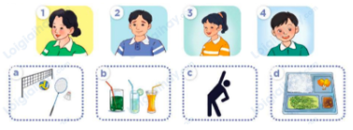  - T ask Ss to guess the answers.  + T writes Ss’guessing on the board.  - Listen to the tape:  + Play the recording  + Play the recording again for pupils to do the task.  + Play the recording a third time for pupils to check their answers.  - Get Ss to swap books with their partner, then check answers as a class.  + Write the answers on the board for Ss to correct their answers. Then checks Ss’ guessing.  - If time allows, play the recording, sentence by sentence, for Ss to listen and repeat individually and in chorus Key: 1. b 2. c 3. b 4. d  Activity 2. Read and complete.  *Aims: Ss will be able to complete four gapped exchanges with the help of picture cues.  *Procedure:  - Have Ss read the question and answer, and guess the missing word  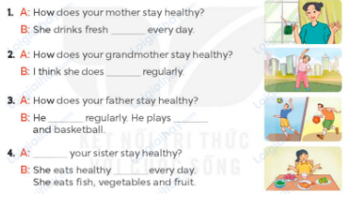  - Have Ss look at the four incomplete exchanges and elicits the missing words in the sentences.  - T models with sentence 1  + Have Ss look at the picture and identify the needed information (juice).  - Have Ss work in groups and complete the exchanges 2, 3 and 4.  - Get Ss to swap books with a partner and check their answers before checking as a class.  - Invite four pairs of Ss to act out the four completed exchanges in front of the class  Key:  1. juice  2. morning exercise  3. plays sports; volleyball  4. How does; food  Activity 3. Listen, complete and sing.  *Aims: Ss will be able to listen to and complete the song Staying healthy and to sing it with the correct pronunciation, rhythm and melody.  *Procedure:  - Introduce the title and lyrics of the song: “Staying healthy”  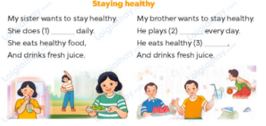  - Tell ss the aim of the activity  - Draw ss’ attention to the gapped sentences and guess the missing words and complete the sentences.  - Play the recording all the way through for ss to listen to the whole song.  - Play the recording again for them to fill in the gaps with the missing words.  - Check answers together as a class.  - Play the recording line by line for ss to listen and repeat.  - Invite a few groups to the front of the class to sing the song.  Key: 1. morning exercise  2. sports 3. fruit  3. Fun corner and wrap- up (5’)  Game: Pass the ball  - T gives Ss a ball.  - T asks Ss to listen to music and transfer a ball around the class.  - When the music stops, Ss who keep a ball have to answer the question using: How does he/ she stay healthy? and he/ she………..  - T gives feedback. | - Ss listen  - Ss play the game  - Ask and answer the question  Ex:  A: How does your sister stay healthy?  B: She drink fresh juice  - Continue playing the game.  - Ss open their books  -Look at the pictures and say:  a. a mother  b. a father  c. a sister  d. a brother  1. sports  2. fresh juice  3. morning exercise  4. healthy food  -Ss guess the answers  - Ss listen to the tape  - Ss listen again and do the task.  - Ss listen and check their answers  - Ss swap books with their partner, then check answers as a class  - Ss check the guessing  -Ss listen and repeat  -Ss look at the picture and read and guess  -Ss look and follow the teacher demonstrating the exchange 1.  -Ss answer: (She drinks fresh juice every day.  -Ss complete the sentences  -Ss swap books with a partner and check their answers before checking as a class.  -Ss read the completed exchanges aloud.  - Ss listen  -Ss listen to the song  - Ss listen to the teacher’s instruction.  - Ss look at the gapped sentences and guess the missing words and complete the sentences.  - Ss listen to the song  - Ss listen and fill in the gaps with missing words.  - Ss check answers together as a class.  - Ss listen to the recording, line by line, and repeat.  - Ss come to the front of the class to sing the song.  -Ss listen  -Ss play a game  - Ss continue playing the game.  -Ss praise the winner
D. ADJUSTMENTS (if necessary):
………………………………………………………………………………………….…..……………………………………………………………………………...

Duyệt bài, Ngày 21 tháng 02 năm 2025
Phó hiệu trưởng

Nguyễn Thị Hằng

