ĐĂNG KÝ GIẢNG DẠY TUẦN 22 ( Từ ngày 17-21/02/2025)

Thứ  Ngày | Buổi | Lớp | Tiết | Môn | Tên bài
Hai | Chiều | 4B | 1 | English | Unit 13: Appearance - Lesson 1 (1,2,3)
 |  | 4B | 2 | English | Unit 13: Appearance - Lesson 1 (4,5,6)
Ba | Sáng | 4A | 1 | English | Unit 13: Appearance - Lesson 1 (1,2,3)
 |  | 4A | 2 | English | Unit 13: Appearance - Lesson 1 (4,5,6)
 |  | 5B | 1 | English | Unit 13: Our special days  Lesson 1 (1,2,3)
 |  | 5B | 2 | English | Unit 13: Our special days  Lesson 1 (4,5,6)
 | Chiều |  | 1
 |  | 3A | 2 | English | Unit 13: My house - Lesson 1 (1,2,3)
 |  | 3A | 3 | English | Unit 13: My house - Lesson 1 (4,5,6)
Tư | Sáng | 4C | 1 | English | Unit 13: Appearance - Lesson 1 (1,2,3)
 |  | 4C | 2 | English | Unit 13: Appearance - Lesson 1 (4,5,6)
 |  | 4B | 3 | English | Unit 13: Appearance - Lesson 2 (1,2,3)
 |  | 4B | 4 | English | Unit 13: Appearance - Lesson 2 (4,5,6)
Năm | Sáng | 4C | 1 | English | Unit 13: Appearance - Lesson 2 (1,2,3)
 |  | 4C | 2 | English | Unit 13: Appearance - Lesson 2 (4,5,6)
 |  | 5B | 3 | English | Unit 13: Our special days  Lesson 2 (1,2,3)
 |  | 5B | 4 | English | Unit 13: Our special days  Lesson 2 (4,5,6)
Sáu | Sáng | 3A | 1 | English | Unit 13: My house - Lesson 2 (1,2,3)
 |  | 3A | 2 | English | Unit 13: My house - Lesson 2 (4,5,6)
 |  | 4A | 3 | English | Unit 13: Appearance - Lesson 2 (1,2,3)
 |  | 4A | 4 | English | Unit 13: Appearance - Lesson 2 (4,5,6)
Duyệt bài, Ngày 14 tháng 02 năm 2025
Phó hiệu trưởng

Nguyễn Thị Hằng
WEEK 22
Grade 3: Lớp 3A: Chiều thứ ba ngày 18 tháng 02 năm 2025
ENGLISH
Unit 13: My house - Lesson 1 (1, 2, 3)
A. OBJECTIVES:
By the end of the lesson, Ss will be able to:
1. Knowledge:
–Use the words living room, bedroom, kitchen, bathroom, here, there
–Use Where’s the……….? – It’s here/ there. to ask and answer questions about the location of a room in a house
- Vocabulary: living room, bedroom, kitchen, bathroom, here, there
- Model sentences:
A: Where’s the……….?B: It’s here/ there.
- Skills: speaking and listening
2. Competences:
- Critical Thinking: talk about house
- Co-operation: ready to help friends in pair work/ group work.
- Sociability: Talk to each other, say good words to others.
3. Attitude/ Qualities:
- Kindness: Help partners to complete learning tasks.
- Honesty: tell the truth about feelings and emotions
B. TEACHING AIDS:
- Teacher: Teacher’s guide Pages 161, 162, audio Tracks 22, 23, website sachmem.vn, posters, laptop, pictures, textbook, lesson plan, TV or projector.
- Students: Pupil’s book Page 18, notebooks, workbooks, school things.
C. PROCEDURES:
Teacher’s activities | Students’ activities
1.Warm- up: (3’)  Game: jigsaw puzzle  *Aims: to create a friendly and active atmosphere in the class to beginning the lesson.  *Procedure:  - Divide class into 4 groups: Doreamon, Nobita, Xuka and Xeko.  - Ask Ss look at the pieces of picture.  - Ask Ss go to the board and jigsaw puzzle into the correct picture  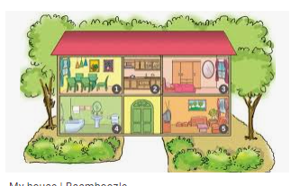  -T checks who’s the winner?  - Ask Ss look at the pieces of picture  - Say “Open your book page 18” and look at “Unit 13, Lesson 1 (1,2,3)”.  2. Presentation(16’)  Activity 1. Vocabulary.  *Aims: Ss will be able to know the vocabulary in front of starting the new lesson.  *Procedure:  -T elicits the new words  + living room : phòng khách  (picture)  + bedroom : phòng ngủ (situation)  + kitchen : phòng bếp (picture)  + bathroom : phòng tắm (picture)  + house : ngôi nhà (translation)  + here : ở đây (situation)  + there : ở kia (translation)  - T models (3 times).  - T writes the words on the board.  - Checking: Rub out and remember  Activity 2. Listen, point and repeat:  *Aims: Ss will be able to understand and correctly repeat the sentences in two communicative contexts (pictures) focusing on asking and answering about the location of a room in a house.  *Procedure:  - Have Ss look at Pictures a and b and identify the characters in the pictures.  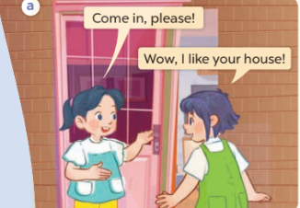  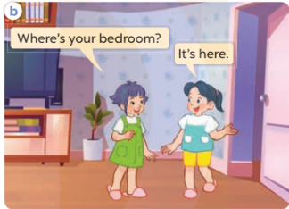  - Play the audio twice (sentence by sentence). Correct their pronunciation where necessary.  - Have Ss to practice the dialogue  - T invites a few pairs to the front of the class to practice.  - T checks pronunciation for ss.  Activity 3 Listen, point and say.  *Aims: Ss will be able to correctly say the words and use Where’s the……..? − It’s here / there. to ask and answer questions about the location of a room in a house.  *Procedure:  * Model sentences:  - T asks Ss look at picture a , b and helps Ss know the structure from the dialogue.  - T introduces new structure for Ss.  - T explains, models and gives meaning.  -Have Ss repeat the model sentences.  A: Where’s the bedroom?  B: It’s here/ there.  3.Practice: (7’)  *Drill pictures  - Elicit and check comprehension the name of the rooms.  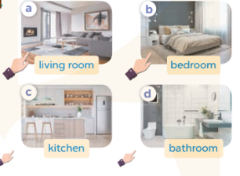  - Run through all the pictures.  - Run through model sentences.  + Run through the questions.  + Run through the answers  - Have Ss to practise:  + T says asks and Ss answer (change role).  + Ss – Ss (change role).  - Ask Ss to work in pairs.  - T controls and corrects.  - Invite a few pairs to come to the front of the classroom, point at the relevant character in each picture, and act out his/her role.  - Encourage Ss to practise speaking English.  - T gives feedbacks.  4.Production: (7’)  Activity 4. Let’s talk.  *Aims: Ss will be able to enhance the correct use of Where’s the……? − It’s here / there. to ask and answer questions about the location of a room in a house in a freer context.  *Procedure:  - T asks ss to guess each character and what the children say.  + What can you see in the picture?  +How many rooms are there in the picture?  +What rooms are they?  +Where’s the ……….?  - T fills the gaps and writes the sentences on the board.  - T models  - T asks Ss to work in pairs to ask and answer  - Invite some pupils to the front of the class to present their exchanges.  - Give feedbacks  *Consolidation  *Aims: Ss will be able consolidate and wrap up the content of the lesson.  *Procedure:  - T asks ss to answer the following questions:  + What have you learnt from the lesson today?  - T review the vocabulary and model sentences.  - T praises some Ss who are hardworking / active/ good…. as well as encourage others to try more.  5. Homework. (2’)  - Learn the number by heart  - Prepare the new lesson: Unit 13, Lesson 1 (4,5,6). | - Ss listen  - Ss play the game  - Ss open their books  -Ss listen and answer  - - Ss listen and repeat  + Choral repetition (3 times).  + Individual repetition (3 ss)  - Ss take note  - Ss look, remember and write  -Look at the pictures and get to know the characters in the pictures.  + Mai says Come in, please!Linh says Wow, I like your house! in picture a.  + Linh asks Where’s your bedroom? Mai answers It’s here. in picture b.  -Ss listen and repeat in chorus (twice)  -Ss work in pairs to practice  -Ss practice the dialogue  -Ss listen  -Ss look at the picture and answer.  -Ss listen  -Ss listen and repeat  -Ss repeat  - Ss look, listen and repeat  -Ss practice in chorus  -Ss work in pairs to practice  -Ss point and say  -Ss listen.  -Ss listen  -Ss look at the picture and answer  +I can see a house  + There are four rooms  + They are living room, kietchen, bedroom, bathroom.  + It’s here/ there  -Ss note  - Ss say the completed sentences.  -Ss work in pairs  -Ss perform in front of the class.  -Ss answer the questions  - Ss listen  -Ss listen and clap their hands  -Ss listen and take note
D. ADJUSTMENTS (if necessary):
………………………………………………………………………………………….…..……………………………………………………………………………...
---------------------------------------------------------------
Grade 3: Lớp 3A: Chiều thứ ba ngày 18 tháng 02 năm 2025
ENGLISH
Unit 13: My house - Lesson 1 (4, 5, 6)
A. OBJECTIVES:
By the end of the lesson, Ss will be able to:
1. Knowledge:
- Listen to and understand simple exchanges in relation to the topic “My house”
- Read and write about the location of rooms in a house and things in a room.
- Vocabulary: Review
- Skills: speaking, listening, reading and writing.
2. Competences:
- Co-operation: ready to help friends in pair work/ group work.
- Self-control and independent learning: perform listening tasks.
3. Attitude/ Qualities:
- Kindness: Help partners to complete learning tasks.
- Honesty: tell the truth about feelings and emotions.
- Diligence: complete learning tasks.
B. TEACHING AIDS:
- Teacher: Teacher’s guide Pages 163, 164; audio Tracks 24, 25; website sachmem.vn, posters, laptop, pictures, textbook, lesson plan, TV or projector.
- Students: Pupil’s book Page 19, notebooks, workbooks, school things.
C. PROCEDURES:
Teacher’s activities | Students’ activities
1.Warm- up: (5’)  Game: “Passing the ball”  *Aims: to create a friendly and active atmosphere in the class to beginning the lesson.  *Procedure:  - Divide class into 3 teams.  - Each team has 1 sticky ball.  - Play the music, ss in each team take turn to pass the ball.  - After the music ends, 3 ss have the ball – stand up and say the name, using the sentence model.  - Say “Open your book page 19” and look at “Unit 13, Lesson 1 (4,5,6)”.  2.Practice: (27’)  Activity 1. Listen and circle:  *Aims: Ss will be able to listen to and understand two communicative contexts in which pupils ask and answer questions about the location of a room in a house and circle the correct pictures  *Procedure:  - Elicit the name of the room in each picture 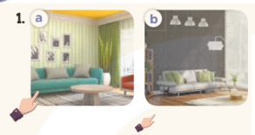  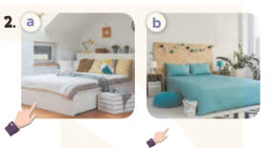  - T ask Ss to guess the answers.  + T writes Ss’guessing on the board.  - Listen to the tape:  + Play the recording  + Play the recording again and get Ss to swap books with their partners.  + Play the recording again to check answers together as a class.  + Write the answers on the board for Ss to correct their answers. Then checks Ss’ guessing.  - Play the recording, sentence by sentence, for the class to listen and repeat in chorus.  Key: 1.a 2.b  Activity 2. Look, complete and read.  *Aims: Ss will be able to complete four gapped exchanges with the help of picture cues.  *Procedure:  - Have Ss look at the pictures and identify the rooms (a living room, a kitchen, a bathroom and a bedroom).  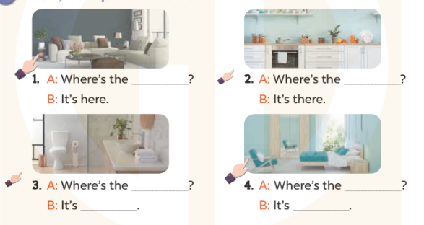  - Have Ss look at the four incomplete exchanges and elicits the missing words in the sentences.  - T models with sentence 1  + Ask Ss what is missing in the sentence.  + Have Ss look at the picture and complete the gap, then read the completed sentence in chorus.  -Have Ss work in groups and complete the sentences 2,3 and 4.  - Ask a few Ss to stand up and read the completed sentences aloud.  -T gives feedbacks.  Key:  1. living room 2. kitchen  3. bathroom; there 4. bedroom; here  Activity 3. Let’s sing.  *Aims: Ss will be able to sing the song Where is it? with the correct melody and pronunciation.  *Procedure:  - Introduce the title and lyrics of the song: “Where is it? ” song.  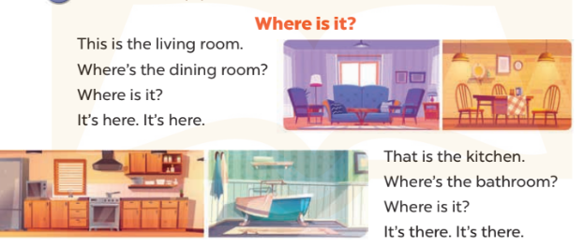  - Play the recording for Ss to listen to the whole song.  + Have them repeat the title and lyrics line by line.  + Tell Ss to point at the relevant character while singing his or her name.  - Play the recording all the way through for Ss to listen to pronunciation and melody of the song.  - Play the recording line by line for Ss to listen, repeat and point at the relevant character.  - Play the recording for Ss to sing and do actions.  - Ask Ss to practice singing and doing actions in pairs or groups.  - Invite groups to the front of the classroom to perform the song  -T gives feedback.  *Consolidation  *Aims: Ss will be able consolidate and wrap up the content of the lesson.  *Procedure:  - T asks ss to answer the following questions:  + What have you learnt from the lesson today?  +What are the core values of the lesson? (if the teacher can take from the lesson).  - T praises some Ss who are hardworking / active/ good…. as well as encourage others to try more.  3. Homework. (3’)  - Learn the number by heart  - Prepare the new lesson: Unit 13, Lesson 2 (1,2,3). | - Ss listen and keep the puppet  - Ss listen to music and play the game  -Ss listen  - Ss open their books  -Look at the pictures and say:  + Picture 1a: a hand pointing at a nearby living room  + Picture 1b: a hand pointing at distant living room  + Picture 2a: a hand pointing at a nearby bedroom  + Picture 2b: a hand pointing at a distant bedroom  -Ss guess the answers  - Ss listen to the tape and circle  - Ss listen again, circle and swap books with their partners.  - Ss check their answers and guessing  -Ss listen and repeat.  -Ss look at the picture and say:  -Ss look and answer  -Ss answer: living room  -Ss look, complete and read the completed sentence in chorus.  -Ss complete the sentence  -Ss read aloud  - Ss look and listen.  -Ss listen to the song  - Ss listen and repeat line by line without the action.  -Ss point to the character while singing  -Ss listen to melody of the song  - Ss listen and sing line by line.  - Ss sing and do actions.  + Ss work in groups (two groups) to sing.  -Ss perform in front of the class.  -Ss listen  -Ss answer the questions  -Ss listen and clap their hands  -Ss listen and take note
D. ADJUSTMENTS (if necessary):
………………………………………………………………………………………….…..……………………………………………………………………………...
-----------------------------------------------------------------
Grade 3: Lớp 3A: Sáng thứ sáu, ngày 21 tháng 02 năm 2025
ENGLISH
Unit 13: My house- Lesson 2 (1, 2, 3)
A. OBJECTIVES:
By the end of the lesson, Ss will be able to:
1. Knowledge:
- use the words table, chair, book, lamp, in and on in the target sentence patterns
- use Where are the…..? – They’re……. to ask and answer questions about the locations of things in a room
- Vocabulary: table, chair, book, lamp, in, on
- Model sentences:
A: Where are the tables?
B: They’re in the living room.
- Skills: speaking and listening
2. Competences:
- Critical Thinking: talk about house
- Co-operation: ready to help friends in pair work/ group work.
- Oral Communication: speak about someone, ask and answer the questions
3. Attitude/ Qualities:
- Kindness: Help partners to complete learning tasks.
- Honesty: tell the truth about feelings and emotions
B. TEACHING AIDS:
- Teacher: Teacher’s guide Pages 165, 166; audio Tracks 26,27, website sachmem.vn, posters, laptop, pictures, textbook, lesson plan, TV or projector.
- Students: Pupil’s book Page 20, notebooks, workbooks, school things.
C. PROCEDURES:
Teacher’s activities | Students’ activities
1.Warm- up: (3’)  Game: Guess the pictures  *Aims: to create a friendly and active atmosphere in the class to beginning the lesson.  *Procedure:  - Write any word on the board.  - The first pupil has to take the last four or three letters of that word and form a new word.  - The second pupil does the same, and the chain continues until a pupil is unable to form a word.  - The pupil who fails to form a word or misspells it is out of the game.  - Say “Open your book page 20” and look at “Unit 13, Lesson 2 (1,2,3)”.  2. Presentation(16’)  Activity 1. Vocabulary.  *Aims: Ss will be able to know the vocabulary in front of starting the new lesson.  *Procedure:  -T elicits the new words  + table : cái bàn (realia)  + chair : cái ghế (realia)  + lamp : cái đèn (picture)  + on : trên (visual)  + in : trong (visual)  - T models (3 times).  - T writes the words on the board.  - Checking: Rub out and remember  Activity 2. Listen, point and repeat:  *Aims: Ss will be able to understand and correctly repeat the sentences in two communicative contexts (pictures) to to ask and answer questions about the locations of things in a room.  *Procedure:  - Have Ss look at Pictures a and b and identify the characters in the pictures.  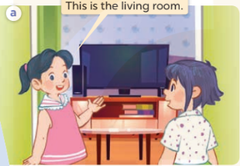  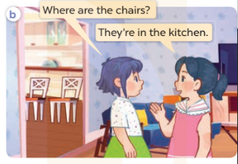  - Play the audio twice (sentence by sentence). Correct their pronunciation where necessary.  - Have Ss to practice the diaguage  - T invites a few pairs to the front of the class to practice.  - T checks pronunciation for ss.  Activity 3. Listen, point and say.  *Aims: Ss will be able to correctly say the words and use Where are the….? – They’re ……. to ask and answer questions about the locations of things in a room.  *Procedure:  * Model sentences:  - T asks Ss look at picture b and helps Ss know the structure from the dialogue.  - T introduces new structure for Ss.  - T explains, models and gives meaning.  - Have Ss repeat the model sentences.  A: Where are the tables?  B: They’re in the living room.  3.Practice: (7’)  *Drill pictures  - Elicit and check comprehension the name of each character.  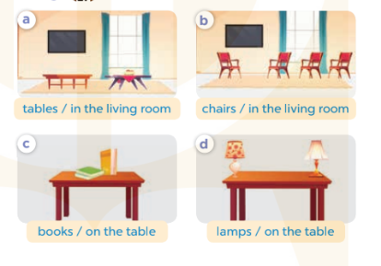  - Run through all the pictures.  - Run through model sentences.  +Run through the question sentences  +Run through the answer sentences  - Have Ss to practise:  + T asks, Ss answer picture a  + Ss ask, T answers picture b  + Group A ask, group B answer picture c  + Group B ask, group A answer picture d  - Ask Ss to work in pairs.  - T controls and corrects.  - Invite a few pairs to come to the front of the classroom, point at the relevant character in each picture, and act out his/her role.  - T gives feedbacks.  4.Production: (7’)  Activity 4. Let’s talk.  *Aims: Ss will be able to enhance the correct use of Where are the ….? – They’re…….. to ask and answer questions about the locations of things in a room in a freer context.  *Procedure:  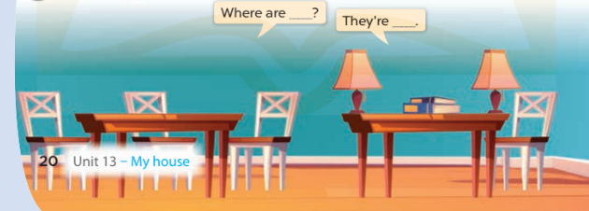  - T asks ss to attend to the picture.  + What can you see in the picture?  +What are they?  +Where are they?  - T fills the gaps and writes the sentences on the board.  - T models  - T asks Ss use of Where are…..? and They’re ……. to ask and answer (groups of four)  - Invite some groups to perform.  - Give feedbacks  *Consolidation  *Aims: Ss will be able consolidate and wrap up the content of the lesson.  *Procedure:  - T asks ss to answer the following questions:  + What have you learnt from the lesson today?  +What are the core values of the lesson? (if the teacher can take from the lesson).  - T review the vocabulary and model sentences.  - T praises some Ss who are hardworking / active/ good…. as well as encourage others to try more.  5. Homework. (2’)  - Learn the number by heart  - Prepare the new lesson: Unit 13, Lesson 2 (4,5,6). | - Ss listen  - Ss play the game  - Ss open their books  -Ss listen and answer  - - Ss listen and repeat  + Choral repetition (3 times).  + Individual repetition (3 ss)  - Ss take note  - Ss look, remember and write  -Look at the pictures and get to know the characters in the pictures.  + In picture a: Mai says This is the living room.  – In picture b: Linh asks Where are the chairs? And Mai answers They’re in the kitchen.  -Ss listen and repeat in chorus (twice)  -Ss work in pairs to practice  -Ss practice the diaguage  -Ss listen  -Ss look at the picture and answer.  -Ss listen  -Ss listen and repeat  -Ss repeat  - Ss look, listen and answer  + Picture a: a. tables in the living room  + Picture b: chairs in the living room  + Picture c: books on the table  + Picture d: lamps on the table  -Ss practice in chorus  - Ss practice in chorus  -Ss work in pairs to practice  -Ss listen  -Ss go to the board and role play.  -Ss listen  -Ss look at the picture and answer  + two tables, four chairs, two books and two lamps on a table  -Ss note  - Ss say the completed sentences.  -Ss work in groups  -Ss perform in front of the class.  -Ss answer the questions  - Ss listen  -Ss listen and clap their hands  -Ss listen and take note
D. ADJUSTMENTS (if necessary):
………………………………………………………………………………………….…..……………………………………………………………………………...
---------------------------------------------------------
Grade 3: Lớp 3A: Sáng thứ sáu, ngày 21 tháng 02 năm 2025
ENGLISH
Unit 13: My house - Lesson 2 (4, 5, 6)
A. OBJECTIVES:
By the end of the lesson, Ss will be able to:
1. Knowledge:
- Listen to and understand simple exchanges in relation to the topic “My house”
- Read and write about the location of rooms in a house and things in a room.
- Vocabulary: Review
- Skills: speaking, listening, reading and writing.
2. Competences:
- Critical Thinking: talk about rooms in a house and things in a room.
- Co-operation: ready to help friends in pair work/ group work.
- Self-control and independent learning: perform listening tasks.
3. Attitude/ Qualities:
- Kindness: Help partners to complete learning tasks.
- Honesty: tell the truth about feelings and emotions.
- Diligence: complete learning tasks.
B. TEACHING AIDS:
- Teacher: Teacher’s guide Pages 167, 168; audio Tracks 28; website sachmem.vn, posters, laptop, pictures, textbook, lesson plan, TV or projector.
- Students: Pupil’s book Page 21, notebooks, workbooks, school things.
C. PROCEDURES:
Teacher’s activities | Students’ activities
1.Warm- up: (5’)  Sing a song: “My house”  *Aims: to create a friendly and active atmosphere in the class to beginning the lesson.  *Procedure:  - Show the song on the screen.  https://www.youtube.com/watch?v=qZyJPZxsmZk  - Ask pupils to listen, sing and dance the song.  - Say “Open your book page 21” and look at “Unit 13, Lesson 2 (4,5,6)”.  2.Practice: (27’)  Activity 1. Listen and number:  *Aims: Ss will be able to listen to and understand four communicative contexts in which two characters ask and answer questions about the locations of things in a room and number the correct pictures.  *Procedure:  - Elicit the names and ages of the characters in the pictures.  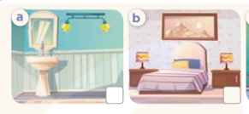  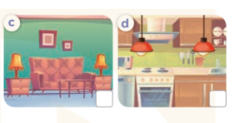  - T ask Ss to guess the answers.  + T writes Ss’guessing on the board.  - Listen to the tape:  + Play the recording  + Play the recording again and get Ss to swap books with their partners.  + Play the recording again to check answers together as a class.  + Write the answers on the board for Ss to correct their answers. Then checks Ss’ guessing.  - Play the recording, sentence by sentence, for the class to listen and repeat in chorus.  Key: 1.c 2. d 3. a 4. b  Activity 2. Look, circle and read.  *Aims: Ss will be able to circle the correct answers to the gapped exchanges with the help of picture cues.  *Procedure:  - Have Ss look at the pictures and identify the rooms and things in the pictures.  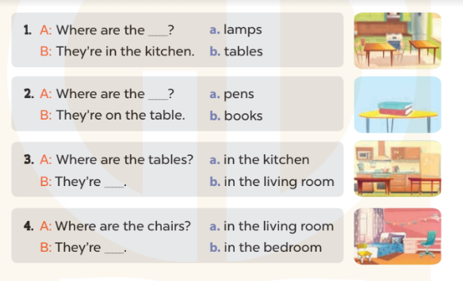  - T models with sentence 1.  + Have Ss look at the sentence.  + Ask them what is missing in the answer (tables).  + Have Ss circle the correct options  + Have Ss read the completed sentence in chorus.  -Have Ss work in pairs and circle the sentences 2, 3 and 4.  - Invite pairs of pupils to stand up and read aloud the sentences.  -T gives feedbacks.  Key: 1. b 2. b 3. a 4. b  Activity 3. Let’s play.  *Aims: Ss will be able to review vocabulary and structure words in relation to the topic “My house” and use them in the sentence patterns Where’s…….? − It’s here / there. and Where are …….?– They’re ……. by playing the game Bingo.  *Procedure:  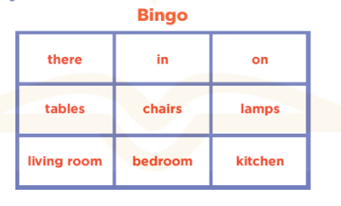  - Explain how to play the game:  + Draw a 3 x 3 Bingo grid on the board and a list of the vocabulary words for reviewing.  + Get Ss to copy the grid onto a paper sheet and fill their grids with the vocabulary words.  + Ss need to listen carefully for the words that you’ll be calling out from the list on the board. If they have a word that is called out, then they need to cross it out on their grids.  + Eventually, one pupil will have crossed out all of his or her words and should out “Bingo!” to show that he / she has finished.  - Give Ss time to play the game in pairs or groups.  - When time runs out, invite a few pairs to stand up and take turns asking and answering questions using the sentence patterns Where’s …….? − It’s here / there. and Where are …….? – They’re…….  *Consolidation  *Aims: Ss will be able consolidate and wrap up the content of the lesson.  *Procedure:  - T asks ss to answer the following questions:  + What have you learnt from the lesson today?  +What are the core values of the lesson? (if the teacher can take from the lesson).  - T praises some Ss who are hardworking / active/ good…. as well as encourage others to try more.  3. Homework. (3’)  - Prepare the new lesson: Unit 13, Lesson 3 (1,2,3). | - Sing and dance the song in chorus.  - Ss open their books  -Look at the pictures and say:  + Picture a: two lamps in the bathroom  + Picture b: two lamps in the bedroom  + Picture c: two lamps in the living room  + Picture d: two lamps in the kitchen  -Ss guess the answers  - Ss listen to the tape and write number  - Ss listen again, write number and swap books with their partners.  - Ss check their answers and guessing  -Ss listen and repeat.  -Ss look at the pictures and say  -Ss listen and answer  -Ss read and complete  -Ss work in pairs  -Ss read  - Ss listen  -Ss play the game  - Ss play the game  -Ss listen and answer  -Ss listen and take note

D. ADJUSTMENTS (if necessary):
………………………………………………………………………………………….…..……………………………………………………………………………...
---------------------------------------------------------------
Grade 4: Lớp 4A: Sáng thứ Ba, Ngày 18 tháng 02 năm 2025
Lớp 4B: Chiều thứ Hai, Ngày 17 tháng 02 năm 2025
Lớp 4C: Sáng thứ tư , Ngày 19 tháng 02 năm 2025
ENGLISH
Unit 13: Appearance - Lesson 1 (1, 2, 3)
A. OBJECTIVES:
By the end of the lesson, Ss will be able to:
1. Knowledge:
- Use the words and phrases big, short, slim, tall in relation to the topic "Appearance”
- Use What does he / she look like? – He's / She's ……. to ask and answer questions about someone’s appearance;
- Vocabulary: short, slim, tall, look like
- Model sentences:
A: What does he/ she look like?
B: He’s/ She’s tall.
- Skills: speaking and listening
2. Competences:
- Co-operation: ready to help friends in pair work/ group work.
- Sociability: Talk to each other, say good words to others.
3. Attitude/ Qualities:
- Kindness: Help partners to complete learning tasks.
- Honesty: tell the truth about feelings and emotions
B. TEACHING AIDS:
- Teacher: Teacher’s guide Pages 183, 84, audio Tracks 21, 22, website hoclieu.vn, posters, laptop, pictures, textbook, lesson plan, TV or projector.
- Students: Pupil’s book Page 18, notebooks, workbooks, school things.
C. PROCEDURES:
Teacher’s activities | Students’ activities
1.Warm- up: (3’)  Game: jigsaw puzzle  *Aims: to create a friendly and active atmosphere in the class to beginning the lesson.  *Procedure:  - Divide class into 4 groups: Doreamon, Nobita, Xuka and Xeko.  - Ask Ss look at the pieces of picture.  - Ask Ss go to the board and jigsaw puzzle into the correct picture  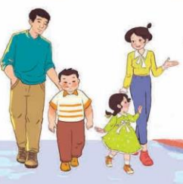  -T checks who’s the winner?  - Ask Ss look at the pieces of picture  - Say “Open your book page 18” and look at “Unit 13, Lesson 1 (1,2,3)”.  2. Presentation (16’)  Activity 1. Vocabulary.  *Aims: Ss will be able to know the vocabulary in the new lesson.  *Procedure:  -T elicits the new words  + short : thấp, ngắn (picture)  + slim : mảnh mai (situation)  + tall : cao (picture)  + look like : trông như (translation)  - T models (3 times).  - T writes the words on the board.  - Checking: Rub out and remember  Activity 2. Look, listen and repeat:  *Aims: Ss will be able to understand and correctly repeat the sentences in two communicative contexts focusing on asking and answering questions about someone’s appearance.  *Procedure:  - Have Ss look at Pictures a and b and identify the characters in the pictures.  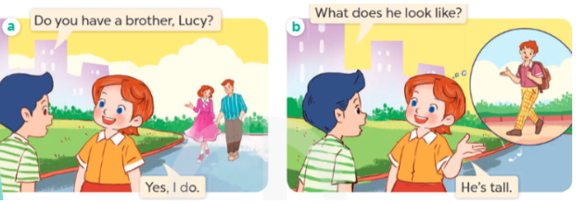  - Play the audio twice (sentence by sentence). Correct their pronunciation where necessary.  - Have Ss to practice the dialogue  - T invites a few pairs to the front of the class to practice.  - T checks pronunciation for ss.  Activity 3 Listen, point and say.  *Aims: Ss will be able to correctly say the words and use What does he / she look like? – He’s / She’s ….. to ask and answer questions about someone’s appearance *Procedure:  * Model sentences:  - T asks Ss look at picture b and helps Ss know the structure from the dialogue.  - T introduces new structure for Ss.  - T explains, models and gives meaning.  -Have Ss repeat the model sentences.  A: What does he/ she look like?  B: He’s/ She’s tall.  3.Practice: (7’)  *Drill pictures  - Elicit and check comprehension the appearance  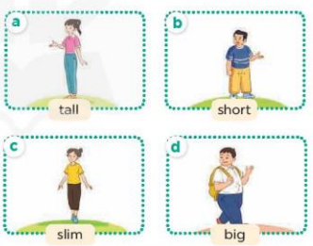  - Run through all the pictures.  - Run through model sentences.  + Run through the questions.  + Run through the answers  - Have Ss to practise:  + T says asks and Ss answer (change role).  + Ss – Ss (change role).  - Ask Ss to work in pairs.  - T controls and corrects.  - Invite a few pairs to come to the front of the classroom, point at the relevant character in each picture, and act out his/her role.  - Encourage Ss to practise speaking English.  - T gives feedbacks.  4.Production: (7’)  Activity 4. Let’s talk.  *Aims: Ss will be able to enhance the correct use of What does he / she look like? – He’s / She’s …….. to ask and answer questions about someone’s appearance in a freer context.  *Procedure:  - T asks ss to guess each  + What can you see in the picture?  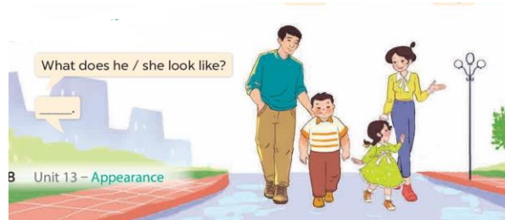  - T fills the gaps and writes the sentences on the board.  - T models  - T asks Ss to work in pairs to ask and answer  - Invite some pupils to the front of the class to present their exchanges.  - Give feedbacks  *Consolidation  *Aims: Ss will be able consolidate and wrap up the content of the lesson.  *Procedure:  - T asks ss to answer the following questions:  + What have you learnt from the lesson today?  - T review the vocabulary and model sentences.  - T praises some Ss who are hardworking / active/ good…. as well as encourage others to try more.  5. Homework. (2’)  - Learn the number by heart  - Prepare the new lesson: Unit 13, Lesson 1 (4,5,6). | - Ss listen  - Ss play the game  - Ss open their books  -Ss listen and answer  - - Ss listen and repeat  + Choral repetition (3 times).  + Individual repetition (3 ss)  - Ss take note  - Ss look, remember and write  -Look at the pictures and get to know the characters in the pictures.  + Picture a  Nam: Do you have a brother, Lucy? Lucy: Yes, I do  + Picture b  Nam: What does he look like?  Lucy: He’s tall.  -Ss listen and repeat in chorus (twice)  -Ss work in pairs to practice  -Ss practice the dialogue  -Ss listen  -Ss look at the picture and answer.  -Ss listen  -Ss listen and repeat  -Ss repeat  - Ss look, listen and repeat  -Ss practice in chorus  -Ss practice in chorus  -Ss practice in chorus  -Ss work in pairs to practice  -Ss listen to the teacher  -Ss point and say  -Ss listen.  -Ss listen  -Ss look at the picture and answer  +I can see a family of four people with different appearances  -Ss note  - Ss say the completed sentences.  -Ss pay attention  -Ss work in pairs  -Ss perform in front of the class.  -Ss answer the questions  - Ss listen  -Ss listen and clap their hands  -Ss listen and take note
D. ADJUSTMENTS (if necessary):
………………………………………………………………………………………….…..……………………………………………………………………………...
-------------------------------------------------------------------
Grade 4: Lớp 4A: Sáng thứ Ba, Ngày 18 tháng 02 năm 2025
Lớp 4B: Chiều thứ Hai, Ngày 17 tháng 02 năm 2025
Lớp 4C: Sáng thứ tư , Ngày 19 tháng 02 năm 2025
ENGLISH
Unit 13: Appearance - Lesson 1 (4, 5, 6)
A. OBJECTIVES:
By the end of the lesson, Ss will be able to:
1. Knowledge:
- Use the words and phrases big, short, slim, tall in relation to the topic "Appearance"
- Listen to and demonstrate understanding of simple communicative contexts in relation to the topic “Appearance
- Vocabulary: Review
- Skills: speaking, listening, reading and writing.
2. Competences:
- Co-operation: ready to help friends in pair work/ group work.
- Self-control and independent learning: perform listening tasks.
3. Attitude/ Qualities:
- Kindness: Help partners to complete learning tasks.
- Honesty: tell the truth about feelings and emotions.
- Diligence: complete learning tasks.
B. TEACHING AIDS:
- Teacher: Teacher’s guide Pages 186, 187; audio Tracks 23, 24; website hoclieu.vn, posters, laptop, pictures, textbook, lesson plan, TV or projector.
- Students: Pupil’s book Page 19, notebooks, workbooks, school things.
C. PROCEDURES:
Teacher’s activities | Students’ activities
1.Warm- up: (5’)  Game: “Passing the ball”  *Aims: to create a friendly and active atmosphere in the class to beginning the lesson.  *Procedure:  - Divide class into 3 teams.  - Each team has 1 sticky ball.  - Play the music, ss in each team take turn to pass the ball.  - After the music ends, 3 ss have the ball – stand up and say the name, using the sentence model.  - Say “Open your book page 19” and look at “Unit 13, Lesson 1 (4,5,6)”.  2.Practice: (27’)  Activity 1. Listen and tick:  *Aims: Ss will be able to listen to and understand two communicative contexts in which characters ask and answer questions about a family member’s appearance, and tick the correct pictures.  *Procedure:  - Elicit the name of the room in each picture 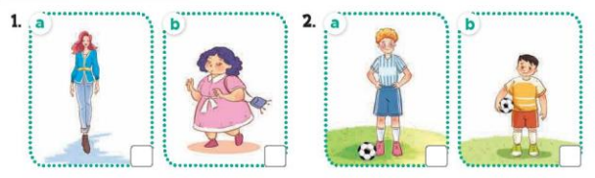  - T ask Ss to guess the answers.  + T writes Ss’guessing on the board.  - Listen to the tape:  + Play the recording  + Play the recording again and get Ss to swap books with their partners.  + Play the recording again to check answers together as a class.  + Write the answers on the board for Ss to correct their answers. Then checks Ss’ guessing.  - Play the recording, sentence by sentence, for the class to listen and repeat in chorus.  Key: 1.a 2.b  Activity 2. Look, complete and read.  *Aims: Ss will be able to complete the target sentence patterns in four exchanges about appearance with the help of picture cues.  *Procedure:  - Have Ss look at the pictures and identify the appearance of the people (tall, short, big, slim).  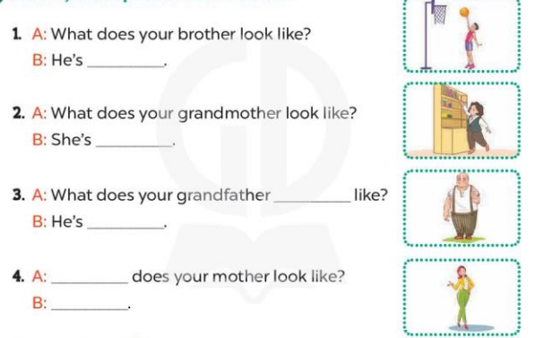  - Have Ss look at the four incomplete exchanges and elicits the missing words in the sentences.  - T models with sentence 1  + Ask Ss what is missing in the sentence.  + Have Ss look at the picture and complete the gap, then read the completed sentence in chorus.  -Have Ss work in groups and complete the sentences 2,3 and 4.  - Ask a few Ss to stand up and read the completed sentences aloud.  -T gives feedbacks.  Key:  - tall 2. short 3. look; big  4. What; She’s slim.  Activity 3. Let’s sing.  *Aims: Ss will be able to sing the song What do your parents look like? with the correct melody and pronunciation.  *Procedure:  - Introduce the title and lyrics of the song: “ What do your parents look like? ” song.  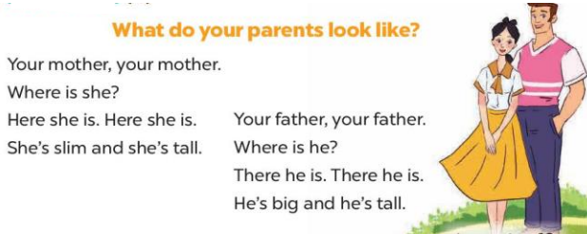  - Play the recording for Ss to listen to the whole song.  + Have them repeat the title and lyrics line by line.  + Tell Ss to point at the relevant character while singing his or her name.  - Play the recording all the way through for Ss to listen to pronunciation and melody of the song.  - Play the recording line by line for Ss to listen, repeat and point at the relevant character.  - Play the recording for Ss to sing and do actions.  - Ask Ss to practice singing and doing actions in pairs or groups.  - Invite groups to the front of the classroom to perform the song  -T gives feedback.  *Consolidation  *Aims: Ss will be able consolidate and wrap up the content of the lesson.  *Procedure:  - T asks ss to answer the following questions:  + What have you learnt from the lesson today?  +What are the core values of the lesson? (if the teacher can take from the lesson).  - T praises some Ss who are hardworking / active/ good…. as well as encourage others to try more.  3. Homework. (3’)  - Learn the number by heart  - Prepare the new lesson: Unit 13, Lesson 2 (1,2,3). | - Ss listen and keep the puppet  - Ss listen to music and play the game  -Ss listen  - Ss open their books  -Look at the pictures and say:  + Picture 1a: a slim woman  + Picture 1b: a short woman  + Picture 2a: a tall boy playing football  + Picture 2b: a short boy playing football  -Ss guess the answers  - Ss listen to the tape and tick  - Ss listen again, tick and swap books with their partners.  - Ss check their answers and guessing  -Ss write the correct answer  -Ss listen and repeat.  -Ss look at the picture and say  -Ss look and answer  -Ss answer: tall  -Ss look, complete and read the completed sentence in chorus.  -Sswork in groups and complete the sentence  -Ss read aloud  - Ss look and listen.  -Ss listen to the song  - Ss listen and repeat line by line without the action.  -Ss point to the character while singing  -Ss listen to melody of the song  - Ss listen and sing line by line.  - Ss sing and do actions.  + Ss work in groups (two groups) to sing.  -Ss perform in front of the class.  -Ss listen  -Ss answer the questions  -Ss listen and clap their hands  -Ss listen and take note
D. ADJUSTMENTS (if necessary):
………………………………………………………………………………………….…..……………………………………………………………………………...
---------------------------------------------------------------------
Grade 4: Lớp 4A: Sáng thứ Sáu Ngày 21tháng 02 năm 2025
Lớp 4B: Sáng thứ tư, Ngày 19 tháng 02 năm 2025
Lớp 4C: Sáng thứ năm , Ngày 20 tháng 02 năm 2025
ENGLISH
Unit 13: Appearance - Lesson 2 (1, 2, 3)
A. OBJECTIVES:
By the end of the lesson, Ss will be able to:
1. Knowledge:
- Use the words and phrases a round face, big eyes, long hair, and short hair in relation to the topic "Appearance"
- Use What does he / she look like? –He / She has …… to ask and answer questions about someone’s appearances
- Vocabulary: long, round
- Model sentences:
A: What does he / she look like?
B: He/ She has a round face.
- Skills: speaking and listening
2. Competences:
- Co-operation: ready to help friends in pair work/ group work.
- Oral Communication: speak about someone, ask and answer the questions
3. Attitude/ Qualities:
- Kindness: Help partners to complete learning tasks.
- Honesty: tell the truth about feelings and emotions
B. TEACHING AIDS:
- Teacher: Teacher’s guide Pages 188, 189; audio Tracks 25, 26, website hoclieu.vn, posters, laptop, pictures, textbook, lesson plan, TV or projector.
- Students: Pupil’s book Page 20, notebooks, workbooks, school things.
C. PROCEDURES:
Teacher’s activities | Students’ activities
1.Warm- up: (3’)  Game: Teacher says  *Aims: to create a friendly and active atmosphere in the class to beginning the lesson.  *Procedure:  - Teachers quickly review body parts, focusing on Face features.  -Teacher plays "Teacher says": Touch your ears/nose/face/eyes/hair .... to review face features.  - Say “Open your book page 20” and look at “Unit 13, Lesson 2 (1,2,3)”.  2. Presentation(16’)  Activity 1. Vocabulary.  *Aims: Ss will be able to know the vocabulary in the new lesson.  *Procedure:  -T elicits the new words  + round : tròn (realia)  + long : dài (realia)  - T models (3 times).  - T writes the words on the board.  - Checking: Rub out and remember  Activity 2. Look, listen and repeat:  *Aims: Ss will be able to understand and correctly repeat the sentences in two communicative contexts focusing on asking and answering questions about someone’s appearance, using the verb to have  *Procedure:  - Have Ss look at Pictures a and b and identify the characters in the pictures.  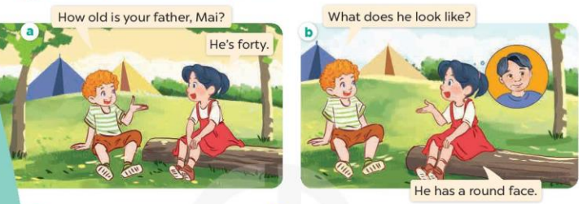  - Play the audio twice (sentence by sentence). Correct their pronunciation where necessary.  - Have Ss to practice the diaguage  - T invites a few pairs to the front of the class to practice.  - T checks pronunciation for ss.  Activity 3. Listen, point and say.  *Aims: Ss will be able to correctly say the phrases and use What does he / she look like? – He / She has …... to ask and answer questions about someone’s appearance.  *Procedure:  * Model sentences:  - T asks Ss look at picture b and helps Ss know the structure from the dialogue.  - T introduces new structure for Ss.  - T explains, models and gives meaning.  - Have Ss repeat the model sentences.  A: What does he / she look like?  B: He/ She has a round face.  3.Practice: (7’)  *Drill pictures  - Elicit and check comprehension the name of each character.  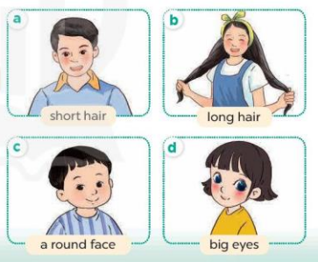  - Run through all the pictures.  - Run through model sentences.  +Run through the question sentences  +Run through the answer sentences  - Have Ss to practise:  + T asks, Ss answer picture a  + Ss ask, T answers picture b  + Group A ask, group B answer picture c  + Group B ask, group A answer picture d  - Ask Ss to work in pairs.  - T controls and corrects.  - Invite a few pairs to come to the front of the classroom, point at the relevant character in each picture, and act out his/her role.  - T gives feedbacks.  4.Production: (7’)  Activity 4. Let’s talk.  *Aims: Ss will be able to enhance the correct use of What does he / she look like? – He / She has ………. to ask and answer questions about someone’s appearance in a freer context.  *Procedure:  - T asks ss to attend to the picture.  + What can you see in the picture?  +Where are they?  + What do they look like?  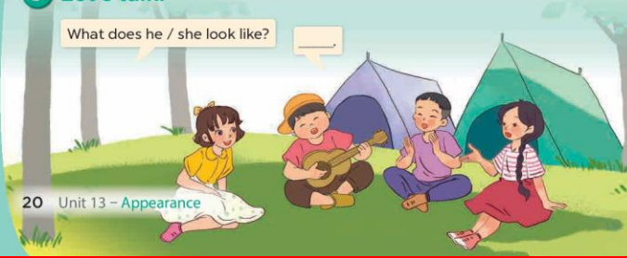  - T fills the gaps and writes the sentences on the board.  - T models  - T asks Ss use of What does he/ she look like? and He has/ She has……. to ask and answer (pairs work)  - Invite some groups to perform.  - Give feedbacks  *Consolidation  *Aims: Ss will be able consolidate and wrap up the content of the lesson.  *Procedure:  - T asks ss to answer the following questions:  + What have you learnt from the lesson today?  - T review the vocabulary and model sentences.  5. Homework. (2’)  - Learn the number by heart  - Prepare the new lesson: Unit 13, Lesson 2 (4,5,6). | - Ss listen  - Ss play the game  - Ss open their books  -Ss listen and answer  - - Ss listen and repeat  + Choral repetition (3 times).  + Individual repetition (3 ss)  - Ss take note  - Ss look, remember and write  -Look at the pictures and get to know the characters in the pictures.  + In picture a:  Bill: How old is your brother, Mai? Mai: He’s four  – In picture b:  Bill: What does he look like?  Mai: He has a round face.  -Ss listen and repeat in chorus (twice)  -Ss work in pairs to practice  -Ss practice the diaguage  -Ss listen  -Ss look at the picture and answer.  -Ss listen  -Ss listen and repeat  -Ss repeat  - Ss look, listen and answer  + Picture a: a boy with short hair + Picture b: a girl with long hair  + Picture c: a boy with a round face  + Picture d: a girl with big eyes  -Ss practice in chorus  - Ss practice in chorus  -Ss practice in chorus  -Ss work in pairs to practice  -Ss listen  -Ss go to the board and role play.  -Ss listen  -Ss look at the picture and answer  + a group of four pupils with different appearance  -Ss note  - Ss say the completed sentences.  -Ss work in pairs and ask and answer  -Ss perform in front of the class.  -Ss answer the questions  - Ss listen  -Ss listen and take note
D. ADJUSTMENTS (if necessary):
………………………………………………………………………………………….…..……………………………………………………………………………...
--------------------------------------------
Grade 4: Lớp 4A: Sáng thứ Sáu Ngày 21tháng 02 năm 2025
Lớp 4B: Sáng thứ tư, Ngày 19 tháng 02 năm 2025
Lớp 4C: Sáng thứ năm , Ngày 20 tháng 02 năm 2025
ENGLISH
Unit 13: Appearance - Lesson 2 (4, 5, 6)
A. OBJECTIVES:
By the end of the lesson, Ss will be able to:
1. Knowledge:
- Use the words and phrases big, short, slim, tall, a round face, big eyes, long hair, and short hair in relation to the topic "Appearance".
- Listen to and demonstrate understanding of simple communicative contexts in relation to the topic “Appearance”
- Vocabulary: Review
- Skills: speaking, listening, reading and writing.
2. Competences:
- Co-operation: ready to help friends in pair work/ group work.
- Self-control and independent learning: perform listening tasks.
3. Attitude/ Qualities:
- Kindness: Help partners to complete learning tasks.
- Diligence: complete learning tasks.
B. TEACHING AIDS:
- Teacher: Teacher’s guide Pages 190, 191; audio Tracks 27; website hoclieu.vn, posters, laptop, pictures, textbook, lesson plan, TV or projector.
- Students: Pupil’s book Page 21, notebooks, workbooks, school things.
C. PROCEDURES:
Teacher’s activities | Students’ activities
1.Warm- up: (5’)  Game: play the Angry Bird game (PPT)  *Aims: to create a friendly and active atmosphere in the class to beginning the lesson.  *Procedure:  - Divide the class into 2 teams.  - Pupils from each team choose a number, then answer the question in that number.  - If the Ss answer correctly, the teacher clicks on the brick of that number to find out the scores.  - Say “Open your book page 21” and look at “Unit 13, Lesson 2 (4,5,6)”.  2.Practice: (27’)  Activity 1. Listen and number:  *Aims: Ss will be able to listen to and understand four communicative contexts in which characters ask and answer questions about someone’s appearance, and number the correct pictures.  *Procedure:  - Elicit the questions to ask for the appearance of the character in each picture.  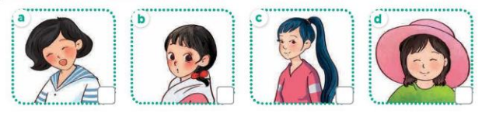  - T ask Ss to guess the answers.  + T writes Ss’guessing on the board.  - Listen to the tape:  + Play the recording  + Play the recording again and get Ss to swap books with their partners.  + Play the recording again to check answers together as a class.  + Write the answers on the board for Ss to correct their answers. Then checks Ss’ guessing.  - Play the recording, sentence by sentence, for the class to listen and repeat in chorus.  Key: 1.d 2. a 3. c 4. b  Activity 2. Look, complete and read.  *Aims: Ss will be able to complete the target sentence patterns in two exchanges about appearance with the help of picture cues *Procedure:  - Have Ss look at the pictures and identify the appearance of the characters in the pictures 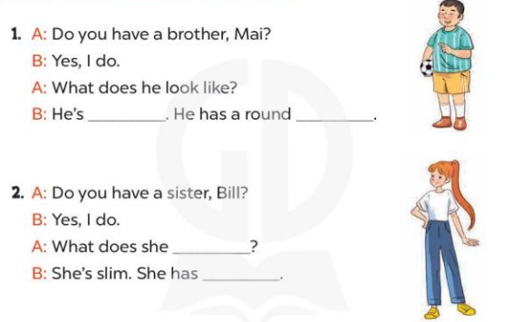  - T models with sentence 1.  + Have Ss look at the sentence.  + Ask them what is missing in the answer (big).  + Have Ss write the first word  + Have Ss read the completed sentence in chorus.  -Have Ss work in pairs and complete the sentences 2.  - Invite pairs of pupils to stand up and read aloud the sentences.  -T gives feedbacks.  Key: 1. big / short, face 2. look like, long hair  Activity 3. Let’s play.  *Aims: Ss will be able to review vocabulary about family members and appearance by playing the game Tic-tac-toe.  *Procedure:  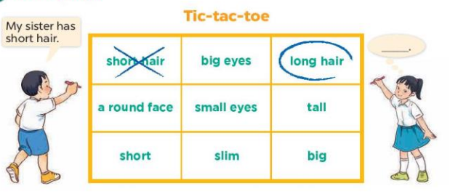  - Tell pupils that they are going to play the game Tic-tac-toe.  +Two pupils play at a time. One pupil is X, and the other is O.  +The pupils take turns choosing a square by saying a word and putting their mark in the corresponding square.  +The first pupil to write three marks in a vertical, horizontal or diagonal line is the winner.  - Invite two pupils to play at a time.  - Change the words in the grid and let pupils play the game several times if there is enough time.  *Consolidation  *Aims: Ss will be able consolidate and wrap up the content of the lesson.  *Procedure:  - T asks ss to answer the following questions:  + What have you learnt from the lesson today?  +What are the core values of the lesson? (if the teacher can take from the lesson).  - T praises some Ss who are hardworking / active/ good…. as well as encourage others to try more.  3. Homework. (3’)  - Prepare the new lesson: Unit 13, Lesson 3 (1,2,3). | - Ss listen and play the game  - Ss open their books  -Look at the pictures and say:  + Picture a: a girl with short hair + Picture b: a girl with big eyes  + Picture c: a girl with long hair + Picture d: a girl with a round face  -Ss guess the answers  - Ss listen to the tape and write number  - Ss listen again, write number and swap books with their partners.  - Ss check their answers and guessing  -Ss write the correct answer  -Ss listen and repeat.  -Ss look at the pictures and say  -Ss listen and answer  -Ss read and complete  -Ss write  -Ss read the completed sentence  -Ss work in pairs and complete  -Ss read aloud  - Ss listen the rule of the game  - Ss listen the rule of the game  - Ss listen the rule of the game  -Ss play the game  - Ss play the game  -Ss listen and answer  -Ss listen and take note
D. ADJUSTMENTS (if necessary):
………………………………………………………………………………………….…..……………………………………………………………………………...
-----------------------------------------------------------------
Grade 5 : Lớp 5B : Sáng thứ ba, Ngày 18 tháng 02 năm 2025
ENGLISH
Unit 13: Our special days - Lesson 1 (1, 2, 3)
A. OBJECTIVES:
By the end of the lesson, Ss will be able to:
1. Knowledge:
- Use What will you do ___? – We’ll ___. to ask and answer questions about what someone will do for a special day
- Listen to and demonstrate understanding of simple communicative contexts in relation to the topic “Our special days”.
- Vocabulary: Children’s Day, Teachers’ Day, Sports Day, Mid-Autumn Festival
- Structures: A: What will you do on Children’s Day?
B: We’ll sing, dance and have a party.
- Skills: speaking and listening
2. Competences:
- Communication and collaboration: work in pairs and groups to complete the learning tasks.
- Self-control and independent learning: perform pronunciation and speaking tasks.
3. Attitude/ Qualities:
- Enhance understandings of what people do on special occasions
B. TEACHING AIDS:
- Teacher: Teacher’s guide Pages 207, 208, 209, audio Tracks 21, 22, website hoclieu.vn, posters, laptop, pictures, textbook, lesson plan, TV or projector.
- Students: Students’ book Page 18, notebooks, workbooks, school things.
C. PROCEDURES:
Teacher’s activities | Students’ activities
1.Warm- up: (3’)  Sing a song: Tet’s coming  *Aims: to create a friendly and active atmosphere in the class to beginning the lesson.  *Procedure:  - Show the video on the screen.  https://www.youtube.com/watch?v=cv8d4alcdk8  - Ask Ss to listen, sing and dance the song.  - Say “Open your book page 18” and look at “Unit 13, Lesson 1 (1,2,3)”.  2. Presentation (15’)  Activity 1. Vocabulary.  *Aims: Ss will be able to know the vocabulary in the new lesson.  *Procedure:  -T elicits the new words  + Children’s Day: ngày Quốc tế Thiếu nhi (explain)  + Teachers’ Day: ngày Nhà giáo Việt Nam (situation)  + Sports Day: ngày hội thể thao (picture)  + Mid-Autumn Festival: Tết Trung thu  (picture)  - T models (3 times).  - T writes the words on the board.  - Checking: Rub out and remember  Activity 2. Look, listen and repeat:  *Aims: Ss will be able to understand and correctly repeat the sentences in two communicative contexts in which the characters ask and answer questions about what someone will do for a special  day.  *Procedure:  - Have Ss look at Pictures a and b and identify the characters and their activities in the pictures.  + Who are they?  + Where are they?  + What are they talking about?  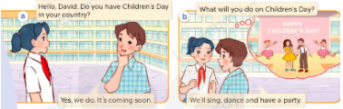  - Play the audio twice (sentence by sentence). Correct their pronunciation where necessary.  - Have Ss to practice the dialogue  - T invites a few pairs to the front of the class to practice.  - T checks pronunciation for ss.  Activity 3 Listen, point and say.  *Aims: Ss will be able to correctly use What will you do ____? – We’ll ____. to ask and answer questions about what someone will do on / at a special day.  *Procedure:  * Structures:  - T asks Ss look at picture b in activity 1 and helps Ss know the structure from the dialogue.  - T introduces new structures for Ss.  - T explains, models and gives meaning.  - Have Ss repeat the model sentences.  A: What will you do on Children’s Day?  B: We’ll sing, dance and have a party.  3.Practice: (7’)  *Drill pictures  - Have Ss look at the picture and identify the characters and their activities  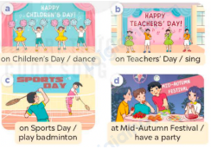  - Have Ss point at pictures, listen and run through all the pictures.  - Have Ss point at the bubbles, listen and run through model sentences.  - Have Ss to practise:  + T asks the first picture, Ss answer  + Ss asks the second picture, T answers  + Group A asks the third picture, group B  answers  + Group B asks the last picture, group A  - Ask Ss to work in pairs to practise asking and answering the question What will you do ____? – We’ll ____.  - T controls and corrects.  - Invite a few pairs to point at the pictures and say the questions and answers in front of the class.  4. Production: (6’)  Activity 4. Let’s talk.  *Aims: Ss will be able to correctly What will you do ___? – We’ll ___. in a freer context.  *Procedure:  - Have ss look at the picture and draw their attention to the names of four special days and the activities characters will do on / at these days.    - Elicit the answer in the speech bubble and write it on the board. Get Ss to say the completed sentences.  - Have Ss role-play to practise asking the questions and giving their answers in pairs, using the structures What will you do ___? – We’ll ___.  - Invite a few pairs to point at the pictures and ask and answer questions.  5. Fun corner and wrap- up (4’)  Game: Spin the wheel  - Divide class into 2-4 teams  - Each team takes turns choosing a month of the year, then asks and answers using the clues shown on the screen. If the ss can successfully make a conversation, they get to spin the wheel and get points for their teams. | - Sing and dance the song together.  - Ss listen and open their books  -Ss listen and answer  - - Ss listen and repeat  + Choral repetition (3 times).  + Individual repetition (3 ss)  - Ss take note  - Ss look, remember and write  -Look at the pictures and say  +In picture a:  Mai: Do you also have Children's Day in your country, David?  David: We went to the beach.  + In picture b:  Mai: What will you do on Children’s Day?  David: We’ll sing, dance and have a party.  -Ss listen and repeat in chorus (twice)  -Ss work in pairs to practice  -Ss come to the front of the classroom to practice.  -Ss listen  - Ss look at the picture and answer.  -Ss listen  -Ss listen and repeat  -Ss repeat to the structures  - Ss look, listen and repeat  +Picture a: Some children dancing on Children’s Day  + Picture b: Some children singing on Teachers’ Day  + Picture c: Two children playing badminton on Sports Day  + Picture d: Some children having a party at Mid-Autumn Festival  -Ss point at pictures, listen and repeat  -Ss point at the bubbles, listen and repeat  -Ss practice in chorus  -Ss practice in chorus  -Ss work in pairs to practise asking and answering the question  - Pairs of Ss point at the pictures and say in front of the class  -Ss look at the picture and answer  + Four pictures showing four different activities on / at four special days  - Ss say the completed sentences.  -Ss work in pairs to ask and answer  -Ss perform in front of the class.  - Ss listen  -Ss listen and play the game  -Ss praise the winner.
D. ADJUSTMENTS (if necessary):
………………………………………………………………………………………….…..……………………………………………………………………………...
------------------------------------------------------------
Grade 5 : Lớp 5B : Sáng thứ ba, Ngày 18 tháng 02 năm 2025
ENGLISH
Unit 13: Our special days - Lesson 1 (4, 5, 6)
A. OBJECTIVES:
By the end of the lesson, Ss will be able to:
1. Knowledge:
- Listen to and understand two communicative contexts in which pupils ask and answer questions about what someone will do for a special day.
- Listen to and demonstrate understanding of simple communicative contexts in relation to the topic “Our special days”.
- Vocabulary: Review
- Skills: speaking, listening, reading and writing.
2. Competences:
- Communication and collaboration: work in pairs and groups to complete the learning tasks.
- Self-control and independent learning: perform listening and reading tasks.
3. Attitude/ Qualities:
- Show their pride in their personal information and what someone will do for a special day.
B. TEACHING AIDS:
- Teacher: Teacher’s guide Pages 210, 211, 212; audio Tracks 23, 24; website hoclieu.vn, posters, laptop, pictures, textbook, lesson plan, TV or projector.
- Students: Student’s book Page 19, notebooks, workbooks, school things.
C. PROCEDURES:
Teacher’s activities | Students’ activities
1.Warm- up and review: (5’)  Game: Pass the teddy bears  *Aims: to revise the learned structures.  *Procedure:  - Give two different colored teddy bears to two pupils, a black teddy bear (ask the question) and a white teddy bear (answer the question).  - Ask ss to listen to music and pass the teddy bears.  - Stop music suddenly. Have the student with a black teddy bear make a question. Have the student with a white teddy bear answer the question.  - Repeat the game several times.  - Say “Open your book page 19” and look at “Unit 13, Lesson 1 (4,5,6)”.  2.Practice: (25’)  Activity 1. Listen and tick or cross:  *Aims: Ss will be able to listen to and understand four communicative contexts in which speakers ask and answer questions about what someone will do on / at a special day.  *Procedure:  - Have ss look at the picture and elicit the activities in the pictures.  +What will they do?  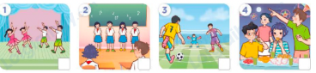  - T ask Ss to guess the answers.  + T writes Ss’guessing on the board.  - Listen to the tape:  + Play the recording  + Play the recording again for pupils to do the task.  + Play the recording a third time for pupils to check their answers.  - Get Ss to swap books with their partner, then check answers as a class.  + Write the answers on the board for Ss to correct their answers. Then checks Ss’ guessing.  - Have ss explain the answers.  Key: 1. x 2. x 3.v 4.v  Activity 2. Read and complete.  *Aims: Ss will be able to complete four gapped exchanges with the help of picture cues.  *Procedure:  - Get Ss to look at the pictures and identify the activities.  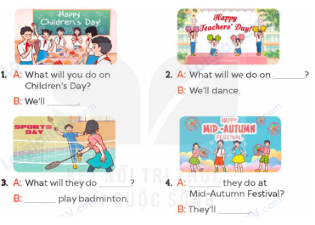  - Have Ss look at the four incomplete exchanges and elicits the options  - T models with sentence 1  + Have Ss circle the correct answer (have a party)  + Have Ss look at the picture and identify the needed information (have a party).  - Have Ss work in groups and complete the sentences 2, 3 and 4.  - Get Ss to swap books with a partner and check their answers before checking as a class.  -T gives feedbacks.  Key:  1. have a party  2. Teachers’ Day  3. on Sports Day, We’ll  4. What will, sing and dance  Activity 3. Listen, complete and sing  *Aims: Ss will be able to listen and complete the song What will you do on Children’s Day? and sing it with correct pronunciation, rhythm and melody.  *Procedure:  - Introduce the title and lyrics of the song:What will you do on Children’s Day?  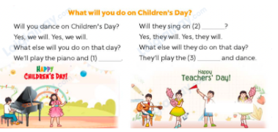  - Tell ss the aim of the activity  - Draw ss’ attention to the gapped sentences and guess the missing words and complete the sentences.  - Play the recording all the way through for ss to listen to the whole song.  - Play the recording again for them to fill in the gaps with the missing words.  - Check answers together as a class.  - Play the recording line by line for pupils to listen and repeat.  - Invite a few groups to the front of the class to sing the song.  3. Fun corner and wrap- up (5’)  Game: Guessing game  - Draw ss’ attention to the screen.  - Explain the rules of the game: Ss look at the clue and guess  + 1 open-picture: get 3 points  + 2 open -pictures: get 2 points  + All pictures left: 1 point . | - Ss listen to the teacher’s instruction  - Ss play the game  Ex:  A: What will you do on Teacher’s Day?  B: We’ll sing and dance.  - Continue playing the game.  - Ss open their books  -Look at the pictures and say:  + Picture 1: A group of children dancing  + Picture 2: A group of children singing  + Picture 3: Some boys playing football  + Picture 4: A group of children having a party in the moon  -Ss guess the answers  - Ss listen to the tape  - Ss listen again and do the task.  - Ss listen and check their answers  - Ss swap books with their partner, then check answers as a class and guessing  -Ss explain the answers  -Ss look at the picture and identify the activities.  -Ss look at the exchanged and pay attention  -Ss look and say the correct answer  -Ss listen and pay attention  -Ss complete the sentences  -Ss swap books with a partner and check their answers before checking as a class.  -Ss listen  - Ss listen and pay attention  - Ss listen to the teacher’s instruction.  - Ss look at the gapped sentences and guess the missing words and complete the sentences.  - Ss listen to the song  - Ss listen and fill in the gaps with missing words.  - Ss check answers together as a class.  - Ss listen to the recording, line by line, and repeat.  - Ss come to the front of the class to sing the song.  - Ss follow the teacher’s instructions.  - Ss look at the screen and guess what the word is.
D. ADJUSTMENTS (if necessary):
………………………………………………………………………………………….…..……………………………………………………………………………...
----------------------------------------------------------------
Grade 5 : Lớp 5B : Sáng thứ năm, Ngày 20 tháng 02 năm 2025
ENGLISH
Unit 13: Our special days - Lesson 2 (1, 2, 3)
A. OBJECTIVES:
By the end of the lesson, Ss will be able to:
1. Knowledge:
- Understand and correctly repeat the sentences in two communicative contexts in
which characters ask and answer questions about drinks they will have at an event.
- Correctly use What food / drinks will you have at the party? – We’ll have _to ask and answer questions about food and drinks someone will hav an event.
- Use What food / drinks will you have at the party? – We’ll have
- Vocabulary: burgers, milk tea,
- Structures: A: What food / drinks will you have at the party?
B: We’ll have milk tea.
- Skills: speaking and listening
2. Competences:
- Critical thinking and creativity: learn how to ask and answer questions about someone’s food and drinks at an event correctly and fluently.
- Communication and collaboration: work in pairs and groups to complete the learning tasks.
3. Attitude/ Qualities:
- Enhance understanding of different kinds of food and drinks at different styles of event.
B. TEACHING AIDS:
- Teacher: Teacher’s guide Pages 212, 213, 214; audio Tracks 25, 26, website hoclieu.vn, posters, laptop, pictures, textbook, lesson plan, TV or projector.
- Students: Students’ book Page 20, notebooks, workbooks, school things.
C. PROCEDURES:
Teacher’s activities | Students’ activities
1.Warm- up and review: (4’)  Game: Roll the dice  *Aims: to revise the sentence structures about someone who did something in the past.  *Procedure:  - Divide the class into groups of six. Have each student count the numbers from one to six.  - Ask a student from each group to roll the dice to choose a pupil asking the question.  - Ask that student to ask the question and invite another student of the group to answer the question.  - Say “Open your book page 20” and look at “Unit 13, Lesson 2 (1,2,3)”.  2. Presentation (16’)  Activity 1. Vocabulary.  *Aims: Ss will be able to know the vocabulary in the new lesson.  *Procedure:  -T elicits the new words  + burgers: những bánh mì kẹp thịt  (picture)  + milk tea: trà sữa (picture)  - T models (3 times).  - T writes the words on the board.  - Checking: Rub out and remember  Activity 2. Look, listen and repeat:  *Aims: Ss will be able to understand and correctly repeat the sentences in two communicative contexts in  which characters ask and answer questions about drinks they will have at an event.  *Procedure:  - Have Ss look at Pictures a and b and identify the characters and predict what they are talking about.  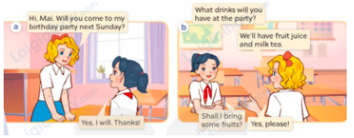  - Play the recording for them to listen.  - Play the recording again (sentence by sentence) for Ss to listen and repeat Correct their pronunciation where necessary.  - Invite a few pairs to the front of the classroom to listen to and repeat the sentences.  - T checks pronunciation for ss.  Activity 3. Listen, point and say.  *Aims: Ss will be able to use What food / drinks will you have at the party? – We’ll have ___. to ask and answer questions about food and drinks someone will have at an event.  *Procedure:  * Structures:  - T asks Ss look at picture b and helps Ss know the structure from the dialogue.  - T introduces new structure for Ss.  - T explains, models and gives meaning.  - Have Ss repeat the structures.  A: What food / drinks will you have at the party?  B: We’ll have milk tea.  3.Practice: (6’)  *Drill pictures  - Have Ss look at the pictures and elicit identify the food and drinks.  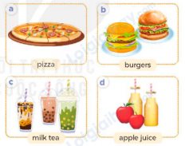  - Have Ss point at pictures, listen and run through all the pictures.  - Have Ss point at the bubbles, listen and run through model sentences.  - Have Ss to practise:  + T asks the first picture, Ss answer  + Ss asks the second picture, T answers  + Group A asks the third picture, group B  answers  + Group B asks the last picture, group A  - Ask Ss to work in pairs to practise asking and answering the question What food / drinks will you have at the party? – We’ll have ___.  - T controls and corrects.  - Invite a few pairs to point at the pictures and say the questions and answers in front of the class.  - T gives feedbacks.  4.Production: (5’)  Activity 4. Let’s talk.  *Aims: Ss will be able to use What food / drinks will you have at the party? – We’ll have ___. in a freer context.  *Procedure:  - Ask questions to help them identify the context.  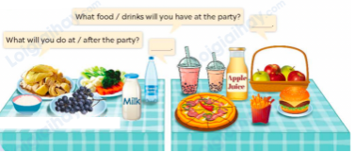  - Elicit the answer in the speech bubble and write it on the board. Get Ss to say the completed sentences.  - Have Ss role-play to practise asking the questions and giving their answers in pairs, using the picture cue What food / drinks will you have at the party? – We’ll have ___. And What will you do at/ after the party?- We___  - Invite a few pairs to point at the pictures and ask and answer questions.  - Invite some pairs of ss to ask and answer questions about the real activities  5. Fun corner and wrap- up (4’)  Game: Prepare for your party  - Divide the class into three teams.  - Tell the ss that they are working at a restaurant. They have to ask their customers what food and drinks they want for their parties and serve on the table.  - Ask the ss to look at pictures and read the full sentences.  - Ask ss to check their friends’ pronunciation.  - Play the game. | - Ss listen to teacher’s instruction  - Ss play the game  Ex:  A: What will you do on ______?  B: We’ll ______  - Ss open their books  -Ss listen and answer  - - Ss listen and repeat  + Choral repetition (3 times).  + Individual repetition (3 ss)  - Ss take note  - Ss look, remember and write  -Look at the pictures and get to know the characters in the pictures.  + In picture a:  Mary: Hi, Mai. Will you come to my birthday party next Sunday?  Mai: Yes, I will. Thanks!  – In picture b:  Mai: What drinks will you have at the party?  Mary: We’ll have fruit juice and milk tea.  Mai: Shall I bring some fruit?  Mary: Yes, please!  -Ss listen  -Ss listen and repeat in chorus  - Pairs of Ss listen and repeat  -Ss listen  -Ss look at the picture and answer.  -Ss listen  -Ss listen and repeat  -Ss repeat to the structures.  - Ss look, listen and answer  a: A pizza  b: Two burgers  c: Three glasses of milk tea  d: Two bottles of apple juice  -Ss point at pictures, listen and repeat  -Ss point at the bubbles, listen and repeat  -Ss practice in chorus  -Ss practice in chorus  -Ss work in pairs to practise asking and answering the question  - Pairs of Ss point at the pictures and say in front of the class  -Ss look at the picture and answer  + Some food and drinks (chicken, vegetables, rice, grapes, mineral water and milk) for a meal on the first table. Some food and drinks (apples, chips, a pizza and a burger, apple juice and milk tea) for a  party on the second table  - Ss say the completed sentences.  -Ss work in pairs to ask and answer  A:What food / drinks will you have at the party?  B:We’ll have pizza.  A: What will you do at/ after the party?  B: We’ll sing and dance  -Ss perform in front of the class.  - Ss ask and answer about their family.  -Ss listen to the teacher  - Ss play the game  - Continue playing the game.
D. ADJUSTMENTS (if necessary):
………………………………………………………………………………………….…..……………………………………………………………………………...
---------------------------------------------------------------
Grade 5 : Lớp 5B : Sáng thứ năm, Ngày 20 tháng 02 năm 2025
ENGLISH
Unit 13: Our special days - Lesson 2 (4, 5, 6)
A. OBJECTIVES:
By the end of the lesson, Ss will be able to:
1. Knowledge:
- Use What food / drinks will you have at the party? – We’ll have ___. to ask and answer questions about the food and drinks someone will have at an event
- listen to and demonstrate understanding of simple communicative contexts in relation to the topic “Our special days”.
- Vocabulary: Review
- Skills: speaking, listening, reading and writing.
2. Competences:
- Communication and collaboration: work in pairs and groups to complete the learning tasks.
3. Attitude/ Qualities:
- Enhance understanding of what people eat and drink on special occasions.
- Express their preferences for food and drinks.
B. TEACHING AIDS:
- Teacher: Teacher’s guide Pages 216, 217; audio Tracks 27; website hoclieu.vn, posters, laptop, pictures, textbook, lesson plan, TV or projector.
- Students: Pupil’s book Page 21, notebooks, workbooks, school things.
C. PROCEDURES:
Teacher’s activities | Students’ activities
1.Warm- up and review: (4’)  Play a game: “Run to the corner”  *Aims: to revise the sentence structure *Procedure:  - Draw ss’ attention to the pictures and say the name of food and drinks.  - Ask 2 ss to come to the front and ask about their food and drinks they want at their parties.  + When they finish answering the questions, other players (1 from each team) will run to the pictures mentioned and say the name of that food/ drinks.  + Who faster is the winner and get 1 point for that round.  - Say “Open your book page 21” and look at “Unit 13, Lesson 2 (4,5,6)”.  2. Practice: (27’)  Activity 1. Listen and tick:  *Aims: Ss will be able to listen to and understand two communicative contexts in which characters talk about food and drinks they will have at an event and tick the correct pictures  *Procedure:  - Elicit the names of the food and drinks  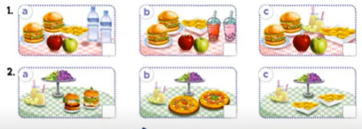  - T ask Ss to guess the answers.  + T writes Ss’guessing on the board.  - Listen to the tape:  + Play the recording  + Play the recording again and get Ss to swap books with their partners.  + Play the recording again to check answers together as a class.  + Write the answers on the board for Ss to correct their answers. Then checks Ss’ guessing.  - Play the recording, sentence by sentence, for the class to listen and repeat in chorus.  Key: 1.b 2. a  Activity 2. Read and complete  *Aims: Ss will be able to complete two gapped exchanges with the help of picture cues.  *Procedure:  - Ask Ss to identify the food and drinks someone will have at a meal / party. 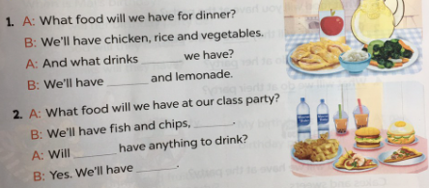  - Have Ss look at the 2 incomplete exchanges and elicits the missing words in the sentences.  - T models with the first sentence  + Ask Ss what is missing in the sentence (will).  + Have Ss look at the picture and identify the needed information (And what drinks will we have)  - Have Ss work in pairs and complete  - Get Ss to swap books with a partner and check their answers before checking as a class.  Key:  1. will, apple juice  2. burgers and pizza, we, mineral water and milk tea  Activity 3. Let’s play.  *Aims: Ss will be able to practise the target vocabulary and sentence patterns by playing the game Our Children’s Day party menu  *Procedure:  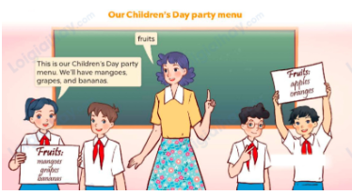  - Tell the class that the game will be played in groups of three. Ss in each group will discuss as many names of fruit, food and drinks as possible in the menu for their Children’s Day party  - Invite two or three groups to the front of the class.  - Let Ss have a time limit to make a menu (including fruit, food and drinks).  - Each group shows and tells the menu to the class. The group that says the most sentences about their menu with correct grammar will be given five points / stars.  3. Fun corner and wrap- up (4’)  Game: Lucky Food (ppt)  - Divides the class into 3 teams.  - Each team takes turns choosing a food/ drink and answering the question.  - T checks the answer with the whole class.  - Ss collect the points if they answer the question correctly.  - The team with the most points is the winner. | - Ss pay attention.  -Ss play the game  - Ss congratulate to the winner  - Ss open their books  - Look at the pictures and say:  1a. Two burgers, some chips, two apples and two bottles of mineral water  1b. Two burgers, some chips, two apples and two glasses of milk tea  1c. Two burgers, some chips, two apples and two glasses of apple juice  2a. Two burgers, some grapes and two glasses of apple juice  2b. Two pizzas, some grapes and two glasses of apple juice  2c. Some chips, some grapes and two glasses of apple juice  -Ss guess the answers  - Ss listen to the tape and match  - Ss listen again, match and swap books with their partners.  - Ss check their answers and guessing  - Ss answer and check  -Ss listen and repeat.  -Ss look at the picture and say  -Ss follow the teacher.  -Ss read and answer  -Ss work in pairs and fill in the gaps  - Ss swap books and check  -Ss listen and pay attention  - Ss play the game  -Ss play the game  -Ss play the game  -Ss play the game
D. ADJUSTMENTS (if necessary):
………………………………………………………………………………………….…..……………………………………………………………………………...
Duyệt bài, Ngày 14 tháng 02 năm 2025
Phó hiệu trưởng

Nguyễn Thị Hằng

