ĐĂNG KÝ GIẢNG DẠY TUẦN 14 ( Từ ngày09-13 /12/2024)

Thứ  Ngày | Buổi | Lớp | Tiết | Môn | Tên bài
Hai | Chiều | 4B | 1 | English | Unit 8: My favourite subjects  Lesson 2 (4,5,6)
 |  | 4B | 2 | English | Unit 8: My favourite subjects  Lesson 3 (1,2,3)
Ba | Sáng | 4A | 1 | English | Unit 8: My favourite subjects  Lesson 2 (4,5,6)
 |  | 4A | 2 | English | Unit 8: My favourite subjects  Lesson 3 (1,2,3)
 |  | 5B | 3 | English | Unit 8: In our classroom- Lesson 2 (4,5,6)
 |  | 5B | 4 | English | Unit 8: In our classroom- Lesson 3 (1,2,3)
Tư | Sáng | 4C | 1 | English | Unit 8: My favourite subjects  Lesson 2 (4,5,6)
 |  | 4C | 2 | English | Unit 8: My favourite subjects  Lesson 3 (1,2,3)
 |  | 4B | 3 | English | Unit 8: My favourite subjects  Lesson 3 (4,5,6)
 |  | 4B | 4 | English | Unit 9: Our sports day- Lesson 1 (1,2,3)
 | Chiều | 3A | 1 | English | Unit 8: My school things - Lesson 2 (4,5,6)
 |  | 3A | 2 | English | Unit 8: My school things - Lesson 3 (1,2,3)
Năm | Sáng | 5B | 1 | English | Unit 8: In our classroom- Lesson 3 (4,5,6)
 |  | 5B | 2 | English | Unit 9: Our outdoor activities  Lesson 1 (1,2,3)
 | Chiều | 3A | 1 | English | Unit 8: My school things - Lesson 3 (4,5,6)
 |  | 3A | 2 | English | Unit 9: Colours - Lesson 1 (1,2,3)
Sáu | Sáng | 4C | 1 | English | Unit 8: My favourite subjects  Lesson 3 (4,5,6)
 |  | 4C | 2 | English | Unit 9: Our sports day- Lesson 1 (1,2,3)
 |  | 4A | 3 | English | Unit 8: My favourite subjects  Lesson 3 (4,5,6)
 |  | 4A | 3 | English | Unit 9: Our sports day- Lesson 1 (1,2,3)

Duyệt bài, Ngày 06 tháng 12 năm 2024
Phó hiệu trưởng

Nguyễn Thị Hằng

WEEK 14
Grade 3: Lớp 3A: Chiều thứ tư ngày 04 tháng 12 năm 2024
ENGLISH
Unit 8: My school things - Lesson 2 (4, 5, 6)
A. OBJECTIVES:
By the end of the lesson, Ss will be able to:
1. Knowledge:
- Listen to and understand four communicative contexts in which pupils ask and answer questions about having a school thing.
- Read and match four simple exchanges with the correct pictures
- Review vocabulary words for school things and use them in the sentence patterns Do you have ………...? and Yes, I do. / No, I don’t. by playing the matching game or Pelmanism.
- Vocabulary: Review
- Skills: speaking, listening, reading and writing.
2. Competences:
- Critical Thinking: self-introduce
- Co-operation: ready to help friends in pair work/ group work.
- Self-control and independent learning: perform listening tasks.
3. Attitude/ Qualities:
- Kindness: Help partners to complete learning tasks.
- Honesty: tell the truth about feelings and emotions.
- Diligence: complete learning tasks.
B. TEACHING AIDS:
- Teacher: Teacher’s guide Pages 105, 106, 107; audio Tracks 83; website sachmem.vn, posters, laptop, pictures, textbook, lesson plan, TV or projector.
- Students: Pupil’s book Page 59, notebooks, workbooks, school things.
C. PROCEDURES:
Teacher’s activities | Students’ activities
1.Warm- up: (5’)  Game: Who says fast?  *Aims: to create a friendly and active atmosphere in the class to beginning the lesson.  *Procedure:  - Hold a school thing card, then reveal it slowly.  - Ask What is it?  - Ask the Ss guess the answer as fast as possible.  - Then have Ss do the same with the rest.  - This can be played in groups to make it more interesting.  - Say “Open your book page 59” and look at “Unit 8, Lesson 2 (4,5,6)”.  2.Practice: (27’)  Activity 1. Listen and number:  *Aims: Ss will be able to listen to and understand four communicative contexts in which pupils ask and answer questions about having a school thing.  *Procedure:  - Elicit the words for the school thing in each picture.  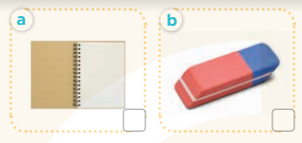  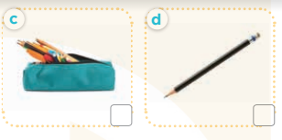  - T ask Ss to guess the answers.  + T writes Ss’guessing on the board.  - Listen to the tape:  + Play the recording  + Play the recording again and get Ss to swap books with their partners.  + Play the recording again to check answers together as a class.  + Write the answers on the board for Ss to correct their answers. Then checks Ss’ guessing.  - Play the recording, sentence by sentence, for the class to listen and repeat in chorus.  Key: 1. c 2. d 3. a 4. b  Activity 2. Read and match  *Aims: Ss will be able to read and match four simple exchanges with the correct pictures.  *Procedure:  - Get Ss to look at the pictures and identify the school things.  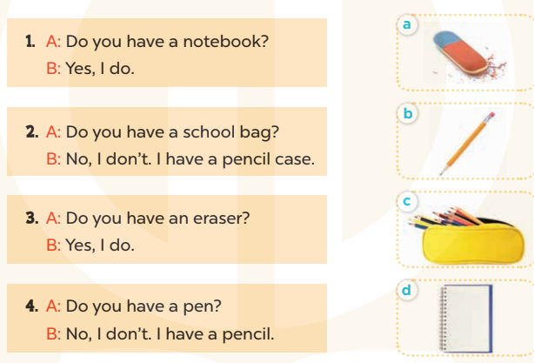  - Have Ss look at the four dialogues and the pictures. Elicit and model with number 1  + Get Ss to read number 1 in chorus. + Ask them what A and B are talking about.  + Write the word notebook on the board.  + Tell Ss to identify the picture of a notebook (Picture d).  + Then match number 1 with Picture d.  -Have Ss work in pairs and match the sentences 2, 3, 4.  - Ask a few Ss to stand up and read the sentences aloud.  -T gives feedbacks.  Key:  1. d 2. c 3. a 4. b  - Activity 3. Let’s play  *Aims: Ss will be able to review vocabulary words for school things and use them in the sentence patterns Do you have ………..? and Yes, I do. / No, I don’t. by playing the matching game or Pelmanism.  *Procedure:  - Explain how to play the game:  + Players take turns to flip over two matching cards.  + A picture matches with the name of the object in the picture.  For example, a picture of a pen matches with the word pen.  + If two cards match, they are left turned face up and the player scores one point.  + If they do not match, they are returned to their face down layout and play passes to the next player.  + Players that successfully match cards get to take another turn and try to match two more cards.  + This continues until that player fails to match a pair.  + The player with the most points is the winner.  - Set a time limit for Ss to play the game in pairs.  - When time runs out, show the cards one by one and invite a few pairs to ask and answer questions using the sentence patterns Do you have ………? And Yes, I do. / No, I don’t.  *Consolidation  *Aims: Ss will be able consolidate and wrap up the content of the lesson.  *Procedure:  - T asks ss to answer the following questions:  + What have you learnt from the lesson today?  +What are the core values of the lesson? (if the teacher can take from the lesson).  - T praises some Ss who are hardworking / active/ good…. as well as encourage others to try more  3. Homework. (3’)  - Practice part 5 again.  - Prepare the new lesson: Unit 8, Lesson 3 (1,2,3). | - Ss listen  - Ss play game  -Ss play game  - Ss open their books  -Look at the pictures and say:  + Picture a: a notebook  + Picture b: an esaser  + Picture c: a pencil case  + Picture d: a pencil.  -Ss guess the answers  - Ss listen to the tape and write  - Ss listen again, write and swap books with their partners.  - Ss check their answers and guessing  -Ss listen and repeat.  -Ss look at the picture and say  -Ss look and answer  -Ss read  -Ss answer  -Ss write  -Ss listen and match  -Ss work in pairs and complete  -Ss read aloud  - Ss listen  - Ss play game  -Ss ask and answer the questions  -Ss answer the questions  -Ss listen and clap their hands  -Ss listen and take note
D. ADJUSTMENTS (if necessary):
………………………………………………………………………………………….…..……………………………………………………………………………...
--------------------------------------------------------------
Grade 3: Lớp 3A: Chiều thứ tư ngày 04 tháng 12 năm 2024
ENGLISH
Unit 8: My school things - Lesson 3 (1, 2, 3)
A. OBJECTIVES:
By the end of the lesson, Ss will be able to:
1. Knowledge:
- Correctly repeat the sounds of the letter cluster oo and letter a in isolation, in the words book and eraser, and in the sentences I have a book. and Do you have an eraser? with correct pronunciation and intonation.
- Identify the target words book and eraser while listening.
- Say the chant with the correct rhythm and pronunciation.
- Vocabulary: Review
- Skills: speaking, listening, reading and writing.
2. Competences:
- Co-operation: ready to help friends in pair work/ group work.
- Sociability: Talk to each other, say good words to others.
3. Attitude/ Qualities:
- Kindness: Help partners to complete learning tasks.
- Honesty: tell the truth about feelings and emotions
B. TEACHING AIDS:
- Teacher: Teacher’s guide Pages 107, 108; audio Tracks 84, 85, 86; website sachmem.vn, posters, laptop, pictures, textbook, lesson plan, TV or projector.
- Students: Pupil’s book Page 60, notebooks, workbooks, school things.
C. PROCEDURES:
Teacher’s activities | Students’ activities
1.Warm- up: (5’)  Game: Find and circle the words  *Aims: to create a friendly and active atmosphere in the class to beginning the lesson.  *Procedure:  B O O K E P S C E T  H C T H N E H C R H  C L U A A N A O A I  L E L N N C T S S N  A A W K E I O E E K  S C H O O L I I R B  S R O E E C V C A H  L O O K I A S D A Y  D T S S R S O T S M  A C E B F E Z Y W  - Divide class into 2 groups  - Ask Ss to find and circle the words that they learnt.  - Which groups find the best correct words is winner.  - Give Ss time to play the game.  Rows: book, school, look  Columns: pencil case, eraser  -T checks who’s winner?  - Say “Open your book page 60” and look at “Unit 8, Lesson 3 (1,2,3)”.  2. Presentation (9’)  Activity 1. Listen and repeat:  *Aims: Ss will be able to correctly repeat the sounds of the letter cluster oo and letter a in isolation, in the words book and eraser, and in the sentences I have a book. and Do you have an eraser? with correct pronunciation and intonation.  *Procedure:  - T gives instruction to the letter oo and a, book and erase, and in the sentences I have a book. and Do you have an eraser?  - Play the recording for the letter oo, a.  - Encourage Ss to point at the letter/ word/ sentence while listening.  - Play the recording again and encourage Ss to listen and repeat.  - Do this several times until Ss feel confident.  - T calls some Ss to practice.  - T gives feedbacks.  3.Practice: (19’)  Activity 2. Listen and circle.  *Aims: Ss will be able to identify the target words book and eraser while listening.  *Procedure:  - Elicit the sentences and the gap-fill options.  - T ask Ss to guess the answers.  + T writes Ss’guessing on the board.  - Listen to the tape:  + Play the recording  + Play the recording again and get Ss to swap books with their partners.  + Play the recording again to check answers together as a class.  + Write the answers on the board for Ss to correct their answers. Then checks Ss’ guessing.  - Play the recording, sentence by sentence, for the class to listen and repeat in chorus.  - Invite one or two Ss to stand up and read the completed sentences.  Key: 1.b 2.c  Activity 3. Let’s chant  *Aims: Ss will be able to say the chant with the correct rhythm and pronunciation  *Procedure:  - Introduce the title and lyrics of the chant.  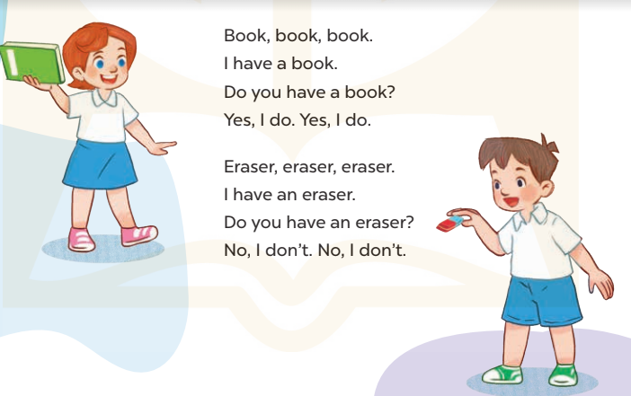  - Play the recording for Ss to listen to the whole chant.  + Have them repeat the title and lyrics line by line.  + Ask Ss to attend to the sounds of the letters oo and a and the words book and eraser.  - Play the recording all the way through for Ss to listen to pronunciation and melody.  - Play the recording line by line for Ss to listen and repeat  - Play the recording for Ss to chant and clap along.  - Ask Ss to practice chant and clap along in pairs or groups.  - Invite groups to the front of the classroom to perform the chant  -T gives feedback.  *Consolidation  *Aims: Ss will be able consolidate and wrap up the content of the lesson.  *Procedure:  - T asks ss to answer the following questions:  + What have you learnt from the lesson today?  +What are the core values of the lesson? (if the teacher can take from the lesson).  - T praises some Ss who are hardworking / active/ good…. as well as encourage others to try more.  4. Homework. (2’)  - Practice the chant more.  - Collect three school things  - Prepare the new lesson: Unit 8, Lesson 3 (4, 5, 6). | - Ss listen  -Ss play game  - Ss open their books  - Ss recognize the differences about color of letter  - - Ss listen  - Ss listen and point  - Ss listen again and repeat  -Ss listen again and repeat  -Ss practice  -Ss listen  -Ss listen and say:  + Number 1: I have .…….  + Number 2: Do you have …?  -Ss guess the answers  - Ss listen to the tape and circle  - Ss listen again, circle and swap books with their partners.  - Ss check their answers and guessing  -Ss listen and repeat.  -Ss read the sentences  - Ss look and listen.  -Ss listen to the chant  - Ss listen and repeat line by line without clap their hands  -Ss note the sounds, words  -Ss listen to melody of the chant  - Ss listen and chant line by line.  - Ss chant and clap along.  - Ss work in groups (two groups) to chant  -Ss perform in front of the class.  -Ss listen  -Ss listen.  -Ss answer the questions  -Ss listen and clap their hands  -Ss listen and take note
D. ADJUSTMENTS (if necessary):
………………………………………………………………………………………….…..……………………………………………………………………………...
-----------------------------------------------------------------
Grade 3: Lớp 3A: Chiều thứ năm ngày 05 tháng 12 năm 2024
ENGLISH
Unit 8: My school things - Lesson 3 (4, 5, 6)
A. OBJECTIVES:
By the end of the lesson, Ss will be able to:
1. Knowledge:
- Read and complete a gapped paragraph with the words provided.
- Read, understand and complete the writing frame with Ss’ information.
- Collect three school things from home and bring them to the classroom to present to their classmates
- Vocabulary: Review
- Skills: speaking, listening, reading and writing.
2. Competences:
- Listening: Listen to the teacher and classmates in communicating.
- Critical Thinking: complete a task in reading a text.
- Co-operation: ready to help friends in pair work/ group work.
- Self-control and independent learning: perform listening tasks.
3. Attitude/ Qualities:
- Kindness: Help partners to complete learning tasks.
- Honesty: tell the truth about feelings and emotions.
- Diligence: complete learning tasks.
B. TEACHING AIDS:
- Teacher: Teacher’s guide Pages 109, 110; website sachmem.vn, posters, laptop, pictures, textbook, lesson plan, TV or projector.
- Students: Pupil’s book Page 61, notebooks, workbooks, school things.
C. PROCEDURES:
Teacher’s activities | Students’ activities
1.Warm- up: (5’)  Game: “Chant”  *Aims: to review the vocabulary and structure about greet and respond to greetings.  *Procedure:  - Ask Ss chant and do the actions in Unit 8, Lesson 3 page 60 in groups.  - Give point for the groups and encourage them.  - Say “Open your book page 61” and look at “Unit 8, Lesson 3 (4, 5, 6)”.  2.Practice: (8’)  Activity 1. Read and complete:  *Aims: Ss will be able to read and complete a gapped paragraph with the words provided.  *Procedure:  - Elicit and introduce the paragraph to complete  - Elicit the missing word for the first gap (have)  - Then tell Ss to pay attention to the article a / an to select appropriate nouns in the box for the next two gaps  - Give Ss time to do the rest individually or in pairs.  - Tell Ss to swap their answers with a partner.  - Check answers as a class. Write the correct answers on the board for Ss to correct their answers.  - Have Ss read the text aloud.  Key: 1. have 2. pen 3. eraser 4. my  3.Production: (19’)  Activity 2. Let’s write  *Aims: Ss will be able to read, understand and complete the writing frame with pupils’ information  *Procedure:  - Write the writing frame on the board.  - Have Ss read the sentences in chorus.  - When you reach the first gap, point to it and tell Ss to complete it with their name.  - Then read the next line and tell them to complete each gap with the school things they have.  - Give Ss time to do the task.  - Invite a few Ss to stand up and read their writing aloud.  Key: Pupils’ answer  Activity 3. Project.  *Aims: Ss will be able to collect three school things from home and bring them to the classroom to present to their classmates.  *Procedure:  - Tell Ss about the activity.  - Check their school things.  - Draw a school thing on the board and write the presentation language under it.  - Check comprehension and give feedback.  - Have Ss repeat the sentences until they can say them by themselves.  - Invite a pupil to the front of the class to model the presentation.  -Watch and offer your support with the language.  - Put Ss into groups to rehearse their presentation.  - Invite a few Ss from different groups to show and talk about their school things in front of the class.  - Create a class display of school things and vote for the best presentation.  *Consolidation  *Aims: Ss will be able consolidate and wrap up the content of the lesson.  *Procedure:  - T asks ss to answer the following questions:  + What have you learnt from the lesson today?  +What are the core values of the lesson? (if the teacher can take from the lesson).  - T praises some Ss who are hardworking / active/ good…. as well as encourage others to try more.  4. Homework. (3’)  - Prepare the new lesson: Unit 9, Lesson 1 (1, 2, 3). | - Ss listen and chant  - Ss open their books  - Ss look at the pictures and answer  -Ss read and complete the first sentence  -Ss listen and answer  -Ss do the task  -Ss swap their answers  -Ss check their answer  -Ss read aloud  -Ss look and listen  -Ss read  -Ss write  -Ss do the task  My name is…….Look at my school things. I have……..  and……….  -Ss listen and repeat  - Ss listen  - Ss listen  - Ss look and note  -Ss listen and answer  -Ss repeat the sentences  -Ss present  -Ss listen  -Ss present into groups  -Ss talk about their school things  -Ss vote for the best presentation  -Ss answer the questions  -Ss listen and clap their hands  -Ss listen and take note
D. ADJUSTMENTS (if necessary):
………………………………………………………………………………………….…..……………………………………………………………………………...

Grade 3: Lớp 3A: Chiều thứ năm ngày 05 tháng 12 năm 2024
ENGLISH
Unit 9: Colours - Lesson 1 (1, 2, 3)
A. OBJECTIVES:
By the end of the lesson, Ss will be able to:
1. Knowledge:
- Use the words blue, brown, red, yellow related to the topic “colours”
- Use What colour is it? – It’s ……… to ask and answer questions about colours of school things
- Vocabulary: blue, brown, red, yellow, colour
- Skills: speaking and listening
2. Competences:
- Self-control and independent learning: perform listening tasks.
- Communication and collaboration: work in pairs or groups.
- Sociability: talk to each other, say good words to others.
3. Attitude/ Qualities:
- Kindness: Help partners to complete learning tasks.
- Honesty: tell the truth about feelings and emotions
B. TEACHING AIDS:
- Teacher: Teacher’s guide Pages 111, 112, audio Tracks 87, 88, website sachmem.vn, posters, laptop, pictures, textbook, lesson plan, TV or projector.
- Students: Pupil’s book Page 62, notebooks, workbooks, school things.
C. PROCEDURES:
Teacher’s activities | Students’ activities
1.Warm- up: (3’)  Jigsaw puzzle  *Aims: to create a friendly and active atmosphere in the class to beginning the lesson.  *Procedure:  - Divide class into 4 groups: Tom, Jerry, Miu and Chit.  - Ask Ss look at the pieces of picture.    - Ask Ss go to the board and jigsaw puzzle into the correct picture.  -T checks who’s the winner?  - Say “Open your book page 62” and look at “Unit 9, Lesson 1 (1,2,3)”.  2. Presentation (16’)  Activity 1. Vocabulary.  *Aims: Ss will be able to know the vocabulary in front of starting the new lesson.  *Procedure:  -T elicits the new words  + blue : màu xanh da trời  (visual)  + brown : màu nâu (visual)  + red :màu đỏ (visual)  + yellow : màu vàng (visual)  + colour: màu sắc (translation)  - T models (3 times).  - T writes the words on the board.  - Checking: Rub out and remember  Activity 2. Look, listen and repeat:  *Aims: Ss will be able to understand and correctly repeat the sentences in two communicative contexts (pictures) to talk about colours.  *Procedure:  - Have Ss look at Pictures a and b and identify the characters (Minh and Mary) in the pictures.  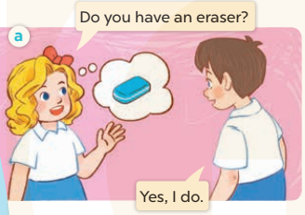  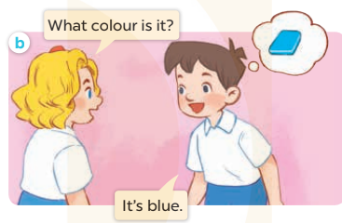  - Play the audio twice (sentence by sentence). Correct their pronunciation where necessary.  - Have Ss to practice the dialogue  - T invites a few pairs to the front of the class to practice.  - T checks pronunciation for ss.  Activity 3 2. Listen, point and say.  *Aims: Ss will be able to correctly use What colour is it? It’s ……. for asking and answering questions about the colours of school things.  *Procedure:  * Model sentences:  - T asks Ss look at picture b and helps Ss know the structure from the dialogue.  - T introduces new structure for Ss.  - T explains, models and gives meaning.  -Have Ss repeat the model sentences.  A: What colours is it?  B: It’s blue.  3.Practice: (7’)  *Drill pictures  - Have Ss look at the pictures and identify the names of the school things in the pictures  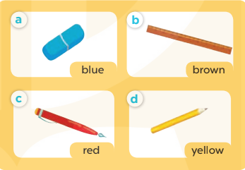  - Run through all the pictures.  - Run through model sentences.  +Run through question sentence  +Run through answer sentence  - Have Ss to practise:  + T asks, Ss answer picture a  + Ss asks, T answers picture b  + Group A ask, group B answer picture c  + Group B ask, group A answer picture d  - Ask Ss to work in pairs.  - T controls and corrects.  - Invite a few pupils to stand up, point at each school thing in the picture and say the sentence aloud.  - T gives feedbacks.  4.Production: (7’)  Activity 4. Let’s talk.  *Aims: Ss will be able to enhance the correct use of What colour is it? – It’s …….. for asking and answering questions about the colour of a school thing.  *Procedure:  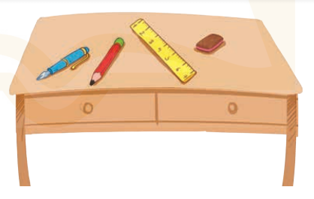  - Have Ss look at the picture and elicit the question and the answer in context.  + What are they?  + Where are they?  + What colours is it?  - Have Ss look at the school things on the desk and say their names, and then their colours.  - Have Ss look at the first speech bubble and read What colour are they?  - Then have them point at the school bags and complete the gapped answer in the second bubble (Ex: They’re black.). After that, let them say the question and the answer.  - Give Ss time to practise asking and answering the question What colour are they? – ……. in pairs.  - Invite a few pairs to practise asking and answering questions about the colours of the school things on the desk in front of the class.  - If time allows, let Ss point at the school things around them, ask and answer questions about their colours.  *Consolidation  *Aims: Ss will be able consolidate and wrap up the content of the lesson.  *Procedure:  - T asks ss to answer the following questions:  + What have you learnt from the lesson today?  +What are the core values of the lesson? (if the teacher can take from the lesson).  - T review the vocabulary and model sentences.  - T praises some Ss who are hardworking / active/ good…. as well as encourage others to try more.  5. Homework. (2’)  - Learn the vocabulary and model sentences by heart  - Prepare the new lesson: Unit 9, Lesson 1 (4,5,6). | - Ss listen  -Ss look at the pieces of the picture  -Ss put into the correct picture  -Ss check  -Ss open their books  -Ss listen and answer  - - Ss listen and repeat  + Choral repetition (3 times).  + Individual repetition (3 ss)  - Ss take note  - Ss look, remember and write  -Look at the pictures and say  + In picture a: Mary asks Minh: Do you have an eraser?  Minh replies: Yes, I do.  + In picture b: Mary asks Minh: What colour is it?  Minh replies: It’s blue.  -Ss listen and repeat in chorus (twice)  -Ss work in pairs to practice  -Ss practice the dialogue  -Ss listen  -Ss look at the picture and answer.  -Ss listen  -Ss listen and repeat  -Ss repeat  - Ss look, listen and answer  + Picture a: a blue eraser + Picture b: a brown ruler  + Picture c: a red pen  + Picture d: a yellow pencil  -Ss listen and repeat  -Ss practice in chorus, individuals.  -Ss work in pairs  -Ss point and say  -Ss listen.  -Ss look at the picture and answer  + a blue pen, a red pencil, a yellow ruler, and a brown eraser on a desk.  -Ss point and say  -Ss read the sentence  -Ss point and complete  -Ss ask and answer  -Ss work in pairs, point and ask and answer  -SS practice to ask amd amswer  -Ss ask and answer about their colours  -Ss answer the questions  - Ss listen  -Ss listen and clap their hands  -Ss listen and take note
D. ADJUSTMENTS (if necessary):
………………………………………………………………………………………….…..……………………………………………………………………………...
---------------------------------------------------

Grade 4: Lớp 4A: Sáng thứ ba, Ngày 03 tháng 12 năm 2024
Lớp 4B: Chiều thứ hai, Ngày 02 tháng 12 năm 2024
Lớp 4C: Sáng thứ tư , Ngày 04 tháng 12 năm 2024

ENGLISH
Unit 8: My favourite subjects
Lesson 2 (4, 5, 6)
A. OBJECTIVES:
By the end of the lesson, Ss will be able to:
1. Knowledge:
- Use the words and phrases art, music, PE, IT, an English teacher, a maths teacher, a painter and a singer in relation to the topic “My favourite subjects”.
– Listen to and demonstrate understanding of simple communicative contexts in relation to the topic “My favourite subjects”.
- Vocabulary: Review
- Skills: speaking, listening, reading and writing.
2. Competences:
- Critical Thinking: self-introduce
- Co-operation: ready to help friends in pair work/ group work.
- Self-control and independent learning: perform listening tasks.
3. Attitude/ Qualities:
- Kindness: Help partners to complete learning tasks.
- Diligence: complete learning tasks.
B. TEACHING AIDS:
- Teacher: Teacher’s guide Pages 119, 120, 121; audio Tracks 83; website hoclieu.vn, posters, laptop, pictures, textbook, lesson plan, TV or projector.
- Students: Pupil’s book Page 59, notebooks, workbooks, school things.
C. PROCEDURES:
Teacher’s activities | Students’ activities
1.Warm- up: (5’)  Game: Pass the ball  *Aims: to create a friendly and active atmosphere in the class to beginning the lesson.  *Procedure:  - T gives Ss a ball.  - T asks Ss to listen to music and transfer a ball around the class.  - When the music stops, Ss who keep a ball have to answer the question using: Why do you like……? and Because I……  - T gives feedback.  - Say “Open your book page 59” and look at “Unit 8, Lesson 2 (4,5,6)”.  2.Practice: (27’)  Activity 1. Listen and number:  *Aims: Ss will be able to listen to and understand four communicative contexts in which pupils gives reasons why they like the school subject, and number the correct pictures.  *Procedure:  - Elicit the favourite subject and the reason for liking it.  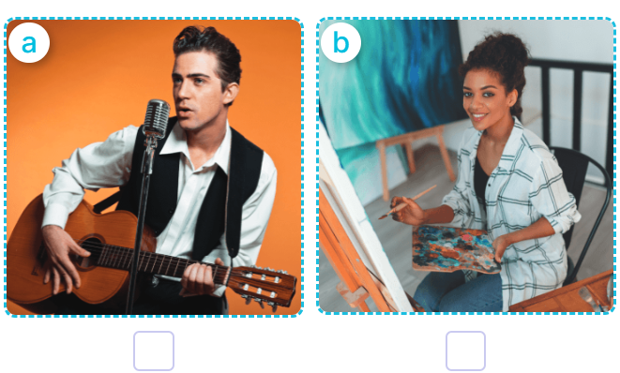  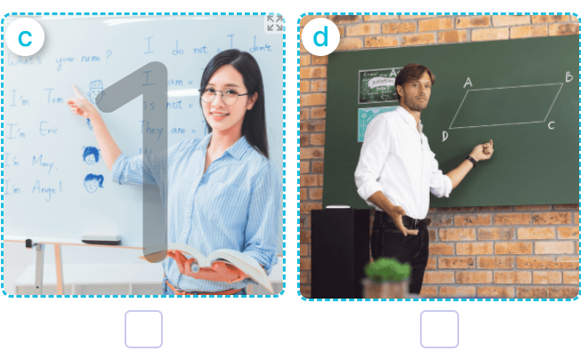  - T ask Ss to guess the answers.  + T writes Ss’guessing on the board.  - Listen to the tape:  + Play the recording  + Play the recording again and get Ss to swap books with their partners.  + Play the recording again to check answers together as a class.  + Write the answers on the board for Ss to correct their answers. Then checks Ss’ guessing.  - Play the recording, sentence by sentence, for the class to listen and repeat in chorus.  Key: 1. b 2. d 3. a 4. c  Activity 2. Look, complete and read  *Aims: Ss will be able to complete two dialogues about their favourite subjects and the reasons why pupils like them with the help of picture cues  *Procedure:  - Get Ss to look at the pictures and ask them what the girl and the boy are doing 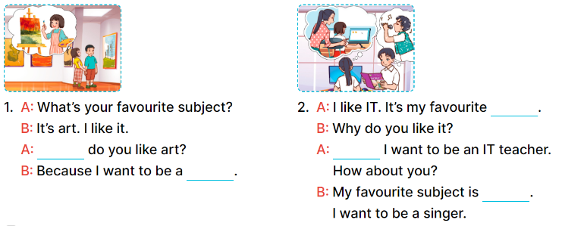  - Model and elicit the missing words from the Exchange 1 (Why, painter).  -Have pupils to do the task individually.  - Get pupils swap books with their partners and check the answers before checking as a class.  - Invite a few pairs to stand up and read the sentences aloud.  Key:  - Why/ painter  - Subject; because; music  Activity 3. Let’s play  Sentence making  *Aims: Ss will be able to practice making meaningful and grammatically correct sentences about future jobs by playing the game “sentence making”.  *Procedure:  - Tell pupils the goal of the game and how to play it. 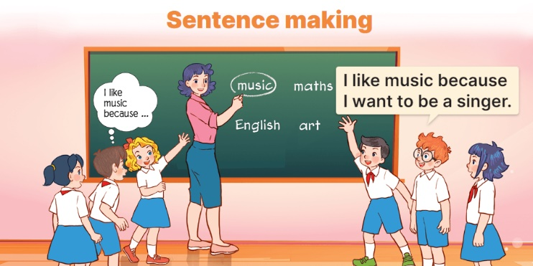  - How to play the game:  + When the teacher circles or says one of the words on the board, the groups make as many sentence as possible.  + The group that gives the correct sentences more quickly gets one point or one star for one correct sentence.  + The group with more points or stars is the winner.  - Divide the class into groups of three or four pupils to play.  *Consolidation  *Aims: Ss will be able consolidate and wrap up the content of the lesson.  *Procedure:  - T asks ss to answer the following questions:  + What have you learnt from the lesson today?  +What are the core values of the lesson? (if the teacher can take from the lesson).  - T praises some Ss who are hardworking / active/ good…. as well as encourage others to try more  3. Homework. (3’)  - Practice part 5 again.  - Prepare the new lesson: Unit 8, Lesson 3 (1,2,3). | - Ss listen  - Ss play game  -Ss play game  - Ss open their books  -Look at the pictures and say:  + Picture a: A male singer singing  + Picture b: A female painter working  + Picture c: An English teacher writing  + Picture d: A maths teacher writing  -Ss guess the answers  - Ss listen to the tape and write  - Ss listen again, write and swap books with their partners.  - Ss check their answers and guessing  -Ss listen and repeat.  -Ss look at the picture and say  -Ss look and answer  -Ss do the task  -Ss swap books and check their answer  -Ss read the sentences aloud  - Ss listen  - Ss listen  - Ss play game  - Ss play game  -Ss answer the questions  -Ss listen and clap their hands  -Ss listen and take note
D. ADJUSTMENTS (if necessary):
………………………………………………………………………………………….…..……………………………………………………………………………...
---------------------------------------------------
Grade 4: Lớp 4A: Sáng thứ ba, Ngày 03 tháng 12 năm 2024
Lớp 4B: Chiều thứ hai, Ngày 02 tháng 12 năm 2024
Lớp 4C: Sáng thứ tư , Ngày 04 tháng 12 năm 2024
ENGLISH
Unit 8: My favourite subjects
Lesson 3 (1, 2, 3)
A. OBJECTIVES:
By the end of the lesson, Ss will be able to:
1. Knowledge:
- Correctly pronounce the sounds of the letters ke and te in isolation, in the words like and write, and in the sentences I like English. and Let's write.
– Use the words and phrases art, music, PE, IT, an English teacher, a maths teacher, a painter and a singer in relation to the topic “My favourite subjects”
– Use Why do you like …….? – Because I want to be …….. to ask for and give reasons for liking a school subject
– Listen to and demonstrate understanding of simple communicative contexts in relation to the topic “My favourite subjects”
- Vocabulary: Review
- Skills: speaking, listening, reading and writing.
2. Competences:
- Co-operation: ready to help friends in pair work/ group work.
- Sociability: Talk to each other, say good words to others.
3. Attitude/ Qualities:
- Kindness: Help partners to complete learning tasks.
- Honesty: tell the truth about feelings and emotions
B. TEACHING AIDS:
- Teacher: Teacher’s guide Pages 121,122; audio Tracks 84, 85, 86; website hoclieu.vn, posters, laptop, pictures, textbook, lesson plan, TV or projector.
- Students: Pupil’s book Page 60, notebooks, workbooks, school things.
C. PROCEDURES:
Teacher’s activities | Students’ activities
1.Warm- up: (5’)  Game: Find and circle the words  *Aims: to create a friendly and active atmosphere in the class to beginning the lesson.  *Procedure:  L I K E E W S C M T  H C T H N R H C A H  C L U A A I A O K I  L E L N N T T S E N  A A W K E E O E E K  A C D E G H O S V B  F A V O U R I T E H  B I K E I A S D A Y  D T S S R S N O T E  A C E B F E Z Y W  - Divide class into 2 groups  - Ask Ss to find and circle the words that they learnt.  - Which groups find the best correct words is winner.  - Give Ss time to play the game.  Rows: like, bike, note, favourite  Columns: write, make  -T checks who’s winner?  - Say “Open your book page 60” and look at “Unit 8, Lesson 3 (1,2,3)”.  2. Presentation (9’)  Activity 1. Listen and repeat:  *Aims: Ss will be able to correctly repeat the sounds of the letter cluster ke and letter te in isolation, in the words like and write, and in the sentences I like English. and Let’s write with correct pronunciation and intonation.  *Procedure:  - T gives instruction to the letter ke and te, like and write, and in the sentences I like English. and Let’s write.  - Play the recording for the letter ke, te.  - Encourage Ss to point at the letter/ word/ sentence while listening.  - Play the recording again and encourage Ss to listen and repeat.  - Do this several times until Ss feel confident.  - T calls some Ss to practice.  - T gives feedbacks.  3.Practice: (19’)  Activity 2. Listen and circle.  *Aims: Ss will be able to identify the target words like and write while listening.  *Procedure:  - Elicit the sentences and the gap-fill options.  - T ask Ss to guess the answers.  + T writes Ss’guessing on the board.  - Listen to the tape:  + Play the recording  + Play the recording again and get Ss to swap books with their partners.  + Play the recording again to check answers together as a class.  + Write the answers on the board for Ss to correct their answers. Then checks Ss’ guessing.  - Play the recording, sentence by sentence, for the class to listen and repeat in chorus.  - Invite one or two Ss to stand up and read the completed sentences.  Key: 1.a 2.b  Activity 3. Let’s chant  *Aims: Ss will be able to say the chant with the correct rhythm and pronunciation  *Procedure:  - Introduce the title and lyrics of the chant.  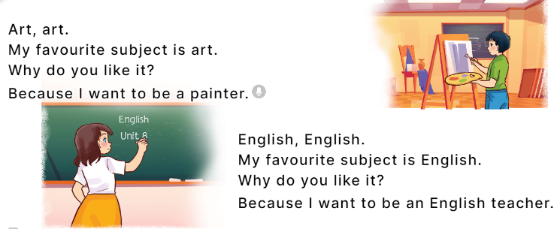  - Play the recording for Ss to listen to the whole chant.  + Have them repeat the title and lyrics line by line.  + Ask Ss to attend to the sounds of the letters ke and te and the words like and write.  - Play the recording all the way through for Ss to listen to pronunciation and melody.  - Play the recording line by line for Ss to listen and repeat  - Play the recording for Ss to chant and clap along.  - Ask Ss to practice chant and clap along in pairs or groups.  - Invite groups to the front of the classroom to perform the chant  -T gives feedback.  *Consolidation  *Aims: Ss will be able consolidate and wrap up the content of the lesson.  *Procedure:  - T asks ss to answer the following questions:  + What have you learnt from the lesson today?  +What are the core values of the lesson? (if the teacher can take from the lesson).  - T praises some Ss who are hardworking / active/ good…. as well as encourage others to try more.  4. Homework. (2’)  - Practice the chant more.  - Collect three school things  - Prepare the new lesson: Unit 8, Lesson 3 (4, 5, 6). | - Ss listen  -Ss play game  - Ss open their books  - Ss recognize the differences about color of letter  - - Ss listen  - Ss listen and point  - Ss listen again and repeat  -Ss listen again and repeat  -Ss practice  -Ss listen  -Ss listen and say  -Ss guess the answers  - Ss listen to the tape and circle  - Ss listen again, circle and swap books with their partners.  - Ss check their answers and guessing  -Ss listen and repeat.  -Ss read the sentences  - Ss look and listen.  -Ss listen to the chant  - Ss listen and repeat line by line without clap their hands  -Ss note the sounds, words  -Ss listen to melody of the chant  - Ss listen and chant line by line.  - Ss chant and clap along.  - Ss work in groups (two groups) to chant  -Ss perform in front of the class.  -Ss listen  -Ss listen.  -Ss answer the questions  -Ss listen and clap their hands  -Ss listen and take note
D. ADJUSTMENTS (if necessary):
………………………………………………………………………………………….…..……………………………………………………………………………...
-----------------------------------------------
Grade 4: Lớp 4A: Sáng thứ sáu Ngày 06 tháng 12 năm 2024
Lớp 4B: Sáng thứ tư, Ngày 04 tháng 12 năm 2024
Lớp 4C: Sáng thứ sáu , Ngày 06 tháng 12 năm 2024
ENGLISH
Unit 8: My favourite subjects
Lesson 3 (4, 5, 6)
A. OBJECTIVES:
By the end of the lesson, Ss will be able to:
1. Knowledge:
- Read and write about someone’s favourite subject.
- Do a survey on their classmates’ favourite subjects and the reasons why they like these subjects and present it to their classmates at Project time.
- Vocabulary: Review
- Skills: speaking, listening, reading and writing.
2. Competences:
- Critical Thinking: complete a task in reading a text.
- Co-operation: ready to help friends in pair work/ group work.
- Self-control and independent learning: perform listening tasks.
3. Attitude/ Qualities:
- Kindness: Help partners to complete learning tasks.
- Diligence: complete learning tasks.
B. TEACHING AIDS:
- Teacher: Teacher’s guide Pages 123, 124, 125; website hoclieu.vn, posters, laptop, pictures, textbook, lesson plan, TV or projector.
- Students: Pupil’s book Page 61, notebooks, workbooks, school things.
C. PROCEDURES:
Teacher’s activities | Students’ activities
1.Warm- up: (5’)  Game: “Chant”  *Aims: to review the vocabulary and structure about greet and respond to greetings.  *Procedure:  - Ask Ss chant and do the actions in Unit 8, Lesson 3 page 60 in groups.  - Give point for the groups and encourage them.  - Say “Open your book page 61” and look at “Unit 8, Lesson 3 (4, 5, 6)”.  2.Practice: (8’)  Activity 1. Read and complete:  *Aims: Ss will be able to read a paragraph and decide whether the sentences are true or false.  *Procedure:  - Have pupils read all the sentences under the paragraph.  - Have pupil read Sentence 1 and pay attention to the keywords name and Peter, then scan the paragraph for the information.  + If it is the same, they should put a tick in the True box.  + If the information is not the same, they should put a tick in the False box.  -Ask pupils to do the activity independently.  - Get pupils to swap books with their partners and check their answers before checking as a class.  - Invite some pupils to stand up and read the paragraph aloud.  Key: 1. True 2. False 3. True 4. False  3.Production: (19’)  Activity 2. Let’s write  *Aims: Ss will be able to read, understand and complete a paragraph about their favourite subjects.  *Procedure:  - Tell pupils what they are going to do.  - Then get them to read the incomplete paragraph.  - Elicit what the paragraph is about (someone’s favourite subject and the reason why he / she likes it).  - Get pupils to fill the first gap with their name as an example.  -Have pupils to complete the paragraph independently.  - Get pupils to swap books with their partners and check the answers in pairs or groups.  - Have a few pupils to stand up and read their writing aloud.  - Invite a few pupils to read their completed texts in front of the class.  Key: Pupils’ answer  Ex: My name is Huong. I have English, PE, music, art and maths today. My favorite subject is English. I like it because I want to be an English teacher. What is your favorite subject?  Activity 3. Project.  *Aims: Ss will be able to do a survey on their classmates’ favourite subjects and the reasons why they like these subjects and present them to the class  *Procedure:  - Tell Ss about the activity.  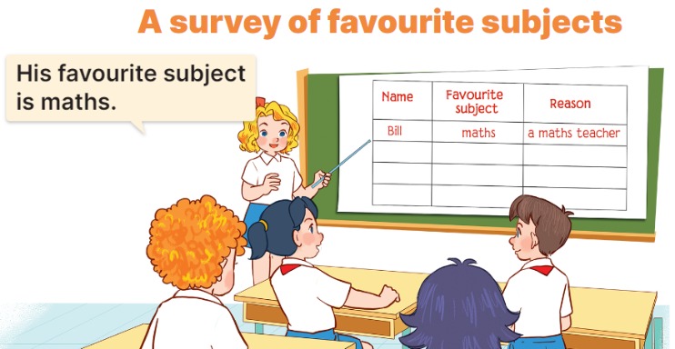  - Get pupils to work in groups to show their surveys on their classmates’ favourite subjects and the reasons why they like these subjects which they have prepared at home as homework.  - Invite a pupil to the front of the class to model the presentation.  Ex: Look at Bill. His favourite subject is maths. He likes it because he wants to be a maths teacher.  - Have the pupils repeat the language a few times to help them feel confident when they present.  - Have pupils to present the project in their groups.  - Invite a few pupils to the front of the class to present their projects.  *Consolidation  *Aims: Ss will be able consolidate and wrap up the content of the lesson.  *Procedure:  - T asks ss to answer the following questions:  + What have you learnt from the lesson today?  +What are the core values of the lesson? (if the teacher can take from the lesson).  - T praises some Ss who are hardworking / active/ good…. as well as encourage others to try more.  4. Homework. (3’)  - Prepare the new lesson: Unit 9, Lesson 1 (1, 2, 3). | - Ss listen and chant  - Ss open their books  - Ss read the paragraph  -Ss read and complete the first sentence  -Ss do the task  -Ss swap their answers  -Ss check their answer  -Ss read aloud  -Ss look and listen  -Ss read  -Ss listen and pay attention  -Ss fill the first gap  -Ss do the task  -Ss swap books and check their answer  -Ss check the answer  -Ss read aloud  -Ss listen and pay attention  -Ss work in groups and show their survey  -Ss report the survey  -Ss repeat the languege  -Ss present into groups  -Ss present in front of the class.  -Ss answer the questions  -Ss listen and clap their hands  -Ss listen and take note
D. ADJUSTMENTS (if necessary):
………………………………………………………………………………………….…..……………………………………………………………………………...

Grade 4: Lớp 4A: Sáng thứ sáu Ngày 06 tháng 12 năm 2024
Lớp 4B: Sáng thứ tư, Ngày 04 tháng 12 năm 2024
Lớp 4C: Sáng thứ sáu , Ngày 06 tháng 12 năm 2024
ENGLISH
Unit 9: Our sports day
Lesson 1 (1, 2, 3)
A. OBJECTIVES:
By the end of the lesson, Ss will be able to:
1. Knowledge:
- Use the words and phrase December, July, June, November, October, September, sports day in relation to the topic "Our sports day"
- Use Is your sports day in ……..? – Yes, it is. / No, it isn’t. It’s in ……. to ask and answer questions about sports days;
- Listen to and demonstrate understanding of simple exchanges in relation to the topic "Our sports day"
- Vocabulary: June, July, August.
- Skills: speaking and listening
2. Competences:
- Self-control and independent learning: perform listening tasks.
- Communication and collaboration: work in pairs or groups.
3. Attitude/ Qualities:
- Kindness: Help partners to complete learning tasks.
- Honesty: tell the truth about feelings and emotions
B. TEACHING AIDS:
- Teacher: Teacher’s guide Pages 125,126,127, audio Tracks 87, 88, website hoclieu.vn, posters, laptop, pictures, textbook, lesson plan, TV or projector.
- Students: Pupil’s book Page 62, notebooks, workbooks, school things.
C. PROCEDURES:
Teacher’s activities | Students’ activities
1.Warm- up: (3’)  Sing a song  *Aims: to create a friendly and active atmosphere in the class to beginning the lesson.  *Procedure:  https://www.youtube.com/watch?v=Fe9bnYRzFvk  - Have pupils listen and sing the song “Months of the Year”  - Say “Open your book page 62” and look at “Unit 9, Lesson 1 (1,2,3)”.  2. Presentation (16’)  Activity 1. Vocabulary.  *Aims: Ss will be able to know the vocabulary in the new lesson.  *Procedure:  -T elicits the new words  + June : tháng 6 (situation)  + July : tháng 7 (translation)  + August :tháng 8 (situation)  - T models (3 times).  - T writes the words on the board.  - Checking: Rub out and remember  Activity 2. Look, listen and repeat:  *Aims: Ss will be able to understand and correctly repeat the sentences in two communicative contexts focusing on asking and answering questions about sports days *Procedure:  - Have pupils look at Pictures a and b and identify the characters in the pictures.  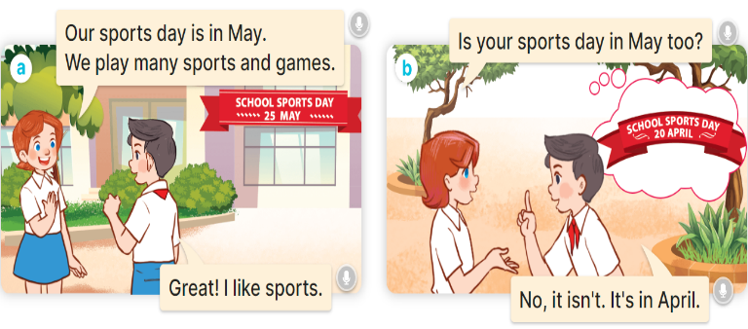  - Play the audio twice (sentence by sentence). Correct their pronunciation where necessary.  - Have Ss to practice the dialogue  - T invites a few pairs to the front of the class to practice.  - T checks pronunciation for ss.  Activity 3 Listen, point and say.  *Aims: Ss will be able to correctly say the words and use Is your sports day in …….? – Yes, it is. / No, it isn’t. It’s in …... to ask and answer questions about sports days.  *Procedure:  * Model sentences:  - T asks Ss look at picture b and helps Ss know the structure from the dialogue.  - T introduces new structure for Ss.  - T explains, models and gives meaning.  - Have Ss repeat the model sentences.  A: Is your sports day in May?  B: Yes, it is. / No, it isn’t. It’s in June  3.Practice: (7’)  *Drill pictures  - Have pupils look at the pictures and elicit the names of the months in the pictures.  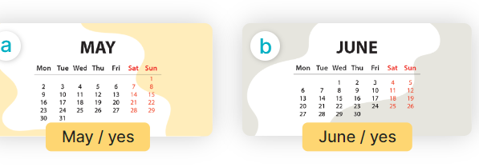  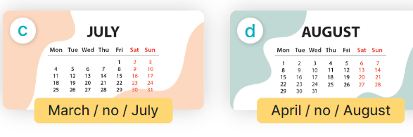  - Run through all the pictures.  - Run through model sentences.  +Run through question sentence  +Run through answer sentence  - Have Ss to practise:  + T asks, Ss answer picture a  + Ss asks, T answers picture b  + Group A ask, group B answer picture c  + Group B ask, group A answer picture d  - Ask Ss to work in pairs.  - T controls and corrects.  - Invite a few pupils to stand up, point at each school thing in the picture and say the sentence aloud.  - T gives feedbacks.  4.Production: (7’)  Activity 4. Let’s talk.  *Aims: Ss will be able to enhance the correct use of Is your sports day in ………? – Yes, it is. / No, it isn’t. It’s in ……... to ask and answer questions about sports days  *Procedure:  - Have Ss look at the picture and say the names of the months in the picture.  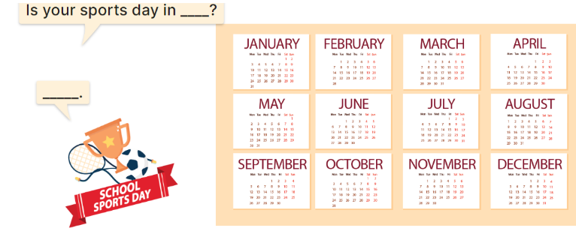  - Have pupils look at the bubbles to understand how the sentence pattern is used. - Have pupils role-play to practise asking the questions and giving their answers in pairs, using picture cues.  - Invite some pupils to practise asking and answering questions in front of the class.  - Have pupils ask and answer questions about what their friend(s) do on school sports day, using the structure learnt.  ex: What do you do on sports day? – I ……..  *Consolidation  *Aims: Ss will be able consolidate and wrap up the content of the lesson.  *Procedure:  - T asks ss to answer the following questions:  + What have you learnt from the lesson today?  +What are the core values of the lesson? (if the teacher can take from the lesson).  - T review the vocabulary and model sentences.  - T praises some Ss who are hardworking / active/ good…. as well as encourage others to try more.  5. Homework. (2’)  - Learn the vocabulary and model sentences by heart  - Prepare the new lesson: Unit 9, Lesson 1 (4,5,6). | - Ss listen  -Ss sing and dance  -Ss open the books  -Ss listen and answer  - - Ss listen and repeat  + Choral repetition (3 times).  + Individual repetition (3 ss)  - Ss take note  - Ss look, remember and write  -Look at the pictures and say  + In picture a:  Lucy: Our sports day is in May. We play many sports and games.  Nam: Great! I like sports.  + In picture b:  Lucy: Is your sports day in May too?  Nam: No, it isn't. It's in April.  -Ss listen and repeat in chorus (twice)  -Ss work in pairs to practice  -Ss practice the dialogue  -Ss listen  -Ss look at the picture and answer.  -Ss listen  -Ss listen and repeat  -Ss repeat  - Ss look, listen and answer  + Picture a: a calendar sheet of April  + Picture b: a calendar sheet of May  + Picture c: a calendar sheet of June  + Picture d: a calendar sheet of July  -Ss listen and repeat  -Ss practice in chorus, individuals.  -Ss practice in chorus, individuals.  -Ss work in pairs  -Ss point and say  -Ss listen.  -Ss look at the picture and answer  + a picture of a sports day and calendar sheets of the months of the year.  -Ss look at the bubbles and say  -Ss work in pairs, point and ask and answer  -SS practice to ask amd amswer  -Ss ask and answer about what their friend(s) do on school sports day  -Ss answer the questions  - Ss listen  -Ss listen and clap their hands  -Ss listen and take note
D. ADJUSTMENTS (if necessary):
………………………………………………………………………………………….…..……………………………………………………………………………...
-----------------------------------------------------------------
Grade 5 : Lớp 5B : Sáng thứ ba, Ngày 03 tháng 12 năm 2024
ENGLISH
Unit 8: In our classroom
Lesson 2 (4, 5, 6)
A. OBJECTIVES:
By the end of the lesson, Ss will be able to:
1. Knowledge:
- Listen to and understand two communicative contexts in which characters ask and answer questions about the locations of school things and possession and tick the correct pictures.
- Complete two gapped exchanges with the help of picture cues.
- Revise target words about possession and school things by playing the game Whose pen is this?
- Vocabulary: Review
- Skills: speaking, listening, reading and writing.
2. Competences:
- Communication and collaboration: work in pairs and groups to complete the learning tasks.
3. Attitude/ Qualities:
- Show their pride in school things they have and great respect for other people’s school things by using appropriate gestures and intonation when asking and answering about school things.
B. TEACHING AIDS:
- Teacher: Teacher’s guide Pages 122, 123 124; audio Tracks 82; website hoclieu.vn, posters, laptop, pictures, textbook, lesson plan, TV or projector.
- Students: Student’s book Page 59, notebooks, workbooks, school things.
C. PROCEDURES:
Teacher’s activities | Students’ activities
1.Warm- up and review: (5’)  Game: Flower picking!  *Aims: to revise the sentence structures Whose ___ is this? - It’s ___. to ask and answer questions about possession.  *Procedure:  - Tell Ss that they are going to pick up the flowers, then look at the things and ask and answer questions about possession.  - Divide the class into two groups. Two Ss from each group will play the game in turns.  - If ss ask and answer the questions correctly, they will get points for their group.  - Continue the game until all the flowers are picked.  - The group with more points wins the game. Praise the winner.  - Say “Open your book page 59” and look at “Unit 8, Lesson 2 (4,5,6)”.  2.Practice: (25’)  Activity 1. Listen and tick:  *Aims: Ss will be able to listen to and understand two communicative contexts in which characters ask and answer questions about the locations of school things and possession and tick the correct pictures.  *Procedure:  - Have Ss look at the pictures and help ss identify the locations of the three crayons and set squares  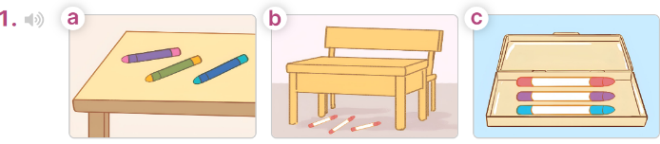  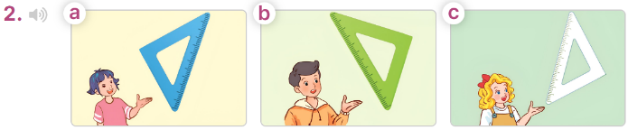  - T ask Ss to guess the answers.  + T writes Ss’guessing on the board.  - Listen to the tape:  + Play the recording  + Play the recording again for pupils to do the task.  + Play the recording a third time for pupils to check their answers.  - Get Ss to swap books with their partner, then check answers as a class.  + Write the answers on the board for Ss to correct their answers. Then checks Ss’ guessing.  - If time allows, play the recording, sentence by sentence, for Ss to listen and repeat individually and in chorus Key: 1. b 2. a  Activity 2. Read and complete  *Aims: Ss will be able to complete two gapped exchanges with the help of picture cues.  *Procedure:  - Have Ss look at the pictures and identify the directions to the rooms in the pictures.  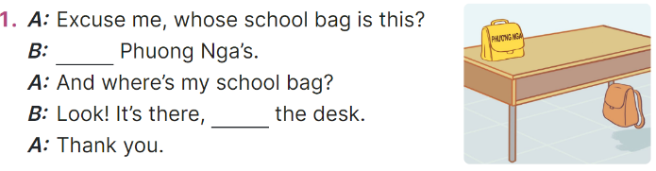  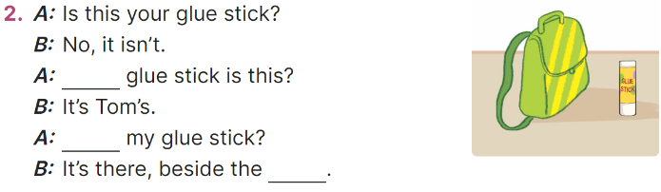  - Model the first sentence: have Ss read the question and ask what words are missing (It’s)  - Give Ss a time limit to read the gapped dialogues, look at the pictures and do the task independently.  - Get Ss to swap books with a partner and check their answers before checking as a class.  + Invite one student to write the answers on the board.  - Invite two pairs of Ss to act out the completed dialogues.  Key: 1. It’s; under,  2. Whose; Where’s; school bag Activity 3. Let’s play  *Aims: Ss will be able to revise target words about possession and school things by playing the game Whose pen is this?  *Procedure:  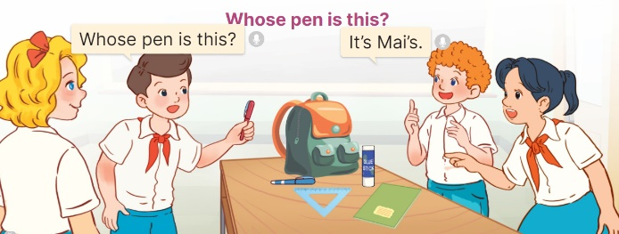  - Tell ss that they are going to play Whose pen is this? game in groups of four.  - The teams take turns asking and answering about possession.  - When a team gives a correct answer, they get one point. The winning team is the one that gets the most points.  - Have ss work in groups. Invite two groups to the front of the class to play the game.  3. Fun corner and wrap- up (5’)  Game: Pass the balls  - Give two different colored balls to two pupils, a red ball (ask the question) and a yellow ball (answer the question).  - Ask ss to listen to music and pass the balls.  - Stop music suddenly.  - Have the student with a red ball ask a question. Have the student with a yellow ball answer the question. | - Ss listen to the teacher’s explanation.  - Ss work in two groups and play the game  - Ss continue playing the game until all the flowers are picked.  - Pupils praise the winner.  - Ss open their books  -Look at the pictures and say:  + Picture 1a: three pencils on a desk  + Picture 1b: three pencils under a desk  + Picture 1c: three pencils in a pencil case  + Picture 2a: Linh’s set square  + Picture 2b: Nam’s set square  + Picture 2c: Mary’s set square  -Ss guess the answers  - Ss listen to the tape  - Ss listen again and do the task.  - Ss listen and check their answers  - Ss swap books with their partner, then check answers as a class and guessing  -Ss write the answer on the board  -Ss listen and repeat  -Ss look at the picture and say  -Ss follow the teacher  - Ss do the task independently.  - Ss swap books with a partner and check their answers.  - Ss write the answers on the board  - Pairs of Ss read the completed dialogues aloud  - Ss listen to the teacher’s explanation.  - Ss work in two groups to ask and answer about possession.  - The team that gives a correct answer will get one point.  - Ss comes to the front of the class to play the game.  -Ss listen to the teacher  - Ss play the game.  Ex: A: Whose pen is this?  B: It’s Linh’s.
D. ADJUSTMENTS (if necessary):
………………………………………………………………………………………….…..……………………………………………………………………………...
* Start preparing for the Project: Tell Ss about the project on page 61, Lesson 3, Activity 6. Ask them to draw their study corners with the locations of school things, and present their group’s pictures to the class at Project time.
-----------------------------------------------------------
Grade 5 : Lớp 5B : Sáng thứ ba, Ngày 03 tháng 12 năm 2024
ENGLISH
Unit 8: In our classroom
Lesson 3 (1, 2, 3)
A. OBJECTIVES:
By the end of the lesson, Ss will be able to:
1. Knowledge:
- Correctly pronounce the two-syllable words a’bove and be’side with the stress on the second syllable, in isolation and as in the sentences The picture is a’bove the window. and The map is be’side the board.
- Identify the stress on some two-syllable words and circle the word with a different stress pattern from the other two words.
- Say the chant with the correct pronunciation, word stress and rhythm.
- Vocabulary: Review
- Skills: speaking, listening, reading and writing.
2. Competences:
- Communication and collaboration: work in pairs and groups to complete the learning tasks.
- Self-control and independent learning: perform pronunciation and listening tasks.
3. Attitude/ Qualities:
- Show their pride in school things they have and great respect for other people’s school things by using appropriate gestures and intonation when asking and answering about school things.
B. TEACHING AIDS:
- Teacher: Teacher’s guide Pages 124, 125; audio Tracks 83, 84, 85; website hoclieu.vn, posters, laptop, pictures, textbook, lesson plan, TV or projector.
- Students: Students’ book Page 60, notebooks, workbooks, school things.
C. PROCEDURES:
Teacher’s activities | Students’ activities
1.Warm- up and review: (5’)  Dance: Chicken dance  *Aims: to create a friendly and active atmosphere in the class to beginning the lesson.  *Procedure:  - Show the song on the screen.  https://www.youtube.com/watch?v=WZJAIkmT3Rg  - Ask Ss to listen, sing and dance the song.  - Say “Open your book page 60” and look at “Unit 8, Lesson 3 (1,2,3)”.  2. Presentation (9’)  Activity 1. Listen and repeat:  *Aims: Ss will be able to correctly pronounce the two-syllable words a’bove and be’side with the stress on the second syllable, in isolation and as in the sentences The picture is a’bove the window. and The map is be’side the board.  *Procedure:  - Have Ss point at the a’bove and be’side with the stress on the second syllable, in isolation and in the sentences The picture is a’bove the window. and The map is be’side the board.  - Play the recording for Ss to listen and repeat in chorus and individually until they feel confident.  - Let Ss work in pairs or groups, saying the words and reading the sentences.  - T invites some Ss to practice.  3.Practice: (17’)  Activity 2. Circle, listen and check.  *Aims: Ss will be able to identify the stress on some two-syllable words and circle the word with a different stress pattern from the other two words.  *Procedure:  - Tell Ss circle the word having a different stress from each line. Then listen to the recording to check their answers.  - Set a time for Ss to do the task.  - Play the recording, once or twice, for Ss to listen and check their answers.  - Get Ss to swap books with a partner and check their answers before checking as a class.  - Play the recording again for Ss to double-check their answers.  - Invite a few Ss to read aloud all the words in the words.  Key: 1. b 2. b 3. B  Activity 3. Let’s chant  *Aims: Ss will be able to say the chant with the correct pronunciation, word stress and rhythm.  *Procedure:  - Introduce the title and lyrics of the chant.  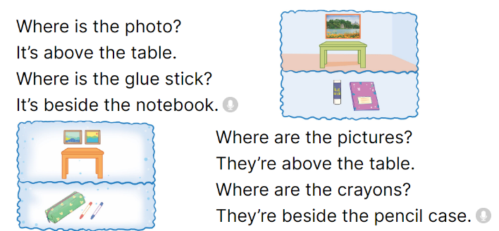  - Play the recording for Ss to listen to the whole chant.  + Have them repeat the title and lyrics line by line.  + Ask Ss to attend to two-syllable words with the stress on the second syllable in the chant, above and beside.  - Play the recording all the way through for Ss to listen to pronunciation and melody.  - Play the recording line by line for Ss to listen and repeat  - Play the recording for Ss to chant and clap along.  - Ask Ss to practice chant and clap along in pairs or groups.  - Invite groups to the front of the classroom to perform the chant  3. Fun corner and wrap- up (4’)  Game: Pictionary  - Prepare pictures about the locations of school things and a real bag. Put the pictures in the bag.  - Divide the class into two groups.  - Ask one student from each group to choose a picture from the bag, ex: a picture of a crayon beside the pencil case.  - Tell him/ her to draw a picture (a picture of a crayon beside the pencil case) on the board and encourage their group to guess it and say the sentence, ex: The crayon is beside the pencil case.  - The first group to shout the correct answer gets one point. Praise the winner. | - Ss sing and dance the song  - Ss open their books  - - Ss point and pay attention  - Ss listen to the recording again and repeat.  -Ss work in pairs and practice  -Ss say the words and sentences  - Ss pay and listen to the teacher’s explanation.  - Ss do the task  - Ss listen to the recording to check their answers (individual)  - Ss swap books with a partner and check the answers  - Ss listen to the recording again and check their answers again.  - Ss stand up and read aloud the words.  - Ss look and listen.  - Ss listen to the chant  - Ss listen and repeat line by line without clap their hands  - Ss note the rhythm and pronunciation.  -Ss listen to melody of the chant  - Ss listen and chant line by line.  - Ss chant and clap along.  - Ss work in groups (two groups) to chant  -Ss perform in front of the class.  -Ss listen  -Ss play the game  -Ss play the game
D. ADJUSTMENTS (if necessary):
………………………………………………………………………………………….…..……………………………………………………………………………...
---------------------------------------
Grade 5 : Lớp 5B : Sáng thứ năm, Ngày 05 tháng 12 năm 2024
ENGLISH
Unit 8: In our classroom
Lesson 3 (4, 5, 6)
A. OBJECTIVES:
By the end of the lesson, Ss will be able to:
1. Knowledge:
- Read and show understanding of a text about the locations of characters’ school things by answering the questions.
- Complete four sentences about someone’s school things by writing the target words in the gaps with the help of picture cues.
- Present their group’s pictures of study corners to the class by using the target language.
- Vocabulary: Review
- Skills: speaking, listening, reading and writing.
2. Competences:
- Communication and collaboration: work in pairs and groups to complete the learning tasks.
- Self-control and independent learning: perform reading and writing tasks.
3. Attitude/ Qualities:
- Show their pride in school things they have and great respect for other people’s school things by using appropriate gestures and intonation when asking and answering about school things.
B. TEACHING AIDS:
- Teacher: Teacher’s guide Pages 125, 126, 127; website hoclieu.vn, posters, laptop, pictures, textbook, lesson plan, TV or projector.
- Students: Pupil’s book Page 61, notebooks, workbooks, school things.
C. PROCEDURES:
Teacher’s activities | Students’ activities
1.Warm- up and review: (5’)  Game: Musical cards  *Aims: to revise the new words and structures from previous lessons.  *Procedure:  - Stick the cards on the board. Ask ss to say the words related to the cards.  - Hand out the cards to different ss around the class.  - Play the song “Where are they? Ask ss to pass the cards to the ss next to them while the music is playing.  - Stop the music suddenly. Invite a student to ask the question “Where are the pens?”.  Ask the student who is holding the card to answer the question, ex: They’re beside the books.  - Play the music again and repeat the activity.  - Ask ss to check their friends’ pronunciation.  - Say “Open your book page 61” and look at “Unit 8, Lesson 3 (4,5,6)”.  2.Practice: (8’)  Activity 1. Read and answer:  *Aims: Ss will be able to read and show understanding of a text about the locations of characters’ school things by answering the questions.  *Procedure:  - Have ss read the questions carefully and pay attention to key words such as Whose set square.  - Ask Ss scan the text for relevant information.  - Set a time limit for ss to do the task independently.  - Get ss to swap books with their partners and check the answers before checking as a class. - Have ss read the sentences in the reading text that help them find the correct information.  - Invite some pairs to take turns asking and answering the questions.  - Ask ss some more questions, ex: Whose pencils are in front of his pencil sharpener? Whose school bag is under her desk? Where is Hung’s story book?  Key:  1. Trang’s (set square is on her desk).  2. They are on his desk, in front of his pencil sharpener.  3. Trang’s (storybook is in her school bag).  4. It’s in the desk.  3.Production: (18’)  Activity 2. Let’s write  *Aims: Ss will be able to complete four sentences about someone’s school things by writing the target words in the gaps with the help of picture cues.  *Procedure:  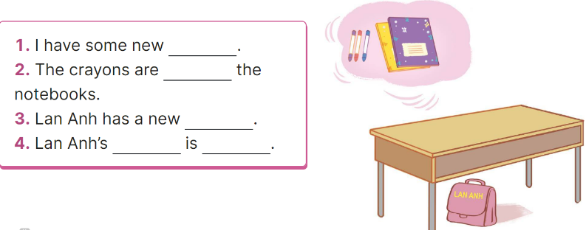  - Explain that ss have to read the four incomplete sentences and fill in the gaps with specific information about someone’s school things and their locations.  - Have ss do the first gapped sentence together as an example. Ex: crayons  - Give ss time to complete the sentences independently.  - Get ss to swap their books with a partner and check their answers before checking as a class.  - Invite a few ss to read their completed texts in front of the class.  Suggested key:  1. crayons.  2. beside  3. school bag.  4. school bag / under the desk.  Activity 3. Project.  *Aims: Ss will be able to present their group’s pictures of study corners to the class by using the target language  *Procedure:  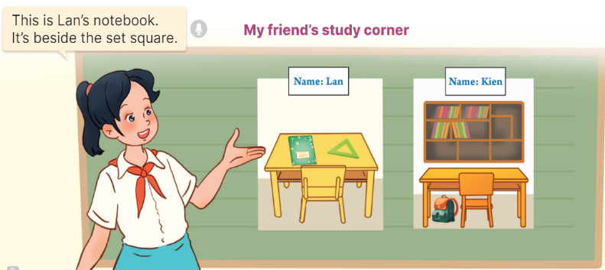  - Tell Ss about the goal of the activity.  - Have Ss work in groups of three. Each student looks at his/ her picture and talks about the locations of their school things in the picture.  - Invite a representative from each group to tell the class about their group's pictures  Ex: This is Lan’s notebook. It’s beside the set square.  - Have the rest of the class applaud if ss perform well.  4. Fun corner and wrap- up (4’)  Game: Missing cards  - Prepare pictures related to the topic “In our classroom”. Explain how to play the game.  - Divide the class into four groups. Take turns sticking four cards on the board, Ex: a glue stick, a crayon, a notebook, a pencil.  - Ask the first group to look at the cards and name the things illustrated on the cards. Ask the group to close their eyes for 10 seconds, then take out a card from the set, Ex: a pencil. - Let ss open their eyes and say out the word for that card.  - Count the points for each group and announce the winner. | - Ss listen and say  - Ss play the game  - Ss play the game  - Ss open their books  - Ss follow the teacher’s instructions.  -Ss scan the text  - Ss do the task independently.  - Ss swap books and check the answers  - Ss give the evidence to explain their answers.  - Ss ask and answer the questions.  - Ss answer the questions.  - Ss listen to the teacher’s instruction.  - Ss do the first gapped  - Ss complete the sentences independently.  - Ss swap their books and check their answers  - Ss read their completed texts  - Ss listen to the teacher  - Ss work in groups of three and say about their pictures of study corners  - Ss tell the class about their groups’ pictures of study corners  - Ss congratulate the groups perform well  -Ss listen to the teacher  -Ss play the game  -Ss congratulate the winner
D. ADJUSTMENTS (if necessary):
………………………………………………………………………………………….…..……………………………………………………………………………...
---------------------------------------------------------------
Grade 5 : Lớp 5B : Sáng thứ năm, Ngày 05 tháng 12 năm 2024
ENGLISH
Unit 9: Our outdoor activities
Lesson 1 (1, 2, 3)
A. OBJECTIVES:
By the end of the lesson, Ss will be able to:
1. Knowledge:

- Understand and correctly repeat the sentences in two communicative contexts focusing on asking and answering about where someone was in the past.

- Correctly say the words theatre, aquarium, campsite, funfair and use Were you at the ___ yesterday? - Yes, we were. / No, we weren’t. to ask and answer questions about where someone was in the past.

- Use Were you at the ___ yesterday? - _____ in a freer context.

- Vocabulary: theatre, aquarium, campsite, funfair

- Structures:
A: Were you at the theatre yesterday?
B: Yes, we were. / No, we weren’t.
- Skills: speaking and listening
2. Competences:
- Critical thinking and creativity: learn how to ask and answer questions about where someone was in the past correctly and fluently.
- Communication and collaboration: work in pairs and groups to complete the learning tasks.
3. Attitude/ Qualities:
- Show their love and interest in outdoor activities.
- Show their knowledge of doing outdoor activities safely.
B. TEACHING AIDS:
- Teacher: Teacher’s guide Pages 141, 142, 143, 144, audio Tracks 86, 87; website hoclieu.vn, posters, laptop, pictures, textbook, lesson plan, TV or projector.
- Students: Students’ book Page 62, notebooks, workbooks, school things.
C. PROCEDURES:
Teacher’s activities | Students’ activities
1.Warm- up and review: (3’)  Game: Matching game  *Aims: to revise the phrases about places.  *Procedure:  - Tell the class they are going to match the phrases with the correct pictures.  - Stick the pictures and the phrases on the board. Have Ss read the phrases once or twice.  - Model the Picture 1. Have one student choose a phrase suitable with Picture 1.  - If the Ss give the correct answers, they will get stickers.  - Continue the game until all the pictures and phrases are matched.  - Say “Open your book page 62” and look at “Unit 9, Lesson 1 (1,2,3)”.  2. Presentation (15’)  Activity 1. Vocabulary.  *Aims: Ss will be able to know the vocabulary in the new lesson.  *Procedure:  -T elicits the new words  + theatre : nhà hát (picture)  + aquarium : thủy cung (picture)  + campsite : địa điểm cắm trại (picture)  + funfair : hội chợ giải trí (picture)  - T models (3 times).  - T writes the words on the board.  - Checking: Matching  Activity 2. Look, listen and repeat:  *Aims: Ss will be able to understand and correctly repeat the sentences in two communicative contexts focusing on asking and answering about where someone was in the past.  *Procedure:  - Have Ss look at Pictures a and b and identify the characters and what they can see in the pictures.  + Where was Mai?  + Where were Mai’s family? 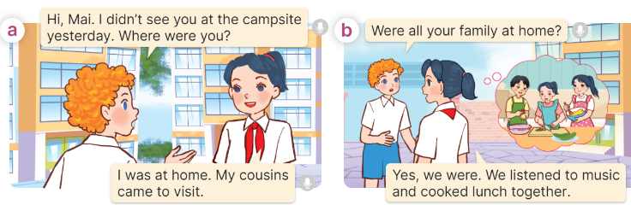  - Play the audio twice (sentence by sentence). Correct their pronunciation where necessary.  - Have Ss to practice the dialogue  - T invites a few pairs to the front of the class to practice.  - T checks pronunciation for ss.  Activity 3 Listen, point and say.  *Aims: Ss will be able to correctly say the words theatre, aquarium, campsite, funfair and use Were you at the ___ yesterday? - Yes, we were. / No, we weren’t. to ask and answer questions about where someone was in the past.  *Procedure:  * Structures:  - T asks Ss look at in activity 1 and helps Ss know the structure from the dialogue.  - T introduces new structures for Ss.  - T explains, models and gives meaning.  - Have Ss repeat the structures  A: Were you at the theatre yesterday?  B: Yes, we were. / No, we weren’t.  3.Practice: (7’)  *Drill pictures  - Have Ss look at the pictures and identify the places. 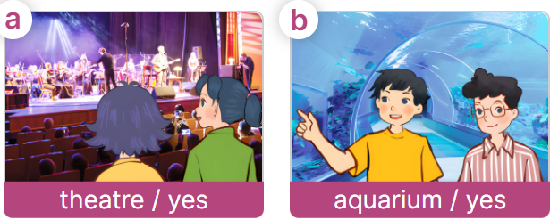  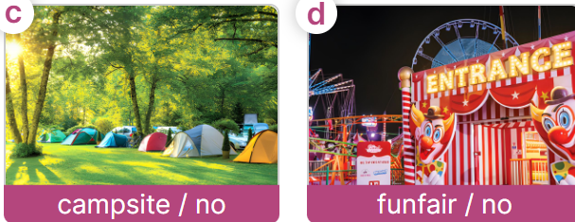  - Have Ss point at pictures, listen and run through all the pictures.  - Have Ss point at the bubbles, listen and run through model sentences.  - Have Ss to practise:  + T asks the first picture, Ss answer  + Ss asks the second picture, T answers  + Group A asks the third picture, group B  answers  + Group B asks the last picture, group A  - Ask Ss to work in pairs to practise asking and answering the Were you at the ___ yesterday? - Yes, we were. / No, we weren’t.  - T controls and corrects.  - Invite a few pairs to point at the pictures and say the questions and answers in front of the class.  4. Production: (6’)  Activity 4. Let’s talk.  *Aims: Ss will be able to use Were you at the ____ yesterday? - Yes, we were. / No, we weren’t in a freer context  *Procedure:  - Ask Ss to look at the pictures and say the words they have learnt.  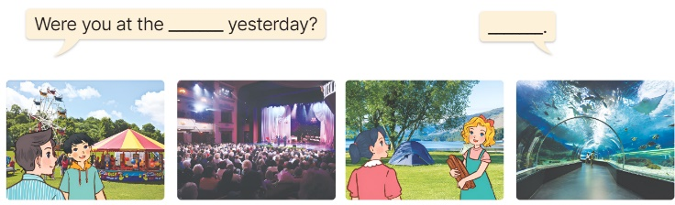  - Point at the ﬁrst building and elicit the question in the ﬁrst speech bubble Were you at the ___ yesterday? and the answer in the second speech Yes, we were. / No, we weren’t.as an example.  - Give Ss time to work in pairs and take turns pointing at each picture to ask and answer using Were you at the ___ yesterday? - Yes, we were. / No, we weren’t.  - Invite a few pairs to come to the front of the classroom and act out the exchanges.  5. Fun corner and wrap- up (4’)  Game: Pass the card  - Have Ss stand in two lines.  - Give a student of each group a card.  - Play music. Ask the student to pass the card to the next one.  - Stop music. Ask the student holding the card to ask a question. Invite another student to answer the question.  - If ss ask and answer the questions correctly, they will get stickers.  - Continue the game until all the words are said. | - Ss listen to the teacher  - Ss look at the pictures and read  - Ss follow the teacher  - Ss continue the game.  - Ss listen and open their books  -Ss listen and answer  - - Ss listen and repeat  + Choral repetition (3 times).  + Individual repetition (3 ss)  - Ss take note  - Ss look and match  -Look at the pictures and say.  + In picture a:  Bill: Hi, Mai. I didn’t see you at the campsite yesterday. Where were you?  Mai: I was at home. My cousins came to visit.  + In picture b:  Bill: Were all your family at home? Mai: Yes, we were. We listened to music and cooked lunch together.  -Ss listen and repeat in chorus (twice)  -Ss work in pairs to practice  -Ss come to the front of the classroom to practice.  -Ss listen  - Ss look at the picture and answer.  -Ss listen  -Ss listen and repeat  -Ss repeat to the structures  - Ss look, listen and repeat  +Picture a: two girls at the theatre  + Picture b: two boys at the aquarium  + Picture c: a campsite and the words campsite / no underneath  + Picture d: a funfair and the words funfair / no underneath  -Ss listen to the teacher  -Ss point at pictures, listen and repeat  -Ss point at the bubbles, listen and repeat  -Ss practice in chorus  -Ss practice in chorus  -Ss work in pairs to practise asking and answering the question  - Pairs of Ss point at the pictures and say in front of the class  -Ss look at the picture and say  - Ss look at the first building and elicit the missing words in speech bubbles and say the completed sentences.  - Ss role-play to practise asking and answering questions  - Ss practise asking and answering questions in front of the class.  -Ss listen to the teacher  -Ss play the game  -Ss continute to play the game
D. ADJUSTMENTS (if necessary):
………………………………………………………………………………………….…..……………………………………………………………………………...
Duyệt bài, Ngày 06 tháng 12 năm 2024
Phó hiệu trưởng

Nguyễn Thị Hằng

