ĐĂNG KÝ GIẢNG DẠY TUẦN 10 ( Từ ngày 11-15/11/2024)

Thứ  Ngày | Buổi | Lớp | Tiết | Môn | Tên bài
Hai | Chiều | 4B | 1 | English | Extension activities
 |  | 4B | 2 | English | Unit 6: Our school facilities  Lesson 1 (1,2,3)
Ba | Sáng | 4A | 1 | English | Extension activities
 |  | 4A | 2 | English | Unit 6: Our school facilities  Lesson 1 (1,2,3)
 |  | 5B | 3 | English | Extension activities
 |  | 5B | 4 | English | Unit 6: Our school rooms  Lesson 1 (1,2,3)
Tư | Sáng | 4C | 1 | English | Extension activities
 |  | 4C | 2 | English | Unit 6: Our school facilities  Lesson 1 (1,2,3)
 |  | 4B | 3 | English | Unit 6: Our school facilities  Lesson 1 (4,5,6)
 |  | 4B | 4 | English | Unit 6: Our school facilities  Lesson 2 (1,2,3)
 | Chiều | 3A | 1 | English | Fun time
 |  | 3A | 2 | English | Unit 6: Our school -Lesson 1 (1,2,3)
Năm | Sáng | 5B | 1 | English | Unit 6: Our school rooms  Lesson 1 (4,5,6)
 |  | 5B | 2 | English | Unit 6: Our school rooms  Lesson 2 (1,2,3)
 | Chiều | 3A | 1 | English | Unit 6: Our school -Lesson 1 (4,5,6)
 |  | 3A | 2 | English | Unit 6: Our school -Lesson 2 (1,2,3)
Sáu | Sáng | 4C | 1 | English | Unit 6: Our school facilities  Lesson 1 (4,5,6)
 |  | 4C | 2 | English | Unit 6: Our school facilities  Lesson 2 (1,2,3)
 |  | 4A | 3 | English | Unit 6: Our school facilities  Lesson 1 (4,5,6)
 |  | 4A | 3 | English | Unit 6: Our school facilities  Lesson 2 (1,2,3)

Duyệt bài, Ngày 01 tháng 11 năm 2024
Phó hiệu trưởng

Nguyễn Thị Hằng

WEEK 10
Grade 3: Lớp 3A: Sáng thứ tư ngày 13 tháng 11 năm 2024
ENGLISH
Fun time 1
A. OBJECTIVES:
By the end of the lesson, Ss will be able to:
1. Knowledge:
- take part in three fun activities relating to their language knowledge and competences.
- Vocabulary: Review
- Skills: speaking, writing and listening
2. Competences:
- Co-operation: ready to help friends in pair work/ group work.
- Sociability: Talk to each other, say good words to others.
3. Attitude/ Qualities:
- Kindness: Help partners to complete learning tasks.
- Honesty: tell the truth about feelings and emotions
B. TEACHING AIDS:
- Teacher: Teacher’s guide Pages 76, 77, 78; website sachmem.vn, posters, laptop, pictures, textbook, lesson plan, TV or projector.
- Students: Pupil’s book Page 42, 43, notebooks, workbooks, school things.
C. PROCEDURES:
Teacher’s activities | Students’ activities
1.Warm- up: (3’)  Sing: Head, shoulders, knees and toes  *Aims: to create a friendly and active atmosphere in the class to beginning the lesson.  *Procedure:  - Show the song on the screen.  https://www.youtube.com/watch?v=WX8HmogNyCY  - Ask Ss to listen, sing and dance the song.  - Say “Open your book page 42, 43” and look at “Fun time”.  2. Practice (30’)  Activity 1. Find, circle and match:  *Aims: Ss will be able to revise learnt vocabulary by doing the word search.  *Procedure:  - Have Ss look at the pictures and ask +What’s this?  + What do you see in the pictures?  - Write the words or stick the flash cards of the words, one by one, on the board.  - Point at each word on the board and have Ss say the word as a class.  - Point at the picture of an ear, and match the word “ear” that has been circled as an example.  - Tell Ss to find the rest of the words in the word search.  - Have Ss match the words in the word search with the pictures.  - Have Ss check and correct their answers in pairs  - Have Ss work in pairs, one points at the pictures and the other points at the circled words in the word search and say them aloud.  Key:  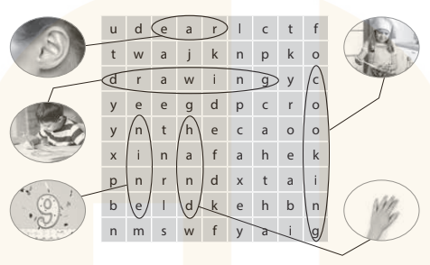  Activity 2. Quiz time  *Aims: Ss will be able to revise vocabulary and sentence patterns learnt in Units 1–5.  *Procedure:  - Put Ss into two teams, Team 1 and Team 2.  - Have one representative of each team stand next to their boxes, Box 1 and Box 2.  - Explain the rules: Two quiz masters will read different dialogues for each pair of Ss.  Example:  Quiz master 1 (showing a flash card): What’s this?  Quiz master 2: It’s a hand.  - After listening to the dialogue, each representative has to find the right flash card and put it in their team’s box.  - The quicker representative earns one point for his / her team. Then, other pairs take turns to compete. The quiz continues until the end of the time limit (5 – 10 dialogues are recommended).  - The team with most points wins.  Activity 3. Look and match  *Aims: Ss will be able to learn the five senses and how they relate to our bodies.  *Procedure:  - T elicits the names of the body parts: eye, ear, nose, hand, mouth.  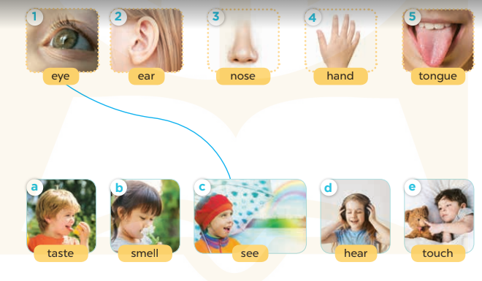  - Point to your eyes and ask Ss what they do with their eyes  - Write see on the board and model it  for Ss to repeat.  - Have Ss complete the activity by drawing lines to match the body parts to the senses.  - Check answers together as a class.  Key: 1-c 2-d 3-b 4-e 5-a  *Consolidation  *Aims: Ss will be able consolidate and wrap up the content of the lesson.  *Procedure:  - T asks ss to answer the following questions:  + What have you learnt from the lesson today?  +What are the core values of the lesson? (if the teacher can take from the lesson).  - T praises some Ss who are hardworking / active/ good…. as well as encourage others to try more.  3. Homework. (2’)  - Prepare the new lesson: Unit 6, Lesson 1 (1,2,3). | - Ss listen  - Ss sing a song  -Ss open the book  -Ss look at the picture and answer  - - Ss note  - Ss say the word  - Ss look and match  -Ss find the words  -SS match the words with pictures  -Ss check their answer  -Ss say aloud  -Ss listen  -Ss listen and play game  -Ss play game  - Ss look, listen and answer  - Ss answer  -Ss listen and repeat  -Ss work in pairs to practice  -Ss check their answer.  -Ss answer the questions  -Ss listen and clap their hands  -Ss listen and take note
D. ADJUSTMENTS (if necessary):
………………………………………………………………………………………….…..……………………………………………………………………………...
--------------------------------------------------------------
Grade 3: Lớp 3A: Sáng thứ tư ngày 13 tháng 11 năm 2024
ENGLISH
Unit 6: Our school
Lesson 1 (1, 2, 3)
A. OBJECTIVES:
By the end of the lesson, Ss will be able to:
1. Knowledge:
- use the words school, classroom, library, playground in the sentence pattern: Is this our ……………? – Yes, it is. / No, it isn’t.
- use Is this our………… ? – Yes, it is. / No, it isn’t. to ask and answer questions about their school.
- Vocabulary: school, classroom, library, playground
- Skills: speaking and listening
2. Competences:
- Co-operation: ready to help friends in pair work/ group work.
- Sociability: Talk to each other, say good words to others.
3. Attitude/ Qualities:
- Kindness: Help partners to complete learning tasks.
- Honesty: tell the truth about feelings and emotions
B. TEACHING AIDS:
- Teacher: Teacher’s guide Pages 79, 80, 81, audio Tracks 57, 58, website sachmem.vn, posters, laptop, pictures, textbook, lesson plan, TV or projector.
- Students: Pupil’s book Page 44, notebooks, workbooks, school things.
C. PROCEDURES:
Teacher’s activities | Students’ activities
1.Warm- up: (3’)  Sing: Jigsaw puzzle  *Aims: to create a friendly and active atmosphere in the class to beginning the lesson.  *Procedure:  - Divide class into 4 groups: Tom, Jerry, Miu and Chit.  - Ask Ss look at the pieces of picture.    - Ask Ss go to the board and jigsaw puzzle into the correct picture.  -T checks who’s the winner?  - Say “Open your book page 44” and look at “Unit 6, Lesson 1 (1,2,3)”.  2. Presentation (16’)  Activity 1. Vocabulary.  *Aims: Ss will be able to know the vocabulary in front of starting the new lesson.  *Procedure:  -T elicits the new words  + school : trường học (picture)  + library : thư viện (picture)  + classroom :phòng học (picture)  + playground : sân chơi (picture)  - T models (3 times).  - T writes the words on the board.  - Checking: Matching  Activity 2. Look, listen and repeat:  *Aims: Ss will be able to understand and correctly repeat the sentences in two communicative contexts (pictures) to ask and answer questions about their school.  *Procedure:  - Have Ss look at Pictures a and b and identify names of the speakers in the pictures.  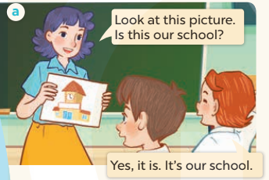  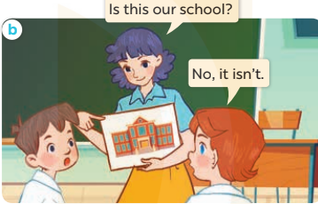  - Play the audio twice (sentence by sentence). Correct their pronunciation where necessary.  - Have Ss to practice the dialogue  - T invites a few pairs to the front of the class to practice.  - T checks pronunciation for ss.  Activity 3 Listen, point and say.  *Aims: Ss will be able to correctly say the words and use Is this our …….? – Yes, it is. / No, it isn't. to ask and answer questions about their school.  *Procedure:  * Model sentences:  - T asks Ss look at picture a and helps Ss know the structure from the dialogue.  - T introduces new structure for Ss.  - T explains, models and gives meaning.  -Have Ss repeat the model sentences.  A: Is this our school?  B: Yes, it is. / No, it isn't.  3.Practice: (7’)  *Drill pictures  - Elicit and check comprehension the places of school  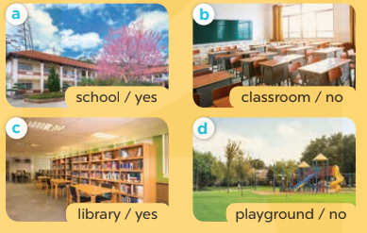  - Run through all the pictures.  - Run through model sentences.  +Run through the question sentences  +Run through the answer sentences  - Have Ss to practise:  + T asks, Ss answer picture a  + Ss ask, T answers picture b  + Group A ask, group B answer picture c  + Group B ask, group A answer picture d  - Ask Ss to work in pairs.  - T controls and corrects.  - Invite a few pairs to come to the front of the classroom and point at the pictures and say the questions and answers in front of the class.  - T gives feedbacks.  4.Production: (7’)  Activity 4. Let’s talk.  *Aims: Ss will be able to enhance the correct use of Is this our ……..? – Yes, it is. / No, it isn't. to ask and answer questions about their school.  *Procedure:  - Have Ss look at the picture and elicit the question and the answer in context.  + What can you see in the picture?  + How many pictures are there?  - Stick the flash cards for school, classroom, library and playground on the wall at various places around the classroom and point at a certain flash card to elicit the question and answer.  - Give Ss time to practise in pairs.  - Invite some pairs of Ss to the front of the class to perform their conversations.  *Consolidation  *Aims: Ss will be able consolidate and wrap up the content of the lesson.  *Procedure:  - T asks ss to answer the following questions:  + What have you learnt from the lesson today?  +What are the core values of the lesson? (if the teacher can take from the lesson).  - T review the vocabulary and model sentences.  - T praises some Ss who are hardworking / active/ good…. as well as encourage others to try more.  5. Homework. (2’)  - Learn the vocabulary and model sentences by heart  - Prepare the new lesson: Unit 6, Lesson 1 (4,5,6). | - Ss listen  -Ss look at the pieces of the picture  -Ss put into the correct picture  -Ss check  - Ss open their books  -Ss listen and answer  - - Ss listen and repeat  + Choral repetition (3 times).  + Individual repetition (3 ss)  - Ss take note  - Ss look, remember and match  -Look at the pictures and say  + In picture a: Ms Hoa says: Look at this picture. Is this our school? Lucy answers: Yes, it is. It’s our school.  + In picture b: Ms Hoa asks: Is this our school? Lucy answers: No, it isn’t.  -Ss listen and repeat in chorus (twice)  -Ss work in pairs to practice  -Ss practice the dialogue  -Ss listen  -Ss look at the picture and answer.  -Ss listen  -Ss listen and repeat  -Ss repeat to the place  - Ss look, listen and answer  + Picture a: a school  + Picture b: a classroom  + Picture c: a library  + Picture d: a playground  -Ss listen and repeat  -Ss practice in chorus  -Ss work in pairs to practice  -Ss point and say  -Ss listen.  -Ss look at the picture and answer  + I can see 4 places…  + There are 4 pictures  -Ss look and answer  -Ss work in pairs  -Ss perform in front of the class.  -Ss answer the questions  - Ss listen  -Ss listen and clap their hands  -Ss listen and take note
D. ADJUSTMENTS (if necessary):
………………………………………………………………………………………….…..……………………………………………………………………………...
-----------------------------------------------------------------
Grade 3: Lớp 3A: Chiều thứ năm ngày 14 tháng 11 năm 2024
ENGLISH
Unit 6: Our school
Lesson 1 (4, 5, 6)
A. OBJECTIVES:
By the end of the lesson, Ss will be able to:
1. Knowledge:
- listen to and understand four communicative contexts in which pupils ask and answer questions about their school
- read and complete three target sentence patterns with the help of picture cues.
- sing the song Our school with the correct pronunciation and melody.
- Vocabulary: Review
- Skills: speaking, listening, reading and writing.
2. Competences:
- Critical Thinking: self-introduce
- Co-operation: ready to help friends in pair work/ group work.
- Self-control and independent learning: perform listening tasks.
3. Attitude/ Qualities:
- Kindness: Help partners to complete learning tasks.
- Honesty: tell the truth about feelings and emotions.
- Diligence: complete learning tasks.
B. TEACHING AIDS:
- Teacher: Teacher’s guide Pages 81,82,83; audio Tracks 59,60; website sachmem.vn, posters, laptop, pictures, textbook, lesson plan, TV or projector.
- Students: Pupil’s book Page 45, notebooks, workbooks, school things.
C. PROCEDURES:
Teacher’s activities | Students’ activities
1.Warm- up: (5’)  Game: Matching game  *Aims: to create a friendly and active atmosphere in the class to beginning the lesson.  *Procedure:  - Write 4 new words on the board and asks Ss to read (whole class).  - Ask 4 Ss to come to the board and write their school in the pieces of paper and keep them in secret.  - Ask 1 Ss to come to the board and guess their school written in the paper (He has to write the answers in the small pieces of paper and stick to each 4 Ss.  - Ask the Ss on the board to ask the question to find out the answers and give him or her point if correct (repeat the activities depending the time).  - Say “Open your book page 45” and look at “Unit 6, Lesson 1 (4,5,6)”.  2.Practice: (27’)  Activity 1. Listen and tick:  *Aims: Ss will be able to listen to and understand two communicative contexts to ask and answer questions about a school.  *Procedure:  - Elicit the word for the place in each picture  - Point at the pictures respectively to explain the context.  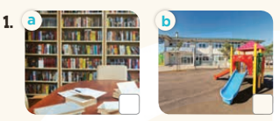  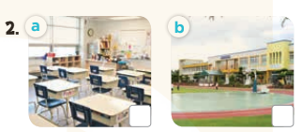  - T ask Ss to guess the answers.  + T writes Ss’guessing on the board.  - Listen to the tape:  + Play the recording  + Play the recording again and get Ss to swap books with their partners.  + Play the recording again to check answers together as a class.  + Write the answers on the board for Ss to correct their answers. Then checks Ss’ guessing.  - Play the recording, sentence by sentence, for the class to listen and repeat in chorus.  Key: 1. b 2. a  Activity 2. Look, complete and read  *Aims: Ss will be able to complete three target sentence patterns with the help of picture cues.  *Procedure:  - Get Ss to look at the pictures and identify the places in the pictures.  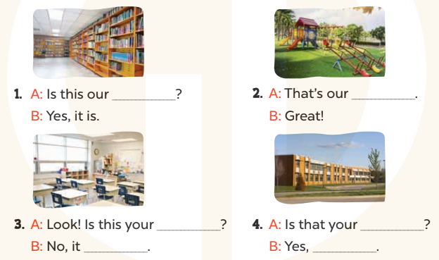  - Have Ss look at the four dialogue and the pictures. Elicit and model with picture 1  + Ask Ss to read the sentence 1 in chorus.  + Ask them what is missing in the question (library). Then have them complete the gap (Is this our library?).  -Have Ss work in pairs and complete the dialogue 2, 3, 4.  - Ask a few Ss to stand up and read the sentences aloud.  -T gives feedbacks.  Key:  1. library 2. playground  3. classroom; isn’t  4. school; it is  Activity 3. Let’s sing  *Aims: Ss will be able to sing the song Our school with the correct pronunciation and melody.  *Procedure:  - Introduce the title and lyrics of the song: “Our school”  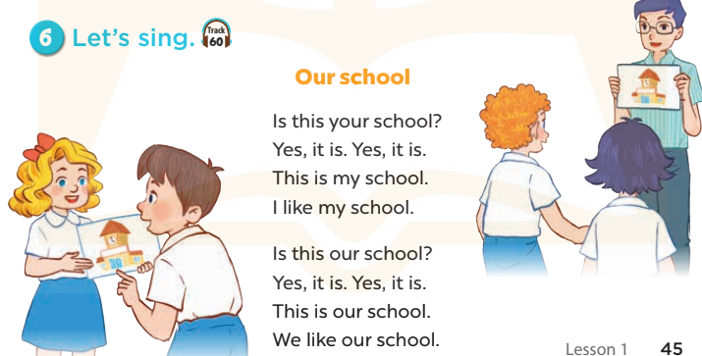  - Play the recording for Ss to listen to the whole song.  + Have them repeat the title and lyrics line by line.  + Tell Ss to point at the pictures while singing.  - Play the recording all the way through for Ss to listen to pronunciation and melody of the song.  - Play the recording line by line for Ss to listen, repeat and point to the pictures  - Play the recording for Ss to sing and do actions.  - Ask Ss to practice singing and doing actions in pairs or groups.  - Invite groups to the front of the classroom to perform the song  -T gives feedback.  *Consolidation  *Aims: Ss will be able consolidate and wrap up the content of the lesson.  *Procedure:  - T asks ss to answer the following questions:  + What have you learnt from the lesson today?  +What are the core values of the lesson? (if the teacher can take from the lesson).  - T praises some Ss who are hardworking / active/ good…. as well as encourage others to try more.  3. Homework. (3’)  - Practice part 5 again.  - Prepare the new lesson: Unit 6, Lesson 2 (1,2,3). | - Ss read the words  - Ss play game  -Ss play game  - Ss open their books  -Look at the pictures and say:  + Picture 1a: a library + Picture 1b: a playground  + Picture 2a: a classroom  + Picture 2b: a school  -Ss guess the answers  - Ss listen to the tape and tick  - Ss listen again, tick and swap books with their partners.  - Ss check their answers and guessing  -Ss listen and repeat.  -Ss look at the picture and say  -Ss look and answer  -Ss read  -Ss say and complete  -Ss work in pairs and complete  -Ss read aloud  - Ss listen  -Ss listen to the song  - Ss listen and repeat line by line without the action.  -Ss point to the pictures while singing  -Ss listen to melody of the song  - Ss listen and sing line by line.  - Ss sing and do actions.  + Ss work in groups (two groups) to sing.  -Ss perform in front of the class.  -Ss listen  -Ss answer the questions  -Ss listen and clap their hands  -Ss listen and take note
D. ADJUSTMENTS (if necessary):
………………………………………………………………………………………….…..……………………………………………………………………………...………………………………………….…..………………………………………
---------------------------------------------------------
Grade 3: Lớp 3A: Chiều thứ năm ngày 14 tháng 11 năm 2024
ENGLISH
Unit 6: Our school
Lesson 2 (1, 2, 3)
A. OBJECTIVES:
By the end of the lesson, Ss will be able to:
1. Knowledge:
- use the words school, classroom, library, playground, computer room, art room, music room and gym in the sentence pattern Let’s go to the ……….
- use Let’s go to the ……. – OK, let’s go. to make suggestions to go to a place at school and express agreement;
- Vocabulary: computer room, art room, music room and gym
- Skills: speaking and listening
2. Competences:
- Co-operation: ready to help friends in pair work/ group work.
- Sociability: Talk to each other, say good words to others.
3. Attitude/ Qualities:
- Kindness: Help partners to complete learning tasks.
- Honesty: tell the truth about feelings and emotions
B. TEACHING AIDS:
- Teacher: Teacher’s guide Pages 83, 84; audio Tracks 61, 62, website sachmem.vn, posters, laptop, pictures, textbook, lesson plan, TV or projector.
- Students: Pupil’s book Page 46, notebooks, workbooks, school things.
C. PROCEDURES:
Teacher’s activities | Students’ activities
1.Warm- up: (3’)  Game: Guessing and Choosing  *Aims: to create a friendly and active atmosphere in the class to beginning the lesson.  *Procedure:  - T shows 4 pictures of places and calls 4 Ss to come to the board and choose.  - T asks 4 Ss to come to the board and choose 1 picture of place and keep them in secret by covering them.  - The others will write their place in the board at their desks and keep their ides in secret.  - The Ss on the board will 1 by 1 show their pictures they chose.  - When the teacher says the word of the pictures 1 by 1 shown on the board, who has the same places will raise their board or raise their hands.  - The Ss on the board will get the same points as the numbers of Ss raising their hands.  - Say “Open your book page 46” and look at “Unit 6, Lesson 2 (1,2,3)”.  2. Presentation(16’)  Activity 1. Vocabulary.  *Aims: Ss will be able to know the vocabulary in front of starting the new lesson.  *Procedure:  -T elicits the new words  + art room : phòng mĩ thuật  (picture)  + computer room: phòng tin học  (picture)  + music room : phòng âm nhạc (picture)  + gym : nhà thể chất (picture)  - T models (3 times).  - T writes the words on the board.  - Checking: What and where  Activity 2. Look, listen and repeat:  *Aims: Ss will be able to understand and correctly repeat the sentences in two communicative contexts (pictures) to make suggestions to go to a place at school and express agreement.  *Procedure:  - Have Ss look at Pictures a and b and identify the characters in the pictures.  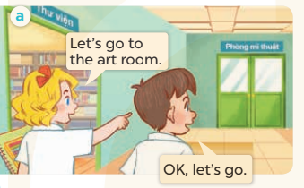  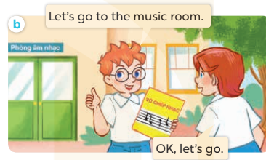  - Play the audio twice (sentence by sentence). Correct their pronunciation where necessary.  - Have Ss to practice the diaguage  - T invites a few pairs to the front of the class to practice.  - T checks pronunciation for ss.  Activity 3. Listen, point and say.  *Aims: Ss will be able to correctly say the words and use Let's go to the …… .- OK, let’s go. to make suggestions to go to a place at school and express agreement.  *Procedure:  * Model sentences:  - T asks Ss look at picture a and helps Ss know the structure from the dialogue.  - T introduces new structure for Ss.  - T explains, models and gives meaning.  - Have Ss repeat the model sentences.  A: Let’s go to the art room.  B: OK, let’s go.  3.Practice: (7’)  *Drill pictures  - Have Ss look at the pictures and elicit the names of the places  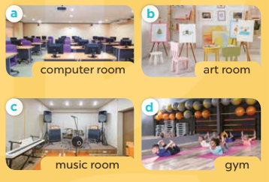  - Run through all the pictures.  - Run through model sentences.  - Have Ss to practise:  + T say – Ss respond (change role).  + Ss – Ss (change role).  - Ask Ss to work in pairs.  - T controls and corrects.  - Invite a few pairs to come to the front of the classroom, point at the pictures and say the questions and answers in front of the class.  - T gives feedbacks.  4.Production: (7’)  Activity 4. Let’s talk.  *Aims: Ss will be able to enhance the correct use of Let's go to the …... – OK, let's go. to make suggestions to go to a place at school and express agreement.  *Procedure:  - T asks ss to guess each character and what the children say.  + What can you see in the picture?  +Who are they?  +Where are they?  +What are they doing?  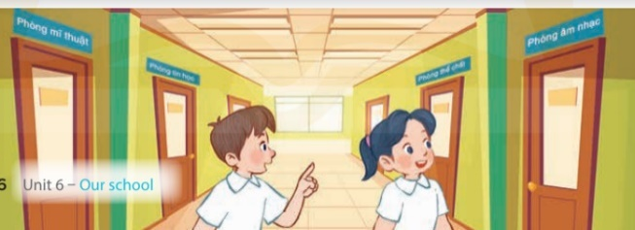  - Put Ss into pairs and encourage them to make suggestions to go to a place at school and express agreement using Let’s go to the..… -Ok, let’s go.  - Invite some pairs to stand up to perform their exchanges.  *Consolidation  *Aims: Ss will be able consolidate and wrap up the content of the lesson.  *Procedure:  - T asks ss to answer the following questions:  + What have you learnt from the lesson today?  - T review the vocabulary and model sentences.  - T praises some Ss who are hardworking / active/ good…. as well as encourage others to try more.  5. Homework. (2’)  - Learn the vocabulary and model sentences by heart  - Prepare the new lesson: Unit 6, Lesson 2 (4,5,6). | - Ss listen  - Ss play the game  -Ss play game  - Ss open their books  -Ss listen and answer  - - Ss listen and repeat  + Choral repetition (3 times).  + Individual repetition (3 ss)  - Ss take note  - Ss look, remember and slap  -Look at the pictures and get to know the characters in the pictures.  + In picture a: Mary says: Let’s go to the art room. And Minh says: OK, let’s go.  – In picture b: Ben says: Let’s go to the music room. And Lucy says: OK, let’s go.  -Ss listen and repeat in chorus (twice)  -Ss work in pairs to practice  -Ss practice the diaguage  -Ss listen  -Ss look at the picture and answer.  -Ss listen  -Ss listen and repeat  -Ss repeat to the hobbies  -Ss listen and answer  +Picture a: a computer room  +Picture b. an art room  +Picture c. a music room  +Picture d. a gym  - Ss look, listen and repeat  - Ss practice in chorus  -Ss work in pairs to practice  -Ss listen  -Ss go to the board and point and say  -Ss listen  -Ss look at the picture and answer  + Two Ss are standing in the hall and pointing to the four school rooms.  -Ss work in pairs  -Ss ask and answer  -Ss answer the questions  - Ss listen  -Ss listen and clap their hands  -Ss listen and take note
D. ADJUSTMENTS (if necessary):
………………………………………………………………………………………….…..……………………………………………………………………………...
---------------------------------------------------
Grade 4: Lớp 4A: Sáng thứ tư, Ngày 13 tháng 11 năm 2024
Lớp 4B: Sáng thứ năm, Ngày 14 tháng 11 năm 2024
Lớp 4C: Sáng thứ ba , Ngày 12 tháng 11 năm 2024
ENGLISH
Extension activities
A. OBJECTIVES:
By the end of the lesson, Ss will be able to:
1. Knowledge:
- take part in fun activities to apply their language knowledge and competences.
- Vocabulary: Review
- Skills: speaking, writing and listening
2. Competences:
- Co-operation: ready to help friends in pair work/ group work.
- Sociability: Talk to each other, say good words to others.
3. Attitude/ Qualities:
- Kindness: Help partners to complete learning tasks.
- Honesty: tell the truth about feelings and emotions
B. TEACHING AIDS:
- Teacher: Teacher’s guide Pages 76, 77; website hoclieu.vn, posters, laptop, pictures, textbook, lesson plan, TV or projector.
- Students: Pupil’s book Page 42, 43, notebooks, workbooks, school things.
C. PROCEDURES:
Teacher’s activities | Students’ activities
1.Warm- up: (3’)  Sing: Head, shoulders, knees and toes  *Aims: to create a friendly and active atmosphere in the class to beginning the lesson.  *Procedure:  - Show the song on the screen.  https://www.youtube.com/watch?v=WX8HmogNyCY  - Ask Ss to listen, sing and dance the song.  - Say “Open your book page 42, 43” and look at “Extension activites”.  2. Practice (30’)  Activity 1. Look and write  *Aims: Ss will be able to identify five different countries in the pictures.  *Procedure:  - Have Ss look at the pictures and ask  + What do you see in the pictures?  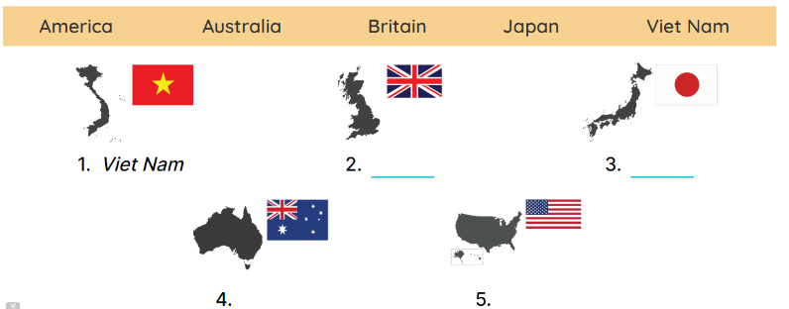  - Draw pupils’ attention to the pictures.  - Ask Where is Viet Nam? and encourage pupils to point to it. Write Viet Nam on the board.  - Point and ask about the other pictures: England, Japan, Australia and America.  - Have pupils complete the activity by writing the name next to each country.  - Check answers together as a class.  Key: 1. Viet Nam 2. England  3. Japan 4. Australia 5.America.  Activity 2. Look and write  *Aims: Ss will be able to identify the different times in different countries.  *Procedure:  - Have pupils look at the clocks. 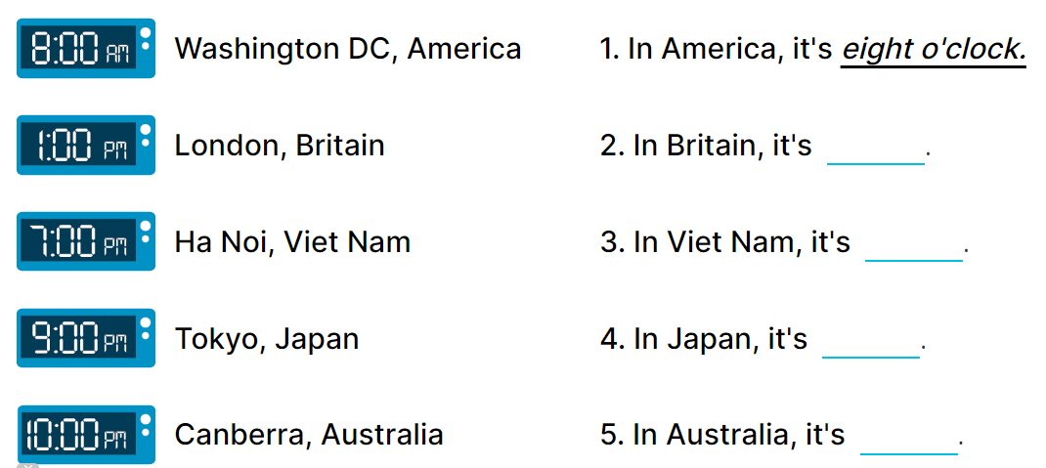  - Draw pupils’ attention to the different times in different countries.  - Write In America, it’s _____. on the board.  -Read the first part of the sentence aloud and encourage pupils to complete it. When pupils answer correctly, write the answer on the board: 8:00 AM.  - Have pupils work in pairs and complete the activity by completing the sentences.  - Check answers as a class.  Key: 1. 8:00 AM 2. 1:00 PM  3. 7:00 PM 4. 9:00 PM  5. 10:00 PM  Activity 3. Read the questions. Then tick the answers.  *Aims: Ss will be able to read the questions and tick the correct answers, then say what countries are near / far from Viet Nam.  *Procedure:  - Draw pupils’ attention to Question 1 and read it as a class.  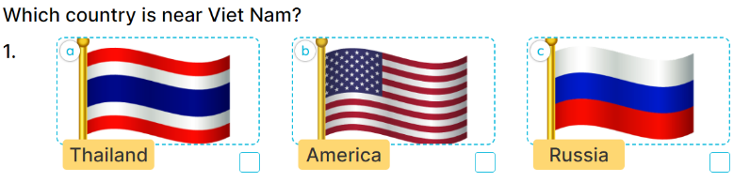        - Ask pupils to look at Answer A with three answer options a, b and c.  - Explain the new word Russia. Get them to look at the flags of Thailand, America and Russia, elicit the right answer and tick it (Picture a).  - Repeat the same procedure with Answer B and question 2.  - Get pupils to swap books with a partner, then check answers together as a class.  - Write the correct answers on the board for pupils to correct their answers.  - Have pupils say the answers by asking them Questions 1 and 2  Key: 1. A. It’s Thailand. B. It’s Malaysia  . 2. A. It’s Canada. B. It’s Australia.  *Consolidation  *Aims: Ss will be able consolidate and wrap up the content of the lesson.  *Procedure:  - T asks ss to answer the following questions:  + What have you learnt from the lesson today?  +What are the core values of the lesson? (if the teacher can take from the lesson).  - T praises some Ss who are hardworking / active/ good…. as well as encourage others to try more.  3. Homework. (2’)  - Prepare the new lesson: Unit 6, Lesson 1 (1,2,3). | - Ss listen  - Ss sing a song  -Ss open the book  -Ss look at the picture and answer  - - Ss note  -Ss answer  -SS point and answer  -Ss do the task  -Ss check their answer  -Ss look at the clocks  -Ss pay attention  -Ss listen and answer  -Ss answer  -Ss complete the sentences  -Ss check their answers  - Ss look, listen and answer  - Ss answer  -Ss listen and answer  -Ss do the task  -Ss swap books and check their answer.  -Ss write the correct answer on the board  - Ss ask and answer the questions  -Ss answer the questions  -Ss listen and clap their hands  -Ss listen and take note
D. ADJUSTMENTS (if necessary):
………………………………………………………………………………………….…..……………………………………………………………………………...………………………………………….…..………………………………………
---------------------------------------------------
Grade 4: Lớp 4A: Sáng thứ tư, Ngày 13 tháng 11 năm 2024
Lớp 4B: Sáng thứ năm, Ngày 14 tháng 11 năm 2024
Lớp 4C: Sáng thứ ba , Ngày 12 tháng 11 năm 2024
ENGLISH
Unit 6: Our school facilities
Lesson 1 (1, 2, 3)
A. OBJECTIVES:
By the end of the lesson, Ss will be able to:
1. Knowledge:
- use the words city, mountains, town, village in relation to the topic "Our school facilities".
- use Where’s your school? – It’s in the …………. to ask and answer questions about the location of a school;
-listen to and demonstrate understanding of simple communicative contexts in relation to the topic “Our school facilities”.
- read and write about school locations
- Vocabulary: city, mountains, village, town
- Skills: speaking and listening
2. Competences:
- Co-operation: ready to help friends in pair work/ group work.
- Sociability: Talk to each other, say good words to others.
3. Attitude/ Qualities:
- Kindness: Help partners to complete learning tasks.
- Honesty: Show pride in where they’re from and great respect for other people’s locations by using appropriate gesture and intonation when asking and answering about school locations.
B. TEACHING AIDS:
- Teacher: Teacher’s guide Pages 78,79, audio Tracks 58, 59, website hoclieu.vn, posters, laptop, pictures, textbook, lesson plan, TV or projector.
- Students: Pupil’s book Page 44, notebooks, workbooks, school things.
C. PROCEDURES:
Teacher’s activities | Students’ activities
1.Warm- up: (3’)  Sing: Jigsaw puzzle  *Aims: to create a friendly and active atmosphere in the class to beginning the lesson.  *Procedure:  - Divide class into 4 groups: Tom, Jerry, Miu and Chit.  - Ask Ss look at the pieces of picture.  - Ask Ss go to the board and jigsaw puzzle into the correct picture.  -T checks who’s the winner?  - Say “Open your book page 44” and look at “Unit 6, Lesson 1 (1,2,3)”.  2. Presentation (16’)  Activity 1. Vocabulary.  *Aims: Ss will be able to know the vocabulary in the new lesson.  *Procedure:  -T elicits the new words  + city : thành phố (picture)  + mountain : vùng núi (picture)  + town :thị trấn (picture)  + village : ngôi làng (picture)  - T models (3 times).  - T writes the words on the board.  - Checking: Matching  Activity 2. Look, listen and repeat:  *Aims: Ss will be able to understand and correctly repeat the sentences in two communicative contexts focusing on asking and answering questions about the location of a school.  *Procedure:  - Have Ss look at Pictures a and b and guess the locations of the schools.  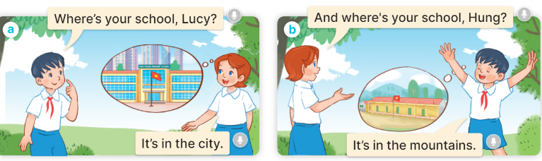  - Play the audio twice (sentence by sentence). Correct their pronunciation where necessary.  - Have Ss to practice the dialogue  - T invites a few pairs to the front of the class to practice.  - T checks pronunciation for ss.  Activity 3 Listen, point and say.  *Aims: Ss will be able to correctly say the words and use Where’s your school? – It’s in the ……….. to ask and answer questions about the location of a school.  *Procedure:  * Model sentences:  - T asks Ss look at picture a and helps Ss know the structure from the dialogue.  - T introduces new structure for Ss.  - T explains, models and gives meaning.  -Have Ss repeat the model sentences.  A: Where is your school?  B: It’s in the village.  3.Practice: (7’)  *Drill pictures  - Elicit and check comprehension the places of school  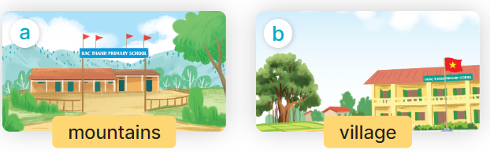  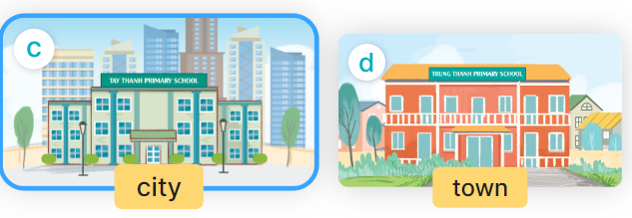  - Run through all the pictures.  - Run through model sentences.  +Run through the question sentences  +Run through the answer sentences  - Have Ss to practise:  + T asks, Ss answer picture a  + Ss ask, T answers picture b  + Group A ask, group B answer picture c  + Group B ask, group A answer picture d  - Ask Ss to work in pairs.  - T controls and corrects.  - Invite a few pairs to come to the front of the classroom and point at the pictures and say the questions and answers in front of the class.  - T gives feedbacks.  4.Production: (7’)  Activity 4. Let’s talk.  *Aims: Ss will be able to enhance the correct use of Where’s your school? – It’s in the ……. to ask and answer questions about the location of a school in a freer context *Procedure:  - Have Ss look at the picture and elicit the question and the answer in context.  + What can you see in the picture?  + How many places are there?  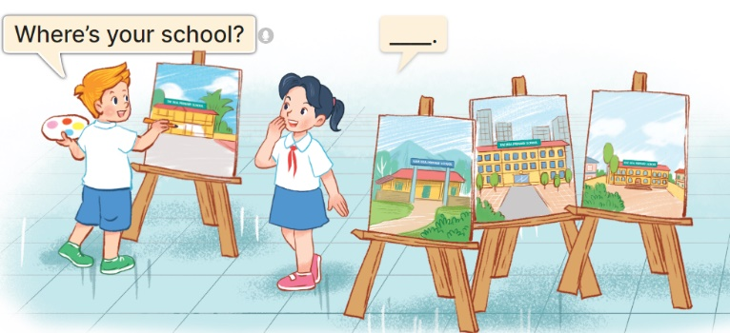  - Ask pupils to look at the second bubble and identify what the answer should be.  -Give an example answer It’s in the village. - Get pupils to repeat the question and the answer several times.  - Have pairs of pupils practise asking and answering questions about the locations of the schools in the paintings.  - Invite some pairs of Ss to the front of the class to perform their conversations.  *Consolidation  *Aims: Ss will be able consolidate and wrap up the content of the lesson.  *Procedure:  - T asks ss to answer the following questions:  + What have you learnt from the lesson today?  +What are the core values of the lesson? (if the teacher can take from the lesson).  - T review the vocabulary and model sentences.  - T praises some Ss who are hardworking / active/ good…. as well as encourage others to try more.  5. Homework. (2’)  - Learn the vocabulary and model sentences by heart  - Prepare the new lesson: Unit 6, Lesson 1 (4,5,6). | - Ss listen  -Ss look at the pieces of the picture  -Ss put into the correct picture  -Ss check  - Ss open their books  -Ss listen and answer  - - Ss listen and repeat  + Choral repetition (3 times).  + Individual repetition (3 ss)  - Ss take note  - Ss look, remember and match  -Look at the pictures and say  + In picture a:  Hung: Where’s your school, Lucy?  Lucy: It’s in the city  + In picture b:  Lucy: And where’s your school, Hung?  Hung: It’s in the mountains  -Ss listen and repeat in chorus (twice)  -Ss work in pairs to practice  -Ss practice the dialogue  -Ss listen  -Ss look at the picture and answer.  -Ss listen  -Ss listen and repeat  -Ss repeat to the place  - Ss look, listen and answer  + Picture a. a school in the mountains  + Picture b. a school in the village  + Picture c. a school in the city  + Picture d. a school in the town  -Ss listen and repeat  -Ss practice in chorus  -Ss work in pairs to practice  -Ss point and say  -Ss listen.  -Ss look at the picture and answer  + I can see 4 places…  + There are 4 pictures  -Ss look and answer  -Ss pay attention and answer  -Ss repeat and answer  -Ss work in pairs to ask and answer  -Ss perform in front of the class.  -Ss answer the questions  - Ss listen  -Ss listen and clap their hands  -Ss listen and take note
D. ADJUSTMENTS (if necessary):
………………………………………………………………………………………….…..……………………………………………………………………………...………………………………………….…..………………………………………
..----------------------------------------------------
Grade 4: Lớp 4A: Sáng thứ năm Ngày 14 tháng 11 năm 2024
Lớp 4B: Sáng thứ sáu, Ngày 15 tháng 11 năm 2024
Lớp 4C: Chiều thứ tư , Ngày 13 tháng 11 năm 2024
ENGLISH
Unit 6: Our school facilities
Lesson 1 (4, 5, 6)
A. OBJECTIVES:
By the end of the lesson, Ss will be able to:
1. Knowledge:
- use the words city, mountains, town, village in relation to the topic "Our school facilities";
- use Where’s your school? – It’s in the ……. to ask and answer questions about the location of a school;
- listen to and demonstrate understanding of simple communicative contexts in relation to the topic “Our school facilities”.
- read and write about school locations
- Vocabulary: Review
- Skills: speaking, listening, reading and writing.
2. Competences:
- Critical Thinking: self-introduce
- Co-operation: ready to help friends in pair work/ group work.
- Self-control and independent learning: perform listening tasks.
3. Attitude/ Qualities:
- Kindness: Help partners to complete learning tasks.
- Honesty: tell the truth about feelings and emotions.
- Diligence: complete learning tasks.
B. TEACHING AIDS:
- Teacher: Teacher’s guide Pages 80,81,82; audio Tracks 60; website hoclieu.vn, posters, laptop, pictures, textbook, lesson plan, TV or projector.
- Students: Pupil’s book Page 45, notebooks, workbooks, school things.
C. PROCEDURES:
Teacher’s activities | Students’ activities
1.Warm- up: (5’)  Game: play the Doraemon Game ( ppt)  *Aims: to create a friendly and active atmosphere in the class to beginning the lesson.  *Procedure:  - Divide the class into 3 teams.  - Pupils from each team choose a letter, then answer the question  - Pupils answer correctly get some points corresponding to the number of pies.  - Say “Open your book page 45” and look at “Unit 6, Lesson 1 (4,5,6)”.  2.Practice: (27’)  Activity 1. Listen and number:  *Aims: Ss will be able to listen to and understand four communicative contexts in which pupils ask and answer questions about school locations and number the correct pictures.  *Procedure:  - Point at the pictures respectively to explain the context.  + How many pictures are there?  + What can you see in each picture?  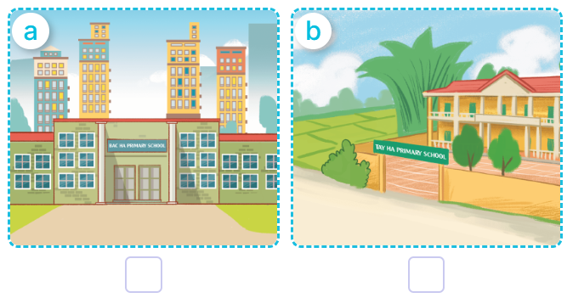  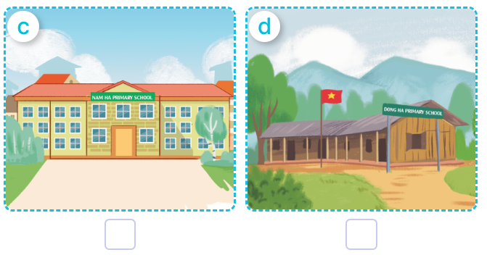  - T ask Ss to guess the answers.  + T writes Ss’guessing on the board.  - Listen to the tape:  + Play the recording  + Play the recording again and get Ss to swap books with their partners.  + Play the recording again to check answers together as a class.  + Write the answers on the board for Ss to correct their answers. Then checks Ss’ guessing.  - Play the recording, sentence by sentence, for the class to listen and repeat in chorus.  Key: 1. c 2. d 3.a 4.b  Activity 2. Look, complete and read  *Aims: Ss will be able to complete four target gapped exchanges with the help of picture cues  *Procedure:  - Ask pupils to look at the pictures and identify the school locations in the four pictures.  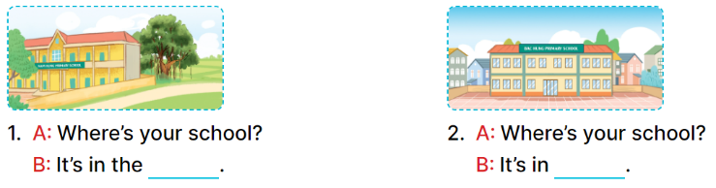  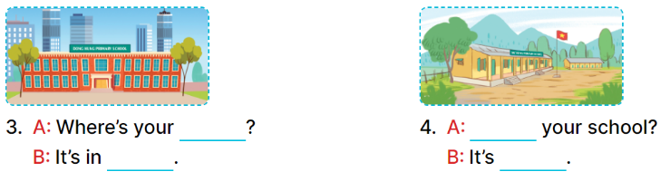  - Have Ss look at the four dialogue and the pictures. Elicit and model with picture 1  + Ask Ss to read the sentence 1 in chorus.  + Ask them what is missing in the question (village). Then have them complete the gap (Is It’s in the village).  -Have Ss work in pairs and complete the dialogue 2, 3, 4.  - Ask a few Ss to stand up and read the sentences aloud.  -T gives feedbacks.  Key:  1. village 2. the town  3. school, the city  4. Where’s, in the mountains  Activity 3. Let’s play  Matching pairs  *Aims: Ss will be able to review the words mountains, village, city and town by playing the game Matching pairs.  *Procedure:  -Tell pupils that they are going to find four pairs of pictures and words as quickly as possible.  - Stick the picture cards face down in the left column on the board. Stick the word cards face down in the right column on the board.  - Invite one pupil to play the game by selecting a picture card and a word card, turning them over.  + If two cards are a matching pair, ask the pupil to say the word aloud.  + The pupil can continue to take another turn.  + If the cards do not make a match, ask the pupil to turn them face down again, and invite another pupil to take the next turn.  - Let pupils play the game until all pairs have been matched.  - Play the game several times if there is enough time.  *Consolidation  *Aims: Ss will be able consolidate and wrap up the content of the lesson.  *Procedure:  - T asks ss to answer the following questions:  + What have you learnt from the lesson today?  +What are the core values of the lesson? (if the teacher can take from the lesson).  - T praises some Ss who are hardworking / active/ good…. as well as encourage others to try more.  3. Homework. (3’)  - Practice part 5 again.  - Prepare the new lesson: Unit 6, Lesson 2 (1,2,3). | - Ss read the words  - Ss play game  -Ss play game  - Ss open their books  -Look at the pictures and say:  + Picture a. a school in the city  + Picture b. a school in the village  + Picture c. a school in the town  + Picture d. a school in the mountains  -Ss guess the answers  - Ss listen to the tape and number  - Ss listen again, number and swap books with their partners.  - Ss check their answers and guessing  -Ss listen and repeat.  -Ss look at the picture and say  -Ss look and answer  -Ss read  -Ss say and complete  -Ss work in pairs and complete  -Ss read aloud  - Ss listen  -Ss listen  -Ss play the game  -Ss play the game  -Ss play the game  -Ss answer the questions  -Ss listen and clap their hands  -Ss listen and take note
D. ADJUSTMENTS (if necessary):
………………………………………………………………………………………….…..……………………………………………………………………………...
-----------------------------------------------------
Grade 4: Lớp 4A: Sáng thứ năm Ngày 14 tháng 11 năm 2024
Lớp 4B: Sáng thứ sáu, Ngày 15 tháng 11 năm 2024
Lớp 4C: Chiều thứ tư , Ngày 13 tháng 11 năm 2024
ENGLISH
Unit 6: Our school facilities
Lesson 2 (1, 2, 3)
A. OBJECTIVES:
By the end of the lesson, Ss will be able to:
1. Knowledge:
- use How many ….. are there at your school? – There is ….. / There are …… to ask and answer questions about the quantity of school facilities;
-listen to and demonstrate understanding of simple communicative contexts in relation to the topic “Our school facilities”.
-draw their school with some facilities and present it to the class.
- Vocabulary: building, garden.
- Skills: speaking and listening
2. Competences:
- Co-operation: ready to help friends in pair work/ group work.
- Sociability: Talk to each other, say good words to others.
3. Attitude/ Qualities:
- Kindness: Help partners to complete learning tasks.
- Honesty: tell the truth about feelings and emotions
B. TEACHING AIDS:
- Teacher: Teacher’s guide Pages 82, 83, 84; audio Tracks 61, 62, website hoclieu.vn, posters, laptop, pictures, textbook, lesson plan, TV or projector.
- Students: Pupil’s book Page 46, notebooks, workbooks, school things.
C. PROCEDURES:
Teacher’s activities | Students’ activities
1.Warm- up: (3’)  Game: Guessing and Choosing  *Aims: to create a friendly and active atmosphere in the class to beginning the lesson.  *Procedure:  - T shows 4 pictures of places and calls 4 Ss to come to the board and choose.  - T asks 4 Ss to come to the board and choose 1 picture of place and keep them in secret by covering them.  - The others will write their place in the board at their desks and keep their ideas in secret.  - The Ss on the board will 1 by 1 show their pictures they choose.  - When the teacher says the word of the pictures 1 by 1 shown on the board, who has the same places will raise their board or raise their hands.  - The Ss on the board will get the same points as the numbers of Ss raising their hands.  - Say “Open your book page 46” and look at “Unit 6, Lesson 2 (1,2,3)”.  2. Presentation (16’)  Activity 1. Vocabulary.  *Aims: Ss will be able to know the vocabulary in the new lesson.  *Procedure:  -T elicits the new words  + building : tòa nhà (picture)  + garden : khu vườn (picture)  - T models (3 times).  - T writes the words on the board.  - Checking: What and where  Activity 2. Look, listen and repeat:  *Aims: Ss will be able to understand and correctly repeat the sentences in two communicative contexts focusing on asking and answering questions about the quantity of school facilities.  *Procedure:  - Have Ss look at Pictures a and b and identify the characters in the pictures.  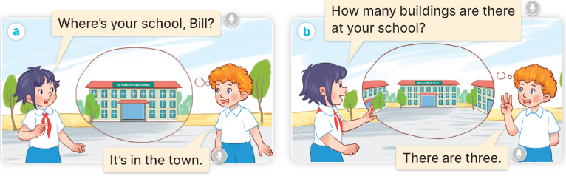  - Play the audio twice (sentence by sentence). Correct their pronunciation where necessary.  - Have Ss to practice the diaguage  - T invites a few pairs to the front of the class to practice.  - T checks pronunciation for ss.  Activity 3. Listen, point and say.  *Aims: Ss will be able to correctly say the phrases and use How many …… are there at your school? – There is …….. / There are …….. to ask and answer questions about the quantity of school facilities.  *Procedure:  * Model sentences:  - T asks Ss look at picture a and helps Ss know the structure from the dialogue.  - T introduces new structure for Ss.  - T explains, models and gives meaning.  - Have Ss repeat the model sentences.  A: How many buildings are there at your school?  B: – There is one. / There are two.  3.Practice: (7’)  *Drill pictures  - Have Ss look at the pictures and elicit the names of the places  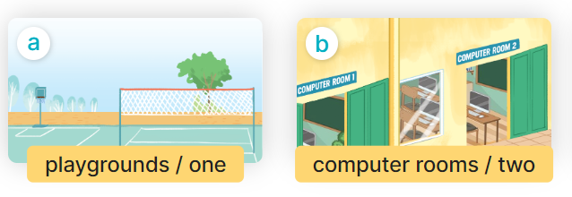  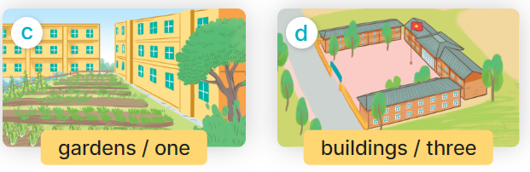  - Run through all the pictures.  - Run through model sentences.  - Have Ss to practise:  + T say – Ss respond (change role).  + Ss – Ss (change role).  - Ask Ss to work in pairs.  - T controls and corrects.  - Invite a few pairs to come to the front of the classroom, point at the pictures and say the questions and answers in front of the class.  - T gives feedbacks.  4.Production: (7’)  Activity 4. Let’s talk.  *Aims: Ss will be able to enhance the correct use of How many…… are there at your school? and There is …….. / There are ……… to ask and answer questions about the quantity of school facilities in a freer context.  *Procedure:  - Ask questions to help them identify the context.  + What can you see in the picture?  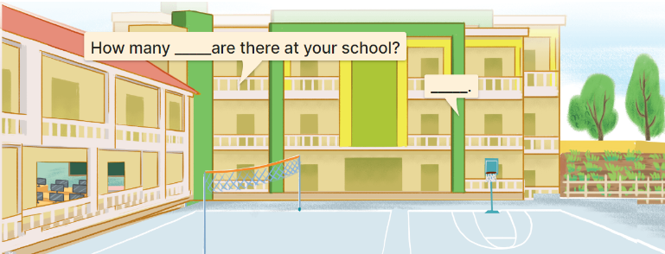  - Elicit the missing words in the speech bubbles and write them on the board. Get pupils to say the completed sentences.  - Have pairs of pupils practise asking and answering the questions about the quantity of school facilities in the picture.  - Invite some pairs to practise asking and answering questions about the quantity of school facilities in front of the class.  *Consolidation  *Aims: Ss will be able consolidate and wrap up the content of the lesson.  *Procedure:  - T asks ss to answer the following questions:  + What have you learnt from the lesson today?  - T review the vocabulary and model sentences.  - T praises some Ss who are hardworking / active/ good…. as well as encourage others to try more.  5. Homework. (2’)  - Learn the vocabulary and model sentences by heart  - Prepare the new lesson: Unit 6, Lesson 2 (4,5,6). | - Ss listen  - Ss play the game  -Ss play game  - Ss open their books  -Ss listen and answer  - - Ss listen and repeat  + Choral repetition (3 times).  + Individual repetition (3 ss)  - Ss take note  - Ss look, remember and slap  -Look at the pictures and get to know the characters in the pictures.  + In picture a:  Linh: Where’s your school, Bill?  Bill: It’s in the town.  – In picture b:  Linh: How many buildings are there at your school?  Bill: There are three.  -Ss listen and repeat in chorus (twice)  -Ss work in pairs to practice  -Ss practice the diaguage  -Ss listen  -Ss look at the picture and answer.  -Ss listen  -Ss listen and repeat  -Ss repeat to the hobbies  -Ss listen and answer  +Picture a: one playground  +Picture b: two computer rooms  +Picture c: one garden  +Picture d: three buildings  - Ss look, listen and repeat  - Ss practice in chorus  - Ss practice in chorus  -Ss work in pairs to practice  -Ss listen  -Ss go to the board and point and say  -Ss listen  -Ss look at the picture and answer  + a school with two buildings, a playground, a computer room and a garden  -Ss listen and answer  -Ss work in pairs and ask, answer  -Ss perform in font of the class.  -Ss answer the questions  - Ss listen  -Ss listen and clap their hands  -Ss listen and take note
D. ADJUSTMENTS (if necessary):
………………………………………………………………………………………….…..……………………………………………………………………………...
-----------------------------------------------------------------
Grade 5 : Lớp 5B : Chiều thứ hai, Ngày 11 tháng 11 năm 2024
ENGLISH
Extension activities
A. OBJECTIVES:
By the end of the lesson, Ss will be able to:
1. Knowledge:
- read six descriptions of jobs and match them to the jobs and places of work.
- complete a table about jobs, workplaces and job activities.
- talk about future jobs and give reasons for wanting these jobs.
- Vocabulary: Review
- Skills: speaking, writing and listening
2. Competences:
- Co-operation: ready to help friends in pair work/ group work.
- Sociability: Talk to each other, say good words to others.
3. Attitude/ Qualities:
- Kindness: Help partners to complete learning tasks.
B. TEACHING AIDS:
- Teacher: Teacher’s guide Pages 93, 94; website hoclieu.vn, posters, laptop, pictures, textbook, lesson plan, TV or projector.
- Students: Student’s book Page 42, 43, notebooks, workbooks, school things.
C. PROCEDURES:
Teacher’s activities | Students’ activities
1.Warm- up: (3’)  Sing: Head, shoulders, knees and toes  *Aims: to create a friendly and active atmosphere in the class to beginning the lesson.  *Procedure:  - Show the song on the screen.  https://www.youtube.com/watch?v=WX8HmogNyCY  - Ask Ss to listen, sing and dance the song.  - Say “Open your book page 42, 43” and look at “Extension activites”.  2. Practice (28’)  Activity 1. Look and read. Choose and write the correct words on the lines  *Aims: Ss will be able to read six descriptions of jobs and match them to the jobs and places of work.  *Procedure:  - Have Ss look at the pictures and ask  + What do you see in the pictures?      - Draw pupils’ attention to the pictures.  - Have Ss work independently to read and choose the picture that matches each one.  - Get Ss swap the books and check  - Check answers together as a class.  Key: 1 - school 2 –doctor 3 – theatre  4 - reporter 5 – firefighter 6 - garden  Activity 2. Complete the table about jobs  *Aims: Ss will be able to complete a table about jobs, workplaces and job activities.  *Procedure:  - Tell Ss the goal of the activity.  - Have Ss point to each heading and give examples, ex: doctor, help people.  - Have Ss read and complete the reat of the table.  - Have ss check their answer in pairs, the check as a class.  Key:  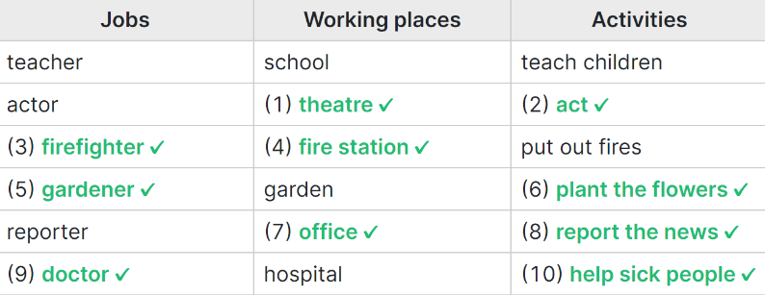  Activity 3. Work in groups. Talk about what you want to be in the future. Say why you like this job.  *Aims: Ss will be able to talk about future jobs and give reasons for wanting these jobs.  *Procedure:  - Tell Ss the goal of the activity  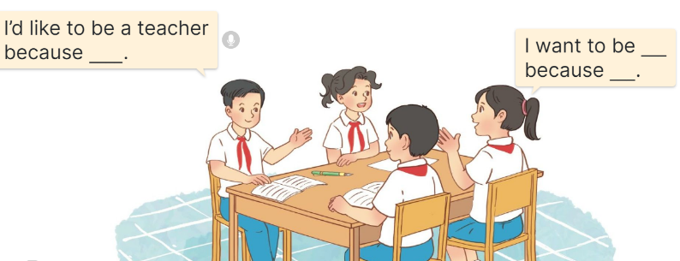  - Have Ss read the sentences in the speech bubbles aloud.  - Have ss name as many jobs as they can and write.  - Revise the questions and the answers  - Put ss work in groups and talk about the job in the future.  - Have a few groups repeat the conversations in front of the class.  Ex: I’d like to be a teacher because I want to teach children.  I’d like to be a biological professor because I like studying.  3. Fun corner and wrap- up (4’)  Game: “Kim’s game”  - Divide the class into two teams.  - Display many words and phrases on the board. Give sls two minutes to memorise these words and phrases.  - Turn the word cards face down on the board. In their teams, the ss try to write down many words as they can remember.  - Check the answers as the class.  - Count the points for each team and announce the winner. The team with the most points wins. | - Ss listen  - Ss sing a song  -Ss open the book  -Ss look at the picture and answer  - - Ss note  -Ss do the task  -Ss swap the books and check  -Ss check together  -Ss listen to the teacher  -Ss read and do the task  -Ss work in pair and check  -Ss pay attention  -Ss read aloud  -Ss work in groups and talk  -Ss repeat the conversations  - Ss listen to the teacher  -Ss play the game  Ex: sandwich, pink, pizza, Japanese, American, building, friendly, active, play the violin, go for a walk, water the flowers, firefighter, gardener.  -Ss praise the winner
D. ADJUSTMENTS (if necessary):
………………………………………………………………………………………….…..……………………………………………………………………………...
-----------------------------------------------------------
Grade 5 : Lớp 5B : Chiều thứ hai, Ngày 11 tháng 11 năm 2024
ENGLISH
Unit 6: Our school rooms
Lesson 1 (1, 2, 3)
A. OBJECTIVES:
By the end of the lesson, Ss will be able to:
1. Knowledge:

- understand and correctly repeat the sentences in two communicative contexts focusing on asking and answering questions about the location of rooms in a school

- use Where’s the ___? – It’s on the ___. to ask and answer questions about the location of a room in a school

- use Where’s the _____? – It’s on the _____. in a freer context.

- Vocabulary: first ﬂoor, ground ﬂoor, second ﬂoor, third ﬂoor.

- Structures:

A: Where’s the library?
B: It’s on the second floor.
- Skills: speaking and listening
2. Competences:
- Critical thinking and creativity: learn how to ask and answer questions about personal information correctly and fluently.
- Self-control and independent learning: perform speaking tasks.
3. Attitude/ Qualities:
- Show their love and interest in school.
B. TEACHING AIDS:
- Teacher: Teacher’s guide Pages 88, 89, 90, audio Tracks 56, 57, website hoclieu.vn, posters, laptop, pictures, textbook, lesson plan, TV or projector.
- Students: Students’ book Page 44, notebooks, workbooks, school things.
C. PROCEDURES:
Teacher’s activities | Students’ activities
1.Warm- up and review: (3’)  Game: Slap the board  *Aims: to revise the vocabulary about different rooms that pupils have learnt in English 4.  *Procedure:  - Prepare some flashcards about different jobs and stick on the board  (library, computer room, classroom, music room…)  - Divide class into 2 groups: Tom and Jerry.  - How to play:  + Each group chooses five Ss to play.  + Class will read aloud.  + Look at the picture, listen and slap the picture you heard.  + Who faster will get 1 mark.  + Which group with higher mark is the winner.  - Say “Open your book page 44” and look at “Unit 6, Lesson 1 (1,2,3)”.  2. Presentation (15’)  Activity 1. Vocabulary.  *Aims: Ss will be able to know the vocabulary in the new lesson.  *Procedure:  -T elicits the new words  + ground floor : tầng trệt (picture)  + first floor : tầng 1 (picture)  + second floor : tầng 2 (picture)  + third floor : tầng 3 (picture )  - T models (3 times).  - T writes the words on the board.  - Checking: Matching  Activity 2. Look, listen and repeat:  *Aims: Ss will be able to understand and correctly repeat the sentences in two communicative contexts focusing on asking and answering questions about the location of rooms in a school.  *Procedure:  - Have Ss look at Pictures a and b and identify the characters and say what they are talking  + Who is he/ she?  + Where is he/ she?  + What are they talking about?  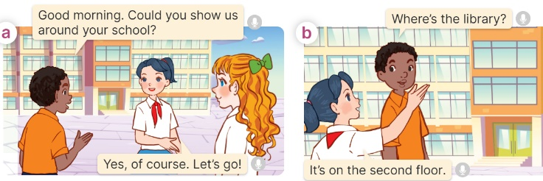  - Play the audio twice (sentence by sentence). Correct their pronunciation where necessary.  - Have Ss to practice the dialogue  - T invites a few pairs to the front of the class to practice.  - T checks pronunciation for ss.  Activity 3 Listen, point and say.  *Aims: Ss will be able to correctly say the phrases and use “Where’s the ____? – It’s on the ____. to ask and answer questions about the location of a room in a school.  *Procedure:  * Structures:  - T asks Ss look at picture b in activity 1 and helps Ss know the structure from the dialogue.  - T introduces new structures for Ss.  - T explains, models and gives meaning.  - Have Ss repeat the structures  A: Where’s the library?  B: It’s on the second floor.  3.Practice: (7’)  *Drill pictures  - Have Ss look at the pictures and say what they can see in the pictures.  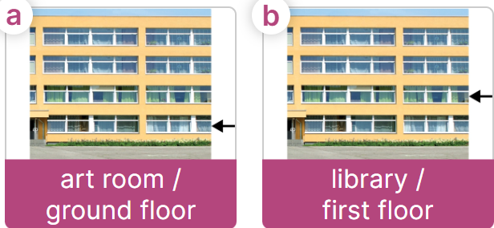  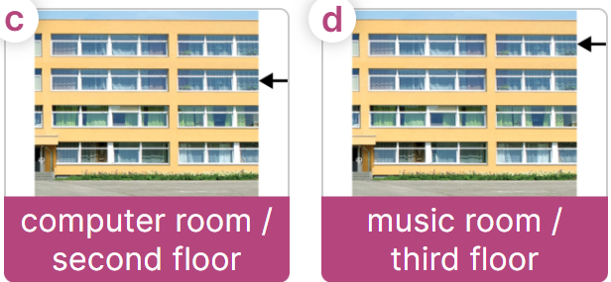  - Have Ss point at pictures, listen and run through all the pictures.  - Have Ss point at the bubbles, listen and run through model sentences.  - Have Ss to practise:  + T asks the first picture, Ss answer  + Ss asks the second picture, T answers  + Group A asks the third picture, group B  answers  + Group B asks the last picture, group A  - Ask Ss to work in pairs to practise asking and answering the Where’s the …….?  - It’s on the ……..  - T controls and corrects.  - Invite a few pairs to point at the pictures and say the questions and answers in front of the class.  4. Production: (6’)  Activity 4. Let’s talk.  *Aims: Ss will be able to use Where’s the ____? – It’s on the ____. in a free context  *Procedure:  - Ask Ss to look at the pictures and elicit the context  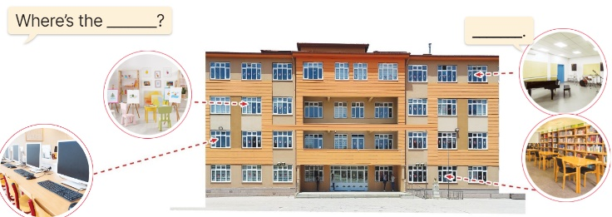  - Point at the ﬁrst building and elicit the question in the ﬁrst speech bubble Where’s the……? and the answer in the second speech bubble It’s ……. as an example.  - Give Ss time to work in pairs and take turns pointing at each picture to ask and answer using structures.  - Invite a few pairs to come to the front of the classroom and act out the exchanges.  5. Fun corner and wrap- up (4’)  Game: Spin the wheel  - Divide class into 2 teams: Boys and Girls  - Draw ss’ attention to the questions on the screen.  - In teams, they take turns spinning the wheel and answer the questions. Read the question aloud and answer it. If they have the correct ones, they get the points.  - The team with more points wins the game. | -Ss listen and pay attention  - Ss listen to the teacher  -Ss play the game  .  -Ss continute playing the game  - Ss listen and open their books  -Ss listen and answer  - - Ss listen and repeat  + Choral repetition (3 times).  + Individual repetition (3 ss)  - Ss take note  - Ss look and match  -Look at the pictures and say.  + In picture a:  Boy: Good morning. Could you show us around your school?  Mai: Yes, of course. Let’s go!  + In picture b:  Boy: Where’s the library?  Mai: It’s on the second floor.  -Ss listen and repeat in chorus (twice)  -Ss work in pairs to practice  -Ss come to the front of the classroom to practice.  -Ss listen  - Ss look at the picture and answer.  -Ss listen  -Ss listen and repeat  -Ss repeat to the structures  - Ss look, listen and repeat  +Picture a: an art room on the ground floor  + Picture b: a library on the first floor  + Picture c: a computer room on the second floor  + Picture d: a music room on the third floor  -Ss point at pictures, listen and repeat  -Ss point at the bubbles, listen and repeat  -Ss practice in chorus  -Ss practice in chorus  -Ss work in pairs to practise asking and answering the question  - Pairs of Ss point at the pictures and say in front of the class  -Ss look at the picture and say  + four rooms (computer room, art room, music room and library) located on different floors of a school building.  - Ss look at the first building and elicit the missing words in speech bubbles and say the completed sentences.  - Ss role-play to practise asking and answering questions  - Ss practise asking and answering questions in front of the class.  -Ss listen to the teacher  -Ss play the game  -Ss continute the game
D. ADJUSTMENTS (if necessary):
………………………………………………………………………………………….…..……………………………………………………………………………...
---------------------------------------
Grade 5 : Lớp 5B : Chiều thứ ba, Ngày 12 tháng 11 năm 2024
ENGLISH
Unit 6: Our school rooms
Lesson 1 (4, 5, 6)
A. OBJECTIVES:
By the end of the lesson, Ss will be able to:
1. Knowledge:
- listen to and understand four communicative contexts in which the characters ask and answer questions about the location of a room in a school and tick or cross the correct pictures
- complete four gapped exchanges with the help of picture cues
- sing the song Where are the rooms in our school? with the correct pronunciation, rhythm and melody.
- Vocabulary: Review
- Skills: speaking, listening, reading and writing.
2. Competences:
- Communication and collaboration: work in pairs and groups to complete the learning tasks.
- Self-control and independent learning: perform listening and reading tasks.
3. Attitude/ Qualities:
- Knowing their way around the school and recognizing different spaces can help pupils feel more comfortable and secure in their learning environment.
B. TEACHING AIDS:
- Teacher: Teacher’s guide Pages 90, 91, 92; audio Tracks 58, 59; website hoclieu.vn, posters, laptop, pictures, textbook, lesson plan, TV or projector.
- Students: Student’s book Page 45, notebooks, workbooks, school things.
C. PROCEDURES:
Teacher’s activities | Students’ activities
1.Warm- up and review: (5’)  Game: Hot potato  *Aims: to create a friendly and active atmosphere in the class to beginning the lesson.  *Procedure:  - Ss pass the ball while the teacher plays the music. When the music stops, the pupil holding the ball says a word or sentence learnt in the lesson.  - Say “Open your book page 45” and look at “Unit 6, Lesson 1 (4,5,6)”.  2.Practice: (25’)  Activity 1. Listen and tick or cross:  *Aims: Ss will be able to listen to and understand four communicative contexts in which the characters ask and answer questions about the location of a room in a school and tick or cross the correct pictures.  *Procedure:  - Draw Ss’ attention to the pictures and ask questions  + How many pictures are there?  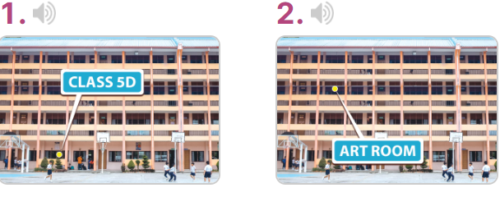  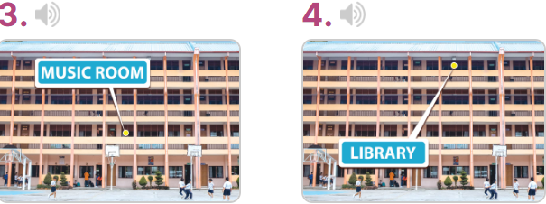  - T ask Ss to guess the answers.  + T writes Ss’guessing on the board.  - Listen to the tape:  + Play the recording  + Play the recording again for ss to do the task.  + Play the recording a third time for ss to check their answers.  - Get Ss to swap books with their partner, then check answers as a class.  + Write the answers on the board for Ss to correct their answers. Then checks Ss’ guessing.  - If time allows, play the recording, sentence by sentence, for Ss to listen and repeat individually and in chorus Key: 1. v 2. x 3. x 4. v  Activity 2. Read and complete  *Aims: Ss will be able to complete four gapped exchanges with the help of picture cues.  *Procedure:  - Have Ss read the sentences and elicit the answer to fill in the gap.  (ex: first).  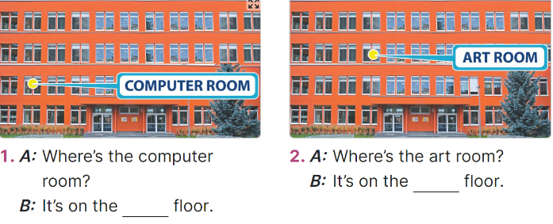  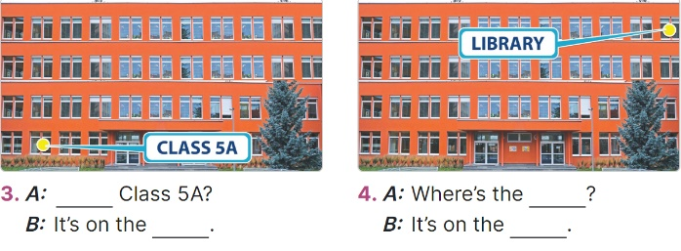  - Give Ss a time limit to read the gapped dialogues, look at the pictures and do the task independently.  - Get Ss to swap books with a partner and check their answers before checking as a class.  + Invite one student to write the answers on the board.  - Invite two pairs of Ss to act out the completed dialogues.  Key: 1. first  2. second  3. Where’s; ground floor  4. library; third floor  Activity 3. Let’s sing  *Aims: Ss will be able to sing the song Where are the rooms in our school? with the correct pronunciation, rhythm and melody.  *Procedure:  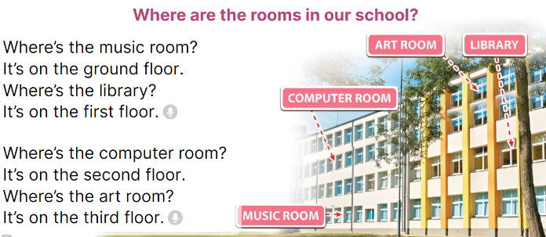  - Introduce the title and lyrics of the song: Where are the rooms in our school? song.  Play the recording for Ss to listen to the whole song.  + Have them repeat the title and lyrics line by line.  - Play the recording all the way through for Ss to listen to pronunciation and melody of the song.  - Play the recording line by line for Ss to listen, repeat  - Play the recording for Ss to sing and do actions.  - Ask Ss to practice singing and doing actions in pairs or groups.  - Invite groups to the front of the classroom to perform the song  -T gives feedback.  3. Fun corner and wrap- up (5’)  Game: Roll the dice  - Divide the class into groups of six. Have each student count the numbers from one to six.  - Ask a student from each group to roll the dice to choose a pupil asking the question.  - Have that student ask the question and invite another student of the group to answer  the question about future jobs.  - The student who gives the correct answers will continue rolling the dice. | -Ss listen to the teacher  -Ss play the game  - Ss open their books  -Look at the pictures and say:  + Picture 1: Class 5D on the ground floor  + Picture 2: Art room on the second floor  + Picture 3: Music room on the first floor  + Picture 4: Library on the third floor  -Ss guess the answers  - Ss listen to the tape  - Ss listen again and do the task.  - Ss listen and check their answers  - Ss swap books with their partner, then check answers as a class and guessing  -Ss listen and repeat  -Ss look at the picture and read, fill the gap  - Ss do the task independently.  - Ss swap books with a partner and check their answers.  - Ss write the answers in the notebook  - Pairs of Ss read the completed dialogues aloud  -Ss look and listen to the teacher  -Ss listen to the song  - Ss listen and repeat line by line without the action.  -Ss listen to melody of the song  - Ss listen and sing line by line.  - Ss sing and do actions.  - Ss work in groups (two groups) to sing.  -Ss perform in front of the class.  -Ss listen  -Ss listen to the teacher  - Ss play the game.  Ex. A: Where is the library?  B: It’s on the ground floor.  - Ss continue playing the game.  - Ss praise the winner.
D. ADJUSTMENTS (if necessary):
………………………………………………………………………………………….…..……………………………………………………………………………....
---------------------------------------------------------------
Grade 5 : Lớp 5B : Chiều thứ ba, Ngày 12 tháng 11 năm 2024
ENGLISH
Unit 6: Our school rooms
Lesson 2 (1, 2, 3)
A. OBJECTIVES: By the end of the lesson, Ss will be able to:
1. Knowledge:

- understand and correctly repeat the sentences in two communicative contexts focusing on asking for and giving directions in a school.

- use Could you tell me the way to the computer room, please? - ________. to ask for and give directions in a school;

- use Where’s ______? – It’s on the ______. and Could you show me the way to _____, please? – ____. in a freer context.

- Vocabulary: go along, go downstairs, go past, go upstairs.
- Structures:
A: Could you show me the way to the computer room, please?
B: Go upstairs. It’s on the first floor.
- Skills: speaking and listening
2. Competences:
- Critical thinking and creativity: learn how to ask and answer questions about personal information correctly and fluently.
- Self-control and independent learning: perform pronunciation and speaking tasks.
3. Attitude/ Qualities:
- Show their pride in their school and raise awareness about the location of different rooms in their school.
B. TEACHING AIDS:
- Teacher: Teacher’s guide Pages 92, 93, 94, audio Tracks 60, 61; website hoclieu.vn, posters, laptop, pictures, textbook, lesson plan, TV or projector.
- Students: Students’ book Page 46, notebooks, workbooks, school things.
C. PROCEDURES:
Teacher’s activities | Students’ activities
1.Warm- up and review: (3’)  Game: School tour  *Aims: to create a friendly and active atmosphere in the class to beginning the lesson.  *Procedure:  - Display the slide of 6 doors.  - Put Ss in 3 teams. Each team chooses a door and completes the questions and the answer by looking at the picture cues.  - Check Ss’ pronunciation and their answers. Give points as the stars appeared on the screen to the team having the correct answer.  - Continue playing until all six doors are opened.  - Say “Open your book page 46” and look at “Unit 6, Lesson 2 (1,2,3)”.  2. Presentation (15’)  Activity 1. Vocabulary.  *Aims: Ss will be able to know the vocabulary in the new lesson.  *Procedure:  -T elicits the new words  + go along: đi dọc theo (situation)  + go downstairs: đi lên lầu (picture)  + go upstair: đi xuống lầu (situation)  + go past: đi qua (picture)  - T models (3 times).  - T writes the words on the board.  - Checking: Rub out and remember  Activity 2. Look, listen and repeat:  *Aims: Ss will be able to understand and correctly repeat the sentences in two communicative contexts focusing on asking for and giving directions in a school  *Procedure:  - Have Ss look at Pictures a and b and identify the characters  + What can you see in the picture?  + What are they talking about?  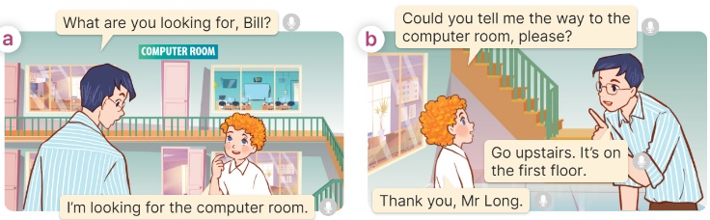  - Play the audio twice (sentence by sentence). Correct their pronunciation where necessary.  - Have Ss to practice the dialogue  - T invites a few pairs to the front of the class to practice.  - T checks pronunciation for ss.  Activity 3 Listen, point and say.  *Aims: Ss will be able to correctly say the phrases and use Could you show me the way to the computer room, please? - ______. to ask for and give directions in a school.  *Procedure:  * Structures:  - T asks Ss look at picture b in activity 1 and helps Ss know the structure from the dialogue.  - T introduces new structures for Ss.  - T explains, models and gives meaning.  - Have Ss repeat the structures  A: Could you show me the way to the computer room, please?  B: Go upstairs. It’s on the first floor.  3.Practice: (7’)  *Drill pictures  - Have Ss look at the pictures and say what they can see in the pictures.  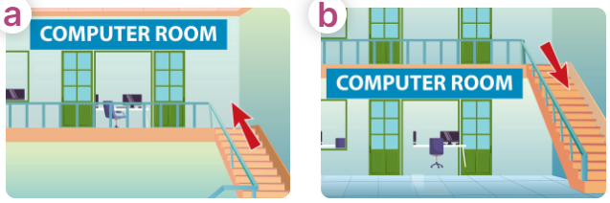  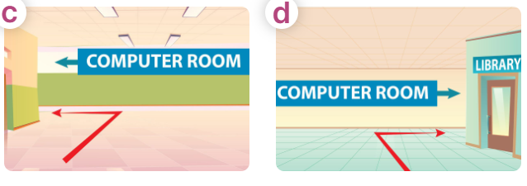  - Have Ss point at pictures, listen and run through all the pictures.  - Have Ss point at the bubbles, listen and run through model sentences.  - Have Ss to practise:  + T asks the first picture, Ss answer  + Ss asks the second picture, T answers  + Group A asks the third picture, group B  answers  + Group B asks the last picture, group A  - Ask Ss to work in pairs to practise asking and answering the question Could you show me the way to the computer room, please?  - Go upstairs. It’s on the first floor.  - T controls and corrects.  - Invite a few pairs to point at the pictures and say the questions and answers in front of the class.  4. Production: (6’)  Activity 4. Let’s talk.  *Aims: Ss will be able to use Could you show me the way to……., please? – ____.in a freer context.  *Procedure:  - Ask Ss to look at the pictures and point to the locations of each of the school rooms  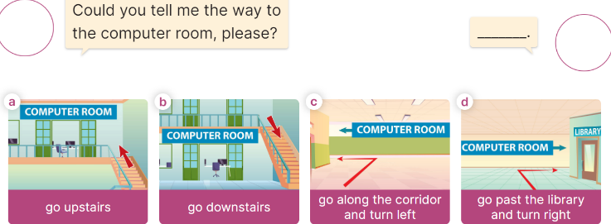  - Remind Ss that Could you show me the way to……., please? – ____. are used to ask and answer questions about the reasons why someone would like to be a certain job.  - Give Ss time to work in pairs and take turns pointing at each picture to ask and answer using Could you show me the way to……., please? – ____.  - Invite a few pairs to come to the front of the classroom and act out the exchanges.  5. Fun corner and wrap- up (4’)  Game: Pass the teddy bears  - Divide the class into 2 teams: boys and girls.  - Draw Ss’ attention to the questions on the screen.  - In teams, they take turns looking at the picture and answer the questions. Read the question aloud and answer it. If they have the correct ones, they will get the points.  - The team with more points wins the game. | -Ss listen and pay attention  -Ss play the game  - Ss listen and open their books  -Ss listen and answer  - - Ss listen and repeat  + Choral repetition (3 times).  + Individual repetition (3 ss)  - Ss take note  - Ss look, remember and write  -Look at the pictures and say.  + In picture a:  Mr Long: What are you looking for, Bill?  Bill: I’m looking for the computer room.  + In picture b:  Bill: Could you tell me the way to the computer room, please?  Mr. Long: Go upstairs. It’s on the first floor.  Bill: Thank you  -Ss listen and repeat in chorus (twice)  -Ss work in pairs to practice  -Ss come to the front of the classroom to practice.  -Ss listen  - Ss look at the picture and answer.  -Ss listen  -Ss listen and repeat  -Ss repeat to the structures  - Ss look, listen and repeat  +Picture a: a go upstairs  + Picture b: go downstairs  + Picture c: go along the corridor and turn left  + Picture d: go past the library and turn right  -Ss point at pictures, listen and repeat  -Ss point at the bubbles, listen and repeat  -Ss practice in chorus  -Ss practice in chorus  -Ss work in pairs to practise asking and answering the question  - Pairs of Ss point at the pictures and say in front of the class  -Ss look at the picture and say  - Ss listen to the teacher  - Ss role-play to practise asking and answering questions about address  - Ss practise asking and answering questions in front of the class.  -Ss listen to the teacher  -Ss play the game  Ex:  A: Could you tell me the way to the computer room, please?  B: Go upstairs and turn right.  -Ss play the game  -Ss congratulate the winner.
D. ADJUSTMENTS (if necessary):
……………………………………………………………………………………….…..……………………………………………………………………………...……

Duyệt bài, Ngày 08 tháng 11 năm 2024
Phó hiệu trưởng

Nguyễn Thị Hằng

