ĐĂNG KÝ GIẢNG DẠY TUẦN 7 ( Từ ngày 21-25/10/2024)

Thứ  Ngày | Buổi | Lớp | Tiết | Môn | Tên bài
Hai | Chiều | 5B | 1 | English | Unit 4: Our free-time activities  Lesson 2 (1,2,3)
 |  | 5B | 2 | English | Unit 4: Our free-time activities  Lesson 2 (4,5,6)
Ba | Sáng | 4C | 1 | English | Unit 4: My birthday party  Lesson 2 (1,2,3)
 |  | 4C | 2 | English | Unit 4: My birthday party  Lesson 2 (4,5,6)
 |  | 5B | 3 | English | Unit 4: Our free-time activities  Lesson 3 (1,2,3)
 |  | 5B | 4 | English | Unit 4: Our free-time activities  Lesson 3 (4, 5, 6)
Tư | Sáng | 3A | 1 | English | Unit 4: Our bodies - Lesson 2 (1,2,3)
 |  | 3A | 2 | English | Unit 4: Our bodies - Lesson 2 (4,5,6)
 |  | 4A | 3 | English | Unit 4: My birthday party  Lesson 2 (1,2,3)
 |  | 4A | 4 | English | Unit 4: My birthday party  Lesson 2 (4,5,6)
 | Chiều | 4C | 1 | English | Unit 4: My birthday party  Lesson 3 (1,2,3)
 |  | 4C | 2 | English | Unit 4: My birthday party  Lesson 3 (4, 5, 6)
 |  |  | 3
Năm | Sáng | 4B | 1 | English | Unit 4: My birthday party  Lesson 2 (1,2,3)
 |  | 4B | 2 | English | Unit 4: My birthday party  Lesson 2 (4,5,6)
 |  | 4A | 3 | English | Unit 4: My birthday party  Lesson 3 (1,2,3)
 |  | 4A | 4 | English | Unit 4: My birthday party  Lesson 3 (4, 5, 6)
 | Chiều | 3A | 1 | English | Unit 4: Our bodies - Lesson 3 (1,2,3)
 |  | 3A | 2 | English | Unit 4: Our bodies - Lesson 3 (4, 5, 6)
 |  |  | 3
Sáu | Sáng | 4B | 1 | English | Unit 4: My birthday party  Lesson 3 (1,2,3)
 |  | 4B | 2 | English | Unit 4: My birthday party  Lesson 3 (4, 5, 6)

Duyệt bài, Ngày 18 tháng 10 năm 2024
Phó hiệu trưởng

Nguyễn Thị Hằng

WEEK 7
Grade 3: Lớp 3A: Sáng thứ tư ngày 23 tháng 10 năm 2024
ENGLISH
Unit 4: Our bodies - Lesson 2 (1, 2, 3)
A. OBJECTIVES:
By the end of the lesson, Ss will be able to:
1. Knowledge:
- use Open your ………! and Touch your …........! to give instructions
- listen to and demonstrate understanding of simple communicative contexts in relation to the topic “Our bodies”.
- Vocabulary: touch, open, mouth, hair
- Skills: speaking and listening
2. Competences:
- Oral Communication: speak about names, ask and answer the questions
- Co-operation: ready to help friends in pair work/ group work.
- Sociability: Talk to each other, say good words to others.
3. Attitude/ Qualities:
- Kindness: Help partners to complete learning tasks.
- Honesty: tell the truth about feelings and emotions
- Diligence: complete learning tasks
B. TEACHING AIDS:
- Teacher: Teacher’s guide Pages 55, 56, audio Tracks 39,40, website sachmem.vn, posters, laptop, pictures, textbook, lesson plan, TV or projector.
- Students: Pupil’s book Page 30, notebooks, workbooks, school things.
C. PROCEDURES:
Teacher’s activities | Students’ activities
1.Warm- up: (3’)  Game: Review  *Aims: to create a friendly and active atmosphere in the class to beginning the lesson.  *Procedure:  - T says to Ss answer the parts of the body  +We use ... for listening (pretend to listen to music)  + We use ... for looking (pretend to wear glasses)  + We use ... for smelling (pretend to smell something good)  + We put makeup on a ... (pretend to put on makeup)  + We hold something with ... (pretend to hold heavy thing)  - Say “Open your book page 30” and look at “Unit 4, Lesson 2 (1,2,3)”.  2. Presentation (16’)  Activity 1. Vocabulary.  *Aims: Ss will be able to know the vocabulary in front of starting the new lesson.  *Procedure:  -T elicits the new words  + touch : chạm (situation)  + open : mở / há (realia)  +mouth :miệng (realia)  + hair : tóc (realia)  - T models (3 times).  - T writes the words on the board.  - Checking: Rub out and remember  Activity 2. Listen, point and repeat:  *Aims: Ss will be able to understand and correctly repeat the sentences in two communicative contexts (pictures) focusing on giving instructions.  *Procedure:  - Have pupils look at Pictures a and b and identify the characters in the pictures.  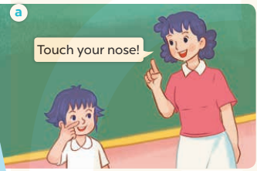  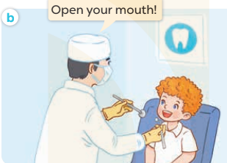  - Play the audio twice (sentence by sentence). Correct their pronunciation where necessary.  - Have Ss to practice the dialogue  - T invites a few pairs to the front of the class to practice.  - T checks pronunciation for ss.  Activity 3 Listen, point and say.  *Aims: Ss will be able to correctly say the words and use Touch your ……..! and Open your ……….! to give instructions.  *Procedure:  * Model sentences:  - T asks Ss look at picture a, b and helps Ss know the structure from the dialogue.  - T introduces new structure for Ss.  - T explains, models and gives meaning.  -Have Ss repeat the model sentences.  - Touch your nose!  - Open your mouth!  3.Practice: (7’)  *Drill pictures  - Elicit and check comprehension the actions and the body parts.  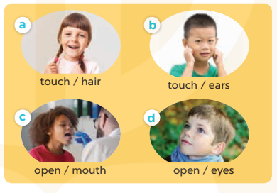  - Run through all the pictures.  - Run through model sentences.  - Have Ss to practise:  + T says the first picture  + Ss say the second picture  + Group A say the third picture  + Group B say the last picture.  - Ask Ss to work in pairs to point and say the strucure Touch your….! Open your…….!  - T controls and corrects.  - Invite a few pairs to point at the pictures and giving the instructions in front of the class.  - Encourage Ss to practise speaking English.  - T gives feedbacks.  4.Production: (7’)  Activity 4. Let’s talk.  *Aims: Ss will be able to enhance the correct use of Touch your …..! and Open your …..! to give instructions  *Procedure:  - Have Ss look at the picture and answer the questions:  +Who are they?  + What are they doing?  - T asks Ss look at the first speech bubble and say Touch your……!  - Get Ss to repeat and give instructions several times in pairs.  - T models: Go around the classroom, pointing to the parts of body and says Touch your…..!  - Ask Ss work in pairs to give more instructions using the words that they have learnt (ex: nose, face, ear, …..).  - Invite some pairs to perform in front of the class.  - Give feedbacks  *Consolidation  *Aims: Ss will be able consolidate and wrap up the content of the lesson.  *Procedure:  - T asks ss to answer the following questions:  + What have you learnt from the lesson today?  +What are the core values of the lesson? (if the teacher can take from the lesson).  - T review the vocabulary and model sentences.  - T praises some Ss who are hardworking / active/ good…. as well as encourage others to try more.  5. Homework. (2’)  - Learn the vocabulary and model sentences by heart  - Prepare the new lesson: Unit 4, Lesson 2 (4,5,6). | -Ss answer  + an ear  + an eye  + a nose  + a face  + a hand  - Ss open their books  -Ss listen and answer  - - Ss listen and repeat  + Choral repetition (3 times).  + Individual repetition (3 ss)  - Ss take note  - Ss look, remember and write  -Look at the pictures and get to know the characters in the pictures.  + In picture a: Ms Hoa says: Touch your nose!  + In pucture b: The doctor says: Open your mouth!  -Ss listen and repeat in chorus (twice)  -Ss work in pairs to practice  -Ss practice the dialogue  -Ss listen  -Ss look at the picture and answer.  -Ss listen  -Ss listen and repeat  -Ss repeat to the actions and the body parts.  -Ss look at the picture and answer  + In picture a: a girl touching her hair  + In picture b: a boy touching his ears  + In picture c: a boy opening his mouth  + In picture d: a boy opening his eyes  - Ss look, listen and repeat  -Ss practice in chorus  -Ss work in pairs to practice  -Ss point and say  -Ss listen.  -Ss listen  -Ss look at the picture and listen  + A boy asks a girl to touch her hair  +A doctor asks a boy to open his mouth.  -Ss look and answer  + hair  -Ss say  - Ss answer  -Ss work in pairs  -Ss perform in front of the class.  -Ss answer the questions  - Ss listen  -Ss listen and clap their hands  -Ss listen and take note
D. ADJUSTMENTS (if necessary):
………………………………………………………………………………………….…..……………………………………………………………………………...………………………………………….…..………………………………………
--------------------------------------------------------------
Grade 3: Lớp 3A: Sáng thứ tư ngày 23 tháng 10 năm 2024
ENGLISH
Unit 4: Our bodies - Lesson 2 (4, 5, 6)
A. OBJECTIVES:
By the end of the lesson, Ss will be able to:
1. Knowledge:
- listen to and demonstrate understanding of simple communicative contexts in relation to the topic “Our bodies”
- read and match the sentence halves to make complete instructions and read them aloud.
- Vocabulary: Review
- Skills: speaking, listening, reading and writing.
2. Competences:
- Critical Thinking: self-introduce
- Co-operation: ready to help friends in pair work/ group work.
- Self-control and independent learning: perform listening tasks.
3. Attitude/ Qualities:
- Kindness: Help partners to complete learning tasks.
- Honesty: tell the truth about feelings and emotions.
- Diligence: complete learning tasks.
B. TEACHING AIDS:
- Teacher: Teacher’s guide Pages 56, 57, 58; audio Tracks 41; website sachmem.vn, posters, laptop, pictures, textbook, lesson plan, TV or projector.
- Students: Pupil’s book Page 31, notebooks, workbooks, school things.
C. PROCEDURES:
Teacher’s activities | Students’ activities
1.Warm- up: (5’)  Game: Simon says  *Aims: to create a friendly and active atmosphere in the class to beginning the lesson.  *Procedure:  - T is the “Simon” and calls out the actions. Every student must follow and do the action, but only when they hear “Simon says ...”.  - If teacher leaves out “Simon says” before giving instruction, anyone who does the action is out.  - Then, teacher can choose one or more students as the leader to continue a game.  - Say “Open your book page 31” and look at “Unit 4, Lesson 2 (4,5,6)”.  2.Practice: (27’)  Activity 1. Listen and number:  *Aims: Ss will be able to listen to and understand four communicative contexts in which instructions are given.  *Procedure:  - Elicit the actions of the characters in the pictures.  - Point at the pictures respectively to explain the context.    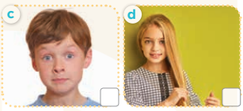  - T ask Ss to guess the answers.  + T writes Ss’guessing on the board.  - Listen to the tape:  + Play the recording  + Play the recording again and get Ss to swap books with their partners.  + Play the recording again to check answers together as a class.  + Write the answers on the board for Ss to correct their answers. Then checks Ss’ guessing.  - Play the recording, sentence by sentence, for the class to listen and repeat in chorus.  Key: 1. b 2. d 3. a 4. c  Activity 2. Look, match and read.  *Aims: Ss will be able to correctly match the sentence halves to make complete instructions and read them aloud.  *Procedure:  - Get Ss to look at the pictures and identify the actions of the characters.  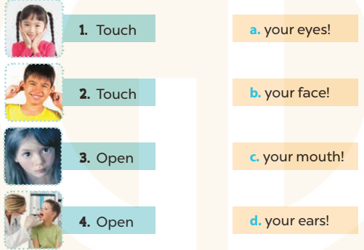  - Have Ss look at the first picture and incomplete sentence.  - T models with sentence 1  + Ask Ss to read and match. When Ss answer correctly (Touch your face!)  + Tell them to draw a line to match the two sentence halves  -Have Ss work in groups and match the sentence 2, 3 and 4.  - Ask a few Ss to stand up and read the matched instructions aloud.  -T gives feedbacks.  Key: 1. b 2. d 3. a 4. c  Activity 3. Let’s play.  *Aims: Ss will be able to practise using target sentence patterns by playing the game Touch your hair!  *Procedure:  - Elicit the language that Ss need to give instructions (Touch your ……! and Open your……..!). When Ss answer correctly, write the language on the board.  - Have Ss look at the picture. Get them to say how to play the game. Explain the rules of the game again:  + A boy / girl standing in the centre gives an instruction and other Ss have to follow it.  + If a pupil does not follow the instruction, he or she will be "out".  + Check Ss’ understanding by getting one Ss to repeat what they have to do.  - Have the whole class play the game. Ask one or two Ss to be the observer(s) of the game. Give out the instructions and monitor Ss while they play the game. Ss who cannot follow the rules of the game will be “out” and become the observers.  - Divide the class into four teams. Each team plays the game. Ss are eliminated if they do not perform the correct actions. Give stars/ points to the winner.  *Consolidation  *Aims: Ss will be able consolidate and wrap up the content of the lesson.  *Procedure:  - T asks ss to answer the following questions:  + What have you learnt from the lesson today?  +What are the core values of the lesson? (if the teacher can take from the lesson).  - T praises some Ss who are hardworking / active/ good…. as well as encourage others to try more.  3. Homework. (3’)  - Practice about the pictures on page 31.  - Prepare the new lesson: Unit 4, Lesson 3 (1,2,3). | - Ss listen  -Ss play game  - Ss open their books  -Look at the pictures and say:  + Picture a: a boy touching his nose  + Picture b: a girl opening her mouth  + Picture c: a boy opening his eyes  + Picture d: a girl touching her hair  -Ss guess the answers  - Ss listen to the tape and write number  - Ss listen again, write and swap books with their partners.  - Ss check their answers and guessing  -Ss listen and repeat.  -Ss look at the pictures and say  -Ss listen and answer  -Ss read and match  -Ss complete the sentence  -Ss read aloud  -Ss listen  -Ss look at the picture and play the game  -Ss play the game  -Ss listen to the teacher.  -Ss answer the questions  -Ss listen and clap their hands  -Ss listen and take note
D. ADJUSTMENTS (if necessary):
………………………………………………………………………………………….…..……………………………………………………………………………...
-----------------------------------------------------------------
Grade 3: Lớp 3A: Chiều thứ năm ngày 24 tháng 10 năm 2024
ENGLISH
Unit 4: Our bodies - Lesson 3 (1, 2, 3)
A. OBJECTIVES:
By the end of the lesson, Ss will be able to:
1. Knowledge:
- correctly pronounce the sounds of the letters air and ear in isolation, in the words hair and ears, and in the sentences Touch your hair! and Touch your ears!
- listen and circle the correct words.
- Vocabulary: Review
- Skills: speaking, listening, reading and writing.
2. Competences:
- Co-operation: ready to help friends in pair work/ group work.
- Sociability: Talk to each other, say good words to others.
3. Attitude/ Qualities:
- Kindness: Help partners to complete learning tasks.
- Honesty: tell the truth about feelings and emotions
B. TEACHING AIDS:
- Teacher: Teacher’s guide Pages 58, 59; audio Tracks 42, 43; website sachmem.vn, posters, laptop, pictures, textbook, lesson plan, TV or projector.
- Students: Pupil’s book Page 32, notebooks, workbooks, school things.
C. PROCEDURES:
Teacher’s activities | Students’ activities
1.Warm- up: (5’)  Game: I want to see ...  *Aims: to create a friendly and active atmosphere in the class to beginning the lesson.  *Procedure:  - Divide the class into 10 groups (4 Ss/ group).  - T calls out “I want to see ... 4 hands!”  - T calls out “I want to see ... 6 eyes!”  - T calls out “I want to see ... 1 mouth!”  - T calls out “I want to see ... 3 faces!”  - T calls out “I want to see ... 2 noses!”  - Say “Open your book page 32” and look at “Unit 4, Lesson 3 (1,2,3)”.  2. Presentation(9’)  Activity 1. Listen and repeat:  *Aims: Ss will be able to correctly pronounce the sounds of the letters air and ear in isolation, in the words hair and ears, and in the sentences Touch your hair! and Touch your ears! with correct pronunciation and intonation.  *Procedure:  - T gives instruction to the letter air and ear, hair and ears, and in the sentences Touch your hair! and Touch your ears!  - Play the recording for the letter air, ear.  - Encourage Ss to point at the letter/ word/ sentence while listening.  - Play the recording again and encourage Ss to listen and repeat.  - Do this several times until Ss feel confident.  - T calls some Ss to practice.  - T gives feedbacks.  3.Practice: (19’)  Activity 2. Listen and circle.  *Aims: Ss will be able to identify the target words hair and ears while listening.  *Procedure:  - Elicit the sentences and the gap-fill options.  - T ask Ss to guess the answers.  + T writes Ss’guessing on the board.  - Listen to the tape:  + Play the recording  + Play the recording again and get Ss to swap books with their partners.  + Play the recording again to check answers together as a class.  + Write the answers on the board for Ss to correct their answers. Then checks Ss’ guessing.  - Play the recording, sentence by sentence, for the class to listen and repeat in chorus.  - Invite one or two Ss to stand up and read the completed sentences.  Key: 1.c 2.b  Activity 3. Let’s chant  *Aims: Ss will be able to say the chant with the correct rhythm and pronunciation.  *Procedure:  - Introduce the title and lyrics of the chant.  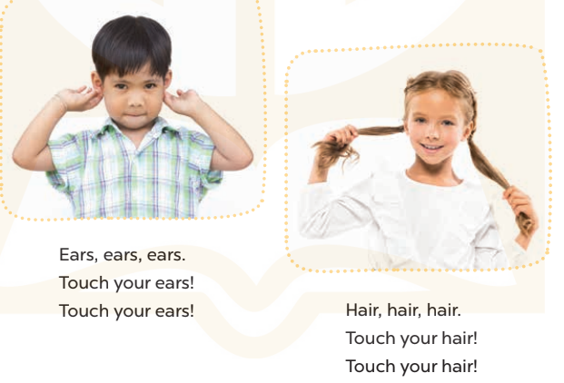  - Play the recording for Ss to listen to the whole chant.  + Have them repeat the title and lyrics line by line.  + Ask Ss to attend to the sounds of the letters air and ear and the words hair and ears.  - Play the recording all the way through for Ss to listen to pronunciation and melody.  - Play the recording line by line for Ss to listen and repeat  - Play the recording for Ss to chant and clap along.  - Ask Ss to practice chant and clap along in pairs or groups.  - Invite groups to the front of the classroom to perform the chant  -T gives feedback.  *Consolidation  *Aims: Ss will be able consolidate and wrap up the content of the lesson.  *Procedure:  - T asks ss to answer the following questions:  + What have you learnt from the lesson today?  +What are the core values of the lesson? (if the teacher can take from the lesson).  - T praises some Ss who are hardworking / active/ good…. as well as encourage others to try more.  4. Homework. (2’)  - Practice the chant more.  - Prepare the new lesson: Unit 4, Lesson 3 (4,5,6). | - Ss listen  -Ss must show only 4 hands (other hands can be hidden behind their backs).  - Ss show only 6 eyes (other eyes can be closed).  - Ss show only 1 opened mouth (other mouths can be covered).  - Ss show only 3 faces (other mouth can be covered by hand).  - Ss show only 2 noses (other noses can be covered by hand).  - Ss open their books  - Ss recognize the differences about color of letter  - - Ss listen  - Ss listen and point  - Ss listen again and repeat  -Ss listen again and repeat  -Ss practice  -Ss listen  -Ss listen and say:  + Number 1: Touch your….!  + Number 2: Touch your…..!  -Ss guess the answers  - Ss listen to the tape and circle  - Ss listen again, circle and swap books with their partners.  - Ss check their answers and guessing  -Ss listen and repeat.  -Ss read the sentences  - Ss look and listen.  -Ss listen to the chant  - Ss listen and repeat line by line without clap their hands  -Ss note the sounds, words  -Ss listen to melody of the chant  - Ss listen and chant line by line.  - Ss chant and clap along.  - Ss work in groups (two groups) to chant  -Ss perform in front of the class.  -Ss listen  -Ss answer the questions  -Ss listen and clap their hands  -Ss listen and take note
D. ADJUSTMENTS (if necessary):
………………………………………………………………………………………….…..……………………………………………………………………………...
---------------------------------------------------------
Grade 3: Lớp 3A: Chiều thứ năm ngày 24 tháng 10 năm 2024
ENGLISH
Unit 4: Our bodies - Lesson 3 (4, 5, 6)
A. OBJECTIVES:
By the end of the lesson, Ss will be able to:
1. Knowledge:
- read and write about parts of the body and instructions;
- make flashcards of the body parts and present them to the class.
- Vocabulary: Review
- Skills: speaking, listening, reading and writing.
2. Competences:
- Critical Thinking: self-introduce
- Co-operation: ready to help friends in pair work/ group work.
- Self-control and independent learning: perform listening tasks.
3. Attitude/ Qualities:
- Kindness: Help partners to complete learning tasks.
- Honesty: tell the truth about feelings and emotions.
- Diligence: complete learning tasks.
B. TEACHING AIDS:
- Teacher: Teacher’s guide Pages 60, 61; website sachmem.vn, posters, laptop, pictures, textbook, lesson plan, TV or projector.
- Students: Pupil’s book Page 33, notebooks, workbooks, school things.
C. PROCEDURES:
Teacher’s activities | Students’ activities
1.Warm- up: (5’)  Game: “Chant”  *Aims: to review the vocabulary and structure about greet and respond to greetings.  *Procedure:  - Ask Ss chant and do the actions in Unit 4, Lesson 3 page 32 in groups.  - Give point for the groups and encourage them.  - Say “Open your book page 33” and look at “Unit 4, Lesson 3 (4, 5, 6)”.  2.Practice: (8’)  Activity 1. Read and match:  *Aims: Ss will be able to read the four sentences/ exchanges on the left and match them with the pictures on the right correctly.  *Procedure:  - T models with sentence 1.  + Get Ss to read Sentence 1  + Ask Ss to read the first exchange and draw a line to match.  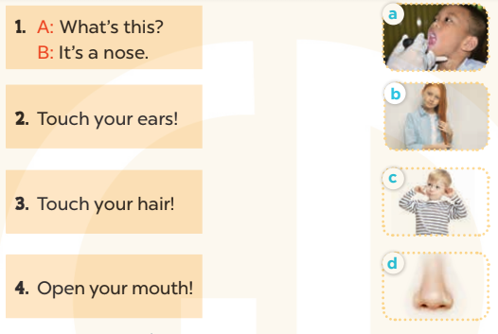  -Have Ss work in pairs and match the sentences 2, 3, 4.  - Tell Ss to swap books with a partner, then check answers together as a class.  - Write the correct answers on the board for pupils to correct their answers.  - Invite pairs of Ss to stand up and role play  -T gives feedbacks.  Key: 1. d 2. c 3. b 4. a  3.Production: (19’)  Activity 2. Let’s write  *Aims: Ss will be able to read, understand and complete four target sentences / exchanges with picture cues.  *Procedure:  - Have Ss read the sentences and ask some questions:  + What’s this?  + What’s that?  + What are they doing?  - Check their comprehension and remind Ss to write their personal information.  - Give Ss time to write the answers to the questions independently  - Get Ss to swap books with a partner, then check the answers together as a class.  - Ask a few Ss to stand up and role play the dialogue in front of the class.  -T gives feedbacks.  Key: 1. a hand 2. an eye  3. nose 4. Open  Activity 3. Project.  *Aims: Ss will be able to revise the target vocabulary items by making flashcards of the body parts pupils have learnt and presenting them to the class.  *Procedure:  - Ask Ss to look at the picture of an eye in the book. Demonstrate how to make a flashcard of an eye. Draw an eye on a card and write the word eye under the picture.  - Show Ss your flashcard of an eye. Tell them to pass it around so that they can see what they are going to make.  - Put Ss into groups and give each group a set of materials for making flashcards of the body parts.  - Give Ss enough time to make flashcards. Encourage them to decorate their flashcards.  - When Ss have finished making their flashcards, give them time to present the flashcards to their classmates. Go around the classroom to monitor and offer support.  Game: Who is the fastest writer?  - T asks 6 - 8 Ss to join this game.  - T says out loud a word (twice).  *Consolidation  *Aims: Ss will be able consolidate and wrap up the content of the lesson.  *Procedure:  - T asks ss to answer the following questions:  + What have you learnt from the lesson today?  +What are the core values of the lesson? (if the teacher can take from the lesson).  - T praises some Ss who are hardworking / active/ good…. as well as encourage others to try more.  4. Homework. (3’)  - Prepare the new lesson: Unit 5, Lesson 1 (1, 2, 3). | - Ss listen and chant  - Ss open their books  - Ss look at the pictures and answer  -Ss read and match  -Ss work in pairs and match  -Ss swap books and check  -Ss check the correct their answers  -Ss role play  -Ss listen  -Ss look at the pictures and say:  + It’s a hand  + It’s an eye  + A girl touches her nose  + A boy opens his mouth.  -Ss listen to the teacher  -Ss write  -Ss swap books and check their answers  -Ss role play  -Ss listen  - Ss listen and note  -Ss listen to the teacher  -Ss make flashcards of the body parts  -Ss continute to make the flashcards  -Ss present the flashcards  -Ss listen  -Ss write as fast as they can.  -Ss answer the questions  -Ss listen and clap their hands  -Ss listen and take note
D. ADJUSTMENTS (if necessary):
………………………………………………………………………………………….…..……………………………………………………………………………...
---------------------------------------------------
Grade 4: Lớp 4A: Sáng thứ tư, Ngày 23 tháng 10 năm 2024
Lớp 4B: Sáng thứ năm, Ngày 24 tháng 10 năm 2024
Lớp 4C: Sáng thứ ba , Ngày 22 tháng 10 năm 2024
ENGLISH
Unit 4: My birthday party - Lesson 2 (1, 2, 3)
A. OBJECTIVES:
By the end of the lesson, Ss will be able to:
1. Knowledge:
- understand and correctly repeat the sentences in two communicative
contexts focusing on what someone wants to eat / drink.
- correctly say the phrases and use What do you want to eat / drink? – I want ……….to ask and answer questions about what someone wants to eat / drink.
- enhance the correct use of What do you want to eat / drink? – …….. to ask and answer questions about what someone wants to eat / drink in a freer context.
- Vocabulary: chips, grapes, jam, juice.
- Skills: speaking and listening
2. Competences:
- Oral Communication: speak about names, ask and answer the questions
- Co-operation: ready to help friends in pair work/ group work.
- Sociability: Talk to each other, say good words to others.
3. Attitude/ Qualities:
- Kindness: Help partners to complete learning tasks.
- Honesty: tell the truth about feelings and emotions
- Diligence: complete learning tasks
B. TEACHING AIDS:
- Teacher: Teacher’s guide Pages 59, 60, 61, audio Tracks 40, 41, website hoclieu.vn, posters, laptop, pictures, textbook, lesson plan, TV or projector.
- Students: Pupil’s book Page 30, notebooks, workbooks, school things.
C. PROCEDURES:
Teacher’s activities | Students’ activities
1.Warm- up: (3’)  Sing a song  *Aims: to create a friendly and active atmosphere in the class to beginning the lesson.  *Procedure:  - Sing the song When’s your birthday? on page 29.  - Say “Open your book page 30” and look at “Unit 4, Lesson 2 (1,2,3)”.  2. Presentation (16’)  Activity 1. Vocabulary.  *Aims: Ss will be able to know the vocabulary in the new lesson.  *Procedure:  -T elicits the new words  + chips : khoai tây chiên (realia)  + grapes : quả nho (realia)  +jam :mứt (realia)  + juice : nước ép (realia)  - T models (3 times).  - T writes the words on the board.  - Checking: Rub out and remember  Activity 2. Look, listen and repeat:  *Aims: Ss will be able to understand and correctly repeat the sentences in two communicative contexts focusing on what someone wants to eat / drink.  *Procedure:  - Have pupils look at Pictures a and b and identify the characters in the pictures.  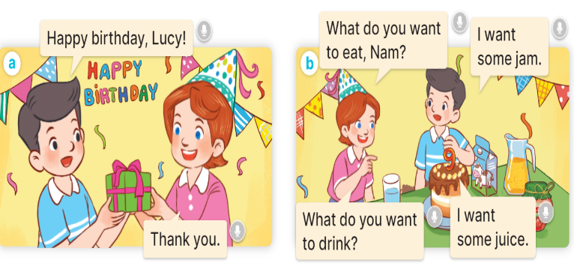  -  Play the audio twice (sentence by sentence). Correct their pronunciation where necessary.  - Have Ss to practice the dialogue  - T invites a few pairs to the front of the class to practice.  - T checks pronunciation for ss.  Activity 3 Listen, point and say.  *Aims: Ss will be able to correctly say the phrases and use What do you want to eat / drink? – I want ……… to ask and answer questions about what someone wants to eat / drink  *Procedure:  * Model sentences:  - T asks Ss look at picture a, b and helps Ss know the structure from the dialogue.  - T introduces new structure for Ss.  - T explains, models and gives meaning.  -Have Ss repeat the model sentences.  A: What do you want to eat/ drink?  B: I want some chips/ milk..  3.Practice: (7’)  *Drill pictures  - Have pupils look at the pictures and elicit the names of the food and drinks.  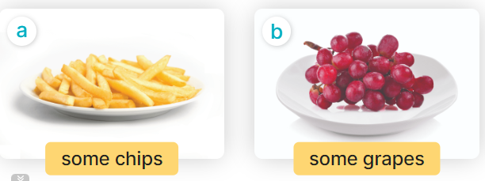  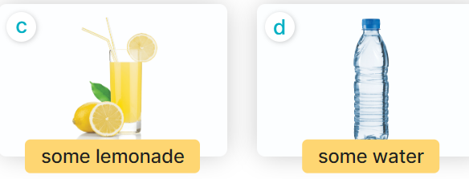  - Run through all the pictures.  - Run through model sentences.  + Run through the questions.  + Run through the answers.  - Have Ss to practise:  + T asks the first – Ss answer (change role).  + Ss – Ss (change role).  - Ask Ss to work in pairs to ask and answer the question What do you want to eat/ drink? I want……  - T controls and corrects.  - Invite a few pairs to point at the pictures and giving the instructions in front of the class.  - Encourage Ss to practise speaking English.  - T gives feedbacks.  4.Production: (7’)  Activity 4. Let’s talk.  *Aims: Ss will be able to enhance the correct use of What do you want to eat / drink? – I want ……... to ask and answer questions about what someone wants to eat / drink in a freer context.  *Procedure:  - Have Ss look at the picture and answer the questions:  +Who are they?  + What are they doing?  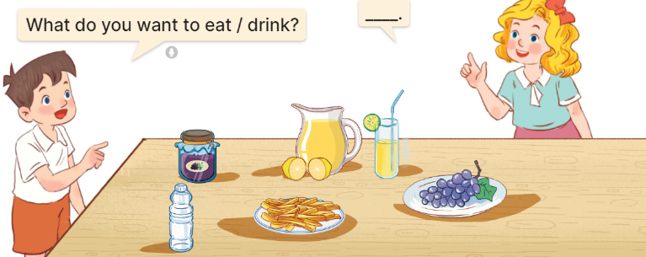  - Have pupils look at the bubbles to understand how the sentence pattern is used. - Have pupils role-play to practise asking the questions and giving their answers in pairs, using the picture cue.  - Invite some pupils to practise asking and answering questions in front of the class.  - Have pupils ask and answer questions about what they want to eat / drink at a birthday party, using the structure learnt.  *Consolidation  *Aims: Ss will be able consolidate and wrap up the content of the lesson.  *Procedure:  - T asks ss to answer the following questions:  + What have you learnt from the lesson today?  +What are the core values of the lesson? (if the teacher can take from the lesson).  - T review the vocabulary and model sentences.  - T praises some Ss who are hardworking / active/ good…. as well as encourage others to try more.  5. Homework. (2’)  - Learn the vocabulary and model sentences by heart  - Prepare the new lesson: Unit 4, Lesson 2 (4,5,6). | -Ss listen, sing and dance  - Ss open their books  -Ss listen and answer  - - Ss listen and repeat  + Choral repetition (3 times).  + Individual repetition (3 ss)  - Ss take note  - Ss look, remember and write  -Look at the pictures and get to know the characters in the pictures.  + In picture a:  Nam: Happy birthday, Lucy.  Lucy: Thank you.  + In pucture b:  Lucy: What do you want to eat, Nam?  Nam: I want some jam.  Lucy: What do you want to drink?  Nam: I want some juice.  -Ss listen and repeat in chorus (twice)  -Ss work in pairs to practice  -Ss practice the dialogue  -Ss listen  -Ss look at the picture and answer.  -Ss listen  -Ss listen and repeat  -Ss look at the picture and answer  + In picture a: some chips  + In picture b: some grapes  + In picture c: a glass of lemonade  + In picture d: a bottle of water  - Ss look, listen and repeat  -Ss practice in chorus  -Ss work in pairs to practice  -Ss point and ask and answer  -Ss listen.  -Ss take turns pointing at the pictures, asking and answering the question in front of the class.  -Ss look at the picture and listen  Minh and Mary asking and answering questions about food and drink items on a table at a birthday party: jam, lemonade, water, chips, and grapes  -Ss look and pay attention  -Ss work in pairs  -Ss perform in front of the class.  -Ss says about the birthday party.  -Ss answer the questions  - Ss listen  -Ss listen and clap their hands  -Ss listen and take note
D. ADJUSTMENTS (if necessary):
………………………………………………………………………………………….…..……………………………………………………………………………...………………………………………….…..………………………………………

--------------------------------------------------------------------
Grade 4: Lớp 4A: Sáng thứ tư, Ngày 23 tháng 10 năm 2024
Lớp 4B: Sáng thứ năm, Ngày 24 tháng 10 năm 2024
Lớp 4C: Sáng thứ ba , Ngày 22 tháng 10 năm 2024
ENGLISH
Unit 4: My birthday party - Lesson 2 (4, 5, 6)
A. OBJECTIVES:
By the end of the lesson, Ss will be able to:
1. Knowledge:
- listen to and understand two communicative contexts in which pupils ask and answer questions about what they want to eat / drink and tick the correct pictures.
- complete two gapped dialogues with the help of picture cues.
- revise the target vocabulary items through playing the game Board race.
- Vocabulary: Review
- Skills: speaking, listening, reading and writing.
2. Competences:
- Critical Thinking: self-introduce
- Co-operation: ready to help friends in pair work/ group work.
- Self-control and independent learning: perform listening tasks.
3. Attitude/ Qualities:
- Kindness: show kindness in inviting someone to a birthday party and offering them food and drink they want.
- Honesty: tell the truth about feelings and emotions.
- Diligence: complete learning tasks.
B. TEACHING AIDS:
- Teacher: Teacher’s guide Pages 62,63; audio Tracks 42; website hoclieu.vn, posters, laptop, pictures, textbook, lesson plan, TV or projector.
- Students: Pupil’s book Page 31, notebooks, workbooks, school things.
C. PROCEDURES:
Teacher’s activities | Students’ activities
1.Warm- up: (5’)  Game: Guessing game  *Aims: to create a friendly and active atmosphere in the class to beginning the lesson.  *Procedure:  - T introduces and explains the game.  - How to play:  + T will show some pictures which is hidden.  + Ss look at the pictures in the screen.  + Ss tell what someone is doing.  - T models. (jam)  - Ss play the game.  - T gives feedback.  - Ex:  1. jam 2. grapes 3. chips  4. milk 5. lemonade 6.chicken  - Say “Open your book page 31” and look at “Unit 4, Lesson 2 (4,5,6)”.  2.Practice: (27’)  Activity 1. Listen and tick:  *Aims: Ss will be able to listen to and understand two communicative contexts in which pupils ask and answer questions about what they want to eat / drink and tick the correct pictures.  *Procedure:  - Elicit the names of the food and drink items.  - Point at the pictures respectively to explain the context.  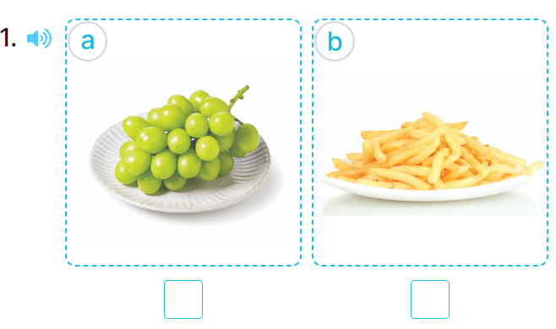  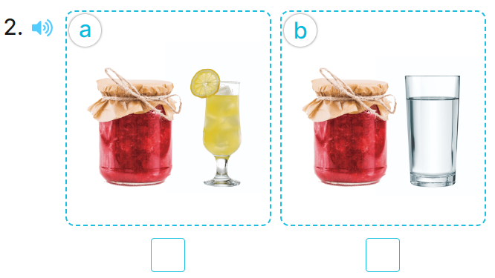  - T ask Ss to guess the answers.  + T writes Ss’guessing on the board.  - Listen to the tape:  + Play the recording  + Play the recording again and get Ss to swap books with their partners.  + Play the recording again to check answers together as a class.  + Write the answers on the board for Ss to correct their answers. Then checks Ss’ guessing.  - Play the recording, sentence by sentence, for the class to listen and repeat in chorus.  Key: 1. a 2.a  Activity 2. Look, complete and read.  *Aims: Ss will be able to complete two gapped dialogues with the help of picture cues.  *Procedure:  - Have pupils look at the pictures and identify the food and drink items in the pictures.  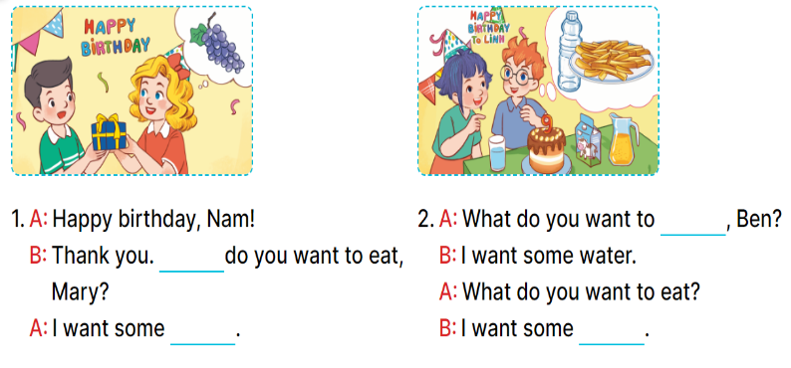  - Have pupils look at the two incomplete dialogues.  - Model Dialogue 1, ask pupils what is missing in the question (What) and the answer (the food).  - Ask pupils to complete the gap (What do you want to eat, Mary? – I want some grapes.).  - Have pupils complete the dialogues individually.  - Ask a few pairs to read them aloud.  - Correct their pronunciation where necessary, praise the readers, and get the class to clap or cheer if their pronunciation is good  Key: 1. What; grapes 2. drink; chips  Activity 3. Let’s play.  *Aims: Ss will be able to revise the target vocabulary items through playing the game Board race.  *Procedure:  - Tell pupils the goal of the game and how to play it.  - Divide pupils into two teams. They take turns going to the board and each pupil tries to write one word in the columns Drinks and Food as fast as possible.  - The team that writes the most words in the set time wins.  - Point to the words and have pupils read the words out loud.  - Have pupils play the game using other word sets, ex: months, countries, days of the week.  *Consolidation  *Aims: Ss will be able consolidate and wrap up the content of the lesson.  *Procedure:  - T asks ss to answer the following questions:  + What have you learnt from the lesson today?  +What are the core values of the lesson? (if the teacher can take from the lesson).  - T praises some Ss who are hardworking / active/ good…. as well as encourage others to try more.  3. Homework. (3’)  - Practice about the pictures on page 31.  - Prepare the new lesson: Unit 4, Lesson 3 (1,2,3). | - Ss listen  -Ss play game  - Ss open their books  -Look at the pictures and say:  + Picture 1a: grapes  + Picture 1b: chips  + Picture 2a: jam ad lemonade  + Picture 2b: jam and water  -Ss guess the answers  - Ss listen to the tape and write number  - Ss listen again, write and swap books with their partners.  - Ss check their answers and guessing  -Ss listen and repeat.  -Ss look at the pictures and say  -Ss listen and pay attention  -Ss read and answer  -Ss complete the sentence  -Ss complete the second dialogues  -Ss read aloud  - Ss listen  -Ss listen  -Ss play the game  -Ss play the game  -Ss listen to the teacher.  -Ss answer the questions  -Ss listen and clap their hands  -Ss listen and take note
D. ADJUSTMENTS (if necessary):
………………………………………………………………………………………….…..……………………………………………………………………………...………………………………………….…..………………………………………
----------------------------------------------------
Grade 4: Lớp 4A: Sáng thứ năm Ngày 24 tháng 10 năm 2024
Lớp 4B: Sáng thứ sáu, Ngày 25 tháng 10 năm 2024
Lớp 4C: Chiều thứ tư , Ngày 23 tháng 10 năm 2024
ENGLISH
Unit 4: My birthday party - Lesson 3 (1, 2, 3)
A. OBJECTIVES:
By the end of the lesson, Ss will be able to:
1. Knowledge:
- correctly repeat the sounds of the letters j and w in isolation, in the words jam and water, and in the sentences I like jam. and I want some water.
- listen to and demonstrate understanding of simple communicative to identify the target words jam and water while listening.
- say the chant with the correct pronunciation and rhythm.
- Vocabulary: Review
- Skills: speaking, listening, reading and writing.
2. Competences:
- Co-operation: ready to help friends in pair work/ group work.
- Sociability: Talk to each other, say good words to others.
3. Attitude/ Qualities:
- Kindness: show self-respect to what they want and what others want
- Honesty: tell the truth about feelings and emotions
B. TEACHING AIDS:
- Teacher: Teacher’s guide Pages 64,65; audio Tracks 43,44,45; website hoclieu.vn, posters, laptop, pictures, textbook, lesson plan, TV or projector.
- Students: Pupil’s book Page 32, notebooks, workbooks, school things.
C. PROCEDURES:
Teacher’s activities | Students’ activities
1.Warm- up: (5’)  Game: Pass the ball  *Aims: to create a friendly and active atmosphere in the class to beginning the lesson.  *Procedure:  - T gives Ss a ball.  - T asks Ss to listen to music and transfer a ball around the class.  - When the music stops, Ss who keep a ball have to answer the question using: What do you want to eat/ drink? and I want some…..  - T gives feedback.  - Say “Open your book page 32” and look at “Unit 4, Lesson 3 (1,2,3)”.  2. Presentation (9’)  Activity 1. Listen and repeat:  *Aims: Ss will be able to correctly repeat the sounds of the letters j and w in isolation, in the words jam and water, and in the sentences I like jam. and I want some water.  water.  *Procedure:  - T gives instruction to the letter j and w, in the words jam and water, and in the sentences I like jam. and I want some water.  - Play the recording for the letter j, w.  - Encourage Ss to point at the letter /word/ sentence while listening.  - Play the recording again and encourage Ss to listen and repeat.  - Do this several times until Ss feel confident.  - T calls some Ss to practice.  - T gives feedbacks.  3.Practice: (19’)  Activity 2. Listen and circle.  *Aims: Ss will be able to identify the target words jam and water while listening.  *Procedure:  - Elicit the sentences and the gap-fill options.  - T ask Ss to guess the answers.  + T writes Ss’guessing on the board.  - Listen to the tape:  + Play the recording  + Play the recording again and get Ss to swap books with their partners.  + Play the recording again to check answers together as a class.  + Write the answers on the board for Ss to correct their answers. Then checks Ss’ guessing.  - Play the recording, sentence by sentence, for the class to listen and repeat in chorus.  - Invite one or two Ss to stand up and read the completed sentences.  Key: 1.b 2.c  Activity 3. Let’s chant  *Aims: Ss will be able to say the chant with the correct rhythm and pronunciation.  *Procedure:  - Introduce the title and lyrics of the chant.  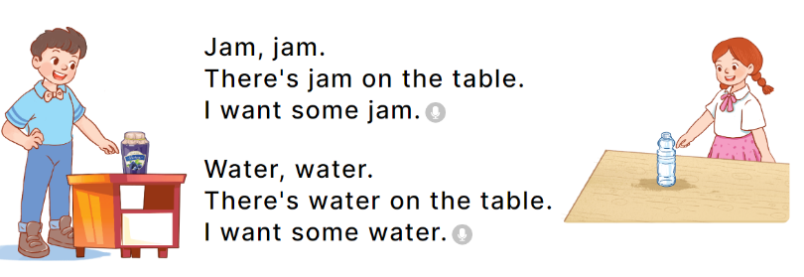  - Play the recording for Ss to listen to the whole chant.  + Have them repeat the title and lyrics line by line.  + Ask Ss to attend to the sounds of the letters j and w and the words jam and water..  - Play the recording all the way through for Ss to listen to pronunciation and melody.  - Play the recording line by line for Ss to listen and repeat  - Play the recording for Ss to chant and clap along.  - Ask Ss to practice chant and clap along in pairs or groups.  - Invite groups to the front of the classroom to perform the chant  -T gives feedback.  *Consolidation  *Aims: Ss will be able consolidate and wrap up the content of the lesson.  *Procedure:  - T asks ss to answer the following questions:  + What have you learnt from the lesson today?  +What are the core values of the lesson? (if the teacher can take from the lesson).  - T praises some Ss who are hardworking / active/ good…. as well as encourage others to try more.  4. Homework. (2’)  - Practice the chant more.  - Prepare the new lesson: Unit 4, Lesson 3 (4,5,6). | - Ss listen  -Ss play the game  - Ss open their books  - Ss recognize the differences about color of letter  - - Ss listen  - Ss listen and point  - Ss listen again and repeat  -Ss listen again and repeat  -Ss practice  -Ss listen  -Ss listen and say:  + Number 1: I want some…….  + Number 2: There is some….on the table.  -Ss guess the answers  - Ss listen to the tape and circle  - Ss listen again, circle and swap books with their partners.  - Ss check their answers and guessing  -Ss listen and repeat.  -Ss read the sentences  - Ss look and listen.  -Ss listen to the chant  - Ss listen and repeat line by line without clap their hands  -Ss note the sounds, words  -Ss listen to melody of the chant  - Ss listen and chant line by line.  - Ss chant and clap along.  - Ss work in groups (two groups) to chant  -Ss perform in front of the class.  -Ss listen  -Ss answer the questions  -Ss listen and clap their hands  -Ss listen and take note

D. ADJUSTMENTS (if necessary):
………………………………………………………………………………………….…..……………………………………………………………………………...………………………………………….…..………………………………………

----------------------------------------------
Grade 4: Lớp 4A: Sáng thứ năm Ngày 24 tháng 10 năm 2024
Lớp 4B: Sáng thứ sáu, Ngày 25 tháng 10 năm 2024
Lớp 4C: Chiều thứ tư , Ngày 23 tháng 10 năm 2024
ENGLISH

Unit 4: My birthday party
Lesson 3 (4, 5, 6)
A. OBJECTIVES:
By the end of the lesson, Ss will be able to:
1. Knowledge:
- read and understand a text (Bill’s letter) and circle the correct answers.
- complete a gapped text using pupils’ personal information.
- make birthday party invitations at home and present them to the class by using the target language.
- Vocabulary: Review
- Skills: speaking, listening, reading and writing.
2. Competences:
- Critical Thinking: self-introduce
- Co-operation: ready to help friends in pair work/ group work.
- Self-control and independent learning: perform listening tasks.
3. Attitude/ Qualities:
- Kindness: Show kindness in inviting someone to a birthday party and offering them food and drink they want.
- Honesty: Show pride in the date of birth of themselves and others’ and respect to their parents for their presence.
B. TEACHING AIDS:
- Teacher: Teacher’s guide Pages 66, 67; website hoclieu.vn, posters, laptop, pictures, textbook, lesson plan, TV or projector.
- Students: Pupil’s book Page 33, notebooks, workbooks, school things.
C. PROCEDURES:
Teacher’s activities | Students’ activities
1.Warm- up: (5’)  Game: “Chant”  *Aims: to review the vocabulary and structure about greet and respond to greetings.  *Procedure:  - Ask Ss chant and do the actions in Unit 4, Lesson 3 page 32 in groups.  - Give point for the groups and encourage them.  - Say “Open your book page 33” and look at “Unit 4, Lesson 3 (4, 5, 6)”.  2.Practice: (8’)  Activity 1. Read and circle:  *Aims: Ss will be able to read and understand a text (Bill’s letter) and circle the correct answers.  *Procedure:  - Draw pupils’ attention to Bill’s letter and read it together as a class.  - Have pupils pay attention to the gap and the three answer options for each sentence.  - Ask pupils to read the letter again and circle the correct options.  - Tell pupils to swap books with a partner, then check answers together as a class.  - Write the correct answers on the board.  - Tell pupils to return the books to their partners.  - Ask pupils to look at the board and check their answers again.  Key: 1. b 2. a 3. a 4. b  3.Production: (19’)  Activity 2. Let’s write  *Aims: Ss will be able to complete a gapped text using pupils’ personal information.  *Procedure:  - Tell the class the goal of this activity: to read the text and fill in the gaps using their personal information.  - Write the first sentence on the board.  - Read the sentence as a class. When you reach the gap, point at it and encourage pupils to say their own names.  - Give pupils time to write the answers.  - Repeat the same procedure with the other sentences.  - Invite a few pupils to read the sentences they have completed aloud in front of the class.  Ex: My name is Huong. I am from Nghia Lam Village. My birthday is in October. I want some chips, milk and a birthday cake at the party.  Activity 3. Project.  *Aims: Ss will be able to make birthday party invitations at home and present them to the class by using the target language.  *Procedure:  - Tell pupils the goal of this activity.  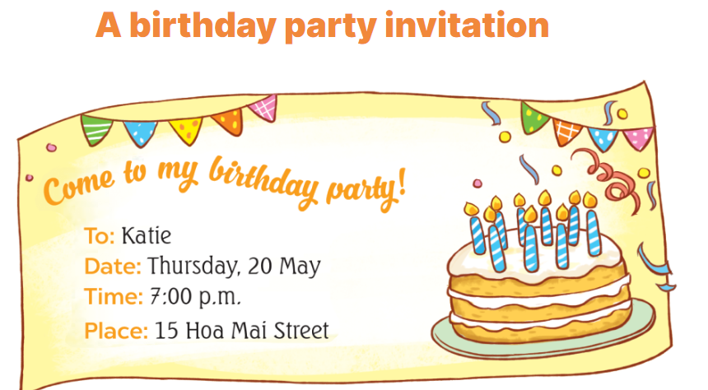  - Explain that they are going to show the birthday party invitations that they have made at home and tell the class about their birthdays.  - Have pupils work in groups of five.  + Each pupil shows his / her invitation and tells the group about his / her birthday  + Ex: My birthday’s in May.  - Invite some pupils to show their work and talk about their birthdays.  - Have pupils stick their invitations on the wall of the classroom as a display.  *Consolidation  *Aims: Ss will be able consolidate and wrap up the content of the lesson.  *Procedure:  - T asks ss to answer the following questions:  + What have you learnt from the lesson today?  +What are the core values of the lesson? (if the teacher can take from the lesson).  - T praises some Ss who are hardworking / active/ good…. as well as encourage others to try more.  4. Homework. (3’)  - Prepare the new lesson: Unit 5, Lesson 1 (1, 2, 3). | - Ss listen and chant  - Ss open their books  - Ss look at the letter and answer  -Ss read and pay attention  -SS read again and circle  -Ss swap books and check  -Ss write the correct answer  -Ss return the books to their partners  -Ss check their answer again.  -Ss pay attention  -Ss listen and asnwer  -Ss write  -Ss write about themselves  -Ss write about themselves  -Ss read the sentences they have completed.  -Ss listen  -Ss listen to the teacher  -Ss work in groups and talk  -Some Ss perfom in front of the class.  -Ss vote the best invitations  -Ss answer the questions  -Ss listen and clap their hands  -Ss listen and take note
D. ADJUSTMENTS (if necessary):
………………………………………………………………………………………….…..……………………………………………………………………………...

-----------------------------------------------------------------
Grade 5 : Lớp 5B : Chiều thứ hai, Ngày 21 tháng 10 năm 2024
ENGLISH
Unit 4: Our free-time activities
Lesson 2 (1, 2, 3)
A. OBJECTIVES:
By the end of the lesson, Ss will be able to:
1. Knowledge:

- understand and correctly repeat the sentences in two communicative contexts in which characters ask and answer questions about what someone does at the weekend;

- correctly say the words and use What do you do at the weekend? – I ____. to ask and answer questions about what someone does at the weekend

- use What do you do at the weekend? – I ______. in a freer context

- Vocabulary: always, usually, often, sometimes, rarely, never

- Structures:
A: What do you do at the weekend?
B: I usually listen to music.
- Skills: speaking and listening
2. Competences:
- Critical thinking and creativity: learn how to ask and answer questions about personal information correctly and fluently.
- Self-control and independent learning: perform speaking tasks.
3. Attitude/ Qualities:
- Explore new interests and develop a healthier and balanced lifestyle, then improve general well-being.
B. TEACHING AIDS:
- Teacher: Teacher’s guide Pages 66, 67, 68, audio Tracks 38, 39; website hoclieu.vn, posters, laptop, pictures, textbook, lesson plan, TV or projector.
- Students: Students’ book Page 30, notebooks, workbooks, school things.
C. PROCEDURES:
Teacher’s activities | Students’ activities
1.Warm- up and review: (3’)  Game: Slap the board  *Aims: to revise the vocabulary about different activities.  *Procedure:  - Prepare some flashcards about different activities and stick on the board  (play football, listen to music, read books, watch TV, clean the floor…)  - Divide class into 2 groups: Tom and Jerry.  - How to play:  + Each group chooses five Ss to play.  + Class will read aloud.  + Look at the picture, listen and slap the picture you heard.  + Who faster will get 1 mark.  + Which group with higher mark is the winner.  - Say “Open your book page 30” and look at “Unit 4, Lesson 2 (1,2,3)”.  2. Presentation (15’)  Activity 1. Vocabulary.  *Aims: Ss will be able to know the vocabulary in the new lesson.  *Procedure:  -T elicits the new words  + always : luôn luôn (explain)  + usually : thường thường (explain)  + often : hay, thường (explain)  + sometimes : thỉnh thoảng (explain)  - T models (3 times).  - T writes the words on the board.  - Checking: Matching  Activity 2. Look, listen and repeat:  *Aims: Ss will be able to understand and correctly repeat the sentences in two communicative contexts in which characters ask and answer questions about what someone does at the weekend.  *Procedure:  - Have Ss look at Pictures a and b and identify the characters and their activities. + Who is he/ she?  + Where is he/ she?  + What is he/ she doing in the picture?  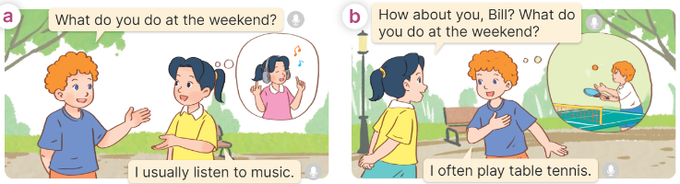  - Play the audio twice (sentence by sentence). Correct their pronunciation where necessary.  - Have Ss to practice the dialogue  - T invites a few pairs to the front of the class to practice.  - T checks pronunciation for ss.  Activity 3 Listen, point and say.  *Aims: Ss will be able to correctly say the words and use What do you do at the weekend? – I ____. to ask and answer questions about what they do at the weekend.  *Procedure:  * Structures:  - T asks Ss look at picture a and b in activity 1 and helps Ss know the structure from the dialogue.  - T introduces new structures for Ss.  - T explains, models and gives meaning.  - Have Ss repeat the structures  A: What do you do at the weekend  B: I usually listen to music.  3.Practice: (7’)  *Drill pictures  - Have Ss look at the pictures and identify the characters and their activities. 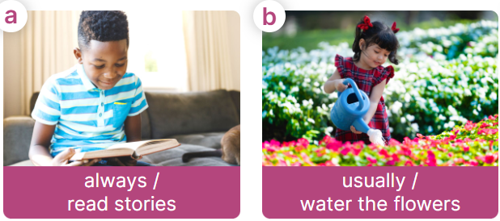  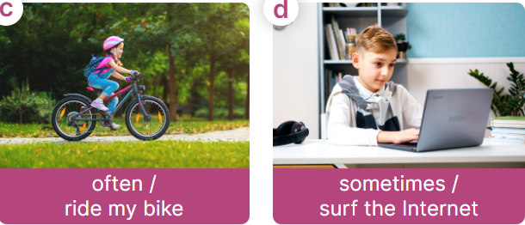  - Have Ss point at pictures, listen and run through all the pictures.  - Have Ss point at the bubbles, listen and run through model sentences.  - Have Ss to practise:  + T asks the first picture, Ss answer  + Ss asks the second picture, T answers  + Group A asks the third picture, group B  answers  + Group B asks the last picture, group A  - Ask Ss to work in pairs to practise asking and answering the What do you do at the weekend? - I _____.  - T controls and corrects.  - Invite a few pairs to point at the pictures and say the questions and answers in front of the class.  4. Production: (6’)  Activity 4. Let’s talk.  *Aims: Ss will be able to correctly use What do you do at the weekend? –_____. to ask and answer questions about what they do at the weekend in a freer context.  *Procedure:  - Ask Ss to look at the pictures and elicit the context  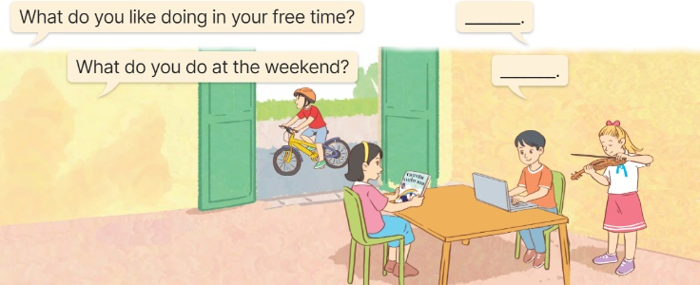  - Point at the ﬁrst building and elicit the question in the ﬁrst speech bubbl What do you like doing in your free time? and What do you do at the weekend? and the answer in the second speech bubble I like……… and I………. as an example.  - Give Ss time to work in pairs and take turns pointing at each picture to ask and answer using What do you like doing in your free time? - ………..  - Invite a few pairs to come to the front of the classroom and act out the exchanges.  5. Fun corner and wrap- up (4’)  Game: Lucky number  - Explain that Ss will play this game in three teams.  + There are six numbers, they have to choose the number and answer the free-time activity behind the number.  + If the answer is correct, their team can get the point. The number of candies behind the picture will be the points they get.  - Ask Ss to read all the words again. | -Ss listen and pay attention  - Ss listen to the teacher  -Ss play the game  .  -Ss continute playing the game  - Ss listen and open their books  -Ss listen and answer  - - Ss listen and repeat  + Choral repetition (3 times).  + Individual repetition (3 ss)  - Ss take note  - Ss look and match  -Look at the pictures and say.  + In picture a:  Bill: What do you do at the weekend?  Mai: I usually listen to music  + In picture b:  Mai: How about you, Bill? What do you do at the weekend?  Bill: I often play table tennis.  -Ss listen and repeat in chorus (twice)  -Ss work in pairs to practice  -Ss come to the front of the classroom to practice.  -Ss listen  - Ss look at the picture and answer.  -Ss listen  -Ss listen and repeat  -Ss repeat to the structures  - Ss look, listen and repeat  +Picture a: a boy reading a story and the words always / read stories underneath  + Picture b: a girl watering the flowers and the words usually / water the flowers underneath  + Picture c: a girl riding her bike in the park and the words often / ride my bike underneath  + Picture d: a boy surfing the Internet and the words sometimes / surf the Internet underneath  -Ss point at pictures, listen and repeat  -Ss point at the bubbles, listen and repeat  -Ss practice in chorus  -Ss practice in chorus  -Ss work in pairs to practise asking and answering the question  - Pairs of Ss point at the pictures and say in front of the class  -Ss look at the picture and say  - Ss look at the first building and elicit the missing words in speech bubbles and say the completed sentences.  - Ss role-play to practise asking and answering questions  - Ss practise asking and answering questions in front of the class.  -Ss listen to the teacher  -Ss play the game  -Ss read all the words again.
D. ADJUSTMENTS (if necessary):
………………………………………………………………………………………….…..……………………………………………………………………………...

------------------------------------------------------------
Grade 5 : Lớp 5B : Chiều thứ hai, Ngày 21 tháng 10 năm 2024
ENGLISH
Unit 4: Our free-time activities
Lesson 2 (4, 5, 6)
A. OBJECTIVES:
By the end of the lesson, Ss will be able to:
1. Knowledge:
- listen to and understand two communicative contexts about what someone does at the weekend and tick the correct pictures
- complete two gapped exchanges with the help of picture cues
- listen to and complete the song What do you like doing in your free time? and to sing it with the correct pronunciation, rhythm and melody.
- Vocabulary: Review
- Skills: speaking, listening, reading and writing.
2. Competences:
- Communication and collaboration: work in pairs and groups to complete the learning tasks.
3. Attitude/ Qualities:
- Explore new interests and develop healthier and balanced lifestyle, then improve general well-being.
B. TEACHING AIDS:
- Teacher: Teacher’s guide Pages 69, 70; audio Tracks 40, 41; website hoclieu.vn, posters, laptop, pictures, textbook, lesson plan, TV or projector.
- Students: Student’s book Page 31, notebooks, workbooks, school things.
C. PROCEDURES:
Teacher’s activities | Students’ activities
1.Warm- up and review: (5’)  Game: Lucky number  *Aims: to revise the learned words *Procedure:  - Divide the class into three teams.  - Have Ss take turns to choose a number.  - Ask Ss to look at the picture and say the activity.  - If the answer is correct, Teacher clicks the picture to open the hidden points.  - The team that gets more points wins. Praise the winner.  - Say “Open your book page 31” and look at “Unit 4, Lesson 2 (4,5,6)”.  2.Practice: (25’)  Activity 1. Listen and tick:  *Aims: Ss will be able to listen to and understand two communicative contexts about what someone does at the weekend and tick the correct pictures.  *Procedure:  - Ask questions to help Ss identify the characters and their free-time activities.  + What’s he/she doing?  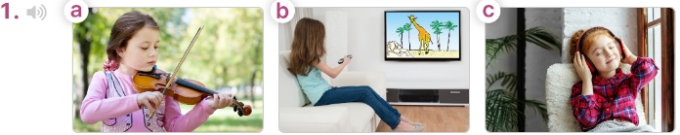    - T ask Ss to guess the answers.  + T writes Ss’guessing on the board.  - Listen to the tape:  + Play the recording  + Play the recording again for pupils to do the task.  + Play the recording a third time for pupils to check their answers.  - Get Ss to swap books with their partner, then check answers as a class.  + Write the answers on the board for Ss to correct their answers. Then checks Ss’ guessing.  - If time allows, play the recording, sentence by sentence, for Ss to listen and repeat individually and in chorus Key: 1. b 2. a  Activity 2. Read and complete  *Aims: Ss will be able to complete two gapped exchanges with the help of picture cues.  *Procedure:  - Have Ss look at the pictures and identify the activities of the characters in the pictures.  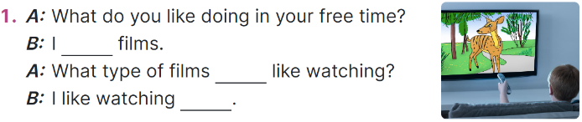  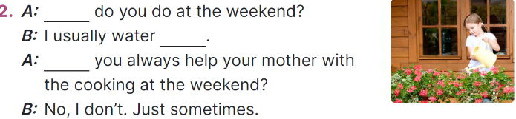  -Model sentences: have Ss read the question and ask what words are missing (like watching)  - Give Ss a time limit to read the gapped dialogues, look at the pictures and do the task independently.  - Get Ss to swap books with a partner and check their answers before checking as a class.  + Invite one student to write the answers on the board.  - Invite two pairs of Ss to act out the completed dialogues.  Key: 1. like watching; do you; cartoons  2. What; the flowers; Do  Activity 3. Listen, complete and sing  *Aims: Ss will be able to listen to and complete the song What do you like doing in your free time? and to sing it with the correct pronunciation, rhythm and melody.  *Procedure:  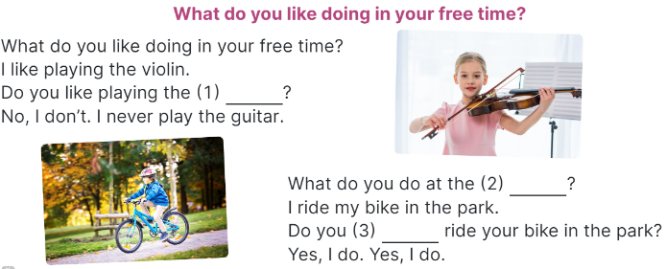  - Draw Ss’ attention to the gapped sentences.  - Play the recording the whole song.  + Then play the recording again to fill in the gaps with missing words.  - Check answers as a class.  + Play the recording line by line for Ss to listen and repeat.  - Play the recording all the way through for Ss to sing along and clap along with the recording.  3. Fun corner and wrap- up (5’)  Game: The football game  - Divide the class into 3 teams.  - Tell Ss that they are going to play football.  - Ss take turns to choose a number, read the question and say the answer.  - If the answer is correct, they will get points for their teams.  - If not, move to another team.  - The group with more points wins the game. | -Ss listen to the teacher  -Ss play the game  - Ss open their books  -Look at the pictures and say:  + Picture 1a: a girl playing the violin + Picture 1b: a girl watching a cartoon on TV  + Picture 1c: a girl listening to music + Picture 2a: a boy surfing the net  + Picture 2b: a boy roller skating in the park  + Picture 2c: a boy playing football  -Ss guess the answers  - Ss listen to the tape  - Ss listen again and do the task.  - Ss listen and check their answers  - Ss swap books with their partner, then check answers as a class and guessing  -Ss write the answer on the board  -Ss listen and repeat  -Ss look at the picture and say  -Ss follow the teacher  - Ss do the task independently.  - Ss swap books with a partner and check their answers.  - Ss write the answers on the board  - Pairs of Ss read the completed dialogues aloud  - Ss guess the missing words  - Ss listen all the way through carefully to the rhythm and pronunciation.  - Ss listen again and fill in the gaps  - Ss listen to the recording, line by line, and repeat.  - Ss listen and sing along  -Ss listen to the teacher  - Ss play the game.  - Ss praise the winner.
D. ADJUSTMENTS (if necessary):
………………………………………………………………………………………….…..……………………………………………………………………………...…..…
---------------------------------------
Grade 5 : Lớp 5B : Chiều thứ ba, Ngày 22 tháng 10 năm 2024
ENGLISH
Unit 4: Our free-time activities
Lesson 3 (1, 2, 3)
A. OBJECTIVES:
By the end of the lesson, Ss will be able to:
1. Knowledge:
- correctly pronounce the two-syllable words ꞌalways and ꞌsometimes with the stress on the first syllable, in isolation and in the sentences I ꞌalways listen to music. and She ꞌsometimes plays the violin.
- identify the stress on some two-syllable words and circle the word with a different stress pattern from the other two words
- say the chant with the correct pronunciation, word stress and rhythm.
- Vocabulary: Review
- Skills: speaking, listening, reading and writing.
2. Competences:
- Communication and collaboration: work in pairs and groups to complete the learning tasks.
- Self-control and independent learning: perform pronunciation and listening tasks.
3. Attitude/ Qualities:
- Explore new interests and develop healthier and balanced lifestyle, then improve general well-being.
B. TEACHING AIDS:
- Teacher: Teacher’s guide Pages 71, 72, 73; audio Tracks 42, 43, 44; website hoclieu.vn, posters, laptop, pictures, textbook, lesson plan, TV or projector.
- Students: Students’ book Page 32, notebooks, workbooks, school things.
C. PROCEDURES:
Teacher’s activities | Students’ activities
1.Warm- up and review: (5’)  Chatting  *Aims: to revise the words about someone’s appearance and personality  *Procedure:  - Place different pictures of free time activities on the board.  - Have Ss say the words related to the pictures.  - Tell Ss they are going to ask and answer the question about someone’s free-time activities in a freer context.  - Invite pairs of volunteers to the board. One asks the question, another one answers the question and points to the suitable picture.  - Continue until practicing all the vocabulary set. Praise Ss if they perform well.  - Say “Open your book page 32” and look at “Unit 4, Lesson 3 (1,2,3)”.  2. Presentation (9’)  Activity 1. Listen and repeat:  *Aims: Ss will be able correctly pronounce the two-syllable words ꞌalways and ꞌsometimes with the stress on the first syllable, in isolation and in the sentences I ꞌalways listen to music. and She ꞌsometimes plays the violin.  *Procedure:  - Have Ss point at the words ꞌalways and ꞌsometimes with the stress on the first syllable, in isolation and in the sentences I ꞌalways listen to music. and She ꞌsometimes plays the violin.  - Play the recording for Ss to listen and repeat in chorus and individually until they feel confident.  - Let Ss work in pairs or groups, saying the words and reading the sentences.  - T invites some Ss to practice.  3.Practice: (17’)  Activity 2. Circle, listen and check.  *Aims: Ss will be able to identify the stress on some two-syllable words and circle the word with a different stress pattern from the other two words.  *Procedure:  - Tell Ss circle the word having a different stress from each line. Then listen to the recording to check their answers.  - Set a time for Ss to do the task.  - Play the recording, once or twice, for Ss to listen and check their answers.  - Get Ss to swap books with a partner and check their answers before checking as a class.  - Play the recording again for Ss to double-check their answers.  - Invite a few Ss to read aloud all the words in the words.  Key: 1. c 2. b 3. b  Activity 3. Let’s chant  *Aims: Ss will be able to say the chant with the correct pronunciation, word stress and rhythm.  *Procedure:  - Introduce the title and lyrics of the chant.  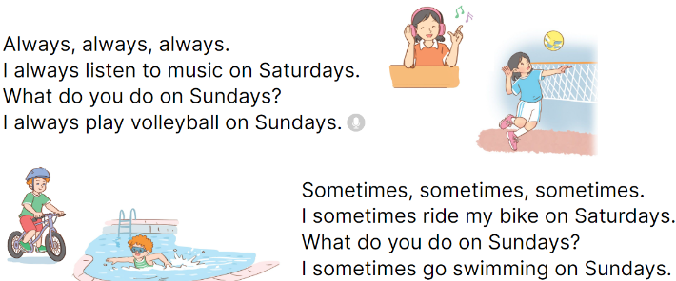  - Play the recording for Ss to listen to the whole chant.  + Have them repeat the title and lyrics line by line.  + Ask Ss to attend to two-syllable words with the stress on the first syllable in the chant, always and sometimes.  - Play the recording all the way through for Ss to listen to pronunciation and melody.  - Play the recording line by line for Ss to listen and repeat  - Play the recording for Ss to chant and clap along.  - Ask Ss to practice chant and clap along in pairs or groups.  - Invite groups to the front of the classroom to perform the chant  3. Fun corner and wrap- up (4’)  Game: Jump  - Flash cards (football, table tennis, Japan, England, dolphin, giraffe)  - Tell Ss they are going to play the game Jump. If the word is the same as the flash card, Ss jump. If it isn’t, they keep still. Ask them to say the word on the flash card.  - Ask Ss to stand at their desks.  - Hold up a flash card from the vocabulary set and say a word.  - Raise all the flash cards for Ss to say the words. | - Follow the T’s instructions.  -Ss pay attention and say  Ex:  A: What do you like doing in your free time?  B: I like playing badinton.  - Ss open their books  - - Ss point and pay attention  - Ss listen to the recording again and repeat.  -Ss work in pairs and practice  -Ss say the words and sentences  - Ss pay and listen to the teacher’s explanation.  - Ss do the task  - Ss listen to the recording to check their answers (individual)  - Ss swap books with a partner and check the answers  - Ss listen to the recording again and check their answers again.  - Ss stand up and read aloud the words.  - Ss look and listen.  - Ss listen to the chant  - Ss listen and repeat line by line without clap their hands  - Ss note the rhythm and pronunciation.  -Ss listen to melody of the chant  - Ss listen and chant line by line.  - Ss chant and clap along.  - Ss work in groups (two groups) to chant  -Ss perform in front of the class.  -Ss listen  -Ss play the game  -Ss read the words
D. ADJUSTMENTS (if necessary):
………………………………………………………………………………………….…..……………………………………………………………………………...……

---------------------------------------------------------------
Grade 5 : Lớp 5B : Chiều thứ ba, Ngày 22 tháng 10 năm 2024
ENGLISH
Unit 4: Our free-time activities
Lesson 3 (4, 5, 6)
A. OBJECTIVES:
By the end of the lesson, Ss will be able to:
1. Knowledge:
- read and show understanding of a text by answering four questions about Laura’s free-time activities at the weekend
- complete a letter to a penfriend about someone’s free-time activities at the weekend by writing the target words in the gaps using picture cues
- present their free-time activities to the class.
- Vocabulary: Review
- Skills: speaking, listening, reading and writing.
2. Competences:
- Communication and collaboration: work in pairs and groups to complete the learning tasks.
- Self-control and independent learning: perform reading and writing tasks.
3. Attitude/ Qualities:
- Show their love and interest in leisure activities and entertainment
B. TEACHING AIDS:
- Teacher: Teacher’s guide Pages 72, 73, 74; website hoclieu.vn, posters, laptop, pictures, textbook, lesson plan, TV or projector.
- Students: Pupil’s book Page 33, notebooks, workbooks, school things.
C. PROCEDURES:
Teacher’s activities | Students’ activities
1.Warm- up and review: (5’)  Game: Spin the wheel  *Aims: to revise the new words and structures from previous lessons.  *Procedure:  - Tell Ss they are going to look at the pictures and answer the questions.  - Divide the class into 3 teams.  - Ss take turns to choose a number and answer the question.  - Check the Ss’ answers as a whole class.  - If they give the correct answers, they can spin the wheel to get points.  - The team with the most points will be the winner.  - Say “Open your book page 33” and look at “Unit 4, Lesson 3 (4,5,6)”.  2.Practice: (8’)  Activity 1. Read and answer:  *Aims: Ss will be able to read and show understanding of a text by answering four questions about Laura’s free-time activities at the weekend  *Procedure:  - Have Ss read the questions carefully and tell ss to read Question 1 and identify the keywords (She always plays the violin).  - Explain the type of information they need for each answer.  - Set a time limit for Ss to do the task independently.  - Get Ss to swap books with a partner and check the answers before checking  as a class.  - Invite some pairs to take turns asking and answering the questions.  - Ask Ss some more questions to check their comprehension of the text.  Ex: Who likes listening to music?  Does she like playing sports and games?  What does she help her mother do?  Key:  1. She always plays the violin (at the weekend).  2. She usually plays volleyball (on Saturdays).  3. She often goes for a walk on Sundays.  4. She helps her mother with the cooking on Sundays.  3.Production: (18’)  Activity 2. Let’s write  *Aims: Ss will be able to complete a letter to a penfriend about someone’s free-time activities at the weekend by writing the target words in the gaps using picture cues.  *Procedure:  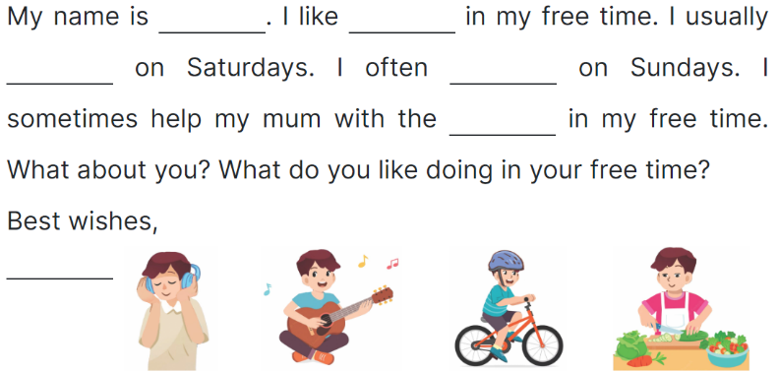  - Ask Ss to read the gapped letter and explain that they need to fill in the gaps with information about the boy in the pictures’ free-time activities.  - Have Ss complete the first, second and third gaps with names and an activity of their choice from the pictures.  - Give Ss time to complete the rest of the letter independently.  - Get Ss to swap their books with a partner and check each other’s spelling  before checking as a class.  Key: Pupil’s answer  Ex:  Hi Kitty,  My name is Hoang. I like listening to music in my free time. I usually play the guitar on Saturdays. I often ride my bike on Sundays. I sometimes help my mum with the cooking in my free time. What about you? What do you like doing in your free time?  Love,  Hoang  Activity 3. Project.  *Aims: Ss will be able to present their free-time activities to the class.  *Procedure:  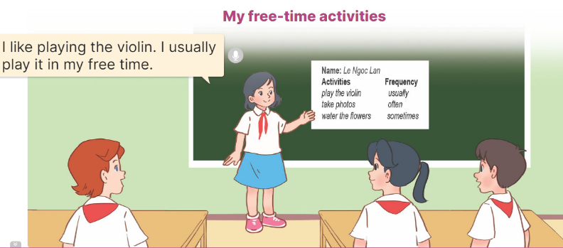  - Tell Ss about the goal of the activity.  - Have Ss work in groups. Each student looks at their lists and tells the group about their free-time activities.  - Invite a few ss to look at their lists and tell the class about them, ex: I like playing the guitar. I usually play it in my free time.  -T gives feedback  4. Fun corner and wrap- up (4’)  Game: Slap the board  - Divide the class into two or three teams.  - Teacher puts up a set of pictures or words on a board.  - A student from each team comes up to the board with fly swatters.  - They listen as the teacher calls out a word or a sentence and they race to slap the correct picture.  - Whoever is the fastest with the correct slap gets a point for their team.  - Team with the most points is the winner. | - Ss listen  - Ss listen to the rules  -Ss play game  - Ss open their books  - Ss read Question 1 and pay attention to keywords  - Ss read and answer question 2,3,4  - Ss read the text again and write the correct answers.  - Ss swap books and check answers  - Ss ask and answer the questions.  - Ss answer the questions.  - Ss listen to the teacher  - Ss complete the first, second and third gaps with names and an activity  - Ss complete the rest of the letter independently.  - Ss swap their and check  - Ss listen to the teacher  - Ss work in groups of five.  - Ss show their work and talk about their free-time activities in front of the class.  - Ss listen  -Ss listen to the teacher  -Ss play the game  -Ss congratulate the winner
D. ADJUSTMENTS (if necessary):
………………………………………………………………………………………….…..………………………………………………………………………

Duyệt bài, Ngày 18 tháng 10 năm 2024
Phó hiệu trưởng

Nguyễn Thị Hằng

