WEEK 30
Wedsnesday, April 16th 2025 Class: 5B English
Unit 11: Animals
Lesson 3: 4,5,6
I. OBJECTIVES:
1. Knowledge:
- Grammar: the adverb “ really”, the position of “really” in sentences.
2. Competences:
By the end of the lesson, students will be able to:
- use the adverb: “really” in the sentences
- talk about their favourite animals using the adverb “really”.
3. Qualities:
- Students use the adverb “really” accurately.
- Students know the correct position of ‘really” in sentences.
II. EQUIPMENT AND MATERIALS:
- Basic things: Student’s book, flashcards, photos.
- Advanced things: PPT, laptop, TV.
III. LESSON PROCEDURE:
Activity 1: Warm-up
Activity 2: Presentation
Activity 3: Practice
Activity 4: Production
Activity 5: Wrap-up & Assessment
Activity 1: Warm-up (5 minutes)
A guessing game “ At the laundry ?”
Aims: Warm up the class with an “At the laundry” game using some vocabulary such as butterfly, lizard, flamingo, peacock and lead in the new lesson.
Teacher’s Activities | Students’ Activities
Procedure
1. Greet students. Chatting…  “Do you like playing games?”  2. Introduce the game:  - Ask Ss to play the “At the laundry” game to revise the vocabulary.  - T shows the questions and pictures.  - Let Ss guess what animal it is and answer the question on time.  - If they have the correct answer, they can roll the dice to get stars.  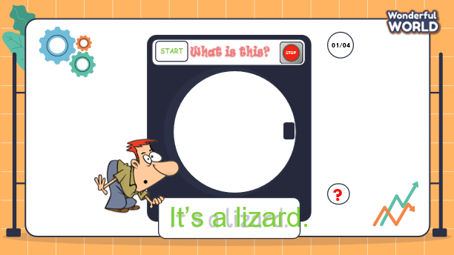  -“The teacher will show some questions and pictures. You can guess what animal it is. If you have the correct answer, you can roll the dice to get stars.”  - Let students join the game and lead in the topic and write it down on the board.  3. Play the game:  - 4 turns to play using 4 words/flashcards: lizard, flamingo, butterfly, peacock.  4. Lead in the new lesson:  Unit 11 – Lesson 3 parts 4,5,6 | - Greet Teacher  - Ss answers: “Yes”  - Join the activity.  - Look at the question and guess about the animal.  - Give the correct answers.  - Ss roll the dice to get stars if they have correct answers.
Activity 2: Presentation (10 minutes)
a. Aims:- Ss understand the meaning and pronounce correctly new structures using really.
- Finish part 4 – listen and read.
b. Procedure
Teacher’s Activities |  | Students’ Activities
Lead in: Let Ss join the “Good Delivery” game to learn about the new structure. (4’)  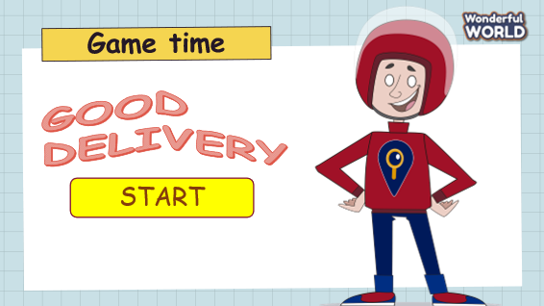  - T shows Ss a picture with some letters given.  - Ask them to look at the pictures and reorder the given letters to make the correct words.  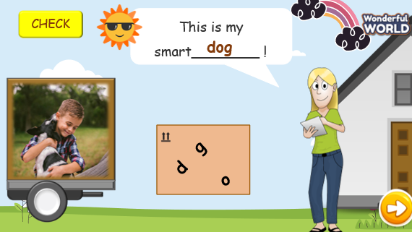  “Look at the pictures and reorder the given letters to make correct words to fill in the blank.”  “If you have correct answers, you can through the dart to get stars.”  - After participating in the game, Ss can guess what grammar they have learnt.  - Show Ss the structures and let them write them down in their notebooks.  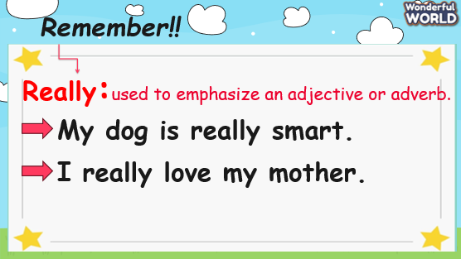  Part 4. Listen and circle(6’)  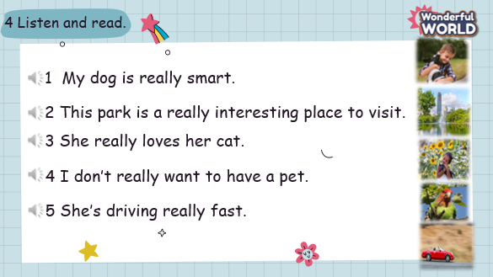  - Show the pictures and sentences on the screen.  - Tell students to look at the photo and say what they can see.  What can you see?  - Ask students to look at the first sentence. Read the sentence.  - Listen to the recording and repeat.  - Have Ss work in pairs and take turns to practice reading each sentence.  -Call some Ss to read each sentence out aloud and check their pronunciation. |  | - Ss participate in the game.  - Raise your hand and reorder the letters.  - Answer the questions and through the dart to get stars.  - Guess what structure that we learn.  - Read the structures a loud.  - Write the new structures on their notebooks.  - Look at the picture and answer the question:  I can a dog, a park, and a girl holding a cat, ….  - Look at the first sentence, listen, and read aloud  - Ss listen and read individually and in pairs.  - Then, some Ss come to the board and read out aloud.  - Others can check their pronunciation.
Activity 3: Practice – Controlled practice (10 minutes)
a. Aims: - Ss can practice using really through writing skills.
- Finish task 5 – Find and correct a mistake in each sentence.
b. Procedure
Teacher’s Activities |  | Students’ Activities
- Let’s Ss participate in the “Catch a butterfly” game to learn about how to use really.  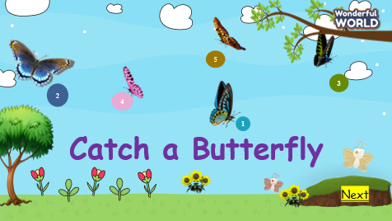  - T asks Ss to look at pictures and numbers. They can choose the numbers, and answer the questions.  - If they have the correct answer, they can get some different stars.  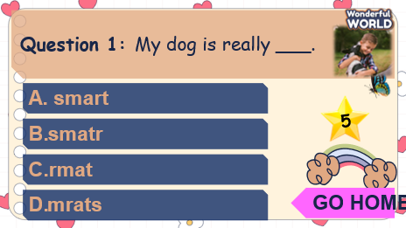  Answers: 1. A 2.D 3. B 4.A 5. C  Part 5. Find and correct a mistake  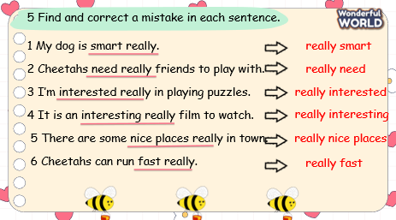  - Ask Ss to look at sentence 1 and read it carefully.  - Tell Ss that they are going to find out a mistake in each sentence.  - Give them 1 minute to underline a mistake and correct it.  - Demonstrate sentence 1 as an example.  - Give Ss 5 minutes to do the rest of the task.  - Call 5 Ss to share the answers and check them with the whole class.  - Have Ss say aloud each sentence individually and in groups. |  | - Ss join the game.  - Some Ss raise their hands and answer the questions.  - Ss having correct answers will have different stars.  Answers: 1. A 2.D 3. B 4.A 5. C  - Look at sentence 1 and read it carefully.  - Find out the mistake and correct it.  - Check the result.  - Do the rest of the task in 5 minutes  - Some Ss read their answers.  - Ss read sentences individually and in groups.
Activity 4: Production – Free practice (6 minutes)
a. Aims: Apply the grammar to present in front of the class to discuss and make sentences using new structure: Let’s do smt!
Encourage sts to answer and make full sentences using the new structure.
b. Procedure
Teacher’s Activities |  | Students’ Activities
Task 6: Point and say  - T shows the pictures and asks Ss what can they see in each picture.  What animal can you see in these pictures?  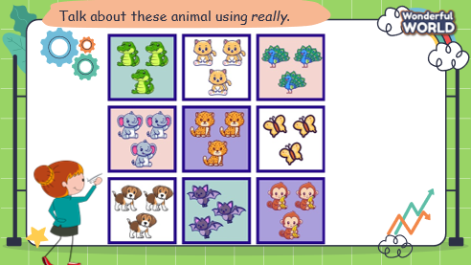  - Tell Ss to look at the picture and make the sentences using really.  - Explain how they will use hand gestures for rock-paper-scissors.  The winner will have a move and can choose one square to make the sentence with “I like … because they are really…”  - Cross out the square when they have finished the sentences.  - The one who can finish making all the sentences with all the squares is the winner.  - Have Ss play the game in pairs.  - Call some pairs to the board and read about their sentences.  - Check their pronunciation. Discuss any challenging words and reinforce correct spelling and pronunciation. |  | - Sts look at the picture and answer the questions about what they can see.  I can see some peacocks, cats, dogs, elephants, butterflies, monkeys….  - Watch the examples, and read the sentences.  - Make their sentences using the structure with really.  - Work in pairs to find out the winners.  - Some pairs come to the board and say aloud their sentences.  - Check their friend’s pronunciation.
Activity 5: Wrap up & Assessment (4 minutes)
Teacher’s Activities |  | Students’ Activities
a, Aims:
- Check students’s understanding of what they have learned.
- Students rehearse what they have learned in the lesson.
Asks sts to do the assessment.  - T gives the assessment to the class and some Ss can answer them.  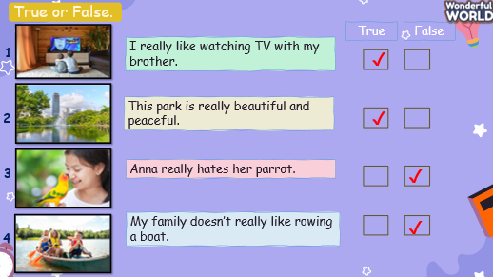  - Check with the class.  - Wrap-up  * Remember  VOCABULARY  really, interest, peacocks, dogs  STRUCTURE  - I like …. because I really …. |  | - Do the assessment.  - Check with the teacher  - Sts read the wrap-up  - Stand up and say goodbye to the teacher.

