WEEK 28
Wednesday, April 2nd 2025 Class : 3B
English
Unit 9: My favourite food
Lesson 3: 7,8,9
I. OBJECTIVES:
1. Knowledge:
Students will learn the phonic /dr/ and /br/ in the words and revise the words related to the topic Food.
2. Competences:
- English competences: Students will be able to listen and pronounce the sound separately and in words correctly
- Common competences: Students will have an opportunity to develop the solving problem skill in doing the tasks and the creativeness in chant.
3. Qualities:
- Students are given opportunities to think about good and favourite food
II. EQUIPMENT AND MATERIALS:
- Basic things: Student’s books, flashcards, crayons.
- Advanced things: PPT, projector/interactive whiteboard/laptop/TV.
III. LESSON PROCEDURE:
Activity 1: Warm-up (5 minutes)
Teacher’s activities | Student’s activities
- Greet students  Game: Finding the way home.  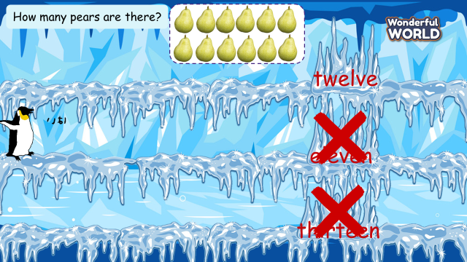  (Set the context: A penguin lost his way. There are 8 questions, each question has 3 answers  Students choose the correct answer to help the penguin find the right way home)  - Tell students how to play the game  - Do as a model  - Ask students to choose the missing letters.  1 How many pears are there?  A. twelve B. eleven C thirteen  2 What can you do?  A. cook B. swim C draw  3 How many tomatoes are there?  A. fifteen B. twenty C thirteen  4. Who’s this?  A. teacher B. brother C grandpa  5. What’s this?  A. dress B. shorts C t-shirt  6. What can you do?  A. dance B. eat C. drink  7. What’s this?  A. pizza B. bread C cheese | - Greet teacher  -Listen  -Look and play with the teacher  - Look and choose the missing letter  1. A. twelve  2. C. draw  3. B twenty  4.B. brother  5. A. dress  6. C. drink  7. B. bread
Activity 2: Presentation (8 minutes)
Teacher’s activities | Student’s activities
Lead-in: Use some words (brother, drink, dress, draw, bread..) in the previous game to lead in the sound /dr/, /br/  Task 7: Listen and repeat. (Track 9.12)  - Play the recording and tell students how to pronounce the sound /dr/, / br/, pronounce the sound /dr/ in the word drink, / br / in the word bread and in the sentence I’m drinking juice and eating bread.  - Play the recording again. Tell students to repeat the words and sounds (whole class, in groups and individually).  - Ask some volunteers to perform in front of the whole class.  - Checking: “Let’s dance” game  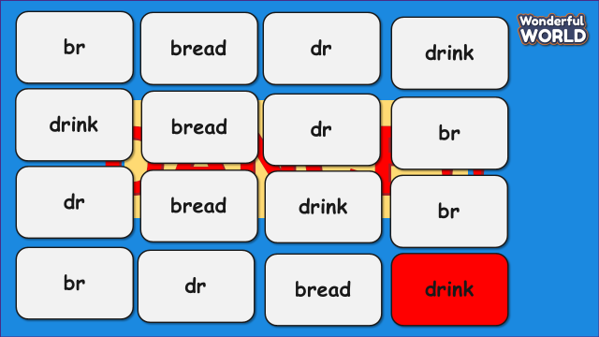  + Students must take turns reading the words (bread, drink) or sound /dr/ /br/ in order.  + Each time a student can choose to say in 1 square or 2 squares  + The student who says the last word must dance. | - Learn to pronounce the sound /dr/, /br /  - Listen and repeat  - Perform in front of the whole class.  - Join in the game
Activity 3: Practice (12 minutes)
Teacher’s activities | Student’s activities
Task 8: Listen and chant. (Track 9.13)  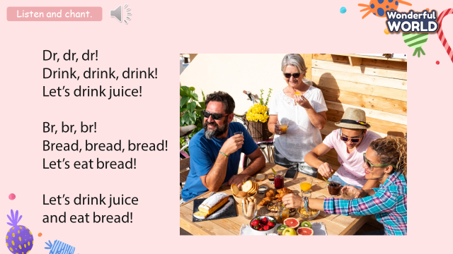  - Play the recording and tell students to listen and follow the words with their fingers.  - Read out the chant one line at a time and ask students to repeat it after the teacher.  - Play the recording again. Encourage students to chant along. Practice several times until students are familiar with the words and sounds.  - Ask one team to make the beat by clapping hands, the team has to follow the beat to chant.  - Ask some volunteers to chant in front of the class.  Task 9: Say it!  - Show three pictures and ask some questions:  1 What is she doing?  2 What can he do?  3 What is he doing?  - Ask students to look at the sentences. Tell them to pay attention to the sounds /dr/ and /br/ in each word.  - Read out the words with /dr/ and /br/ and ask students to repeat them.  - Ask students to work in pairs and say the sentences, paying attention to the correct pronunciation of /dr/ and /br/  - Ask volunteers to say the sentences in front of the class. | - Listen and follow the words with their fingers.  - Listen and repeat after the teacher  - Listen and practice the chants  - One team makes the beat by clap hands and another team have to follow the beat to chant.  - Look and answer:  1 She is drawing a picture  2 He can play the drums  3 He is drinking juice  - Look  - Listen and repeat  - Say the sentences in pairs  - Perform in front of the class.
Activity 4: Production (7 minutes)
Teacher’s activities | Student’s activities
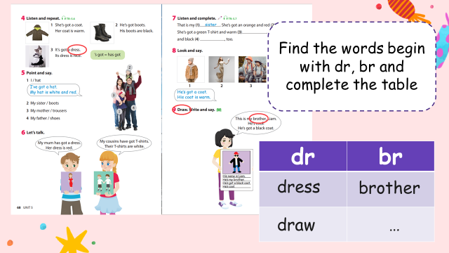  - Divide the class into 8 groups.  - Ask students to open the book and find all the words that begin with the sound /dr/, /br/ in the book.  - Ask students to complete the table and show their work in front of the class. | - Sit in 8 groups.  - Make a survey.  - Perform in front of the class.
  dr | br
Activity 5: Assessment (3 minutes)
Teacher’s activities | Student’s activities
- Ask students to do the assessment.  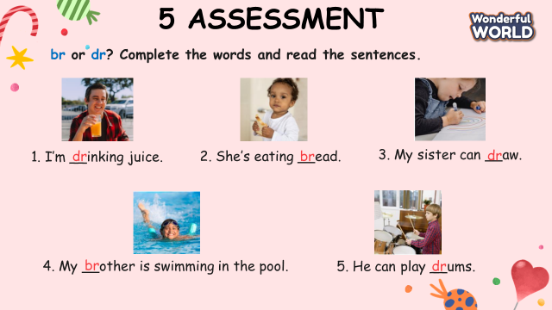  - Check in pair then whole class.  - Say goodbye. | - Do the assessment.  - Check with friends and then with the teacher and the whole class.  - Say goodbye.

