WEEK 26
Thursday, March 20th 2025 Class : 1B
Engish
Review 3- Self-check: 4,5,6
I. OBJECTIVES |  |  | By the end of the lesson, pupils will be able to:
- - recognize the words they have learnt.
- - read the words they have learnt.
- - write the letter to complete the words.
II. INPUT |  |  | Language:
- - Sounds /ɒ/ (letter o), /m/ (letter m), /ʌ/ (letter u), and /l/ (letter l)
- - Vocabulary:
clocks, locks, pots
monkey, mother, mouse
bus, running, sun, truck
lake, leaf, lemons
Resources/Material:
- - Student’s book p. 56
- - hoclieu.vn
- - Teacher’s guide pp. 136-138
- - Flashcards to play games
- - Computer, projector
III. PROCEDURE |  |  | Warm-up – Read and tick.– Find the words –  Write the letters – Homelink.
 | Procedure | Teaching and learning activities |  | Classroom management
 | Warm-up | 5 minutes
 |  | Option 1:  Have pupils sing the chants from Unit 9 and 12 to revise the words and structures they have learnt. If pupils do not remember the songs, play the recording for them to sing along.  Ask them what words appear in the songs. Stick the flashcards of the words on the board.  Option 2:  Have pupils play the game Slap the board to revise the sounds and words they learnt in previous units.  - Lead to Activity 4, Review 3. |  | Whole class  Individual work  Whole class
 | 4. Read and tick. 8 minutes
 | Step 1 | Have pupils look at the pictures (saying Look at the pictures, please!) and say what they can see. Draw pupils’ attention to the boxes  next to the letters a and b. |  | Whole class  Individual work
 | Step 2 | Ask pupils to look at the words in question 1. Model with this question. Invite one pupil to read the word and choose a or b. Confirm the correct answer. |  | Whole class  Individual work
 | Step 3 | Get pupils to read the word/phrases in other questions and tick the correct boxes, saying  Now read and tick the correct pictures, please! Give further support to those pupils who find it difficult to do the task. |  | Whole class  Individual work
 | Step 4 | Ask pupils to work in pairs and to swap their work, saying Now work in pairs and check each other’s answers. Give pupils time to work.  Go around and oﬀer help, if necessary. |  | Pair work
 | Step 5 | Invite some pupils to show what they have done. Praise them if they have done well.  Key:  1. b 2. a 3. a |  | Whole class work  Individual work
 | Extension: | Say aloud some words/phrases an  have pupils circle the suitable pictures. |  | Individual work
 | 5. Find the words. 8 minutes
 | Step 1 | Have pupils read the words around the table. Explain how to do the activity, saying Look at the words around the table, find and circle the words in the table using pencils. |  | Whole class
 | Step 2 | Model the first word. Have pupils look at the first word on the left, saying Look at the word bus, please! Ask them to find the word bus in the table and circle, saying Find and circle the word bus, please! |  | Whole class
 | Step 3 | Have pupils find other words in the wordsearch. Give further support to those pupils who find it difficult to do the task. |  | Individual work
 | Step 4 | Have pupils exchange their answers in pairs or in groups before checking as class. |  | Pair work
 | Step 5 | Invite some pupils to point to the words in the table and say them in front of the class.  KEY:  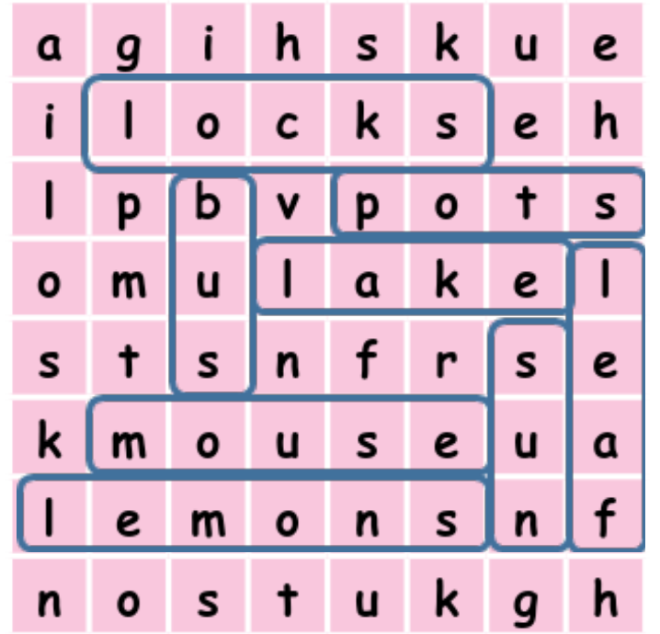 |  | Individual work
 | Extension: | Have pupils read the words aloud one more time and make a sentence with each word. |  | Individual work
 | 6. Write the letters. 9 minutes
 | Step 1 | Have pupils look at the picture. Draw pupils’ attention to the missing letters of the words next to the person/ things. |  | Whole class
 | Step 2 | Ask pupils to look at the sun and the incomplete word __un.  Model with this word so that pupils can understand how to complete the task. |  | Whole class
 | Step 3 | Have pupils look at the things/person and the incomplete words and complete the words. Give further support to those pupils who find it difcult to do the task. |  | Individual work
 | Step 4 | Ask pupils to swap their answers with other classmates. Then check the answers as a class. |  | Pair work
 | Step 5 | Invite some pupils to point at the picture and say the words they have completed. |  | Individual work
 | Extension: | Write a list of letters on the board (b, t, u, l, a, r, e, s, k…). Have pupils make words from the letters given. |  | Individual work  Whole class
 | Homelink 5 minutes
 |  | Option 1:  Write a chant with some sentences from Exercise 5 on the board and have pupils read them together.  E.g. Look at the bus.  Look at the truck.  That’s a lake.  ...Option 2:  Stick some flashcards on the board. Write some words on the board. Have pupils match.  - Tell pupils to practise saying the words and sentences at home. |  | Whole class  Individual work

