WEEK 25
Wedsnesday, March 12th 2025 Class: 5B
English
Unit 9: Holidays and Travel
Fun time and project: 1,2,3
I. OBJECTIVES:
1. Knowledge:
Students will be able to review all target vocabulary and structures of Unit 9 via some fun activities.
2. Competences:
- English competences: Students will be able to think and talk about topics.
- Common competences: Students will have the opportunity to develop logical thinking and develop communication among friends.
3. Qualities:
- Students develop an appreciation and understanding of what is important to their friends and other people they meet in the community.
- Be confident and active in communicating with friends and teachers.
II. EQUIPMENT AND MATERIALS:
- For Teacher: PPT, flashcards, printed papers, dice.
- For students: textbook
III. LESSON PROCEDURE:
Activity 1: Warm-up
Activity 2: Review
Activity 3: Practice
Activity 4: Project
Activity 5: Assessment

Activity 1: Warm-up (5 minutes)
“Let’s sing a song and do actions”
 | Teacher’s Activities | Students’ Activities
 | a. Aims: Welcome students. Engage the class with a song.
 | b. Procedure:  - Greet students. Chatting….. Do you like to sing?  - Play the song “ Hands in the air”.  - Demonstrate the TPR actions that go with the song  - Encourage Ss to do the actions and try to sing along. | - Greet Teacher.  - Let’s sing a song and do the actions.
Activity 2: Review (12 minutes)
Teacher’s Activities |  | Students’ Activities
a. Aims:
- Review the vocabulary of Unit 9 with the “Hangman” game.
- Review regular verbs and irregular verbs with the “Odd one out” game.
- Review asking questions in the past simply with the “Making question” game.
b. Procedure:  - Play game 1: Hangman in class  - Divide the class into 2 or 4 groups.  - Show the secret word with spaces for the number of letters in a word.  - Ask Ss to guess letters in the word alternating between the groups.  - If a letter in the word is guessed correctly, the T shows it in the correct space.  - If a letter is guessed that is not in the word, the T draws part of the man being hanged.  - The group that can guess the word first receives 3 points.  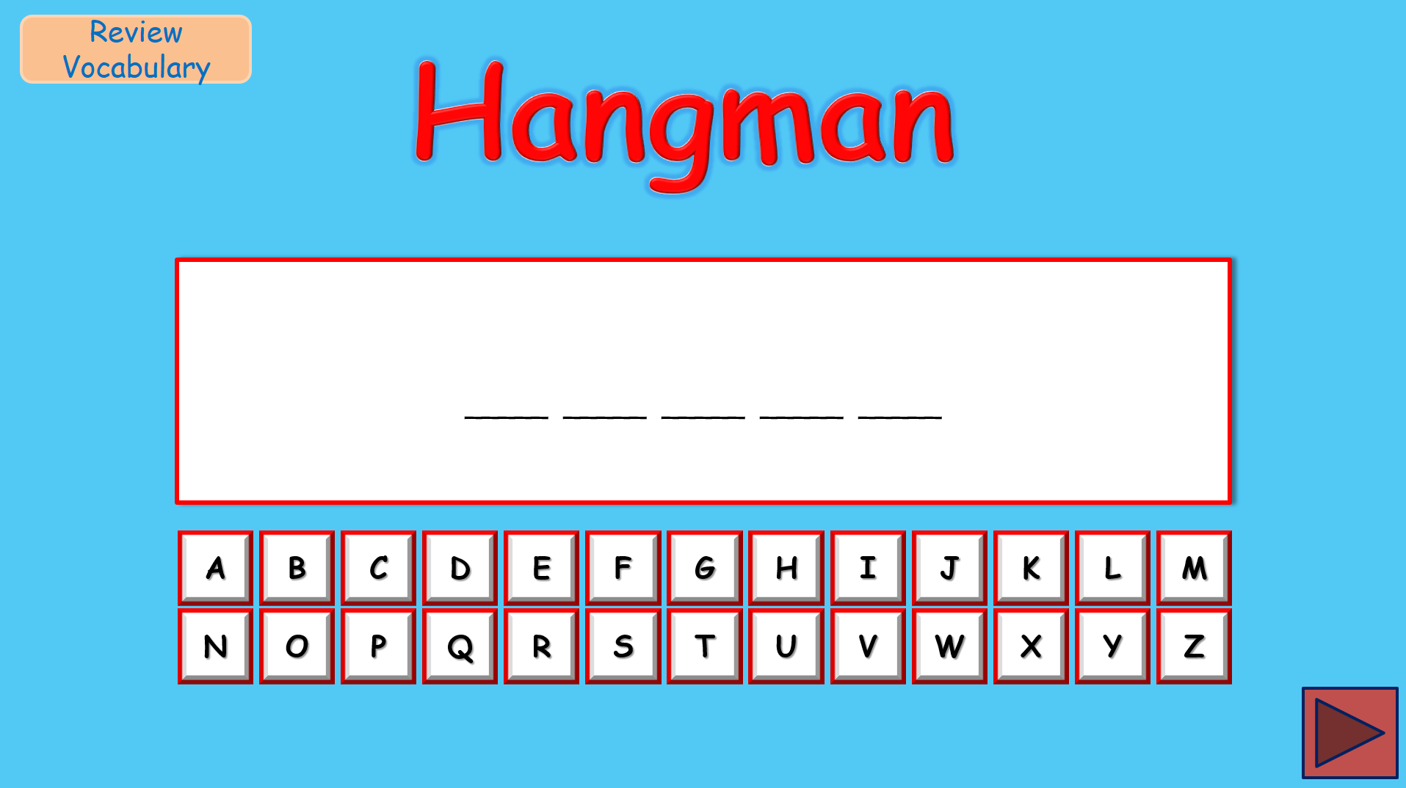  - Play game 2: Odd one out  - Divide the class into 2 or 4 groups.  - Ask Ss to choose a word that is different from three words.  - Read all the words carefully and find a connection before you choose the different word.  - After the player has successfully identified the odd one out, they can either guess the explanation or challenge their opponents to guess.  - Choosing the correct item would score two points and figuring out why it didn't belong by guessing the common bond of the other three or a successful challenge is worth three points more, for a total of five points.  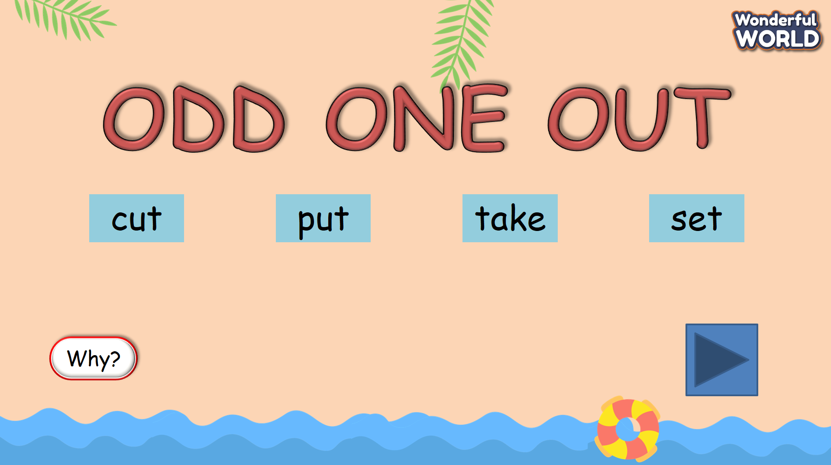  - Play game 3: Making question  - Divide the class into 2 groups.  - Ask Ss to choose a color and T opens it.  - Ask Ss to read the sentence carefully and the player has to ask a question in the past simple to suit the answer.  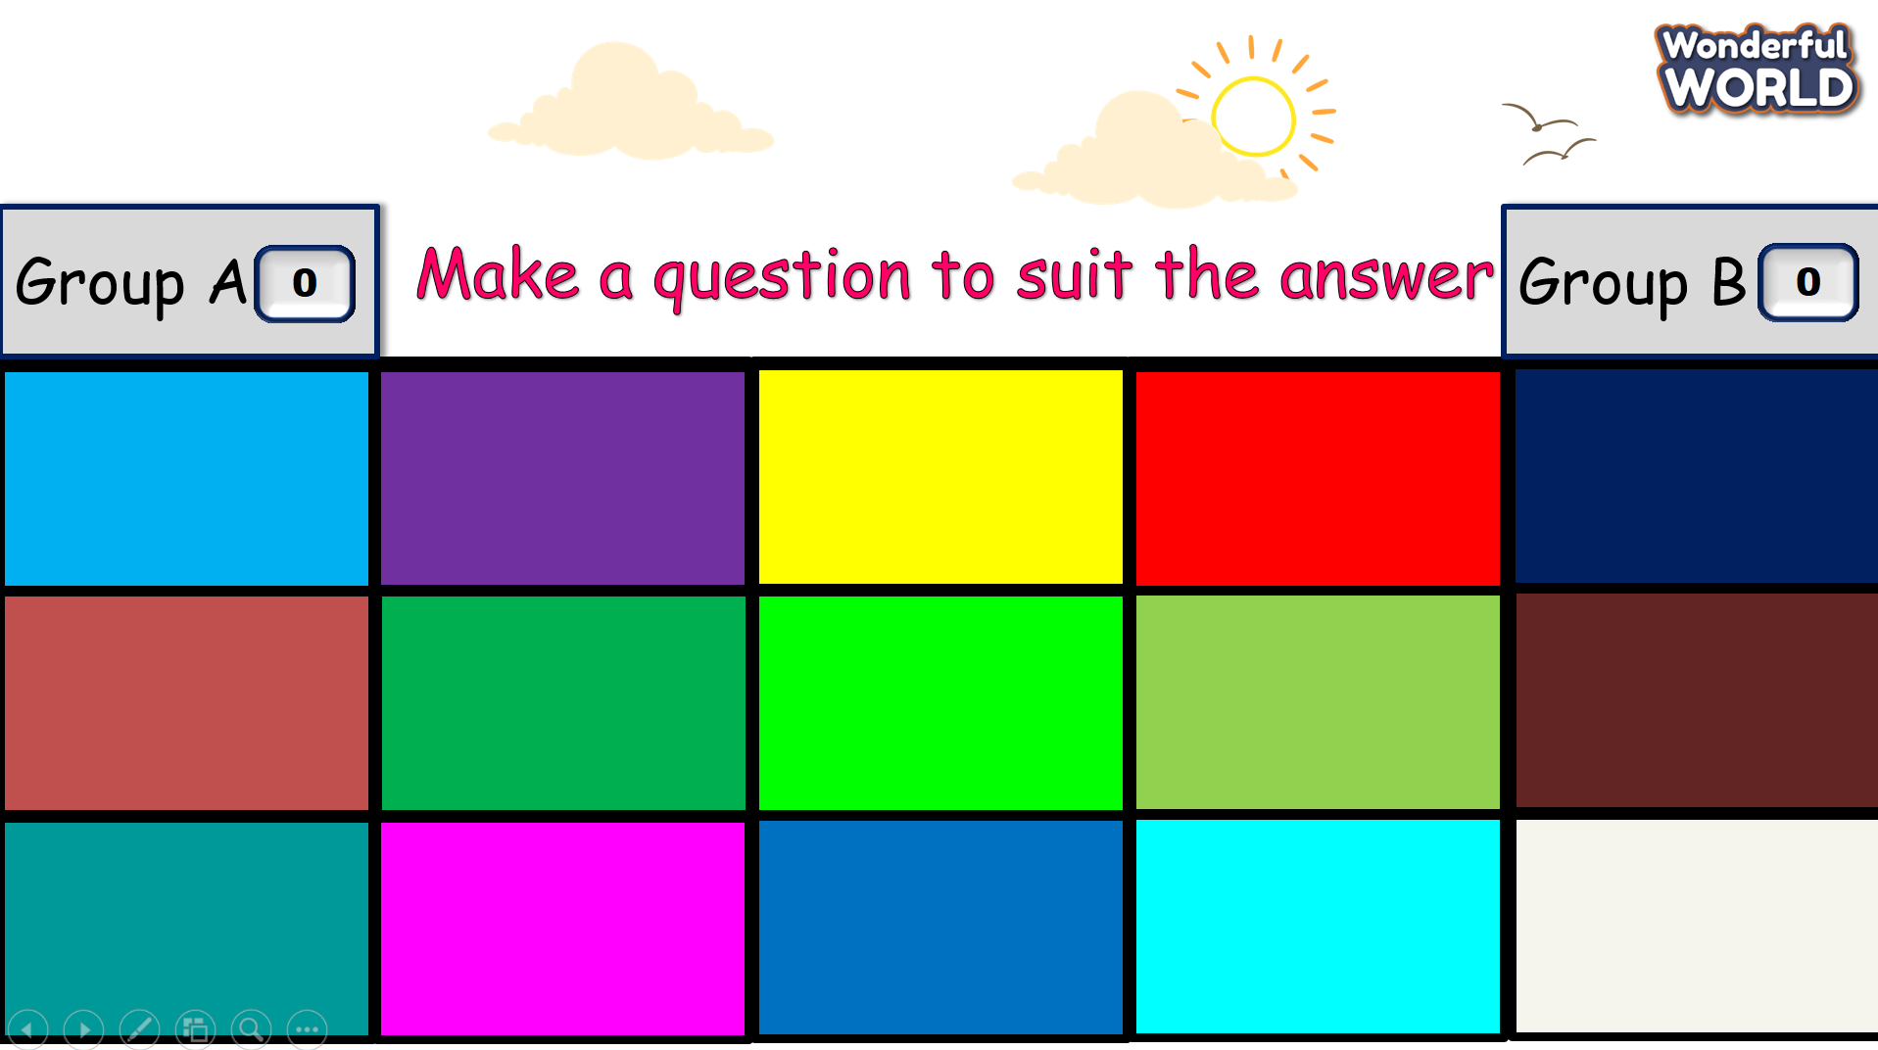 |  | - Look at the secret word and try to guess the correct letters.  - Read all the words carefully and choose the word that is different from the three words.  - Explain why it is different.  - Choose a color and ask a question in the past simple to suit the answer.
Activity 3: Practice – Controlled practice (5 minutes)
Teacher’s Activities |  | Students’ Activities
a. Aim:
Ss will be able to use the words and structures learned in the unit to complete the handout. Then report the results to the class.
b. Procedure:  Task 1: Find someone who …  - Tell students that they are going to do a Find someone who  activity.  - Show the handout on the screen.  - Make an example conversation with one student:  T: Did you watch a movie last night?  S: Yes, I did.  T: What movie did you watch?  S: I watched one of the Star Wars movies. I liked it very much.  - Tell students that they will ask their friends and then write  their friends’ names on the second column and extra  information on the third column.  - Give each student a handout.  - Tell students that they can go around and talk with  different classmates.  - Give students 10 minutes to do the task.  - After the time limit, ask some students to stand up and  report about what they found. |  | - Listen to the teacher.  - Ask their friends and then write your friends’ names in the second column and extra  information on the third column.  - Go around and talk with  different classmates.  - Stand up and share in front of the class.
Activity 4: Production (8 minutes)
Teacher’s Activities |  | Students’ Activities
a. Aim:
Ss will be able to develop students' English speaking skills.
b. Procedure:  Task 2: Let’s talk  - Ask students to look at Activity 1 again and tell them that they are going to practise talking.  - Model one example.  - Give students five to eight minutes to work in pairs.  - Call on some students to go to the board and talk aloud.  - Give feedback and check pronunciation if necessary. |  | - Work in pairs and talk about what Ss found in Activity 1.  - Go to the board and talk aloud.
Activity 5: Wrap up & Assessment (5 minutes)
Teacher’s Activities |  | Students’ Activities
a, Aims:
- Assess individuals or groups who have done the best in the lesson.
- Wrap up the activities Ss have done during the lesson.
Assessment:  Find and correct the mistakes below.  - Tell Ss that each of the sentences below has at least one mistake.  - Ask Ss to underline the mistakes and rewrite the correct answer.  - Check answers as a class.  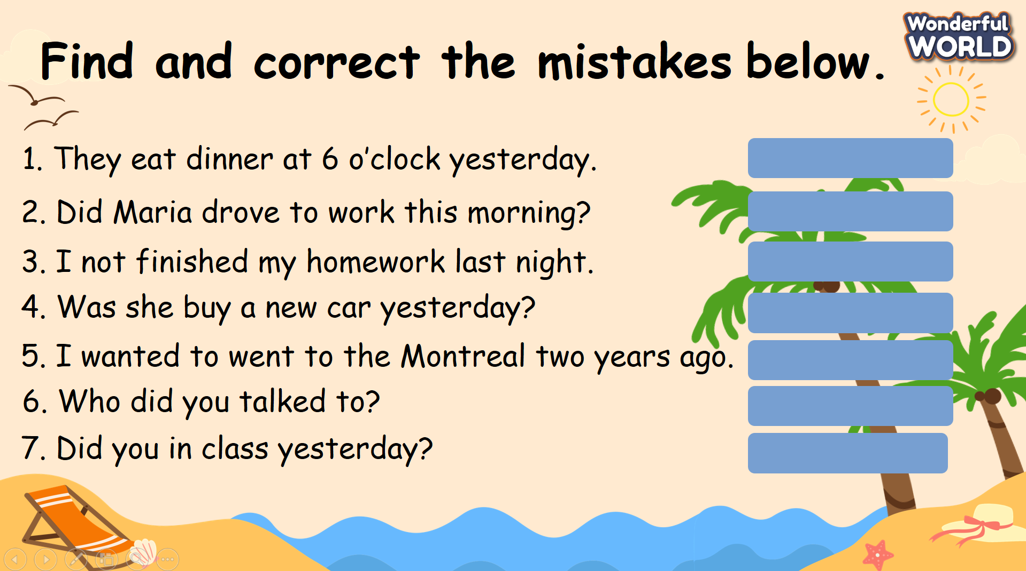  - Wrap-up: Ask Ss the question: “What have we learnt today?”  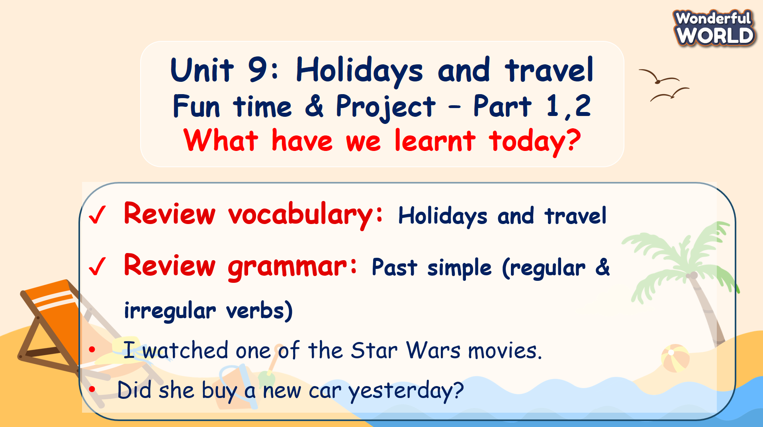 |  | - Join the activity.  - Stand up and say goodbye to the teacher.

