WEEK 23
Thursday, February 27th 2025 Class : 3A
English
Review 4 – Part 1
I. OBJECTIVES:
1. Knowledge:
By the end of the lesson, students will review the words related to the topic ability: read a book, watch TV, fly a kite, ride a bike, play the guitar, run, buy, colour, dance, draw, paint, sing. and some structures:
- I/he/she/it/we/they/you can or can’t …
- Can I/he/she/it/we/they/you …?
+ Yes, I/he/she/it/we/they/you can.
+ No, I/he/she/it/we/they/you can’t.
- The Present Continuous tense : I/he/she/it/we/they/you + is/ are+ V-ing.
2. Competences:
- English competences: Students will able to talk and answer about people/animal’s ability.
- Common competences: Students will have opportunities to develop communication through presenting in front of the class.
3. Qualities:
+ Students are given chances to think about one’s ability.
II. EQUIPMENT AND MATERIALS:
- For teacher:
+ Basic things: Student’s book, teacher’s book, flashcards.
+ Advanced things: PPT, projector/interactive whiteboard/laptop/TV
- For students: student’s book, work book.
III. LESSON PROCEDURE:
Activity 1: Warm up (10 minutes)
Teacher’s activities | Student’s activities
- Greeting  Option 1:  - “Pass the ball ” Game:  + While the music is playing Ss will pass the ball around the class. When the music stops, the student with the ball must answer the question from the teacher about hobby.  Option 2:  Mini game: Guessing game  - T prepares 4 slides relating to the knowledge of previous lesson about that one can do.  - Tell the rule and let children do a trial. Ss can see the hints for pictures and answer the questions.  - Check children’s understanding. (If children can’t understand well, T can explain the rule in Vietnamese).  - T lets SS answer the questions and roll the dice to get stars | - Pass the ball and answer questions  - Look at the hints on the screen.  - Listen to the rule and do a trial.  - Listen  - Join to the activity.  - Get stars.
Activity 2: Review (20 minutes)
Teacher’s activities | Student’s activities
Task1: Look and say  -Show pictures about activities.  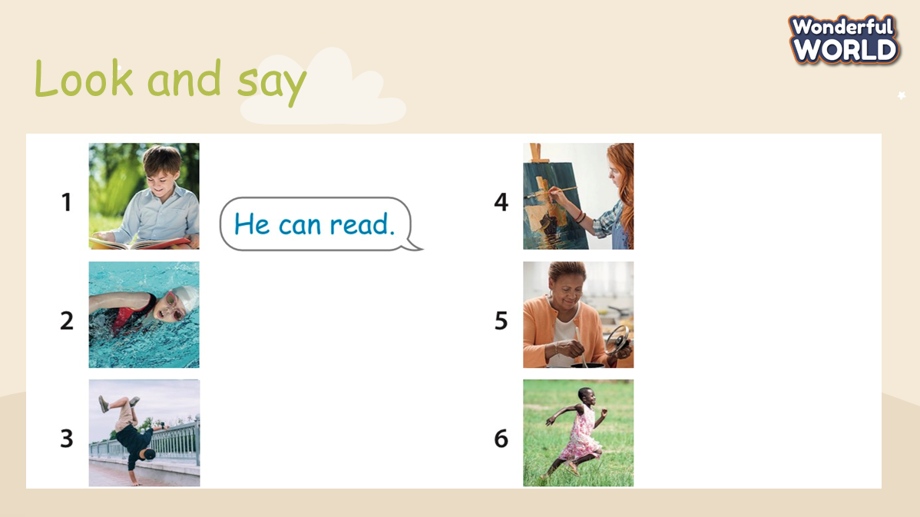  - Read the instruction to the class.  - Ask Ss to look at pictures and answers about what people can do.  - Ask Ss to read loudly individually, in team and whole class. | - Do the task and receive stars.  - Ss read loudly.
Activity 3: Review
Teacher’s activities | Student’s activities
- Play game: “ Big Wheel”  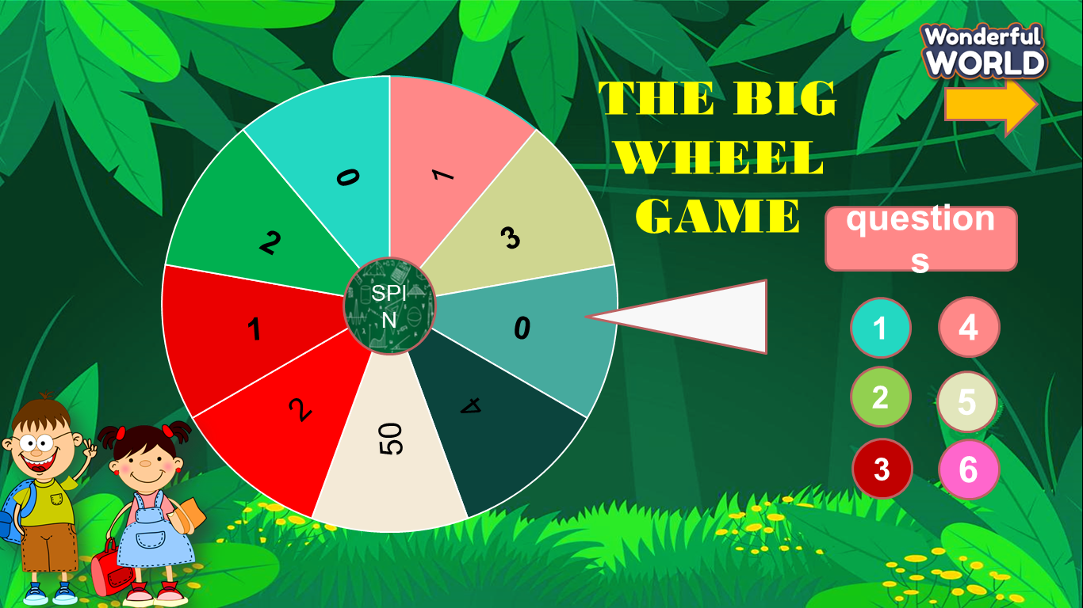  - T prepares 6 slides relating to the knowledge at previous lessons and asks students to choose the numbers and answer all questions.  - Check children’s understanding. (If children can’t understand well, T can explain the rule in Vietnamese).  - If Ss answer correctly, they will spin the wheel to get stars.  Task 2: Complete the sentences  - Ask Ss to open the book and do their task.  - Check children’s understanding. (If children can’t understand well, T can explain the rule in Vietnamese).Then, Ss will write the answer in the book.  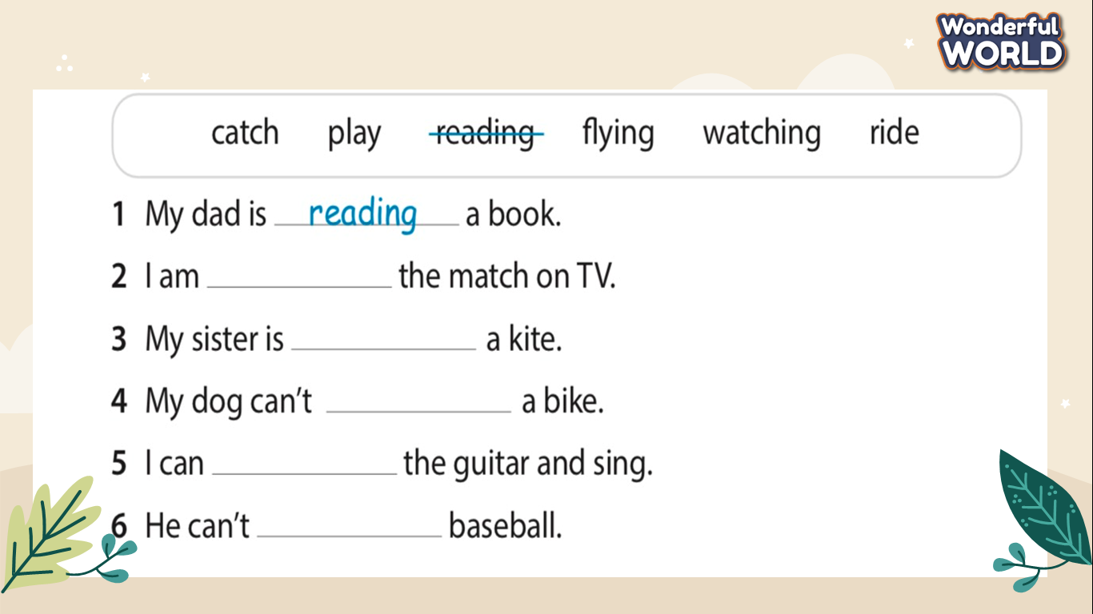  - Ask Ss to answer questions individually to get stars  - T goes around class and checks their answers | - Join the game and get stars for the team.  - Ss do the task in their books.  - Ss answer all questions.  - Ss check their results.
Activity 4: Extra Activity (10 minutes )
Teacher’s activities | Student’s activities
- Task 3: Look and say  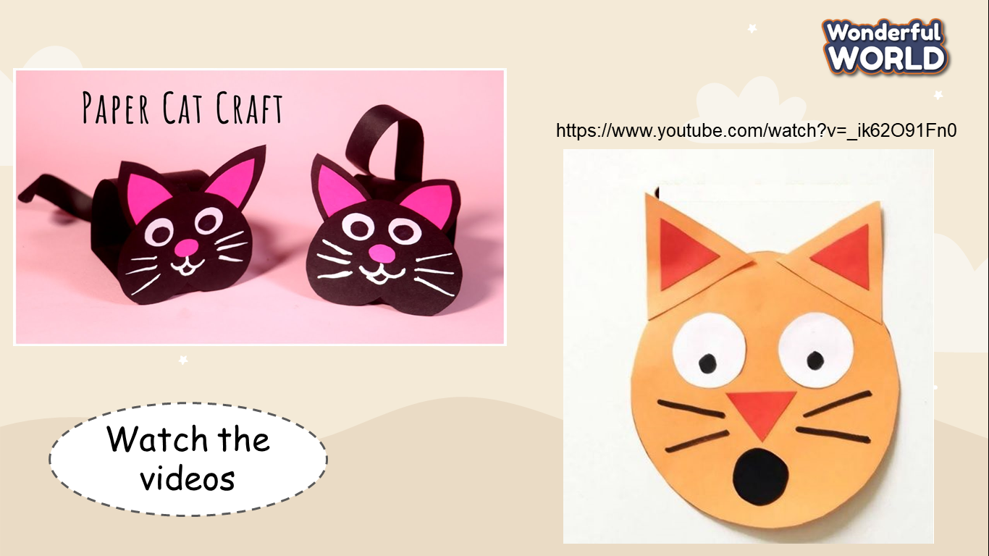  + Ask Ss to look at picture on screen and watch the video.  + Let Ss make their own cats and talk about the cats.  + Invite some SS go to the board to present.  - Assess each presentation of Ss and give them stars. | - Ss watch the video.  - Be confident and present smoothly.
Activity 5 : Wrap up (5 minutes )
Teacher’s activities | Student’s activities
- Require SS to do homework  - Say goodbye | - Say goodbye.

