WEEK 20
Wedsnesday, February 5th 2025 Class: 5B
English
Unit 8: People and places
Lesson 1: 1,2,3
I. OBJECTIVES:
1. Knowledge:
To introduce and engage students to the topic of the unit
To identify words relating to accommodation
To listen to and read a passage about a type of house in Japan
2. Competences:
- English competences: Students are able to use English to effectively use new vocabulary and structures to describe and discuss various types of accommodation, express preferences, and share information with others.
- Common competences: Students can draw their house and introduce them to their friends.
3. Qualities:
- Students will
+ Discuss accommodation types from different cultures, which enhances cross-cultural awareness and appreciation.
+ Develop a curiosity about different living environments and cultural practices related to housing.
II. EQUIPMENT AND MATERIALS:
- Basic things: Student’s book, flashcards, photos, papers
- Advanced things: PPT, laptop, TV.
III. LESSON PROCEDURE:
Activity 1: Warm-up
Activity 2: Presentation
Activity 3: Practice
Activity 4: Production
Activity 5: Wrap-up & Assessment
Activity 1: Warm-up (5 minutes)
Game: EXPLORE OUR WORLD.
Quiz game about famous landmarks
Aims: Welcome students. Warm the class up with a game to check their knowledge and widen their understanding of the famous landmarks in the world.
Teacher’s Activities | Students’ Activities
Procedure
Do you want to travel and explore the world with me? I will take you to discover the landmarks in the world!  Let’s play the game.  Quiz Instruction :  - Write your 5 answers on your paper.  - You must solve each question individually.  - You get one point for each right answer.  Question 1 . What is the name of the iconic tower in Paris, France, that is one of the most famous landmarks in the world?  Question 2. How many years did it take to complete the construction of the Big Ben clock tower, which stands over 96 meters tall?  Question 3: In which city can you find the iconic Opera House, which is shaped like sails and is one of the most famous buildings in Australia?  Question 4: What is the name of the rock that was used to build the Great Pyramid of Giza, one of Egypt's largest and most famous pyramids?  Question 5: In which city can you find the Colosseum, an ancient amphitheater that was once used for gladiator fights and other public spectacles?  T asks Sts to write the answers on the paper and tick the answers if they’re correct.  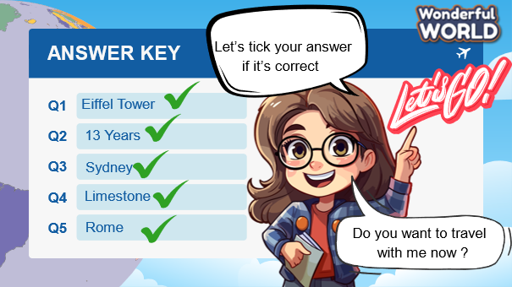 | - Greet Teacher  - Join the activity.  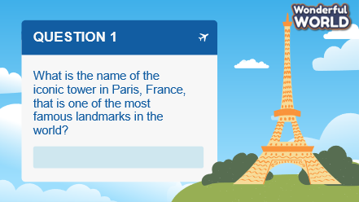  -
Activity 2: Presentation – Controlled practice (8 minutes)
a. Aims: Ss can practice listening and writing skills about the topic: the house
b. Procedure
Teacher’s Activities | Students’ Activities
To engage students with the topic and activate knowledge and vocabulary with a picture,  Tell students to look at the photo on page 15 and say what they can see. Ask: “ Have you seen the house before? Is it unique? Is it beautiful ?”  Elicit ideas (house, rock, coastline, beach, mountains) and write them on the board.  Listen and read. Would you like to live in a football-shaped house? Why or why not?  • Tell students to look at the text. Ask them to read quickly and find out what the photo is showing (a football-shaped house).  Tell students to look at the text about a football-shaped house in Japan. Tell them to read the pre-reading questions.  Play the recording. Pause after each sentence for students to repeat.  Play the recording again. Ask students to each read out a sentence from the text.  Check answers to the pre-reading questions.  Read again and write the words.  To elicit the new words, ask S to read again and fill in the blanks.  Keywords  Ladder/ basements/ balconies/ views.  Present new words :  Balcony/ basement/ floor/ garden/ ladder/ view/ | - Answer the questions.  - Read  - Write
Activity 3: Practice – Controlled practice (8 minutes)
a. Aims: Ss can remember the new words.
b. Procedure
Teacher’s Activities | Students’ Activities
Complete the sentences with these words.  Tell students to complete the sentences with the words in the box.  Remind them to re-read the text for help if necessary.  Check answers. Write the answers on the board if necessary.  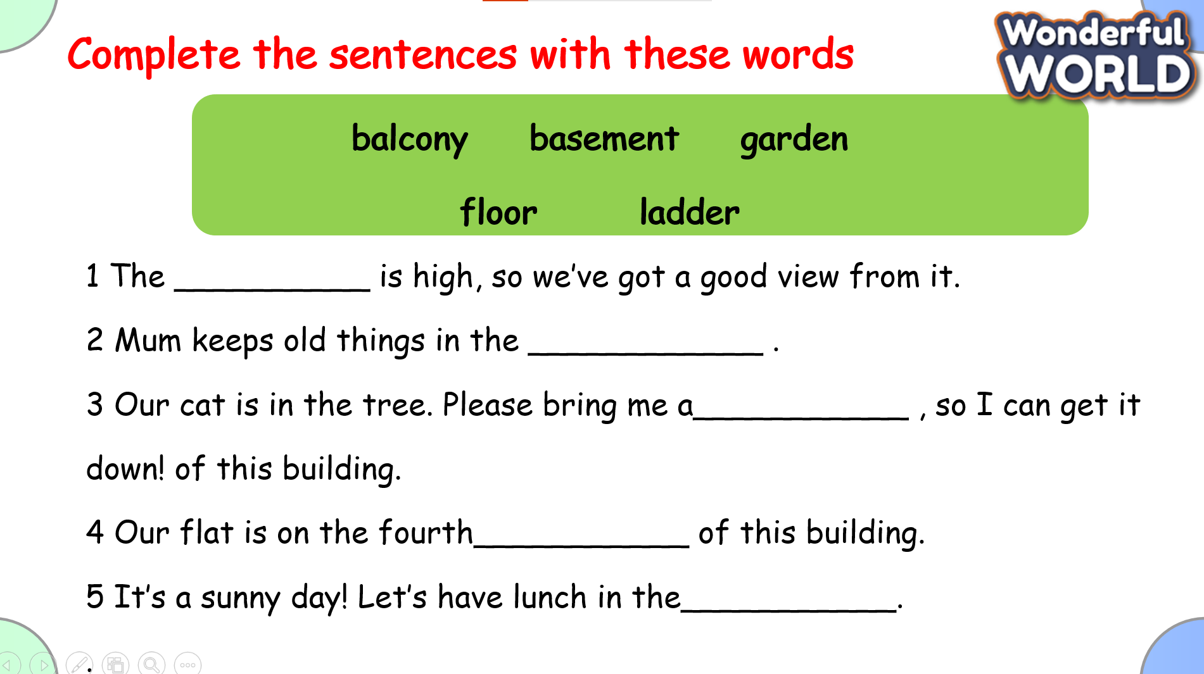  Game: TREASURE HUNT  By answering the questions,  1. How do you access the bedrooms in the house?  I climb a ladder to get into the house.  2. These houses do not have________ or balconies.  Basements  3. Our flat is on the fourth___________ of this building.  Floor  4. Do football-shaped houses in Japan provide strong protection during earthquakes and floods?  Yes  5 She climbed the _______ to fix the roof.  balcony | 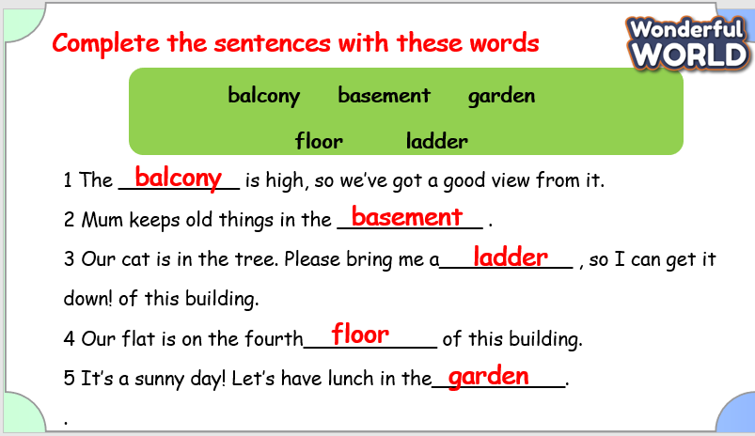  - Answer the questions.
Activity 4: Production – Free practice (6 minutes)
a. Aims:
Apply their understanding in drawing the picture about the house and talk with their friends
b. Procedure
Teacher’s Activities | Students’ Activities
Preparation:  Prepare Materials: Ensure each student has access to drawing paper and coloring materials.  Begin with a brief discussion about houses. Ask questions like, “What do you see in a house?” or “What are some parts of a house?”  Show Examples: Display images of different types of houses. Discuss various features (roof, windows, doors, etc.) and their functions.  Drawing Activity  Instructions: Explain that each student will draw a picture of a house. Encourage them to include various parts such as the roof, windows, door, and any additional details they like (garden, trees, etc.).  Drawing Time:  Worksheet: If using a worksheet, have students write a few sentences describing their house. Prompts might include, “My house has…” or “I drew a big…”  Assist: Provide help with spelling and sentence structure if needed.  Discussion  Pair Up: Have students pair up with a classmate.  Share and Describe: Each student will take turns showing their drawing and describing it to their partner. Encourage them to use descriptive language to explain the different features and why they chose them.  Discuss: After each student has shared, ask pairs to discuss what they liked about each other’s houses. | - Draw and say in front of the class.
Activity 5: Wrap up & Assessment (4 minutes)
Teacher’s Activities | Students’ Activities
a, Aims:
- Check students’s understanding of what they have learned about the house.
Asks sts to do the assessment.  T assesses class and some Ss.  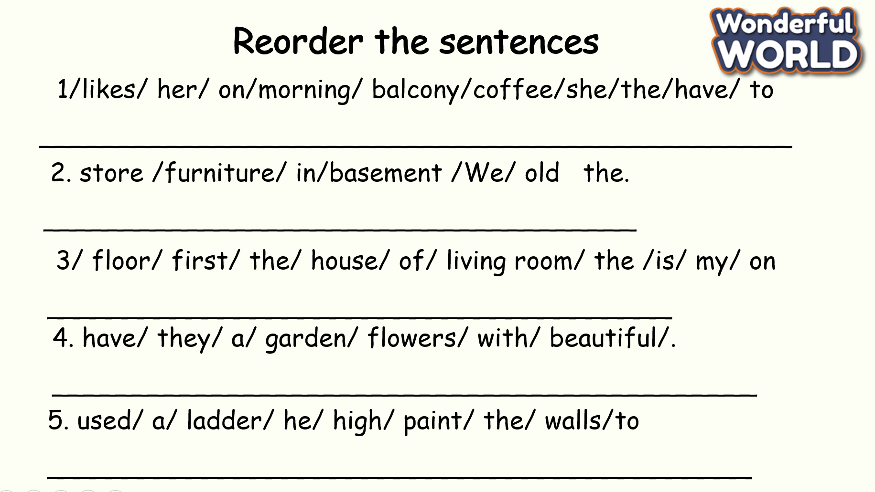  - Check with the class.  - Wrap-up  * Remember  Vocabulary:  balcony, basement, floor, garden, ladder, view | -Do the assessment.  -Check with the teacher  - Sts read the wrap-up  - Stand up and say goodbye to the teacher.  