WEEK 18
Friday, January 10th 2025 Class : 3B
English
Unit 6: My hobby
Lesson 1: 4,5,6
I. OBJECTIVES:
1. Knowledge:
Students will be able to review the words related to the topic My family, My school, animals, My house, My clothes and review the structure
2. Competences:
- English competences: Students will be able to introduce My family, My school, animals, My house, My clothes
- Common competences: Students will have the opportunity to develop autonomy in doing tasks and communicating among friends.
3. Qualities:
- Students will be friendly and confident in communicating with friends.
II. EQUIPMENT AND MATERIALS:
- For Teacher: PP, TV, music, related audio track.
- For students: paper, colour pencils or crayons, personal boards and markers.
III. LESSON PROCEDURE:

Activity 1: Warm-up (5 minutes)
Teacher’s activities | Student’s activities
Watch and sing: Tooty ta  - Ask students to watch the video and let them do action.  Watch the video and sing along to the song. | - Listen and do along  - Watch the video again and sing along to the song.
Activity 2: Review (10 minutes)
Teacher’s activities | Student’s activities
Lead-in: Use the song and the Opener picture to lead in the topics: My family, My school, animals, My house, My clothes  Vocabulary: Listen and Repeat.  - Play the words one by one  - Play the audio, ask students to listen, and repeat in chorus, groups.  - Vocabulary checking: Ask the students to recall all the words they have learnt.  Sentence structure:  - Present the structure and ask the students to repeat it.  - Sentence structure checking: Ask the students to use the sentence structure to describe their family and school | - Learn the words and structures through story and pictures.  - Repeat the words.  - Repeat then point.  - Say aloud the words  - Learn the structures and repeat the sentences  - Share their sports with the whole class.
Activity 3: Practice (15 minutes)
Teacher’s activities | Student’s activities
Task 1: Play pass the bag game (7 minutes)  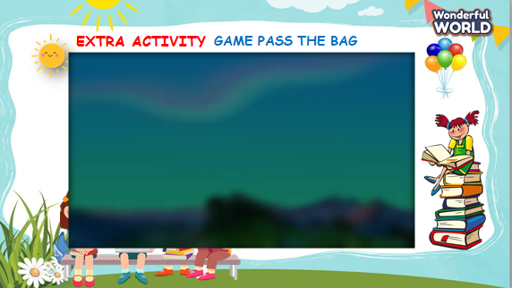  - Lead-in: Introduce the game rule:  - The teacher puts all flashcards of 6 units into 1 bag/pair/box and plays the music.  - While the music is playing, students should pass the bag around the class.  - When the music stops, the student with the bag must put out any flashcard and say aloud.  - If the student is good, he/ she can show the flashcard and ask her/his partner.  - Play the game.  - Show the questions and check if the answers are correct or not.  - Award the best student. | - Listen to the instruction carefully.  - Play the game.  - Read and give the answers.
Activity 4: Assessment (5 minutes)
Teacher’s activities | Student’s activities
- Ask students to do the task in WB.  - Check in pairs then the whole class.  - Wrap up the lesson by showing a summary.  - Say goodbye. | - Do the assessment.  - Check with friends and then with the teacher and the whole class.  - Listen carefully and repeat.  - Say goodbye.

