WEEK 15
Wedsnesday, December 18th 2024 Class: 5B
English
Unit 6: Food
Lesson 3: 4,5,6
I. OBJECTIVES:
1. Knowledge:
- Students will be able to:
+ To review some adjectives describing food.
+ To learn the usage of food quantifiers.
2. Competences:
- English competences: Students will be able to use English to write about their favorite meal.
- Common competences: Students will be able to build more confidence in applying vocabulary and quantifiers to write sentences and speak in English what they like eating at a meal.
3. Qualities:
- Students will
+ develop public speaking in front of the class.
+ develop a sense of love towards food.
II. EQUIPMENT AND MATERIALS:
- Basic things: Student’s Book, Class Audio CD, IWB, DVD.
- Advanced things: PPT, laptop, TV.
III. LESSON PROCEDURE:
Activity 1: Warm-up
Activity 2: Presentation
Activity 3: Practice
Activity 4: Production
Activity 5: Wrap-up & Assessment
Activity 1: Warm-up (5 minutes)
“Speed up”
 | Teacher’s Activities |  | Students’ Activities
 | a. Aims: Welcome students. Engage and recall the class about adjectives describing food they have learned previously and then lead in the lesson.
 | b. Procedure:  1. Greet Ss and chat.  2. Introduce and conduct the activity “Speed up”:  ‘Before starting the new lesson, let’s do a “Speed up” activity to review some food vocabulary that we’ve learned before.’  - Divide the class into different teams. It depends on T’s plan.  + Rules: T will show different hints for each word on the screen. The team that finds the answer faster is the winner.  + 1st word: delicious  + 2nd word: crispy  + 3rd word: salty  + 4th word: tasty  + 5th word: sour  + 6th word: sweet  + 7th word: spicy  3. Leading in the lesson: Unit 3 – Lesson 3 tasks 4, 5, 6.  Lead in: Food is usually uncountable nouns, so how to count uncountable nouns. Today, let’s find out what food quantifiers. |  | - Greet Teacher.  - Join the activity.
Activity 2: Presentation (7 minutes)
Teacher’s Activities |  | Students’ Activities
a. Aims:
- Check & learn the usage of food quantifiers.
- Complete task 4.
b. Procedure:  Task 4. Listen and read. Then look and match.  - Ask students to look at the phrases. Then play the recording and tell students to listen and read.  - Ask students to practice saying the phrases in pairs.  - Walk around and correct any mistakes.  - Quick check: Say Vietnamese and ask them to say it in English.  - Tell the students that they are going to match words and pictures.  - Show students how to do the task by matching the first word with the correct picture. Praise or award a prize to the quickest student with all correct answers.  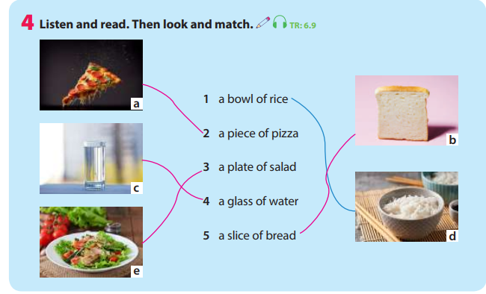  Presentation: the plural form of food quantifiers  - Let Ss guess the plural form of each phrase and then show the final answer on the screen.  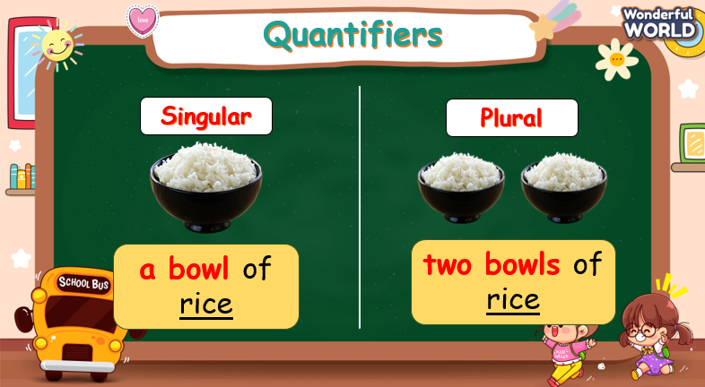  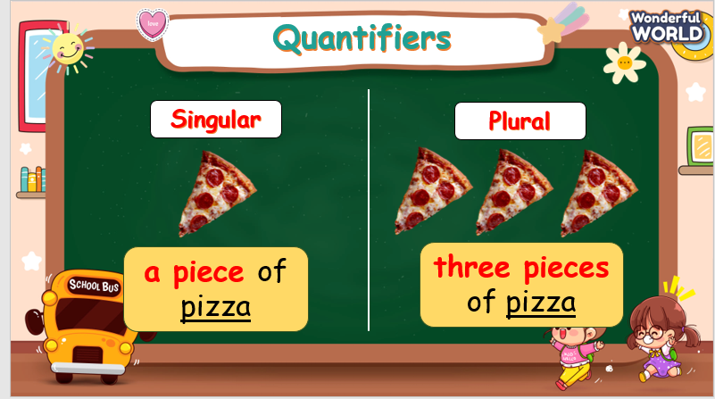  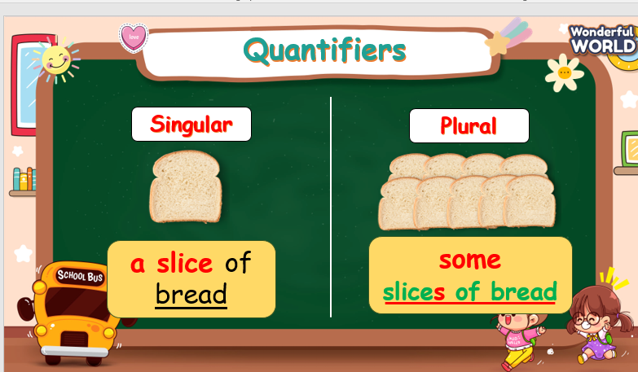 |  | - Look, listen, and read again.  - Look and match.  - Listen and answer.
Activity 3: Practice – Controlled practice (10 minutes)
Teacher’s Activities |  | Students’ Activities
a. Aims:
Ss will:
- practice using food quantifiers.
- complete task 5.
b. Procedure:  Activity “What do you love having?”  - There are five questions. Ss are asked to look at the pictures and answer questions by saying in a full sentence and using food quantifiers.  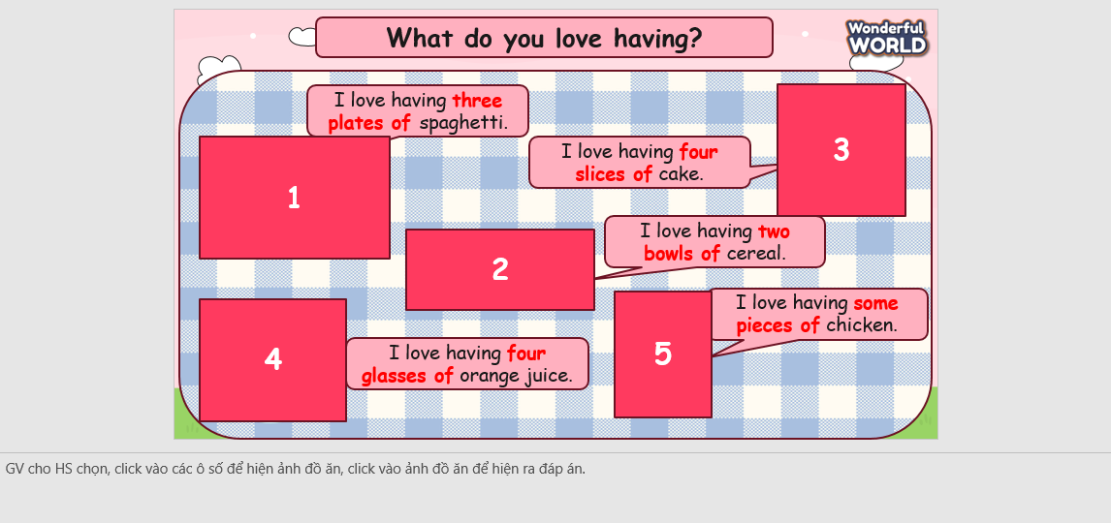  Task 5: Read and write.  + Tell students to read and write the correct form of food quantifiers.  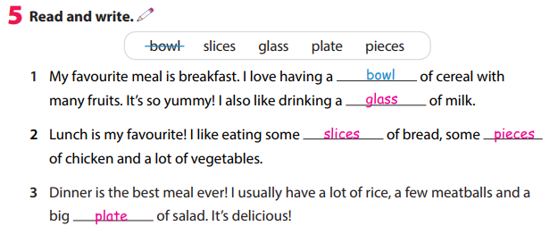  + Show answers and do the correction. |  | - Join in the activity.  - Look and answer.  - Read and write.
Activity 4: Production (8 minutes)
Teacher’s Activities |  | Students’ Activities
a. Aim: Ss will be able to apply food quantifiers to write about their favorite meal and work in pairs to share with their partners.
b. Procedure:  - Let Ss work individually for 5 minutes to draw and write a short paragraph about their favorite meal. Remember to use food quantifiers.  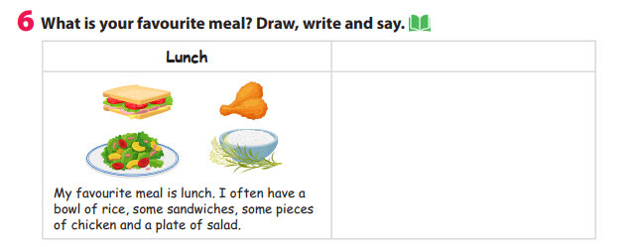  - Divide the class into different pairs.  - Let Ss work in pairs to share about their favorite meal. Choose Ss voluntarily to share in front of the class about their partners’ favorite meal. |  | - Write a short paragraph.  - Work in pairs.  - Take notes and talk in front of the class.
Activity 5: Wrap up & Assessment (5 minutes)
Teacher’s Activities |  | Students’ Activities
a, Aims:
- Assess individuals or groups who have done the best in the lesson.
- Wrap up the activities Ss have done during the lesson.
- Assessment: Do the activity “catch the word”.  + Ask Ss to look at two small pictures and guess what word or phrase is made from these two pictures.  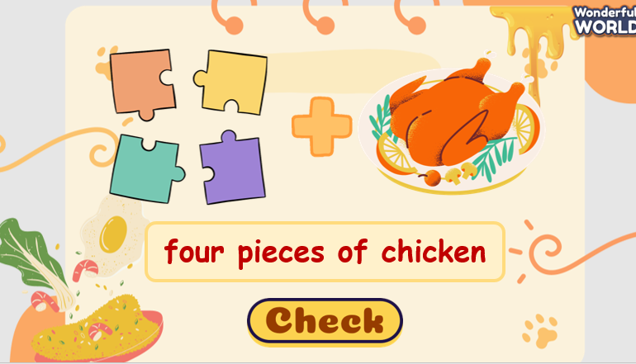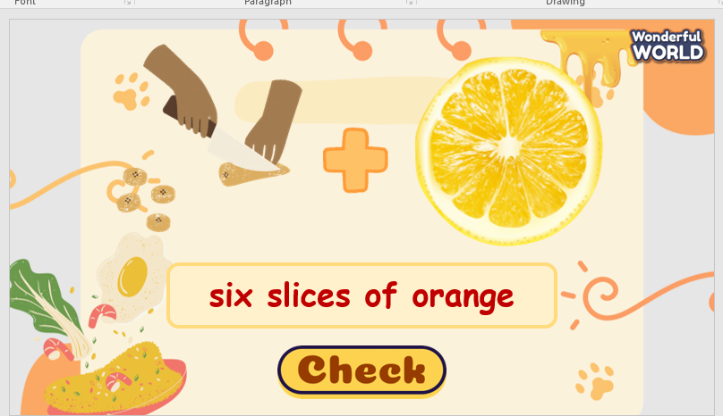  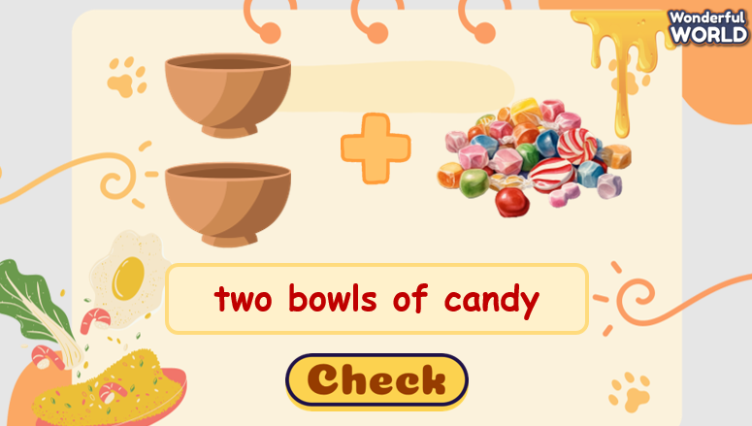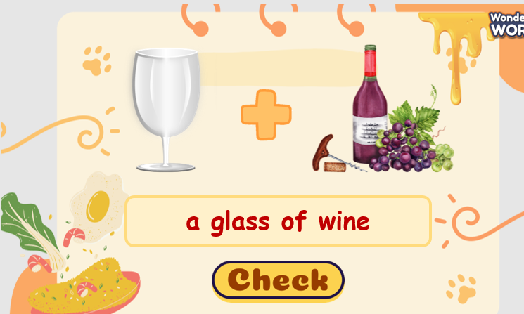  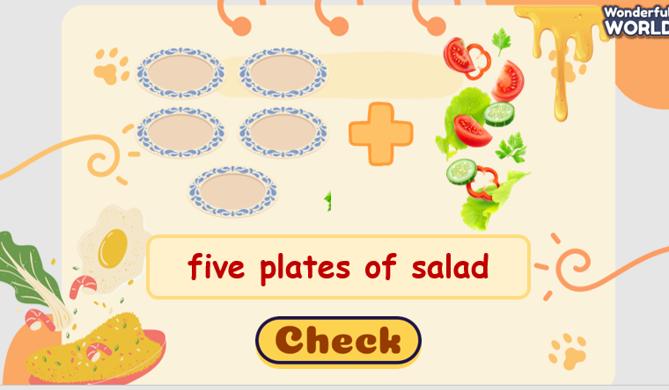  + Give compliments to the individuals/ groups who have completed the activities the best and encourage the other groups/teams to keep doing them during the next lessons.  - Wrap-up:  ‘What have we learnt today?’ - T might ask 1 S or a group of Ss to talk about what they learnt in today’s lesson.  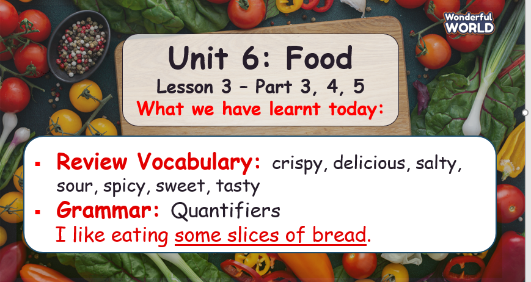 |  | - Ss answer.  - Ss answer T’s question about what they have learnt today.  - Stand up and say goodbye to the teacher.

