WEEK 13
Friday, December 5th 2024 Class : 3A
English
Unit 4: My house
Lesson 3: 4,5,6
I. OBJECTIVES:
1. Knowledge:
- Students will learn how to use : a/ an/ the
2. Competence:
- English competences: Students will be able to use a/ an/ the properly
- Common competences: Students will have the opportunity to develop communication among friends.
3. Qualities:
- Students will be friendly and confident in communicating with their friends.
II. EQUIPMENT AND MATERIALS:
- Teacher: PPT, flashcards; audio track 4.11, TV
- Students: Student’s book, pens, A4 paper, picture of their house
III. LESSON PROCEDURE

Activity 1: Warm up (5 minutes)
Teacher’s activities | Student’s activities
- Greet students.  + Play the Brain gym. Students look, listen, and do.  Hidden Treasure Game  + Review name of the colors and some vocabulary a ball, an elephant, a car, a teddy bear, a doll, a game  + Set the rules: There are 6 numbers, each number contains one color question What color is it? whoever wins in the game will be opened in order from 1 to 6. If the opener answers the question correctly, it will get 3 stars, if not, the answer will be given to the remaining team back and the score will be 1 star back for each team. When answering each question, sts will see a photo of the lesson (a ball, an elephant, a car, a teddy bear, a doll, a game). The team that says aloud the word first get a star.  + Divide the class into groups; ask four students to come into the front, they rock paper and scissors. The winner opens the cross and answers the question.  + Each time they get stars for their groups  + Students have six times to open the key picture. | - Greet teacher.  - Look, listen, and then do the action with teacher.  - Read follow teacher if possible.  Work in groups  Count the number of stars
Activity 2: Presentation (8 minutes)
Teacher’s activities | Student’s activities
Lead in: Use the game and the picture to lead in the new lesson  - Write on the board The date and introduce the lesson.  Task 4: Listen and repeat (Track 4.11)  - Show the picture a ball, an elephant, a game in task 4 one by one  - Explore the pictures  - Ask sts to talk about the picture  - Collect the suitable answer on the board  - Show the sentences one by one  - Play the audio for each sentence  - Ask sts to listen and repeat sentence by sentence | -Copy down  -Look and answer: a ball; an elephant; a game  -Listen and repeat  - Listen and repeat
Activity 3: Practice (10 minutes)
Teacher’s activities | Student’s activities
Task 5: Look and say  Game: Broken Sentence  - Make an enlarged copy the the worksheet and cut out the card, select the oppropriate number of cards , ensuring that they make up complete sentences  - Explain that the activity involves forming sentences, and each sentence consists the cards. They should use the punctuation to help them (full stop and captital letter).  - Elicit the model sentence.  “There’s a car. The car is blue..”  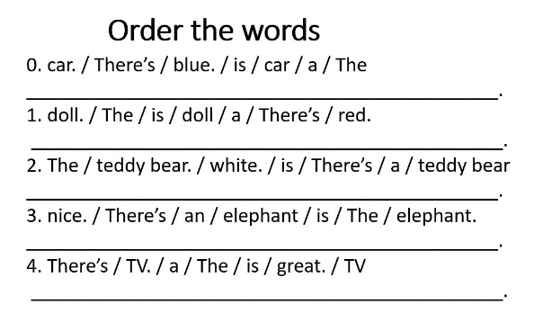  Give the sts the worksheet. Sts must put the words into the correct order. They can do this by:  + cutting out  + stick on the group boards  - Correct collectively on the board  - Divide class into 4 teams  - Divide the board into 4 corners  Show the pictures in task 5 one by one  Ask sts to pick up the equivalent sentence and say  The first correct saying have chance to stick the sentence on the group corner.  Award the group with most sticking sentences | - Look and work in group  - Work in groups  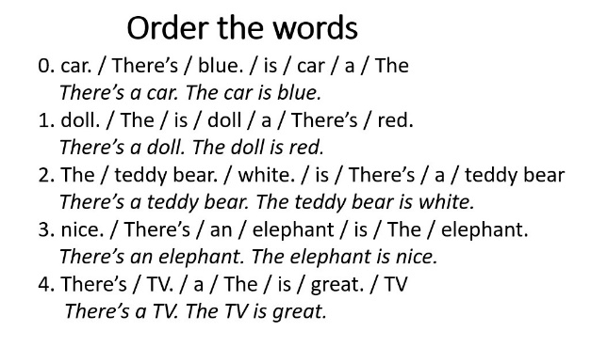  Form 4 teams  Look at the pictures  Pick up the sentence and say  Stick the sentence
Activity 4: Production (9 minutes)
Teacher’s activities | Student’s activities
Task 6: Draw. Write and say.  Prewriting  - Ask sts to look at the picture of Ana (the girl) then ask sts to describe the content of the picture  Revise the words of the lesson  + Is there a….?  + What color is it?  ….  While writing  Game: Word maze  + Give out the worksheet and demonstrate the activity to the class  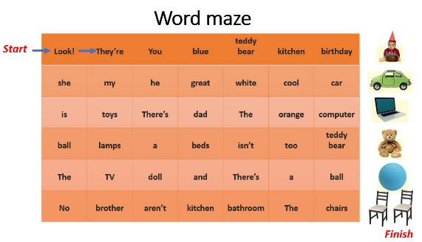  + Explain sts must draw lines through the words to make the correct sentences. Starting at the START arrow and FINISH at the FINISH arrow  + Insist that sts use pencil to be able to rub out and correct go along  + Demonstrate the first two words “Look!”; “They’re”  + Point out to sts that they can go left, right, up or down, but not diagonally. They may have to go back on themselves, so sts must look at all words  + Circulate to monitor but try to encourage sts autonomy.  Post writing  + Sts correct the puzzle in pairs first. Then correct collectively  + Correct the activity collectively. Sts swap worksheets and dictate the answers  + Have sts present their works  Draw and write. Then say  Context: sts are going to invite some of friends to visit their houses. Ask sts to draw their house with rooms (and things in each room (optional))  Give sts time to draw  Have sts do gallery walk  Tell friends about their house | -Look and answer  -Yes, there is. / No, there isn’t.  - It’s…….  ….  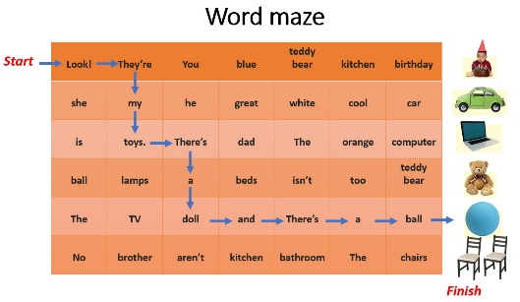  -Look, draw lines  - Check answers  - Present
Activity 5: Assessment (3 minutes)
Teacher’s activities | Student’s activities
Ask sts to do the assessment  Read and circle the correct word.  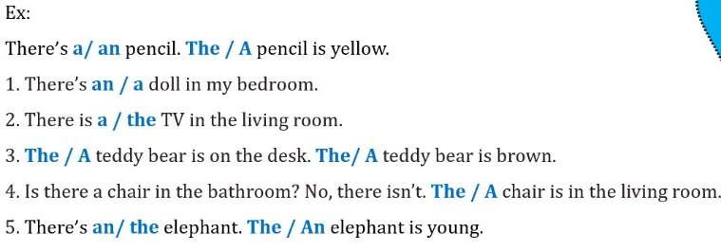  - Check in pairs then whole class.  - Say goodbye | - Do the assessment.  - a/The  - a  - The  - The  - an/The  - Check with friends and then with teacher and whole class.  - Say goodbye. Sing the Goodbye song.

