WEEK 10
Monday, November 11th 2024 Class: 5B
English
Unit 4: Free time
Lesson 3: 4,5,6
I. OBJECTIVES:
1. Knowledge:
- Students will be able to:
+ To review some activities in the free time
+ To learn and use new grammar: Verb forms (Gerund and infinitive)
2. Competences:
- English competences: Ss can use English to make conversations with verb forms.
- Common competences: Ss know how to use verb forms and write sentences about their hobbies.
3. Qualities:
- Students show their love and passion for language.
- Be confident and active in communication with friends and teachers.
II. EQUIPMENT AND MATERIALS:
- Basic things: Student’s Book, Class Audio CD, IWB, DVD.
- Advanced things: PPT, laptop, TV.
III. LESSON PROCEDURE:
Activity 1: Warm-up
Activity 2: Presentation
Activity 3: Practice
Activity 4: Production
Activity 5: Wrap-up & Assessment
 | Activity 1: Warm-up (5 minutes)
 | Teacher’s Activities | Students’ Activities
 | a. Aims: Welcome students. Engage and recall the class about school activities they have learned previously to lead in the lesson.
 | b. Procedure:  1. Greet the Ss  Ask the Ss to read the question aloud:  + How are you?  + What’s the weather like today?  Ask them to watch the video and dance along.  Listen to the song “A ram sam sam”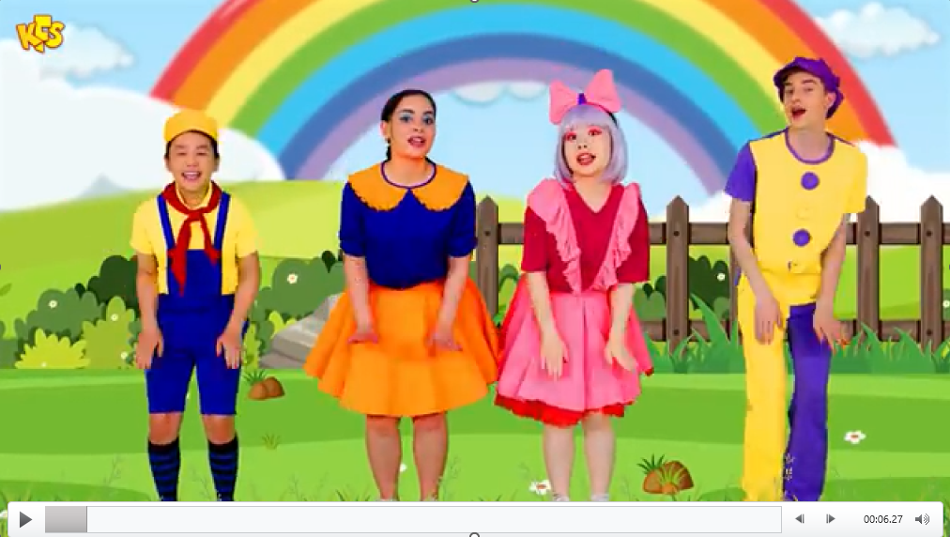  2. After warming up, let students play a mini-game to review vocabularies:  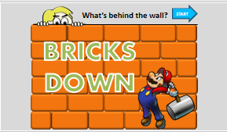  How to play:  - Divide the class into groups.  - Groups take turns to break down a wall (brick by brick) to reveal the picture.  - When enough bricks are removed, groups can try to guess the action.  - To check students' answers, click the check button and the whole picture is revealed (the wall simply crumbles). Assign points to groups for any correct answer.  3. Leading in the lesson: Unit 4 – Lesson 3 tasks 4, 5, 6. | - Greet the T  - Answer the questions aloud  - Watch the video and dance along  - Students can warm up and move their bodies to start the lesson.  - Listen to the game rules carefully  - Play the game in groups
Activity 2: Presentation (7 minutes)
Teacher’s Activities |  | Students’ Activities
a. Aims:
- Check & learn grammar: Verb forms (gerund and infinitive).
- Complete task 4.
b. Procedure:  Grammar  Write the structure “verb forms” on the board:  + Gerund: like / good at/ enjoy + V-ing  Give some examples:  I like playing sports.  She is good at dancing.  I enjoy going fishing.  + infinitive: can + V  Give some examples:  1. I can do my homework.  2. She can sing well.  Task 4. Read and circle the correct answer. Then listen and check. (track 4.9)  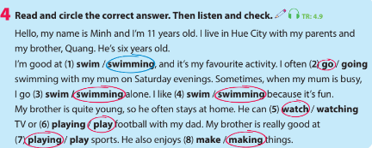  Tell students to read the letter and find out what Minh’s brother is called (Quang).  • Play the audio for the passage.  • Ask students to listen and check their answers as they follow along with the text.  • Check answers as a class. |  | - Look, listen to the teacher  - Listen to the teacher  - Do the task  - Check answers
Activity 3: Practice – Controlled practice (10 minutes)
Teacher’s Activities |  | Students’ Activities
a. Aims:
- Complete task 5.
- Check the answer with the class and review the target words and structures again.
b. Procedure:  - Task 5: Read the text in Activity 4 again. Ask and answer.  • Tell students to answer the questions. Remind them to re-read  the text for the correct answers if necessary.  • Check answers. Write the answers on the board if necessary.  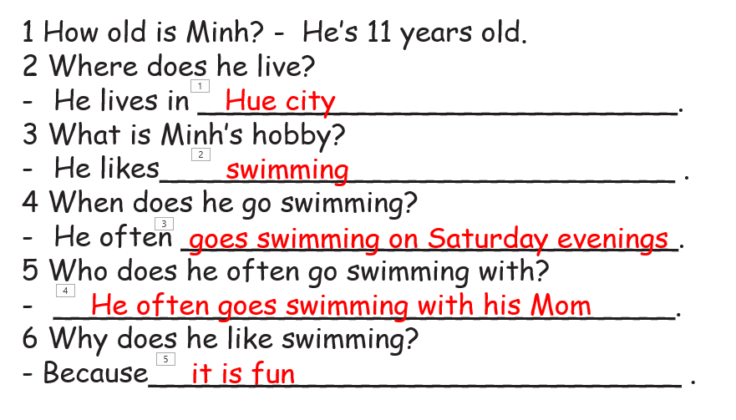  - Play the game “Playing Tennis with Mario”  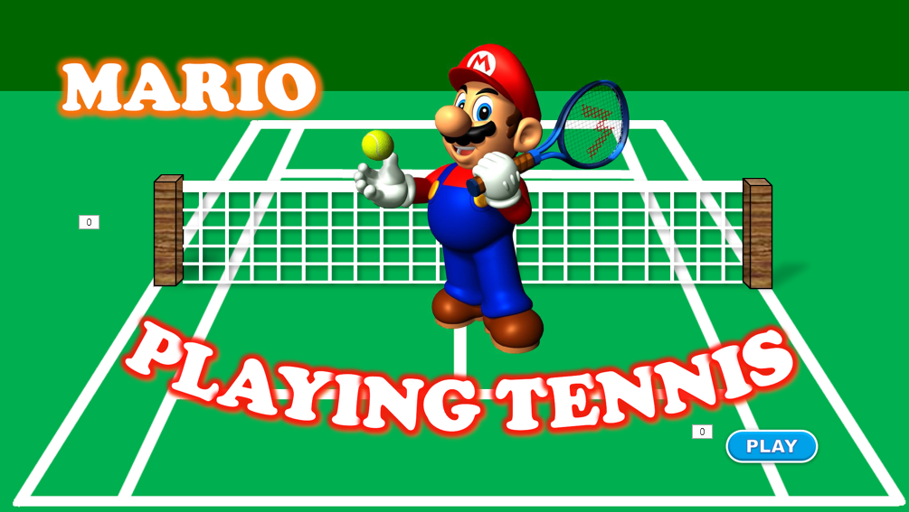  - T divides the class into 2 groups.  - Each group will choose a name and play rock, scissors, and paper to decide which group goes first.  - T clicks on the answer the student chooses. If it is correct, the students will receive 2 points.  - If not, the chance is given to the other team and they will get one score if the answer is correct.  The team who brings the ball to the goal first or closer will win. |  | - Read and write the answers.  - Check with T.  - Listen to the game rules  - Remember their group and play rock, scissors, and paper to decide who goes first  - Take turns to choose a letter and answer the corresponding questions  - Check the results and cheer for the winner
Activity 4: Production (8 minutes)
Teacher’s Activities |  | Students’ Activities
a. Aims:
- Complete task 5.
- Ss will be able to apply the words/phrases to ask their partners as a group.
b. Procedure:  • Tell students they are going to write sentences to introduce their  hobbies.  • Tell them to look at the question. Elicit what information is asked in  each question.  • Go around to check and give support if needed.  • Ask volunteers to read out their sentences to the whole class. |  | - Write sentences.  - Work in pairs.  - Take notes and talk in front of the class.
Activity 5: Wrap up & Assessment (5 minutes)
Teacher’s Activities |  | Students’ Activities
a, Aims:
- Do a small exercise the revive the vocabularies and structures.
- Check the answer with the class and review the target words and structures again
- Ask sts to do the quick assessment.  - Check with the class.  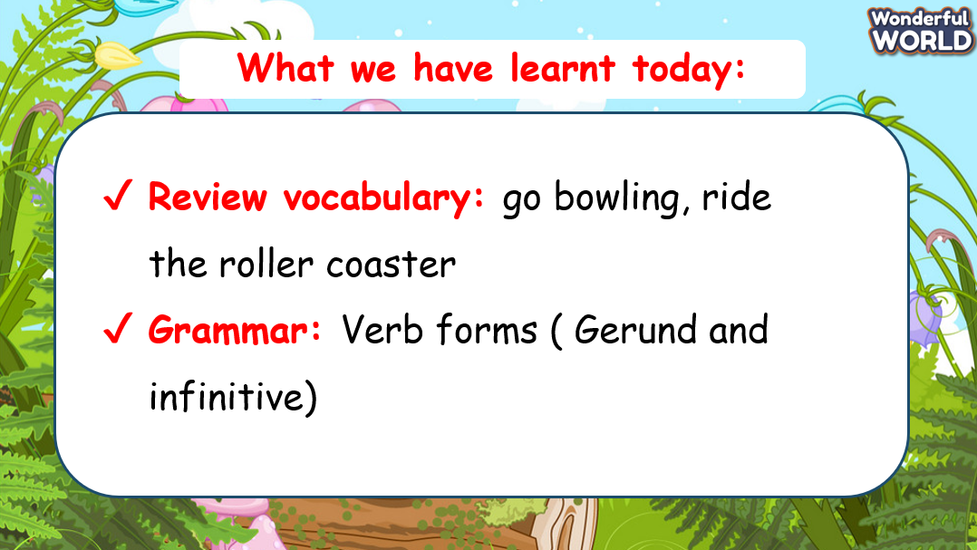  - Wrap-up:  + Review vocabulary: go bowling, ride the roller coaster  + Grammar: Verb forms (Gerund and infinitive) |  | - Ss answer.  - Stand up and say goodbye to the teacher.

