WEEK 9
Wednesday, November 6th 2024 Class: 4B
English
Unit 4: Food and drinks
Lesson 2: 4,5,6
I. OBJECTIVES:
1. Knowledge:
Students will review some body parts of animals and review vocabulary: hands, fur, legs, tail, wings
● The horses haven’t got wings.
● The cows haven’t got hands.

2. Competences:
- English competences: Students will be able to describe the body parts of some farm animals
- Common competences: Students will develop their cooperative skills in composing songs and making their farm.
3. Qualities:
- - Students will think about animals and be nice to them.
II. EQUIPMENT AND MATERIALS:
- For Teacher: PP, flashcards, handout, track 3.6.
- For students: pens, A4 paper, crayons,
III. LESSON PROCEDURE:

Activity 1: Warm up (5 minutes)
a. Aims: Review the words of the previous lesson about some body parts of animals and get the students ready for the lesson.
Teacher’s Activities | Students’ Activities
b. Procedure  - Greet the sudents.  Butterfly Catching Game  Teacher prepares flashcards or slides to review animals, especially their body parts.  Give them the example: The butterflies have got wings.  T can suggest by pointing to the part of animals and Sts have to say: What have the animals got?  Ex: The cows have got long tails.  The sheep have got white fur.  The horses have got long legs.  The chickens have got small wings.  The rabbits have got short tails.  Teacher splits sts into 2 teams. Name each team after their favourite animal. 2 teams are going to play Butterfly Catching with each other. Sts choose a butterfly to catch. The team can rob the flag first and answer correctly the animal behind the chosen butterfly, that team gets the point. Who catches the most butterflies will be the game-winner.  - Set context: Two animals are having a very important contest. The animal that catches most butterflies will become the King of the majesties’ forest.  - Set game rules  - Play as a sample  - Have teams choose a butterfly to catch  - Answer the question hidden behind  - Mark the team that has the correct answer  - Award the new king of the forest | - Greet the teacher.  - Listen to the teacher  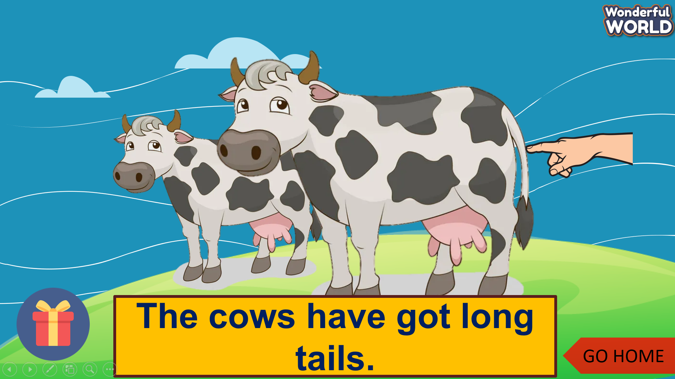  - Listen to the game instructions  - Choose the team name.  - Choose a butterfly  - Drop the flag.  - Answer the question
Activity 2: Presentation (8 minutes)
Aims:
- Introduce the use of model sentence like have not got = haven’t got.
- Guide them how to practice the model sentence.
Teacher’s Activities | Students’ Activities
b. Procedure  Do the task 4: Listen and repeat  Context: Anna takes us to the farm today. She’s a farmer. She wants us to visit the two farm animals at her farm. Guess what they are.  - Show the picture of Anna with two of them  - Ask sts to listen and repeat  - Show the picture of cows and horses.  - Ask sts to listen and repeat  - Ask sts to take turns to practise as a tour  - Perform in front of the class  - Note how to use have not got = haven’t got.  Check Listen, Point, and Repeat.  - Use the cards of animals and say sentences using haven’t got ..  - Sts listen to T and point to other animals in different sentences correctly. Sts repeat after pointing. | - Listen to the teacher  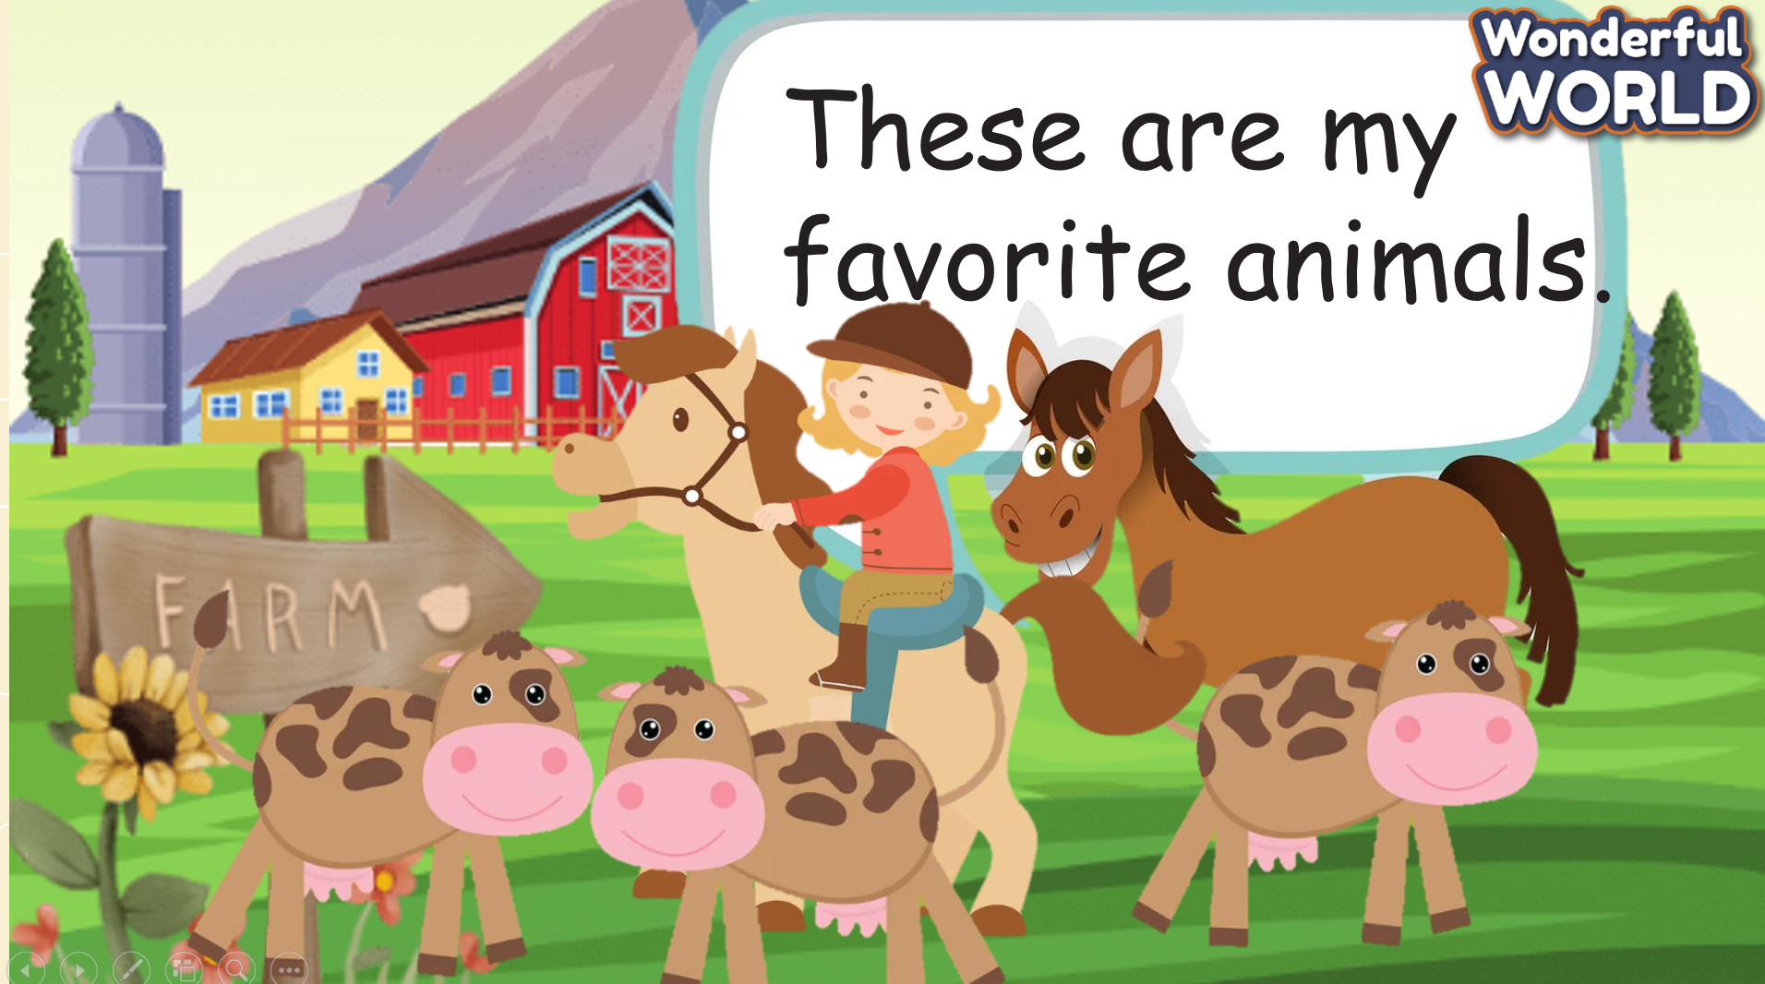  - Guess what animals are  - Look, listen, and repeat  - Practise saying the two sentences  - Perform with friends  - Listen, point then repeat.
Activity 3: Practice (10 minutes)
Aim :
- Controlled- Practice the model sentence: “ …..’ve got…”
- Get sts get ready for a song.
Teacher’s Activities | Students’ Activities
b. Procedure :  Task 5: Point and say  - Use the wheel to give the chance for Ss say the sentences following the model sentence  - If they can say correctly, get stars by spinning.  Ideas :  - Ask sts to work in 8 groups  - Hand them 6 pictures in task 5  - Ask the group to draw pointing hands which implicit the part which the animal hasn’t got.  - Sts practice picking up the pictures in turn and saying the sentence  - Say BINGO when all group members have at least a chance to say  - Go around to provide help when needed  Task 6: Listen and sing  -Set context: Do you want to listen to the animal song? Do you know this song? Do you want to dance and see what animals can do for?  Song: BABA BLACK SHEEP  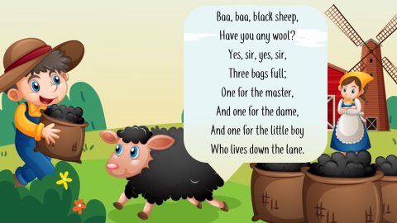  And then introduce another song for Ss:  - Read the song lyric:  - Show the lyric one by one  - Ask sts to listen and repeat  - Model singing:  - Tell sts if they want to understand animals and become their friends, you have to know how to sing and dance with them  - Play the song once for sts to sing along.  - Sing the song  - Ask sts to sing and act along several times | - Work in 8 groups  - Receive the pictures  - Draw pointing hands  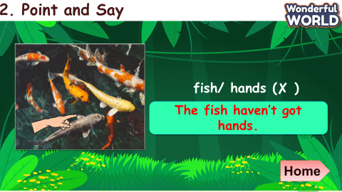  - Listen to the teacher  - Answer the teacher’s questions  - Look at the picture  - Repeat the song lyric  - Listen and act along  - Sing and act along  - Join the show
Activity 4: Production (9 minutes)
- Aims : Words and structure about the parts of animals to make a report.
- Sts can sing a song or can create their own song.
Teacher’s Activities | Students’ Activities
b. Procedure :  Animal show  - Ask sts to work in 4 groups  - Ask groups to find more animals and make their own song on posters  - Give sts time to create their own song version  - Groups perform their song in turns  - Vote for the best performance  Suggested song :  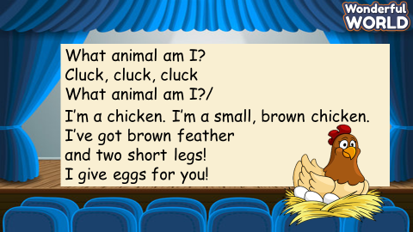 | Work in 4 groups  - Create new song versions  - Perform in front of the class  - Vote for the best performance
Activity 5: Assessment and Wrap up (3 minutes)
a. Aims : Consolidate the content of the lesson.
Teacher’s Activities | Students’ Activities
b. Procedure :  Ask sts to do the assessment.  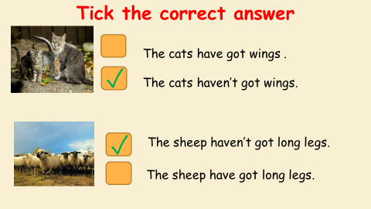  - Drill the structure again and check for correct understanding.  - Count stars and award stamps to winning team  Say goodbye students | Do the assessment.  - Check with the teacher  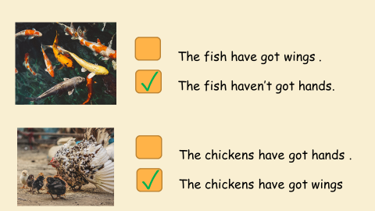  - Join in with drilling structure for their team  Ss stand up to say  - Goodbye Teacher.

