WEEK 25 Monday, March, 10th 2025 Class: 4C
Period 97
English
Unit 9: Places in town.
Lesson 2: 7, 8, 9
I. OBJECTIVES:
1. Knowledge:
Students will review some more places in town
To review asking and answering questions about where someone does something
2. Competences:
- English competences: Students will be able to talk about their town where someone does something
- Common competences: Students will have the opportunity to ask and answer where they go.
3. Qualities:
- Students love their towns.
II. EQUIPMENT AND MATERIALS:
- For Teacher: PP, flashcards, handout, track 9.8.
- For students: pens, pencils
III. LESSON PROCEDURE:
Activity 1: Warm up (5 minutes)
a. Aim: Review the knowledge of the previous lesson by playing a game or checking the learned words.

Teacher’s Activities | Students’ Activities
b. Procedure  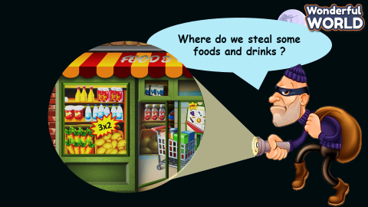  This is a guessing game on places around town. The students have to guess where the thief is by looking at the picture and reading the clue. |   - Guess the place.
Activity 3: Practice (8 minutes)
a. Aim: Controlled- Practice to say the sentences following the model sentence:
“Where do we…………………?
- ……………………………

Teacher’s Activities | Students’ Activities
b. Procedure  GAME: HELP THE MONKEY and get the stars.  Divide the questions into 2 parts:  Part 1: Listen and circle  LEAD IN:  • Stick some of the pictures on board and asks them to speak out places they can see.  • Read aloud the pictures and asks sts to identify the right one on the board  • Tell the students that they are going to listen to some sentences and circle the correct answers a or b  • Check the answer and explain when in need.  Part 2: Match and say.  • Write down the questions on te board:  Where do you buy food and drinks? At the supermarket.  • Ask sts to practice this phrase basing on the picture cards from task 7.  • Tell the students to look at the two columns and the example sentences. Read out the example.  • Explain the rest of the task to the students. Allow them enough time to match and practise saying the  sentences individually and in pairs.  • Go around the class helping students where necessary.  • Ask some volunteers to act out the dialogues. Correct mistakes if necessary.  • Suggested answer:  1.b  2.a  3.b  4.a  5. Where do we buy foods and drinks? - At the Supermarket.  6 Where do we see many plants and flowers?  - In the park.  7 Where do we play football? - In the playground.  8 Where do we surf the internet at school?  - In the computer lab. | - Follow the teacher.  - Listen and tick.  - Match and say  - Do the action as following,  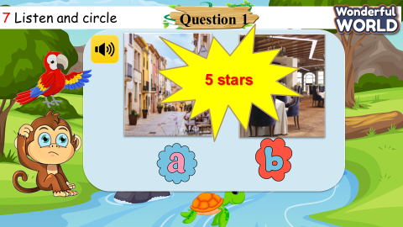
Activity 4: Production (9 minutes)
a. Aim: Apply the learned knowledge about the places, the structures to communicate with each other.

Teacher’s Activities | Students’ Activities
b. Procedure  Tell students to look at the picture and the example dialogue. Read out the example.  • Tell students to work in pairs to ask and answer questions about where they can do different things in their hometown.  • Go around the class to help students where necessary.  • Ask some volunteers to act out the dialogues. Correct mistakes if necessary.  • Give feedback on some common strengths and  weaknesses of the dialogues made by students. | Ask and answer.  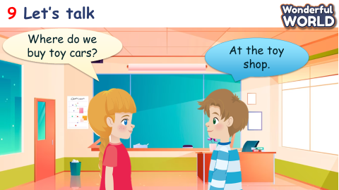
Activity 5: Assessment (3 minutes)
a. Aims: Consolidate the content of the lesson.

Teacher’s Activities | Students’ Activities
b. Procedure  Do the assessment: Circle.  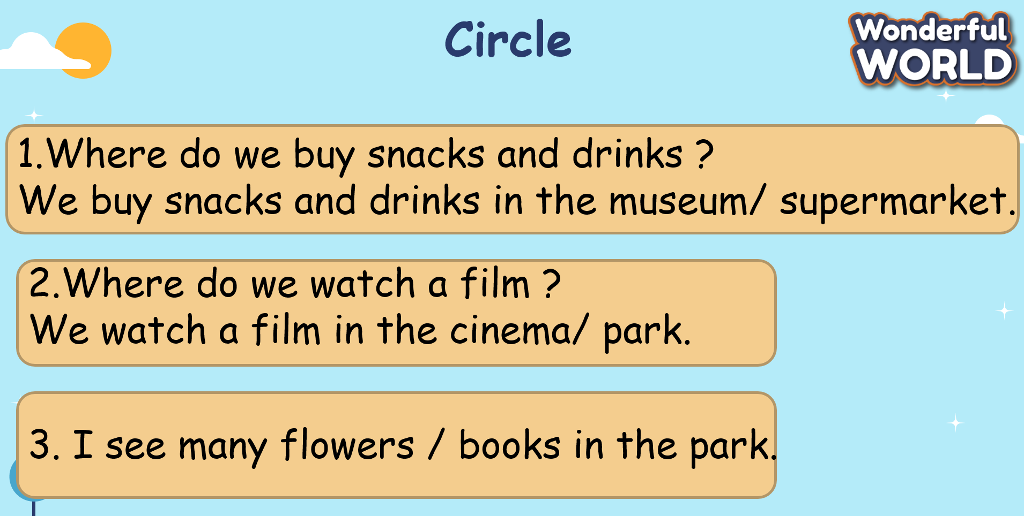 | Do the assessment.  