WEEK 24
Period: 95
Wednesday, March, 5th 2025 Class: 5A, 5C
English
UNIT 9: HOLIDAYS AND TRAVEL
Lesson 2: Part 1-2-3
I. OBJECTIVES:
1. Knowledge:
- Students get to know:
+ some words: flight, hot-air balloon, inventor, silk, smoke.
+ students can draw out new words through listening and reading the text.
2. Competences:
- English competences: Students can use English to describe an invention.
- Common competences: Students can write and talk about an invention.
3. Qualities:
- Students will
+ have a strong sense of respect for teamwork.
+ Raise their confidence by presenting in front of the class.
II. EQUIPMENT AND MATERIALS:
- Basic things: Student’s Book, Class Audio, IWB.
- Advanced things: PPT, laptop, TV.
III. LESSON PROCEDURE:
Activity 1: Warm-up
Activity 2: Presentation
Activity 3: Practice
Activity 4: Production
Activity 5: Wrap-up & Assessment
Activity 1: Warm-up (5 minutes)
Watch a video
Teacher’s Activities | Students’ Activities
a. Aims: Welcome students. Warm the class up with a video to lead in the new lesson.
b. Procedure:  1. Greeting Ss and chatting:  Let's start our new lesson with a video. Please pay attention and then I’ll ask you some related questions!  2. Watch a video:  - Play the video and ask students to pay attention.  https://youtu.be/QGAMTlI6XxY  - Ask Ss to answer the following questions:  1. What can you see? (ANSWER: HOT-AIR BALLOONS)  2. Where do you usually see these? (SUGGESTED ANSWERS: FAIR, EXHIBITION, ETC.)  3. Do you know who invented hot-air balloons? (SUGGESTED QUESTIONS: THE Montgolfier brothers)  3. Leading in the lesson:  Unit 9 – Lesson 2 task 1, 2, 3  - Lead in Today, we are going to read about hot-air balloons and learn some new words! | - Greet Teacher.  - Watch and answer.
Activity 2: Presentation (12 minutes)
Teacher’s Activities | Students’ Activities
a. Aims:
- Present some new words: flight, hot-air balloon, inventor, silk, smoke.
- Encourage Ss with the topic and vocabulary related to the topic.
- Develop Ss’ reading abilities
New words  - Use flashcards and PowerPoint to introduce the lesson's vocabulary (flight, hot-air balloon, inventor, silk, smoke).  + Show the pictures-> show the words -> play audio twice for Ss to listen then ask them to repeat in chorus, groups, and individually.  - Correct student’s pronunciation if necessary.  Task 2: Listen, point, and repeat (Track 9.5)  - Check their understanding if necessary.  - Ask students to listen, point, and repeat after the speaker.  - Call some students to read it out aloud and correct spelling  if necessary.  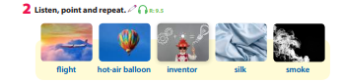  Task 1: Listen and read. Tick T for True or F for False. (Track 9.4)  - Ask students to watch the video on the screen and then listen again.  - Have students listen and read it individually.  - Call one student to read it out aloud and check pronunciation if  necessary.  - Then, ask students to read the text again and tick True or False.  - Model Sentence 1 as an example.  - Give students three to five minutes to do the task independently.  - Go around the classroom and offer help if necessary.  - Invite some students to write the answers on the board and the  whole class checks.  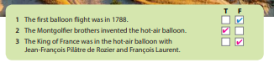 | - Look and answer.  - Listen, point, and repeat.  - Listen and read.  - Tick True or False.
Activity 3: Practice – Controlled practice (8 minutes)
Teacher’s Activities | Students’ Activities
a. Aims:
- Practice new words through exercise 3.
b. Procedure:  Task 3: Circle the correct words.  - Ask students to look at Activity 3. Show them Sentence 1 as an example.  - Tell students that they will read and circle the correct word in each sentence.  - Give students five minutes to complete the task by themselves.  - Call some students to share their answers with the class.  - Give feedback and comments.  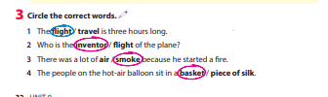  Activity “The Hot Seat”  - First, split your class into different teams (two is best, but if you have a large class, any number could be used).  - Sit the students facing the board.  - Then take an empty chair - one for each team - and put it at the front of the class, facing the team members. These chairs are the 'hot seats'.  - Then get one member from each team to come up and sit in that chair, so they are facing their team-mates and have their back to the board.  - Show the first word on the screen.  - The aim of the game is for the students in the teams to describe that word, using synonyms, antonyms, definitions, etc. to their teammate who is in the hot seat - that person can't see the word!  - The student in the hot seat listens to their teammates and tries to guess the word.  - The first hot-seat student to say the word wins a point for their team. Then change the students over, with a new member of each team taking their place in their team's hot seat. Then show the next word… | - Complete the task.  - Join the activity.
Activity 4: Production (5 minutes)
Teacher’s Activities | Students’ Activities
a. Aims:
- Ss apply the new words to talk about an invention – a light bulb.
b. Procedure:  - Divide the class into different groups of three to four students.  - Work in a group to talk about an invention – a light bulb.  - Call some students to share in front of the class.  - Suggested questions:  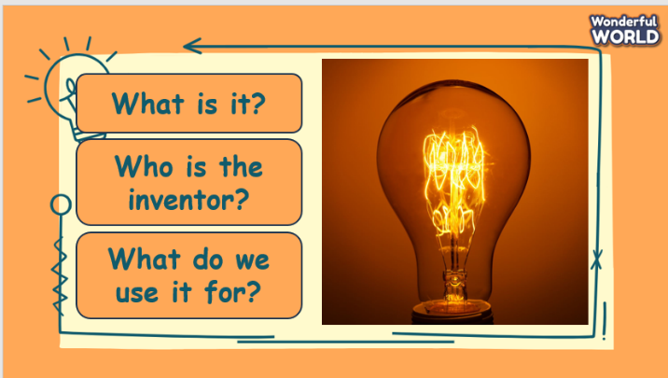 | - Work in groups.
Activity 5: Wrap up & Assessment (5 minutes)
Teacher’s Activities | Students’ Activities
a, Aims:
- Check students’ understanding of what they have learned.
- Students rehearse what they have learned in the lesson.
- Assessment: Give compliments to the group/ team that has completed the activities the best and encourage the other groups/teams to keep doing them during the next lessons.  - Wrap-up: Do the activity “Unscramble the words.”.  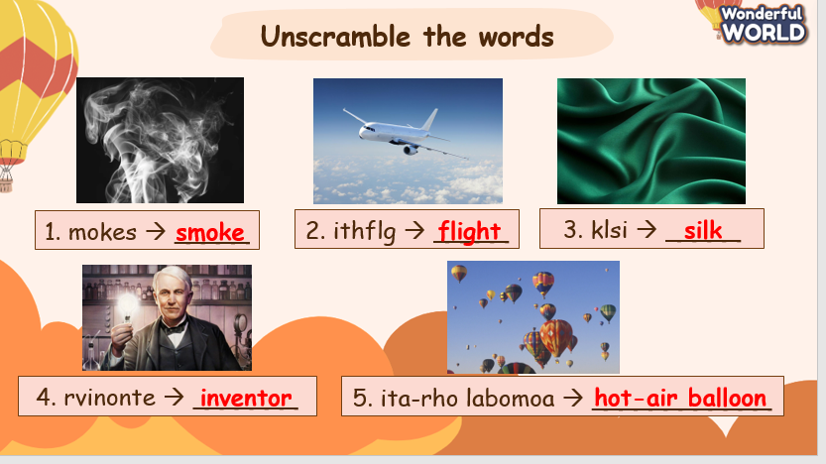  * Remember  - Vocabulary: flight, hot-air balloon, inventor, silk, smoke. | - Check with the teacher.  - Do the activity.  - Stand up and say goodbye to the teacher.

